Student Name: Nancy Leather
Student Number: 2404204
Program Study: Design Craft
Module: ADDA4022

Tasks in Order I Received them:
Manifesto: 507 Words.
Observational Writing: 480 words.
Practice based Writing: 479 words.

Manifesto:
Successful Art is Driven by the Conflict Between Opposing Ideas. The Unity of Opposites.

Manifesto Points:
1) The luscious yet grotesque conflict within a human body.
2) To be successful is to be Unsuccessful.
3) Between Dog and Wolf, is Art Our Friend or Foe.
4) Dialectic of Opposites.
5) To Make is to Not Create.
6) The Death of something Old Brings the Life of Something New.
7) Speaking but with no Words.
8) Realism vs Surrealism. Every fantasy comes from a reality.

2) To be successful is to be Unsuccessful.
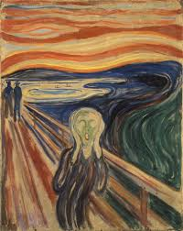
Figure 1, The Scream, Edvard Munch, 1893

Expression of negative emotion is what makes artists so profoundly successful in their ability to provide a connection between the viewer and artist. “…(Could only have been painted by a madman!)” is said to be scratched into the red strip across the sky in Edvard Munch’s, The Scream (Heller, 2006, p.17). “…(Munch screams because the pain suffered is spiritual and projects its insanity outward into a physical expression.)” (Heller, 1973, p.87). Without Munch’s unsuccess, known as Munch’s insanity, or had it not been painted by a ‘madman,’ ‘The Scream’, would not have been as commercially successful. Emotions drive the intensity of art, pouring emotion and experience that comes with the unlucky hand that has been dealt into visual stimulations. Munch has been compared to modernism in the realms of literature as, similarly, Munch wants to work through memories, thoughts, emotions (usually of melancholy attributes) that are felt by himself and seen through art, rather than working from already existing visuals that are solely for aesthetic pleasure (National Gallery, 1993, p.38).
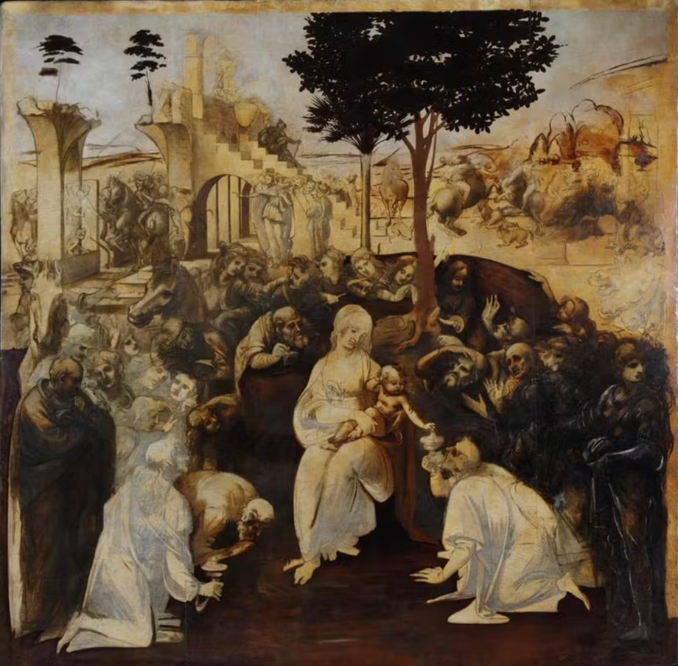
5) To Make is to Not Create.
Figure 2, adoration of the magi, Leonardo Da Vinci, 1481

“MAKING ART IS DIFFICULT. We leave drawings unfinished and stories unwritten.” (Bayles and Orland, 2001, p.1). Mastering the visuals often means having to master the psyche, which we will never fully understand, to perfectly put into context of what we want to create and what we actually create. To make but not create. Creating a finished product may be the most valuable external reason for creating art, but internally for the artist it is the journey, experiences, and technique that shape the work (Bayles and Orland, 2001, p.5). Leonardo Da Vinci, who left many of his pieces, that are also considered his most famous pieces, unfinished (Adoration of the magi) said “Art is never finished, only abandoned.” (Boland, B, 2021) Only an artist can decide weather there painting is fully finished or not. Even then, when a painting has finished there can be infinite more element that can be added, more colour more details, you can work on one painting for your whole life, and you will never be able to stop adding visual elements. Only the artist how creates the image has the power to determine wether it is finished or not. But even then, they are not finished a panting only finished added visual stimulants.

6) The Death of something Old Brings the Life of Something New.
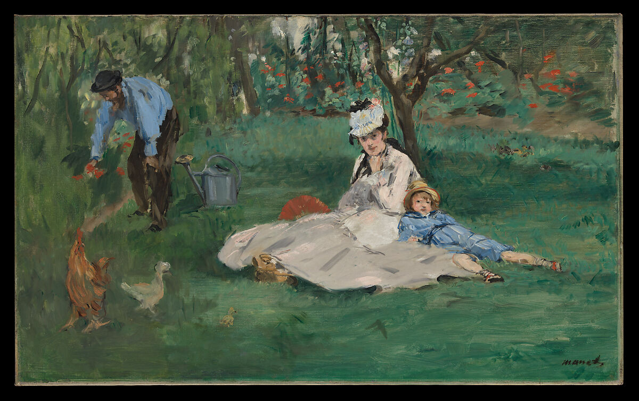
Figure Three, The Monet Family in Their Garden at Argenteuil, Edouard Manet, 1874

Modernism is the point at which historic and conservative values died within art and brought in life of individualism, experimentation, absurdity into the arts (Tate). Manet is considered the founder or farther of the modernist period, who had a major impact and influence on impressionism, an early modernist art style (Witek, 2022). While bringing life to painting and the french palette with opaque painting and Matt painting Manet simultaneously killed the obsession of oil paintings and the tradition values of art (Barnes, 2015, p.72). “Even those who were on Manet’s side knew you cannot have the arrival of something old.” (Barnes, 2015, p.72). Though people appreciate and respect the place for traditional art mediums and ideologies nothing can live for eternity even an inanimate concept, life cannot exist without death.

Bibliography.
Barnes, J. (2015) ‘Manet: Black and White’, in Keeping an Eye Open: Essays on Art. London: Jonathan Cape, pp. 70-89.
Barrelli, A. (2023) The unity of opposites explained, Your Screenplay Guy. Available at: https://yourscreenplayguy.com/blogs/screenwriting-advice/the-unity-of-opposites-explained#:~:text=In%20screenwriting%2C%20the%20unity%20of,and%20drives%20the%20story%20forward. (Accessed: 25 October 2024).
Bayles, D. and Orland T. (2001) ‘The Nature of the Problem’, in Art & Fear: Observation on the perils (and rewards) of Artmaking. Santa Cruz, CA: The Image Continuum, pp. 1-7.
Boland, B. (2021) Art is never finished, only abandoned, ArtsHub Australia. Available at: https://www.artshub.com.au/news/features/art-is-never-finished-only-abandoned-262096-2370305/#:~:text=There's%20a%20popular%20quote%20you,writers%2C%20and%20creatives%20would%20recognise. (Accessed: 28 October 2024).
Heller, R. (2006)’” Could Only Have Been Painted by a Madman”- Or Could It?’, in. Edvard Munch: The Modern Life of the Soul. New York, London: Museum of Modern Art: Thames & Hudson, distributor, pp. 17-34.
Heller, R. (1973) ‘The Scream of Despair’, In Munch: The Scream London: Allen Lane Penguin Press, pp. 87-101.
Lathe, C. (1993) ‘Munch and Modernism in Berlin 1892-1903’, in Edvard Munch: The Frieze of Life. London: National Gallery Publications, pp. 38-44.
Mentler (2019) Nonfinito- the art of unfinished, The Society of Figurative Arts. Available at: https://tsofa.com/infinito/ (Accessed: 28 October 2024).
(No date) Rufino Tamayo- Arts of the Americans. Available at: https://www.oas.org/artsoftheamericas/rufino-tamayo#:~:text=RUFINO%20TAMAYO%20b.,1991%20Mexico&text=Hombre%20contemplando%20a%20la%20luna,as%20a%20dialectic%20of%20opposites. (Accessed: 25 October 2024)
Tate (no date) Modernism, Tate. Available at: https://www.tate.org.uk/art/art-terms/m/modernism (Accessed: 3 October 2024)
Witek, D. (2022) How Manet changed art history, Artsper Magazine. Available at: https://blog.artsper.com/en/a-closer-look/how-manet-changed-art-history/ (Accessed: 31 October 2024)

List of Figures
Da Vinci, L. (1481) adoration of the magi. [Oil on Wood] Available at: https://www.uffizi.it/en/artworks/leonardo-adoration-of-the-magi (Accessed: 28 October 2024)
Manet, E. (1874) The Monet Family in Their Garden at Argenteuil. [ Oil on Canvas] The Metropolitan Museum of Art, New York. Available at: https://www.metmuseum.org/art/collection/search/436965 (Accessed: 31 October)
Munch, E. (1893) The Scream. [Oil, Tempera, Pastel on Cardboard] Munch Museum, Oslo. Available at: https://www.edvardmunch.org/the-scream.jsp (Accessed: 25 October 2024)

Observational Writing:
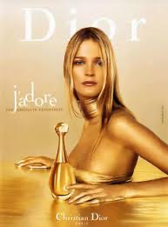
Simply, the concept of semiology using Saussure’s philosophy of signs having a signifier and signified. Signified is the subject and signifier is the associations of the subject (Media Studies, 2022). Denotation and connotation of the sign was developed from Saussure’s theory by Roland Barthes. Bringing the arbitrary nature of semiotics to the surface when connoting a denoted (Barthes, 1964, p.91). Using Christians Diors advertisement of J’Adore perfume I am going to put into context how semiotics is used.
Figure 1: J’Adore, Christian Dior (1999)
“We never look at just one thing; we are always looking at the relation between things and ourselves.” (Berger, 1972, p.9) Psychoanalysis is centred around the human subjective meaning that the way in which spectators respond to the advertisement is in relation to their characteristics that are arbitrary (Rose, 2001, p.100). Using Gillian Roses paradigm on psychoanalysis “Psychoanalysis concepts are used to interpret aspect of visual images, and particularly their effects on spectators.” (Rose, 2001, p.101) Christian Dior has used symbolic signs strategically to guide the decoding of spectators. Denoting the colour gold (the primary colour used in the advertisement) its simply just a colour. Gold is polysemic, connotations to wealth, success, luxury, power the human subjective notices these and the subjective is led to be in favour of the advertisement. Using the Weston connotations and Roland Barthes semiotic theory of myth’s, “The way we see things is affected by what we know or what we believe”(Berger, 1972, p.8), gold is used to affirm the Myth that with this perfume (J’Adore, Christina Dior) comes everything that has ever been wanted, money, success’s, power. A woman being represented through the iconic sign of Marilyn Monroe, blonde hair, a low cut dress that alludes to sexuality, but the body language seems at first to be submissive with the front of the body turned away but still slightly in view. Marlyn Monroe was a highly sexualised women within society who often had childlike, playful, and innocent tendencies and was often portrayed using Freud’s theory of of scopophilia (the pleasure in looking) using the female physique in relation to the male gaze to evoke sexual simulations and visual appealing aesthetics (Mulvey, 2013). Reaffirming the myth of the gains and successes that come with J’Adore perfume. Marilyn Monroe is a strong signifier of it all, the fame, money, success. With being one of the most influential people, even still today, she arguably Is one of the most powerful and influential, loved and visually appealing iconic sign. Christian Dior wants the Spector to believe they can be too with J’Adore. J’Adore translates to “I love,” but only in relation to an object, not loving a being. Encoding to the idea that with J’Adore the only thing that is too be loved by you is the perfume. Whilst the advertisement is aiming for women there is still profound dependency of the male gaze.

Bibliography.
Media Studies (2022) Ferdinand de Saussure’s sign theory: Examples and analysis. Available at: https://media-studies.com/saussure/. (Accessed: 20th November 202).
Barth, R. (1964) Elements of Semiology. First addition. New York, United States: Hill and Wang.
Rose, G. (2001) Visual Metrologies. London, New Deli: SAGE publications.
Berger, J. (1972) Ways of Seeing. London: Penguin Group.
Mulvey, L. (2013) Visual Pleasures and Narrative Cinema.
Edwards, K. (N/A) Laura Mulvey’s Appropriation of the Gaze into Feminist Film Theory. Available at: https://www.vanderbilt.edu/AnS/english/Clayton/engl337a/edwards/337a-template-term-mulveyandgaze98.htm#:~:text=In%20her%20seminal%20article%20%EF%BF%BD,through%20sight%2C”%20and%20narcissism— . (Accessed: 21st November 2024)

List of Figures.
Dior, C. (1999) J’Adore. Available at: https://research-methodology.net/role-of-women-in-media-advertising-a-brief-literature-review/ (Accessed: 20th November 2024).

Practice Based Writing.
Object: Ceramic
Word: Tacit

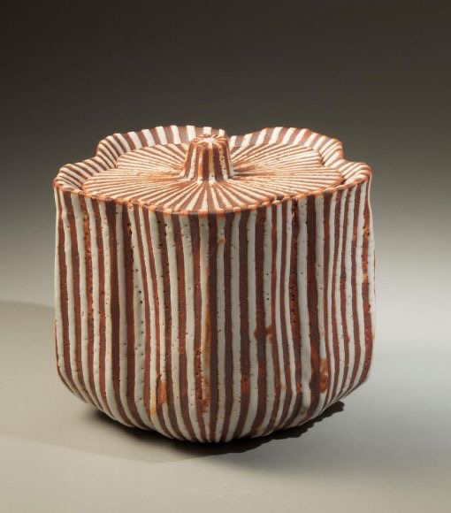
Figure One, virtually stripped white Shino-glazed waterjar (mizusashi) in the form of a cherry blossom. Suzuki Osamu, 1988

Suzuki Osamu explored many ancient local ceramics kilns to Mino, a city in Japan, fascinated with the traditional methods of kiln building, firing, and throwing, deviating all the way back to the 16th century (John B Mirviss, 2024). Vilém Flusser explore through the book ‘the shape of things’ that the Eastern part of the world his more connection to their heritage and they use their heritage to experience the world. Mino’s tradition ceramic decorative technique of Shino is how, figure one, was created. Shino is a traditional Mino glazing technique from the momogama period (1573- 1615) consisting of a thick creamy, usually white, feldspar glaze, the ceramics are used for tea ceremonies; tea blows, water jars and mukozuke food bowls (Japan House, no date, para 2). Tea ceremonies utensils are used for a purpose, and we interact with these objects through our senses, of touch. Touch indicates that we are using something as a tool, wether it be a work tool, or a tool for consuming, a tool from drawing or writing and a tool for creating something. Micheal Polanyi explores this idea through his book of ‘Personal Knowledge.’personal knowledge is of what we personally know about something. We culture our knowledge through the knowledge of a tool, how these tool effect us solving problems. These actions are not stated but through our senses we copy from observations on using an object. We have the knowledge of the tool; to create a personal knowledge you must physically interact with that. Having knowledge and personal knowledge helps us expand ideas beyond just knowledge (Polanyi, 1958). Once we have understood the object, we no longer need to mental interact, only physically, therefor becoming an extension of out body and we experience the world through the object. The use of the Mino Pottery and has become an extension of the body though the derivations of actions, has become tacit, understood without being stated. Tea ceremonies have a universal personal knowledge on how to use them because of the derivation of the use.
Applying phenomenology and epistemology to figure one, the way in which we experience and get all source of meaning is though the experience with the object. The experience of the methods and what makes it true, through the tacit knowledge and the prejudgment of the use. Maurice Merleau-Ponty argues that the knowledge of the object is based on the prejudgment of the object, “the unity of the object is based on the foreshadowing of the object of an imminent order which is about to spring upon us” (1962, p.20). In relation to Suzuki Osamu, figure one, the client must have prior knowledge to this object, knowledge of the tea ceremony, to have personal knowledge. Within my practice of ceramics using tacit knowledge, to create ambiguous pottery can discredit the idea of personal knowledge comes form Ponty ‘s idea of prejudgment.

Bibliography.
Flusser, V. (1999) The Shape of Things. London: Reaktion Books.
Japan House (no date) The Art of the Ramen Bowl. Available at: https://www.japanhousela.com/exhibitions/the-art-of-the-ramen-bowl/mino-techniques/ (Accessed: January 2nd, 2025)
Joan B Mirviss (2024) Suzuki Osamu (Kurt). Available at: https://www.mirviss.com/artists/suzuki-osamu-kura?view=slider#5 (Accessed: January 2nd, 2025)
Merleau- Ponty, M. (1945) Phenomenology of Perception. London, New York: Routledge
Polanyi, M. (1958) Personal knowledge. Taylor & Francis e-Library

List of Figures.
Osamu, S. (1988) virtually stripped white Shino-glazed waterjar (mizusashi) in the form of a cherry blossom. Available at: https://www.mirviss.com/artists/suzuki-osamu-kura?view=slider#5 (Accesses: 2nd December 2024)

