
Windows 10
& Microsoft Surface
New User Guide


Intentionally blank. Inside front cover

Contents
Microsoft Windows 10 New User Guide 4
Starting using Windows 10 4
Access the internet on Windows 10 6
Useful new features. 7
Search your computer 8
Shut down the computer 9
Windows 10 on a Microsoft Surface 10
Logging in to the Surface 10
Use Surface as a Tablet, or as a Laptop. 11

Microsoft Windows 10 New User Guide

Starting using Windows 10
Computers at UWTSD have recently been installed with Microsoft Windows 10 operating system. This system will have many of the features you have become familiar with on your computer but you may find this guide helpful to locate those features and to find what new features are available to you.

First of all familiarise yourself with this image of the Windows icon, you can find it on most (PC) keyboards on the lower right. You will also find it on the lower right of the desktop screen.
This icon will be used to open the Start menu on the computer and there you will find the programs or apps (applications) like Word, Excel, Outlook and others.

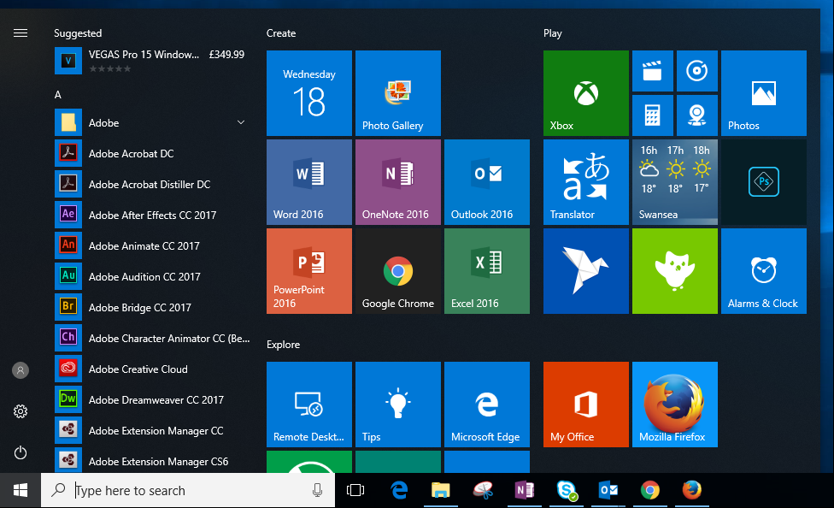
Click the Windows menu icon or tap Windows key on the keyboard to open the Start menu.

This is a screen that can be resized by clicking and dragging on the top right hand corner.

Click the tiles to open the 'app' (application or program)

You can also find programs in the alphabetical apps list on the left hand side, there is a small scroll bar to drag through the list between the list and the tiles.

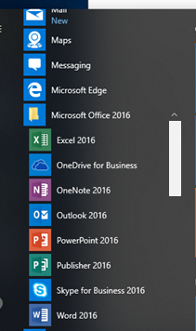
The scroll bar is hidden except when you are using it but you will become used to finding and using it with practice. Hover the mouse pointer between the app list and tiles and the bar becomes visible.

Click on the scroll bar and drag it up and down with the mouse to view the App
list. This is sorted alphabetically.

You will see small downward pointing arrows that indicate further content. Click these to expand the list to see this content.
Click on the arrow again (now facing upward) to close up the menu.

For example, under Microsoft Office 2016 you will find the productivity tools you probably use most often.

Clicking on these small tiles will open the program/application on the desktop and place a small icon on the taskbar you can use to switch between programs.

Quick Tip: press Windows key then type Word, press enter key = opens Word, Windows key then type Excel opens Excel. Use this to quickly open your applications without the mouse, just type what you’re looking for.
When you find a program you use often you can click to drag and drop it into the tiles list as with Skype for business in the example below.
Tiles can also be dragged around to reposition them in the start menu.

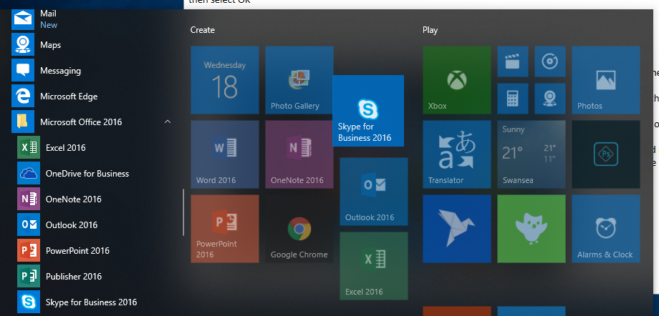

Click the left mouse button on the icon and holding the mouse button down, drag the icon onto the tiles area where you want to put it and then release the mouse button.
The existing tiles will move to fit the new tile in.
You can also right click apps and folder icons and select “pin to start”

If you drag more tiles than can fit a new group is created with smaller tiles inside each group.

Click on a tile group name to open the option to type a new name
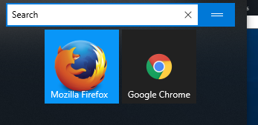
Click and type here

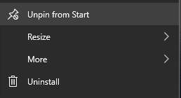
You can Right click the tile to see its edit menu.
Unpin from start will remove the tile.
Resize will allow you to make the tile smaller or larger
The More text options will change depending on the features of the software.
Recent documents associated with a tile will appear below this menu and can be opened with a click.

Access the internet on Windows 10
Open the start menu (Windows key ) and browse the app/program list for Google Chrome (recommended) or Firefox or Microsoft Edge. Drag the icon from the list into the tiles on the right (Edge is already in the Explore Group)
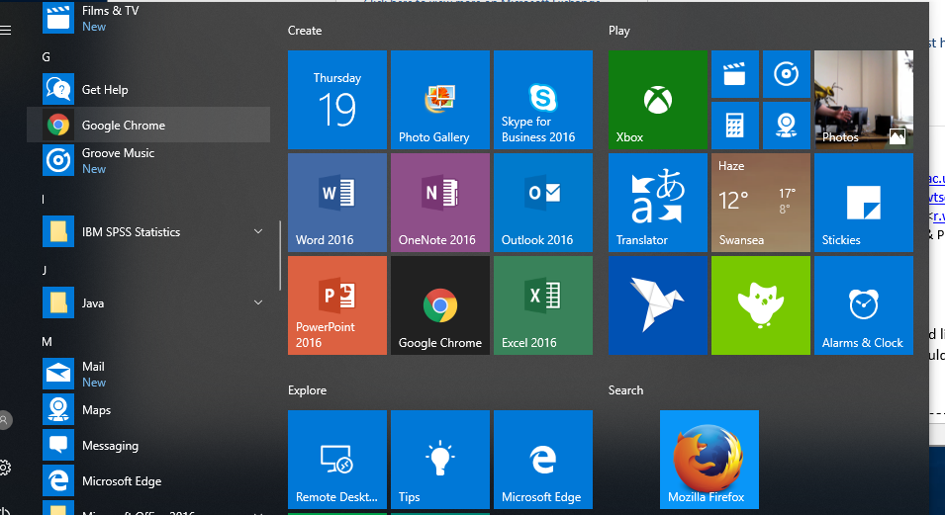
You can then quickly get access to the web for Moodle, MyDay etc. by clicking the tile.

Open programs/apps appear on the Taskbar.
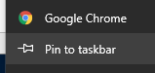
If you right click the browser (or any other app) on the taskbar you have the option to pin it there so it is available even quicker in future.

Useful new features.

Quickly clear your screen. Hold and shake an open window to minimise all others.
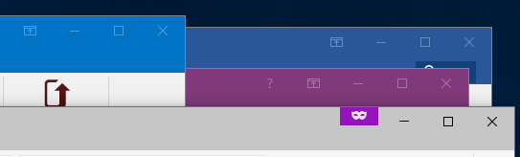
Select and hold one of the top bars from an open window and holding the mouse button, shake it.
Click, hold and shake any top bar to clear all other apps.
All other open windows will minimise to the taskbar reducing distractions and freeing space.
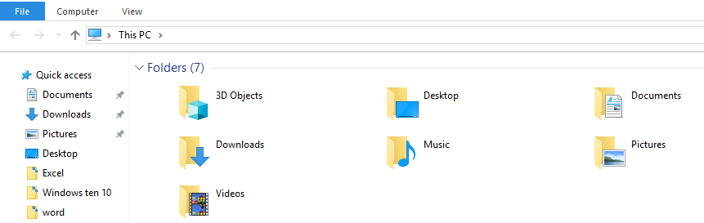
Use File Explorer to manage your files, folders and directories. Click the File Explorer icon on the taskbar to open File Explorer or you can use the My Documents Folder on your desktop.

The Taskview Icon found on the taskbar will change your desktop screen to show all your open programs
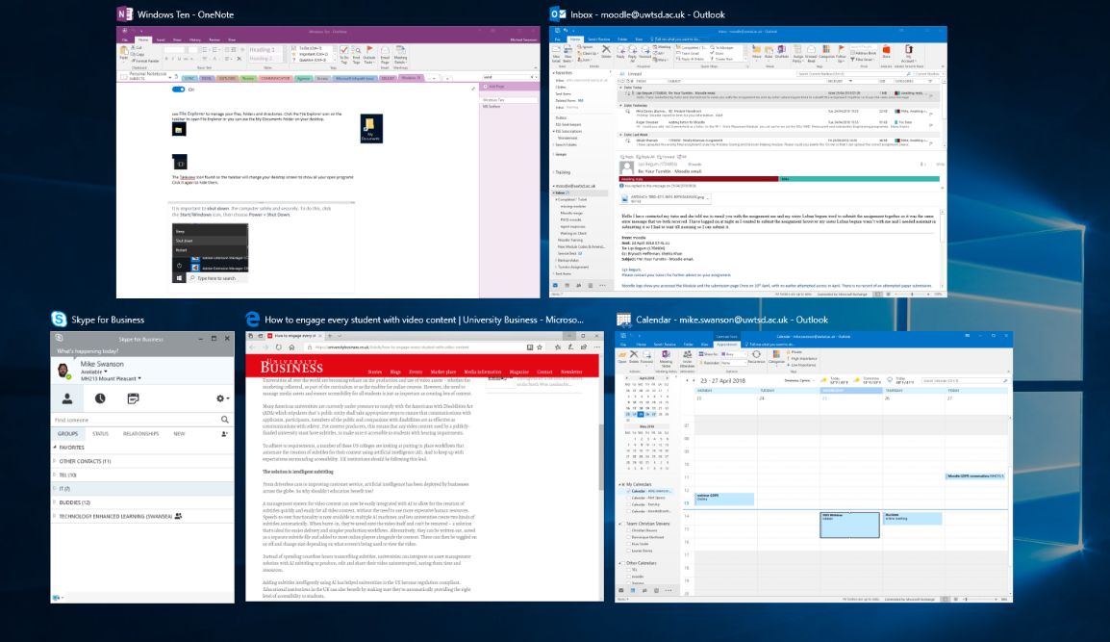
Click it again to hide them or click the one you wish to work with.

Search your computer
The search tool on the taskbar allows you to search for files and applications by typing into the search box.

Click and type here
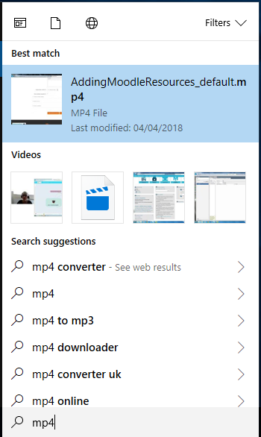
For example when “mp4” is typed the results are as shown on the left, with icons representing content found that matches the search.
Items from your computer are shown first with suggestions from the internet and sometimes commercial products or apps are offered as well.
Use the icons at the top of the results pane to filter for only:
 apps (applications/programs)
Documents
Web results

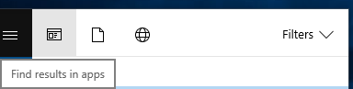

The microphone icon will open “Cortana”™ a speech recognition search tool, you will need a microphone connected to use this feature.

Shut down the computer
Save any open documents before shutting down or using the Sleep or lock feature

It is important to shut down the computer safely and securely. To do this, click the Start/Windows icon, then choose Power > Shut Down.
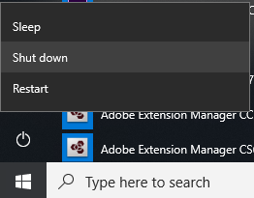
3. Click Shut Down
2. Click Power Icon
1. Click Windows Icon

You can use Sleep to lock your pc if you are leaving your desk for any time, Click the mouse or press any key on the keyboard to wake back up. You will need to use your password during the wake–up process.

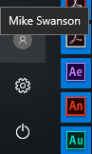
Similarly, to Lock the computer.
1. On the Start menu, click to select your name or picture

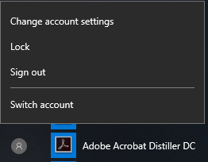
2. Click to select the Lock feature.
You will need to use your password to re-open the computer.

Save any open documents before shutting down or using the Sleep or lock feature

Windows 10 on a Microsoft Surface

Logging in to the Surface
If required, on starting the Surface, enter the bitlocker code. DRAFT is this the case for all users/devices?

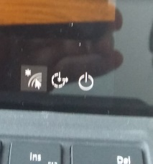When you switch on the Surface accept the UWTSD computer use policy to continue.
Look for the Wi-Fi  symbol in the lower right hand corner of the screen.

Click or tap to select this menu.

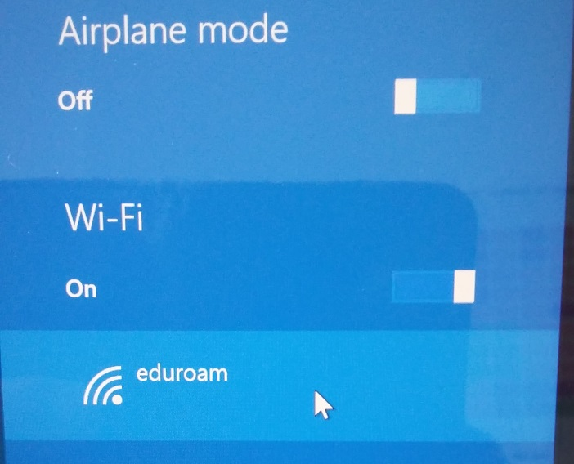

If Wi-Fi is off, tap to switch on.

Select Eduroam to connect to the University’s internet.

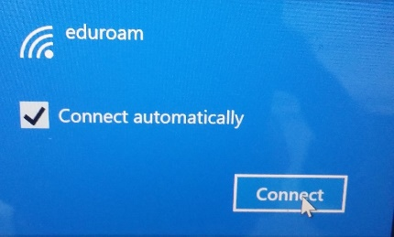
Select “connect automatically” and select connect.

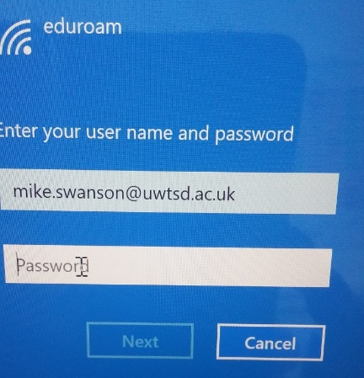
.

Type in your full UWTSD email address and then your usual access password

Then click or tap Next

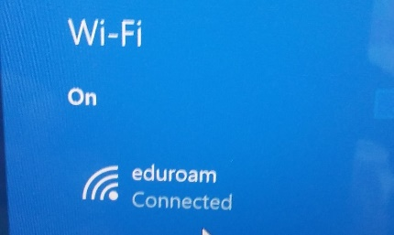

Eduroam will show connected when your details are completed accurately.

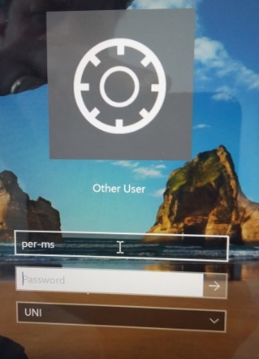
You will then be able to log in the Surface and access your network profile with your usual
ID (Not full email) and Password

Use Surface as a Tablet, or as a Laptop.
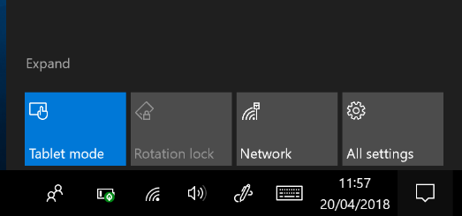
Swipe in from the bottom left of the screen to open the notifications menu.
In tablet mode the Surface is controlled with the touch screen, tap “tablet mode” button to switch to desktop mode. The touchscreen is still active but the Surface appears more like your computer desktop with the tiles hidden in the start menu rather than on the main screen.
In Tablet mode apps work in full screen or are minimised, there is no windowed view.
The Taskview Icon found on the taskbar will show which apps you have open and allow you to select which to show in full screen view.

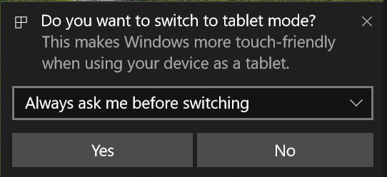
When you remove the keyboard (also called the Type Cover) the following message is displayed.
Click this down arrow for options to hide this message.
Just tap yes or no, you can manually change between Tablet and Desktop mode by swiping in form the bottom right to open the notifications bar then tapping or clicking the “tablet mode” button to switch between them.
On connecting the keyboard a similar message is displayed offering to switch to Desktop mode, again this message can be hidden in future from a down arrow option.
While using the Surface in Tablet mode you may fold the Type Cover behind, the keys will not work.
A Surface user guide is available from Microsoft and from this OneDrive link below. Copy and past into your browser for access.
https://uowtsd-my.sharepoint.com/:b:/g/personal/mike_swanson_uwtsd_ac_uk/EYV01a15IohBvenPJSmJloEBc8BTt8uPfk7TBArjjbf8fw?e=IrqZMC

Intentionally blank. Inside rear cover



