Web Services & Web Development

Major: MSc Software Engineering ( Web Development)
Module code: ACCA7005 + ACCA7004
Student: Mimi Zhang
Email: 1904733@student.uwtsd.ac.uk
Tutor: Tim Bashford, Mike Dacey

Contents

1. Part 2 2
1.1 RESTful Web Services 2
1.1.1 Definition 2
1.1.2 Characters 2
1.1.3 Benefits&Drawbacks 4
1.2 Best Practice of RESTful Web Services 5
1.2.1 Notable points 5
1.2.2 HTTP 6
1.2.3 URL 9
2. Part 3 11
2.1 “Serverless” Technologies 11
2.1.1 Definition 11
2.1.2 Benefits and Drawbacks 12
2.1.3 Relevance to Web Hosting 15
2.2 Circuit Breaker Pattern 15
2.2.1 Definition 15
2.2.2 How to use it？ 19
2.2.3 Using in Modern Web Development 20
3. Reference List 22

Part 2

RESTful Web Services

Definition
Representational State Transfer is a term proposed by Roy Fielding to describe the architectural style of interconnected systems. Why is it called REST? The Web is essentially composed of various resources, which are uniquely identified by URI. The browser (or any other browser-like application) will show a presentation of the resource, or a presentation status. If the user is directed to links to other resources on this page, the resource will be accessed and its status will be displayed. This means that the client application transitions as each resource behaves differently, also known as REST [1].
One of the most important characteristics of RESTful Web Services: REST-style Web Services architecture means that the method information when requesting the Web Services is in the HTTP method of the message, the scoping information is in the URL of the message, and the server is in When you receive an HTTP request, you only need to pay attention to the HTTP method and URL in the first line of the request message to know what the user wants to do (such as the first line of a message: GET / data / username / xxx HTTP / 1.1 ), And the rest of the data in the message is just a matter of detail.
The architectural style of RESTful Web Services is shown in the figure:
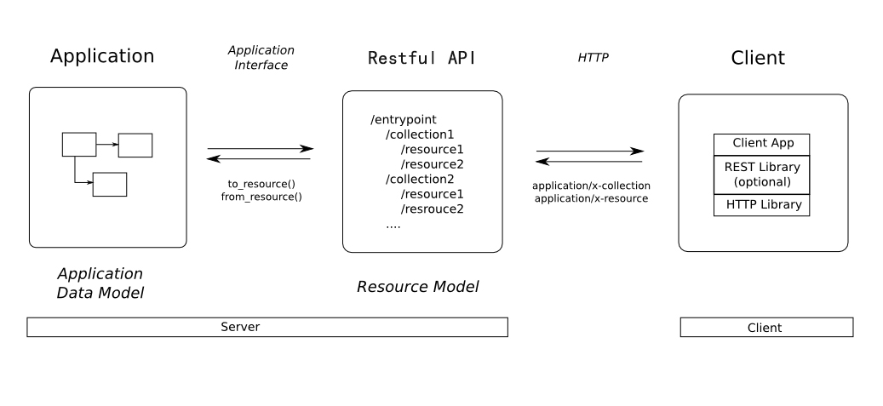

Characters
The REST principles are as follows:
1. Addressability--The resource is specified by the URI
In Web applications, all things should have a unique ID, the unified concept representing ID is: URI. URIs form a global namespace, and using URIs to identify your key resources means that they get a unique, global ID. Resources are exposed to users through URIs, and addressability is the most basic feature. Due to the addressability, you can save the URI in your bookmarks, you can send the link to others, instead of downloading the Html file and sending it to others, you can also cache resources through the URI. You can use a URI (Uniform Resource Locator) to point to the resource, that is, each URI corresponds to a specific resource. To obtain this resource, you can access its URI, so the URI becomes the address or identifier of each resource.
Generally, each resource has at least one URI corresponding to it. The most typical URI is a URL [2].
2. The Uniform Interface--explicit use of HTTP method
RESTful Web Services uses the basic method of HTTP as the expression of his method, mainly using the four methods of HTTP: GET, PUT, DELETE, POST. HEAD and OPTIONS are used less.
Use GET when getting the description of a resource.
When creating a new resource, PUT to a new URI, or POST to an existing URI.
To modify the resource, use PUT to the existing URI.
Delete resources using DELETE.
Both PUT and POST can create new resources, what's the difference? POST can create subordinate resources, such as a webblog program that exposes each blog through resources (/ weblogs / myweblog), and the entry under a blog as a subordinate resource is / weblogs / myweblog / entries / 1, when you need to add an entry At that time, you can POST to the parent resource / weblogs / myweblog, and PUT can also complete this work. The difference between POST and PUT is: When the client can control the URI of the new resource, then use PUT, such as the blog below An article is accessed by name, such as / weblogs / myweblog / entries / restful_ws_1 (so that the articles under a certain blog cannot be repeated), when you post a new article, you can PUT to a new URI such as / weblogs / myweblog / entries / restful_ws_2 to create resources. If the client cannot control the URI, for example, the blog is accessed through a serial number on the server side, the client cannot know what the next serial number is. At this time, only the POST can be used. If this POST is created successfully, it returns 201. The Location in the response header can protect the URI of the newly created resource.
Another difference is that when POST updates an existing resource, it usually appends an append. For example, if POST is performed on a log file, the log is appended to the original log. If it is PUT, the replacement is performed, so PUT is idempotent, but POST is not [3].
3. Representations--multiple representations of resources
Combined with my development practice, my understanding of resources and data is as follows:
The resource is a set of user-oriented data sets with json (or other representation) as the carrier. The resource's expression of information tends to the data in the conceptual model:
Resources are always displayed with a certain representation, that is, serialized information
Commonly used Representation is json (recommended) or xml (not recommended), etc.
Representation is the presentation layer of REST architecture.
Relatively speaking, data (especially databases) is a more abstract, more efficient and friendly form of data representation for computers, and it exists more in the logical model
Representation is the manifestation of resources. The same resource can have different representations. For example, the same bug list can be expressed in XML documents or text. For different representations of the same resource, how do you know which one is requested by the client? It is recommended that different Representations use different URIs. Provide multiple representations of resources for different needs. The multiple expressions mentioned here include XML, JSON, HTML, etc. That is, the server needs to provide a variety of resource representations to the outside for use by different clients. For example, mobile applications can use XML or JSON to communicate with the server, while the browser can understand HTML.
4. Stateless
Statelessness means that every HTTP request is completely isolated. Every time the client sends a request, it must bring all the information needed by the server. Stateless applications are easier to distribute to multiple servers that are responsible for balancing; statelessness is also easier to cache: the caching tool only needs to look at this one request and has nothing to do with any other request.
Application State Versus Resource State:
The application status is on the client, and the resource status is on the server. For the client, each client has its own application status. For example: in Google search, you may search for a certain word and the current page is page 3, I may Search for another word on the first page, so each client has an application status. When the client initiates a request, you must tell the server your application status. For example, you want to see the page of the search result of a certain word. The server returns other links on the result. These links may serve as future requests.
The resource status is the same for each client, which is the resource on the server.
5. Links and Connectedness
To put it simply, there is a link (URI) to other resources in the returned result, such as google search, and the search result may have links to other pages.

Benefits&Drawbacks
The advantage of the traditional B / S architecture is that its deployment is very convenient, but it is not ideal in terms of user experience. To improve this situation, we introduced REST!
REST adds three new specifications to the B / S architecture: unified interface, layered system, and on-demand code.
1. Unified interface: The core feature of the REST architectural style is to emphasize that there is a unified interface between components. This is manifested in the REST world. All things on the network are abstracted as resources, and REST is through a common linker interface pair. Resources to operate. The advantage of this design is to ensure that the services provided by the system are decoupled, which greatly simplifies the system, thereby improving the interactivity and reusability of the system; and REST is optimized for the common situations of the Web, so that the REST interface is Designed to efficiently transfer large-granularity hypermedia data, which leads to the REST interface is not optimal for other architectures [4].
2. Hierarchical system: The addition of hierarchical system rules improves the independence between various layers, sets the boundary for the complexity of the entire system, and encapsulates the legacy services to protect the new server from the impact of legacy clients. This also improves the scalability of the system.
Advantage of:
RESTful Web services use the advantages of standard HTTP methods. From a large perspective: standardized HTTP operation methods, combined with other standardized technologies such as URI, HTML, XML, etc., will greatly improve the integration between systems and systems. Operating ability. Especially in the field of Web applications, the abstract capabilities expressed by RESTful Web services are closer to the way the Web itself works and are more natural.
At the same time, RRESTful Web services implemented using standard HTTP methods also bring some advantages of the HTTP method itself:
Stateless: The HTTP protocol is essentially a stateless protocol. The HTTP requests sent by the client can be isolated from each other, and there is no mutual state dependency. HTTP-based ROA implements stateless service request processing logic in a very natural way. For distributed applications, any given two service requests Request 1 and Request 2, because there is no mutual state dependency between them, there is no need for them to cooperate with each other, the result is: Request 1 and Request 2 can be executed on any server, such an application can easily support load-balance on the server side [5].
Safety / Idempotence: HTTP GET and HEAD requests should be essentially safe calls, that is, GET and HEAD calls will not have any side effects and will not cause changes in the server-side state. For the server, the client makes n GET and HAED calls to a certain URI, and its state is the same as no call, and no change will occur.
HTTP's PUT and DELTE calls have the power-finger equal feature, that is, the client makes n times of PUT and DELTE calls to a URI, and the effect is the same as making one call. HTTP's GET and HEAD methods also have the power-finger equality feature.
These standard methods of HTTP ensure in principle that your distributed system has these characteristics to help build a more robust distributed system.
The disadvantages are:
Maturity: Although the development of SOAP has now departed from its original intention, the service release and invocation of heterogeneous environments and the support of vendors have reached a relatively mature situation. Different platforms and Web services that interact with each other through SOAP can communicate well.
In contrast to REST, compared to SOAP's authoritative protocol specification, the various protocols implemented by REST can only be regarded as private protocols. Of course, you need to follow the REST idea, and it will be much worse in compatibility.
In general, SOAP is superior to REST in terms of maturity.
Security: In terms of security, SOAP uses XML-Security and XML-Signature to form WS-Security to achieve security control. Currently, it has been supported by various manufacturers. REST has no specifications for security [6].

1.2 Best Practice of RESTful Web Services

1.2.1 Notable points
1. Make sure your document is flawless
Using the WSDL (Web Service Definition Language) system of the SOAP protocol, if there is a tool based on WSDL that can automatically generate code, then developing a Web Service is fairly simple. But if you use REST, services do not need to be strictly defined, and they operate on what is known as working properly. This means that the service documentation must be very rigorous. If you want to develop a Web Service, you must ensure that the document is 100% correct.
2. Provide JSON output
JSON has quickly become an important standard on the web. First of all, it is convenient because it makes it easy for JavaScript to use Web Services with the least amount of coding. There are now many libraries that allow the JSON interaction between the server and the client to work very well.
3. Don't miss XML
Make sure that your Web service system supports both formats. This support is done through the "Accepts" parameter in the HTTP request header rather than through a different service URL that contains parameters.
4. Understand HTTP verbs
One of the core keys of REST Web services is a large block of functions already defined by the HTTP protocol.
5. Understand the importance of URI routing
RESTful Web services are largely determined by URIs. For example, in a GET request, a typical URI path will contain the primary key value (or other identification key value) of an entity to retrieve the data of the acquired entity.
6. Update and maintain under version management
Make sure to open a new branch version for maintenance after each update is released. The easiest and most common way is to have your service URI with a version number, which is usually part of the path. The one thing people need most is to use the updated software without any new problems or warnings [7].
7. Keep in touch with your users
8. Provide sample code

1.2.2 HTTP
1.GET
Query product details by id：
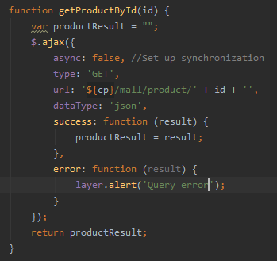
2.PUT
Add product:
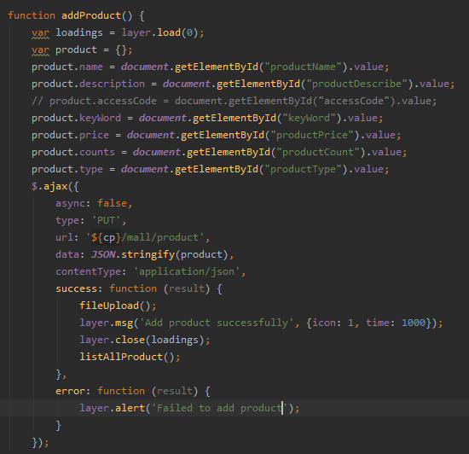
3.POST
Upload product image:
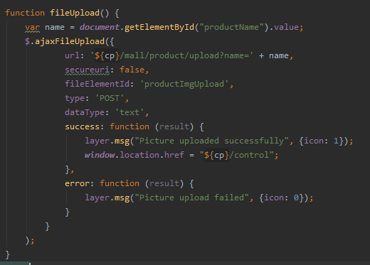
4.DELETE
Delete product based on id:
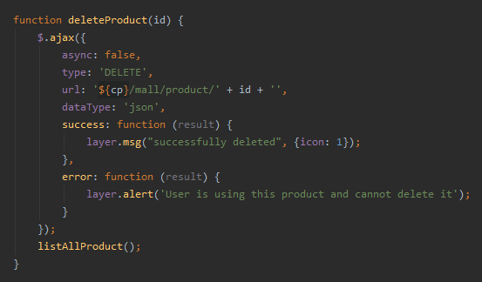

1.2.3 URL
1.GET
Query product details by id：

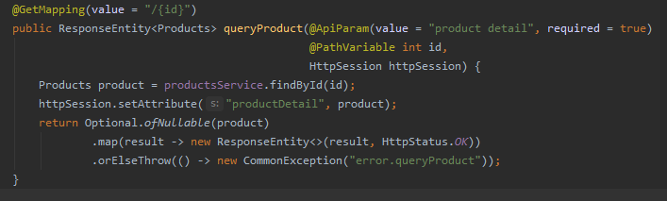
2.PUT
Add product:
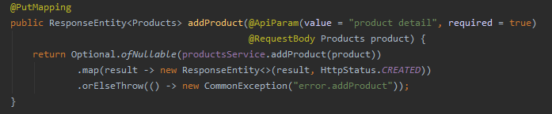
3.POST
Upload product image:
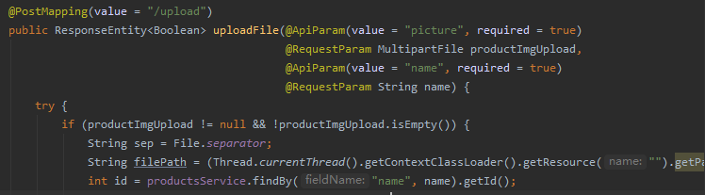
4.DELETE
Delete product based on id:
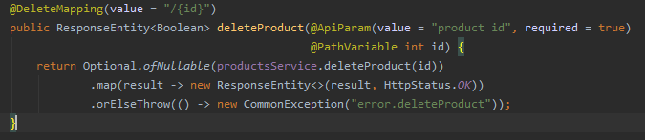

Part 3

2.1 “Serverless” Technologies

2.1.1 Definition
Serverless code can be used in conjunction with traditional server-style code (such as microservices). For example, we can write part of the code in a web application into the form of microservices, while another part can be written into the form of serverless code. Alternatively, applications that do not require any server configuration elements at all can be serverless.
At present, there are several interpretation methods for Serverless: in some scenarios, it can be interpreted as a software system architecture method, usually called Serverless architecture; and in some cases, it can represent a product form, called Serverless product.
When talking about the Serverless architecture, Serverless represents an application architecture implemented using Serverless products. This architecture relies entirely on cloud vendors or cloud platforms to provide products to complete the organization and construction of the system. In this architecture, users do not need to focus on the host that supports the operation of application services, but put their focus on system architecture, business development, and business support operations.
When talking about Serverless products, it means that you do not need to understand and manage the server, use it on demand, and pay for use. Serverless products can actually include storage, computing and other types of products, and the typical computing products are in the form of cloud functions.
Cloud functions, or Function as a Service, together with Backend as a Service, can be called Serverless products; and by using these products in combination, developers can build their own business Serverless architecture.
Serverless technology refers to applications that use third-party functions and services, but no server management is required. Among the two aspects of serverless architecture:
FaaS contains a stateless function of server-side business logic. These functions run in separate containers, are event-driven, and are hosted by third-party vendors, such as AWS Lambda or Azure Functions.
BaaS uses third-party services (such as Firebase, Auth0) to achieve their goals. Applications that use BaaS are usually rich client applications, such as SPA or mobile apps. The client is responsible for handling most of the business logic, and the rest depends on external services, such as authentication, database, user management, and so on.
As mentioned above, if you do not maintain or manage your own infrastructure to run the application, and pay (or not pay) based on usage, and automatically obtain the required level of high availability, scalability, and fault tolerance from the vendor , Then you are running a serverless application. As the owner of an application running in a serverless environment, you can put all your energy on the application business logic without worrying about the infrastructure it runs and other non-functional requirements around the application.
Serverless computing is also known as function-as-a-service, and it is currently the hottest new technology in the cloud. Although it does not really get rid of the server, it does make the deployment and management of complex applications easier and more cost-effective [8].
The characteristics of the serverless architecture: no need to manage the server; statelessness; automatic scaling; no operating costs; costs are driven by events; processing the first event requires some startup time; because the runtime is small, it has high security.
Serverless life cycle
The following diagram describes the life cycle of a Function.
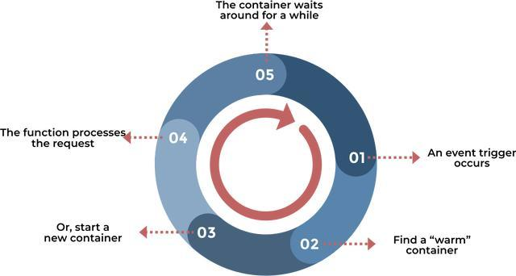
It can be seen from this that serverless technology actually means that developers can complete the entire set of coding, deployment, and application creation without having to care about server deployment, patching the operating system, and creating container images. Process technology. This technology eliminates most of the need for traditional always-on servers. This can significantly reduce operation and maintenance costs, complexity and reduce the time to prepare the project for launch, at the cost of increased dependence on suppliers and relatively immature support services.

2.1.2 Benefits and Drawbacks
Benefits:
First of all, from the developer's point of view, there is no need to consider more about the server's related content, no longer need to consider the server's specifications, storage type, network bandwidth, and automatic expansion and contraction issues; With operation and maintenance, there is no need to constantly apply system patches, apply patches, data backup, software configuration, etc.
Second, Serverless is fully automated and flexible expansion and contraction; at the peak of business, the technology's computing power and capacity are automatically expanded to carry more user requests, and when the business declines, the resources used will also shrink Avoid wasting resources.
Thirdly, following the flexibility of fully automated, it is a new metering and billing model; developers only need to pay according to usage, and in the case of no traffic at night, there will be no idle resources, so also There will be no costs.
With the features mentioned above, Serverless brings specific business value to developers or users:
1. Reduce O & M requirements
Serverless decouples the application from the server, so there is no need to estimate resources before the service goes online, and there is no need to purchase and configure the server;
Serverless also reduces the workload of the underlying operation and maintenance. After the service goes online, there is no need to worry about server operation and maintenance, but all are handed over to the cloud platform or cloud vendor;
2. Reduce operating costs
Serverless applications are executed on demand. The application will only be loaded and run when a request needs to be processed or an event is triggered. In the idle state, the application of the serverless architecture itself does not occupy computing resources;
When using Serverless products, users only need to pay for the computing resources to process the request, and do not need to pay for the resources occupied by the application during idle periods;
3. Shorten the iteration cycle and online time
The serverless architecture brings further business decoupling, application functions are decomposed into several fine-grained stateless functions, and development can focus on the rapid development and online of single functions;
At the same time, the disassembled cloud functions can also be independently iterated and upgraded to achieve faster business iteration and reduce the time to market for functions;
4. Quick trial and error
With the simple operation and maintenance, low cost and fast online capability of the Serverless architecture, you can quickly try out new forms and functions of the business;
Take advantage of the strong elastic expansion capacity of Serverless products, and you do n’t need to worry about resource expansion when your business is successful;

To sum up, using serverless architecture and FaaS has the following benefits:
Reduce server management costs;
Reduce operating costs;
Automatic scaling
Safer than uninterrupted services;
The cost is determined by the number of requests or events;
Simpler packaging and deployment process;
Shorten the release cycle;
Out-of-the-box monitoring.

Drawbacks:
1: functional event-data injection
2: Authentication failed
Because serverless improves the system design for microservices, applications may contain dozens or even hundreds of functions. If it is not carried out carefully, errors will easily occur during the authentication process.
3: Insecure serverless deployment configuration
The cloud provider provides a lot of setting options, which can adjust the service according to specific needs. Setting out of the box is not necessarily the safest option. As more and more enterprise organizations migrate to the cloud, vulnerabilities in cloud configurations are becoming more common.
4: Over-privileged functional permissions and roles
Managing function permissions and roles is one of the most difficult security challenges that enterprise organizations face when deploying applications to the cloud. Sometimes developers want to take shortcuts and adopt a "take-all" permission model, which is very common.
5: Insufficient function monitoring and recording function
6: Rely on unsafe third parties
Although the insecurity of third-party libraries is not only a disadvantage of serverless technology, due to lack of application network and behavioral security control capabilities, malicious software packages detected in serverless environments are more complicated.
7: Insecure application secret storage
One of the most common problems with application secret storage is to simply save the secret information as a plain text file in a software project, or save the secret information as a plain text file as an environment variable.
8: Denial of service and exhaustion of financial resources
9: Serverless business logic operation
Business logic operations are a common problem in many software. However, serverless applications are somewhat special. They are usually designed according to microservices. The various functions contained in them are linked together to form a logical whole. If executed improperly, the expected logic may be tampered by the attacker.
10: Inappropriate exception handling and detailed error messages
Compared with the debugging function of standard applications, the line-by-line debugging function of serverless applications is limited and more complicated. Therefore, very lengthy error messages often appear, which may lead to the leakage of sensitive data.

In summary, like any other technology, the disadvantages of serverless technology are as follows:
Start delay
Vendor lock-in, lack of control over server;
Performance optimization is limited to the internal code;
Execution time limit (AWS Lambda execution time limit is 15 minutes);
Unpredictable costs;
The development environment is different from the production environment;
Testing and debugging are more complicated.

2.1.3 Relevance to Web Hosting
In Chinese, web hosting (service) can be translated into: website hosting, hosting space, virtual hosting service. The providers of such services are called web hosts. The host here is similar to the meaning of "host, host, provide". When the user applies for registering the domain name, of course, they are preparing to design the web page. However, the web page needs the Host in one place. This place is generally a Web Server so that all visitors on the Internet can visit your website. If your ISP does not provide free storage space for you to store web pages, you may also feel that the ISP's free storage space function is insufficient (for example: CGI is not supported, PHP and PERL cannot be executed, no MySQL, etc ...), In this way, your website needs a web hosting service.
Web hosting is commonly known as "web space". You can imagine that your website is a complete family. The house number of your home is convenient for others to find your home. The website also needs a "house number", called "domain name", commonly known as the URL. Your home needs a space to place your furniture, perhaps 80 square feet, or perhaps a larger 300 square feet. The same is true for the website, there needs to be a "virtual host", commonly known as space, used to place the content, pictures, sounds, and videos of the website you made.
With "doorplate" and "space" in the website space, your website will be ready. Now, put your furniture (website content) into the space, and then tell your friends and contacts the "doorplate" of your website ( Domain name), others will be able to visit your website! The website space can be done by buying a server by yourself, but the cost is too high. This is usually only done by large companies or large websites. It takes tens of thousands to buy a common server, and dozens, hundreds, or even high-performance servers. Tens of millions of people must also be turned on 24 hours, and equipped with special personnel to take charge.
The virtual host is divided from the server. The virtual host cannot be used as a server and does not have the complete functions of the server. The virtual host can realize some functions of the server, such as building a website and so on [9].

2.2 Circuit Breaker Pattern

2.2.1 Definition
Assuming that the service provider responds very slowly, the consumer ’s request thread to the provider will be waited until the service returns. In the high-concurrency and high-load scenario, if no processing is done, this problem is likely to cause all processing The thread requested by the user is exhausted and cannot respond to further requests from the user. If the service consumer is another service provider, then there may be a cascading reaction, causing other lower-level service consumers to be unavailable, and eventually an avalanche effect [10].
At this time, the circuit breaker mode will appear. When the circuit breaker mode is similar to an electrical short circuit, it will trip. If the amount of current is too large, the circuit will be automatically disconnected to avoid heating the circuit and burning the circuit or electrical appliances.
When there are a lot of timeouts on the dependent services, it doesn't make much sense to allow new requests to access, it will only consume the existing resources unnecessarily. For example, if we set the timeout to 1 second, if there are a large number of requests in a short period of time and no response is received within 1 second, it often means an exception. At this point, there is no need to allow more requests to access this dependency. We should use circuit breakers to avoid wasting resources.
The circuit breaker can achieve rapid failure. If many similar errors are detected within a period of time, it will force its subsequent multiple calls to fail quickly, and no longer request the services it depends on, thus preventing the application from continuously trying to execute. The failed operation, so that the application can continue to execute without waiting for the error to be corrected. The circuit breaker mode can also enable the application to diagnose whether the error has been corrected, and if it has been corrected, the application will try to call the operation again.
The circuit breaker mode is similar to an agent that is prone to erroneous operation. This kind of agent can record several errors in recent calls, and then decide to use the allow operation to continue, otherwise directly return an error.
In a cloud or distributed system environment, any expression of consistency or reliability is a lie. We must assume that the behavior of microservices or the location of their servers will change frequently. As a result, components sometimes provide low-quality services or may even fail to provide them at all. Failure to deal with these microservices will result in failure of the entire system.
Microservice failures may be transient failures: such as slow network connections, timeouts, and excessive use of resources that are temporarily unavailable; or failures that require longer time to correct in the event of unforeseen unexpected events.
Fault tolerance of distributed services is a problem that must be considered. There are two common approaches:
Retry mechanism: For the expected short-term failure problem, it can be solved through the retry mode.
Circuit Breaker mode: The protected service is encapsulated in a circuit breaker object that can monitor the fault. When the fault reaches a certain threshold, the circuit breaker will trip, and all subsequent calls will not be sent to the protected service. The circuit breaker object Error returned. For failures that require a longer time to resolve, it does n’t make much sense to keep retrying. You can use the circuit breaker mode.
Once a certain electrical appliance fails, the fuse of the circuit will blow to prevent disaster. The circuit breaker is similar to the fuse of the circuit. The implementation idea is very simple. You can encapsulate the remote service that needs to be protected and monitor the number of failures internally. Once the failure number reaches a certain threshold, all subsequent calls to the service, circuit breaker After interception, all errors are directly returned to the caller, instead of continuing to call the service that has a problem, so as to protect the caller, and the entire system will not have a waterfall-like chain reaction due to timeout.
Basic Mode

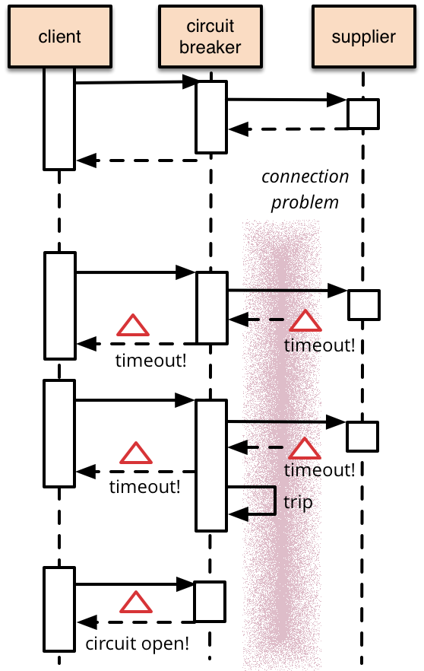
2. Extended mode
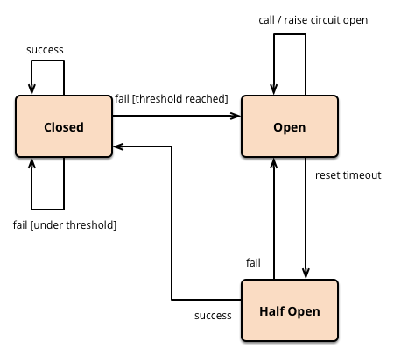

2.2.2 How to use it？
Suitable for the circuit breaker mode: a supplier is generally very stable. If the time required for inspection and recovery is relatively long after a fault occurs, and usually cannot be repaired quickly in a short time, this service is more suitable for the circuit breaker mode. Otherwise, it may cause ping-pong effect.
Not suitable for circuit breaker mode: In order to prevent an application from trying to call a remote service or access shared resources, if the operation is very likely to fail, this mode may not be suitable. For processing applications, access local dedicated resources, such as data structures in memory. In this environment, it is usually not suitable. The use of circuit breakers will only increase system overhead.
When deciding how to implement this model, the following points should be considered:
Exception handling.
Exception type: A request may fail for various reasons, some of which may indicate that the severity of the failure is higher than other failures. For example, a request may fail due to a crash of a remote service that takes several minutes to recover, or it may fail due to a timeout caused by a temporary overload of the service. It is possible that the circuit breaker can check the type of abnormality that occurred and adjust the strategy according to the nature of these abnormalities. For example, the number of service timeout exceptions that cause the switch to the open state (trip) is much greater than the number of failures caused by the service being completely unavailable.
Logging.
Recoverability: The circuit breaker should be configured in the recovery mode that best matches the protected operation. For example, if the circuit breaker is set for a long period of time in and out of the open state, it will return an error even if the underlying operational fault has been resolved. If the switch from the open state to the half-open state is too fast, the protected operation will be called again if the underlying operation failure is not resolved.
Test failed operation.
Manual reset.
Concurrency.
Resource differentiation: When the circuit breaker uses a certain type of resources that may have multiple underlying independent data providers, special care needs to be taken. For example, a data store contains multiple partitions (shards), some partitions have temporary problems, and other partitions may be fully functional. If the error response in this scenario is a merged response, the application may still try to access some working partitions when some of the failed partitions are likely to block the entire request.
Accelerated disconnection.
Retry failed request.
Inappropriate timeout for external services: When the timeout configured for external services is large, the circuit breaker may not be able to protect its faulty operation, and the threads in the circuit breaker will still block the external service before indicating the failure of the operation, and many other applications The instance will still view the service invocation via the circuit breaker [11].

2.2.3 Using in Modern Web Development
Find the configuration of the circuit breaker in HystrixCommandProperties. Mainly these 4 parameters, you can click to see what they mean.
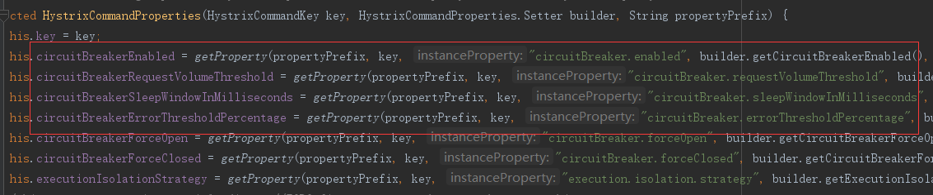
Add a testHystrixCommand4 interface to order, and judge whether to call msg2 according to the passed number.
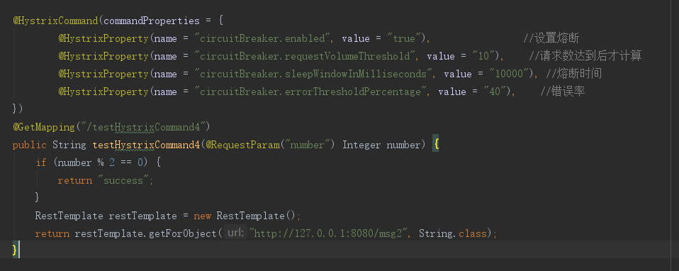
Start services such as product and order, when the number is 1, because there is no timeout set here, calling msg2 will definitely fail.
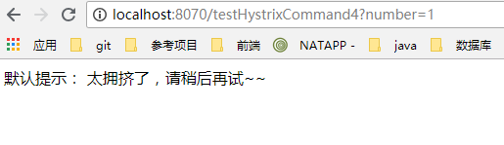
When the number is 2, because the default timeout period is not exceeded, the request will succeed directly.
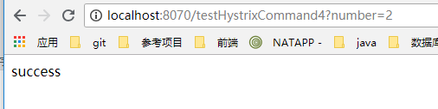
At this time, if you frantically brush the number = 1, and then brush the number 2 again, you will find that the request with the number 2 will also fail.
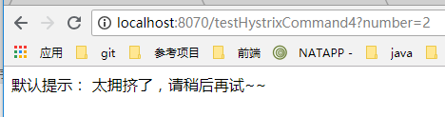
This is the protection function of the circuit breaker. When the number of failures of this interface reaches the number you set, it will trigger the downgrade of the service. After the time you set, the interface with number 2 returns to normal again.
There are three states: closed, open, and half open.
Closed is the closed state, that is, the service request is successful. When the request fails to an abnormal number of times, it will trigger a fuse and enter the open mode.
Open is the open state. At this time, the service will directly return an error, but it involves a clock option. When the default clock reaches this time, it will enter the half open half-blown state.
Half open half-blown state: If the call is successful or the success rate reaches a certain percentage, the service will be considered to be restored and enter the closed mode. Otherwise, the service is considered unsuccessful and it returns to the open state.
@HystrixProperty (name = "circuitBreaker.enabled", value = "true"), // Set to open the fuse
@HystrixProperty (name = "circuitBreaker.requestVolumeThreshold", value = "10"), // The error rate is calculated after the number of requests is reached
@HystrixProperty (name = "circuitBreaker.errorThresholdPercentage", value = "40"), // The success rate exceeds this number means that the service is restored
@HystrixProperty (name = "circuitBreaker.sleepWindowInMilliseconds", value = "10000"), // Fusing time, that is, setting a time window. When the number of failures reaches the fuse, it will enter this time window. At this time, the processing logic of the service degradation is returned by default. After this window time, the service will resume using the original processing logic. If the service is not restored, it will enter a new time. window.

3. Reference List

[1]Olinda Santin,Chris Jenkins,Hoa L. P. Nghiem,Gillian Prue,Joanne Reid,Lynne Lohfeld,Hien T. Ho. The development of a web‐based resource to provide information and psychosocial support to informal cancer carers in hospitals in Vietnam[J]. Psycho‐Oncology,2020,29(5).

[2]. Internet and World Wide Web - Medical Internet Research; Researchers' Work from District General Hospital of Forde Focuses on Medical Internet Research (Rethinking Social Interaction: Empirical Model Development)[J]. Internet Weekly News,2020.

[3]Sergio Trilles,Alberto González-Pérez,Joaquín Huerta. An IoT Platform Based on Microservices and Serverless Paradigms for Smart Farming Purposes[J]. Sensors,2020,20(8).

[4]Jeongchul Kim,Kyungyong Lee. I/O resource isolation of public cloud serverless function runtimes for data-intensive applications[J]. Cluster Computing,2020(prepublish).

[5]. Limelight Networks Inc.; Limelight Adds New Serverless Computing Capability to Leading Edge Services Platform[J]. Internet Weekly News,2020.

[6]Enes Jonatan,ExpÃ³sito Roberto R.,TouriÃ±o Juan. Real-time resource scaling platform for Big Data workloads on serverless environments[J]. Future Generation Computer Systems,2020,105(C).

[7]Bhagya Nathali Silva,Murad Khan,Kijun Han. Integration of Big Data analytics embedded smart city architecture with RESTful web of things for efficient service provision and energy management[J]. Future Generation Computer Systems,2020,107.

[8]Diana M. Naranjo,Sebastián Risco,Carlos de Alfonso,Alfonso Pérez,Ignacio Blanquer,Germán Moltó. Accelerated serverless computing based on GPU virtualization[J]. Journal of Parallel and Distributed Computing,2020,139.

[9]José Renato Villela Dantas,Pedro Porfirio Muniz Farias. An Architecture for Restful Web Service Discovery Using Semantic Interfaces[J]. International Journal on Semantic Web and Information Systems (IJSWIS),2020,16(1).

[10]I. Pispidikis,E. Dimopoulou. CONCEPTUAL MODEL OF CITYGML RESTFUL WEB SERVICE[J]. ISPRS - International Archives of the Photogrammetry, Remote Sensing and Spatial Information Sciences,2019,XLII-4/W15.

[11]Lee Benjamin D,Timony Michael A,Ruiz Pablo. DNAvisualization.org: a serverless web tool for DNA sequence visualization.[J]. Nucleic acids research,2019,47(W1).

