BA BUSINESS MANAGEMENT

ASSIGNMENT-2
MODULE NAME – DATA HANDLIING AND BUSINESS INTELLIGENCE

MODULE CODE – LCBB5000
MODULE LECTURER – ANUPAM MAZUMDAR
NAME – AMRITA
STIDENT ID – 2214339
SUBMISSION DATE- 03-MAY2024

TABLE OF CONTENT

1)INTODUCTION………………………………………………………………
2)ANALYSIS USING MICROSOFT EXCEL………………………………..
- SALES TREND OVER THE MONTHS……………………………..
- MOST FREQUENTLY PURCCHJASED PRODUCTS……………..
- NUMBER OF PRODUCTS PURCHASED PER TRANSACTION…
- MOST PROFITABLE CUSTOMER SEGMENT…………………….
3)SOME STRATEGY TO GAIN BUSINESS PROFIT…………………………
4)STATICAL ANYALYSIS BY USING SPSS…………………………………....
- ANALYSIS OF STUDENT DEMOGRAPHICS (GENDER)………….
- ANALYSIS OF ELIGIBILITY FOR REDUCDED/FREE LUNCH……
- MEAN AND MEDIAN OF STUDENTS ELIGIBLE FOR REDUCED/FREE LUNCH……………………………………………….
- SPECIFIC EXAMPLE OF CLUSTERING(K-MEANS) WITH SCREENSHOTS AND EXPLANATION…………………………………..
- THE PROS AND CONS OF USING SPSS AND EXCEL WITH SOME PRACTIVCAL EXAMPLES………………………………………………
5)CONCLUSION………………………………………………………………….
6)REFERENCES…………………………………………………………………...

Introduction: In the digital age, businesses rely on data to make informed decisions and understand operations. The e-commerce sector, particularly in the UK, relies on sales transaction data to understand customer behaviour, identify market trends, and optimize strategies. Data analysts play a crucial role in this process. The analysis focuses on a UK-based e-commerce business specializing in gifts and homewares for adults and children, operating since 2007. The sales transaction dataset offers valuable information for understanding customer preferences, product performance, and operational efficiency. The primary objective is to extract meaningful insights using Microsoft Excel, pre-processing data, analysing sales trends, and visualizing findings. This data analysis aims to provide actionable insights for strategic decision-making and the continued success of the e-commerce business.
PRE-PROCESSING DATA: For pre-processing the data, the given dataset was selected. There was no total sales column, so I estimated it by multiplying the price and quantity. Also, months are calculated using the formula =TEXT (B2, "mmm"). Evidence is provided below because these columns are required for determining sales patterns over time, the most often purchased goods, and so on.

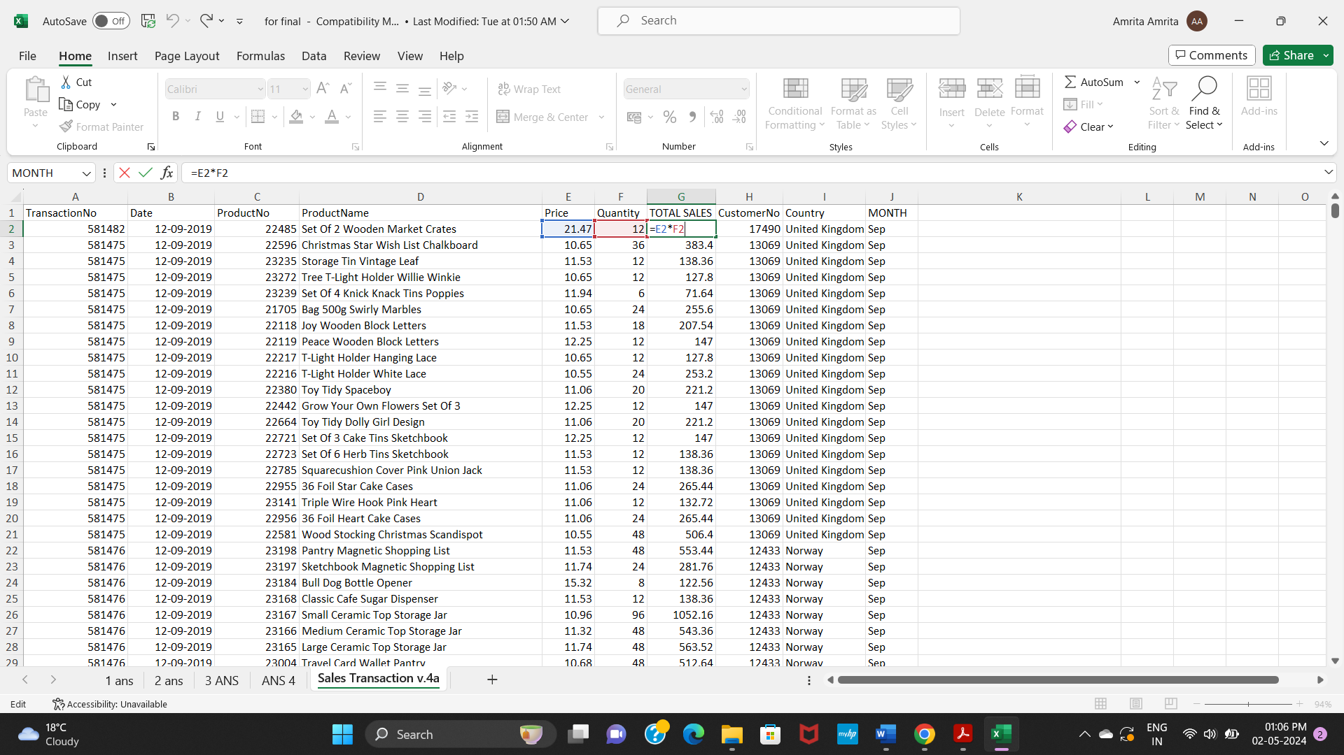

1)How was the sales trend over the months?

Solution: As an analyst using data to study the sales variations throughout the months, I have selected some data from the provided sales transaction dataset that shows the sales trend in the month of September with the help of bar chart to represent the data.

(Figure no.1)

The above figure showing the sales trend for September moth was relatively stable, with total sales amounting to £15,750.34. highest trends were observed for Product No 22693, which had a total sale of £2177.28, possibly due to high demand, promotional activities, or some seasonal trends. Product No 23167 also experienced a peak trend of $1052.16, possibly due to increased demand, marketing campaigns, or unique selling propositions.
However, Product No 22726 had significantly lower sales of£56.36, possibly due to poor product performance, lack of marketing efforts, or seasonal factors. Moreover, Product No 23239 had a sale of £71.64, indicating a need for revaluation in marketing strategy or product positioning. Furthermore, there is fluctuation in these sale of product on this particular date.
The data highlights the importance of understanding market dynamics, consumer behaviour, and product performance to optimize sales strategies and maximize revenue. While most products maintain a relatively stable sales trend, peaks and dramatically low trends underscore the need for better understanding of market dynamics, consumer behaviour, and product performance.

2)What are the most frequently purchased products?

Solution: Based on the selected data from the transaction dataset, as a data analyst, I can choose the most popular commodities from the comprehensive list while taking into account the total number of units sold. This data helps to understand customer preferences and can be used to direct marketing campaigns, sales optimisation, and inventory control. The following are the top goods, along with a popularity breakdown using data visualisation.

(Figure no. 2)
According to the line graph can be created to visualize the most frequently purchased products and their corresponding sales amounts. The x-axis represents product names, while the y-axis represents the total sales amount. Each point on the graph represents a product's sales value. The top-selling products are "Small Folding Scissor (Pointed Edge)" with a sales value of 2488.8 is highly bought product, second one is "Grow A Flytrap or Sunflower In Tin" with a sales value of 2177.28, and "Popcorn Holder" with a sales value of 1099. These products are positioned higher on the y-axis, reflecting their larger sales amounts and dominance in terms of sales volume.
On the other hand, graph was showed the Other products with moderate sales values, such as "Chocolate This Way Metal Sign" (446.4), "English Rose Spirit Level" (398.16), and "Gin and Tonic Diet Metal Sign" (594.24), also contribute to the overall sales but to a lesser extent compared to the top-selling items
Lastly, there are numerous products with relatively lower sales values, such as "Red Retro Kitchen Wall Clock" (37.2), "Retro spot Large Milk Jug" (91.92), and "Set Of 4 Knick Knack Tins Poppies" (71.64). These products appear closer to the lower end of the y-axis, indicating they are less frequently purchased.
3) How many products does the customer purchase in each transaction?

Solution: To investigate the number of products purchased by consumers, I have selected some data from the given dataset. The following figure given some information data which help me to analyse the purchase habits indicated by this data and the implications for business analysis.

(Figure no. 3)
Examining the above bar graph data reveals that customer have a variety of purchase tendencies. Some transactions involve only one product, such as Transaction no’s 581479 and 581483, which have a Total count of one, suggesting that these clients purchased one product each. These cases could illustrate customers purchasing specific things for immediate requirements or even testing a product before making larger purchases.

Alternatively, there are transactions involving numerous products. For example, Transaction no 581476 has the most products at 59, indicating a bulk purchase or a broad shopping binge. Such transactions could indicate that buyers are storing up on necessities, taking advantage of discounts on bundled items, or simply meeting many needs in a single shopping trip. Furthermore, the difference in transaction sizes suggests a variety of purchase promotions. Transactions with smaller product counts, such as Transaction No. 581477 with 9 products, may indicate that buyers are purchasing only what they need at the time, possibly for immediate consumption or usage. Transactions with a higher product count, such as Transaction No. 581492 (31 products), may indicate that people are purchasing on a larger scale for domestic necessities, business inventories, or special occasions.
4) What are the most profitable segment customers?

Solution: The selected data from the given dataset includes Belgium, Norway and the United Kingdom, and this data provides some additional information about the sales contributions of specific customer in these countries. As a data analyst, the breakdowns provided here enable me to better analyse the most profitable consumer groupings.

(Figure no. 4)
The above presented data includes a breakdown of overall sales in three countries: Belgium, Norway, and the United Kingdom, as well as individual customer numbers and sales quantities.
Analysing the graph indicates that the United Kingdom contributes significantly to total sales, particularly customer number 16446, which stands out as the most profitable segment with sales of £1,002,718.1. Following closely after is customer number 15492, again from the United Kingdom, who contributed £12,852.9 to total sales. Customer number 12433 from Norway also contributes significantly, with transactions totalling £25,434.2. These clients' sales data produce noticeable peaks on the graph, indicating a significant impact on overall revenue as compared to other segments. While other customers in the United Kingdom contribute to overall sales, none compare to customer 16446. This insight emphasises the importance of customer segmentation and the necessity for specific approaches to capitalise on the most profitable segments, specifically customer 16446, for long-term business growth.

5)Based on your findings, what strategy could you recommend to the business to gain more profit?

Solution: To increase profit based on sales transaction data analysis, a multifaceted approach involving customer segmentation, cost reduction, customer retention, market growth, price strategies, and investment in innovation should be considered. Here's a full method suggestion:
Market Analysis and Segmentation: Begin by thoroughly researching the market to find profitable segments and emerging trends. Know your target audience's needs, preferences, and pain areas. Segmentation enables personalised marketing techniques, product offerings, and pricing structures that appeal to certain client groups.
Product and Service Innovation: To remain relevant and competitive, innovate on a continuous basis. This could include launching new products or services, upgrading existing ones, or diversifying offerings to meet changing client needs. Invest in research and development to discover untapped prospects and differentiate your company from competition.
Pricing Strategies: Use dynamic pricing strategies depending on market demand, rival price, and customer behaviour. Use data analytics to determine the ideal price points that maximise revenue without losing volume. Investigate value-based So pricing systems, which link pricing with the perceived worth provided to customers.
Enhanced customer Experience: Prioritise customer satisfaction and loyalty by providing excellent experiences at all touchpoints. Invest in training employees to deliver personalised service, streamline processes to reduce wait times, and use technology to provide handy solutions like mobile ordering, online assistance, and self-service choices.
Efficient Supply Chain Management: Optimise your supply chain to save money, improve inventory management, and increase agility. Collaborate directly with suppliers to negotiate better prices, shorten lead times, and assure consistent supply. Embrace blockchain and IoT technology to improve real-time tracking and transparency throughout the supply chain.

Digital Transformation: Adopt digitalization to improve operations, reach new markets, and engage customers more effectively. Build a strong online presence using e-commerce platforms, mobile apps, and social media outlets. Use data analytics to better understand client behaviour, optimise marketing campaigns, and personalise services.

To execute these strategies, it is vital to weigh the short- and long-term benefits. To ensure that the strategies successfully contribute to increased profitability, it is critical to conduct regular assessments and adjustments depending on market feedback and financial results. Each component must be properly implemented, taking into account the company's unique circumstances and capacities, to ensure that it supports overall corporate goals and competitive market conditions.
PART - 2 (SPSS)

The purpose of this research is to examine the relationship between students reduced/free lunch eligibility and their gender, as well as their pre-test and post-test results. The information analysed came from 2133 school students. Gender, reduced/free lunch eligibility, pre-test and post-test scores are among the attributes in the dataset.
The open-source SPSS data mining application will be used for the investigation, which provides powerful statistical analysis and visualisation tools. By investigating these links, the school can acquire insights about potential discrepancies in academic achievement and resource availability among pupils.

1.HOW MANY STUDENTS ARE MALE AND FEMALE?

Solution: The below figures show the gender distribution among a set of students. The analysis includes 2,133 students.

Statistics
Gender
N | Valid | 2133
N | Missing | 0

Gender
 |  | Frequency | Percent | Valid Percent | Cumulative Percent
Valid | Male | 1056 | 49.5 | 49.5 | 49.5
Valid | Female | 1077 | 50.5 | 50.5 | 100.0
Valid | Total | 2133 | 100.0 | 100.0

Males comprised 1,056 of these students, or 49.5% of the total. The remaining 1,077 students, or 50.5%, were female. Overall, there is approximately an equal split between male and female students, with a slightly higher ratio of females. These data also represented in the below graph.

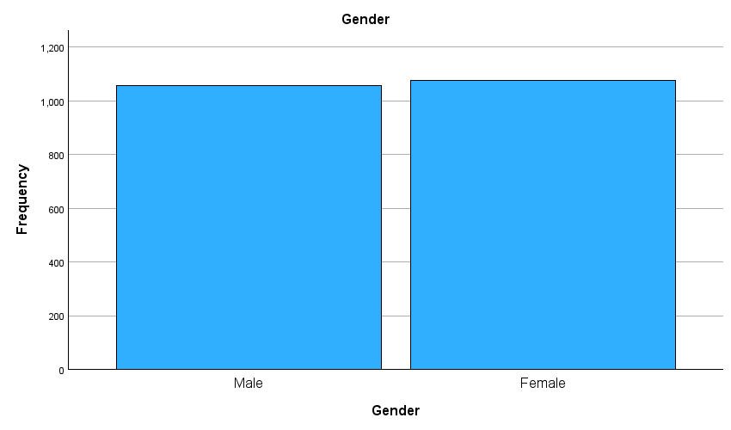

2). How many students qualifies and does not qualify for reduced/free lunch?
Solution: According to the given dataset, the lunch qualification distribution includes 2133 valid items, all of which include complete data, similar to the gender distribution. Moreover bar graph showed, the majority of student is 1215 which percentages is (57.0%) do not qualify for free lunch, whereas the number of student 918 who is qualify for free lunch and there represented percentage is 43.0% . These percentages shed light on the distribution of free lunch qualifying among these students.

Statistics
Lunch
N | Valid | 2133
N | Missing | 0

Lunch
 |  | Frequency | Percent | Valid Percent | Cumulative Percent
Valid | Does not qualify for free lunch | 1215 | 57.0 | 57.0 | 57.0
Valid | Does qualify for free lunch | 918 | 43.0 | 43.0 | 100.0
Valid | Total | 2133 | 100.0 | 100.0

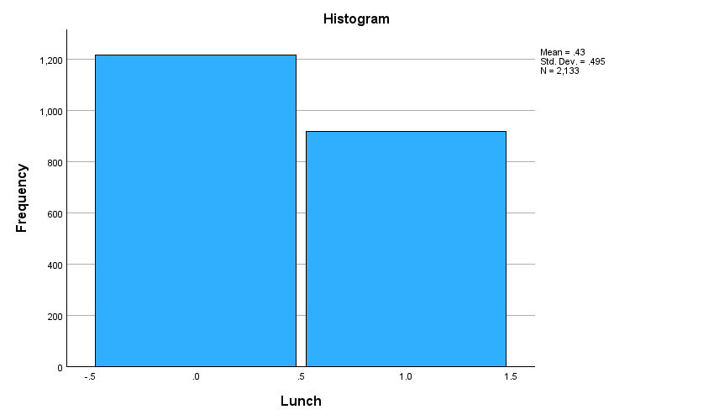
3) What are the mean and median of students who qualifies and does not qualify for reduced/free lunch?

Solution: The given below dataset includes all 2133 students. The analysis uses the median and mean statistical measures to describe the central tendency of numerical data. The data shows a difference in median values between two groups based on lunch qualification, but the mean values are quite similar. This suggests some variation in the data distribution, and further analysis could be conducted to understand the significance of these differences and their implications. The median value for the group not qualifying for free lunch is 2.00, while the mean value is 1.50. Students who are eligible for free lunch have a median value is 1.00 and a mean value is 1.50.
Case Processing Summary
 | Cases
 | Included |  | Excluded |  | Total
 | N | Percent | N | Percent | N | Percent
Gender * Lunch | 2133 | 100.0% | 0 | 0.0% | 2133 | 100.0%

Report
Gender
Lunch | Median | Mean
Does not qualify for free lunch | 2.00 | 1.51
Does qualify for free lunch | 1.00 | 1.50
Total | 2.00 | 1.50

4) Using the dataset Student_Score.csv provided in conjunction with SPSS, give a specific example of Clustering (ex. K-Means Clustering). Show your workings with screenshots and clearly explain your results.
Solution:
Initial Cluster Centers
 | Cluster
 | 1 | 2 | 3 | 4 | 5
Posttest | 49 | 83 | 32 | 100 | 66

Iteration History
Iteration | Change in Cluster Centers
Iteration | 1 | 2 | 3 | 4 | 5
1 | 1.660 | 1.736 | 6.233 | 5.260 | .376
2 | 1.617 | 1.658 | 3.124 | 1.734 | .043
3 | 1.255 | 1.179 | 1.326 | 1.155 | .090
4 | .837 | .214 | 1.574 | .429 | .000
5 | .920 | .367 | .731 | .754 | .472
6 | .900 | .000 | .609 | .000 | .514
7 | .000 | .000 | .000 | .000 | .000
a. Convergence achieved due to no or small change in cluster centers. The maximum absolute coordinate change for any center is .000. The current iteration is 7. The minimum distance between initial centers is 17.000.

Final Cluster Centers
 | Cluster
 | 1 | 2 | 3 | 4 | 5
Posttest | 56 | 78 | 46 | 91 | 67

Number of Cases in each Cluster
Cluster | 1 | 510.000
Cluster | 2 | 537.000
Cluster | 3 | 288.000
Cluster | 4 | 247.000
Cluster | 5 | 551.000
Valid |  | 2133.000
Missing |  | .000

These above data show the results of a clustering study on a dataset. In this analysis, the dataset was separated into five clusters, each representing a distinct group of cases.
The "Posttest" column indicates the average posttest score for each cluster. Cluster 1 has an average posttest score of 56; Cluster 2 has an average score of 78; Cluster 3 has an average score of 46; Cluster 4 has an average score of 91; and Cluster 5 has an average score of 67. The "Iteration History" explains how the clustering method got at its final answer. Each iteration marks a phase in the process in which the method refines the cluster centres to better fit the data. The "Change in Cluster Centres" columns indicate how much the cluster centres shifted throughout each iteration. Convergence was attained in the seventh iteration, as evidenced by the minor shift in cluster centres.
The "Final Cluster Centres" table displays the coordinates of the final cluster centres following convergence. These centres show the average posttest scores for each cluster.
Finally, the "Number of Cases in Each Cluster" table provides the number of cases allocated to each cluster. As an illustration, Cluster 1 has 510 cases, Cluster 2 has 537, Cluster 3 has 288, Cluster 4 has 247, and Cluster 5 has 551.
Overall, this approach identifies unique groups within the dataset based on posttest scores, providing information about patterns or relates to among the data points.
5) Discuss the advantages and disadvantage of using SPSS and Excel using relevant practical examples and present your discussions in a table by using different criteria.

Solution:

Criteria | SPSS | EXCEL
Advantages
Ease of data analysis | SPSS is mainly designed for statistical analysis, with a diverse set of statistical methods and tools. For instance, easily controls survey data using statistical processes such as correlation analysis. | Excel is adaptable and easy to use for basic data analysis tasks, particularly with small datasets.  For example, Suitable for basic analysis, such as calculating correlation values, but may need manual effort for bigger datasets.
Statistical tools | It provides complicated statistical analysis methods such as regression analysis, factor analysis, and ANOVA. For example, Includes built-in ANOVA analysis and post-hoc evaluation for extensive comparisons | Supports basic statistical functions such as mean, median, and standard deviation, but lacks advanced analysis features.  For example, Excel can run ANOVA using built-in routines but lacks advanced capabilities such as post-hoc testing.
Data visualization | Offers extensive graphical features for data visualisation, including charts and graphs designed for statistical analysis. Example, offers different chart options, including histograms that can be modified for statistical research. | Basic charting and graphing capabilities are available, however advanced statistical visualisation elements are not available. For instance, provides basic charting tools, including histograms, but lacks advanced statistical visualisation features.
Automation | Allows the automation of repetitive activities using syntactic programming, which improves reproducibility and efficiency | Automation capabilities are limited when compared to SPSS, but can be extended with VBA (Visual Basic for Applications) to provide some automation

Disadvantages
Cost | SPSS is a paid commercial software that may be too expensive for individuals or small businesses. | Excel is widely available as part of the Microsoft Office suite or separately, making it more accessible and affordable.
Learning curve | There is some learning curve, particularly for complex statistical analytic techniques and syntactic programming. | Basic data analysis activities are relatively simple to understand, while advanced analysis may require additional skills or components.
Data handling | It is designed for processing massive data sets and performing complex analysis, making it ideal for research and academic applications. | Excel can become slow and challenging when dealing with huge datasets or conducting complex computations, limiting its potential for advanced statistical research.

CONCLUSION: To summarise, both SPSS and Excel are useful data analysis tools, having their own advantages and disadvantages. SPSS is best suited for extensive statistical analysis and advanced data mining activities, whereas Excel is more intuitive and versatile for basic analysis and data processing. Depending on the user's unique needs and skill level, selecting the suitable tool can significantly improve the efficiency and accuracy of data analysis procedures.

REFRENCES:
Pedamkar, P. (2018). SPSS vs EXCEL - 8 Most Important Differences You Should Know. [online] EDUCBA. Available at: https://www.educba.com/spss-vs-excel/.

Narain, J. (2021). Top 7 Strategies to improve profit. [online] Strategists World. Available at: https://strategistsworld.com/top-7-strategies-to-improve-profit/.

‌

‌

