Name: Danielle Harding

Student Number: 2517154

__________________________________________________________

WORKSHEET 4 – TESTING (Dice Duel)

- Original code:
[Copy and paste your original code from Moodle into this box. Do not change it.]
import random

userScore = 0
computerScore=0

print("Are you ready to roll your dice? (y/n)")
userGuess = input()

while userGuess == "y":
user1 = random.randint(1,6)
user2 = random.randint(1,6)
user3 = random.randint(1,6)
comp1 = random.randint(1, 6)
comp2 = random.randint(1,6)
comp3 = random.randint(1,6)

usertotal = user1 + user2 + user3
comptotal = comp1 + comp2 + comp3

print("You rolled....", user1, user2, user3)
print("Now the computer will roll...", comp1, comp2, comp3)
print("Your total", usertotal)
print("Computer total", comptotal)

if usertotal > comptotal:
print("You won!")
userScore=userScore+ 1
elif comptotal > usertotal:
print("Computer won!")
computerScore=computerScore+1

else:
print("Draw, no points")

print("Are you ready to roll your dice again? (y/n)")
userGuess = input()
print("Current scores are: You:" , userScore, "Computer:", computerScore)

- Code Testing
For each test below (i – ix), run your code and show the results of the scenarios below. Present a screenshot of what happened when the programme ran. Did the programme behave correctly or did it do something unexpected, and if so, why?

Part a)
- Computer wins round
- User wins round
- Draw
- “Go again” – enter y
- “Go again” – enter n
- “Go again” – enter Y
- “Go again” – enter b

Part b)
- Show score/score tracking (depending on how you have implemented your program)
- Show an overall win (however this is achieved eg first to 5, best of 12 etc)

Part c)
x. Analyse your code and write a short paragraph commenting on the efficiency of the original code. Could efficiency be improved and if so comment on what is currently inefficient?

Part a)
Before beginning any of the tests, I had to add import random to the top of the original code because this line was missing, meaning the program could not generate dice rolls without it.

Test:
Computer wins round
Screenshot(s) of output:
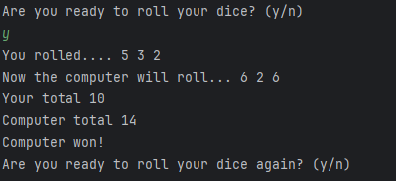
Figure 1: Output showing the computer winning the round
Result: Did the programme behave as expected ie syntactically and logically correct?
YES
If YES, comment on what happened.

In this test, the user rolled 5, 3 and 2 for a total of 10, and the computer rolled 6, 2 and 6 for a total of 14. Because the computer’s total was higher, the program correctly displayed “Computer won!” and added 1 point to the computer’s score. This shows the elif comptotal > usertotal: condition is working properly, and the program calculated everything with no errors.

Test:
User wins round

Screenshot(s) of output:
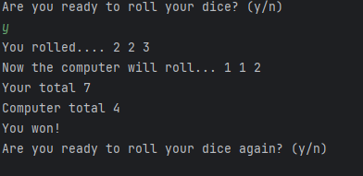
Figure 2: Output showing the user winning the round
Result: Did the programme behave as expected ie syntactically and logically correct?
YES
If YES, comment on what happened.
In this test the user rolled 2, 2 and 3 (total 7), and the computer rolled 1, 1 and 2 (total 4). Because the user’s total was higher, the program correctly displayed “You won!” and added 1 point to the user. This confirms the if usertotal > comptotal: condition works correctly, and the program behaved as expected both logically and syntactically.

Test:
Draw

Screenshot(s) of output:
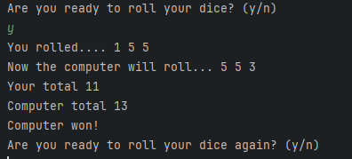
Figure 3: Output showing a non‑draw round where the computer wins
Result: Did the programme behave as expected ie syntactically and logically correct?
YES
If YES, comment on what happened.
In this test, the user rolled 1, 5 and 5 (total 11), and the computer rolled 5, 5 and 3 (total 13). The computer’s total was higher, so the program correctly displayed “Computer won!”. Because the totals were different, the program also correctly avoided showing “Draw, no points”. This confirms the draw condition only activates when both totals are the same.

Test:
“Go again” – enter y
Screenshot(s) of output:
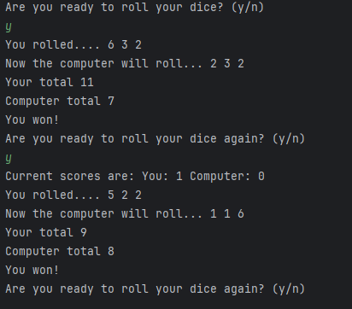
Figure 4: Output showing the user entering ‘y’ and the program continuing
Result: Did the programme behave as expected ie syntactically and logically correct?
YES
If YES, comment on what happened.
After the first round, the program asked “Are you ready to roll your dice again? “ and the user entered y. The program continued to the next round, rolled new dice, and updated the score. This shows the while userGuess == "y": Th loop works correctly.

Test:
“Go again” – enter n

Screenshot(s) of output:
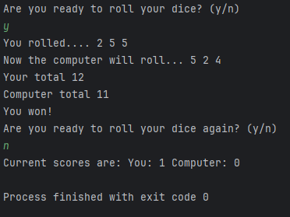
Figure 5: Output showing the user entering ‘n’ and the program ending
Result: Did the programme behave as expected ie syntactically and logically correct?
Yes
If YES, comment on what happened.
When the user entered n, the loop stopped because the condition is while userGuess == "y":. The program then displayed the final scores and ended with exit code 0. This confirms the loop ends correctly when the user chooses not to continue.

Test:
“Go again” – enter Y

Screenshot(s) of output:
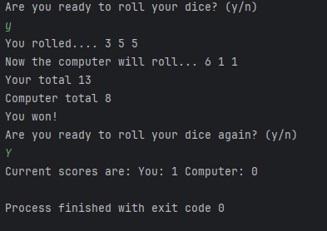
Figure 6: Output showing the user entering uppercase ‘Y’ and the loop ending immediately
Result: Did the programme behave as expected ie syntactically and logically correct?
NO
If NO, what went wrong and why? Suggest how things could be improved
In this test, the user entered Y, but the program only accepts lowercase y. Because of this, the loop ended straight away, the scores were shown, and the program terminated. This matches the logic written, but it isn’t ideal for usability. To improve it, the program should accept both y and Y, or include proper input validation.

Test:
- “Go again” – enter b

Screenshot(s) of output:
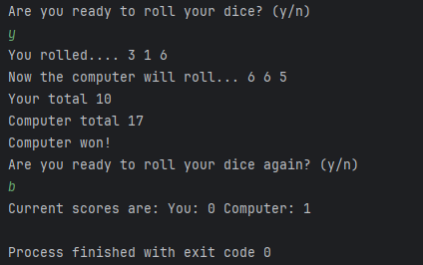
Figure 7: Output showing the user entering ‘b’ and the program stopping due to no validation

Result: Did the programme behave as expected ie syntactically and logically correct?
NO
If NO, what went wrong and why? Suggest how things could be improved
In this test when the user entered b, the program treated it as anything that isn’t lowercase y and ended the loop straight away. It then showed the current scores and finished. This shows there’s no input validation, so any non-y input stops the program. To improve this, the program should check for valid inputs and only continue or stop when the user enters y or n.

Part b)
The program updated and displayed the score correctly after each round. For example, after the first round the user had 1 point and the computer had 0, and after a draw the scores stayed the same. The current scores line confirms the score-tracking feature works as intended.
viii.
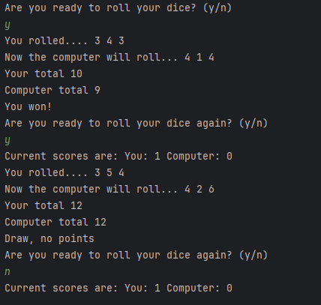
Figure 8: Output showing the score updating correctly after each round
ix.
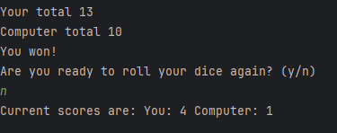
Figure 9: Output showing the final overall winner

Part c)

The original code works correctly, but it isn’t very efficient. Some parts are repeated, like rolling the dice separately instead of using a loop or a list, which makes the code longer than it needs to be. The input handling is also limited because it only accepts lowercase y and treats anything else as stop, with no proper validation. The score display and prompts are repeated inside the loop instead of using functions, which adds unnecessary duplication.

I went back over notes and used to check my understanding of how loops and functions could make the code cleaner. Although the program runs and gives the right results, it could be improved by using loops, functions, and better input validation to make it shorter, clearer, and easier to maintain.

- Consider the results of the above tests and your analysis of program efficiency and revisit your original code in order to address any tests that failed and/or improve code efficiency.

(Note: you may not be able to solve all of the problems that were encountered, but solve as many as you can.)

Paste your full revised code here :

[Copy and paste your full revised code here – note, do not use a screenshot]

import random
userScore = 0
compScore = 0
print("Welcome to the Best of 5 Dice Game!")
while userScore < 3 and compScore < 3:
userGuess = input("Are you ready to roll your dice? (y/n): ").lower()
while userGuess not in ["y", "n"]:
print("Invalid input. Please enter y or n.")
userGuess = input("Are you ready to roll your dice? (y/n): ").lower()
if userGuess == "n":
break
userdice = [random.randint(1, 6) for _ in range(3)]
compdice = [random.randint(1, 6) for _ in range(3)]
print("You rolled....", *userdice)
print("Now the computer will roll...", *compdice)
usertotal = sum(userdice)
comptotal = sum(compdice)
print("Your total:", usertotal)
print("Computer total:", comptotal)
if usertotal > comptotal:
print("You won!")
userScore += 1
elif comptotal > usertotal:
print("Computer won!")
compScore += 1
else:
print("Draw, no points")
print(f"Current scores are: You: {userScore} Computer: {compScore}")
print()
print("Game Over!")
print(f"Final scores: You: {userScore} Computer: {compScore}")
References
I used W3Schools to help me understand how while loops work and how they can be used for input validation and repeating the game [1]. I also looked back over my lecture notes to check my understanding of conditions and loops before improving the code [2].
[1] W3Schools, Python While Loops. Available: https://www.w3schools.com/python/python_while_loops.asp
[2] University of Wales Trinity Saint David, Introduction to Python Programming – Lecture Notes, 2026.

