

Module Name: Analysing & Solving Problems
Module Code: ACCA4019

Student Name: Mohamed Alkahtany
Student ID: 251545
Lecturer Name: Dr Abida Perveen

Table of Contents
1. Introduction 3
2. Problem Deconstruction 4
2.1 Overview of the Problem 4
2.2 Key Requirements Using MoSCoW Analysis 4
2.3 Key Constraints 5
2.4 Key Variables 5
3. Proposed Solution and Explanation 6
3.1 Solution Approach 6
3.2 Flowchart for Classroom Allocation Process 6
3.3 Explanation of the Flowchart 7
3.4 Achievement of Objectives 8
4. Reflection and Justification 8
5. Conclusion 10

Table of Figures
Figure 1: Current Classroom Allocation Problems in the College 4
Figure 2: MoSCoW Prioritisation of Classroom Allocation Requirements 5
Figure 3: Proposed Classroom Allocation System Architecture 7
Figure 4: Problem-Solving Framework Used in the Study 10

1. Introduction
Effective resource distribution is a critical provision in the learning institutions, specifically the use of classroom areas and school schedules. Most colleges have issues with their operations in assigning classrooms, which leads to overcrowding of the rooms, underutilisation of facilities, schedule conflicts and unnecessary movement of staff and students around the facilities. These inefficiencies affect the teaching quality, organisational productivity and the general learning experience negatively.
This report examines the issue of the ineffective allocation of classes in a neighboring college and comes up with a systematic solution with the application of classical methodologies of problem-solving. The first stage involves deconstructing the problem using the tools of analysis in the identification of its major requirements, constraints, and variables. MoSCoW prioritisation method is used to classify the requirements of the system and identify the essential functional requirements.
An algorithmic reasoning is then used to propose a logical solution model, which is represented by a flowchart of the decision-making process applied in the process of classroom allocation on the basis of class size, room capacity, timetable availability and proximity. Lastly, the report reflects on the problem-solving approaches used and the strengths and weaknesses of the suggested solution.

2. Problem Deconstruction

2.1 Overview of the Problem
The college is already facing a challenge of operation in terms of classroom scheduling and allocation. There are those classrooms that have high populations of students and are often overcrowded, whereas other rooms are not fully used. Moreover, there are scheduling conflicts where two or more classes are scheduled in a room at the same time. There is also a lack of a systematic allocation strategy that reduces the time that students and lecturers spend in between classes, which are in various buildings.
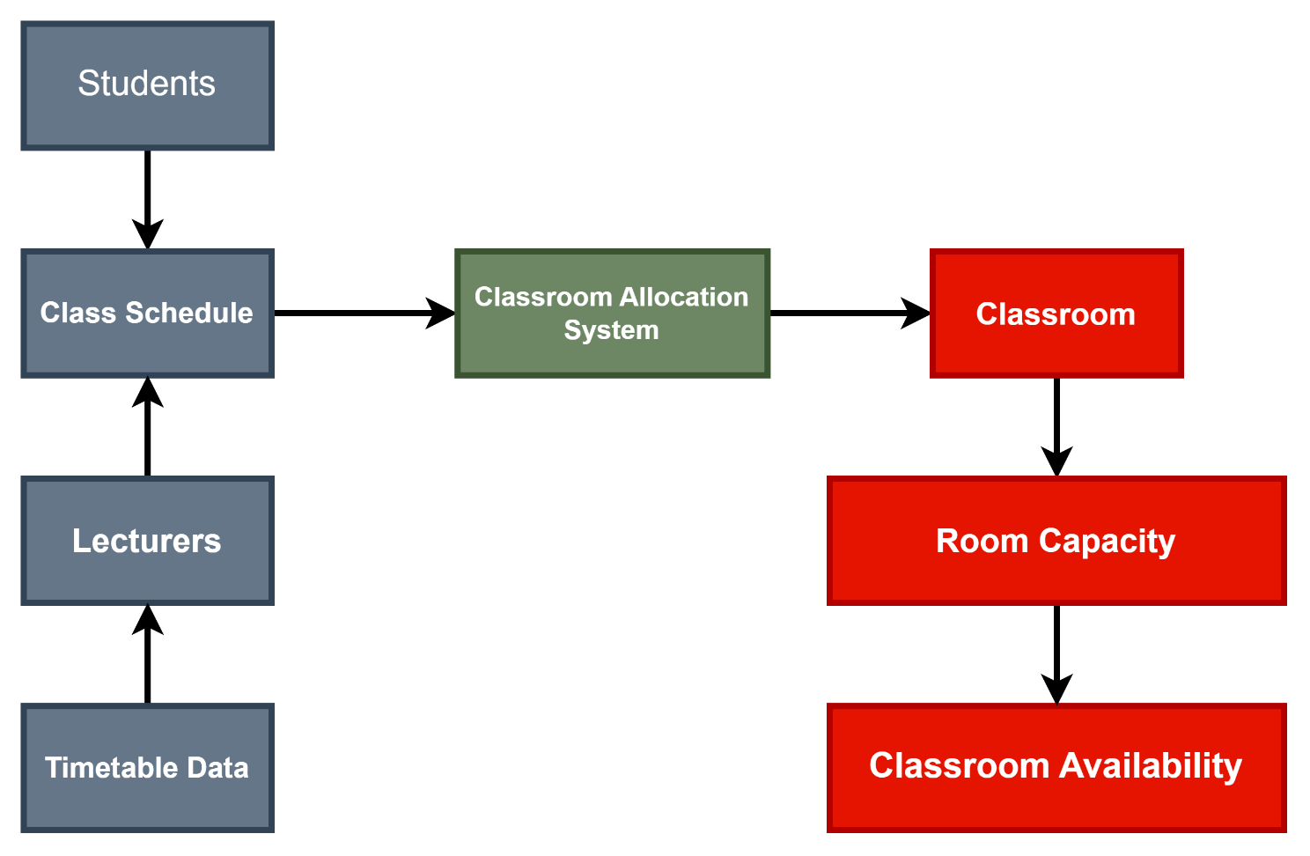
Figure 1: Current Classroom Allocation Problems in the College
This scenario means that the institution is not well equipped with a system that can be used in the distribution of rooms based on demand, availability and logistical factors. In the absence of systematic planning, the utilisation of educational resources is performed inefficiently and the organisational productivity is minimised.
Based on the principles of computational problem-solving, the operational problems or the complex components should be broken down into smaller and manageable parts to enable the systematic assessment and development of solutions (Hoerl, Jensen and de Mast, 2021). Disaggregating the classroom allocation problem allows for identifying more clearly the factors that shape the decisions of scheduling.

2.2 Key Requirements Using MoSCoW Analysis
The MoSCoW prioritisation tool classifies the system requirements based on their priority in the solution design (Suchetha Vijayakumar, Krishna Prasad K and Holla M., 2024).
Priority | Requirement | Explanation
Must Have | Allocate rooms according to class size | Prevent overcrowding
Must Have | Prevent timetable clashes | Avoid room conflicts
Must Have | Assign a classroom to every class | Ensure all classes are scheduled
Should Have | Reduce walking distance | Improve student convenience
Should Have | Improve room utilisation | Maximise resource efficiency
Could Have | Use specialised rooms when required | Support practical classes
Could Have | Automatic timetable updates | Improve flexibility
Won’t Have | External system integration | Out of scope
Won’t Have | Real-time navigation system | Not required for this solution
Figure 2: MoSCoW Prioritisation of Classroom Allocation Requirements
Must Have
- Allocation of classrooms based on class size and room capacity
- Prevention of timetable clashes
- Assignment of a classroom for every scheduled class
Should Have
- Reduction of walking distance between consecutive classes
- Improved overall utilisation of classroom resources
Could Have
- Prioritisation of specialised facilities such as laboratories
- Automated timetable updates when scheduling changes occur
Won’t Have
- Full integration with external institutional databases
- Real-time navigation or location services for students
This prioritisation will make sure that the most important requirements to satisfy in terms of operation are met in the process of system design.

2.3 Key Constraints
Classroom allocation is affected by a number of operational constraints.
- Capacity constraint: the capacity of each classroom is determined, and it should fit the number of students enrolled in a classroom.
- Time limitation: It is impossible to have more than one class in the same time slot in a classroom.
- Location constraint: The distance between classrooms might be very high, thereby increasing the time taken to go between lectures.
- Facility constraint: There are courses that demand some specialised facilities like laboratories or even computer rooms.
The allocation process is required to have these constraints in it to meet realistic and achievable scheduling results (Watanabe et al., 2024).

2.4 Key Variables
The optimisation process is based on a number of variables that affect allocation decisions.
Variable | Description
Class Size | Number of students enrolled in a class
Room Capacity | The maximum number of students a classroom can accommodate
Time Slot | Scheduled time for the class
Room Location | Physical location of the classroom within the campus
Course Requirement | Special facilities required for certain subjects
It is these variables that form the foundation of developing an algorithm that can be used to pair classes with the right rooms.

3. Proposed Solution and Explanation

3.1 Solution Approach
An organised system of classroom distribution is suggested to be applied to the outlined inefficiencies. The solution makes use of the rule algorithm, which assigns classrooms depending on capacity, availability and proximity.
The algorithm takes into account the information about the scheduling and data about the classroom to calculate the most suitable allocation of each class session. It aims at maximising room utilisation and avoiding schedule conflict and minimising inter-class movement time.

Figure 3: Proposed Classroom Allocation System Architecture
The suggested system will be based on the following logical steps:
1. Gathering of timetable and course data.
2. Determination of capacity and facilities of the classroom.
3. Correlating room size with appropriate room capacity.
4. Check the room availability at each time slot.
5. Assessment of proximity in classrooms to limit the distance covered in travelling.
6. Provision of the most appropriate classroom.
7. Restructuring of the schedule database.
This is a systems thinking process, under which various parts of an organisation are examined as a unit to maximise the efficiency of operations (Sumairah and Zainon, 2024).

3.2 Flowchart for Classroom Allocation Process
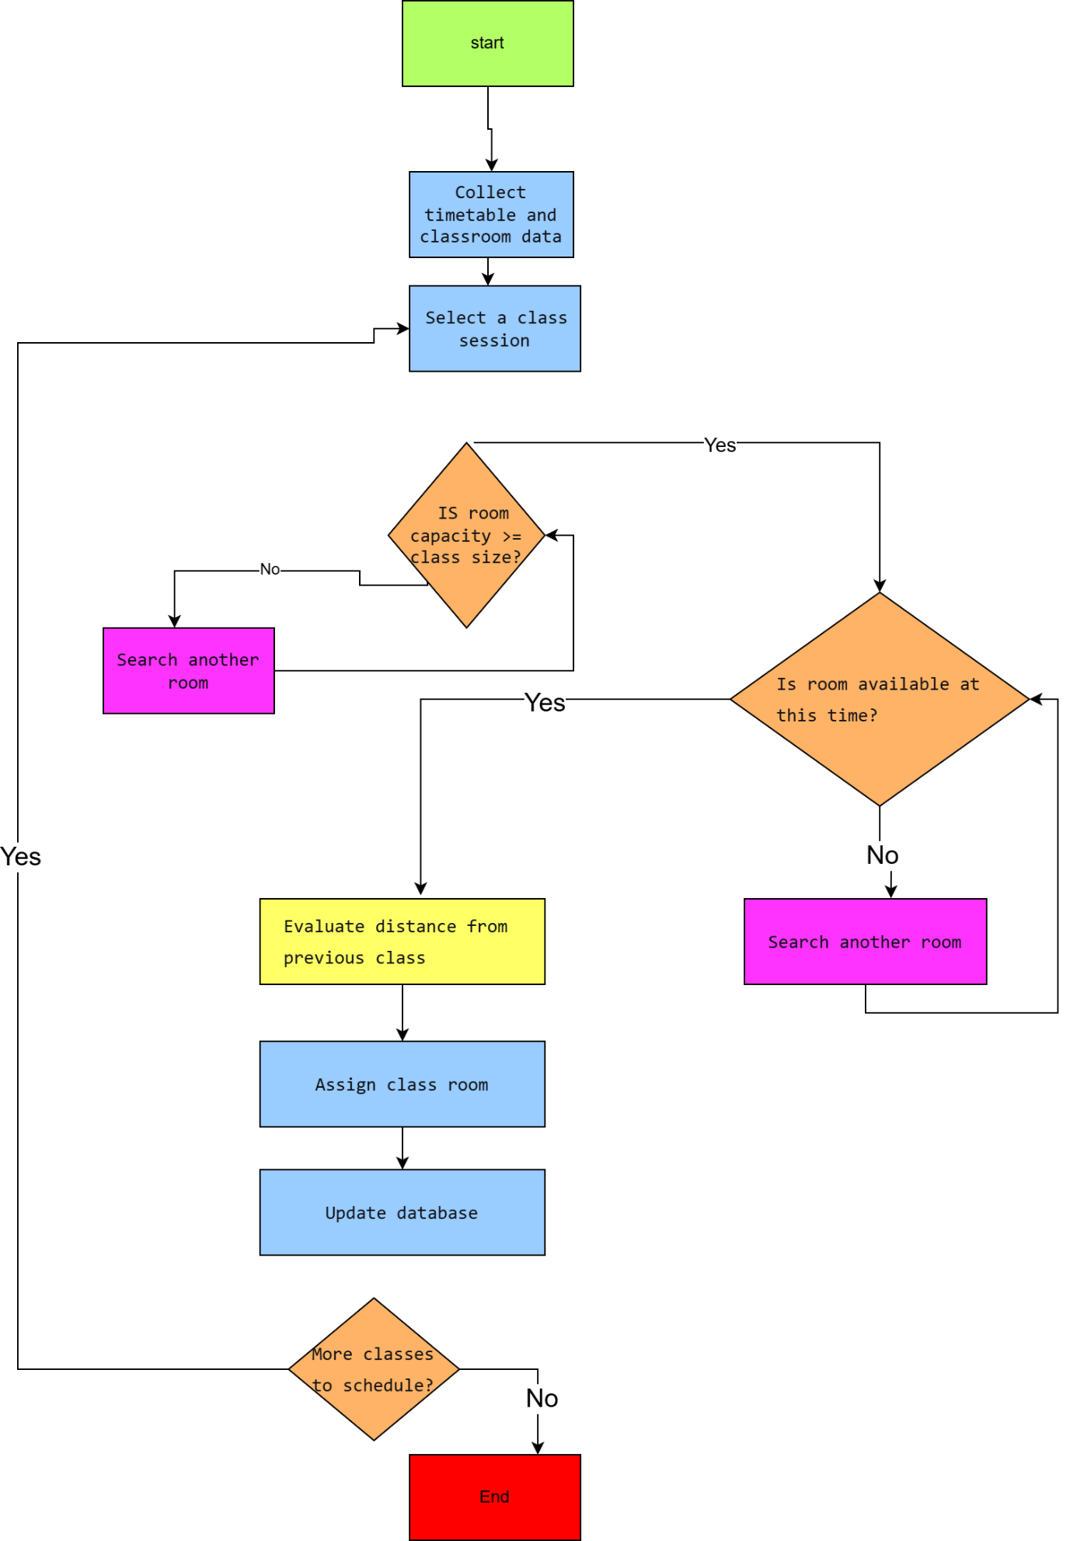

3.3 Explanation of the Flowchart

The flow chart represents a constraint based and iterative decision making process applied in the efficient allocation of classrooms. The system has a well-defined process of procedures that involve processing of inputs, decision structures (IF/ELSE), and looping to make sure that all scheduling requirements are met before an allocation is verified.

Data Collection Phase

The process will start with the gathering of necessary input data such as schedule of classes, the number of students, capacity of rooms, room time slot, and location of rooms. These are inputs that are important variables influencing the decision making process. It is essential to make sure that the data at this stage is accurate and complete, and the rest of the decisions rely on that.

Capacity Check (Constraint 1)

The classes are done one at a time. The initial decision point will be the capacity constraint assessment (room capacity [?] class size).

In the event of the condition being not met, the system will go on an iterative process, to look into finding an alternative room that has a sufficient capacity. This is done until a valid room has been found. This will stop congestion and at the same time will not result in wastage of too large rooms.

Availability Check (Constraint 2)

Once a room is found that satisfies the capacity requirement the system will check the availability of the room at this specific time.

In case the room is not available, the system restarts a looping process in an attempt to find another room. This is to make sure that there is no conflict of scheduling like double-booking.

Distance Optimisation (Optimisation Criteria)

After meeting both of the constraint conditions, the system compares the distance between the assigned room and the last place of the class. This adds a layer of optimisation, which gives priority to those rooms that have the least travel distance.

This enhances efficiency through a reduction of the transition time of students and staff.

Assignment and Data Change.

Once the most appropriate room is determined, the system allocates the same to the class session and records the same in the database.

This contributes to the integrity and uniformity of data, whereby future scheduling activities can be done based on reliable data.

Recurrent Process of Scheduling.

This is repeated in all other lessons sessions of the classes. The validation of the decision points and loops used promises that only legit allocations are admitted and therefore conflict-free and constraint-adhering timetable is produced.

The project will have the following objectives: 3.4 Achievement of Objectives (Improved Version).

The selected solution is effective in meeting the major goals of the scheduling dilemma via combining constraints and optimisation methods.

Proper Distribution in Class Size.

The capacity check is to make sure that every class is allocated to a room which is capable of accommodating all students. This will help to avoid overcrowding and also will help to avoid inefficient utilization of spacious rooms.

Reduction of Movement Time.

The distance evaluation inclusion follows the allocations of rooms that minimise the movement between classes. This will increase efficiency and user experience.

Conflict-Free Timetabling

The availability check is used to make sure that a room is not occupied by more than one class at that moment and therefore no conflicts are created in the scheduling.

Effective use of resources.

The system will be effective on the utilisation of available resources by linking constraints (capacity and availability) with optimisation criteria (distance).

Nevertheless, this solution is also sequential (greedy) that is, at each step it takes the best option available instead of considering all the combinations. Although this enhances performance it does not necessarily ensure a world-optimal solution.

4. Reflection and Justification
The process of problem solving that was employed in this report depended more on abstract thinking and problem decomposition. The abstract thinking made it possible to conceptualise the classroom allocation problem as a wider resource management problem that comprises inputs, decision processes, and outputs.

Figure 4: Problem-Solving Framework Used in the Study
With this approach to the system, a logical structure could now be developed, and could be used to work with the complex scheduling needs. Depletion of problems was also significant. The original issue was further divided into sub-sections in order to encompass capacity matching, timetable validation and proximity optimisation. Analysis of these factors separately helped to ensure that an organised solution was developed easily. The use of MoSCoW technique was a prioritised method of requirement definition and deployment of the most important elements of the system first.
Nonetheless, there are some assumptions on which the proposed model is based, such as the presence of correct scheduling information. Moreover, the rule-based method might not realise the high degree of optimisation as sophisticated methods like machine-learning-based scheduling systems.

5. Conclusion
The report evaluated the issue of inefficient classroom assignment at a college setting and came out with a streamlined solution to the problem involving some known problem-solving strategies. The most significant requirements, constraints and variables that affected classroom allocation were pinpointed through the problem decomposition and MoSCoW prioritisation.
An algorithmic solution was developed rationally and modeled in the form of a flowchart that defined the decision-making process based on which classrooms will be assigned efficiently. The suggested system guarantees a more efficient use of the classroom resources, less time is spent on moving between classes, and no time clashes.
Despite some shortcomings, the systematic methodology reveals how the systematic problem-solving methods may be applied successfully to deal with some operational problems in learning institutions.

Reference
Diallo, F.P. and Tudose, C. (2024). Optimizing the Scheduling of Teaching Activities in a Faculty. Applied Sciences, [online] 14(20), p.9554. doi:https://doi.org/10.3390/app14209554.
Hoerl, R., Jensen, W. and de Mast, J. (2021). Understanding and addressing complexity in problem solving. Quality Engineering, [online] 33(4), pp.612–626. doi:https://doi.org/10.1080/08982112.2021.1952230.
Liu, B. (2024). Strategic Planning and Resource Allocation in Higher Education Institutions. The Educational Review, USA, 8(11), pp.1359–1364. doi:https://doi.org/10.26855/er.2024.11.014.
Suchetha Vijayakumar, Krishna Prasad K and Holla M., R. (2024). Assessing the Effectiveness of MoSCoW Prioritization in Software Development: A Holistic Analysis across Methodologies. EAI Endorsed Transactions on Internet of Things, [online] 10. doi:https://doi.org/10.4108/eetiot.6515.
Sumairah, S. and Zainon, E. (2024). Comparative Analysis of Systems Thinking Application and Its Impact on Organizational Effectiveness in Sharia Banking. Journal International Economic Sharia, [online] 1(3), pp.175–189. doi:https://doi.org/10.69725/jies.v1i3.144.
Watanabe, W.C., Shafiq, M., Ali, S., Nawaz, M.J. and Nazeer, S. (2024). The impact of triple constraints on the project success, a moderating role of organizational support. Journal of Project Management, [online] 9(1), pp.73–84. doi:https://doi.org/10.5267/j.jpm.2023.8.002.
‌

