ELENA MUNTEANU TURCU
STUDENT NUMBER:2029759
LECTURER: Lloyd Beharry
MODULE CODE:BMNSW4001_LON

Effective Team Work and Communication

Table of Contents

1. Introduction 3
2. Models of Communication 4
2.1 The data transmission model of Shannon-Weaver 4
2.2 Schramm’s Model of communication 5
2.3 Communication model of Berlo 7
3. Communication Skills 8
3.1 Verbal communication 8
3.2 Nonverbal communication 8
3.3 Listening 9
Active listening 9
Empathetic listening 10
4. Conclusion 11
References 12

1. Introduction
When one provides information while simultaneously making one's self and message understandable to another or others, it is possible to communicate effectively. Communication is important and necessary for the proper execution of all administrative obligations, and it cannot be overlooked (Graham, 2009). Having the capacity to communicate effectively is a skill that must be developed in the workplace for a company to boost productivity and accomplish its objectives. The administration has communication difficulties since they are accountable for exchanging information to guarantee that firms operate smoothly and successfully.
2. Models of Communication
Model is a systematic representation of a structure for representing an idealised or abstract from is recognised as a model. A model is an abstracting structure that only focuses on the essential factors by eliminating certain details (Muyeen, 2017). There are different models used for explaining communication.

2.1 The data transmission model of Shannon-Weaver
For explaining the process of communication Shannon-Weaver’s model is the most used one. This model is created in 1948 by a mathematician and a scientist.
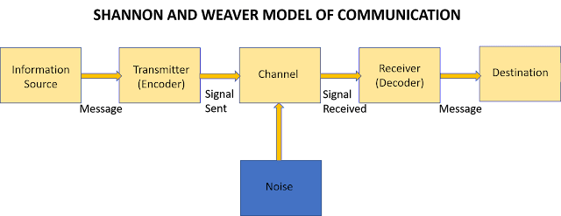
Figure: The data transmission model of Shannon-Weaver (source: Internet)
Sender: In this model, the sender is the person who works for creating a particular message. The sender is also responsible for choosing the channel for message sending.
Encoder: It is the sender who utilises a machine to turn the message into signals or binary data who is known as the encoder (Richards, 2005). This may be a direct allusion to the machine itself.
Channel: Channel is the medium that is used for sending and receiving messages.
Decoder: Signals or binary data are decoded by the decoder, and messages are received by the receiver, which then turns them into signals.
Destination: Individuals who receive messages or places to which communications must be sent are referred to as the receiver and sender, respectively, in communication terminology. The message is responded to by the receiver, who then provides feedback.
Connection with the case:
When Maria called Pedro while he was working at the building site, he misunderstood the message of Maria because of the noise and receiver destination. This case study of Maria and Pedro can be taken into consideration for explaining this model because this model is helpful in making long-distance communication using different hardware devices. In avoiding this situation, it is important to maintain a necessary balance between entropy that refers to the limit of uncertainty redundancy and uniqueness of information. As this model is based on hard work respect there are many devices connected for performing the communication. In order to communicate effectively, the more noise there is in communication, the more redundancy is required (Kapur, 2020).

2.2 Schramm’s Model of communication
In the book name the process and effects of mass communication, Wilbur Schramm presented a model for straightforward communication (Cartwright, 2007). This model is well known as the Schramm model that represented that communication needs elements that are a source, the message and a destination. In An ideal world, the source is used to encrypt a message and send it over a certain channel to its destinations in the destination the message is received and decoded. From this model, the concept of shared orientation between the sender and receiver is introduced. The main concept of this model emphasises the sharing of information between the sender and the receiver on the basis of experience. When the sender and the receiver are of similar experiences, the communication process becomes much more effective and efficient. Schramm didn't differentiate between technical and non-technical communication but he moved forward from the simple type of communication model to creating a more complicated word (Kapur, 2020).
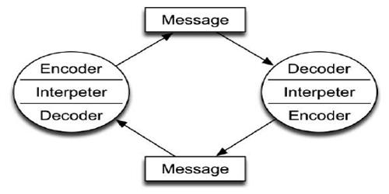
Figure: Communication model of Berlo (Qs study.com)

The difference of Schramm’s Model
This model is very similar to the Shannon and Weaver model but the process of communication is visualised as a sharing of common experiences in terms of individuals who are engaged in the process of communication. The main difference between this model and other model is its cyclical nature. All the essential elements of communication are circulated in this model and use a classical approach for explaining the flow of communication. It is really endless in nature as the elements are really switchboard centres that are handling and re-routing the great endless current of information.” (Schramm, 1955). Consequently, the flow of information is equal and reciprocal that requires interpretation. Another major important difference of this model is the listener can be both sender and receiver.
The village people didn't help the professor because they did not understand the meaning of the word the professor was saying because they were educated and the professor did and communicate with them much. Consequently, they didn't understand what the professor was trying to say. as the professor knew that the village people are not much educated, he should have used easily understandable words to ask for help from them. Schramm’s Model of communication is helpful for explaining the situation. In this model, it is explained that the individual engaged in the communication process need to have similar background, understanding or experience. When the individual is not similar to each other in terms of different factors, there will be a problem in performing an effective communication process (Kapur, 2020).

2.3 Communication model of Berlo
In 1960 an elaborated model of communication is presented by Berlo. This model is also called the SMRC model because it is prepared based on 4 steps including source, message, receiver, and channel (Berlo, 1960). It is a linear model; every step of this model is nicely elaborated. Bitstream, data and information are not separated in this model, instead, all of them are embedded in a code.
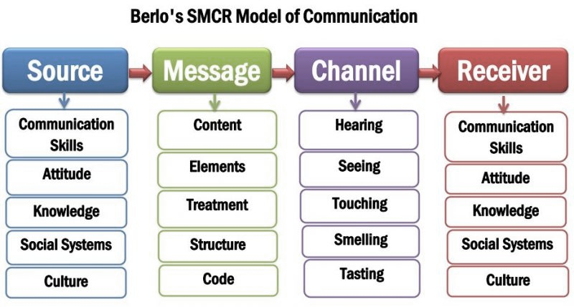
Figure: Communication model of Berlo (newsmoor.com)
Source: In this model source is indicating the centre of a message who starts the process of communication bypassing particular information to the receiver. There are different factors that are acknowledged within the criteria of this element. The factors are effective communication skills, the attitude of the sender and receiver, knowledge level social system and culture.
Message: This is the second element of this model that refers to the information that is used by the sender to communicate with the receiver. The entire body of a message is the content. The message can contain different nonverbal communication cues. The message is arranged in a structure and uses different codes like text, audio, video or visual mode for sending the message.
Channel: It is the medium that works for sharing the message from the sender to the receiver. In the model below there are five different channels that have been highlighted as a crucial part of the process of communication (Tiainen et al., 2007). The channels are senses including the process of hearing, seeing, tasting touching and smelling.
Receiver: The final element of this model is the receiver. It is the ultimate person who will receive the message sent by the sender.

3. Communication Skills
The act of sending and receiving information from one place or person to another with the help of a medium is called communication. In the process of communication, there are three basic factors consisting of a sender, a message and recipient. The transmission process of data from the sender to the receiver can be affected by different situations. So, paying attention to the entire process of communication instead of only focusing on the content of the message is important for maintaining effective communication (Pract, 2007). There are different forms of communication, among them the most common forms are verbal communication and nonverbal communication.
3.1 Verbal communication
It is the most common and understandable way of communication and one of the most powerful methods. This process of communication includes sharing of information through words between individuals. Verbal communication can be performed using two ways oral and written.
Oral: Oral communication is a process of transferring messages between individuals staying in the same place talking face-to-face or using a medium like a phone call, video chat, and voice chat. The clarity of speech, modulation, voice, body language analysis speed of speech influences the effectiveness of oral communication.
Writing: Writing is also a form of verbal communication because it uses words for expressing a situation. But one of the major differences between spoken and written communication is the level of formality. Spoken communication is more informal than written communication. For example, Major contracts, educational material are mostly found in written form.

3.2 Nonverbal communication
It is a form of communication that uses body language, gesture, posture, eye contact, facial expression instead of using words. The nonverbal communication process depends on seeing and analysing different physical movements. It helps in providing information about the situation regarding how an individual is feeling or going through, the way of receiving information and the way of approaching a group of individuals for making them understand the context of a situation.

3.3 Listening
In the process of communication, listening refers to the ability to accurately receive information and interpret messages provided by the speaker. Listening is one of the most important skills for maintaining effective communication. Listening helps an individual to obtain information, understand the context and learn from the situation. If the messages are misunderstood the communication breaks down.

Active listening
Active listening happens when an individual focuses on the information expressed by the sender with all senses and focus (Gearhart and Maben, 2021). This is an active process that requires conscious decisions for listening and understanding the message. There are some signs of active listening.
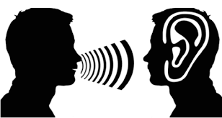
Figure: Active listening (source: Internet)
Eye contact: The listener must make eye contact with the speaker for being present at the moment.
Mirroring: Mirroring is also important that reflects focusing on the context of the speech. This can be done by copying or agreeing with the expression and gesture of the speaker.
Avoiding distracting behaviour: But the active listener must avoid distracting behaviour like playing with hair, picking fingernails, or fidgeting.
Providing feedback: Asking a different question for clarifying if the listener has any doubt in their mind (Jahromi et al., 2016).
Empathetic listening
Empathetic listening is a way of developing and enhancing the relationship with the speaker by listening actively and questioning for understanding the proper context of the information (Myers, 2000). It is a very important part of communication that allows the listener to understand the context and connect with the speaker both emotionally and intellectually. The important listening skill requires a lot of patience because instead of assuming what the speaker is going to send next it requires patiently listening and understanding even if the listener doesn't agree with the information. This process also requires interjecting summary responses for encouraging the speaker to continue with their message. The listener should also ask questions for clarifying the information without directly saying disputing facts for making arguments. This Process requires focus, attention and techniques (Gearhart and Maben, 2021).
The case study of Max the multitasker
The process of empathic listening is missing in this context of the case as a result Max fell into an unpleasant situation. Max is an event manager but he did not ask questions to the clients for clearing out their requirements and also avoided summarising or repeating the information provided by the clients for clarifying the situation on a phone call. While Tamara was talking about making changes in the schedule of the program, he just said yes instead of actively listening and understanding the situation.
Consequently, he forgot to reschedule the program. This situation can be avoided by empathic listening to the clients’ calls and asking them questions for clearing and understanding their needs. While answering the phone call if max focuses on the current client and listens to the requirements carefully and remembers them, it will be possible to maintain effective communication. The behaviour of Tamara was not correct in this respect because max was continuously telling that he is having different issues regarding handling the whole work process. Instead of only talking about her issues, she should also talk to Max about his situation. She should behave more patiently and actively knowing that maths is having difficulties and also it was her responsibility to ensure that Max was understanding for remembering the program. In this case, it can be said that both Tamara and max lacked empathic listening.

4. Conclusion
It is possible to provide the individual with an efficient understanding of the communication process with the help of the models of communication (Kapur, 2020). The importance and information about different communication models like the model of Shannon-weaver, Schramm and the model of Berlo are explained in connection with different case studies. The importance of different communication is clear is undeniable for effective transformation of information. In the process of communication, listening is as much important as speaking. So, it is essential to listen with activeness and sympathy for maintaining an effective process of communication.

References
Bear, J., 2004. Communication. London: Macdonald Educational.
Berlo, D. (1960) The process of communication. S.N.
Cartwright, R., 2007. Communication. 1st ed. Oxford, U.K.: Capstone Pub., pp.67-71.
Gearhart, C. C. and Maben, S. K. (2021) “Active and empathic listening in social media: What do stakeholders really expect,” International journal of listening, 35(3), pp. 166–187.
Graham, I., 2009. Communication. Mankato, Minn.: QEB Pub.
Jahromi, V. K. et al. (2016) “Active listening: The key of successful communication in hospital managers,” Electronic physician, 8(3), pp. 2123–2128.
Kapur, R. (2020) “The models of communication.” Available at: http://dx.doi.org/ (Accessed: October 28, 2021).
Muyeen, S., 2017. Communication. Stevenage, Herfordshire, UNKNOWN: The Institution of Engineering and Technology.
Myers, S. (2000) “Empathic Listening: Reports on the Experience of being Heard,” Journal of humanistic psychology, 40(2), pp. 148–173.
Oncol Pract, J. (2007) “Developing effective communication skills,” Journal of oncology practice, 3(6), pp. 314–317.
Oxlade, C., 2010. Communication. Austin, Tex.: Raintree Steck-Vaughn.
Richards, J., 2005. Communication. [North Mankato, Minn.]: Chrysalis Education.
Tiainen, T. et al. (2007) Proceedings of 30th systems research Scandinavia, Core.ac.uk. Available at: https://core.ac.uk/download/pdf/250105068.pdf#page=1137 (Accessed: October 28, 2021).

