Sustainable Development Goals
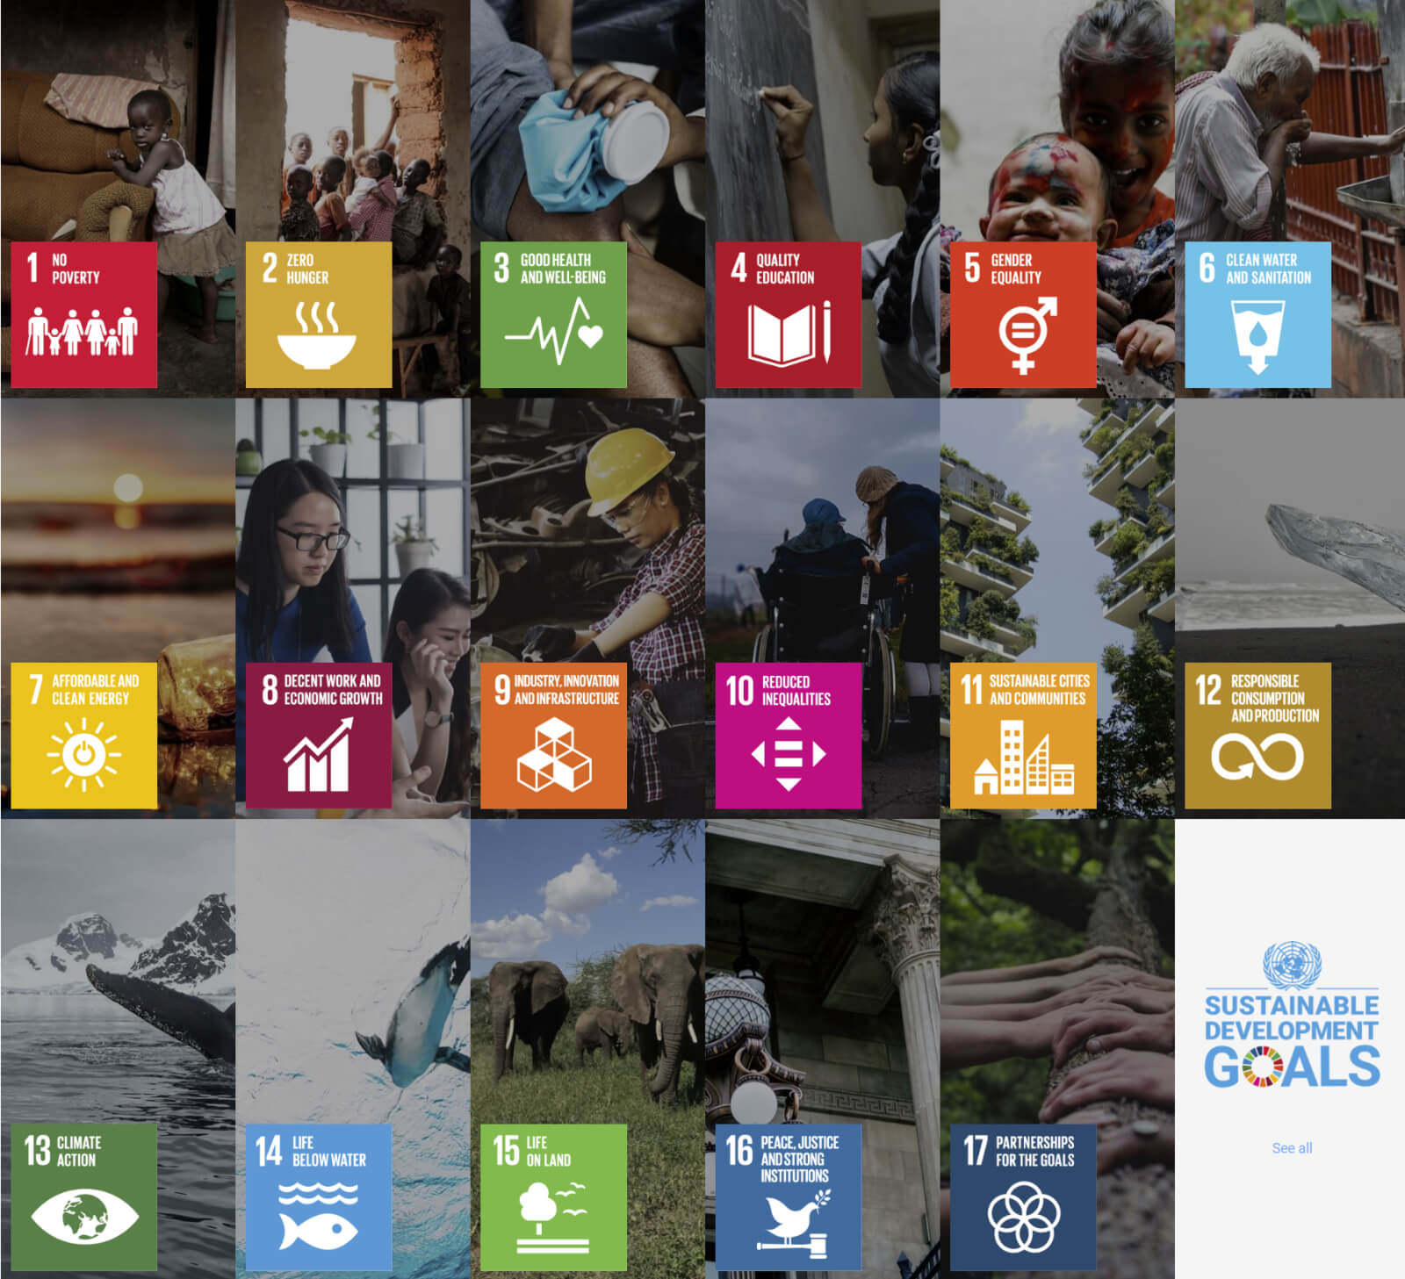
Health, Wellbeing and Sustainable Development
BMHP6021_BIRM

Abstract
Sharette Lawrence: 2017889
Lecturer: Gillian Weaver

Sustainable development has three pillars that encompass the 17 interconnected goals of the United Nations Sustainable development goals blueprint ‘Agenda 2030’.
The global population need to collectively work towards obtaining a balance to ensure human civilization has a future. Inequalities hold significant implications for all individuals. The inability to address and eliminate discrimination, while also failing to ensure equal opportunities, adversely affects individuals, weakens society, and imposes significant economic burdens which all in turn impact health and wellbeing.
By prioritising filling gaps to avoid forgetting unfinished achievements and exclusions, the possibility of success in achieving Agenda 2030 is still viable even after the drawbacks covid-19 caused. Collective global wellbeing is the end objective.

Contents Page
Abstract 0
Introduction 4
Key Concepts 4
Wellbeing 5
Sustainable Development 6
Health 9
Sustainable Development Goals 9
Goal review A 11
SDG 3: Good health and wellbeing. 11
Target 3.8 12
Strategies to achieve SDG 3 target 3.8. 12
Target 3.4 14
Strategies relating to SDG 3 target 3.4. 15
Challenges: SDG 3 17
Recommendations 17
Goal review B 18
SDG :10 Reduce inequality within and among countries 18
Target 3 ‘Ensure equal opportunity and reduce inequalities’ 19
Strategy relating to SDG 10 target 10.3. 19
Target 10.7 20
Strategy relating to SDG 10 target 10.7. 20
Challenges: SDG 10 22
Recommendations 22
Conclusion 23

Introduction
The purpose of this health and wellbeing consultant’s report is to update the National Health Service chief, outlining the progress made thus far in achieving two of the United Nations Sustainable Development Goals (SDG) and related targets to improve health, wellbeing, and sustainable development within the UK.
These goals and targets are to ensure the UK proactively help to achieve a sustainable future within the SDG addressed issues globally. There are a total of 17 goals created in unity from 49 organisations and 14 networks and working groups. In totality, 169 targets were compiled across 193 countries with a target achievement date of 2030.
Key terms such as sustainable development, wellbeing, health, and sustainable development goals are used regularly throughout the report to help determine the baseline for progress on the UK’s development in achieving the 2030 deadline.
Expressed concerns regarding concepts are noted and goals 3: Good health and wellbeing and 10: Reduced inequalities are reviewed to determine progress made within the UK. To conclude recommendations against achievement of the targets are advised.

Key Concepts

The effective resolution of economic challenges relating to poverty, environmental concerns regarding climate shifts, disruptions to underwater ecosystems, and the emission of greenhouse gases is a matter currently under scrutiny. Concepts of wellbeing, sustainable development, health and SDGs provide a heavy impact on individual and collective goal achievements. Global Wellbeing Initiative (no date) identifies global wellbeing can only be achieved once each leader secures its own populations wellbeing and joins in efforts to obtain it comprehensively.

Wellbeing
A singular definition of wellbeing is not unanimously reached within academia. Wellbeing supported by Rigby, Hagell and Starbuck (2018) is thought to reflect what people think and feel about their lives. The concept of wellbeing according to Stoewen (2018) is commonly understood by individuals to primarily encompass physical health considering aspects such as nutrition, exercise, and weight management. However, CDC (2018) determines it indeed contains a broader range of aspects. Wellbeing incorporates a comprehensive amalgamation of physical, mental, and spiritual wellbeing, thereby nourishing the body, stimulating the mind, and cultivating the spirit promotes wellbeing. Ruggeri et al. (2020) recognise that the concept of wellbeing entails the pursuit of physical wellbeing and the holistic attainment of a fulfilling existence. Department of Health (2014) acknowledges it includes a distinct way of life and an individualized approach to maximizing one's personal growth within the parameters set by one's abilities, environment, and predetermined circumstances.
In acknowledgment of the parameters OECD (no date) states countries vary widely in wellbeing levels. Osberg and Sharpe (no date) illustrate societies with higher wellbeing have high economic development, low corruption in governance, and meet citizens' basic needs for food and wellbeing.
For relevant and global comparison, Covid-19 showed that Wellbeing is essential to reaching the 2030 agenda of SDG.
According to Mehlmann-Wicks (2022), the UK’s well-being around Covid-19 restrictions were impacted negatively lowering quality and access of many pre-established healthcare systems.
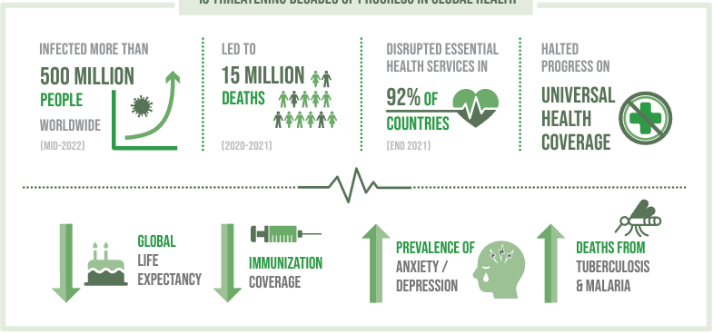
United Nations (2022a)
Important medical services and life-saving treatments were disrupted in all areas of health. Various studies including Office for Health Improvement and Disparities (2022) clarify the population's wellbeing deteriorated between March 2020 and May 2021. This point highlights that the concept of high economies produce high levels of population wellbeing, when put to the test, was flawed (Modi, 2022b)
Kapoor and Debroy (2019) express that economy growth has generally improved life quality globally. However, economies have forgotten that GDP only shows how big a country's economy is. Tenaglia (2022) confirms GDP is increased when the wellbeing of a nation is high, higher wellbeing levels create harder working individuals and faster growing economies.
Did Covid-19 push back the ability to attain some of the goals for the 2030 target, or did it highlight gaps not addressed within wellbeing and health? The importance of wellbeing weighs heavily upon many aspects of sustainable development as individuals and as a country but also along the route of achieving the United Nations SDG’s 2030 agenda.

Sustainable Development
International Institute for Sustainable Development (IISD) (no date) determined Sustainable development means growing and progressing in a way that satisfies our current needs, United Nations (2023b) contends it is also without harming the ability of future generations to satisfy their needs.
The conceptual framework of sustainability as Lemke (2021) indicates, encompasses three essential pillars, social, economic, and environmental, which together contribute to the achievement of sustainable development over the long term. The art of maintaining a delicate balance among these pillars has long been deemed crucial for fostering a sustainable society (Foley, Bogue and Onakuse, 2016).

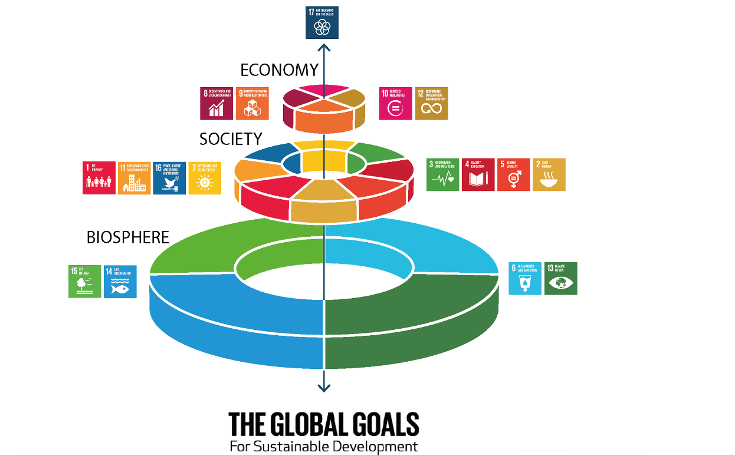
(Folke et al., 2016)

The three fundamental pillars that constitute the foundation of sustainable development are:
Economic Development: This holds the effective and responsible allocation and utilization of resources, which ultimately leads to sustained financial gains and the enduring viability of enterprises. (Arushanyan, Ekener and Moberg, 2017)
The Social: The emphasis on social elements, such as employee safety, health, diversity and inclusion, fosters the establishment of healthier communities with high levels of wellbeing.
The Environment: Contributions to the mitigation of detrimental effects on the environment, namely pollution and global warming.
Ensuring sustainable development holds utmost importance and is fostered throughout the entire human civilization is vital for the longevity of our global population. (United Nations, 2015a)
However, the objective of human sustainability is to uphold and enhance the collective human potential within a given society.
Negru (2021) advocates by actively participating in sustainability behaviours individuals, communities, stakeholders, and governments can prolong human civilization and secure its viability in the long run while efficiently making use of existing resources.
Programs around investments in the health and education sectors, provision of accessible services, promotion of adequate nutrition, and acquisition of knowledge and skills, collectively fall within the purview of human sustainability (Cabinet Office, 2021). With limited reserves of natural resources and limited spatial capacity, Modi (2022a) reiterates it is imperative to strike a delicate equilibrium between perpetual expansion, advancements in health, and the attainment of economic prosperity for individuals across all divisions of society.
Public Health England (2021) has created many opportunities for prosperity that benefits everyone such as supporting place-based actions to reduce health inequalities like build back better (HM Treasury, 2021).
The implementation of the sustainable development framework enables the efficient resolution and mitigation of a wide array of issues. Biermann et al. (2022) state due to the lack of adoption of these provisions since 2015 it has resulted in a minimal political influence on the global, national, and local impact of sustainability goals. Critically looking at the global actions Purvis, Mao and Robinson (2019) confirm the interpretation of the concept is only limited for developing economies and the UK has its feet firmly on the ground to strive for high wellbeing levels to ensure health and wellbeing goals are attained to for SDG success.

Health
WHO (2023b) constitutes health as a state of complete physical, mental and social well-being and not merely the absence of disease or infirmity.
Public health is an interdisciplinary field that encompasses various scientific processes and methodologies (CDC, 2023). It is aimed at ensuring the protection and enhancement of the health of individuals and communities. This endeavour is accomplished through the promotion of health-conscious lifestyles, extensive investigation of disease and injury prevention strategies, as well as the identification, deterrence, and timely handling of infectious diseases. Comprehensively, public health efforts are aimed at safeguarding the well-being of whole communities and populations across the globe (Kivits, Ricci and Minary, 2019).
According to Office for Health Improvements and Disparities (2023), In the UK access to optimal levels of physical and mental well-being embodies an essential entitlement for all individuals, regardless of racial, religious, political, economic, or social disparities. Health Education England (no date) states the NHS provides healthcare to everyone in the UK based on need. Raleigh (2022) determines more people now have better healthcare than ever before.
With global health being a prominent feature in the SDG benefits, UNICEF (2022) adopts a comprehensive approach referred to as the 3As. “raising awareness, taking action and holding decision-makers accountable for progress” encouraging health leaders to acknowledge their role in achieving SDGs. Public Health has a key role in Agenda 2030 SDG.

Sustainable Development Goals
The 2030 agenda, agreed by all UN state members in 2015, maps a path to peace and prosperity for all. The 17 SDGs are an urgent call for action by all nations in a global partnership (United Nations, 2015b). They recognize that fighting poverty and other deprivations should align with improving health and education, reducing inequality, promoting economic growth, addressing climate change, and preserving our oceans and forests (United Nations, 2020). Although all 17 goals are mutually dependent, each goal has its path to attain success (Breuer, Janetschek and Malerba, 2019) which will imprint on the overall success of the 2030 agenda.
The goals are:
1: No Poverty- aims to eradicate all forms of poverty globally (Open Development Laos, 2019).
2: Zero Hunger. Stopping people from being hungry and having poor nutrition (FAO, IFAD, UNICEF, WFP and WHO, 2020).
3: Good Health and Wellbeing. Improve health for all and decrease health-risk factors (Team, 2023).
4: Quality Education. Promote inclusive quality education and lifelong learning opportunities for all (Unterhalter, 2019).
5: Gender equality. To stop the unfairness between genders and support women in becoming leaders in all decision-making areas (Kaltenborn, Krajewski and Kuhn, 2020).
6: Clean Water and Sanitation. Ensure water and sanitation for all, is safe and affordable, and promote sustainable freshwater supply. (Tortajada, 2020)
7: Affordable and Clean Energy. Make sure that everyone can afford and rely on energy that will last (Gielen et al., 2019).
8: Decent Work and Economic Growth. Promotes and supports good economic growth that can be maintained for a long time and ensures that everyone has fair and good job opportunities. (Rai, Brown and Ruwanpura, 2019)
9: Industry, Innovation and Infrastructure. Create strong and lasting structures, encourage fair and sustainable business growth, and support new ideas and advancement (Denoncourt, 2019).
10: Reduced Inequalities. Reduce inequality within and among countries (The Global Goals, 2022).
11: Sustainable Cities and Communities. Make sure that settlements are open to all people, safe and protected, capable of adapting to different needs and affordable (United Nations, 2022b).
12: Responsible Consumption and Production. Making sure that we use resources in a way that can continue without harming the Earth and support the lives of people now and in the future (United Nations, 2023a).
13: Climate Action. Immediate action is needed to combat climate change with a focus on aiding underdeveloped nations (United Nation Environment Programme, 2017).
14: Life Below Water. Protect and responsibly use the oceans, seas, and resources within them to ensure long-term and sustainable development (United Nations, 2022c).
15: Life on Land. Nurture and preserve the land. This means preserving and supporting land, plants, and animals. We must also protect forests, combat desertification, and preserve the land's natural diversity (Joint SDG fund, no date).
16: Peace, Justice and Strong Institutions. Peaceful and inclusive societies (United Nations, 2022d).
17: Partnerships for the goals. Calls for a united global partnership for efforts to sustainable development and attain all the goals (Oliveira‐Duarte et al., 2021).

Goal review A

SDG 3: Good health and wellbeing.
Goal 3 aims to ensure health and well-being for all by improving reproductive, maternal and child health, ending epidemics of major contagious diseases, reducing non-contagious diseases, promoting mental health and well-being, and reducing health-risk factors. The targets include reducing maternal mortality, neonatal mortality, and diseases such as AIDS, tuberculosis, malaria, and hepatitis. Other targets include reducing deaths from road accidents, ensuring access to sexual and reproductive healthcare services, achieving universal health coverage, reducing deaths from pollution, and supporting the development of vaccines and medicines. The goals also include improving health financing, strengthening early warning systems, and managing health risks. WHO (2022a) observes in total that goal 3 has 9 targets in achieving health and wellbeing for all.
Target 3.8
Target 3.8 requires addressing health inequities based on geography, socioeconomic status, protected characteristics and socially excluded groups. Health inequities arise from limited access to healthcare services, resulting in heightened mortality and illness. (Bond, 2022a)

Strategies to achieve SDG 3 target 3.8.
Ensuring adequate assistance and support for all children throughout their lifespan is of utmost significance as it facilitates their growth and future success.
Early intervention refers to the proactive approach of providing timely assistance to children, with the goal of enhancing their wellbeing and fostering positive trajectories in life.
In order to foster a promising future, it is imperative for children to have access to a secure and stable living environment. Consequently, the government has taken measures to provide enhanced assistance to families confronting multiple challenges, aiming to aid them in surmounting their obstacles (Better Health NHS, 2023a).
The Healthier Families strategy (Better Health NHS, 2022) is previously known as Change4Life. It is a campaign that is happening all over the country to help adults and families to eat healthy and exercise more (NSMC, no date). Findings from this programme established child obesity was a major concern needing to be addressed.
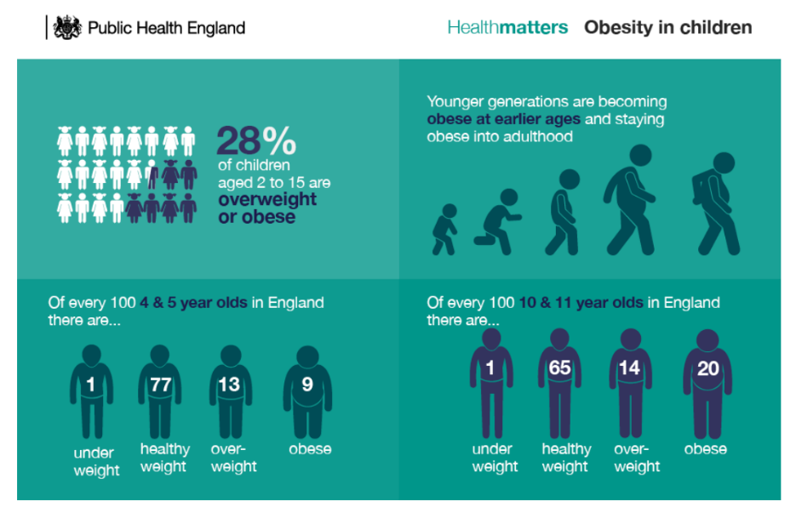 (Public Health England, 2017)
The Best Start for Life evolved when the healthier family’s strategy was not as impactful as desired at adapting behaviors of the young. (Department for Education, 2022) The programme focuses on 6 areas of action to gain a higher success rate for overall child wellbeing.
- Families receive smooth and connected support from the start of their child's conception. Instead of educating after the child after birth help create healthy family behaviours for the child to be born into.
- A family hub welcoming centre where families can access services for their children's development. Developing trust in communities with families being supported within their community by their community.
- Providing crucial information to families in need. In digital, virtual, and telephone services format. Ensuring all communication formats are accessible as n two family setups ate the same.
- Creating a stronger team of professionals to support and help families adapt to new challenges and requirements. Using support workers and community leaders to strengthen teams.
- Continuously improves the Start for Life program through enhanced data, evaluations, results, and inspections. Always ensure the people have access to the services they need.
- Leadership driving positive change in our communities.
According to National Institute for Health and Care Research (2022), the OHID gave £10m to invest in trials to test innovative early years workforce models. However, the investment of incorporating a 'skill mix', was rolled out in only 75 of the UK’s 317 local authorities limiting its impact on a vast number of children (Department of Health and Social Care and Department for Education, 2023).
This programme disregards the aim is to build an evidence base that informs decision-making around commissioning effective early years workforce and supporting families as it only has a limited number of participants. Start for Life programme, 1001 days users showed improved outcomes for all (NHS, 2023). As a segment of the better health strategy, this pushes success towards achieving target 3.8.
Should this be rolled out within all 317 local authorities for bigger evidence base result?
This programme guides parents in ensuring a bright future for babies from conception to age two (Better Health NHS, 2023b). The first 1,001 days of a baby's life are crucial for their long-term wellbeing (Department of Health, 2014). The vision is that the mental and physical aspects of the child starting from conception are guided in a way to ensure that behaviours taught through supporting the family continue long after the 1001 days (Department of Health and Social Care, 2021). This in turn improves societal health outcomes for longevity.

Target 3.4
Target 3.4 highlights promoting mental health.
Mental health is a crucial aspect of humanity within wellbeing. Mind UK (2020) articulate 25% of individuals will develop a mental health condition in their lifetime. The number of people with these conditions is expected to rise as populations and life expectancies increase.
People with mental health conditions and disabilities face challenges regarding their rights. The Human Rights Council says mental health systems worldwide are in crisis United Nations (2017), they confirm there is evidence of violations of various rights common in mental health services. Mental health remains neglected and underfunded.

Strategies relating to SDG 3 target 3.4.
The Five Year Forward View for Mental Health (FyFV-MH) was published in 2016 with a 6-part strategy to improve mental health in the UK over 5 years. However, this strategy didn't cover everything. NHS England (2016) within its roll out literature excluded mental health services for severely affected adults, treatment for older individuals, incarcerated citizens and early years support for children under five.
As awareness increases, more people seek professional support. Despite progress, according to NHS, (2020) racial disparities, insufficient mental health support for learning disabilities and autism, and a youth mental health crisis persist. People with physical health conditions struggle to access mental health support. The FyFV-MH recommendations on housing, welfare, and justice have lagged compared to those for health service.
To improve and progress the failings of this strategy and to work towards attaining the SDG 3, a new strategy was introduced by Department for International Development and Foreign and Commonwealth Office (2020b). “An Approach and Theory of Change to Mental Health and Psychosocial Support”. It was published to improve mental health and wellbeing services in the battle to help achieve target 3.4 for goal 3 in the United Nations SDG in the UK.
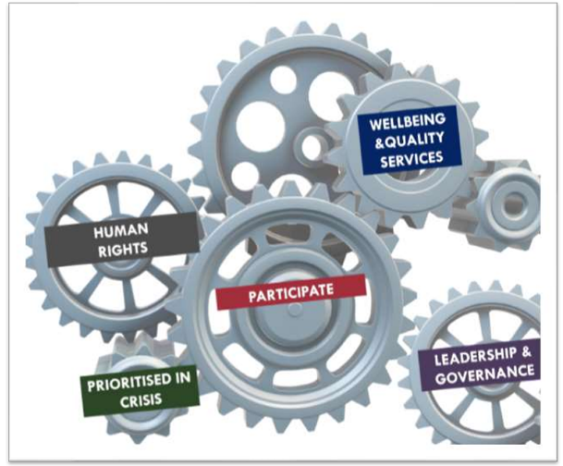
The new visions theory of Change explains five important areas of results that are necessary for achieving the goal of improving mental health for everyone.
(Department for International Development and Foreign & Commonwealth Office, 2020a)

This image depicts how each cog/area in turn helps to provide a more successful service.
Evidence shows this change has improved the success of access to the HNS services.
Improvement for access for all regardless of protected characteristics such as ethnicity and age are evident below.
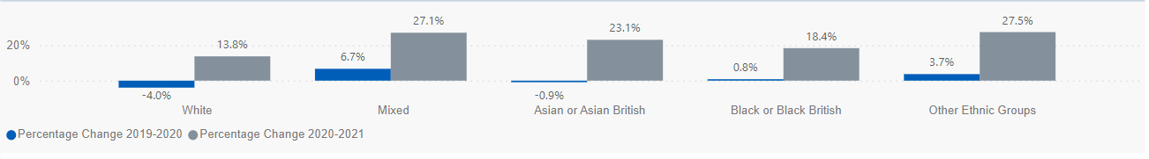
(Baker and Kirk-Wade, 2023a)
This percentage increase graph of service access per ethnicity shows a increase of non-whites percentage change for access to the service.

As below the percentage of service accessed for under 18’s increased significantly.
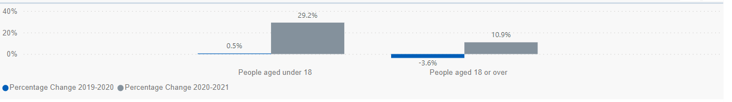
(Baker and Kirk-Wade, 2023b)
Showing that access issues may have been addressed in the change of approach. These major steps implemented show that the UK has a proactive desire to implement target 3.4 and is working towards its overall achievement of SDG 3 to ensure Health and Wellbeing for all.

Challenges: SDG 3
Goal 3 in its essence is a never-ending agenda as presented in healthcare in the UK. It has many impacts on other goals, but other goals also impact many aspects of wellbeing. Finance is the biggest challenges to attain high population levels of health and wellbeing in the UK. As supported by Bond (2022b) we need to ‘Urgently return to the 0.7% commitment and reinstate financial commitments to global health’ to reduce the gap of where we are and where we want to be.
The greater global community levels of wellbeing will also have a major impact on health within the UK. We need to share a global health plan with everyone, including people who have experienced health inequalities in poorer countries as WHO (2018) suggests if they are unable to improve their health systems the goal cannot be achieved collectively.

Recommendations
The UK and other developed countries need to support UHC with knowledge, training, and affordability of products to reduce negative trends in health and wellbeing. As per WHO (2022b) this act will help close the gap in underdeveloped countries making global achievement of SDG 3 easier. As governments also want to help increase their economy the challenge to this recommendation WHO (2023a) say is ensuring governments are aware of the impact assistance has on long term goals and not fixating on short term fixes.

Goal review B

SDG :10 Reduce inequality within and among countries
The SDG 10 pushes to remove discrimination within countries using protected characteristics as reported by Equality and Human Rights Commission (2021). Furthermore, Sustainable Development Goals Data (no date a) states it also attends to disparities among nations and asserts. While securing migration and mobility of individuals.
United Nations (2018) promotes achieving SDG 10 necessitates the incorporation of measures aimed at diminishing inequalities and guaranteeing that no individuals are excluded from the benefits of development. The issue of inequality, both within and among nations, remains a continuous source of apprehension.
United Nation Development Programme (no date) reports Income inequality is increasing with the top 10% holding up to 52% of global income, while the bottom 10% only earn between 8.5% as of 2021.
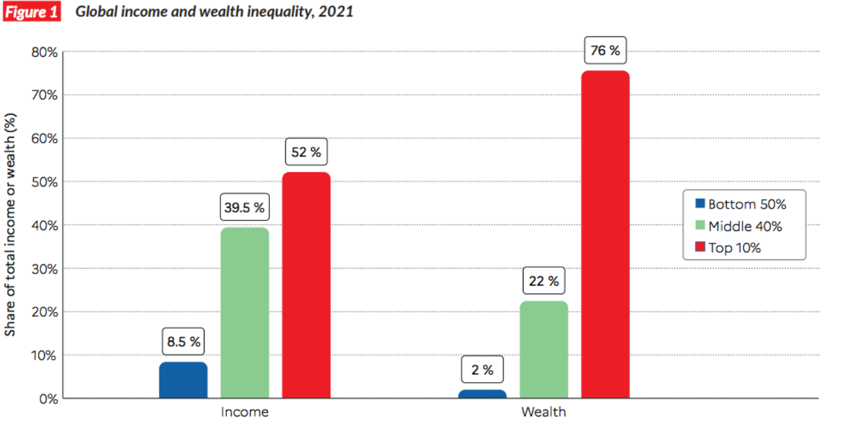(Myers, 2021)
If we consider population growth inequality in developing countries, inequality has increased further since.
Income inequality needs global solutions. Bourguignon (2018) and the international monetary fund believe, this means enhancing financial market regulation, monitoring, and promoting investment in needy regions, significant redistribution of wealth & income. By promoting safe migration and mobility this can also help in bridging the gap.
Its an imperative goal to achieve wellbeing, health and sustainable development and it is crucial to ensure that individuals are not subjected to marginalization when it comes to accessing opportunities that can improve their overall quality of life. SDG 10 has 7 targets to help push for success.

Target 3 ‘Ensure equal opportunity and reduce inequalities’.
Promoting and upholding the principle of equality is an essential obligation bestowed upon any governmental entity. Accountability which the United Kingdom can claim with a sense of accomplishment given its historical record on the matter. The UK has a collection of legislations pertaining to equality. This includes the earliest enactment of the Race Relations Act in 1965, followed by the Equal Pay Act in 1970, and subsequently the implementation of civil partnerships. In the UK Human rights are a main aspect in policy implementation.

Strategy relating to SDG 10 target 10.3.
A fairer Britain strategy 2010, Is Britain fairer 2015, and Is Britain fairer 2018.
HM Government (2010) states ‘this strategy focuses on two principles of equality: equal treatment and equal opportunity’.
The joint agreement signifying the commitment of the government to collaboratively address the impediments to social mobility and equal opportunities within the British society, with an aim to construct a more equitable society.
Across six areas, education, health, justice, living standards, community participation and work have the updated strategy been assessed.
However, among the 2 reviews on this strategy 2015 and 2018 UK Data (2021) highlight two health concerns presented itself in both reviews, showing such as arears for development.
Waiting and referral times and access to health services for ‘at-risk’ groups and disabled people with a range of impairment types, and the prevalence of illness in English and Welsh prisons, particularly mental health conditions.
Unfortunately, the House of Commons (2021) report the Ministry of Justice admitted limited knowledge of mental illness in prisons due to the absence of NHS indicators on performance. Reichert and Jacobs (2018) conclude that the delayed intervention of health services have negative impact on patient outcomes.

Target 10.7
Sustainable Development Goals Data (no date b) explains target 7 for SDG 10 is the facilitation of orderly, safe, regular and responsible migration and mobility of people, including through the implementation of planned and well-managed migration policies.

Strategy relating to SDG 10 target 10.7.
EU settlement scheme.
Sumption and Fernández-Reino (2020) state the purpose of the EU settlement scheme is to provide an option for EU, non-EU EEA, and Swiss individuals residing in the UK prior to the conclusion of Brexit and their eligible relatives to secure their stay in the UK once the transition period is over.
Citizen Advice (2021) goes on to say immigration permission is a pathway to a potential settlement, yet it is not mandatory to pursue settlement through this permission.
However, the scheme deadline for applicants to apply and was driven by Brexit. All who applied to remain where given one of three settlement status. As per the chart Romanian applicants held the greatest number.

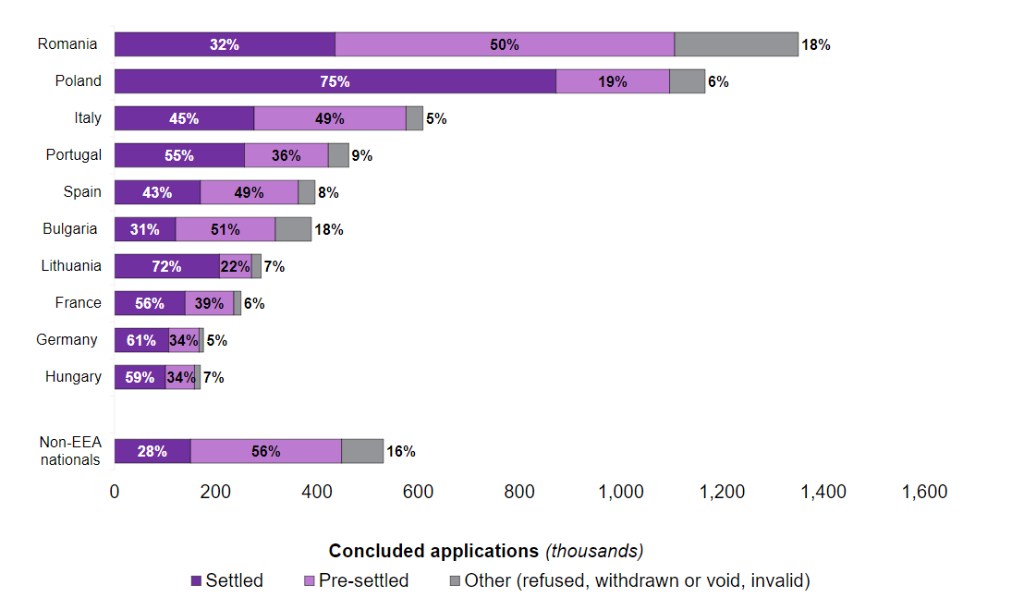
(Home Office, 2023a)

Pre-settled status was given to those who had spent more than 120 days out of the UK in the 5 years leading up to the application. Unfortunately, this means those individuals will have to reapply for full settlement after 5 years of full residency. Duplicating workloads within an already pressured home office system.
The other negative aspect of this scheme as stipulated by Gov.UK, (2019) all applicants will need to neutralise to become British citizenship to prevent limitation of time allowed outside the country (Gov.UK, no date). All processes and financial cost regarding this second tier of the scheme are the individuals responsibility. Home office (2023b) confirms it costs £1,330 to apply. This limitation on movement for fear of the loss of residency is counterproductive. In the long run, this impact may possibly cause wellbeing concerns.

Challenges: SDG 10
As identified by House of Commons (2018) in a prisoner health review, Prisoners can experience mental health issues at any time during their sentence, but systematic assessment only occurs at reception. Under-reporting and mis-recording continue to be significant concerns.
British Medical Association (2022) In contrast support that mental health professional numbers have not increased much within the last decade but demand for mental health services has increased. Leaving a stretched services creating longer waiting times.

Recommendations
Primary recommendation to help progress towards SDG 10 within the UK as supported by findings of Hutchings and Davies (2021), is implementation of a robust and regular interval wellbeing check-up services for all inmates within the UK prison services. Although the challenge for this recommendation, as among the general population, is the limited amount of health and social care professionals currently available to us within the NHS. However, it will help to reduce the disparity of health services available for prisoners who are still a part of the UK population.
Although a regular recommendation, the need for more health and social care staff within the NHS as supported by Amanda Pritchard, NHS chief executive (NHS England, 2023), will help to reduce workloads and backlogs and a necessity recommendation for improvement on the trajectory towards 2030 agenda. This recommendation however does present within the existing realms of low staffing levels nevertheless it is still valid for assistance towards improvement.

Conclusion
By adhering to the principles of sustainable development, it is possible to attain a state of balance within the ecosystem, which enables nature to proceed along its innate trajectory.
According to the Department of Economic and Social Affairs (2020), Overall global progress is under threat due to the discrepancies among different groups of individuals, Piwowar-Sulej, (2021) speculates some economies have been stripped by other leaving a lack of resources and now require a wider community assistance to attain sustainable development. The importance of healthcare professions ability to prioritizing wellbeing, mental health, and varied approaches to thinking, communicating, and working are fundamental aspects of our comprehensive equality objectives.
Leaders need to foster an inclusive culture that facilitates the use of united goals with the use of government policies to support all individuals globally are the steps needed to attain agenda 2030.

Reference list
Arushanyan, Y., Ekener, E. and Moberg, Å. (2017) ‘Sustainability Assessment Framework for Scenarios – SAFS’, Environmental Impact Assessment Review, 63, pp. 23–34. Available at: https://doi.org/10.1016/j.eiar.2016.11.001.
Baker, C. and Kirk-Wade, E. (2023a) ‘Mental Health statistics: prevalence, Services and Funding in England’, commonslibrary.parliament.uk [Preprint]. Available at: https://commonslibrary.parliament.uk/research-briefings/sn06988/ (Accessed: 25 July 2023).
Baker, C. and Kirk-Wade, E. (2023b) ‘Mental Health statistics: prevalence, Services and Funding in England’, commonslibrary.parliament.uk [Preprint]. Available at: https://commonslibrary.parliament.uk/research-briefings/sn06988/ (Accessed: 25 July 2023).
Better Health NHS (2022) Healthier Families - Home, nhs.uk. Available at: https://www.nhs.uk/healthier-families/ (Accessed: 25 July 2023).
Better Health NHS (2023a) Information for Healthcare and Childcare Professionals - Start for Life, nhs.uk. Available at: https://www.nhs.uk/start-for-life/healthcare-and-childcare-professionals/#:~:text=Start%20for%20Life%20is%20part (Accessed: 25 July 2023).
Better Health NHS (2023b) Information for Healthcare and Childcare Professionals - Start for Life, nhs.uk. Available at: https://www.nhs.uk/start-for-life/healthcare-and-childcare-professionals/ (Accessed: 24 July 2023).
Biermann, F. et al. (2022) ‘Scientific evidence on the political impact of the Sustainable Development Goals’, Nature Sustainability, 5. Available at: https://doi.org/10.1038/s41893-022-00909-5.
Bond (2022a) The UK’s Global Contribution to the Sustainable Development Goals | Bond, Bond | The international development network. Available at: https://www.bond.org.uk/resources/the-uks-global-contribution-to-the-sustainable-development-goals/ (Accessed: 25 July 2023).
Bond (2022b) The UK’s Global Contribution to the Sustainable Development Goals | Bond, Bond | The international development network. Available at: https://www.bond.org.uk/resources/the-uks-global-contribution-to-the-sustainable-development-goals/ (Accessed: 25 July 2023).
Bourguignon, F. (2018) Redistribution of Income and Reducing Economic Inequality - IMF F&D Magazine, IMF. Available at: https://www.imf.org/en/Publications/fandd/issues/2018/03/bourguignon (Accessed: 25 July 2023).
Breuer, A., Janetschek, H. and Malerba, D. (2019) ‘Translating Sustainable Development Goal (SDG) Interdependencies into Policy Advice’, Sustainability, 11(7), p. 2092. Available at: https://doi.org/10.3390/su11072092.
British Medical Association (2022) Mental Health Workforce Report, The British Medical Association is the trade union and professional body for doctors in the UK. Available at: https://www.bma.org.uk/advice-and-support/nhs-delivery-and-workforce/workforce/mental-health-workforce-report (Accessed: 26 July 2023).
Cabinet Office (2021) Implementing the Sustainable Development Goals, GOV.UK. Available at: https://www.gov.uk/government/publications/implementing-the-sustainable-development-goals/implementing-the-sustainable-development-goals--2 (Accessed: 20 July 2023).
CDC Foundation (2023) What Is Public Health? | CDC Foundation, www.cdcfoundation.org. Available at: https://www.cdcfoundation.org/what-public-health#:~:text=Public%20health%20is%20the%20science (Accessed: 23 July 2023).
Centers for Disease Control and Prevention (2018) Well-Being Concepts, Centers for Disease Control and Prevention. Available at: https://www.cdc.gov/hrqol/wellbeing.htm.
Citizen Advice (2021) Check If You Can Get pre-settled Status or Settled Status, Citizens Advice. Available at: https://www.citizensadvice.org.uk/immigration/applying-to-the-eu-settlement-scheme/staying-in-the-uk-if-youre-from-the-eu/ (Accessed: 26 July 2023).
Denoncourt, J. (2019) ‘Companies and UN 2030 Sustainable Development Goal 9 Industry, Innovation and Infrastructure’, Journal of Corporate Law Studies, 20(1), pp. 1–37. Available at: https://doi.org/10.1080/14735970.2019.1652027.
Department for Education (2022) Infants, children and families to benefit from boost in support, GOV.UK. Available at: https://www.gov.uk/government/news/infants-children-and-families-to-benefit-from-boost-in-support (Accessed: 24 July 2023).
Department for International Development and Foreign & Commonwealth Office (2020a) ‘An Approach and Theory of Change to Mental Health and Psychosocial Support’, GOV.UK, 19 August. Available at: https://www.gov.uk/government/publications/an-approach-and-theory-of-change-to-mental-health-and-psychosocial-support (Accessed: 25 July 2023).
Department for International Development and Foreign & Commonwealth Office (2020b) ‘An Approach and Theory of Change to Mental Health and Psychosocial Support’, GOV.UK, August. Available at: https://www.gov.uk/government/publications/an-approach-and-theory-of-change-to-mental-health-and-psychosocial-support (Accessed: 16 July 2022).
Department of Economic and Social Affairs (2020) INEQUALITY IN a RAPIDLY CHANGING WORLD. United Nations. Available at: https://desapublications.un.org/file/558/download (Accessed: 20 July 2023).
Department of Health (2014) Wellbeing Why It Matters to Health Policy Health Is the Top Thing People Say Matters to Their Wellbeing. Department of Health, p. 6. Available at: https://assets.publishing.service.gov.uk/government/uploads/system/uploads/attachment_data/file/277566/Narrative__January_2014_.pdf (Accessed: 14 July 2023).
Department of Health and Social Care (2021) The Best Start for life: a Vision for the 1,001 Critical Days, GOV.UK. Available at: https://www.gov.uk/government/publications/the-best-start-for-life-a-vision-for-the-1001-critical-days (Accessed: 25 July 2023).
Department of Health and Social Care and Department for Education (2023) Family Hubs and Start for Life Programme, GOV.UK. Available at: https://www.gov.uk/government/collections/family-hubs-and-start-for-life-programme (Accessed: 24 July 2023).
Equality and Human Rights Commission (2021) Protected Characteristics, Equalityhumanrights.com. Equality and Human Rights Commission. Available at: https://www.equalityhumanrights.com/en/equality-act/protected-characteristics (Accessed: 26 July 2023).
FAO, IFAD, UNICEF, WFP and WHO (2020) The State of Food Security and Nutrition in the World 2020. FAO, IFAD, UNICEF, WFP and WHO. Available at: https://doi.org/10.4060/ca9692en.
Foley, H., Bogue, J. and Onakuse, S. (2016) ‘New Conceptual Framework for Sustainability’, Irish Studies in International Affairs, 27(1), pp. 1–19. Available at: https://doi.org/10.3318/isia.2016.27.11.
Folke, C. et al. (2016) ‘Social-ecological Resilience and biosphere-based Sustainability Science’, Ecology and Society, 21(3). Available at: https://doi.org/10.5751/es-08748-210341.
Gielen, D. et al. (2019) ‘The Role of Renewable Energy in the Global Energy Transformation’, Energy Strategy Reviews, 24(24), pp. 38–50. Available at: https://doi.org/10.1016/j.esr.2019.01.006.
Global Wellbeing Initiative (no date) Our Approach, Global Wellbeing Initiative. Available at: https://www.globalwellbeinginitiative.org/our-approach (Accessed: 23 July 2023).
Gov.UK (no date) Apply for Citizenship If You Have Indefinite Leave to Remain or ‘settled status’, GOV.UK. Available at: https://www.gov.uk/apply-citizenship-indefinite-leave-to-remain/after-youve-applied#:~:text=You (Accessed: 26 July 2023).
Gov.UK (2019) British Citizenship - GOV.UK, Www.gov.uk. Available at: https://www.gov.uk/browse/citizenship/citizenship (Accessed: 26 July 2023).
Health Education England (no date) Step Into The NHS :: About the NHS, www.stepintothenhs.nhs.uk. Available at: https://www.stepintothenhs.nhs.uk/about-the-nhs#:~:text=The%20NHS%20was%20set%20up.
HM Government (2010) The Equality Strategy - Building a Fairer Britain Large Print Version. Available at: https://assets.publishing.service.gov.uk/government/uploads/system/uploads/attachment_data/file/85301/equality-strategy-large-print.pdf (Accessed: 26 July 2023).
HM Treasury (2021) Build Back Better: Our Plan for Growth (HTML), GOV.UK. Available at: https://www.gov.uk/government/publications/build-back-better-our-plan-for-growth/build-back-better-our-plan-for-growth-html (Accessed: 20 July 2023).
Home Office (2023a) EU Settlement Scheme Quarterly statistics, December 2022, GOV.UK. Available at: https://www.gov.uk/government/statistics/eu-settlement-scheme-quarterly-statistics-december-2022/eu-settlement-scheme-quarterly-statistics-december-2022#:~:text=4.- (Accessed: 26 July 2023).
Home Office (2023b) Home Office Immigration and Nationality fees: 13 April 2023, GOV.UK. Available at: https://www.gov.uk/government/publications/visa-regulations-revised-table/home-office-immigration-and-nationality-fees-13-april-2023#other-applications-made-in-the-uk (Accessed: 26 July 2023).
House of Commons (2018) House of Commons Health and Social Care Committee Prison Health Twelfth Report of Session 2017-19 Report, Together with Formal Minutes Relating to the Report. Available at: https://publications.parliament.uk/pa/cm201719/cmselect/cmhealth/963/963.pdf (Accessed: 27 July 2023).
House of Commons (2021) Mental Health in Prison Fifth Report of Session 2021-22 Report, Together with Formal Minutes Relating to the Report. Available at: https://committees.parliament.uk/publications/7455/documents/78054/default/ (Accessed: 26 July 2023).
Hutchings, R. and Davies, M. (2021) ‘How Prison Health Care in England Works’, Nuffield Trust, 20 October. Available at: https://www.nuffieldtrust.org.uk/resource/prison-health-care-in-england (Accessed: 26 July 2023).
International Institute for Sustainable Development (no date) Sustainable Development, International Institute for Sustainable Development. Available at: https://www.iisd.org/mission-and-goals/sustainable-development#:~:text=What%20is%20sustainable%20development%3F (Accessed: 14 July 2023).
Joint SDG fund (no date) Goal 15: Life on Land, Goal 15: Life on Land | Joint SDG Fund. Available at: https://www.jointsdgfund.org/sustainable-development-goals/goal-15-life-land (Accessed: 24 July 2023).
Kaltenborn, M., Krajewski, M. and Kuhn, H. (2020) Interdisciplinary Studies in Human Rights 5 Sustainable Development Goals and Human Rights. Available at: https://library.oapen.org/bitstream/handle/20.500.12657/22942/1007219.pdf?sequence=1#page=106 (Accessed: 24 July 2023).
Kapoor, A. and Debroy, B. (2019) GDP Is Not a Measure of Human Well-Being, Harvard Business Review. Harvard Business Review. Available at: https://hbr.org/2019/10/gdp-is-not-a-measure-of-human-well-being.
Kivits, J., Ricci, L. and Minary, L. (2019) ‘Interdisciplinary Research in Public health: the “why” and the “how”’, Journal of Epidemiology and Community Health, 73(12), pp. 1061–1062. Available at: https://doi.org/10.1136/jech-2019-212511.
Lemke, C. (2021) ‘Conceptual Framework of Sustainable Development’, Sustainable Management, Wertschöpfung Und Effizienz, pp. 9–39. Available at: https://doi.org/10.1007/978-3-658-33246-4_2.
Mehlmann-Wicks, J. (2022) COVID-19: Impact of the Pandemic on Healthcare Delivery, The British Medical Association Is the Trade Union and Professional Body for Doctors in the UK. Available at: https://www.bma.org.uk/advice-and-support/covid-19/what-the-bma-is-doing/covid-19-impact-of-the-pandemic-on-healthcare-delivery#:~:text=Health%20services%20across%20the%20UK (Accessed: 20 July 2023).
Mind UK (2020) How Common Are Mental Health problems? , Mind.org.uk. Mind. Available at: https://www.mind.org.uk/information-support/types-of-mental-health-problems/statistics-and-facts-about-mental-health/how-common-are-mental-health-problems/ (Accessed: 24 July 2023).
Modi, N. (2022a) Valuing health: Why Prioritising Population Health Is Essential to Prosperity, The British Medical Association Is the Trade Union and Professional Body for Doctors in the UK. Available at: https://www.bma.org.uk/what-we-do/population-health/addressing-social-determinants-that-influence-health/valuing-health-why-prioritising-population-health-is-essential-to-prosperity (Accessed: 23 July 2023).
Modi, N. (2022b) Valuing health: Why Prioritising Population Health Is Essential to Prosperity, The British Medical Association Is the Trade Union and Professional Body for Doctors in the UK. Available at: https://www.bma.org.uk/what-we-do/population-health/addressing-social-determinants-that-influence-health/valuing-health-why-prioritising-population-health-is-essential-to-prosperity (Accessed: 26 July 2023).
Myers, J. (2021) These Charts Show the Growing Gap between the world’s Richest and Poorest, World Economic Forum. Available at: https://www.weforum.org/agenda/2021/12/global-income-inequality-gap-report-rich-poor/ (Accessed: 26 July 2023).
National Institute for Health and Care Research (2022) Policy Research Programme - Evaluation of Trials to Test Innovative Early Years Workforce Models, www.nihr.ac.uk. Available at: https://www.nihr.ac.uk/documents/policy-research-programme-evaluation-of-trials-to-test-innovative-early-years-workforce-models/31368 (Accessed: 25 July 2023).
Negru, M. (2021) How to Create a Sustainable Behaviour Change in Your Life and Work, 2030.Builders. Available at: https://2030.builders/how-to-create-sustainable-behaviour-change-in-your-life-and-work/ (Accessed: 21 July 2023).
NHS (2020) Mental Health of Children and Young People in England, 2020: Wave 1 follow up to the 2017 survey, NHS Digital. Available at: https://digital.nhs.uk/data-and-information/publications/statistical/mental-health-of-children-and-young-people-in-england/2020-wave-1-follow-up (Accessed: 25 July 2023).
NHS (2023) Start for Life Home, nhs.uk. Available at: https://www.nhs.uk/start-for-life/ (Accessed: 25 July 2023).
NHS England (2016) The Five Year Forward View for Mental Health. Available at: https://www.england.nhs.uk/wp-content/uploads/2016/02/Mental-Health-Taskforce-FYFV-final.pdf (Accessed: 25 July 2023).
NHS England (2023) NHS England» Record Recruitment and Reform to Boost Patient Care under First NHS Long Term Workforce Plan, www.england.nhs.uk. Available at: https://www.england.nhs.uk/2023/06/record-recruitment-and-reform-to-boost-patient-care-under-first-nhs-long-term-workforce-plan/ (Accessed: 26 July 2023).
NSMC (no date) Change4Life | the NSMC, www.thensmc.com. Available at: https://www.thensmc.com/resources/showcase/change4life#:~:text=Change4Life%20exceeded%20all%20of%20its (Accessed: 24 July 2023).
OECD (no date) About the OECD - OECD, www.oecd.org. Available at: https://www.oecd.org/about/#:~:text=The%20Organisation%20for%20Economic%20Co (Accessed: 14 July 2023).
Office for Health Improvement and Disparities (2022) Important Findings so Far, GOV.UK. Available at: https://www.gov.uk/government/publications/covid-19-mental-health-and-wellbeing-surveillance-report/2-important-findings-so-far (Accessed: 20 July 2023).
Office for Health Improvements and Disparities (2023) NHS entitlements: Migrant Health Guide, GOV.UK. Available at: https://www.gov.uk/guidance/nhs-entitlements-migrant-health-guide#:~:text=Hospital%20treatment%20is%20free%20of (Accessed: 20 July 2023).
Oliveira‐Duarte, L. et al. (2021) ‘Innovation Ecosystem Framework Directed to Sustainable Development Goal #17 Partnerships Implementation’, Sustainable Development [Preprint]. Available at: https://doi.org/10.1002/sd.2191.
Open Development Laos (2019) SDG 1 No Poverty | Open Development Laos, Open Development Laos. Available at: https://laos.opendevelopmentmekong.net/topics/sdg-1-no-poverty/#ref-4401-2 (Accessed: 12 July 2023).
Osberg, L. and Sharpe, A. (no date) Comparisons of Trends in GDP and Economic Well-being -the Impact of Social Capital Comparisons of Trends in GDP and Economic Well-being -the Impact of Social Capital 2. Available at: https://www.oecd.org/education/innovation-education/1824740.pdf (Accessed: 25 July 2023).
Piwowar-Sulej, K. (2021) ‘Sustainable Development and National cultures: a Quantitative and Qualitative Analysis of the Research Field’, Environment, Development and Sustainability, 24. Available at: https://doi.org/10.1007/s10668-021-02011-w.
Public Health England (2017) Health matters: Obesity and the Food Environment, GOV.UK. Public Health England . Available at: https://www.gov.uk/government/publications/health-matters-obesity-and-the-food-environment/health-matters-obesity-and-the-food-environment--2 (Accessed: 24 July 2023).
Public Health England (2021) Inclusive and Sustainable economies: Leaving no-one behind, GOV.UK. Available at: https://www.gov.uk/government/publications/inclusive-and-sustainable-economies-leaving-no-one-behind (Accessed: 20 July 2023).
Purvis, B., Mao, Y. and Robinson, D. (2019) ‘Three Pillars of sustainability: in Search of Conceptual Origins’, Sustainability Science, 14(3), pp. 681–695. Available at: https://doi.org/10.1007/s11625-018-0627-5.
Rai, S.M., Brown, B.D. and Ruwanpura, K.N. (2019) ‘SDG 8: Decent Work and Economic Growth – a Gendered Analysis’, World Development, 113(113), pp. 368–380. Available at: https://doi.org/10.1016/j.worlddev.2018.09.006.
Raleigh, V. (2022) What Is Happening to Life Expectancy in England?, The King’s Fund. Available at: https://www.kingsfund.org.uk/publications/whats-happening-life-expectancy-england (Accessed: 20 July 2023).
Reichert, A. and Jacobs, R. (2018) ‘The Impact of Waiting Time on Patient outcomes: Evidence from Early Intervention in Psychosis Services in England’, Health Economics, 27(11), pp. 1772–1787. Available at: https://doi.org/10.1002/hec.3800.
Rigby, E., Hagell, A. and Starbuck, L. (2018) What Do Children and Young People Tell Us about What Supports Their wellbeing? Evidence from Existing Research. Available at: https://ayph.org.uk/wp-content/uploads/2022/02/CYP-views-on-wellbeing-scoping-review.pdf (Accessed: 14 July 2023).
Ruggeri, K. et al. (2020) ‘Well-being Is More than Happiness and Life satisfaction: a Multidimensional Analysis of 21 Countries’, Health and Quality of Life Outcomes, 18(1). Available at: https://doi.org/10.1186/s12955-020-01423-y.
Stoewen, D.L. (2018) ‘Dimensions of wellness: Change Your habits, Change Your Life’, The Canadian Veterinary Journal , 58(8), pp. 861–862. Available at: https://www.ncbi.nlm.nih.gov/pmc/articles/PMC5508938/.
Sumption, M. and Fernández-Reino, M. (2020) Unsettled Status - 2020: Which EU Citizens Are at Risk of Failing to Secure Their Rights after Brexit?, Migration Observatory. Available at: https://migrationobservatory.ox.ac.uk/resources/reports/unsettled-status-2020/.
Sustainable Development Goals Data (no date a) Goal 10 - Reduced inequalities - U.K. Indicators For The Sustainable Development Goals, sdgdata.gov.uk. Available at: https://sdgdata.gov.uk/10/ (Accessed: 26 July 2023).
Sustainable Development Goals Data (no date b) Goal 10 - Reduced inequalities - U.K. Indicators For The Sustainable Development Goals, sdgdata.gov.uk. Available at: https://sdgdata.gov.uk/10/ (Accessed: 26 July 2023).
Team, O.W. in D. (2023) ‘Ensure Healthy Lives and Promote well-being for All at All Ages’, Our World in Data [Preprint]. Available at: https://ourworldindata.org/sdgs/good-health-wellbeing (Accessed: 24 July 2023).
Tenaglia, S. (2022) The Economics of wellbeing: Workplace Mental Health and Productivity, What Works Wellbeing. Available at: https://whatworkswellbeing.org/blog/the-economics-of-wellbeing-workplace-mental-health-and-productivity/#:~:text=High%20wellbeing%20has%20also%20been (Accessed: 25 July 2023).
The Global Goals (2022) Goal 10: Reduced Inequalities, The Global Goals. Available at: https://www.globalgoals.org/goals/10-reduced-inequalities/.
Tortajada, C. (2020) ‘Contributions of Recycled Wastewater to Clean Water and Sanitation Sustainable Development Goals’, Npj Clean Water, 3(1). Available at: https://doi.org/10.1038/s41545-020-0069-3.
UK Data (2021) What do the data tell us about ‘Is Britain Fairer’?, UK Data Service. Available at: https://ukdataservice.ac.uk/case-study/what-do-the-data-tell-us-about-is-britain-fairer/ (Accessed: 26 July 2023).
UNICEF (2022) How Can We Achieve the Sustainable Development Goals for and with children?, www.unicef.org. Available at: https://www.unicef.org/sdgs/how-achieve-sdgs-for-with-children (Accessed: 20 July 2023).
United Nation Development Programme (no date) Sustainable Development Goals | United Nations Development Programme, UNDP. Available at: https://www.undp.org/sustainable-development-goals/reduced-inequalities (Accessed: 25 July 2023).
United Nation Environment Programme (2017) GOAL 13: Climate Action, UNEP - UN Environment Programme. Available at: https://www.unep.org/explore-topics/sustainable-development-goals/why-do-sustainable-development-goals-matter/goal-13 (Accessed: 24 July 2023).
United Nations (2015a) The 17 Sustainable Development Goals, United Nations. United Nations. Available at: https://sdgs.un.org/goals (Accessed: 23 July 2023).
United Nations (2015b) Transforming Our world: the 2030 Agenda for Sustainable Development, United Nations. Available at: https://sdgs.un.org/2030agenda (Accessed: 22 July 2023).
United Nations (2017) World Needs ‘revolution’ in Mental Health Care – UN Rights Expert, OHCHR. Available at: https://www.ohchr.org/en/press-releases/2017/06/world-needs-revolution-mental-health-care-un-rights-expert (Accessed: 25 July 2023).
United Nations (2018) Goal 10: Reduce Inequality within and among Countries, United Nations Sustainable Development. Available at: https://www.un.org/sustainabledevelopment/inequality/ (Accessed: 25 July 2023).
United Nations (2020) Sustainable Development Goals, United Nations Sustainable Development. Available at: https://www.un.org/sustainabledevelopment/sustainable-development-goals/ (Accessed: 23 July 2023).
United Nations (2022a) Goal 3: Ensure Healthy Lives and Promote well-being for All at All Ages, United Nations. United Nations. Available at: https://sdgs.un.org/goals/goal3 (Accessed: 25 July 2023).
United Nations (2022b) Goal 11: Make Cities inclusive, safe, Resilient and Sustainable, United Nations Sustainable Development. United Nations. Available at: https://www.un.org/sustainabledevelopment/cities/.
United Nations (2022c) Oceans, United Nations Sustainable Development. Available at: https://www.un.org/sustainabledevelopment/oceans/#:~:text=Goal%2014%3A%20Conserve%20and%20sustainably (Accessed: 24 July 2023).
United Nations (2022d) Peace, Justice and Strong Institutions - United Nations Sustainable Development, United Nations Sustainable Development. Available at: https://www.un.org/sustainabledevelopment/peace-justice/ (Accessed: 24 July 2023).
United Nations (2023a) Goal 12: Ensure Sustainable Consumption and Production Patterns, United Nations Sustainable Development. United Nations. Available at: https://www.un.org/sustainabledevelopment/sustainable-consumption-production/ (Accessed: 24 July 2023).
United Nations (2023b) The Sustainable Development Agenda, United Nations Sustainable Development. United Nations. Available at: https://www.un.org/sustainabledevelopment/development-agenda/ (Accessed: 14 July 2023).
Unterhalter, E. (2019) ‘The Many Meanings of Quality Education: Politics of Targets and Indicators inSDG4’, Global Policy, 10(S1), pp. 39–51. Available at: https://doi.org/10.1111/1758-5899.12591.
World Health Organisation (2018) Health Inequities and Their Causes, World Health Organization. Available at: https://www.who.int/news-room/facts-in-pictures/detail/health-inequities-and-their-causes (Accessed: 26 July 2023).
World Health Organisation (2022a) Targets of Sustainable Development Goal 3, www.who.int. Available at: https://www.who.int/europe/about-us/our-work/sustainable-development-goals/targets-of-sustainable-development-goal-3 (Accessed: 25 July 2023).
World Health Organisation (2022b) Universal health coverage (UHC), World Health Organization. World Health Organization: WHO. Available at: https://www.who.int/news-room/fact-sheets/detail/universal-health-coverage-(uhc) (Accessed: 25 July 2023).
World Health Organisation (2023a) Collaborating Locally Is Key for Progress Globally Towards health-related SDGs, www.who.int. Available at: https://www.who.int/news/item/03-05-2023-collaborating-locally-is-key-for-progress-globally-towards-health-related-sdgs (Accessed: 25 July 2023).
World Health Organisation (2023b) Constitution of the World Health Organization, World Health Organization. Available at: https://www.who.int/about/governance/constitution (Accessed: 20 July 2023).

