

POLICY BRIEF BY Lynda Peters
November 2022

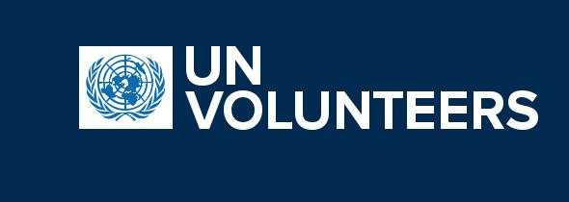

Save afghanisthan girls: their voices deserved to be heard.

Fikrin Bektashi

“Afghan girls want the freedom to dream and the opportunity to achieve those dreams”
(Aaazosh,2021).


The Programmeme is funded by the European Union

_____________________

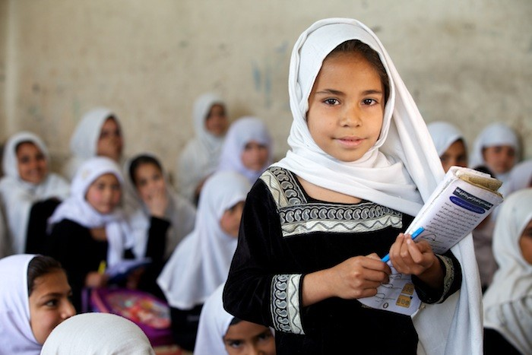
EXECUTIVE SUMMARY

A groundbreaking opportunity to increase educational access for girls in Afghanistan has arisen. The response of the Taliban government and the international community has failed to adequately address the issue of girls’ education which is being oppressed and consequently in jeopardy. This failure to protect the educational rights of these girls who were barred from completing their education following August 15th, 2021 reflects an urgent problem that must be addressed. We must join hands in imploring the Taliban to redress the matter and come to common ground on what are the best measures and policies to be undertaken in the situation. Girls’ re-enrollment must be supported by addressing both preexisting and new barriers which may be preventing them from attending schools, and the Taliban must be held accountable for their promises to reopen schools for girls. This policy brief outlines recommendations about how the international community can collaborate with the Taliban government to respond to the current educational crisis faced by Afghanistan girls.
____________________

INTRODUCTION
Afghanistan became the only country worldwide which prohibits female education after the Taliban leaders closed all female secondary schools in Afghanistan on August 15th, 2021. The Taliban also shut several women’s shelters, dismantled the Ministry for Women’s Affairs, and barred female workers in the department of education from the continuation of their work (BBC News, 2022). These actions have created an existential crisis for their educational prospects. Over 200 days of learning have been lost following this action and the percentage of Afghan girls out of secondary schools has doubled (UNESCO, 2022). In spite of the promise to respect the rights of women, the Taliban’s measures have socially marginalized females and castrate the economic, social, and political participation of women outside the home. According to various women’s rights activists, gender-based violence and forced marriages have increased since the Taliban assumed power (Cone, 2021, Human Rights Watch, 2022). Thus, the actions of the Taliban government have created a negative domino effect and opened the floodgates to a wider system of social oppression for females, one which threatens their safety and undermines the value of their educational rights.

SCOPE OF ISSUE
The loss of education has long-term effects, not only on an individual’s future prospects but on the nation’s prospects as well (Okai, 2021). Girls in Afghanistan have been disproportionately affected because they not only had to deal with COVID-19 but were banned from returning to education following this pandemic by the Taliban government. This means that thousands of girls, particularly adolescent girls, may never have the opportunity to return to school and this effectively limits what they can contribute to society as well as their personal development. Without remedial support, a further 72 thousand children may now fall behind. Unless the Government is held accountable and the international body intervenes and acts quickly, there is a risk of decades of educational progress being lost along with an entire generation.

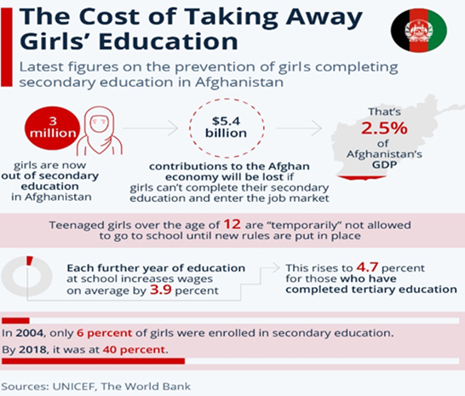
Education is a human right. It’s also a gateway to other rights and is essential for gender equality, and peaceful productive societies. Research over the centuries has shown that educated and empowered females are equally as effective as males in increasing economic growth, improving public health, and environmental sustainability, boosting the workforce, and the reduction of conflict (UNICEF & UNESCO, 2021). The United Nations Development Program (UNDP) estimates that the education of a single Afghan girl generates double the economic benefits to be derived from an educated Afghan boy (UNDP, 2021). Therefore, efforts to support girls’ education in Afghanistan needs to be renewed and redoubled.

Too little, too late?
●●One of the main setbacks in getting the initiative off the ground was that Governments donating to the Afghanistan crisis, compounded the issues by their procrastination. For example: Despite receiving a $280 million donation from the Afghanistan Reconstruction Trust Fund (ARTF) in December of 2021, no set amount from the funds was specifically earmarked/allocated for girls’ education (World Bank, 2022). This was the main source of funding for education and other social services before the Taliban gained power.
●●Additionally, as part of its March 2022 commitment meant to support education and other sectors with a strong focus on girls, the World Bank promised to release 1billon dollars in phases starting with 600 million in 2022. However, this money is yet to be released and project designs and funding allocations are largely vague.
●● As a result of an emergency meeting in December, The Organization of Islamic Cooperation (OIC) agreed to establish a humanitarian trust fund before the end of March 2022. However, it is not clear whether this will support girls’ education or how it will support it (TOLOnews, 2021).
●●Donations came from the European Union (EU), Asian Development Bank, and Indonesia. However, they were insufficient to meet the educational demands that Afghanistan is currently facing as they were too small. This may also indicate that the crisis is being given low priority by the donor community (European Union, 2022).
●●United States and the United Nations Security Council passed sanctions and exemptions obtained to promote humanitarian aid to Afghanistan following the ban on female education (Rose and Pisa, 2022). However, fear of reprisal restricts them from conducting transactions in Afghanistan despite these permissions. Almost 80% of Afghan’s overseas assets under Afghanistan’s central bank, Da Afghanistan Bank (DAB) is held by U.S. financial institutions. The possibility of further delays in getting aid to the female populace became a concern following an executive order redirecting Afghanistan’s assets by U.S. President was issued.
It is important to note that humanitarian aid, though essential, is a short-term solution, and measures geared at reconstructing and developing the economy of Afghanistan need to be enacted in parallel.
●●Many women-led Afghan educational models have been set up and are working to educate women and girls. For example, the SOLA (school of leadership Afghanistan) are female-led boarding school. Another example is the LEARN model which provides access to technological education, resources, professional training, and mentorship for females who don’t have adequate access to formal schooling. However, these need to be expanded.

POLICY RECOMMENDATIONS
Despite the Taliban’s promises to commit to the reopening of schools for girls by late March 2022, there are still concerns (Jazeera, 2022). The mere issuing of an edict to reopen the doors of a physical classroom is not sufficient to ensure that girls return to school in a safe environment conducive to learning. The long-term goal of governments should be to end all violations of the rights of females and this should essentially be a precondition of any recommendation or actions to be taken by the Taliban government and or the international community. I have outlined several major advocacy and policy recommendations that can help to alleviate the problem:
- Create more learning spaces whether physical or virtual: More learning spaces and opportunities for females are necessary. Approximately 80% of the schools in Afghanistan are state-funded which means that educational access for most secondary school girls is restricted. This must be redressed, and females must be given other avenues wherein they can access and attain their educational goals. The necessary applications, facilities, and resources necessary for the flexible delivery of education should be created.

- Provide funding specifically for female education: Budgets need to be regulated and funding made for the provision of female education at a national level. Government should also be forced to stick to these regulations through peaceful protest where they fall short.

- Females should have access to safe, free, and quality education. Unsafe school facilities were cited by the Taliban therefore school sites should be accessible and safe. It should be ensured that girls are safe on their way to school, during school, and on their way from school. This can be monitored through mechanisms set up by Human Rights committees.

- Allow women to participate in politics and the overall governance of the country. Political structures need to be more inclusive/representative, just, democratic, and sustainable. The gendered treatment of males and females is a much deeper problem beyond education. It is a chauvinistic attitude that creates a negative stigma and streams women into the stereotype of inferiority. The current cabinet is not sufficiently representative or inclusive of women and this must be redressed. Laws should be passed which make education for ALL non-negotiable for future governments.

How the international community can become involved:
International Organizations should use their leverage to put pressure on the Taliban by forcing them to accept the education of females as a precondition to being recognized within. Any support for them should be contingent on their obedience to these preconditions.

- Resourcing and Investing in Afghan Teachers: For teachers to continue providing education to children they need a means of livelihood. International bodies can provide funding for teachers in Afghanistan (especially female teachers from rural areas) and establish systems to ensure that they receive such funding.

- Islamic support through media interventions and discussions: Other Islamic countries can host programs that highlight how female rights and education can be balanced within an Islamic framework.

- Offer funding for the education of girls: The World Bank needs to prioritize girls’ secondary education by earmarking funds specifically aimed at targeting female education in forthcoming disbursements. Also, people need to be placed strategically within the committees to help facilitate the flow of aid directly to the formal education system.

- Establish and support Private Schools: The establishment of private schools for females will not only help to reduce the cost to the public sector but also ease the strain for parents from low-income homes.

REFERENCES
Aazosh B. (2021) “My life before and after the Taliban takeover” in Assembly (Malala Fund) Available at: https:// assembly.malala.org/stories/my-life-before-and-after-the-taliban-takeover (Access 5 November 2022).
BBC News (2021) Afghanistan’s Taliban ban long-distance road trips for solo women. https://www. bbc.co.uk/news/world-asia-59800113 (Access 5 November 2022).
Cone, D. (2021) Afghan Women and Girls Under Immediate Threat: The Responsibility to Protect and Assist Is Just Beginning [for Refugees International] https://static1.squarespace.com/static/506c8ea1e4b01d9450dd53f5/t/ (Access 5 November 2022).
European Union (2022) EU supports the education, health and livelihoods of the Afghan people with €268.3 million https://ec.europa.eu/commission/presscorner/detail/en/IP_22_382. (Access 5 November 2022).
Human Rights Watch (2022) report. Taliban Deprive Women of Livelihoods, Identity. https:// www.hrw.org/news/2022/01/18/afghanistan-taliban (Access 6 November 2022).
Jazeera (2022) Taliban says all Afghan girls will be back in school by March https://www.aljazeera.com (Access 5 November 2022).
Okai, A. (UNDP, 2021) Sustaining Development Gains for Afghan Women. Available at: https://www.undp.org/ speeches/sustaining-development-gains-afghan-women (Accessed 5 November 2022).
Rose, S. & Pisa, M. (2022) “Aid Alone Will Not Solve the Humanitarian Crisis in Afghanistan: Exploring ‘All Options Available” in Center for Global Development Available at: https://www.cgdev.org/blog/ (Access 5 November 2022).
Sperling, Gene and Winthrop, Rebecca (2015) What Works in Girls’ Education: Evidence for the World’s Best Investment [ebook] Available at: https://www.brookings.edu/book/what-works-in-girls-educationevidence-for-the-worlds-best-investment/
TOLOnews (2021) Afghan Humanitarian Fund Established by OIC https://tolonews.com/afghanistan-175963 55. (Access 5 November 2022).
UNDP (2021) Socio-Economic Outlook 2021-2022. Averting a basic needs crisis. Available at: https://www.undp.org/publications/afghanistan-socio-economic-outlook-2021-2022 (Access 5 November 2022).
UNICEF UK, UN Convention on the Rights of the Child. Available at: https://www.unicef.org.uk/what-we-do/unconvention-child-rights/ (Accessed 7 November, 2022).
UNICEF & UNESCO (2021) Afghanistan Case Study Situation Analysis on the Education Sector in Asia. Available at: https://www.unicef.org/rosa/media/16466/ (Access 5 November 2022).
World Bank (2022) World Bank Announces Expanded Approach to Supporting the People of Afghanistan https://www.worldbank.org/en/news/press-release/ (Access 5 November 2022).

