Computing Skills for The Workplace (certHE)/BS Cloud Computing
Learning in the digital Error
Assignment 1
Module code ACCA425
Benazir Akhtar-2128771

Q1. How the development skills will support your career after Graduate
There are many skills that help your personal development. Such as:
Communications which is also very important if you find yourself unable to get your point across in certain situations or not understanding people consider on working your communication such as taking part activities group events by taking part such activity which help communications this will improve my understanding other people.
Time management is a very important, being able to manage your time to produce deadlines effectively. Deadlines are important for your professional and personal life. You need to have a balance between your work life and home life and releasing time pressure by completing tasks which can help you avoid unnecessarily which will help myself to be organised.
-Confidence- One of the skills that is also used in social life and professional life, having a positive e thinking about yourself such as strengths which again help you achieve what you can do and prevent an unhealthy mindset
Personal Development
Learning has an impact on our personal and professional development. Keeping a journal or writing blog posts provides opportunities to reflect and engage in ongoing development. How can blogs increase our personal development?
A blog allows you to share your vision and develop your passions as you share your ideas with the world. Writing blog posts helps you reflect on your teaching, learning and/or on your daily activities. Blogs provide you with opportunities to develop critical thinking skills as you evaluate your work and progress. Blogging will transform you into a curator of information. The process will heighten your listening and observation skills and help you gain a better understanding of yourself and others.It can be helpful to conceive of yourself as a product that you are constantly developing with an eye toward the present and future markets for this commodity. Since products can be either goods or services, those in charge of marketing them find that SWOT analysis provides a valuable foundation for formulating their strategy. If you have not used it before, it is incredibly simple to use and comprehend. Strengths are things you already have and might potentially improve upon, or SWOT. You have a weakness, but you could probably lessen it or find another solution. Opportunities that the market presents that you might be able to take advantage of more effectively than others External threats are another thing you need to be aware of and combat.
It can be helpful to conceive of yourself as a product that you are constantly developing with an eye toward the present and future markets for this commodity. goods. services, those in charge of marketing them find that SWOT analysis provides a valuable foundation for formulating their strategy. If you have not used it before, it is incredibly simple to use and comprehend. Strengths are things you already have and might potentially improve upon, or SWOT.
You have a weakness, but you could probably lessen it or find another solution.
- motivation and imagination.
- critical thinking, problem solving, time management.
- teamwork, leadership, and dealing with many cultures.
- values in communication and work ethic.
- digital proficiency research and sleuthing abilities numeracy.

Opportunities that the market presents that you might be able to take advantage of more effectively than others
External threats are another thing you need to be aware of and combat. Which surprised you more, the similarities or variances in employers' views on what a graduate can bring to a position? The professions could be drastically different, and the organization's ideals and beliefs could be significantly different as well.
Q2. An online search was conducted, and the sites that were examined provided recruiters, university advise, as well as some relevant professions, with such a strong thing listed below. I have created an website
https://benazirakhtar38.wixsite.com/benz

Q3: User guide of automated referencing software-
The entry-level reference manager is Zotero. In books and articles, it is intended to store and cite bibliographic references. Each reference in Zotero is considered an item. Zotero is an effective tool for gathering and organising research material and sources since each item carries unique metadata. This includes anything from books, articles, and reports to web pages, films, letters, and sound recordings. The right pane displays the item's metadata, which includes the titles, authors, publishers, page numbers, and other information required to cite the item
There are several automated referencing tools. Such as, Zotero, Mendely and Microsoft Word citation tool. Below you can see a screenshot of MS citation tool.
Open the .dmg you downloaded and drag Zotero to the Applications folder. You can then run Zotero from Spotlight, Launchpad, or the Applications folder and add it to your Dock like any other program.
After installing Zotero, you can eject and delete the .dmg file

Run the setup program you downloaded.

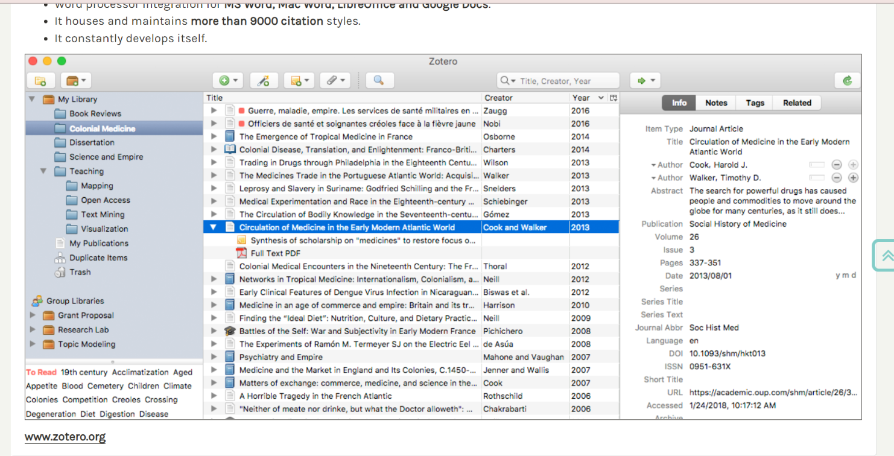

4.Poster – Life is a team ‘Sport becoming a effective team members’
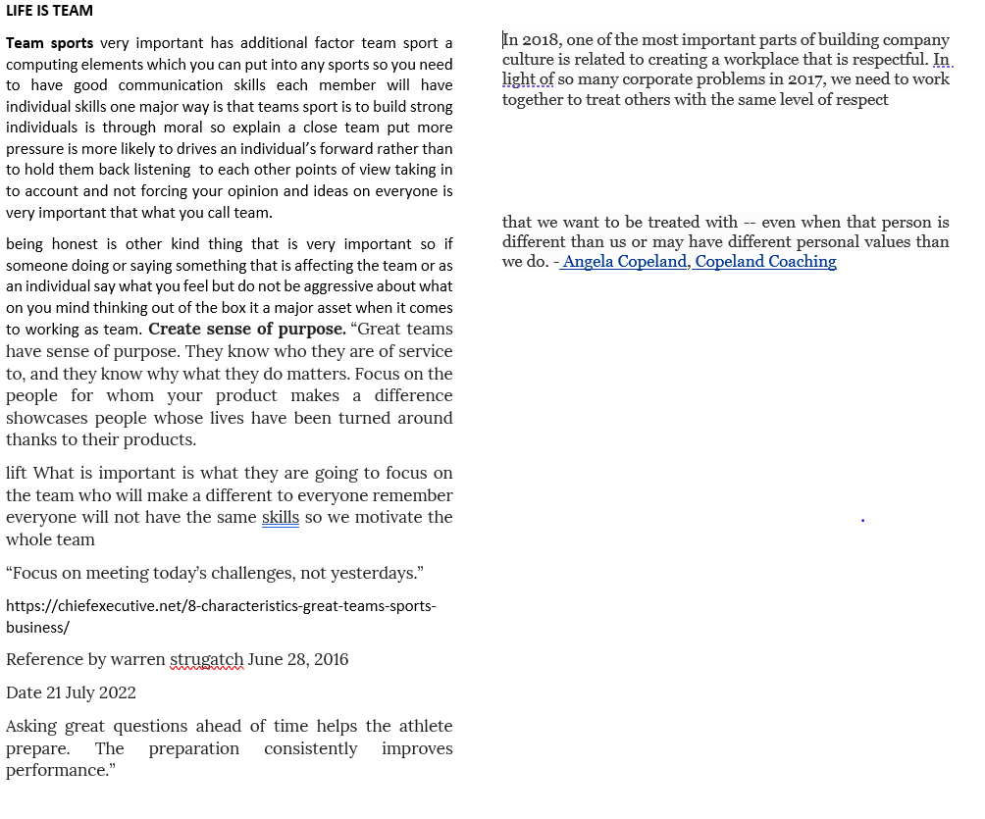

References for Q1
- https://usmc-mccs.org/articles/what-are-personal-development-skills
- https://uk.indeed.com/career-advice/career-development/personal-development
- https://coles.kennesaw.edu/advising/docs/BUSA-4150-The-Personal-SWOT-Analysis.pdf
- Book-study Cameron’s.(2021).The business students handbook: skills for and employment (Seventh edition).Harlow England; Pearson Education, Limited

References for Q3
https://www.zotero.org/support/quick_start_guide

