Samuel Miles (BAE Systems OME Degree Apprentice
2112603@student.uwtsd.ac.uk

Group project portfolio
Rapid Crater Kit

Table of Contents

List of Figures 2

Abstract 3

Introduction 4

Task Brief 5

Group Work 6

Design 9

Manufacturing 13

Design Review Reflection 19

References 20

List of Figures
Figure 1 - mk2 Rapid Crater Kit 3
Figure 2 - Performance figures of mk2 vs Arable Soil 4
Figure 3 - Initial Requirement Set 4
Figure 4 - Results of Pairwise Comparison 5
Figure 5 - Functional Means Analysis (Design) 6
Figure 6 - Beehive crater kit 7
Figure 7 - Comparison of Liners [6] 8
Figure 8 - CAD Design 8
Figure 9 - CAD Final Design 9
Figure 10 - Manufacturing Flow 10
Figure 11 - QFD 1 (Manufacturing) 10
Figure 12 - QFD 1 Results 11
Figure 13 - FMA (Manufacturing) 11
Figure 14 - Image of Case 12
Figure 15 - Flow Forming Diagram [10] 12
Figure 16 - Liner Image 13
Figure 17 - Metal Spinning Diagram [12] 13
Figure 18 - Backplate Image 14
Figure 19 - PBX Mixers (Planetary & RAM) 14
Figure 20 - Munition with Foil Stickers 15

Abstract
This portfolio documents the design of a new insensitive variant of a Rapid Crater Kit. This design process was completed by a team of five engineers who were chosen to complete this urgent operational requirement. The portfolio will focus on the work and contributions made by the Design & Manufacturing engineer who had the role of completing CAD models throughout the design process and working with the systems engineer to develop manufacturing processes using system engineering tools. Throughout the process each member of the team completed both group work and individual. This portfolio will detail the work in the very initial stages, completed as a whole team, and then breakdown the specific work completed by the Design & Manufacturing Engineer.

Introduction
Safety is one of the most important aspects taken into consideration in all industries in the modern world. Safety is particularly important in high hazard industries as an accident could lead to life changing injuries and fatalities. Companies within the defence sector in particular have been researching and developing insensitive munitions (IM) since the early 1970s in an attempt to make munitions safer to handle and store. [1] An insensitive munition is a munition that will reliably reach its performance and operational requirements but minimise the chance of an inadvertent initiation from an external source. [2] A lot of work has been put in throughout the last several decades to overcome the challenges faced when designing IM compliant products. The biggest challenge is meeting the IM requirement while maintaining the performance and keeping the cost at a low. Over the years, many new energetic formulations and techniques have been developed to produce an IM compliant design with most novel munitions having the requirement from the customer to be insensitive. [1]

Task Brief
As part of an urgent operational requirement a customer made the request for an IM compliant variant of a legacy product manufactured last in 2008. The munition that required an update was the mk2 Rapid Crater Kit. The unpackaged kit can be seen in figure 1 below which consists of one pilot charge, two Hexatonal bag charges, two primary charges, shock tube and three detachable legs.
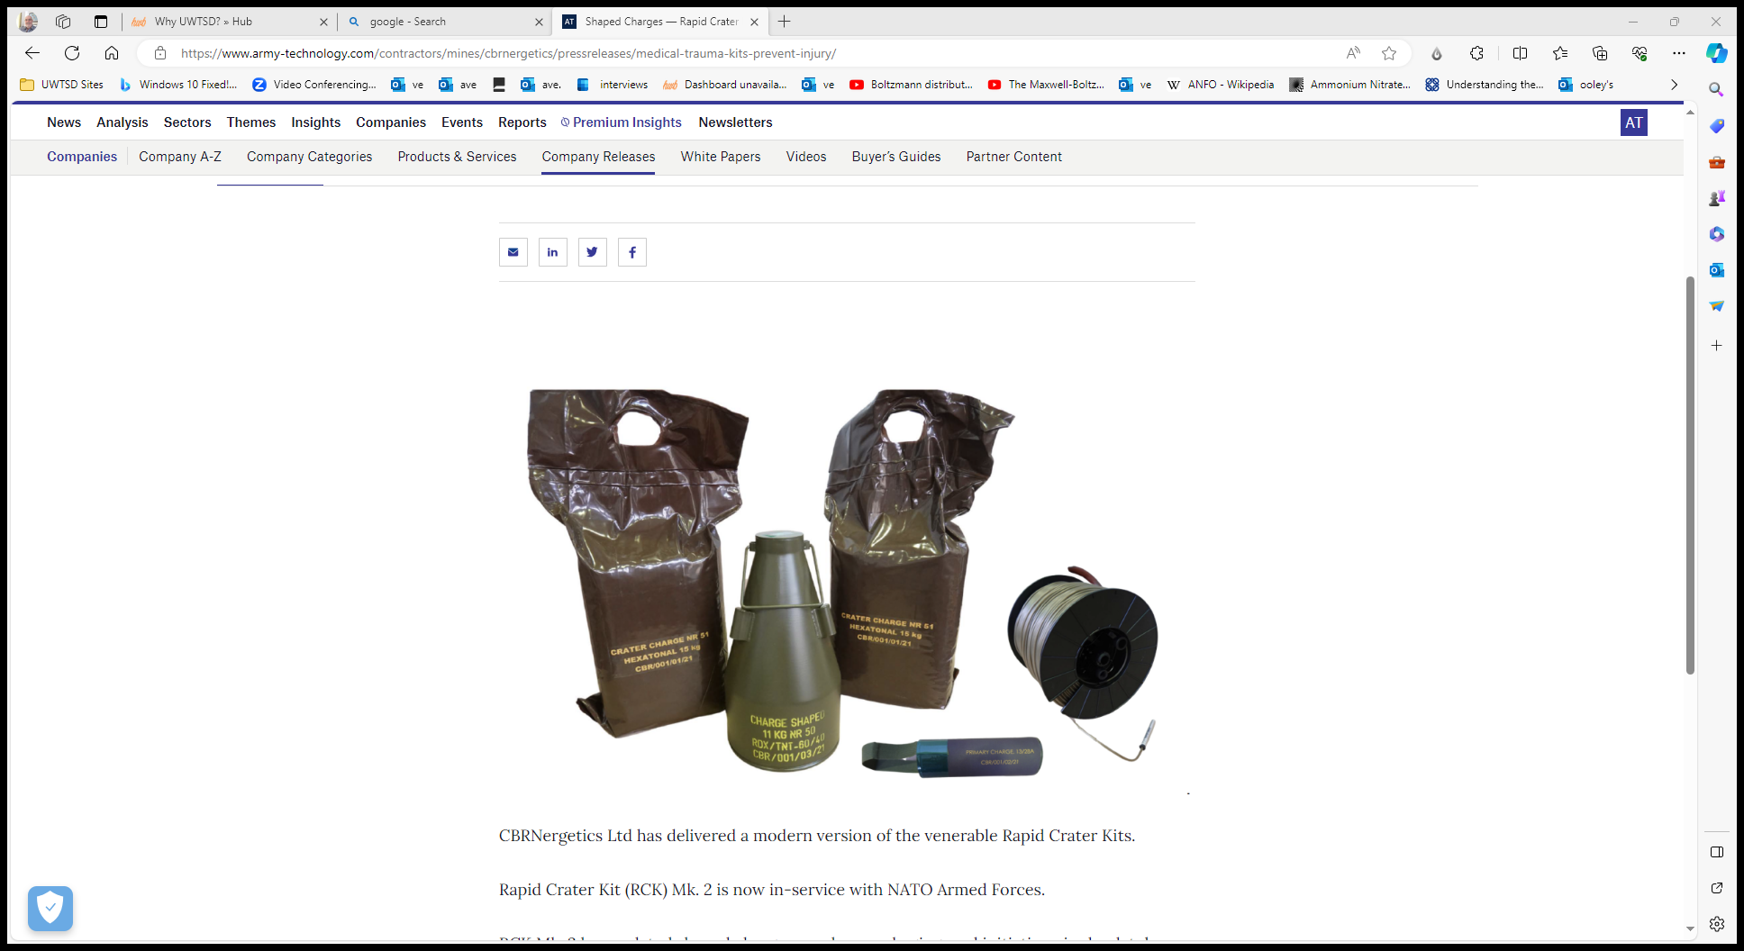
Figure 1 - mk2 Rapid Crater Kit
To successfully fulfil this requirement, a team of five engineers of varying disciplines were put in a team. The information given to the group was that the kit was used in recent conflicts to enable forces to create a defensive position rapidly. The customer wanted the focus of the system to be hot, desert like operation but to have capability for worldwide use. To fit the current transport capability, the customer also requested it to be transportable by all current air and road vehicles. The team were also given some background information of the previous mk2 variant which included previous production information. The crater kit was first manufactured in 1957 at Royal Ordnance Factory (ROF) Chorley using RDX/TNT 60/40 which was produced at ROF Bridgwater. The high explosive (HE) filling used was overspill from the artillery shell filling process which uses the same RDX/TNT. Production then moved to ROF Glascoed in 1995 along with the artillery shell filling still using overspill. With the closure of ROF Bridgwater, the capability of manufacturing RDX/TNT was lost in the UK meaning foreign suppliers needed to be found. Eurenco manufactured explosive was chosen and used to fill artillery shells from 2008 onwards but the production of the crater kit ceased due to poor performance at extreme temperatures and some partial functions. [3]

Group Work
Once the team had been decided and the brief given, the five engineers chose to do individual research to find out as much information as possible about the cratering kit before holding a meeting to compile a list of requirements. Prior to any research the team were slightly confused about how the kit actually worked but through research discovered that the mk2 kit was a two part operation. The first part of the operation being the pilot charge which created a hole roughly 0.4m wide and 2m – 3m deep with a 0.8m stand-off distance created by the legs. This first operation is then followed by the use of the Hexatonal bag charges which are placed in the hole and detonated to increase the crater size up to 9m wide and 3.5m deep. These figures can be seen in the image below which is representative of the mk2 crater kit when used on arable soil. [4]
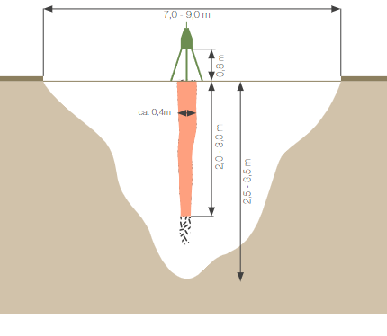
Figure 2 - Performance figures of mk2 vs Arable Soil
The mk2 variant was operational on various ground types which can be seen in the table below.
Ground Type | Approx Penetration Depth (m)
Arable Soil | 3.5
Gravely Soil | 3
Clay | 3
Concrete | 2
Steel | 0.5
Table 1 - Penetration depth of mk2 [4]
It was discovered that the true purpose of a Rapid Cratering Kit was to block important strategic points like runways, highways and main roads. A secondary use for the kit was to create anti-tank trenches in minutes with minimal effort and manual labour from the users.
Once the team had had enough time to complete individual research they held a meeting with the goal to create a list of initial requirements and a pairwise comparison to understand which requirements are most important. Figure 3 is a table showing the requirement set that the team came up with.
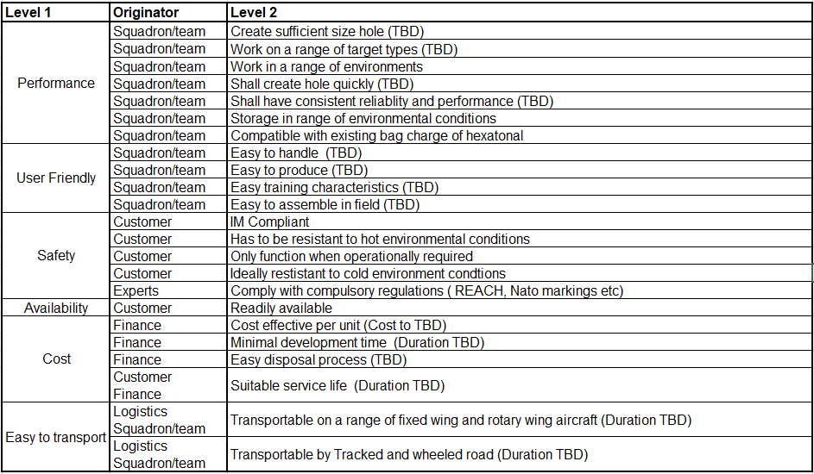
Figure 3 - Initial Requirement Set
A pairwise comparison is the process of comparing a set of options head to head to understand which the most important overall is. The team decided to complete a pairwise comparison on the requirements they come up with to know which to focus on or which to prioritise when designing their mk3 variant.

Figure 4 - Results of Pairwise Comparison
Once the pairwise comparison had been completed the results could be put in a table for simplicity when analysing. Figure 4 above shows the results from the pairwise comparison completed in the meeting. The results being that the most important requirements were to only function when required, create a hole of sufficient size and like the previous variant, work on several ground types. At the end of the meeting, when discussing what the next steps were the team decided to assign roles for each individual to go away and work on themselves. The roles were decided by utilising every member’s strength and making sure every aspect of the process had been covered.
The five roles were:
- Systems & Design Engineer
- Design & Manufacturing Engineer
- Trials Engineer
- Environmental Testing
- Breakdown & Disposal
This report conveys the work completed by the Design & Manufacturing Engineer. The team consisted of two engineers from similar manufacturing backgrounds, two trials/testing engineers and a breakdown & disposal SME (Subject Matter Expert). Due to this, the explosive trials coordinator, environmental testing engineer and Breakdown roles were easily distributed among the team. The two other members however chose to play to strengths and split the duties. The Systems & Design engineer would complete all of the design systems engineering tools while the Design & Manufacturing engineer would complete CAD work and research manufacturing methods.

Design
Once the team had decided roles, all members went away to complete the work needed ready for the next meeting two weeks after the first. The two design engineers organised a separate meeting to complete a Functional Means Analysis (FMA) in order to create an initial design to pitch to the other members of the team. An FMA is a structured technique of selecting system design options. Each function of the system is taken from the functional decomposition, completed by the systems engineer, and given multiple options that could potentially be used to complete the function. [5] Below is the FMA completed by the two design engineers in which multiple options have been considered with the final choices being highlighted in yellow. From completing other system engineering tools further down the process, the systems engineers realised that the original FMA was missing certain functions. This is one of the benefits of system engineering as it brings the missing pieces forward earlier on in the design process when changes are much easier to make. The additional four functions can be seen in figure 5 highlighted in green.
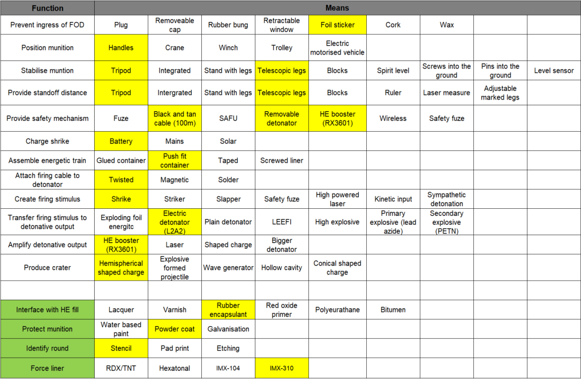
Figure 5 - Functional Means Analysis (Design)
From this FMA, the Design & Manufacturing engineer was then able to create the first initial CAD design to pitch to the other members of the team in the forthcoming meeting. When conducting research, the Deign & Manufacturing engineer looked at information for other types of rapid crater kits and discovered they all had a similar external shape. For example, the beehive charge demolition kit, although has a larger diameter than the current mk2, still has the conical part of the body. Due to this, the decision was made to propose an initial design with a similar body to that of the mk2. The initial design also had a conical shaped charge liner as that was the option initially chosen by the design team when completing the FMA.
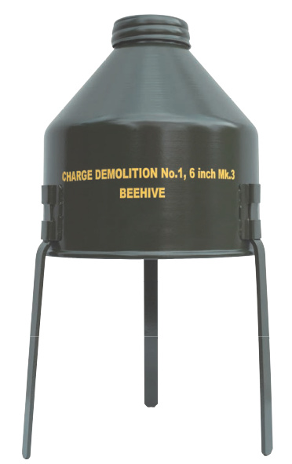
Figure 6 - Beehive crater kit
During the meeting where the team discussed progress, certain points were brought forward from each member’s work. Once the initial design had been pitched, the breakdown and disposal SME brought forward certain design concepts which would ensure that breakdown was as safe and easy as possible. The trials engineer, who was completing the plan for IM testing discovered that for a munition must have certain additions to gain IM compliance. Some of the options available to make a munition IM compliant are vent holes, blow out panels, internal liner or composite materials. As shown in the FMA, a shock absorbent rubber encapsulant was added to interface with the HE fill. The addition of vent holes was the other option which was decided upon with the method of incorporation down to the design team. Also brought up in the meeting was the opportunity to enhance the pilot charge to remove the requirement for the secondary bag charges. Removal of the secondary operation would save vital time when operating the munition but would require major design modifications.
Taking all the points from the meeting with the team, the design team discussed the possible alterations to the design to ensure that everyone’s ideas were incorporated. As shown in figure 2, the mk2 cratering charge created a very thin but deep hole. To remove the requirement for the secondary operation the pilot charge alone would have to create a crater much wider. More research led to the finding that hemispherical liners give a much wider jet than conical shaped charges, as shown in figure 7 [6]. The design engineers’ thinking was if a hemispherical liner was used with an increased charge diameter then a larger crater would be produced. A member of the team suggested the use of an aluminised explosive as they are known to have increased blast effect. The addition of aluminium powder in explosive compounds can release a huge amount heat in the secondary reaction. This therefore increases the detonation heat and volume during detonation giving the explosive a higher work capacity. [7] The addition of the increased blast effect will not only increase the force behind the hemispherical liner but also may act coinciding with the liner to create a bigger crater. Computer simulations would be required to confirm if the idea would be plausible in the real world and produce a crater that would fit the customer’s requirements. If the results of the simulations completed show that it does not meet customer requirements then further development work would be require to produce an IM compliant bag charge to go with the pilot charge. Development process similar to that in this report would be followed to ensure no steps are missed and a successful product is the final outcome.
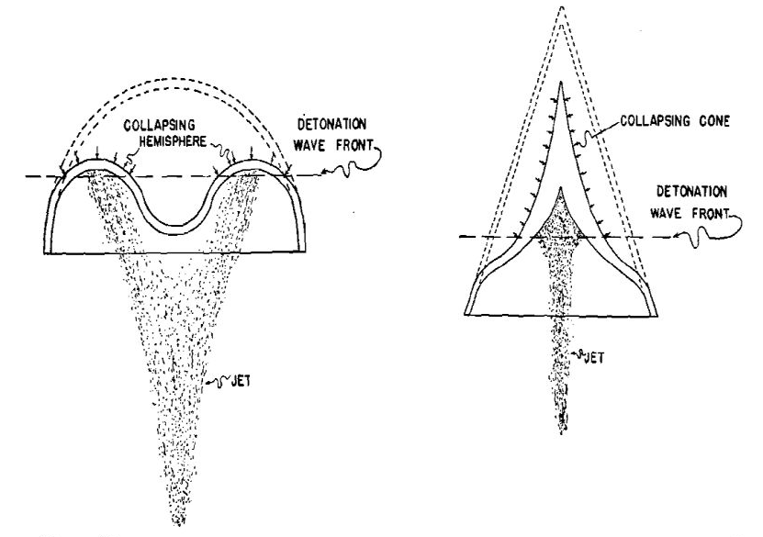
Figure 7 - Comparison of Liners [6]
The Design & Manufacturing engineer had notes full of everyone’s ideas and how they would need to be implemented in the final design. A CAD model, shown in figure 8, was created in order to visualise the team’s ideas and discuss next steps. As shown in the model, the team decided to go for a cylindrical design, removing the conical part seen in most cratering kits. This was to aid the breakdown and disposal of the munition at the end of its life as suggested by the SME. The backplate, which is attached to the body using m4 hexagonal bolts can be removed during breakdown, along with the corresponding bolts attaching the liner. With both sets of these bolts removed, the backplate can be taken off and the fill can be pushed out of the case as the rubber encapsulant is non-stick. Removing the charge without having to section metalwork makes the disposal process a lot safer and reliable.
Creating the CAD design was a vital part of the project not only to gain an understanding of the product being developed but it also enable the design engineer to work out the weight of each part once a material was chosen. This can simply be calculated using the density of the material in question and the volume function in Solidworks. Through this work conducted by the design engineer, it was calculated that the design proposed weighed a total of 34.35kg. Within the initial requirement set that the team generated together was a requirement for the system to be a single person lift. From the calculations completed, it was clear that this requirement was not met. A single person lift is anything up to 20kg so significant design changes would be necessary to meet the requirement.
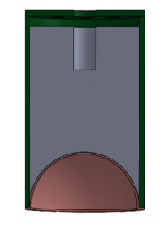
Figure 8 - CAD Design
The design which weighed 34.35kg had a large wall thickness of 14mm which when reduced to 9mm would decrease the weight by 8.3kg. Discussions regarding alternate materials took place for parts such as the back plate but would still not decrease the total weight below 20kg. In order to reach the requirement of a single person lift, the charge diameter and height would need to be decreased which would therefore decrease the crater size produced by the system. Using the pairwise comparison completed early on in the process, it is clear that performance based requirements rank much higher than requirements regarding handling. Due to this reason the design team decided to choose to have the munition a two person lift.
The final design can be seen in figure 9 including two handles to ensure comfort when two operators lifting. Visible in the CAD image below are the vent holes added to aid IM compliance along with a central hole in which the booster assembly can sit in operation. The holes in the back plate will be covered in transport using foil disks, as shown in the FMA, to prevent ingress of foreign objects and debris. To ensure the correct stand-off distance for the system is met every time, three equally distributed telescopic legs are held around the body as shown in the image.
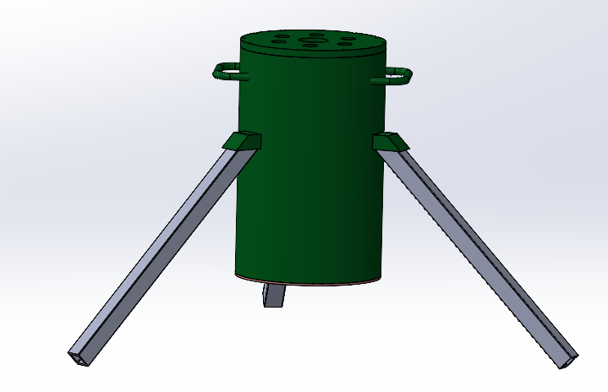
Figure 9 - CAD Final Design

Manufacturing
Before presenting a design to the customer, it is vital to have potential manufacturing plans in place for each part of the product. Before deciding any manufacturing methods, a vital part of the process is creating a flow of the processes without solutionising. This was completed by the manufacturing engineer using the CAD model to visualise all of the potential steps that need a method to create the end munition. Figure 10 is the manufacturing flow for the new mk3 cratering charge design which can be taken into similar system engineering tools as the design stage.
Figure 10 - Manufacturing Flow
As part of the manufacturing system engineering tools a second QFD 1 can be completed to discover the most important manufacturing processes. This was completed by both the system and manufacturing engineers to ensure the correct outcome was found. Manufacturing QFD 1 has the manufacturing requirements on the left hand side and the process along the top, as shown in figure 11.
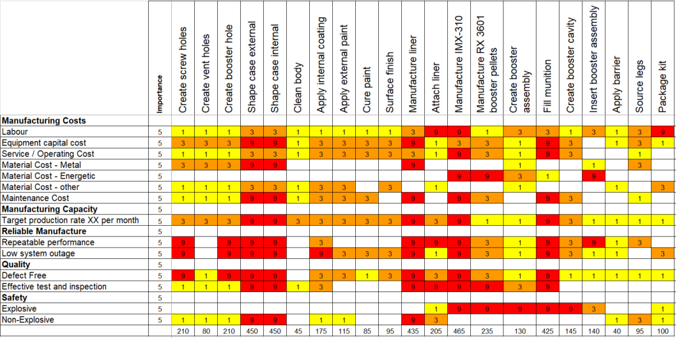
Figure 11 - QFD 1 (Manufacturing)
When completed the results can be shown in a chart. As shown in figure 12, the most important process for the mk3 cratering charge is the manufacture of IMX-310 and the liner. This tool allows the manufacturing engineer to gain an understanding of what processes need more focus on when designing and implementing the process.
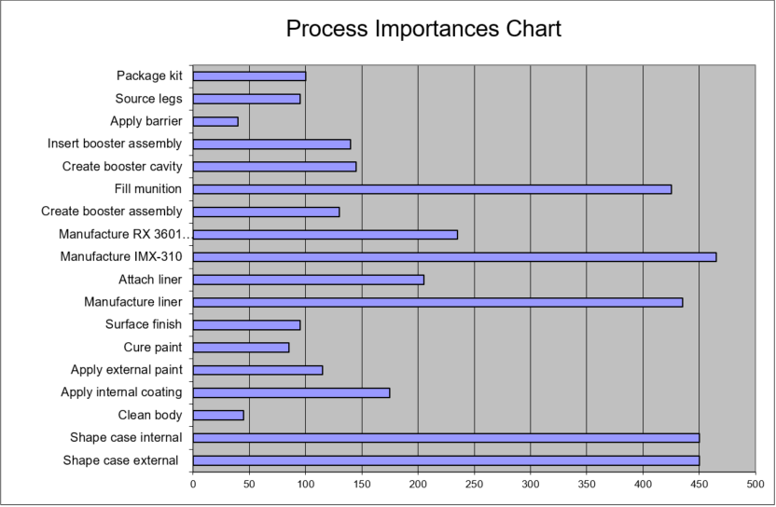
Figure 12 - QFD 1 Results
Like the design stage, a Functional Means Analysis was competed to generate manufacturing methods for each function. As setting up an entire new manufacturing process can be costly the engineers looked for ways to decrease the cost by utilising current processes in place and simplistic methods. For example, the manufacture of RX3601 booster pellets is a process already in place as RX3601 booster pellets are currently used in other munition systems.
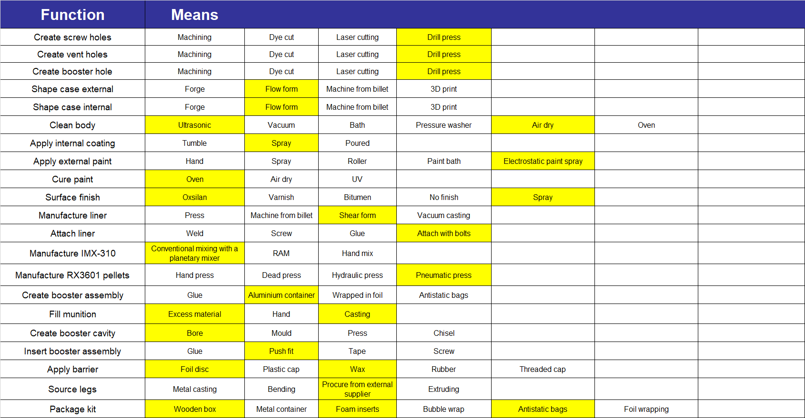
Figure 13 - FMA (Manufacturing)
Most of the other mean are very basic processes which can be carried out in most places by most people especially on the teams manufacturing site. One of the more complex methods of manufacture chosen by the engineer is for the case. The case is to be manufactured out of Steel 4140 which is a standard material in the industry with a 198mm diameter, 310 mm height and 9mm wall thickness. The chosen manufacturing method for this part is flow forming.

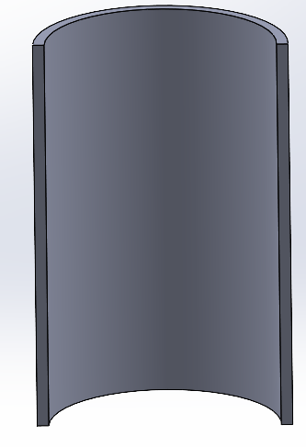
Figure 14 - Image of Case
Flow forming is an incremental metal forming process which uses three equally distributed forming rollers. These rollers push against the material along the length of the preform wall stretching it in the movement direction as the part spins. [8] Due to the process stretching the grain structure, the material strength substantially increases. This process also allows a high degree of accuracy when producing parts which can be as little +/- 0.127mm depending on part size. [9] A diagram of the process can be seen below. Once the case is flow formed it will follow standard procedure for casing in munitions.
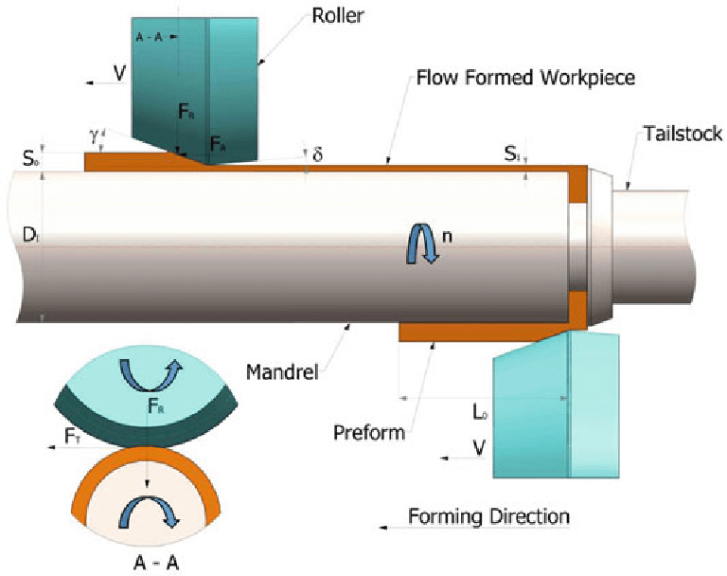
Figure 15 - Flow Forming Diagram [10]
To manufacture the hemispherical shaped charge liner a very similar process to flow forming was chosen. The liner designed by the team was a hemispherical 3mm thick which is to be made out of copper. Copper is used as a shaped charge liner very often in the munitions industry due to its excellent ductility which allows it to deform easily with fracturing. Along with copper’s suitable material characteristics, it is also readily available and well researched in the industry. Due to it being well researched, highly accurate simulations should be able to be created using previous data. Due to the liner size designed by the team, the option of an Aluminium liner would also be given to the customer as a cheaper alternative. The downside of Aluminium liners is slightly less performance, therefore the team suggests to proceed with Copper.
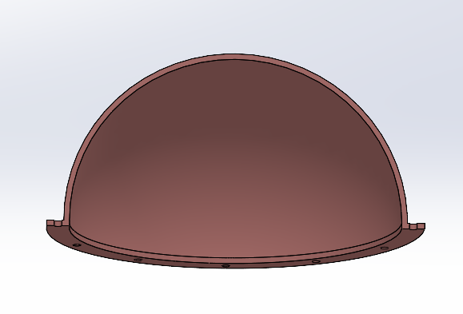
Figure 16 - Liner Image
The manufacturing technique suggested by the team for the liner is metal spinning. Metal spinning takes a flat circular blank and creates symmetrical round shapes. Similar to flow forming the work piece is clamped to a mandrel, which is shape with the inner profile of the final item, and force is applied by a roller(s) as it spins on its axis at a high speed. [11] The reason the team suggested this method of manufacture is partly due to the fact the technique is already used in several fields to manufacture items. Some of the items from other fields like lighting fixtures, mixing bowls and satellite dishes are hemispherical like the liner in the mk3 kit. [12] From the system engineering tools the systems engineer completed, the key noise factors were found to be variation in liner density. This means it is vital that the process chosen to manufacture this item controls the liner density. Metal spinning ensures that density is uniform throughout the item which enables the system to generate a jet which is much more stable and longer than that of a non-uniform liner.
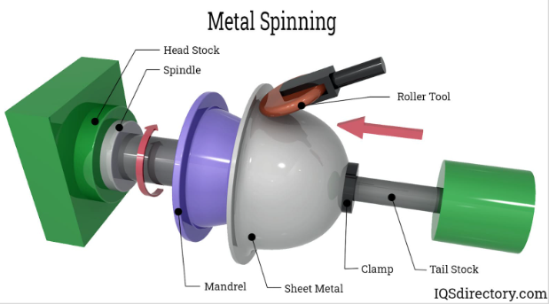
Figure 17 - Metal Spinning Diagram [12]
The final metal work required for the munition is the backplate. Similar to the liner, the piece can be delivered to the manufacturing site as a blank already cut to the correct 10mm thickness. To create all of the necessary holes, a drill press can be used. As the team plan to manufacture this munition at a currently established site, a machine shop with the necessary equipment and staff with the correct training will already be present. The 12 bolt holes can be drilled and threaded with a 4mm diameter, the vent holes to 20mm and the booster hole to 40mm.
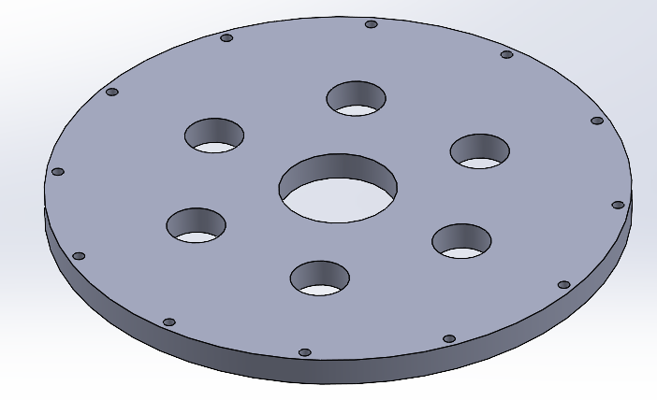
Figure 18 - Backplate Image
Once all metal work has been manufactured, the liner can be attached to the body ready for the assembly to be filled. There are many options for high explosive filling in the munition industry. The team wanted to choose an explosive that was already used and qualified in an IM munition to give the highest chance of the mk3 crater kit being compliant. Along with a variety of explosives, there is also several methods of manufacturing the explosives. The options are filling through melt-cast, conventional planetary mixing or a new upcoming method called Resonant Acoustic Mixing (RAM). The explosive chosen by the team was IMX-310 which is a PBX explosive so cannot be melt casted. RAM does not only give the benefit of being able to mix in case which saves time and waste but it also optimises final material properties [13]. However with this munition being an urgent operational requirement, the team chose to fill the mk3 cratering kit using a planetary mixer as RAM is still under development and not prepared for production. As the explosive is already used in other munitions the mixing facilities are already in place at the manufacturing site. As the mk2 variant was filled using recycled RDX/TNT from another munition, the team intend to do the same with the mk3.
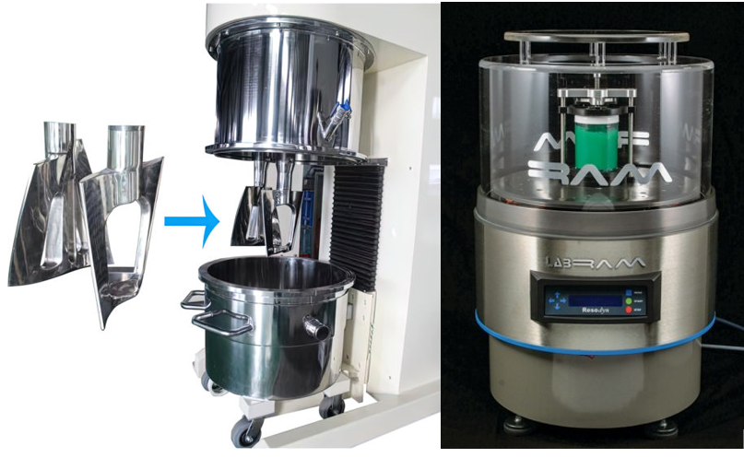
Figure 19 - PBX Mixers (Planetary & RAM)
As the main manufacturing facilities are already in place, some of the necessary manufacturing documents will have already been created. The mixing of the explosive will remain exactly the same, but the filling of the munition will require updated documents due to it being very different to the munition filled currently. Along with updated documentation, fill tolling will have to be designed and manufactured to be implemented in the process. Once the munition is filled, the explosive will need to cure in an oven before it can be taken to the borer to create the cavity for the booster assembly. After curing and boring the back plate will be attached with foil stickers covering holes to prevent ingress of foreign objects. An image with the foil stickers can be seen below to visualise how the final munition would appear.
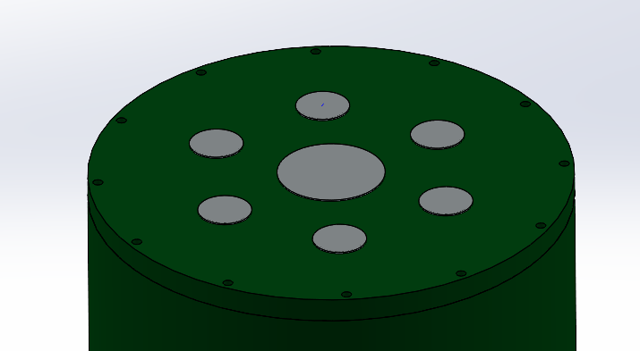
Figure 20 - Munition with Foil Stickers

Design Review Reflection
As part of the project the team presented the design of the mk3 crater kit to the customers. Each member spoke about the contributions towards the end design and answered any questions or queries from the board. From the Design & manufacturing Engineer’s perspective, the presentation went well and good feedback was given. The feedback given mentioned good volume, pace and audience interaction while presenting. The customers were impressed with CAD model which allowed them to view how the final system would appear but were sceptical about other aspects in the manufacturing processes. The manufacturing engineer did not outline the potential issues that could be faced using the specific processes which the board would have liked outlined. The question raised by the customer was regarding the explosive the team planned on using in the munition. The concern was that most shaped charge munitions use a non-aluminised explosive as the increased blast effect would take place after the shaped charge had already exited the system and reached the target. Therefore, extra worked was planned by the Design & Manufacturing Engineer to research what type of explosive would be the best option for the munition. This work would include simulation work to analyse which explosive gives a higher velocity jet and which would penetrate each target ground type more. From these simulations, backwards work can be done if needed to adjust design and manufacturing methods. However, not much work would need to be altered as the explosive manufacturing method is also used on several explosives that do not contain aluminium which are already used in alternative munition systems. This means there is a plethora of choices with sufficient information to complete the necessary simulation work to decide the best HE fill.

References

[1] | I. Powell, "Insensitive Munitions – Design Principles and Technology Developments," in Propellants, Explosives & Pyrotechnics, 2016, pp. 409 -413.
[2] | "WHAT ARE INSENSITIVE MUNITIONS," IMEMG, [Online]. Available: https://imemg.org/imemg-overview/facts-and-figures/what-are-insensitive-munitions-immurat/. [Accessed 01 May 2024].
[3] | D. Holley, "BEng Group Project 2024," UWTSD, Swansea, 2024.
[4] | C. ltd, Shaped Charge.
[5] | D. S. Burge, "Functional Means Analysis (FMA)," in The Systems Engineering Tool Box, Rugby, Burge Hughes Walsh.
[6] | Jorge, "Shape Explosive Charges," 911 Metallurgist, October 2020. [Online]. Available: https://www.911metallurgist.com/shaped-explosive-charges/.
[7] | W. X. Q. R. M. B. Y. T. Y. F. J.Dong, "Effects of Nano Aluminum Powder on the Mechanical Sensitivity of RDX-Based Explosives," Nanomaterials, 2021.
[8] | D. P. &. J. Mont, "Metal spinning versus flow forming," The fabricator, 27 Ocotber 2016. [Online]. Available: https://www.thefabricator.com/thefabricator/article/bending/metal-spinning-versus-flow-forming.
[9] | "Flow Forming – A Complete Overview," AST, [Online]. Available: https://astforgetech.com/flow-forming-a-complete-overview/. [Accessed May 2024].
[10] | A. C. K. S. Y. a. Y. ¸. Aptullah Karaka¸s, "Flow Forming Process for Annealed AISI 5140 Alloy Steel Tubes," 2021.
[11] | "What is Metal Spinning?," Metal Spinner LTD, [Online]. Available: https://www.stockfieldmetalspinners.com/what-is-metal-spinning. [Accessed 02 May 2024].
[12] | "Metal Spinning," Industrial quick search directory, [Online]. Available: https://www.iqsdirectory.com/articles/metal-spinning.html. [Accessed 02 May 2024].
[13] | A. Claydon, "Resonant acoustic mixing of polymer bonded explosives," Cranfield university, 2021.

