Case study Information Sheet:
Laura Williams
Age: 23
Laura lives in a shared house with three friends in the Cathays area of Cardiff. She has been working as a teaching assistant (TA) in a primary school for the last two years.
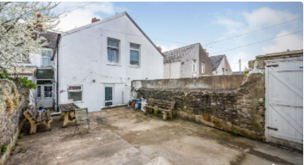
https://www.viamichelin.co.uk/web/Maps/Map-Cathays-_-Cardiff-United_Kingdom
The house has communal living space and a paved garden.
The school at which she works is four miles away and she catches a bus every morning, which gets her in to work 30 minutes early. Laura has a busy day working in the reception class (4 year old children) which she finds tiring.
Laura does not need to lose a significant amount of weight as she is within the healthy range. She does however feel that she has really let her fitness levels drop and feels generally less toned since she started her TA job.
She previously enjoyed running with friends, however they no longer live in the same area. Evenings are usually spent watching television or chatting with friends.
Laura also enjoys visiting other friends (who also do not exercise) at their houses or going out to socialise at bars and restaurants. Laura rarely gets to sleep prior to midnight and gets up at 7am each morning.

Other information:
- When she is not working she likes to spend time with her friends.
- Laura has previously been a member of a nearby hotel gym (membership was a Christmas gift from her parents) however she did not use this regularly as it was always very busy at the times she was free to go.
- She regularly feels tired and run down.
- Does not eat breakfast, has snacks for lunch and a cooked meal in the evening.
- Does not like being out in the dark alone, however she has previously enjoyed group-based exercise.
- She would need to be provided with interesting and exciting alternatives to what she currently spends her free time doing as she does enjoy these activities

Questions to answer:
- What stage of change (from the Transtheoretical Model) is Laura currently at? What makes you think she is at this stage?
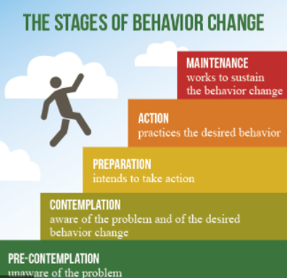

- Based on the information you have been given and what you have covered in the module, identify the benefits that Laura is likely to obtain from exercising regularly?
Benefits:

- What barriers do you think are preventing Laura from exercising / being generally more physically active?
Barriers:

- You have been asked to work with Laura to encourage her to exercise regularly. What initial approach would you take to this?

- What options to become more active are available in the area that she lives? Have a look at what is available locally (Cardiff area) for her to access.

Options available (list):

- What activities would you recommend for Laura?
Activity 1:
Rationale for this choice:

Activity 2:
Rationale for this choice:
Activity 3:
Rationale for this choice:

- Are there any other aspects of her lifestyle that you would suggest she modifies (if so, in what way and why)?
Aspect for change 1:
Reason for this:

Aspect for change 2:
Reason for this:

Remember to link your ideas to research / theory where possible.

A few useful links as a starting point:
https://www.outdoorcardiff.com/parks/
https://www.cardiff.gov.uk/ENG/resident/Parking-roads-and-travel/Walking-and-cycling/Pages/Walking-and-cycling.aspx
https://www.better.org.uk/leisure-centre/cardiff


