A Biomechanical Analysis of a Stationary Netball Shooting Technique

Introduction
Netball shooting is a highly specialised sporting movement that plays a decisive role in match outcomes due to the restricted scoring positions within the sport. Unlike many projectile-based skills where maximal force production is prioritised, netball shooting requires a refined balance between accuracy, consistency and mechanical efficiency. The movement must be repeatable under variable constraints such as defensive pressure, distance, fatigue and psychological stress, making technical proficiency essential for successful performance (Steele and Milburn, 2017).
Newton’s laws of motion help explain the forces involved in netball shooting. Newton’s first law highlights the need for the shooter to apply force to the stationary ball in order to initiate movement, while maintaining balance and stability throughout the action. Newton’s second law states that the acceleration of the ball is proportional to the force applied, meaning sufficient force must be generated to project the ball to the hoop; however, in netball shooting this force must be carefully controlled to prioritise accuracy rather than maximal power. Newton’s third law is evident through ground reaction forces produced during ankle, knee and hip extension, which contribute to upward propulsion and overall shooting stability (McGinnis, 2013).
Biomechanically, netball shooting is a whole body movement involving coordinated action across the lower limbs, trunk and upper extremities. Force generation is initiated through the lower limbs via ankle plantarflexion and knee and hip extension, followed by energy transfer through the trunk and into the upper limb kinetic chain. The movement terminates in elbow extension and wrist flexion at ball release, enabling precise control of ball velocity, trajectory and spin (Pallis, McNitt-Gray and Hung, 2019).Effective coordination of this proximal to distal sequencing is widely recognised as a key determinant of mechanical efficiency in projectile based sporting movements (Lees, Vanrenterghem and De Clercq, 2016).
From an injury prevention perspective, netball shooting exposes athletes to repetitive loading patterns, particularly at the ankle, knee, wrist and elbow joints. Given the high volume of shooting performed during training and competition, even subtle biomechanical inefficiencies may accumulate over time, increasing the risk of overuse injuries (Plummer et al., 2019).
The aim of this report is to investigate the biomechanics of a stationary netball shooting technique using two-dimensional video analysis. Specifically, the study analyses joint angles at the ankle, knee, hip, elbow, and wrist across three shooting trials performed from a consistent distance of 2.6 metres. The objectives are to assess mechanical efficiency, evaluate performance demands, and identify potential injury risks associated with the observed technique.

Methods
Biomechanical data were collected from a single participant recruited from a university practical class. The participant was 5ft 5inch and had prior experience performing netball shooting movements. All data were anonymised to ensure participant confidentiality, in line with ethical research practice (Robertson et al., 2019).
The movement analysed was a stationary netball shot performed from a distance of 2.6 metres from the netball post. The post was a standard post measuring at 10 ft or 3.05 metres. The participant completed three shooting trials from the same starting position, all trials were conducted under consistent environmental conditions and were performed one after another to replicate match play.
Video-based kinematic analysis remains a widely used and accessible method for investigating sporting movements in applied and educational settings. While two-dimensional (2D) analysis is limited to sagittal-plane motion, it can provide valuable insight into joint angular displacement, sequencing, and consistency when applied appropriately (Robertson et al., 2019). Two-dimensional kinematic data were collected using digital video analysis. A 9th generation Ipad was positioned laterally to the participant at a distance of 8 metres on a 1 meter high tripod, providing a clear sagittal-plane view of the shooting action.
Video footage was analysed frame-by-frame using motion analysis software Dartfish. Joint angles were extracted at four key phases of the shooting movement: the starting position, base position, top of the shot, and finish position. Analysing discrete movement phases allows for meaningful comparison of joint kinematics across trials (Robertson et al., 2019).
Sticker markers were placed on key anatomical landmarks to facilitate joint angle measurement. Markers were positioned on the lateral malleolus, lateral epicondyle of the knee, anterior superior iliac spine (ASIS), lateral epicondyle of the elbow, and the styloid process of the radius. These landmarks are frequently used in applied biomechanics to estimate joint centres and calculate joint angles (Pallis, McNitt-Gray and Hung, 2019).
The primary limitation of this investigation was the use of two-dimensional analysis, which restricted measurement to sagittal-plane motion and did not account for transverse or frontal plane mechanics. Additionally, the analysis of a single participant limits the generalisability of findings to broader netball populations (Delextrat and Goss-Sampson, 2010).

Results
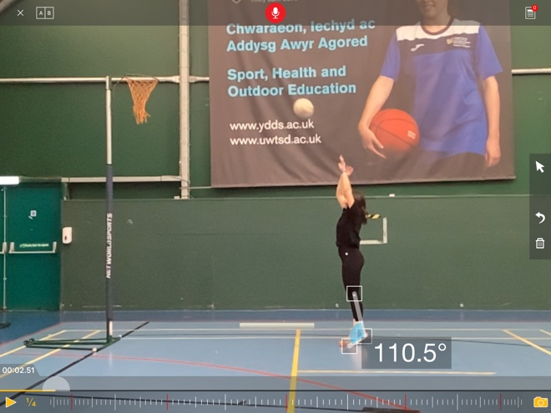
Ankle Joint
At the starting position, the ankle was held in moderate plantarflexion, with angles ranging from 76.1° to 80.8°. As the movement progressed into the base position, ankle plantarflexion increased slightly to between 81.9° and 83.2°, reflecting preparation for force generation. At the top of the shot, a substantial increase in plantarflexion was evident, with ankle angles ranging from 102.9° to 106.9°. This trend continued into the finish position, where the greatest plantarflexion occurred, with angles between 110.5° and 113.7°. Below is a table showing the anglular displacement at the ankle joint and a screenshot of the angle at the ankle at the finish phase.
Shot | Displacement
Shot 1 | 34.4
Shot 2 | 32.9
Shot 3 | 32.8

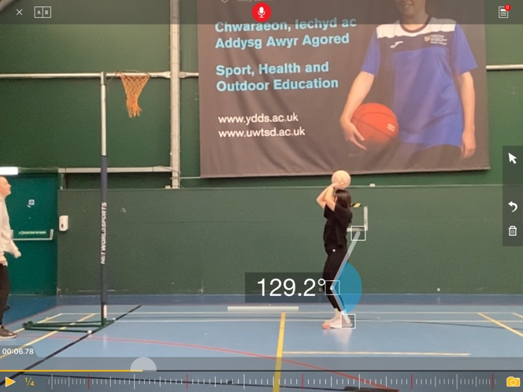
Knee Joint
The knee joint began near full extension in the starting position, with angles between 172.3° and 174.7°. During the base position, marked knee flexion was observed, with angles decreasing to between 126.7° and 129.2°, indicating a controlled countermovement. As the athlete transitioned to the top of the shot, the knee extended rapidly, reaching angles between 164.2° and 173.2°. Near full extension was maintained in the finish position, with knee angles ranging from 174.9° to 176.6°. Below is a table showing the anglular displacement at the knee joint and a screenshot of the angle at the knee at the base phase.

Shot | Displacement
Shot 1 | 2.6
Shot 2 | 1.9
Shot 3 | 2.2

Hip Joint
At the start of the movement, the hip joint was positioned close to full extension, with angles between 168.2° and 169.2°. Increased hip flexion occurred during the base position, where angles reduced to between 142.6° and 147.5°. At the top of the shot, the hip extended toward full extension, with angles ranging from 173.9° to 177.5°. This extended position was largely maintained through the finish phase, with hip angles between 173.4° and 176.9°. Below is a table showing the anglular displacement at the hip joint.
Shot | Displacement
Shot 1 | 4.2
Shot 2 | 8.7
Shot 3 | 6.7

Elbow

The elbow joint demonstrated a progressive increase in angle throughout the movement, beginning at approximately 140° in the starting position and extending steadily to near full extension at the top and finish phases (176.4°-179.5°). Below is a table showing the angular displacement at the elbow joint and a screenshot of the angle at the elbow at the base phase.
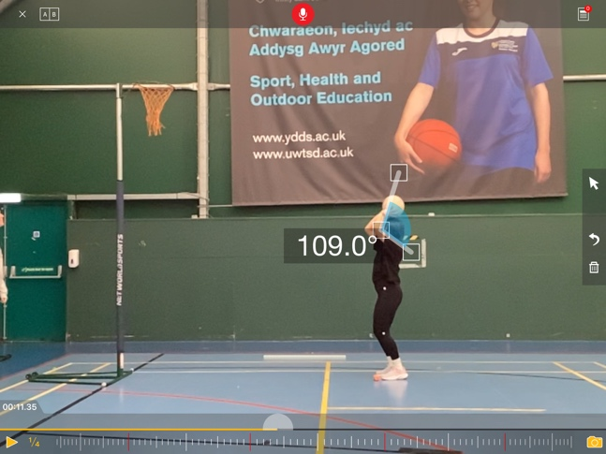
Shot | Displacement
Shot 1 | 39.2
Shot 2 | 35.4
Shot 3 | 36.2

Wrist

The wrist joint followed a distinct pattern, remaining in extension during the preparatory and propulsion phases before moving into flexion at the finish phase, with angles ranging from 158.4° to 160.4°. Low inter-trial variability was observed across both joints throughout all phases of the movement.
Shot | Displacement
Shot 1 | 33.8
Shot 2 | 34.8
Shot 3 | 33.3

Discussion
Across the three shots, a broadly consistent movement pattern was observed, with the greatest angular displacements occurring at the elbow and wrist in all trials. In Shot 1, elbow (+39.2) and wrist (+33.8) displacements were highest, indicating a strong reliance on upper-limb motion during the action. While this may contribute to force production or accuracy, such large elbow and wrist displacements can increase repetitive loading at these joints, elevating the risk of overuse injuries such as medial elbow tendinopathy or wrist strain if repeated frequently. Below is a table showing the angular displacement from the start of shot 1 to the end of shot 1.
Joint | Displacement
Ankle | +34.4
Knee | +2.6
Hip | +4.2
Elbow | +39.2
Wrist | +33.8
In Shot 2, elbow displacement decreased slightly (+35.4) while wrist displacement increased marginally (+34.8). This redistribution of movement suggests altered coordination, potentially shifting mechanical load distally towards the wrist. From a biomechanical perspective, this may reduce stress at the elbow but increase demands on the wrist joint, which could heighten injury risk if adequate strength or control is lacking. Additionally, hip displacement increased notably in Shot 2 (+8.7), indicating greater proximal contribution, which is generally considered beneficial for force transfer and may reduce upper-limb injury risk by spreading load across larger muscle groups. Below is a table showing the angular displacement from the start of shot 2 to the end of shot 2.
Joint | Displacement
Ankle | +32.9
Knee | +1.9
Hip | +8.7
Elbow | +35.4
Wrist | +34.8
Shot 3 demonstrated a more balanced pattern, with moderate elbow (+36.2) and wrist (+33.3) displacements alongside reduced hip displacement compared to Shot 2 (+6.7). Knee displacement remained minimal across all three shots (1.9-2.6), suggesting a relatively static knee position and limited contribution from knee extension. While this stability may aid consistency, it may also indicate underutilisation of the lower limbs, potentially increasing reliance on the upper body and associated injury risk. Below is a table showing the angular displacement from the start of shot 3 to the end of shot 3.
Joint | Displacement
Ankle | +32.8
Knee | +2.2
Hip | +6.7
Elbow | +36.2
Wrist | +33.3
The results demonstrate a clear proximal-to-distal sequencing pattern, which is widely regarded as fundamental to efficient projectile-based movements (Lees, Vanrenterghem and De Clercq, 2016). The increase in lower-limb flexion during the base phase followed by near-complete extension at the top and finish phases suggests effective utilisation of the stretch-shortening cycle. This mechanism enhances force production while reducing energetic cost and minimising excessive joint loading, which is beneficial for injury prevention during repetitive shooting actions (Suchomel, Nimphius and Stone, 2016).

The magnitude of knee and hip flexion observed during the base phase appears sufficient to generate force without compromising postural stability. Excessive flexion may increase compressive and shear forces at the knee and hip joints, elevating the risk of overuse injuries, while insufficient flexion may limit vertical impulse generation and increase reliance on the upper limbs, potentially placing greater stress on the elbow and wrist (Pallis, McNitt-Gray and Hung, 2019). The consistency of these joint angles across trials indicates a stable and repeatable movement strategy, which is associated with reduced injury risk by limiting unnecessary variability and cumulative joint stress during high-volume shooting.

Upper limb kinematics revealed progressive elbow extension culminating near full extension at ball release, supporting effective energy transfer through the kinetic chain (Delextrat and Goss-Sampson, 2010). The transition from wrist extension during the preparatory phases to wrist flexion at the finish phase aligns with biomechanical models of accurate projectile release, where wrist action contributes to ball velocity control and spin (Pallis, McNitt-Gray and Hung, 2019). Whilst this pattern is advantageous for performance, repeated high-volume shooting may increase cumulative loading at the wrist joint, particularly if conditioning and recovery are insufficient (Plummer et al., 2019).
No extreme joint angles were observed that would indicate acute injury risk. However, repeated ankle plantarflexion at the finish phase may increase loading on the Achilles tendon over time (McLean, Walker and Ford, 2018). Similarly, repetitive wrist flexion during ball release may elevate the risk of overuse injuries affecting the wrist flexor tendons.The inability to assess frontal-plane mechanics due to the two-dimensional design limits conclusions regarding knee valgus or rotational loading, which are important considerations in netball injury epidemiology (Taylor et al., 2018).

Conclusion and Recommendations
This biomechanical investigation demonstrated that the analysed stationary netball shooting technique exhibited efficient joint sequencing, consistent kinematic patterns, and generally safe joint positions. Effective use of lower-limb countermovement and coordinated upper-limb extension contributed to mechanical efficiency and repeatability across trials.
To enhance performance, training programmes should prioritise lower-limb strength, particularly at the ankle plantarflexors and knee extensors, to support force generation (Suchomel, Nimphius and Stone, 2016). Technical drills emphasising consistent base depth and smooth extension timing may further improve shooting accuracy. From an injury prevention perspective, conditioning should include targeted strengthening of the ankle and wrist musculature to manage cumulative loading associated with repetitive shooting (Plummer et al., 2019).

References
Baker, J., Schorer, J. & Wattie, N. (2018). Compromising talent: Issues in identifying and developing talent in sport. Frontiers in Psychology, 9, pp. 1-14.
Pallis, J.M., McNitt-Gray, J.L. and Hung, G.K. (eds.) (2019) Biomechanical principles and applications in sports. Cham: Springer. https://doi.org/10.1007/978-3-030-13467-9
Plummer, A., Mugele, H., Steffen, K., Stoll, J., Mayer, F. & Müller, J. (2019). General versus sports-specific injury prevention programs in athletes: A systematic review on the effects on performance. PLoS ONE, 14(8), e0221346. 1
DOI: 0.1371/journal.pone.0221346

Lees, A., Vanrenterghem, J. & De Clercq, D. (2016). Understanding how an arm swing enhances performance in jumping. Journal of Biomechanics, 49(5), pp. 687-695.

McGinnis, P. M. (2013). Biomechanics of Sport and Exercise. 3rd ed. Champaign, IL: Human Kinetics.
Taylor, J.B., Ford, K.R., Schmitz, R.J., Ross, S.E., Ackerman, T.A. & Shultz, S.J. (2018). Sport-specific biomechanical responses to an ACL injury prevention programme: A randomised controlled trial. Journal of Sports Sciences, 36(21), 2492-2501.
DOI: 10.1080/02640414.2018.1465723
Robertson, D.G.E., Caldwell, G.E., Hamill, J., Kamen, G. & Whittlesey, S.N. (2019). Research methods in biomechanics. 3rd edn. Champaign, IL: Human Kinetics.
Delextrat, A. & Goss-Sampson, M. (2010). Kinematic analysis of netball goal shooting: a comparison of junior and senior players. Journal of Sports Sciences, 28(12), 1299-1307. DOI: 10.1080/02640414.2010.498482.
Suchomel, T.J., Nimphius, S. & Stone, M.H. (2016). The importance of muscular strength in athletic performance. Sports Medicine, 46(10), pp. 1419-449.
Winter, D.A. (2015). Biomechanics and motor control of human movement. 4th edn. Hoboken, NJ: Wiley.

