Within a given time period, select examples of what could be considered high and low cultural artefacts. Discuss these, taking into consideration the surrounding social, political and historical context.

P151205

Illustration

2190 words

Louise Burston

From the Bronze Age right through to modern times, men and women of vision have altered the lay of the land and how we visualise things according to their own beliefs and needs. An example of this, is that our understanding of what culture is, has been of constant change through history. Culture is generally considered to be of two levels, which are high culture and low culture, but how do we define the difference between the two and does a difference actually exist? After doing some research, I am going to discuss the possibilities of these different cultures, whether they exist and the effects they have had on society and history. One of the examples that I have come across is Margam Castle, situated in South wales and the artefacts that were housed within it, when it was in its former glory.
Margam Park dates back to the year 1147, when the Cistercian Abbey was founded. A magnificent 12-sided chapter house was built for the Monks to worship, however, following the dissolution of the Monastery by Henry VIII, it allowed the Abbey and its grounds, to be bought by Sir Rice Mansel of Oxwich Castle, Gower Peninsular. Mansel was heavily involved with parliament at the time. He was also a controller of the household of Queen Anne. Being in such favour to the King, allowed Mansel to purchase the Estate. I question here whether this was this the first evidence at Margam, of political power taking precedence with high culture status, especially with the dissolution of the Abbey?
Mansel went on to convert the chapter house and monastery into a mansion. The mansion and estate stayed within the family for many years, being passed down from generation to generation with each heir having strong positions within parliament. The most influential heir, and one that made the most impact on the estate was Christopher Rice Mansel Talbot. His involvement to improve a Harbour, within the town of Aberavon, was so impressive that it led to the town changing its name to Port Talbot to honour him in 1836.
Talbot wanted to create a grand house to show his wealth and 1830, made plans to build an impressive gothic style mansion. The house was an incredible piece of architecture designed by London’s leading architect, Thomas Hopper. The house took 10 years to build with Talbot giving work to local men and used materials sourced locally for the build. It is known that he was the wealthiest commoner of his time. He continually supported industry in Wales, providing jobs for locals and pioneered the introduction of the railway to South Wales. In 1849, the proposed line for the South Wales Railway came to a halt due to lack of funds, however, Talbot provided the capital that was needed to complete the project. He regularly invested large amounts of money in the region’s metal production industries. So as you can see this very influential and wealthy gentleman was having a massive effect on the growing industry around Port Talbot and is a very important piece of history to Port Talbot.
The house was built to a very grand scale and contained expensive artefacts that Talbot had brought from his fathers collection and some were of his own. As a young man, he undertook a Grand Tour of Europe, where he became very interested in art and went on to become an avid art collector. There were many paintings housed at the mansion. Paintings by artist such as Gentileschi, Monamy, Jan van Kessel, Rembrandt, and Rubens were amongst them. Along with sculptures by Hewetson and J.T.Sergel. The house was adorned and decorated with expensive pieces of various arts, and these artefacts were generously on show at the time for the public to come and view.
It wasn’t unusual for middle class people to pay visits to stately homes in the 19th Century. A lot of owners liked to show their wealth by allowing the middle class to come and see what they had built. Though after his completion of Margam Castle, Talbot decided that he no longer wanted this. According to Hughes (1981, p.27), in a letter to Mr Griffith Llewellyn, Talbot wrote:

It is my wish, though I have not made any order on the subject, that the house at Margam should not be indiscriminately shewn. Very great inconvenience is the consequence of parties of 20-30 persons going over to walk around the house not as much to gratify curiosity, as to make parties. I allowed the house to be seen indiscriminately while building, but now it is finished, serious damage to the furniture would be the consequence of allowing large parties to roam about inside. You are very welcome to show it to any friends who may wish to see it.

It is my belief that here, Talbot was defining the difference between High and Low culture. Even though Talbot was quite happy to allow the ‘lower cultural’ people to come and view the build of his house, now that his house contained such expensive and priceless artefacts, he had changed his mind as he felt they didn’t appreciate such splendour or the value of them and was worried that they would damage them.
Among some of the other artefacts contained within the house was a rare daguerreotype of the castle by Calvert Richard Jones, a close friend to Talbot. It was kept hidden up until 1987, when Talbot’s descendants put it up for sale. It was sold in an auction by Christie’s to an American Gallery, however, fortunately it never left the country due to a refusal of an export license and was later purchased by the National Gallery of Wales. This unique picture is probably the earliest view of the castle and is also the first photograph ever to be taken in wales. This photograph has become a crucial part in the history of photography but for over a hundred years, Calvert’s work had been ignored and is only now gaining the recognition that it deserves. So would this photograph now be seen as a high cultural artefact due to its age and the fact that the photographer is now deceased? Or is it high cultural due to it being requested by one of the most influential and wealthiest man in wales of his time?

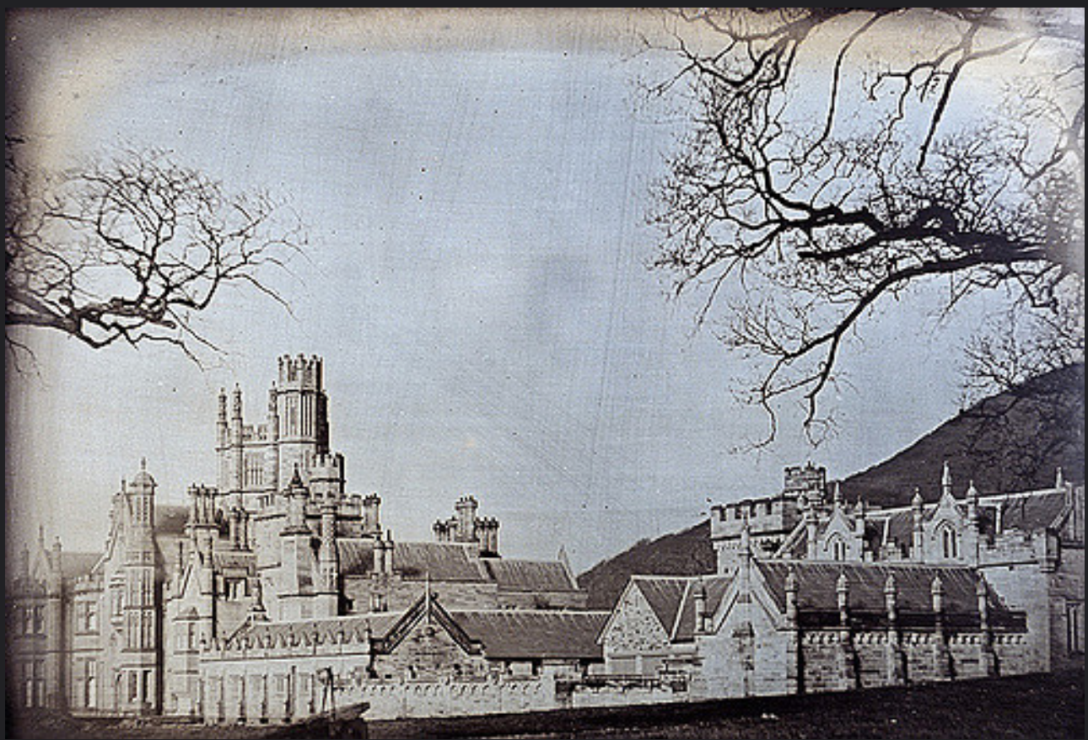

Calvert Richard Jones
Ca.1845
Daguerreotype of Margam Castle
Daguerreotype
West Glamorgan Archive Service

After Talbot passed away, his daughter, Emily Charlotte, who like her father, had a fine eye for art and deco, inherited the house. Miss Talbot gave frequent large parties to the gentry and liked the house to be at its utmost splendour. She made many more alterations to the house and redecorated rooms; many of the rooms were decorated with William Morris Wallpaper, again showing support to local talent.
After Miss Talbot passed away in 1918, the castle and estate was left to her great nephew, John Theodore Talbot Fletcher. The house was put in trust as Fletcher is too young to manage it and his family came to live at Margam.
In 1941, during the Second World War, Margam was used to accommodate the troops. During this time the trustees of the estate decided to sell the house and a portion of its estate. All artefacts within the house were then put up in an auction that was held by Christies. Even though most the items in the auction were unaffordable to the middle class, the locals still came up for the auction with hope of seeing such fine items one last time and maybe purchasing a small memento. The house once again, was a ‘show’ for all to see. Art dealers from all over the country came to see if they could grab a bargain as this beautiful stately home was stripped of its contents. The effects of war, taking victim, one of the most prestigious homes in Wales that was steeped in history. This was to be the start of the sad decline of Margam.
Like most items auctioned, most of the paintings and sculptures were so widely dispersed, it is impossible to trace their current whereabouts. Though we know that two sculptures went on to be displayed at the Victoria and Albert Museum, in London and at the The National Museum in Stockholm, Sweden. Two paintings that dated back to the first house built on Margam Estate, were purchased by Amgueddfa Cymru and are now housed at the National Museum Wales. These were purchased with help and support from the Heritage Lottery and Art Fund. The importance of these items and their history is evident when we see museums wanting to display them and protect them. The war also led to deforestation of the slopes of the park due to the demand for timber, this obviously led to the change of the landscape, and all these changes affected the outcome for Margam.
After the auction, the castle, now bare, remained to be used by the troops until the war ended and Sir. David Evans-Bevans bought it, but chose not to occupy it due to its overwhelming size and opted to live in the near by cottage. The house started falling into disrepair and became subject to vandals. Even Bevans himself stripped parts of it for his own use despite the house now being a listed building. This beautiful gothic style mansion was now subject to abuse when years before it was an object of aspiration to many. It is my belief that the Castle had now become an object of low culture, now that it had lost all the high cultural status it obtained years before.
Margam went on to be sold to Glamorgan Council in 1973 and has been undergoing extensive repair ever since. The orangery was the first of the buildings to undergo renovation and when work eventually started on the mansion a devastating fire tore through the building destroying a lot of the Castle, massively setting back plans to renovate.
The future of the castle still remains hopeful. The park relies heavily on funding and lottery grants. The council have launched several searches for private investors with suggestions that the castle could be turned into a hotel. However no one has wanted take on the scheme as the estimated cost are in the region of £ 6.5 million. Although grants are available, the council are not in a position to fund such an expensive scheme. In 1997, the castle opened its doors to visitors and for the first time in nearly fifty years.
It is my opinion that a house of this magnitude, with residents of such high nobility, can in fact be regarded as a high cultural artefact and that due to the effects of the war, it has fallen into disrepair, and then continued to fall into a decaying mess with lack of funding from a country that helped put it in that state as a result of the placing of troops to the estate. It seems the castle has always been a high cultural show, to all classes through history, switching from being a magnificent, stately home, attracting middle class people to come and view it, to then becoming a derelict, lonely object, where people had no respect and regard for the hard work and money that went into building such a house. Vandalising and abusing it, until it was a shell of its former glory, eventually rotting away from society. Either way I believe the Castle is still a ‘show’ for the all cultures of people to come and visit with it being now open to the public. It has hosted open-air concerts in the past, and thanks to a multi-million pound redevelopment scheme, it now offers a residential field studies centre, which has been part, funded by the Council. The Estate now offers facilities for weddings and corporal events. However, the restoration of this house still relies heavily on help from the public by offering free tours of the house and asking for donations. It is my belief that by doing this, the public are made to feel slightly guilty and sorry about the deterioration of such a stately home, steeped with history, that they end up giving donations in a hope to help save it. It is questionable why a house with this much history attached to it cannot get the full funding needed to restore it fully to its former glory, when similar buildings such as Penrhyn Castle in North Wales, (also designed by Hopper) have been acquired by the National trust and has been protected in conservation. It is in my opinion that the difference between these two buildings is that one was used to house troops during the war, losing its status in society and the other provides an example of the levels of material wealth that was accumulated by those engaged in the slave trade, which was then invested back into British property and land resulting in the government feeling that they owe it conservation. It is my belief that maybe sometimes we see artefacts as high and low culture by the way society wants us to see them.

Bibliography:
Books:
Hughes, J.V. (1981) Margam Castle.
West Glamorgan: West Glamorgan Archive Service.

Web Sources:
A Brief History of Penrhyn Castle [Online]
Available at:
https://www.nationaltrust.org.uk/penrhyn-castle/features/a-brief-history-of-penrhyn-castle
[Accessed: 10th November 2017]

A Guide To Margam Castle [Online]
Available at:
http://www.learn-ict.org.uk/archive/resources/margam/history.htm
[Accessed: 10th November 2017]

Margam Country Park [Online]
Available at:
http://www.margamcountrypark.co.uk/1243
[Accessed: 11th November 2017]

Margam Park: A History – Extracts [Online]
Available at:
https://vimeo.com/135194151
[Accessed: 28th November 2017]

National Museum Cardiff- Art learning resource. [Online]
Available at:
https://museum.wales/media/28919/AGC-NMC-Art-Learning-Resource-Margam-House_1-12.pdf
[Accessed: 11th November 2017]

Online Photographs:
Jones. C. R. (1841) Daguerreotype of Margam Castle . [Photograph]
West Glamorgan Archive Service.

