Celtic Art assignment 1: The Snettisham Great torc

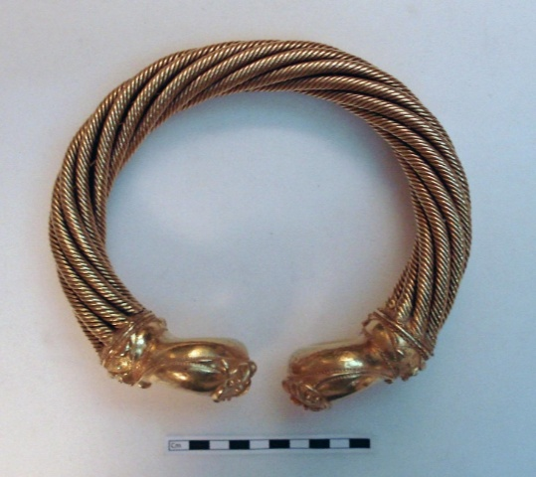
Figure 1Snettisham Great Torc (source: https: //www.britishmuseum.org/)

The object of this biography is the Snettisham Great Torc, which is a gold alloy torc to be worn around a person’s neck. The British Museum has stated this torc was made from a little over one kilo’s worth of gold with some traces of silver and has been dated to have been made around 150BC – 50BC. The gold alloy used for this torc has been shaped into a series of threads, which have been grouped into bundles eight threads each to be twisted to form the rope type pattern seen on the torc. The twisted ropes form the hoop of the torc which ends in decorated terminals in the style of circular shapes and interconnecting lines.
The torc was discovered accidentally in 1950 by a farmer, who was ploughing his field near the village of Snettisham alongside other artefacts such as a coin and a bracelet. This small treasure hoard is not unique to the area as several other hoards of various size has discovered and excavated throughout the 20th century. After the discovery of this particular hoard, the artefacts including the torc were acquired by the British Museum in 1951, where they are still kept on display to this day. It began life as a valuable ornament perhaps connected to status and power in Iron Age society. During its lifetime it fell into obscurity either through purposeful deposition or by mistake only to be rediscovered in the 1950’s to experience a new life as a museum artefact and object of study.
By examining these stages, we can understand not only the object itself more clearly but also view the life of the torc from its creation point to its present state on display.
The Snettisham Great Torc’s creation point is estimated to be around 150BC – 50BC, which would place its manufacture during the Iron Age. While the exact creators of this torc are unknown, the skill and detail put into the torc demonstrates the metal workers of this period were highly skilled artisans. Machling states that the technique to create and attach the terminal to the collar of the torc is known as a tripartitie construction technique, where the core of the terminal and the shell of it are created separately to be attached at a later point to the collar. Producing a torc of this quality would have required time, labour, and skilled expertise. This would suggest patronage by powerful individuals or groups funding its creation. It is unlikely that the torc was made for ordinary use rather, it was likely commissioned as a statement piece intended to communicate authority and prestige amongst the tribal elite of the time.
Machling notes that the Snettisham great torc is unique among other torcs found near the region due to areas of the torc being made either in a less optimal way originally or modifications to the original piece has left noticeable signs of change.
This torc is unusual as the joint between collar and wires is extremely messy: there are a large number of wide gaps between the wire ropes of the neck-ring which have been filled with poorly-applied quantities of gold solder, perhaps overlying and surrounding pressed-in sheet from a collar lip. It would seem that the eight wire ropes of the neck-ring, as made, were not wide enough to snugly fill the collar aperture. Therefore, they had to be splayed open to fit the collar, as witnessed by the widening of the neck-ring as it joins the terminals.
It is odd that an object with such a valuable amount of gold was made with poor technique. There are a number of possible reasons why the neck ring has been attached to inappropriately sized terminals which required the excess use of solder. Machling suggests some possible reasons, the first that British smiths were inexperienced with the soldering technique and the second was that the terminals and neck ring may have been manufactured separately by different goldsmiths with poor measurements. Another suggestion is that the torc was made from recycled parts of broken torcs to reuse the elements.
The concept of inalienable wealth may apply to the Snettisham torc and explain why it may have possibly been repaired or the elements preserved in such a way. Annette Weiner talks about the concept of inalienable objects. Such objects can not be separated from their owners, even when they are circulated. They always have a sense of belonging to a person or group. She writes; ‘The cultural meanings of such wealth made these objects different from those that lacked the value of inalienability.’ The Snettisham torc may have had significant meaning to the owner which transcended the commercial value of its gold.
In contrast to where the torc was discovered in Snettisham, the materials used to create the artefact could have possibly been brought in from elsewhere. Gold mining in Iron Age Britain was rare to the point that most known ancient gold mines that have been rediscovered are from a later time period, most commonly when the Romans arrived and occupied parts of the island from 44AD to 410AD. It should be noted that even modern gold mines in Britain are located away from Snettisham, which could show that even if these later mines existed in the Iron Age period, the gold materials would still have to travel a fair distance to where the torc was discovered.
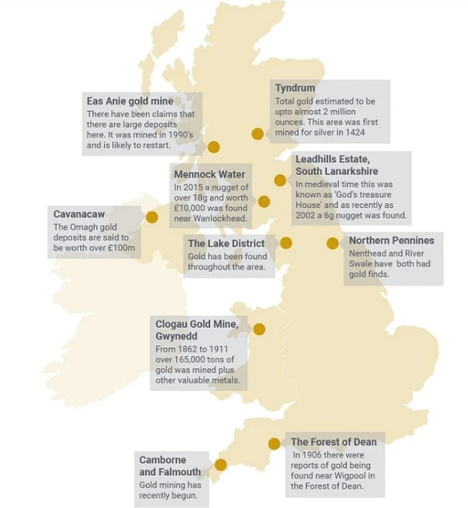
Figure 2 Modern Gold mines in Britain (Source: https://www.bullionbypost.co.uk/)
This raises several questions as to where the gold ore and raw gold could have possibly originated from? If the torc was made from such a rare metal, then who was it intended for? Does the decorative style of the torc or any other signifiers reveal any clues and where it came from? Why was it not made from a more accessible metal such as copper?
We can theorise the answer to these questions by examining the torc itself. The torc is made up from electrum, which is a natural gold and silver alloy with traces of copper. It should be noted that with the rarity and value of gold that it is very likely the gold has been recycled over and over into different forms and objects before becoming its final form as the Snettisham great torc making tracing its origins difficult. Academics are already quite aware of an international trading network throughout Europe during the Iron Age, with the Great Orme copper mine having its ore being linked to artefacts found in several countries across the European mainland. It can then be theorised that early traders using one of these existing trade networks could explain how the materials for the torc had travelled possibly from aboard to Snettisham.

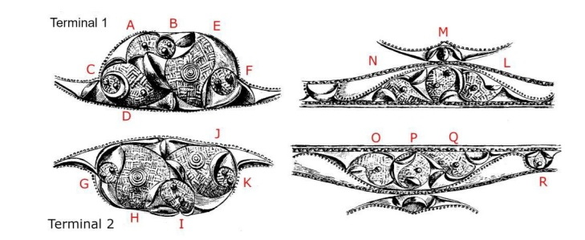
Figure 3 Design pattern on the Great Torc (Source: Tess Machling)
If the estimated creation date between 150 BC – 50 BC is accurate then this would place the torc’s origins to be in the late Iron Age and before the Roman arrival on Britain. Knowing the time period of the creation torc can help us understand it more to see if it has any other relation to other Celtic artwork from this period or is it showing something more unique, which could instead be considered more early British art instead? To define the torc as either Celtic art or a form of early British art is a difficult task. La Tène culture was still influencing the Celtic world in this period and while some distinctions were visible to broadly classify an object as something else, it was still clear in the majority that the depictions on most artefacts were following with the La Tène style.

The theory of it being a gift brought from overseas, could also explain why it appears that the torc has potentially been modified as testified by the messy work found between the joint and the wiring. If the torc was a gift from a far-off place and the measurements for the intended recipient were wrong, then it is possible that the torc was sent to a more local and less experienced metalsmith to adjust the fit and cause the messy work. Machling suggests a theory that instead of the messy work resulting from inexperienced metal workers, it could be possible that what we know as the Snettisham great torc is not the original but instead a recreation of it. Which could explain why the collar does not fit to the terminals correctly because they were created for the original version of the torc instead.

The discovery site of the torc can possibly also answer who the artefact was intended for. The modern settlement of Snettisham is located in the southeast of England and is notably where the Iron Age tribe the Iceni were said to have lived. The Iceni are best known for a later point in their history where their resistance to Roman rule under Boudicca has been a common story retold since the Victorian age. However, at the time the torc was created, the Iceni were likely a part of a thriving interconnected Iron Age world. The presence coins found with the torc also indicates links to other tribal communities across continental Europe and this would reinforce the idea of a culturally and economically connectivity with the rest of Europe. This could possibly mean that the torc was a gift intended for a notable member of the tribe or even its chief from one tribe to another. As evidenced with the discovery of coins among the hoard with the torc was founds reveals the cultural and economic shift of bartering or labour exchange was already being replaced with currency. Given the value of gold during this time period, it is notable that many torcs were preserved instead of being smelted down and recycled into coins. This gives weight to the idea that these torcs were heirlooms and held a deep inalienable wealth to the community over the commercial value gained from destroying them.
Due to other golden torcs being discovered in similar hoards across Snettisham. Archaeologists have noted that there are other discovered torcs of different sizes, suggesting the objects were worn likely by not just men, but also women and young children. Many objects show clear signs of being worn which suggests these torcs were intended for daily wear rather than objects of ritual use or symbols of office. The signs of wear may also indicate the torcs were treasured family heirlooms passed down through generations. It is possible to speculate that even with the growing use of coins these objects were kept in the form as torcs and eventually being buried rather than being melted down to make into coins. Burying objects during this period could have possibly been a way to protect wealth and objects of note from threats such as enemy raids.
Snettisham and the wider Norfolk area is widely notable for over having 75 torcs discovered in a complete state, with more found in pieces as Garrow points out, ‘only around 275 torcs have been found in the whole of Europe.’ What makes this particular region unique for having so many torcs remains a topic of discussion for academics today. The discovery of so many torcs in this region has revealed that not all torcs like the Snettisham great torc were golden with some being found made from silver or copper, both of which are materials that were much more accessible locally at the time.
In order to understand how these ancient torcs were made, the Snettisham great torc has been successfully replicated by Baron Nimmo, Arthur Prescot and Herbert Maryon through a series of moulding, electroforming and fabrication and weaving the neck wires respectively.
The latest stage of life for the Snettisham’s great torc is its life as a museum artefact after being acquired in 1951. It is admired by thousands of visitors to the museum annually and is highly valued as an object of study by students and academics alike. Being able to examine an artefact in such a well preserved state as the great torc has opened up many new topics of study of the Iron Age world from the crafting techniques that went into creating it and if they can be recreated today, to how the artistic decorative style has changed or deviated compared to other artefacts from a similar region or time period, to how its core materials that went into creating the torc ended up far from where they were dug up.

Image Source

Snettisham Great Torc https://www.britishmuseum.org/
Modern Gold Mine sites https://www.bullionbypost.co.uk/index/gold/gold-mining-in-the-uk/
Design patterns of the Great Torc https://bigbookoftorcs.com/wp-content/uploads/2024/01/machling_pattern-and-purpose-a-new-story-about-the-creation-of-the-snettisham-great-torc.pdf

Bibliography

Becker, Katharina, ‘Iron Age Ireland: Continuity, Change, and Identity’, in Atlantic Europe in the First Millennium BC, ed. by Thomas Hugh Moore and Xosê-Lois Armada (OUP Oxford, 2011), p. 690
British Museum Publishing, ‘British Museum - The Great Torc from Snettisham’, Archive, British Museum Archive, 27 October 2015 <https://web.archive.org/web/20151027020809/http://www.britishmuseum.org/explore/highlights/highlight_objects/pe_prb/t/the_great_torc_from_snettisham.aspx> [accessed 7 April 2026]
Farley, Julia, ‘The Snettisham Hoards’, Academic news and history, University of Cambridge, University of Cambridge, 2024 <https://api.repository.cam.ac.uk/server/api/core/bitstreams/6f34d68d-6741-48e2-8184-55bc3d43c66c/content> [accessed 7 April 2026]
Garrow, Duncan, and Chris Gosden, Technologies of Enchantment?: Exploring Celtic Art: 400 BC to AD 100 (Oxford University Press, 2012)
Jenkins, D. A., A. E. Caseldine, and S. Hamilton-Dyer, ‘Prehistoric Copper Mining on the Great Orme, Llandudno, Gwynedd’, Proceedings of the Prehistoric Society, 60.1 (1994), pp. 245–86, doi:10.1017/S0079497X00003455
Machling, Tess, Beyond Snettisham (https://bigbookoftorcs.com/wp-content/uploads/2024/02/machling_williamson_beyond-snettisham.pdf, 2023)
——, Pattern and Purpose: A New Story about the Creation of the Snettisham Great Torc., 29 May 2022, p. 12, doi:10.5281/zenodo.10511412
Shearman, Fluer, and Marilyn Hockey, ‘Conservation of the Snettisham Torcs’, in The Snettisham Hoards Vol.II, ed. by Julia Farley and Judy Joy (British Museum Publishing, n.d.), ii
Shotter, Davied, Roman Britain, 2nd edn (Routledge, 2004) <https://research-ebsco-com.uwtsd.idm.oclc.org/c/onvpsy/ebook-viewer/pdf/uc2nvfu3fz/page/pp_6?location=https%25253A%25252F%25252Fresearch-ebsco-com.uwtsd.idm.oclc.org%25252Fc%25252Fonvpsy%25252Fsearch%25252Fdetails%25252Fuc2nvfu3fz%25253Fdb%25253Dnlebk> [accessed 16 April 2026]
The British Muesum, ‘Torc | British Museum’, Museum Archive, The British Muesum, 1951 <https://www.britishmuseum.org/collection/object/H_1951-0402-2> [accessed 7 April 2026]
Weiner, Annette B., ‘Inalienable Wealth’, American Ethnologist, 12.2 (1985), pp. 210–27
Williams, R. Alan, ‘Boom and Bust in Bronze Age Britain: The Great Orme Copper Mine and European Trade’, in Boom and Bust in Bronze Age Britain, Archaeopress Archaeology (Archaeopress Publishing, 2023)

The British Muesum, ‘Torc | British Museum’, Museum Archive, The British Muesum, 1951 <https://www.britishmuseum.org/collection/object/H_1951-0402-2> [accessed 7 April 2026].
The British Muesum, ‘Torc | British Museum’.
British Museum Publishing, ‘British Museum - The Great Torc from Snettisham’, Archive, British Museum Archive, 27 October 2015 <https://web.archive.org/web/20151027020809/http://www.britishmuseum.org/explore/highlights/highlight_objects/pe_prb/t/the_great_torc_from_snettisham.aspx> [accessed 7 April 2026].
The British Muesum, ‘Torc | British Museum’.
Tess Machling, Pattern and Purpose: A New Story about the Creation of the Snettisham Great Torc., 29 May 2022, p. 12 (p. 1), doi:10.5281/zenodo.10511412.
Katharina Becker, ‘Iron Age Ireland: Continuity, Change, and Identity’, in Atlantic Europe in the First Millennium BC, ed. by Thomas Hugh Moore and Xosê-Lois Armada (OUP Oxford, 2011), p. 690 (p. 452).
Machling, Pattern and Purpose, p. 1.
Machling, Pattern and Purpose, p. 2.
Machling, Pattern and Purpose, p. 2.
Annette B. Weiner, ‘Inalienable Wealth’, American Ethnologist, 12.2 (1985), pp. 210–27 (p. 211).
Davied Shotter, Roman Britain, 2nd edn (Routledge, 2004), p. 6 <https://research-ebsco-com.uwtsd.idm.oclc.org/c/onvpsy/ebook-viewer/pdf/uc2nvfu3fz/page/pp_6?location=https%25253A%25252F%25252Fresearch-ebsco-com.uwtsd.idm.oclc.org%25252Fc%25252Fonvpsy%25252Fsearch%25252Fdetails%25252Fuc2nvfu3fz%25253Fdb%25253Dnlebk> [accessed 16 April 2026].
Tess Machling, Beyond Snettisham (https://bigbookoftorcs.com/wp-content/uploads/2024/02/machling_williamson_beyond-snettisham.pdf, 2023), p. 6.
D. A. Jenkins, A. E. Caseldine, and S. Hamilton-Dyer, ‘Prehistoric Copper Mining on the Great Orme, Llandudno, Gwynedd’, Proceedings of the Prehistoric Society, 60.1 (1994), pp. 245–86 (p. 284), doi:10.1017/S0079497X00003455.
Machling, Pattern and Purpose, p. 1.
Machling, Pattern and Purpose, p. 11.
R. Alan Williams, ‘Boom and Bust in Bronze Age Britain: The Great Orme Copper Mine and European Trade’, in Boom and Bust in Bronze Age Britain, Archaeopress Archaeology (Archaeopress Publishing, 2023), p. 4.
Julia Farley, ‘The Snettisham Hoards’, Academic news and history, University of Cambridge, University of Cambridge, 2024 <https://api.repository.cam.ac.uk/server/api/core/bitstreams/6f34d68d-6741-48e2-8184-55bc3d43c66c/content> [accessed 7 April 2026].
Farley, ‘The Snettisham Hoards’.
Farley, ‘The Snettisham Hoards’.
Duncan Garrow and Chris Gosden, Technologies of Enchantment?: Exploring Celtic Art: 400 BC to AD 100 (Oxford University Press, 2012), p. 1.
Garrow and Gosden, Technologies of Enchantment?, p. 1.
Fluer Shearman and Marilyn Hockey, ‘Conservation of the Snettisham Torcs’, in The Snettisham Hoards Vol.II, ed. by Julia Farley and Judy Joy (British Museum Publishing, n.d.), ii, p. 414.

