REPORT: RESHAPING THE STRATEGIC DIRECTION BY DELIVERING INNOVATIVE CUSTOMER CARE

NAME- BHUMIKA
STUDENT I'D- 2230753

- Executive Summary
This report has given a detailed overview of the chosen organization Microsoft. The assessment will analyse the report remit, the background of Microsoft and definitions of the concepts for strategy, business level strategy, competitive advantage, Porter’s generic strategy for internal analysis and pestle for external analysis. Microsoft Corporation is an American multinational technology corporation which was founded by Bill Gates and Paul Allen in the year 1975 and is currently headquartered in Redmond, Washington. Microsoft is ranked no. 14 in 2022 as the largest united states corporation on total revenue. The following assessment includes a brief analysis that has been made while keeping in mind all the external factors that affect the technological industry. The inclusion of the threat faced by the industry with the increasing foreign trade agreement has been made. Moreover, the factors like the green management of e-waste and how green sustainability in turn helps the product of the insurer to improve have been made. The assessment also has been made in order to portray the various effects that the cultural diversity of the country imposes on the particular industry focused. In this report, it can be analysed that the present strategies of Microsoft are making middle-class customers the target audience and also lowering operational costs. However, it can also be seen in this report that the merger of Microsoft and Skype can be highly beneficial for the organisation as adding innovation can ensure high market growth and high market share. Further, it is recommended to Microsoft that it should focus on sustainability sue to the increased inclination of the customers towards sustainability. Moreover, eliminating regulatory concerns through contingency management can be highly useful for Microsoft for not only enhancing its performance but also enhancing its organisational image and market position.

Table of Contents
2. Introduction 4
2.1 Report Remit 4
2.2 Background of the organization 5
2.3 Definitions of major concepts 6
3. Discussion 9
3.1 External analysis 9
3.2 Internal analysis 12
4. Strategic options and recommendations 15
5. Summary of the recommendations 18
6. Conclusion 18
References 19

List of Figures
Figure 1: Representation and inclusions of Microsoft 6
Figure 2: Pestle Analysis Diagram 9
Figure 3: Revenue of Microsoft 13
Figure 2: BCG Matrix of Microsoft 15

2. Introduction
This report will give a detailed overview of the chosen organization Microsoft. The assessment will analyse the report remit, the background of Microsoft and definitions of the concepts for strategy, business level strategy, competitive advantage, Porter’s generic strategy for internal analysis and pestle for external analysis. In the discussion section, in the external analysis pestle analysis is performed to analyse the critical factors that are impacting Microsoft, on Political, economic, social, technological and environmental and legal levels. For internal analysis Porter’s generic strategy is analysed is evaluated that shows the impact of the current strategies on Microsoft. Microsoft Corporation is an American multinational technology corporation which was founded by Bill Gates and Paul Allen in the year 1975 and is currently headquartered in Redmond, Washington. The USA is known for huge variation in the field of politics. The country is also known for the stability and profit the companies gain from it. The stability in the political standard has helped the technological market gain global opportunities which help to increase firm’s investments and their business. Such political stability and the presence of fair plans which government holds towards the technological market have helped the market to gain many foreign trade agreements. The recommendations are based on improving innovative features in Microsoft, eliminating regulating concerns and focusing on sustainability.

2.1 Report Remit
This report provides a detailed overview of the Microsoft Corporation, USA which was once founded by Bill Gates and Paul Allen in the year 1975. The report aims to critically elaborate on the factors that are impacting the Corporation by analysing Pestle and Porters. The Pestle analysis has given a detailed explanation of the political factors that are impacting Microsoft. The involvement of other foreign firms poses a threat to the IT industry and other existing companies in the foreign firms where they face serious challenges. The economic stability in the USA has become a factor which benefits the technical industry and IT firms to expand their business overseas. Porter’s generic competitive strategy discusses four major elements that are cost leadership, differentiation focus and cost focus. Cost leadership is taken for Microsoft as they operate in different markets which gives them customer retention and as a result, it lowers the operation cost by enhancing the profitability of the organisation.

2.2 Background of the organization
Microsoft Corporation is an American multinational technology corporation which was founded by Bill Gates and Paul Allen in the year 1975 and is currently headquartered in Redmond, Washington. Microsoft is ranked no. 14 in 2022 as the largest united states corporation on total revenue (Microsoft, 2023, ii.). Their best-produced software is Windows Line operating system, Microsoft 365, Internet Explorer and Edge web browsers. Microsoft is the world’s largest software maker and is considered one of the Biggest five American IT companies besides Amazon, apple, Meta platforms and Alphabet which is the parent company of Google. Since the 1990s, they have diversified the operating system market and achieved a number of corporate acquisitions of LinkedIn and Skype technologies. Their values align with their missions and they prioritize their customers and partners. Their aim is to focus on diversity and promote accountability and transparency. Leading on transparency fulfils their accountability to build trust. They refer to themselves as one of the transparent companies according to their size and they regularly share D&I progress with their employees and people. They have committed to evolving their data and expanding them to gain insights and share necessary data for fulfilling accountability and commitments. To progress on the part of inclusion and representation they ensure the employees are responsible enough to practice inclusion, learn from failure and take daily actions for betterment (Microsoft, 2023, iii). Their cultural diversity makes the organization extraordinary. They value respect integrity and accountability the most. On corporate social responsibility, they value inclusive economic growth, protect fundamental rights to build a sustainable future and earn the trust of the employees and users to make a positive impact on the industry and with technical advancements (Microsoft, 2023, i). Microsoft has 221,000 employees and around 60% of employees belong to USA. the employees are divided over some main operational departments (statista.com, 2023). Those are manufacturing, distribution, product support and consulting services, research and development, sales and marketing and general and administration. In April 2023 their annual revenue was 52.9 billion dollars which has been increased up to 7% (Microsoft, 2023, iv).

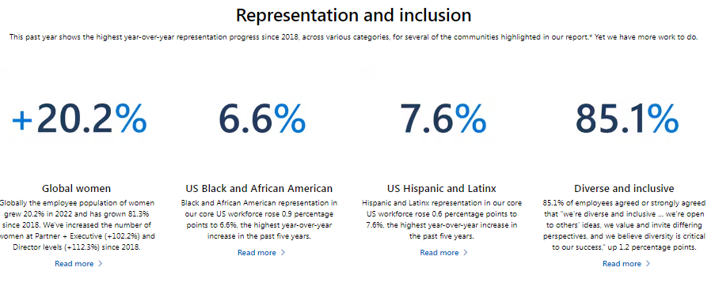

Figure 1: Representation and inclusions of Microsoft
(Source : Microsoft, 2023, iii)

2.3 Definitions of major concepts
Strategy
Strategy is a Greek word which means the art of troop leaders or an office of command, general and generalship. It refers to general plans that are achieved by one or more than one person or group under conditions of uncertainty. Strategy is also utilized as a comprehensive way to pursue political ends by involving actual use or threats in the process of wills. Strategy is an essential factor as it is associated with achieving goals and setting goals by prioritizing and predicting actions to mobile resources and executing them according to those actions. A strategy is also intended to emerge activities of an organization to adapt to the environment which will bring competitive advantage for that organization through activities such as strategic planning and strategic thinking. A company plans strategies that will generate market value with limited cost. The competitive advantage will be the outcome of the profit and strategic planning depending on the activists in the value chain (Lesort et al., 2020). Furthermore, firms make a competitive advantage by analysing and choosing such activities where they will be able to compete and maintain the cost arrangements differently than other firms for making a visible change or transformation in the same industry. Strategic planning brings an advantage by which firms are able to choose the right method to execute and generate value.
Business level strategy
It is referred to as strategic planning which a business has to undertake for developing a process that will generate value for the consumers and will be able to distinguish themselves from the competitors. Business-level strategy is to achieve sustainable competitive advantage and become successful in the market by executing the strategic plan. Business-level strategy is more focused on generating value and having a competitive advantage for the business. Hence it is seen that business-level strategy is an outline that will make a company compete effectively in the market and will serve as the foundation for the overall company’s strategy.
Business-level strategy is about predicting and determining how to compete and be successful in the market (Olson et al., 2021). The business level strategy helps to articulate many operations that can be implemented to achieve success as per business goals. There are several reasons why businesses adopt strategies that will let the organisation thrive in the industry and the operation they perform. These are, understanding the difference from competitors, decision-making ability, improving focus and evaluating the target market, long-term planning, and growth and development. Business level strategy plays a crucial [part for organizations as it supports and motivates them towards the right direction and helps in the growth of the existing resources by putting effort. Adopting this strategy gives a competitive advantage to achieve the overall goals of a particular organisation.
Competitive Advantage
Competitive advantage can be defined as the aggregate of several terms that distinguish potential competitors and gives them a unique and higher position in the market. Several dimensions of competitive advantages are innovation, differentiation and low-cost leadership (Udriyah et al., 2019). Market orientation should bring a competitive advantage to accelerate business performance in the industry. Hence, there’s a positive correlation between market orientation and competitive advantage. The factors of competitive advantage are responsible for a company to produce goods and products to optimise services in a cheaper way than other rivals. This allows the productivity entity to make more sales. Compete advantage is related to a variety of factors are structural cost, branding, the product quality of the offerings, network distribution and customer service. A competitive advantage makes a product and service more attractive and wanted, by the customers than the rival companies. A company is able to produce more efficient items which makes a value for being unique and higher than other companies.
Porter’s generic strategies for internal analysis
This strategy describes the ways a company makes a competitive advantage and beats its rivals in the marketplace. This concept was first introduced by Michael Porter in the year 1980. This strategy targets three main aspects that are cost leadership, differentiation and focus. These three strategies are applicable to any type of business. Porters’s generic strategy forms an interaction between cost minimisation, product differentiation and market focus strategies of organizations (Islami et al., 2020). This Porter’s analysis and strategy are tied to firm performance and strongly resemble prospector strategy and strategy to cost leadership. There are some types of competitive advantages which analyse the scopes that an organization must achieve to give a better performance in the industry. Overall, Porter's generic firm strategy targets customers by offering quality products at lower prices which is a cost leadership strategy. Secondly, It targets customers who prefer higher quality and high prices which makes them stay competitive. This strategy is a differentiation strategy. And the other is focus strategy where firms offer low-cost products which is the only target to succeed in the competitive market. Companies that adopted this strategy were able to achieve the highest market position to gain a competitive advantage and focus on furthering new perspectives.
Pestle for external analysis
A pestle analysis is broad fact relevance activity that explores the external factors which impact organisational performance and decisions that will help the organisation to maximize their performance and reduce potential threats. There are six major factors that influence this analysis (Simões, 2020). They are political, economic, social, technological, environmental and legal factors. Through analysing the external environment, the pestle analysis helps in business planning in the right direction through positioning, growth, targets and risks related to productivity. This helps in evaluating the value and validity of existing products and services for new product development. Workforce planning and marketing planning can be executed through this analysis. This also identifies the gaps, challenges and issues and displacements or job reduction. A pestle analysis can bring organizational change with strategies, reports and projects to deploy a broader organization strategy. A pest analysis gives a detailed insight into data and information that are collected to show the possible impacts and outcomes with more data-driven results.

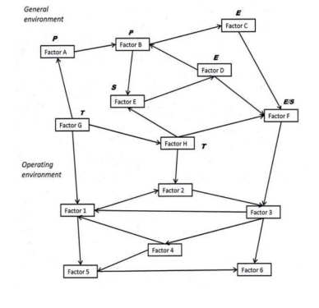

Figure 2: Pestle Analysis Diagram
(Source : Simões, 2020)

3. Discussion

3.1 External analysis
PESTLE Analysis
P-Political factors | The increase in the agreement of the international trade market has become a barrier to the industry (Jefferson, 2023).
E-Economical factors | The considerable economic stability in the country has helped the company to grow its share and market value (Sutton and Williams, 2023).
S-Social factors | The increasing cultural diversity of the country imposes a threat to the information and technology sector (McKelvie and Zimmermann, 2022).
T-Technological factors | The increasing amount of online transactions has become a source of tension for the country as there might be cybercrime attacks (Statista, 2023).
L-Legal factors | The increase in electronic waste in the country (Semuels,2019).
E-Environmental factors | The increase in customer preference for green products (Marketing-and-comms, 2022).
Table 1: PESTLE analysis
(Source:Self-Created)
Political factors
The USA is known for its huge variation in the field of politics. However, the country is also known for the stability that it portrays and the profit companies gain from it. Moreover, the stability in the political standard has helped the technological market to gain worldwide opportunities that help them to increase their investments and also their business (Azmeh et al. 2020). Moreover, such political stability and the presence of fair plans that the government holds towards the technological market have helped the market to gain many foreign trade agreements. However, the growing trade agreements have become a factor of concern for the technology industries. With the involvement of other foreign firms in the market, the competition in the market would also increase. This increase is able to pose a serious threat to the information and technology industry as the existing companies in the industry continue to face serious challenges from foreign firms.
Economical factors
The economic stability in developed countries like the USA has become a factor that poses benefits to the technological industries and helps them to spread their business in various portions of the world. Moreover, the technology industry can also expect sustainability in their business performance keeping in mind this particular kind of market (Chowdhury et al. 2022). Moreover, the information and technology industry also helps in giving a definite boost to middle-class income that is generally neglected by all other sectors or industries. With the help of the strategic address that the industry makes, many companies gain a strategic threshold in the economic market. With the rapid change in the economic market and the continuous development that they face in developed countries like the USA, industries like information technology get help in gaining business opportunities. The US stock market is something that is considered to be the most improved and the most advanced one among all other stock markets.
Social factors
Customers play a very important role in the products across all industries. This however is considered as one of the major factors when dealing with the information and technology industry. As this kind of industry mainly revolves around the customer and the satisfaction that they hold towards the products produced, this imposes great opportunity for the industry (Sull et al. 2022). Based on the innovation of the product that they make, the industry could earn favorable points from their customers. Moreover, the further improvement of the product produced would increase the customer satisfaction rate of the industry. The cultural diversity however makes it hard sometimes to actually incorporate the kind of demands or innovations demanded by the customers. This then becomes a point of rage for the customers. As the USA has people of all kinds of cultures living in it, the cultural diversity thus poses a potential threat to product innovation and customer agreement towards the specified kind of product produced.
Technological factors
Technology varies in all kinds and forms and is always considered something that is easy to adapt. The rapid innovation of the technologies present in mobile is something that is greatly appreciated by people all over the world, as it is easy to use. However, this rapid transformation has made it easy for traditional hardware and software technology to be replaced (Grewal et al. 2020). Other than that many new firms have also seen this rapid change as a scope and entered the competitive market and thus pose a challenge towards the old companies present in the industry. Moreover, the increasing amount of online transactions in the market has created opportunities for the technological industry to develop products that would help customers to have safe and secure transactions. However, technology is changing in such a rapid way that the industry is actually failing to keep up with the regular development and is thus getting exposed to all kinds of cybercrime attacks.
Legal factors
The increase in electronic waste can always result in great criticism that a particular industry might face. Especially when it comes to the technology industry. With the increase in the regulations of waste disposal, the industry tends to gain suitable opportunities that help them to effectively recycle and dispose of the waste that they tend to give out (Seif et al. 2023). However, there also lies factors, like additional challenges that the technological industry might face while addressing the environmental impacts that they tend to pose which becomes a matter of threat for this kind of industry. This factor also tends to disrupt the business of the industry as environmental factors pose a great deal to the customers and makes a huge impact on the kind of decision that the customers would take. The industry also can gain favorable points upon looking after the kinds of issues that the industry makes and in return solving them. The government of the USA has imposed many different laws that could be imposed when taking into account e-waste as the EPR Laws have made it compulsory for all kinds of industries to collect or recycle obsolete waste.
Environmental factors
The customers present in the US tend to focus on the green products produced by the companies that would help the industries to create sustainable standing in actually enhancing the opportunities that the technology industry holds (Hsu et al. 2021). With the help of more green products that the industry aims to develop in the near future, this in turn would help the industry to increase not only its business operation but also would gain the trust of the consumers who are more focused on having a green technological environment. Moreover, consumers nowadays prefer to show satisfaction towards the industry that has a green sustainable environment, especially when it comes to the consumers of the USA.

3.2 Internal analysis
Porter’s generic strategy
According to Torres-Teves et al. (2023), it can be stated that strategies in an organisation are the major cornerstones through which any business plan, as well as functions, can be developed significantly. The model of Porter's generic competitive strategy comprises four effective elements which are differentiation, cost leadership, differentiation focus, and cost focus. In the context of Microsoft, it can be analysed that for cost leadership, Microsoft operates in various markets through which it can gain various groups of customers through which the operation costs are lowered by increasing the profitability of the organisation. This strategy is highly beneficial for the organisation, especially amidst the fast-changing industrial scenario (Nagy, 2022). Operating in various markets allows the organisation to gain cost leadership through which the market share can also expand and increase effectively. Another cost leadership strategy that is incorporated by Microsoft is the way through which it targets only middle-class customers. The majority of the population in the world are middle-class people which increases not only the business opportunities but also increases the sales of the organisation.
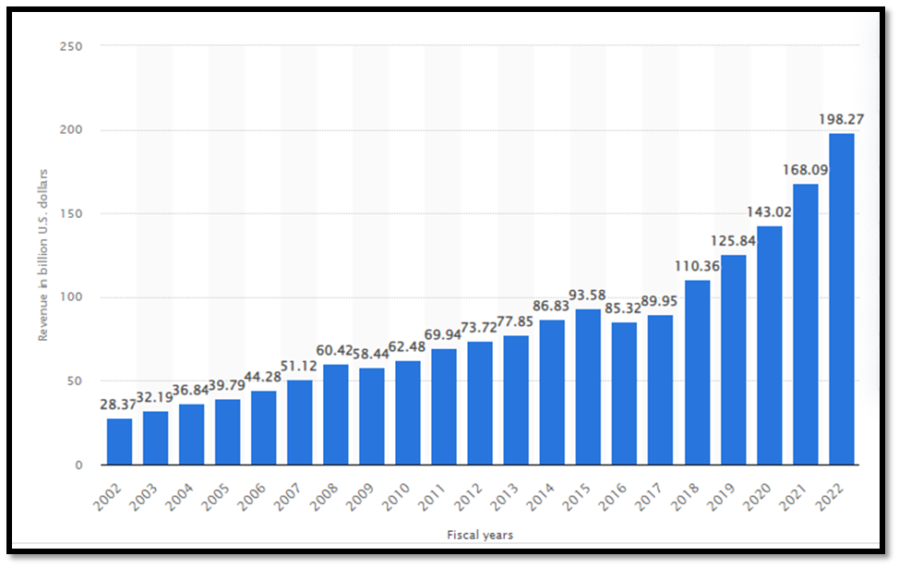

Figure 3: Revenue of Microsoft
(Source: Vailshery, 2023)
From the above figure, it can be observed that the sales and the revenue of the organisation are rising significantly through the incorporation of the cost leadership strategy. For differentiation, Microsoft produces products that are unique in regards to their features like software products that are specially developed and produced for business organisations. According to Rego et al., (2022), through the help of the development of new and unique products, the organisation can lower agility of the organisation. Especially while navigating during a difficult or turbulent market condition, it is the production of new products with unique features can be useful for the organisation. In 2022, Microsoft announced the production of new and unique surface laptops which have features such as enhanced efficiency and increased color palette. Moreover, the organisation also launched an application through which pictures can be generated using AI (The Economic Times, 2022). For the Focus strategy, It can be observed that Microsoft uses niche marketing and also focuses on saving the resources of the organisation. According to Paturkar and Deshpande, (2020), it can be analysed that Microsoft can acquire communication with customers through niche marketing. Moreover, Microsoft is also seen to be forming acquisitions through the new software launch. Further, it can also be observed that Microsoft has a comparable-oriented system through which it can enhance the R&D of the products through which the differentiation, as well as the cost, is focused effectively. Through focus differentiation, Microsoft has also introduced Live Messenger through which the messagability is increased in the organisation. However, on the other hand, for cost focus, Microsoft incorporated a merger with Skype in 2011 through which the organisation was able to lower operational costs (Paturkar and Deshpande, 2020). Through the help of this differentiation focus and cost focus strategy, the organisation can increase market opportunities by also enhancing the market share all across the world.
Impact of the current strategies on the organisation
The above-discussed strategies of Microsoft have developed positive as well as negative impacts on the organisation. From the above, it can be observed that the organisation has been developing different and unique products. It can also be seen that Microsoft is planning to introduce AI in various applications as it has already launched an application (Sehgal et al., 2020). Microsoft is trying to empower workers and employees through the introduction of AI which has helped the organisation to overcome its challenges and also helped the organisation to thrive in the technological market of the USA. Moreover, it can also be assessed that although the organisation's biggest target market is the middle-class people, however, it can be observed that during the pandemic, the organisation faced a huge loss due to the lack of proper sales and also due to the increase in the price of production and operation. Moreover, as the organisation operates in various markets, it can be observed that the organisation faced losses due to the high inflation rates and high costs of raw materials. On the other hand, it is the different product ranges that help the organisation to increase its market share and expand itself in various places. Since the pandemic, the market share of the organisation has raised by approximately 55% (Gaus, 2020). Moreover, it can also be seen that after the partnership with Skype, Microsoft has been facing challenges as the organisation has stated that some configuration issues need to be mitigated which is also creating challenges and difficulties for the users of Skype and Microsoft (Carter, 2021). Moreover, it can also be assessed that this issue has created a connectivity issue for the organisation through which the user experience is lowered. Hence, the lowering and disturbing functions of Skype can lead to the lowering image of Microsoft as well. The evolution of the products in Microsoft has developed significant benefits for the organisation through which it helps the customers effectively work especially the employees. Despite the significant mergers and partnerships, it can be stated that the organisation experiences highetinening operational costs in the various markets that also develop regulatory concerns for the organisation. Hence, it can also be evaluated that on one hand, these strategies of the organisation have helped the organisation to increase revenue and profitability. There has been an increase of approximately 7.37% rise in profitability (Macrotrends, 2023). Further, Microsoft has also faced lowered market share and customer churn rates due to the lack of proper services. The Customer churn rate of Microsoft is currently 4.5% (Cloud Blogs, 2020). The strategies have positively impacted the growth of the organisation. Furthermore, the incorporation of AI in the application allows the organisation to innovate effectively. Despite the investments in AI, the organisation has faced several issues regarding the issues that have been found in the applications which has also increased the number of customer complaints.

4. Strategic options and recommendations
BCG Matrix for strategic options
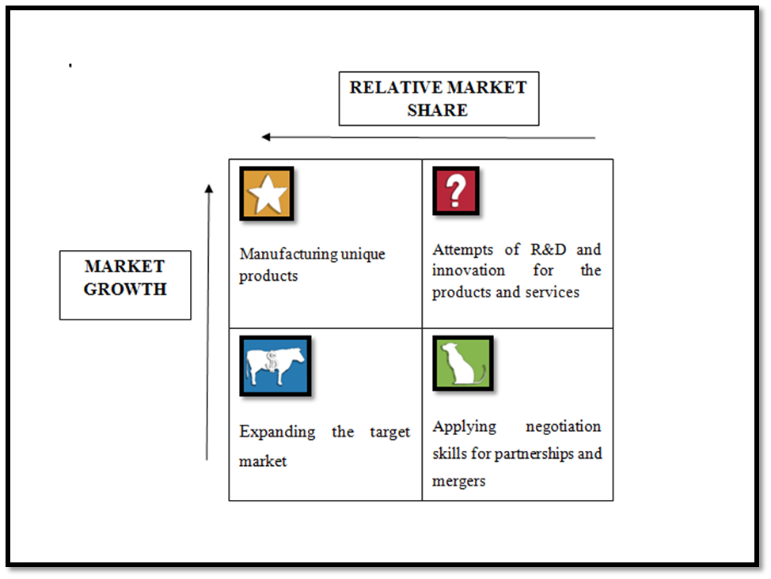

Figure 2: BCG Matrix of Microsoft
(Source: Created by Self)
From the above figure, it is evident that there are many strategic options for the organisation through which the organisation can improve its products and services in the market and also expand its market share. The strategic options for Microsoft are as follows:
Manufacturing Unique Products: At present, Microsoft is already producing products with unique features. However, Microsoft should manufacture products that have unique characteristics and features. Developing futuristic products can be helpful for the organisation to ensure significant product differentiation. At present, it can be seen that Microsoft has been able to successfully implement technological advancements to develop unique features in the products, however, the organisation can develop effective products through which environmental sustainability can be ensured. This will help the organisation to gain more customers, especially after the pandemic, the customer has become more conscious and aware regarding sustainability within organisations (Panda et al., 2020). This strategy is considered a star as it can help the organisation to increase both market growth as well as market share.
Attempts of R&D and innovation: The R&D can be helpful for the organisation to increase market growth as it can be seen that Microsoft after entering into a partnership, the quality of connectivity through Skype where the customers and users are facing issues and challenges along with difficulties. According to the diffusion of innovation theory, it can be analysed that the incorporation of innovation can be helpful in the market growth of the organisation (Grover et al., 2019). Moreover, it can also be analysed that after the partnership, the quality of services and products have been deteriorating significantly. Moreover, the increased R&D especially in Skype can help increase the market growth which is why this strategy is placed in the Question mark.
Expanding target market: Currently, Microsoft targets middle-class families which limit the market growth and expansion of the organisation. Hence, the organisation can expand the target audience by targeting the employees and also the business organisations that need technological innovation and advancements. This can help increase the market share of the organisation through which the growth of the organisational performances can be ensured significantly in the market. Moreover, market expansion can be beneficial for Microsoft in attracting new customers, establishing multi-revenue streams, and enhancing branding opportunities (Quain, 2018).
Application of negotiation skills in partnerships: Microsoft has entered into many partnerships and mergers where the organisation suffered due to the terms and conditions of the partnership. For instance, it can be seen that after the partnership, the quality of Skype deteriorated which also lowered the image and reputation of the organisation. Hence, through negotiation skills, terms and conditions are required to be formed in the organisation through which the liabilities will be divided and also through which the damages can be improved and worked upon effectively. Further, negotiation skills within a partnership can help maximise the benefits (Mohd Som et al., 2020).
Recommendations
Working on improving Skype and Microsoft Teams with innovative features: It can be observed from the above points that working with Skype has been difficult due to the connectivity difficulties that have been faced by the customers and users. This has created a great concern which has also lowered the image of the organisation. Innovation management and the emergence of innovation are highly necessary for the organisation to increase and enhance its performance in the market (Kusi-Sarpong et al., 2019). Moreover, through the help of effective innovation, many new features can be significantly grown. It has already been seen that Microsoft implements AI in its mechanisms. However unique features of AI should be used to improve the user experiences through which Skype calls can be more secure and the connectivity issues can be solved effectively in the organisation. Further, in this way, the organisation will not only gain new customers but also will be able to rely on the technologies and innovation processes of Microsoft.
Focusing on sustainability: There is a high importance on business sustainability at present especially after the pandemic due to the increased inclination of customer interests towards sustainability (Suki et al., 2023). By practicing sustainability effectively, it can be observed that Microsoft can be able to save and manage resources that are highly required. An increased level of sustainability can be beneficial for the organisation to increase market growth and also to increase thee profitability and overall revenue of the organisation. Through the help of increased sustainability of the organisation, Microsoft will be able to flourish effectively. In the case of Microsoft, it can be observed that the organisation has not developed sustainability strategies properly which leaves it only technological. However, with the application of sustainability, Microsoft will be able o work on important aspects that the customers are interested in.
Eliminating the regulatory concerns: Microsoft has faced some significant anti-trust concerns in its regulatory framework (La Monica, 2019). Hence, the regulatory concerns should be managed effectively through which the organisational environment and behavior can be enhanced. Moreover, according to the contingency theory of management, management is highly required especially when the organisation is facing cognitions or challenges (Kohandel et al., 2023). Hence, elimination of the regulatory concerns can be ensured through the proper implementation of proper and effective management. Further, by eliminating the regulatory concerns, Microsoft will be able to gain a high competitive advantage in the market and also will be able to gain more customers effectively in the market. Regulatory concerns can be easily eliminated through strengthening and reconsiderations of the activities as well as the policies of the organisation through which the challenges of the organisation can also mitigate significantly in the market. In this way, effective market share can be increased through which the image of the organisation will be strengthened in the technology industry.

5. Summary of the recommendations
Microsoft should work on improving Skype and Microsoft Teams with innovative features to improve connectivity issues and solve potential difficulties faced by consumers and users. The use of effective innovation with new features can grow their market and customer engagement. With effective sustainability, Microsoft can save and manage resources for sustainability which will bring market growth and increase the profitability and overall revenue of the organization. The regulatory concerns need to be managed effectively by which organisational behaviours and the environment is impacted positively. Using the contingency theory will be required to mitigate the challenges and cognition the company is facing.

6. Conclusion
This report has given a detailed explanation of Microsoft Corporation, USA. The petal analysis is presented with porters generic strategy and BCG matrix of Microsoft, followed by recommendations that can be utilized by Microsft to enhance their market growth and mitigate challenges to strengthen the company and the whole industry.

References
ALANA SEMUELS(2019): The World Has an E-Waste Problem Available at: https://time.com/5594380/world-electronic-waste-problem/ [Accessed 11 July, 2023]
Azmeh, S., Foster, C. and Echavarri, J., 2020. The international trade regime and the quest for free digital trade. International Studies Review, 22(3), pp.671-692.
Callum McKelvie, Kim Ann Zimmermann (2022): American culture: Traditions and customs of the United States Available at:https://www.livescience.com/28945-american-culture.html [Accessed 11 July, 2023]
Carter, U., 2021. Connectivity Challenges Emerge from DDoS Attack on Microsoft Skype. Available at:https://www.uctoday.com/unified-communications/connectivity-challenges-emerge-ddos-attack-microsoft-skype/ [Accessed 11th July 2023]
Chowdhury, E.K., Dhar, B.K. and Stasi, A., 2022. Volatility of the US stock market and business strategy during COVID‐19. Business Strategy & Development, 5(4), pp.350-360.
Cloud Blogs, 2020. Why focus on subscription churn? Available at:https://cloudblogs.microsoft.com/dynamics365/it/2020/10/30/why-focus-on-subscription-churn/#:~:text=Overall%20churn%20rate%20reduced%20from,a%20total%20reduction%20of%201.5%25 [Accessed 11th July 2023]
Gaus, A., 2020. Microsoft's 3 Biggest Challenges for 2020. Available at:https://www.thestreet.com/investing/microsoft-3-biggest-challenges-2020.
Governor Philip N. Jefferson(2023): Financial Stability and the U.S. Economy Available at:https://www.federalreserve.gov/newsevents/speech/jefferson20230531a.htm[Accessed 11 July, 2023]
Grewal, D., Hulland, J., Kopalle, P.K. and Karahanna, E., 2020. The future of technology and marketing: A multidisciplinary perspective. Journal of the Academy of Marketing Science, 48, pp.1-8.
Grover, P., Kar, A.K. and Janssen, M., 2019. Diffusion of blockchain technology: Insights from academic literature and social media analytics. Journal of Enterprise Information Management, 32(5), pp.735-757.
Herbst, J.M., 2019. Harnessing sustainable development from niche marketing and coopetition in social enterprises. Business Strategy & Development, 2(3), pp.152-165.
Hsu, C.C., Quang-Thanh, N., Chien, F., Li, L. and Mohsin, M., 2021. Evaluating green innovation and performance of financial development: mediating concerns of environmental regulation. Environmental Science and Pollution Research, 28(40), pp.57386-57397.
https://www.microsoft.com/en-us/diversity/default.aspx[Accessed 11th July 2023].
ILIEVA, P., 2021. Implementing Lessons from the Microsoft and Google Sagas to Address Challenges Met with Past Remedial Solutions in the Novel DMA Proposal.
Islami, X., Mustafa, N. and Topuzovska Latkovikj, M., 2020. Linking Porter’s generic strategies to firm performance. Future Business Journal, 6, pp.1-15.
Kohandel, Z., Momenzadeh, M.M., Zamanianfar, L. and Ghafarifard, M., 2023. Ranking Psychological Theories with the Accounting-based Approach to Contingency Management using AHP Technique. Iranian Journal of Finance, 7(2), pp.94-121.
Kusi-Sarpong, S., Gupta, H. and Sarkis, J., 2019. A supply chain sustainability innovation framework and evaluation methodology. International Journal of Production Research, 57(7), pp.1990-2008.
La Monica, P., 2019. How Microsoft is dodging the move to regulate Big Tech. Available at:https://edition.cnn.com/2019/06/25/investing/microsoft-big-tech-regulation/index.html [Accessed 11th July 2023]
Lesort, T., Lomonaco, V., Stoian, A., Maltoni, D., Filliat, D. and Díaz-Rodríguez, N., 2020. Continual learning for robotics: Definition, framework, learning strategies, opportunities and challenges. Information fusion, 58, pp.52-68.
Macrotrends, 2023. Microsoft Gross Profit. Available at:https://www.macrotrends.net/stocks/charts/MSFT/microsoft/gross-profit#:~:text=Microsoft%20gross%20profit%20for%20the%20twelve%20months%20ending%20March%2031,a%2017.06%25%20increase%20from%202021 [Accessed 11th July 2023]
Marc Saltzman(2023): Hurricane season is about to start: Tech can help you prepare for natural disasters Available at: https://www.usatoday.com/story/tech/columnist/saltzman/2023/06/24/tech-help-prepare-hurricane-season/70222607007/ [Accessed 11 July, 2023]
Marketing-and-comms (2022): Majority of US Consumers Say They Will Pay More for Sustainable Products Available at: https://sustainablebrands.com/read/marketing-and-comms/majority-of-us-consumers-say-they-will-pay-more-for-sustainable-products [Accessed 11 July, 2023]
Microsoft, 2023, i. Corporate social responsibility. Available at:https://www.microsoft.com/en-us/corporate-responsibility/[Accessed 11th July 2023].
Microsoft, 2023, ii. Company values. Available at:https://www.microsoft.com/en-us/about/values[Accessed 11th July 2023].
Microsoft, 2023, iii. Microsoft Global Diversity.Available at:
Microsoft, 2023, iv. Press Release & Webcast. Available at:https://www.microsoft.com/en-us/investor/earnings/fy-2023-q3/press-release-webcast[Accessed on 11th July 2023].
Mohd Som, R., Omar, Z., Ismail, I.A. and Alias, S.N., 2020. Understanding leadership roles and competencies for public-private partnership. Journal of Asia Business Studies, 14(4), pp.541-560.
Nagy, B.A., 2022. Comparative analysis of two tech giants under the financial perspective: Microsoft versus Alphabet.
Olson, E.M., Olson, K.M., Czaplewski, A.J. and Key, T.M., 2021. Business strategy and the management of digital marketing. Business horizons, 64(2), pp.285-293.
Panda, T.K., Kumar, A., Jakhar, S., Luthra, S., Garza-Reyes, J.A., Kazancoglu, I. and Nayak, S.S., 2020. Social and environmental sustainability model on consumers’ altruism, green purchase intention, green brand loyalty and evangelism. Journal of Cleaner production, 243, p.118575.
Paturkar, A.A. and Deshpande, A.P., 2020. NEW PRODUCT DEVELOPMENT DURING EMBRYONIC STAGE OF INDUSTRY.
Quain, S., 2018. The Advantages of Expanding Business. Available at:https://smallbusiness.chron.com/advantages-expanding-business-21144.html [Accessed 11th July 2023]
Rego, L., Brady, M., Leone, R., Roberts, J., Srivastava, C. and Srivastava, R., 2022. Brand response to environmental turbulence: A framework and propositions for resistance, recovery and reinvention. International Journal of Research in Marketing, 39(2), pp.583-602.
Sehgal, G., Kee, D.M.H., Low, A.R., Chin, Y.S., Woo, E.M.Y., Lee, P.F. and Almutairi, F., 2020. Corporate social responsibility: A case study of Microsoft Corporation. Asia Pacific Journal of Management and Education (APJME), 3(1), pp.63-71.
Seif, R., Salem, F.Z. and Allam, N.K., 2023. E-waste recycled materials as efficient catalysts for renewable energy technologies and better environmental sustainability. Environment, Development and Sustainability, pp.1-36.
Simões, E.N., 2020. A decision support system application module-for PESTLE analysis-competitive intelligence algorithm (Doctoral dissertation).
Statista(2023): Revenue of the e-commerce industry in the U.S. 2017-2027 Available at: https://www.statista.com/statistics/272391/us-retail-e-commerce-sales-forecast/ [Accessed 11 July, 2023]
Statista.com, 2023. Micrpsoft number of Employees. Available at:https://www.statista.com/statistics/273475/number-of-employees-at-the-microsoft-corporation-since-2005/[Accesed 11th July 2023].
Suki, N.M., Suki, N.M., Sharif, A., Afshan, S. and Rexhepi, G., 2023. Importance of green innovation for business sustainability: Identifying the key role of green intellectual capital and green SCM. Business Strategy and the Environment, 32(4), pp.1542-1558.
Sull, D., Sull, C. and Zweig, B., 2022. Toxic culture is driving the great resignation. MIT Sloan Management Review, 63(2), pp.1-9.
The Economic Times, 2022. Microsoft announces new products. Available at:https://economictimes.indiatimes.com/news/international/us/microsoft-announces-new-products-details-here/articleshow/94819990.cms?from=mdr [Accessed 11th July 2023]
Torres-Teves, A.F., Caintic, P.S. and De Ocampo, M.B., 2023. Understanding Porter’s Generic Competitive Strategies and its Effect on Perceived Business Performance: Evidence from a Credit Cooperative. Asian Journal of Entrepreneurship, 4(2), pp.15-28.
Udriyah, U., Tham, J. and Azam, S.J.M.S.L., 2019. The effects of market orientation and innovation on competitive advantage and business performance of textile SMEs. Management Science Letters, 9(9), pp.1419-1428.
Vailshery, L.S., 2023. Microsoft's annual revenue worldwide from FY 2002 to FY 2022. Available at:https://www.statista.com/statistics/267805/microsofts-global-revenue-since-2002/ [Accessed 11th July 2023]

