Signal Conditioning Design
Evidence Provided



Nathan Evans
Electrical and Electronic Engineering / Electrical Engineering
Submitted to: Stalin Jacob Wilson Packia Dhas
UWTSD – Waterfront Campus
12/01/24

Analysis of an RLC network

Contents Page:

The following report will demonstrate competence in the following areas.

 | Page Number
- Abstract | 3
- Introduction | 4-5
- Method | 6-9
- Results | 10-12
- Discussion | 10-12
- Conclusion | 13
- References | 14

The work of this report completed under the supervision of (Stalin Jacob Wilson Packia Dhas). I declare that this report is the product of my own work and is not being submitted for any other degree.

N. Evans

Abstract

The following report demonstrates a range of electrical related theory being implemented into practical value. The student focus’ specifically on an RLC circuit, with a demonstration of power factor correction (PFC) being effectively applied to increase energy efficiency. The report contains all calculations, formulas, and results to achieve a power factor correction of >0.95. In addition, relevant topics are covered that are relevant to PFC, these being resonance, maximum power transfer and their relations to PFC.

Introduction

The main purpose of this report is to show and demonstrate how power factor correction is applied to RLC circuits, ultimately to improve the circuit performance and current consumption rate. It is important to understand the background theory before indulging into the practical aspect of RLC circuits and PFC. This report delves into three fundamental concepts. Power Factor Correction (PFC), Maximum Power Transfer Theory, and Resonance. The report covers their individual significance and also the goes onto how they all interlink.

Parallel RlC circuits are used for countless applications in the world of electronics. The primary use in this report is to demonstrate PFC but some other uses would be, Current magnification and induction heating, filtering, tuning and audio equipment [1]. In electrical engineering, the efficiency and performance of power systems are critical considerations. Engineers are constantly aiming to enhance the efficiency of power transmission, distribution, and consumption.
The report goes into depth about multiple electrical related theories and techniques that are applied in everyday life. For example, the use of power factor correction and maximum power transfer theory are heavily discussed along with the relevance to the chosen circuit. It was deemed that power factor helps improv ethe overall quality of the power flowing through the circuit which intern reduces the load on the system. [2]
After covering PFC, the report covers, maximum Power Transfer Theory. This is a fundamental principle in electrical engineering that addresses the optimal transfer of power between a source and a load[3]. This theory is particularly relevant in the design of electrical circuits and systems, where engineers aim to extract the maximum possible power from a source and deliver it to a load.
The resonant frequency of an RLC circuit is the frequency at which the amplitude of the current is a maximum and the circuit has potential to oscillate[4]. In electrical systems, resonance can lead to undesirable consequences, such as increased current and voltage amplitudes, which may result in equipment damage and power quality issues.
The links between Power Factor Correction, Maximum Power Transfer Theory, and Resonance become evident after achieving the results requires. PFC devices, typically capacitors and inductors, can influence the impedance characteristics of a system, impacting the conditions for maximum power transfer and susceptibility to resonance.

Tasks

Task 1
- Analogue graph showing voltage against time, allowing for the calculation of phase difference.
- Calculation of active, reactive, and apparent power
- Calculation of Power Factor
- Calculation of a suitable capacitor value to correct the power factor of the load to greater than 0.95.
- Graph to show power factor against capacitor value.
- Graph to show phase angle against capacitor value.
- Description of what happens to the energy stored in the capacitor and inductor as it closes to 1.
Task 2
- Phasor diagram at 25Hz below resonance.
- Phasor diagram at resonance
- 25Hz above resonance
- 50Hz
Task 3
- Discuss how task 1 relates to resonance.
- Discuss how task 1 relates to maximum power transfer.

Method

It begins with a virtual schematic of an RL circuit with a Sine pulse wave generator and a resistor labelled Rsrc, which was placed to simulate the internal resistance of the sine generator. These were then followed by the placement of voltage and current probes which were used to measure voltage against current on an analogue graph. Finally, the two components which make the circuit an RL were added, those being a Resistor (13Ω) and an Inductor (106Mh). These values were then used to simulate an analogue graph. Both the circuit and graph can be seen below.

- Using the graph shown in figure 2, this allowed for the calculation of the phase difference between voltage and current. The formula used to calculate the phase difference is $∆t/T$
- $∆$t - was calculated by measuring the time difference between (θ) the voltage and current
- T – was 20ms

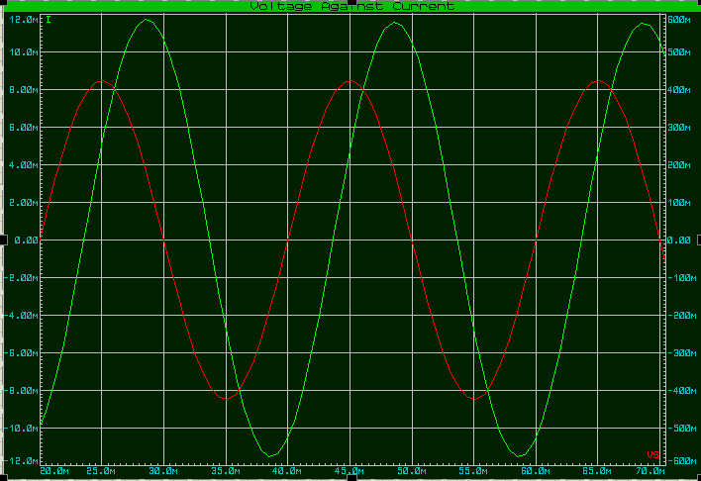
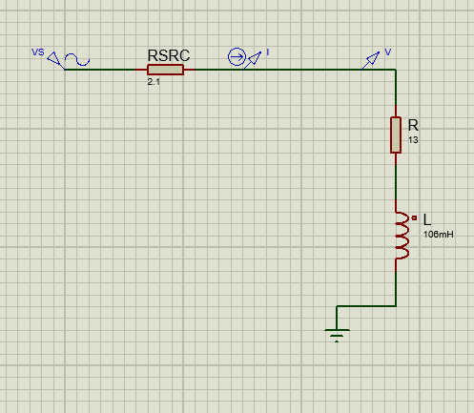

Figure 2: Analogue graph showing voltage against current.
Figure 1: Initial RL circuit

- Following on from the calculation of the phase difference (θ), this allows us to calculate the active, reactive, and apparent power. The formula for each as follows.

- Active Power – VIcosθ
- Reactive Power – Visinθ
- Apparent Power – $\sqrt{{\left(Active Power\right)}^{2}}+\sqrt{{\left(Reactive Power\right)}^{2}}$

- This then allows us to calculate the power factor by using the formula $\frac{Real Power }{Apparent Power }$

- To calculate a capacitor value to improve power factor correction. It was determined that a phasor diagram would be needed.
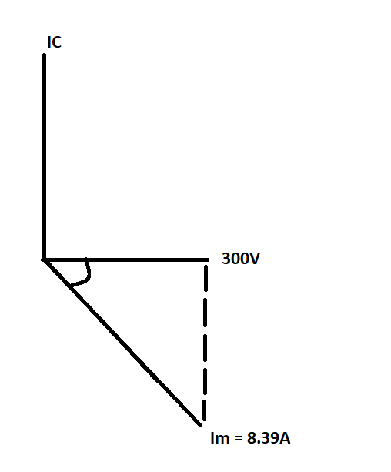

Figure 3: A phasor diagram

The above diagram allows us to calculate the capacitor value for power factor correction. Firstly, the student uses Trigonometry to calculate the opposite angle (The dashed line).
This is calculated by the formula – Sin = $\frac{Opp}{Hyp}$ = $\frac{Ic }{Im}$
Ic = ImSin(θ)
C = $\frac{Ic}{2πFV}$

- Graph to show power factor against capacitor value.

- Graph to show Phase angle against capacitor value.

Energy stored as PFC is close to 1.

- As the power factor gets closer to 1 in an AC circuit, both the capacitor and inductor begin to store energy efficiently. While they share this common ground, there are some key differences in how they store and transfer energy.
Capacitors store electrical energy in an electric field. Once the power factor is as close to 1 as possible, the current and voltage waveforms begin to be in phase, meaning the circuit is running efficiently. Capacitors store energy during the charging cycle and then release the energy during the discharging cycle.

Inductors store energy in the form of a magnetic field. As the power factor hits 1, the current and the voltage are in phase which is like how the capacitor functions. This ensures efficient energy transfer between the inductor and the source.
To summarise, the capacitor and inductor both store and release energy more efficiently when the student achieves a power factor close to 1 This can be seen in figure 4 below. This efficient energy transfer is the result of the voltage and current being in phase.
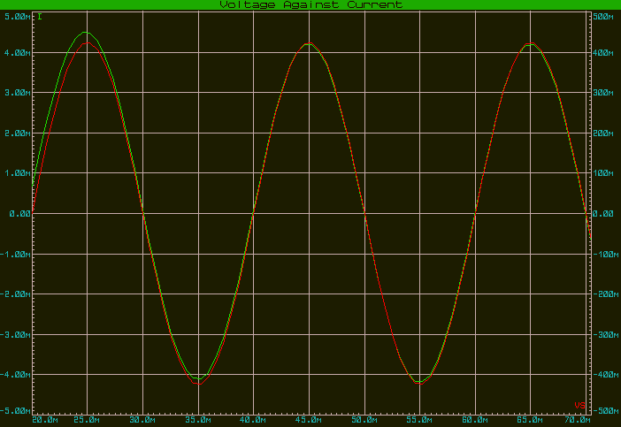

Figure 4: Shows the voltage and current in phase with a power factor correction close to 1

Results & Discussion
Figure 5 – Shows a table of results used to calculate a suitable capacitor value to implement a PFC of >0.95
Column1 | Results
Voltage RMS | 300
Current (ILR) | 8.39
Inductor | 0.106
Frequency | 50
Resistance | 13
Capacitive Reactance (Xc) | 38.44
Inductive Reactance (Xl) | 33.30088213
Impedance (RL) | 35.74840906
Current | 8.391981849
Current RMS | 5.934027273
Phase Angle | 68.67531836
Real Power | 647.3772392
Reactive Power | 1658.325626
Apparent Power | 1780.208182
Power Factor | 0.363652547
IC | 7.815575808
C | 0.000082926

Many elements, such as the components in the circuit, their quantities, and the applied frequency, affect how an electrical system behaves. Resistors, inductors, and capacitors are components of the circuit in Task 1, and their interactions determine the outcomes of the results shown in the table above.
Power factor correction is a key component of the outcomes. The efficiency with which electrical power is transformed into usable work output is measured by the power factor. Reactive components such as capacitors and inductors generate a phase shift between the voltage and current waveforms in AC circuits, which affects power factor.
The power factor in the circuit has been adjusted by adding a capacitor in parallel with the load. Inductive components provide a lagging current, which capacitors offset by introducing a leading current. Making this adjustment is essential for maximising system power consumption and avoiding utility company fines for low power factor.

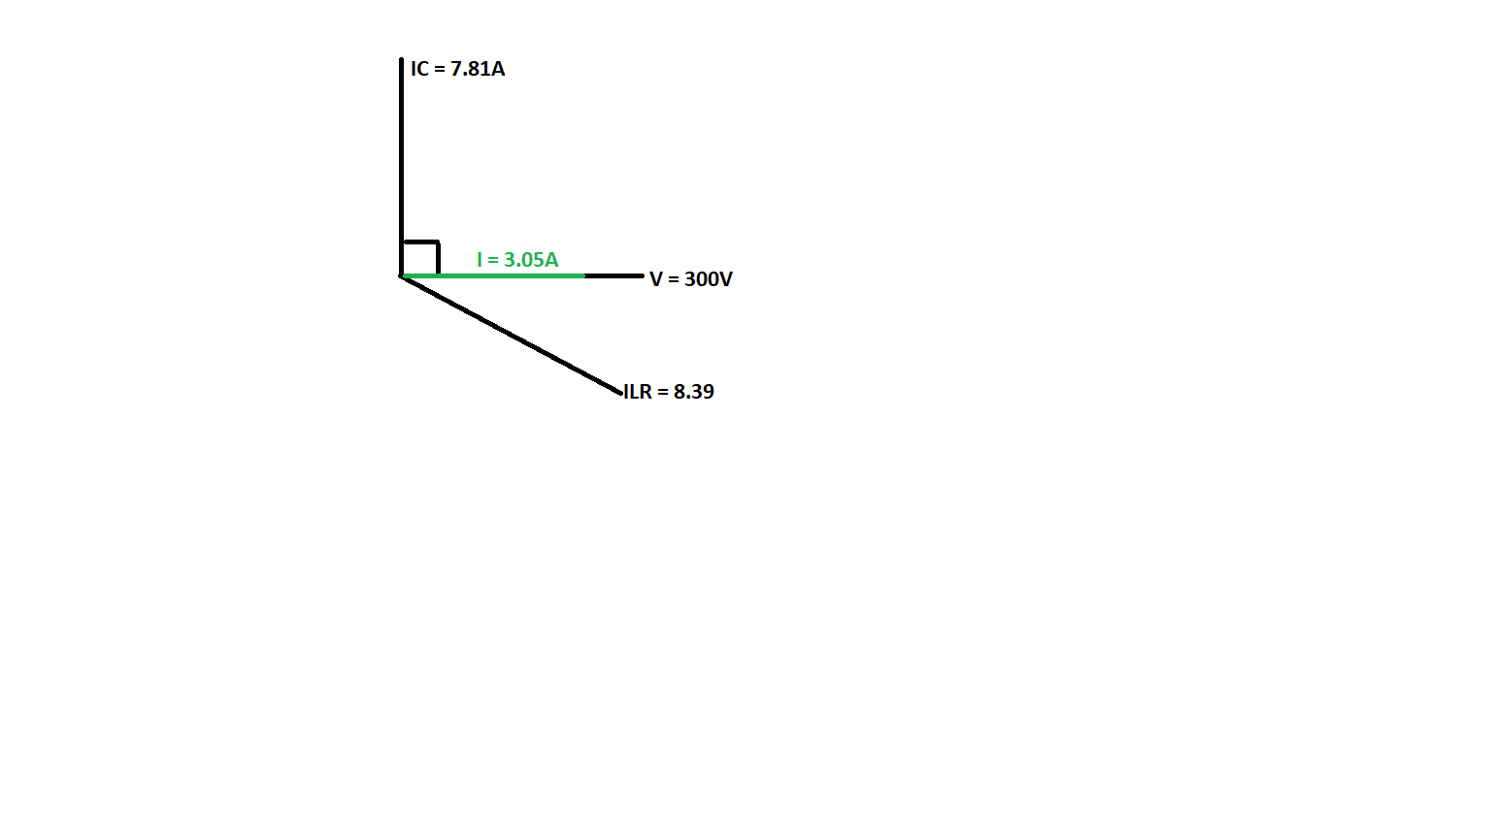
Results

Column1 | Column2
I @ 25Hz Below | 4.527886071
I @ Res | 3.090846173
I @ 25Hz Above | 5.399145272
I @ 50Hz | 3.051084625
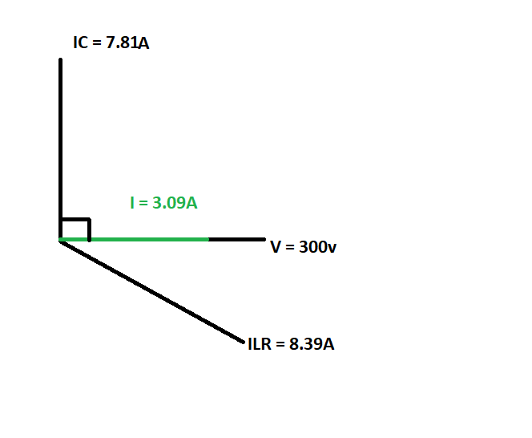
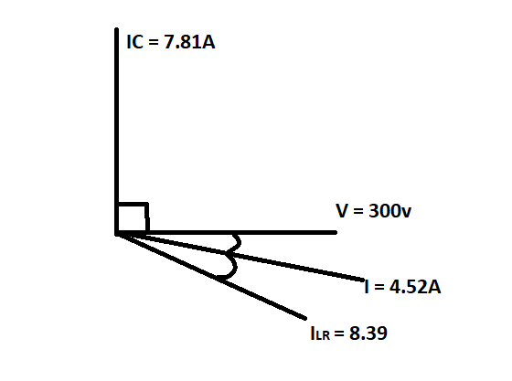

Phasor Diagram at resonance
Phasor Diagram to show 25Hz below Resonance.

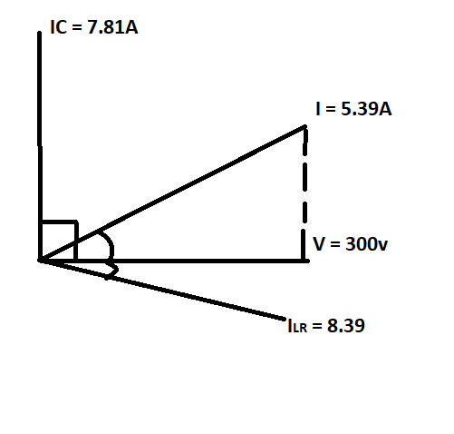

Phasor Diagram to show 25Hz above Resonance.
Phasor Diagram at 50Hz – Baring in mind the resonant Frequency is 53.68Hz

Results & Discussion
Knowing the connections between resonance and maximum power transfer is crucial when it comes to power factor correction in an AC circuit that uses a capacitor.
Resonance:
The state in which the capacitive reactance (Xc) of the capacitor and the inductive reactance (Xl) of the inductor in the circuit are equal is referred to as resonance. [5] As soon as these two reactance’s are equal, the circuit becomes resistive since they cancel each other out. A resistive circuit is one which “A resistive circuit opposes current directly”[6]
To offset the inductive impact in a system and lower the total inductive reactance, power factor correction capacitors are frequently added. Resonance may not always be the aim of power factor correction, but it's still crucial to make sure the capacitor is the correct value to handle the inductive component and raise the power factor.
Resonance happens and the circuit turns entirely resistive if the frequency of the AC source is such that the capacitive reactance and the inductive reactance are equal (Xc = Xl). Capacitors used for power factor correction are typically sized to prevent this from happening.

Maximum Power Transfer:
When the load's impedance equals the source impedance, maximum power transmission takes place. This indicates that in an AC circuit, the load impedance should be equal to the complex conjugate of the circuit's total impedance.[7]
By correcting for the inductive component, a power factor correction capacitor is added with the intention of lowering the circuit's overall impedance and moving it closer to a purely resistive condition. Power factor correction primarily aims to lower reactive power and increase power factor, but it also indirectly influences maximum power transfer by minimising the total impedance that the source perceives.[8]
In conclusion, power factor correction capacitors are used to minimise reactive power and increase power factor by lowering the inductive reactance of a circuit. The main objective was to prevent achieving resonance. This was achieved by calculating the correct capacitor value. Furthermore, power factor adjustment reduces the overall impedance that the source perceives, which has an indirect impact on maximum power transfer.

Conclusion
To conclude, the student confirmed that power factor correction is very important in the realm of electronics. Knowing how to design and implement power factor correction plays a huge part in modern electronics having two fundamentally huge benefits of, saving energy costs and increases energy efficiency. [9]It was also deemed that the resonant frequency was very close the original frequency of 50Hz. It was also discovered that parallel resonance occurs.

[1] Title: RLC Circuits - Southern University, https://www.subr.edu/assets/subr/ElectricalEngineering/TargetedInfusion/Files/ENGR-120_RLC-Circuits.pdf
[2] Voltimum, “Power factor correction – what is it? why is it required? how is it achieved?,” Electrical Apprentice, https://electricalapprentice.co.uk/power-factor-correction-what-is-it-why-is-it-required-how-is-it-achieved/

[3] Author Cadence PCB Solutions et al., “Maximum power transfer theorem in circuit design,” Cadence, https://resources.pcb.cadence.com/blog/2019-maximum-power-transfer-theorem-in-circuit-design
[4] Libretexts, “15.6: Resonance in an AC Circuit,” Physics LibreTexts, https://phys.libretexts.org/Bookshelves/University_Physics/University_Physics_(OpenStax)/Book%3A_University_Physics_II_-_Thermodynamics_Electricity_and_Magnetism_(OpenStax)/15%3A_Alternating-Current_Circuits/15.06%3A_Resonance_in_an_AC_Circuit).
[5] “Determining Series RLC Circuit resonance frequency - technical articles,” EEPower, https://eepower.com/technical-articles/determining-series-rlc-circuit-resonance-frequency/#:~:text=Resonance%20in%20a%20series%20RLC,current%20and%20a%20minimum%20impedance.
[6] “Just a moment...,” Fundamentals of Electricity, https://c03.apogee.net/mvc/home/hes/land/el?utilityname=citizenselectric&spc=foe&id=4573#:~:text=A%20resistive%20circuit%20opposes%20current,winding%20creates%20an%20electromagnetic%20field.
[7] The complex conjugate - mathcentre.ac.uk, https://www.mathcentre.ac.uk/resources/sigma%20complex%20number%20leaflets/sigma-complex6-2009-1.pdf
[8] Admin, “Maximum power transfer theorem - thevenin’s resistance, faqs,” BYJUS, https://byjus.com/physics/maximum-power-transfer-theorem/#:~:text=Asked%20Questions%20%E2%80%93%20FAQs-,What%20is%20the%20Maximum%20Power%20Transfer%20Theorem%3F,resistance%20of%20the%20available%20source.
[9] Voltimum, “Power factor correction – what is it? why is it required? how is it achieved?,” Electrical Apprentice, https://electricalapprentice.co.uk/power-factor-correction-what-is-it-why-is-it-required-how-is-it-achieved/#:~:text=It%20reduces%20the%20load%20on,instability%20and%20failure%20of%20equipment.

