Research in Practice . Dissertation Proposal. basketball, Branding and colours.

Student Name: Deimantas Salvys

P Number: 2306866

Programmeof Study: Graphic Design

Module: Research in Practice

Lecturer: Donna Williams

Word count (2319)

Research about 3 personal interesting keywords (basketball, Branding and colours used withing graphic design)

Context
I have chosen these 3 keywords as these are my personal interest when it comes to graphic design. I have chosen these keywords mostly because i want to learn and find out more about how graphic design is used within these keywords and get a more understanding to help me in the feature. I will be examining their practical applications, cultural significance, and the impact they have both for designers and consumers. To be clearer i will investigate how the use of graphic design influences the world in basketball through the design on team branding and social media identities, i will also be investigating the role of branding and how graphic designers help through their designs in strong visual presence for companies, events, and individuals and look at how design choices help communicate the values of the company to the viewers. And lastly i will be looking at how the colour is used within the graphic design world and how colour has a lot more of a meaning than just a colour, i will research hopw a colour gives an emotional effect to the design and how colour theory is used to enhance messages to create meaningful connections with the audience.

Basketball
In basketball there are huge jobs for graphic designers, from creating logos, to creating promotional posters/billboards to even the court that the players play on, but most importantly is the logo, NBA team logos are the foundation of a team's brand identity. The job for a graphic designer is to create a logo that is visually relevant and resonate with the fans and make sure that the logo is representative of the past and the feature which must have tribute to the historical past (Morell, 2019). Colour plays a huge role in the team's logo let's look at New Orleans Pelicans. They have 3 main colours which represents the Louisiana Flag. Each colour on the flag was created with a meaning behind it where colour blue represents “a symbol of freedom”, Red “evokes brotherhood” and Gold gives “a majestic look”. As shown in fig 1,
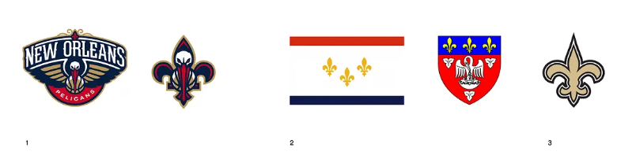
Fig 1
NBA teams do not only use colours to represent and give a meaning behind their team logos, but they also use symbols, usually an intimidating animal and some of these symbols have a meaning behind their team for example New Orleans Hornets, the hornets refer to the “Resistance of Charlotte to the British Empire during the American Revolution” (Morell, 2019). And another popular team that many NBA fans know of is the Chicago Bulls. Chicago was a platform for the “exchange of beef produces in the south of the country and destined for urban areas on the Atlantic coast” (Morell, 2019).
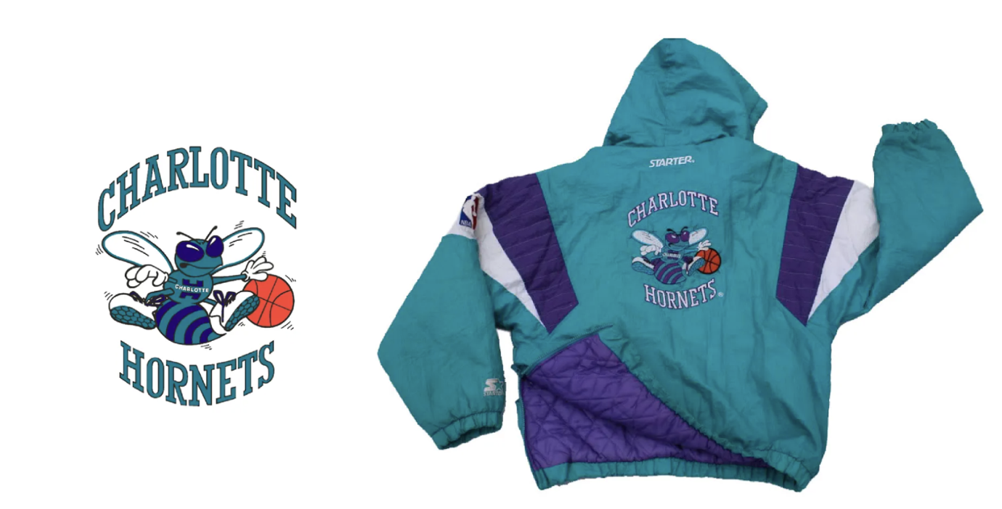Fig 2
In 1988 a team named Charlotte Hornets became a very popular team in basketball but this was not because of how they played but all to do with the logo and the colours that were used for their team as shown in fig 2, they had a fashion designer named “Alexander Julian” who was known for “incorporating bright colours into high-end men’s clothing” (Morell, 2019) he invented a colour scheme for the team that lit up the basketball world by using the turquoise colour with the creation of the identity logo and uniform which then moved on to influencing other sport teams like San Jose Sharks in NHL, the Florida Marlins in MLB and the Jacksonville Jaguars in NFL.
But the graphic design world in the NBA is not just logos and colours for their identity a big role is played in game day and arena visuals, these visuals can be jumbotron animations, scoreboard graphics, and pregame hype videos, graphic designers generate excitement by creating motion graphics, highlights and dramatic effects that use highlight from previous games to be shown before the game to get it hyped and also using clips during the game to be displayed to the viewers through tv or even during the game on the big screen this builds the anticipation and immerses the fans into the games (Morabito, A. 2022).
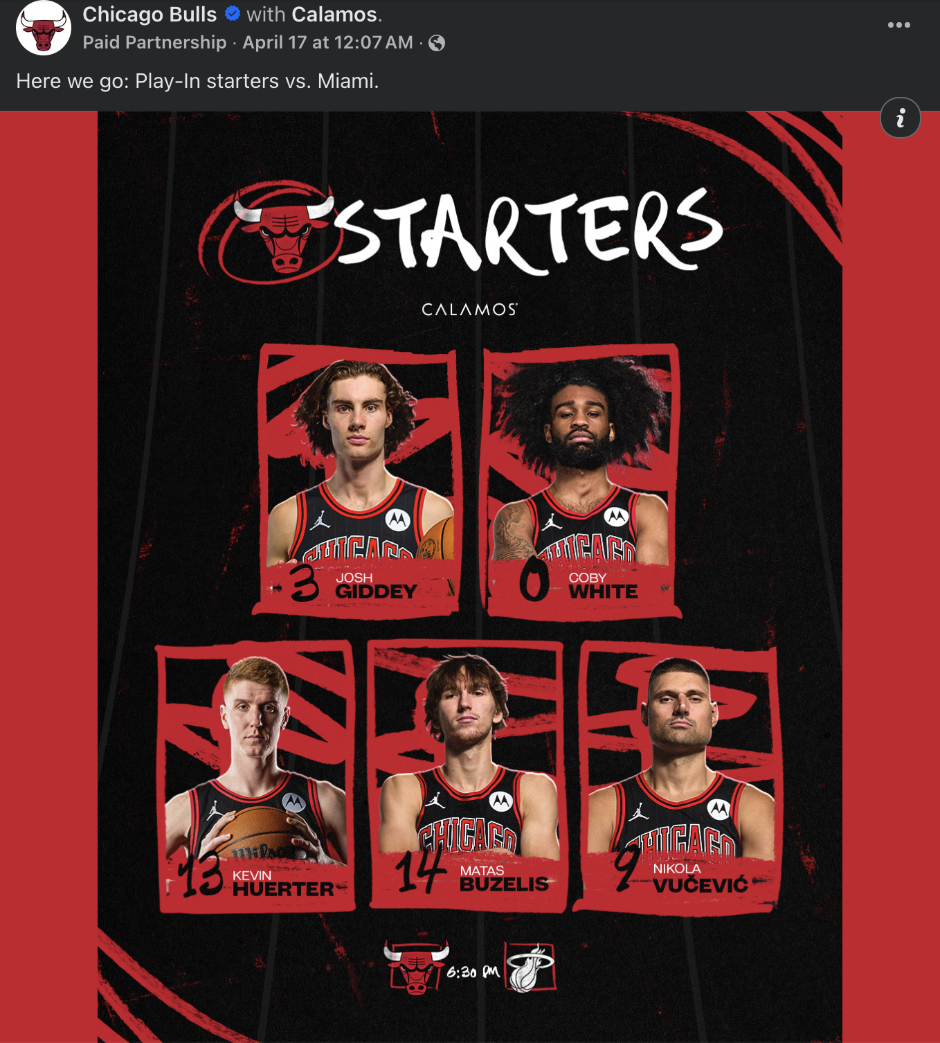Fig 3

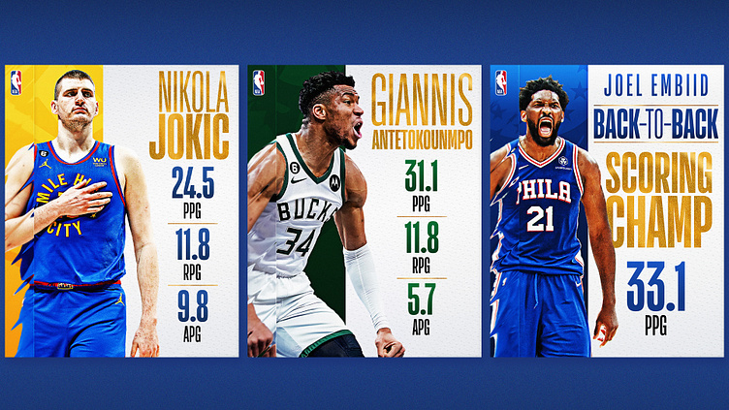
Social media has become one of the most used platforms for any sort of promotion and defiantly for NBA teams and players, NBA teams specifically now have a whole creative department where they have certain people working on certain platforms for promotion, this may be producing content such as game previews, scores, player stats, memes, and community events for the viewers (Bembry, J. 2021). Sporting events such as basketball is not Soley just about the game it’s about the experience, the brand and spectacle and this is done by a graphic designer. There are multiple roles when it comes to designing for a sports team from team logos to promotional materials (Mondragon, n.d.) Every sports team have their own unique identity this is done using a logo and certain colours or assets inside the logo which reflects the team’s spirit, history, and ethos which leads to the fan’s attachment to the team. This then leads to designing merchandise for these fans to show a bigger attachment and support to the team, designers have to have a clear understanding of the team and have to ensure that the merchandise is “appealing and conveys the teams identity” (Mondragon, n.d.) which has to also be stylish that can be worn as an everyday fashion which will also show fan loyalty. Another important role for a graphic designer for the NBA is marketing campaigns for games, this includes seasonal graphics, or special events. These rely heavily on graphic design as shown in fig 4.

Fig 4
Graphic designers also must design posters, flyers, digital ads and billboards to capture viewers’ attention and create excitement in the atmosphere to impact and rise ticker sales and viewership’s. another crucial graphic designer job is to make sure that the fan experience extends to digital platforms especially in the current generation where “45.77 million followers follow NBA on twitter” and “39.85 millions fans follow NBA on Facebook” (Statista, NBA social media fans/followers) this proves that this is a crucial platform for fan engagement, this is where a graphic designer will need to create eye-catching posts, infographics and animations that engage with their fans this will allow the fan base to increase and boost online interactions.

Branding
Graphic design is one of the most crucial parts of branding. Without a good graphic designer, you will not have good branding and most commonly a business or an organization is well known for their excellent branding. A strong built brand identify has the biggest importance of a graphic designer, for good branding you need a creation of “eye-catching and memorable logos and use of colour psychology in branding, branding a graphic design go hand-in-hand” (EDDY, 2024). Many people may thing that branding is all to do with graphic design but this can be a bit misleading, and you may ask so where does graphic design skills come into the branding world?, yes graphic design plays a huge role in having a good brand for example graphic design may be used to carry out brand designs inspirations in the form of, logos, brand colour schemes, overall design styles, photography, website graphics (EDDY, 2024). Graphic design does not just come when you need to be branded companies after sometimes do need a refreshing and this where rebranding comes into play where again the graphic designers will take over, the main reason is why should an established company rebrand? The reasons are that some businesses may have an identify that is being outdated to the merging or acquisition by another business and if rebranding is done carefully and correctly it can push the business away from the competition and make that stand out more and it can better align a brand with a target audience (EDDY, 2024). When rebranding by using the correct research and establishments of core brand elements, designers and marketers it can build the business to the greatest chances of success. Iconic brands with strong Visual Identities
Apple – Most of the world know about this company and their iconic apple logo as well as their sleek black, gray and white colour scheme.
Nike – nike is one of the most successful clothing brand companies and is mostly recognize by the “swoosh” logo.
Coca-cola – this is one of the longest lasting red and white colour schemes and the logo has remained unchanged over the years. This has created one of the longest consistent brand styles that is known and loved by many.
This was sourced from an article EDDY (2024). Available at: https://www.rmcad.edu/blog/the-importance-of-graphic-design-in-branding/.
Colours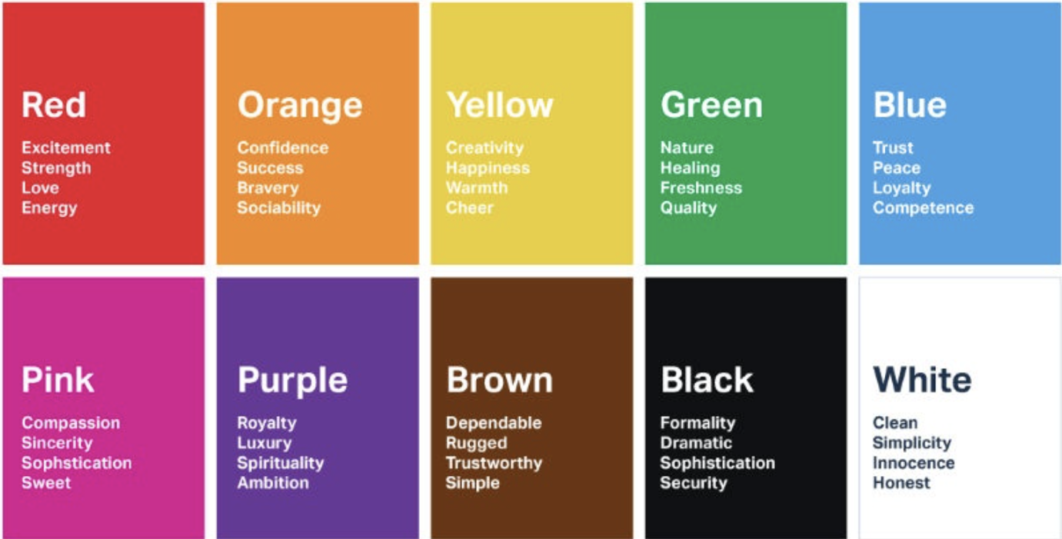fig 4

Colours have one of the biggest roles in graphic design, colour is used in almost anything that is designed and it is crucial to have the correct colour for the correct job, a good colour pallet can enhance a business to a more successful future. There have been many resraches done by psychologists that the use of colours can influence out emotions and perceptions. This is done by a certain colour used at a particular aspect of design to give a feeling and emotion to the viewer. c. It is not simple to assume that all colours effect people the same way as this depends on the experience and culture factors of the viewer, but most commonly researchers have found consistant associations such as “warm colours” for example these would be red, orange and yellow these colours tend to excite and arouse the viewer, we also have cool colours like blue and green which have a more relaxing and calming effect. “There has been a survey done on colours and word association found that 43% of people associated blue with reliability and 76% associated red with speed” (Grinning Graphics, 2020). These colours have other jobs that they are well effect on for example red signs in winodw shops will overall attract more attention and persuade the person for the purchase as a sign of a “good deal” and also colours can be used to increase and decrease a person's appetite, rise or reduce our heart rate and enhance our mood or calm the viewer down. It is important for a designer to understand the use of correct colours when it comes to designing marketing assets and the colours will influence how viewer will feel about the brand and what message they will receive, and the designers must know the importance of the impact of colour in forming consumer perceptions and for a better understanding of the use of colours look at fig 4(Grinning Graphics, 2020). The above image fig 3 gives us a more of an understanding on the overview of some of the kinds of associations between emotional responses that colour can give to a viewer, this can be carefully used by a designer and implemented into their design to develop a more effective design. Colour has a huge meaning when it comes to the customer whether you are developing a brand from scratch, or you are designing some new marketing colletrals for an already established brand this is where colour becomes critical. From some research “80% of consumers believe colour increases brand recognition, and 84.7% cite colour as a primary reason they buy a particular product” (Grinning Graphics, 2020).
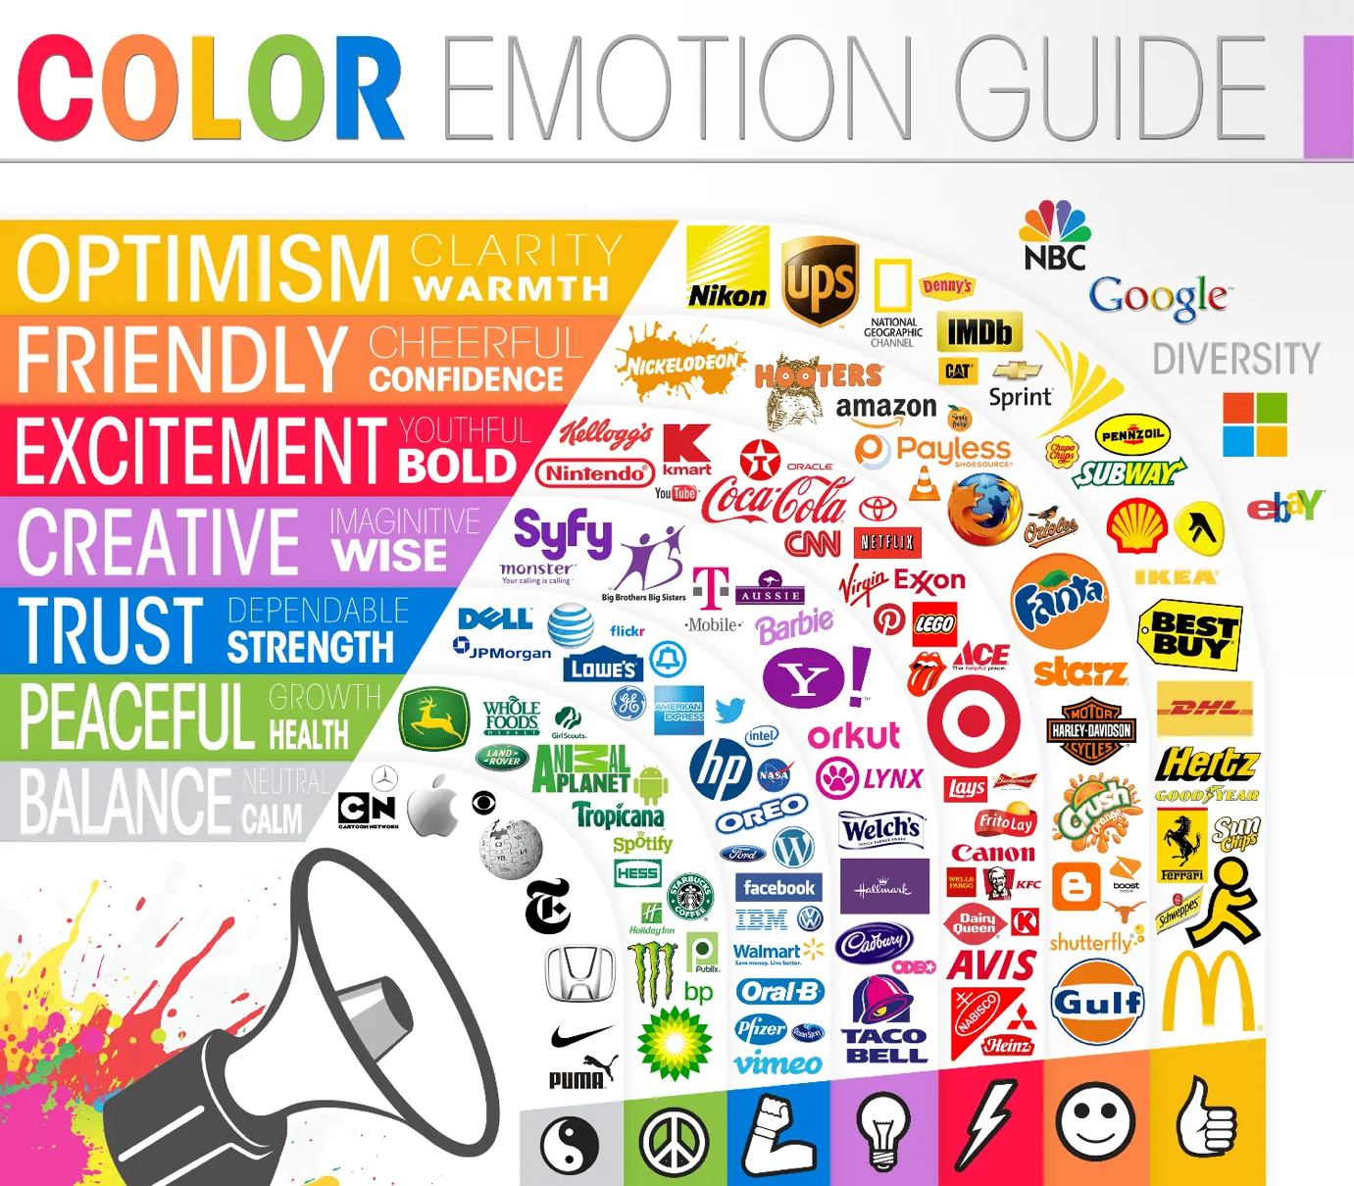Fig 5
One of the most importants to be aware of is that colour can also be cultural and not universal, for example in the UK, Eurioe and North America, we use the colour Orange to symbolise the meaning of “enthusiasm and fun”, however in other coltures like China they use the colour orange to represent “Love, health and humility”(Grinning Graphics, 2020). When it comes to designing with colour you need to make sure you are aiming at the correct target audience. But thats not all also gender plays a big role in the choice of colour for design for example a study on colour preferences stated that “57% of men said blue was their favorite colour, but only 35% of women shared this preference” and study also showed a much stronger preference in the “colour purple among women than men” (Grinning Graphics, 2020).

Conclusion
I personally strongly believe that a success of a business, sport team or even an individual brand heavily relies on the experienced graphic designer that they choose to work with, in today's generation graphic designers are not just artist but they are strategic thinkers who strategically design to turn thrive their customers to success. They do this by shaping how the brand is perceived by its audience. Without a well-designed and cohesive visual presence, a company risks lacking the emotional and psychological connection needed to engage its audience effectively (Wheeler, 2017). As previously mentioned graphic desiners are among the most crucial contributor when it comes to a succesfull company for their personaly identity and public perceptions this is becase their work helps create a “meaning for customers, offering visual cues that represent the brands values, purpose and tone” (Olins, 2008). As mentioned above colour also has a huge role in graphic design and these elements contribute to the way a viewer may feel a correct colour palette can evole trust, excitement, or sophistication depending on the brands intended message (Landa, 2019). A Graphic designer has a responsibility as a visual voice of a brand, they ensure that all their design work aligns with the company's goals and personality, and that their work is translated with the correct message that is given to the public, these visual translations ideas are visually translated to give the customers a visual story to inspire loyalty and drive the business to success (wheeler, 2017) so yes a graphic designer is not just a designer for art, they are one of the most important roles in a successful company.
My question for my destination will be (“How do graphic designers shape brand identity and audience engagement in basketball through the use of visual design, branding, and colour”)

Bibliography
Morell, A. (2019). A graphic design history of the NBA. [online] Medium. Available at: https://medium.com/@anthonymorell/a-graphic-design-history-of-the-nba-3b45f5725b7
[Accessed 9 Jan. 2020].

Morabito, A. (2022). “How NBA Teams Are Using Graphic Design to Engage Fans on Social Media.” Adweek.

Bembry, J. (2021). “The Art of Rebranding in the NBA.” The Undefeated.

EDDY (2024). The Importance of Branding in Graphic Design | RMCAD. [online]
RMCAD. Available at: https://www.rmcad.edu/blog/the-importance-of-graphic-design-in-branding/.

Grinning Graphics. (2020). The Importance of Colour in Graphic Design - Grinning Graphics. [online] Available at: https://grinninggraphics.co.uk/the-importance-of-colour-in-graphic-design/.

NBA Creative Services, 2023. Behind the design: NBA City Edition jerseys and digital campaigns. [online] NBA.com. Available at: https://www.nba.com/news [Accessed 23 Apr. 2025].

Wheeler, A., 2017. Designing brand identity: An essential guide for the whole branding team. 5th ed. Hoboken: Wiley.

Olins, W., 2008. The brand handbook. London: Thames & Hudson.

Landa, R., 2019. Graphic design solutions. 6th ed. Boston: Cengage Learning.

Mondragon, M. (n.d.). Graphic Design’s Impact on Sports Marketing: Bridging the Gap Between Fans and Teams. [online] www.linkedin.com. Available at: https://www.linkedin.com/pulse/graphic-designs-impact-sports-marketing-bridging-gap-fans-mondragon-qh9re/.

Statista. (n.d.). NBA social media fans/followers 2012-2020. [online] Available at: https://www.statista.com/statistics/322941/facebook-fans-twitter-followers-of-nba/.

