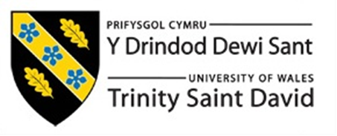

Volkswagen Emissions Scandal

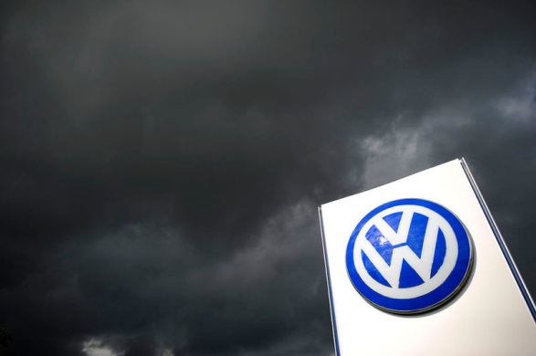

Author: Ting Diao
Submission Date: 20th July 2018
Commissioned By: Caroline Jawad
Word Count: 2500 words

Table of Content
Executive Summary………………………………………………….3
- Introduction………………………………………………………4
1.1Company Overview………………………………………..…4
1.2 Objectives……………………………………………………4
2.0 Main Findings……………………………………………………6
2.1 The cause of this scandal…………………………………….6
2.2 The effect on the environment……………………………….8
2.3 The impact on the economy…………………………………9
2.4 Impact on stakeholders……………………………………..12
2.5 Business Ethics and Corporate Social Responsibility………15
3.0 Conclusions……………………………………………………..17
4.0 Recommendations………………………………………………18
5.0 Self-reflection……………………………………………….......19
Bibliography List…………………………………………………....20

Executive Summary
The purpose of this report is to analyze the process and causes of the Volkswagen emissions scandal. After understanding the reasons, it is the analysis of the main body of the report. This section mainly analyzes the impact of the scandal on the economic environment and evaluates in detail the relationship between stakeholders and CSR and the scandal. Finally, this report presents a solution to this serious scandal, it gave a reasonable proposal for the scandal caused by the company, and Volkswagen could learn from the companies that had happened in previous incidents to improve themselves.

- Introduction
1.1Company Overview
Founded in the 1930s, Volkswagen is a car manufacturing company headquartered in Wolfsburg, Germany. It is a core company and original brand of the Volkswagen Group, and it is also the group’s best-selling brand and the world’s largest automaker. It has a number of overseas subsidiaries. The first overseas sales subsidiary, "VW Canada Ltd." was established in 1952 and became an overseas importer in the United Kingdom in 1953 and officially entered the United Kingdom.(Volkswagen.co.uk,n.d)
In September 2015, the U.S. Environmental Protection Agency discovered a device on some American VW cars. Volkswagen then admitted that it was testing cheating emissions. About 11 million vehicles worldwide are equipped with such devices, which is a serious violation.( bbc.co.uk,2015)
1.2 Objectives
The purpose of this report is to critically analyze the impact of the Volkswagen scandal in order to understand its impact on the Volkswagen economy, its impact on the environment, and how it should be addressed in the future. Objectives are determine the cause of this scandal, what impact Volkswagen's stakeholders have on the environmental impact of the scandal, and analyze the relationship between this scandal and CSR and ethics.

- Main Findings
2.1The cause of this scandal
At present, there are various reasons for the analysis of the “game of intrigues” in the European and American games of the mass events and the use of certain interest groups to use the decline in the auto industry’s share price to generate profits. But none of these reasons can deny the fact that companies are falsifying.
The capital's profitability will inevitably lead to negative externalities, and the government's inadequate supervision of negative externalities caused by market failure will inevitably lead to unsatisfactory results. The "mass fraud incident" is a typical case of negative externality arising from capital's profitability in the absence of market constraints.
There is a lack of corporate social responsibility and a lack of proper understanding of the relationship between self-interest and altruism. Although the concept of Corporate Social Responsibility (CSR) is widely popular, many companies still lack the social responsibility they deserve. Under the trend of environmental protection responsibility highlighting, the public has turned out to be fraudulent in the automobile exhaust. The lack of basic social responsibility is embarrassing.(People.com.cn,2015)
In addition, Jack Ewing, a reporter for the New York Times' business and economics field, has long tracked and reported on this matter. Ewing believes that Volkswagen has a toxic organizational culture. The toxicity of this culture lies in the company's ambition and abuse of power. Finally, thousands of innocent workers employed by Volkswagen are threatened and participated in. This crime occurred.(Ewing J,2017)

2.2 The effect on the environment
This emissions scandal will have a serious impact on the environment. The illicit emission of mass emissions means that the exhaust gas emitted from cars does not meet the standards and it will pollute the air. For example, nitrogen dioxide is a toxic nitrogen oxide that has been more discharged into the air and grows at a rate of 250,000 to 1 million tons per year. These nitrogen oxide emissions are likely to be the same as those in UK power stations, industry and agriculture. Just as excessive smoke can cause inflammation of the respiratory tract and respiratory effects, nitrogen oxides can react with other compounds. The serious consequences it can cause can lead to various respiratory diseases and even aggravate heart problems. A study in London linked 9,500 premature deaths each year to excess emissions of nitrogen oxides. Long-term exposure to pollutants can exacerbate human mortality. The exhaust emissions produced by these Volkswagen cars may be equivalent to the emissions of nitrogen oxides from all UK power stations, industries and agriculture. ( Topham G,2015)
Excessive emissions are not good for human health. Excessive inhalation of these exhaust fumes can cause death. The best solution is to repair or remove unqualified vehicles as much as possible to make up for the pollution that has already occurred.
2.3 The impact on the economy
Martin Winterkorn, CEO of Volkswagen Group, announced on September 23 that he was responsible for the fraud of the tail gas data and resigned. Volkswagen is experiencing the biggest scandal it has encountered since its establishment 78 years ago. Public opinion analysis believes that the fraud scandal will continue to ferment and have a profound impact on the German automobile industry and even on the German economy. After the scandal was exposed, the stock price of Volkswagen fell by 30% and dragged down the market performance of other auto companies. In addition to the multi-party penalty for fraud and illegal discharge, vehicles involved are likely to be recalled on a large scale and will expose the public to greater economic losses. Anton Hofflet, chairman of the German Green Party’s parliamentary group, asked the public to recall and refit all cars equipped with exhaust emission control software. He said that if the masses are reluctant to recall, the German government must put pressure on it. As the largest company in Germany, Volkswagen employs 600,000 people worldwide, operates in 153 countries and regions, and has sales of 200 billion euros. German media and analysts said that the mass fraud scandal will seriously damage the image of “Made in Germany”, endanger the German automotive industry, and negatively affect the German economy.(Kejiang G,2015)
Dragged by the "emissions door" scandal, Germany Volkswagen lost its profits for the first time in ten years in the third quarter. The third quarterly report released on the 28th showed that the public had a net loss of 1.73 billion euros (about 1.9 billion U.S. dollars), and a net profit of 2.9 billion euros in the same period last year. The company’s net loss in the third quarter was mainly due to a special project of 6.7 billion euros, which was mainly due to the company’s global recall of the cost of 11 million vehicles that installed exhaust emission fraud software. Volkswagen also issued a profit warning for the year, saying that due to the cost of the software installed on some diesel engines, the company’s overall operating profitability and operating profit margin of passenger vehicles will be far lower than the previous one. year.(Xinhuanet.com,2015) If the public can not deal with these issues in time, then the loss may be more serious.

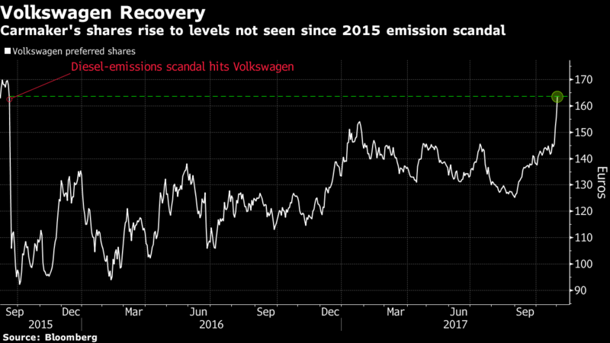
Source: Bloomberg.com,2017
From this chart, it can be seen that Volkswagen's stocks showed an upward trend before the scandal occurred, and then fell significantly to a low point. Its market value has fallen to 36 billion euros. This has a considerable negative impact on the stock.
It can also be seen that the widespread use of such illegal software by Volkswagen illustrates the poor internal management of the company. According to its latest assessment, under the influence of this scandal, the public's brand value has shrunk dramatically, dropping by nearly 16%. In addition, the value of the Volkswagen gasoline car was also affected, and the brand value fell by 2.9%.( Baijiahao.com,2018)
This emissions scandal also had a bad influence on the industry as a whole, and their performance was poor. The reason is that they are worried that this involves the future of diesel and the sales prospects of cars. (MacLennan S,2015) The Volkswagen emissions scandal is no stranger to the automotive industry and will have a long-term impact on output and demand.
2.4 Impact on stakeholders
In general, people or things that are subject to company policies and target behaviors fall into the category of company stakeholders. With regard to the Volkswagen scandal this time, customers, employees, shareholders and other car manufacturers are all stakeholders.(Businessethicscases.co.uk,2016)
Stakeholders determine the development of the Volkswagen sales market. They need to understand the needs and expectations of stakeholders. This is an important prerequisite for the company's success. So Volkswagen has been talking to stakeholders. It's in two aspects, the group level and the local operating area. Volkswagen’s stakeholder network grows with their market share. The company's brand development links with Volkswagen's stakeholders, especially employees and customers. Volkswagen associates these stakeholders and takes a holistic approach to discussing the topics. Their goal is to understand the expectations of stakeholders and respond to it, and then promote the impact on the positions and actions of Volkswagen. Volkswagen is striving to strengthen its dialogue with stakeholders. This is a goal worth achieving.(Volkswagenag.com,n.d)
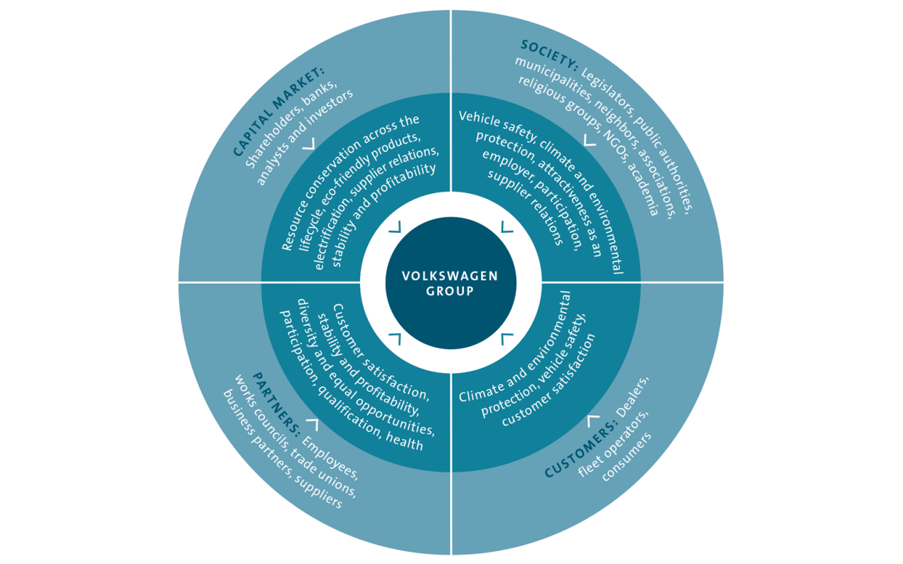
Source: Volkswagenag.com
The chart shows that after the public company scandal occurred, the company’s shareholders received influence. It can be seen that the company’s stock price has been lost and its profits have also been reduced. This behavior of Volkswagen is not in line with its performance in the international automotive market, the company has lost its way. It chooses to cheat in order to gain greater market share, and as the company’s stakeholders—shareholders—have received various concerns at the expense of others. Volkswagen pursues the maximization of profits and shareholder value, but it leads to the final trouble.(Stern S,2015)
There is a famous theory whose name is utilitarianism. This theory mainly talks about creating the greatest benefits for the most people. It belongs to the result of morality.(Duignan B,n.d) Based on this theory to analyze this incident, Volkswagen’s behavior is contrary to the utilitarian behavior, and there is no benefit in this scandal. The employees spent a huge amount of dollars to solve this problem that should not exist, and thus lost their jobs. But this thing also has the only benefit, it may help to strengthen the management of the company.

2.5 Business Ethics and Corporate Social Responsibility
In the past decade, CSR and sustainable development have occupied an important position in the world. Many companies have participated in responsible and sustainable business practices, hoping to create social and commercial value. In spite of this, some companies still have serious scandals caused by corporate ethical issues every few years, which undermines people's trust in the company and corporate responsibility. Corporate social responsibility is how enterprises should think about and build social environment. Business ethics refers to how companies manage themselves and relate to their right things. Volkswagen apparently confused what is right and what is the concept of CSR.( Mallenbaker,2008)
On January 4, 2015, the U.S. judiciary prosecuted Volkswagen. They questioned Volkswagen's efforts and accused it of obstructing regulatory authorities and providing wrong information. Since 2009, Volkswagen has equipped 11 million diesel vehicles and deployed cheating software. This kind of scandal actually belongs to corporate fraud because it damages the health and welfare of customers, governments, and citizens.(Contributor,2016)
This scandal of Volkswagen represents an absolute failure in CSR. The company wants to deliberately design a way to circumvent emission control. This is a known strategy aimed at giving unfair competitive advantage to Volkswagen and other competitors. In this way it can become the world’s number one manufacturer, but Volkswagen is also harming this planet. This refusal of engineering ethical standards makes one thing absolutely clear: Volkswagen's corporate social responsibility department must know what happened. A responsible person for corporate social responsibility has been given an atmosphere of respect and is responsible for this department, whose responsibility is to keep the company's image clean. But this is actually an unclean thing. The behavior of Volkswagen shows that their goal is to maximize profits through any means.(Dans E,2015)
The scandal also caused the credit and credibility of Volkswagen to be destroyed. In the Western culture, social morality and order, "integrity" is a more precious asset than gold. Therefore, the German media and the European media sadly declared "the failure of German manufacturing" after the mass "emission door" incident. The scandal was characterized as "the biggest scandal in the history of German and even global cars." The impact of this corporate crisis was far-reaching. Not only did the market value of Volkswagen fall, but it also affected sales. The long-term damage to the company caused by this scandal is inestimable. It hurts people's reputation for brand trust, customer satisfaction and employee loyalty. Once Volkswagen loses its trust, it will be difficult to regain it. There is also an important point that it has external effects. Similar deceptions like Volkswagen will not only harm the reputation of other automakers or other industry companies, but also undermine people’s trust in the industry and exacerbate consumer sarcasm.

- Conclusions
In conclusion, this report draws some conclusions by analyzing the causes and impact of the Volkswagen company scandal. Whether the company can liberate itself from this scandal still needs to be observed, and its actions in dealing with this scandal are not enough. Volkswagen provides the public with a company's lessons on how to handle social responsibility and sustainable development. Defrauding stakeholders and making verbal promises will not provide real value to the company and society. As people see it, it generates high costs. To create business value, we must embed corporate culture and core business into social responsibility and sustainability. If this thing is done right, then the company will benefit from a more favorable corporate image, higher customer loyalty, and stronger organizational learning. Everything has two sides, and the community can also feel the benefits from the strength and resources of the company to prepare for the urgent social environment challenges.

- Recommendations
History is like a mirror. Volkswagen should learn from companies that have had similar incidents before. Nike had witnessed people's anger and large-scale consumer boycott of factory labor practices in the 1990s, and then realized the image transformation. Nike has strengthened its code of conduct for working hours, hired external professionals to review suppliers, and detailed their performance in the annual corporate social responsibility report, which would increase the transparency of labor practices.
Volkswagen wants to regain its successful recovery image, so it should take decisive action immediately and it needs to accept all the responsibilities that a company should have. Because Volkswagen has carried out this emissions scandal, it must establish a reliable plan based on how to actually reduce emissions and verify that this meets regulatory standards. Volkswagen needs to make important long-term investments in R&D. The advantage of this is that it can offset its stigma and position itself as a leader in technology development, using this approach to reduce emissions and improve performance. Volkswagen needs to build stronger and more robust accountability structures and practices and promote a positive change in corporate culture so that short-term profit motives can be maintained to prevent future fraudulent practices.

5.0 Self-reflection
Through this opportunity to write a report, I learned that the scandal will have some impact on the organization and the industry. The Volkswagen scandal was the biggest scandal of the year. I learned about ethics and how the scandal has affected the environment, the economy, and stakeholders. Most of these effects are not good, which also shows that the management inside Volkswagen is not perfect enough.
Volkswagen should take responsibility for their actions, recall the car in question, and improve it from management. With this approach in place, perhaps they will be able to re-trust their customers to a new starting point.

Bibliography List
3p Contributor(2016). The VW Scandal Continues: Implications for Corporate Social Responsibility. [online] https://www.triplepundit.com/2016/01/vw-scandal-continues-implications-corporate-social-responsibility/. [Accessed 12 Jan.2016]
bbc.co.uk(2015). EU bank chief 'could recall VW loans'. [online] http://www.bbc.co.uk/news/business-34501664. [Accessed 11 Oct.2015]
bbc.co.uk(2015). Volkswagen says 800,000 cars may have false CO2 levels. [online] http://www.bbc.co.uk/news/business-34712435 [Accessed 04 Nov.2015]
Bjiahao.com(2018). The negative impact of the mass emissions door scandal continues to expand. [online] https://baijiahao.baidu.com/s?id=1594065166624317071&wfr=spider&for=pc. [Accessed 05 Mar.2018]
Cctv.com(2016). Volkswagen Exhaust Counterfeit Infringes Triple Rights. [online] http://jingji.cctv.com/2016/05/25/ARTID6CeTwSZ0BFSHFiQSkDg160525.shtml [Accessed 25 May 2016]
Coleman C(2015). VW could face long legal nightmare. [online] http://www.bbc.co.uk/news/business-34352243 [Accessed 24 Sept.2015]
Dans E(2015). Volkswagen And The Failure Of Corporate Social Responsibility. [online] https://www.forbes.com/sites/enriquedans/2015/09/27/volkswagen-and-the-failure-of-corporate-social-responsibility/#2eee6faa4405 [Accessed 27 Sept.2015]
Dong Y(2015). An Analysis of the Deep Causes of the "Popular Fake Incident" in Germany. [online] http://paper.people.com.cn/rmlt/html/2015-10/01/content_1626976.htm [Accessed 01 Oct.2015]
Duignan B(n.d). Utilitarianism. [online] https://www.britannica.com/topic/utilitarianism-philosophy
Gong F(2017). Let the public lose 70 billion U.S. dollars, and how is the emissions scandal still fermenting so far?. [online] https://www.qdaily.com/articles/44436.html [Accessed 24 Aug.2017]
Guan K(2015). Mass scandal scandals shame the "Made in Germany". [online] http://finance.people.com.cn/n/2015/0925/c1004-27631850.html [Accessed 25 Sept.2015]
Hotten R(2015). Volkswagen: The scandal explained. [online] http://www.bbc.co.uk/news/business-34324772 [Accessed 10 Dec.2015]
Jagadeesh N(2017). Volkswagen Recoups Stock Losses Since Emissions Scandal: Chart. [online] https://www.bloomberg.com/news/articles/2017-11-01/volkswagen-recoups-stock-losses-since-emissions-scandal-chart. [Accessed 02 Nov.2017]
Mahler A(2015). Time for German Industry to Abandon Its Arrogance. [online] http://www.spiegel.de/international/business/vw-scandal-shows-german-companies-are-no-longer-big-league-a-1055098.html [Accessed 30 Sept.2015]
MacLennan S(2015). How will the VW emissions scandal impact the auto industry? [online] https://www.schroders.com/en/us/institutional/insights/economic-views3/how-will-the-vw-emissions-scandal-impact-/ [Accessed 24 Sept.2015]
Mallenbaker.net(2008). Arguments against corporate social responsibility - And some responses. [online] http://mallenbaker.net/article/clear-reflection/arguments-against-corporate-social-responsibility-and-some-responses [Accessed 23 May 2008]
Reuters.com(2016). Volkswagen to offer generous compensation for U.S. customers: fund head. [online] https://www.reuters.com/article/us-volkswagen-emissions-idUSKCN0VG0MF [Accessed 07 Feb.2016]
Stern S(2015). VW has myopic view of stakeholders. [online] https://www.ft.com/content/54eb7548-636c-11e5-9846-de406ccb37f2 [Accessed 01 Oct.2015]
Teknikensvarld.se(n.d). Dieselgate: Volkswagen cars lose power after fix. [online] http://teknikensvarld.se/dieselgate-volkswagen-cars-loses-power-after-fix-456111//
Theguardian.com(n.d). VW emissions cheat estimated to cause 59 premature US deaths. [online] https://www.theguardian.com/environment/2015/oct/29/vw-emissions-estimated-to-cause-59-premature-us-deaths
Theguardian.com(n.d). VW repair bill rises as Germany says 540,000 recalled cars need hardware changes. [online] https://www.theguardian.com/business/2015/nov/09/vw-repair-germany-540000-cars-hardware-changes
Topham G(2015). The Volkswagen emissions scandal explained. [online] https://www.theguardian.com/business/ng-interactive/2015/sep/23/volkswagen-emissions-scandal-explained-diesel-cars. [Accessed 23 Sept.2015]
Volkswagen.co.uk(n.d). About Volkswagen UK. [online] http://www.volkswagen.co.uk/about-us/company/volkswagen-uk
Volkswagenag.com(n.d). Stakeholder Management. [online] http://sustainabilityreport2014.volkswagenag.com/strategy/stakeholder-management
Xinhuanet.com(2015). "Importance door" scandal drags Volkswagen's third quarter net loss of 1.73 billion euros. [online] http://www.xinhuanet.com/fortune/2015-10/29/c_128370947.htm [Accessed 29 Oct.2015]

