MarcoVinicio Martinez Garces
1814732
Data center Virtualization
(ACUA6001_LON)

Abstract

This report will discuss technical aspects of data centers' virtualization as virtualization, hypervisor types, design, etc. After the technical part, the scenarios will be addressed.

For the first scenario data virtualization centers, the company's best options will be discussed based on the proposed solution chosen by the team. Then for the second scenario, some technical aspects about security and storage area networks will be addressed.

Table of content
- Scenario 1
  - Virtualization
  - Hypervisor
  - Virtualization implementation levels
  - Scalability
  - Datacentre design and architecture
  - Proposal Review

- Scenario 2
  - Security Policy
  - Storage Area Network
  - SAN and data corruption
  - Conclusion
- References

Scenario 1.
Virtualization.
In the first part of the report, some technical aspects will be discussed. Firstly, virtualization could be defined as the division of a machine into more than one virtual machine. This means that inside a machine (host), different machines can be created by creating a virtual partition of the hardware devices of the host using a hypervisor. The virtual resources designed will be used to virtualize other IT infrastructure elements as :
- Desktop:
  - Desktop virtualization permit running multiple operative systems inside the same host.
- Network:
  - Network virtualization creates a network inside a server or a host. Inside of it will be made switches, routers, connections, etc. Then all these resources will be available for the administrators inside the software to control the elements.
- Storage:
  - Storage virtualization permits keeping the data inside a virtual storage device located in a pool that the network can access. An example is a storage area network (SAN)
For another hand, it is necessary to explain why the use of virtualization by companies is increasing. Because virtualization proportionates some benefits that every company, the main ones are:
- Efficiency:
As the host machines or servers can be divided into multiple virtual partitions, we can use different systems as operative systems or storage data from various applications or companies inside the same machine. As all the services are found inside the same device or server, it is easier to improve efficiency.
- Reliability:
Using virtualization technology, data can easily back up and restore data using snapshots of virtual machines from existing servers. Plus, this process can easily automate this backup process to keep all data up to date. If an emergency occurs, and data needs to restore it, take a backup. After installing the virtual machine, it is easy to migrate that virtual machine to a new location in minutes. Translates into more excellent reliability and business continuity as it is easier to recover from a disaster or loss.
- Scalability:
With scalability, the resources can be upgraded depending on the demands of the customer. These characteristics make a difference in the economic impact. If a company is starting, it can contract virtualization services depending on the needs, and for future growth, these resources can be upgraded.

Hypervisor.
After virtualization, the concept of hypervisor needs to be discussed to understand better how virtualization works.
A hypervisor is software used to create and control virtualization. The hypervisor allows the host to hold multiple virtual machines by sharing the host's physical resources virtually. Another function of the hypervisor is to control that each virtual machine has access to the physical resources and control that virtual machines do not interfere in the memory storage and computer cycles. Inside hypervisor exists two types:
- Hypervisor Type 1:
This hypervisor is located in the host hardware to control and manage the virtual machine operative system. This hypervisor is generally situated in data centers.
- Hypervisor Type 2:
Type 2 runs as an associate application on an existing operative system. Most typically used on endpoint devices to run different operative systems, they carry a performance overhead due to the use of the host operating system to access and coordinate the underlying hardware resources.

Virtualization implementation levels.
As virtualization a complex process so for a better virtualization process, this can be implemented at different levels. These five levels are:
- Instruction set architecture (ISA).
ISA enables the execution of applications and virtual machines designed to run on other processors with different ISA. ISA emulates the entire system so that an application can be started and executed on different processors and operating systems. ISA is provided via a software framework with compiler, assembler, and other essential software libraries to emulate various instruction set architectures.
- Hardware abstraction.
This layer is focused on help with to divide the host's hardware into virtual hardware so each virtual machine has its hardware and multiple virtual hardware can work at the same time.
- Operating system.
These layers create an abstraction layer between the OS and the application. This helps isolate the container into a single server, so the OS uses all the server hardware.
- Library.
As the calls to the OS are so long and take too much time, most of the applications prefer to use API. APIs nowadays are highly documented, making this one a good candidate for virtualization. This virtualization is perfect for doing at the library layer, which is possible by the use of API hooks that control the connection between the applications and the OS.
- Application.
On this layer, the main objective is to virtualize only the application without virtualizing the environment; the most common deployment approach is a high-level language.

Scalability.
Scalability is characteristic of virtualization and cloud computing, where all the resources can be adapted to the specification asked by the customers. For customers, scalability means a cost-saving at the time of including virtualization into their business.
One example of scalability and cost-saving could be: a start-up company is starting the business, but they do not know how many clients they will have, instead of contracting enough resources for thousands of customers. They can acquire resources for three hundred, and in case that these resources with the growth of the demand are not enough, with scalability, they can change the size of the resources or add more resources to be adapted with the need.
Inside the scalability, two types are available:
- Horizontal Scalability (Scale-out):
Scale-out is focused on the divide the workload into more than one server or machine.
This option helps to gain redundancy and resilience to the workload. As the data will be divided into multiple servers, so if any failure happens, the data can be recovered from other storage devices or can work using the data stored in other devices without affecting the workflow of the system.
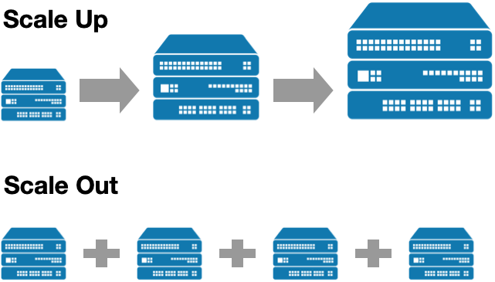[8]
- Vertical Scalability (Scale Up):
Scale Up the main objective is to improve the system's performance by adding or increasing the hardware component as RAM, storage memory, CPU, etc. The disadvantages are that the upgrading time of the resources could affect the workload flow by delaying the services and physical limitations. Once the server is upgraded to the most effective option, it will not be available to go further in growing.
[8]
Datacenter design and architecture.
After all the technical aspects previously explained, one more is needed to be explained that encapsulate all the previous, and it is data center and architecture.
The data center contains the computing power, storage, and applications needed to support the company's business. The data center infrastructure is critical to the IT architecture where all content originates or flows. Design is vital, so performance, flexibility, and scalability must be carefully considered.
Datacenter architecture is divided into different layers. The primary layer design is divided into :
- Core layer.
This layer provides a high-speed on the packets switching flow from outside and inside the data center. These layers provide a layer three connection between multiple aggregation devices, which leads to a connection without any failure point. Inside the core layer, a router protocol is running, which can be OSPF or EIGRP.
- Aggregation layer.
The aggregation layer is in charge of essential functions as service module, spanning tree processing, and default gateway redundancy. This layer is the more important of the three as it is in charge of connecting access and core layers. Some services will be implemented as firewall and server load-balancing to improve the security and optimization of the application, and some services modules will be implemented as SSL offload, network analysis, intrusion detection, etc.
- Access layer.
The access layer is responsible for connecting the data center to the network and making remote access available to the companies.
Respect the use of data centers are two option available rent and build an own data center. So, in this part of the report, the design of a data center will be discussed. The design can be divided into four factors:
- Connectivity.
To design a data center, location is an essential aspect. It is preferable to build it in a modular building which gives the chance to modify racks and servers by removing or adding without interrupting the workload, making possible good scalability. As the cabling connectivity is the part that will be exposed to changes is essential to be careful with the cabling management inside the racks to do not interrupt the connection when connecting or disconnecting units. Another important aspect of connectivity is to separate data and power cabling in differents cabbling systems to avoid any future interruptions between them.
- Cooling.
In data centers, cooling systems are crucial as heat is one of the most factors to have under control as it can affect to server and damage or destroy it. As the amount of devices is considerable the heat generated by them, cooling is necessary, and some solutions are available:
- Adiabatic cooling.
This option is focused on using fans mounted in racks by repealing the warm air from the servers. The most common configuration used the hot/cold aisle. This configuration is focused on makes that the air-conditioned flows along the cold aisle by proportionating cooled air to the rack, and in the hot aisle, the warm air pushed out of the server by the fans flows and leaves the room.
- Liquid cooling.
Water is used as a cooling factor due to the density of the water; this conducts heat better than the air used in the previous one. The cooling system is designed to close the circuit where the cool water is pumped through pumps and coils absorbing the heat, and then the warm water will send to the cooling unit where the cycle will be restarted.
- Liquid immersion cooling.
As the water is better for cooling if any filtration, it has a high risk of producing a short-circuit. So to avoid this risk, an option is to use a dielectric liquid for cooling, which opens a new alternative for refrigeration by immersing the components inside this liquid.

- Security:
As the data inside the data center is a crucial part of the enterprise, security is essential. To good proportionate security, some protocols need to be followed. The entrance to the data centers needs to be controlled strictly; dust or other contamination factors need to keep at the minimum level as possible. As well, some security barriers can be implemented as biometric barriers and security staff in situ.
- Power Supply.
As the data centers have an immense power demand, the power supply needs to be focused on density over 10 kW per rack. The connection of data centers to the primary grid is made using specials cables designed to reduce the heat and increase the distribution power. All the data centers need to have N + 1 redundancy for power as a minimum, so if any failure happens with the power supply, this can still work. To complete this N + 1 redundancy, data centers have to use two extra power suppliers as a fuel-powered generator and an uninterruptible power supply system powered by batteries. So in case of a blackout, the UPS will be in charge of supplying energy until the backup generator turns on and protects the system of voltage spikes by using batteries.
After speaking about the data center creation, another option is available, and it is cloud base solution. Cloud is becoming one of the most popular options for companies that want to start or want to keep the data in a server but without investing too much money.

Proposal review.
Based on the financial statement documents for 2019/20 of UWSTD, it is possible to extract the following data: cash and cash equivalent balances which are £27.0 m, and liquidity of 1.15 which means that the university can pay all its debt for this year with their assets and still a remind to afford further debts. Counting with these numbers and the cost of an own large data center is between £10 and £15m, which is the best option based on the number of students, staff, and data. Considering these numbers and that the data managed is critical as it has personal information from many students and staff, the most accurate option for the university will be on-premise data. Also, according to the GDPR rules, it is mandatory to record who accesses the data, how it is collated, and why it has been held, which is easier to have with an on-premise data center.
However, according to a case study by Cameron Fisher [14]; respect the cost, cloud service is cheaper than on-premise at the start as on cloud services is necessary to pay only for subscription and on-premise is necessary to make a high investment to purchase the resources needed to build the data center server, storage devices, cabling, etc.
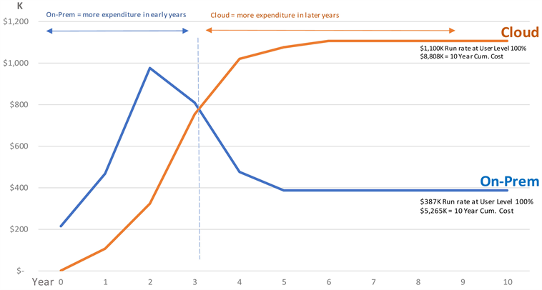[14]
However, the study is done on ten years showing that the cost of on-premise will be reduced after the third year, and for the tenth year, the cost difference between cloud and on-premise will be $3K. In this study, the on-premise price is lower than the cloud, but both have relative costs in other studies.
So we have spoken about cost terms, now is time to speak about security terms. As the cloud is a third-party company and the servers are shared with multiple companies, which makes that risk for the data exist like data loss, malware infections, or legal issues. As a third party manages the data is not possible to have complete control over the data stored inside the cloud, and at the same time, it makes it more difficult to follow the GDPR rules. In other cases, the cloud could be an excellent option to afford, but in this case, it is better to use an on-premise data center.
On-premise data center increases the security of the data as it is stored in a private server controlled by the own company. The company team manages the data, making it easier to record who accesses the data and how it is stored.

In conclusion, for this case study, in my opinion, it is better to prioritize data security instead of the cost. Some characteristics proportionate by the cloud can be implemented in the on-premise as redundancy can be done by implementing a SAN model where the data is stored into different levels, making the system have a recovery option if any failure happens. Finally, to create an on-premise data center, the aspects explained in this report in the design and architecture part should be considered.

Scenario 2.
In part of the report, scenario two will be discussed where the security policies, how storage area network can help to protect the data, and disaster recovery will be explained.
Security Policy.
Security Policy on IT can be defined as the rules and processes that need to be followed by the people who can access and use the IT resources of an organization.
The main object of Security policy is to preserve the CIA principles, which are confidentiality, integrity, and availability of the organization systems used by the company staff where each principle can be defined as:
- Confidentiality.
This principle is focused on protecting the organization's resources from non-authorized access.
- Integrity.
Integrity is referred to the availability to modify the organization's resources, ensuring that these resources will not suffer any unauthorized modification.
- Availability.
Availability is the principle that ensures that the organization's resources are available in a continuous way for authorized users.
On another side, an It security policy needs to be recorded inside a document that will be upgraded to adapt the policies to the business evolution and the new IT requirements. This policy needs to follow some specifications as objective, scope, goals, and responsibility for taking action in nonconformity. ita
The security policy of any organization has a vital role in decisions and directions, but this should not change the strategy or mission of the organization. Therefore, it is essential to write a policy based on the organization's existing cultural and structural framework to support the continuity of good productivity and innovation, rather than as a general policy preventing the organization and its employees from fulfilling their mission and achieving goals.
Storage area network.
In this part of the report, the definition, benefits, and architecture of SAN will be explained.
SAN is defined as a specialized, high-speed network that provides block-level network access to storage.
The architecture of SAN is divided into three parts:
Host components encapsulate host servers with a host bus adapter that allows the host to be connected via a fiber channel or ISCSI.
Fabric component encapsulates switches and cabling. One type of switch is SAN switches are designed to connect servers and shared pools of storage devices and are dedicated to move storage traffic and charge to manage the traffic flow, examine data packets and forward them to their intended destinations. These switches support FC and ISCSI connections.
Storage components are formed by various storage devices collected into various storage pools. In SAN, the storage devices are organized into RAID groups. RAID is a way to store the same data in different places, which helps protect the data in case of failure. Raid has different levels going from 0 to 6.
Use SAN has different benefits, but on this part, five of them will be discussed:
- LAN bandwidth improvement.
As the LAN server storage system has limitations supporting traffic flow, this system usually faces bandwidth blockages. This affects the performance of the system by reducing the performance and increasing the execution time. Nevertheless, the implementation of SAN will take a big part of the network traffic, and it will reduce the suggestion on the LAN bandwidth.
- Data security.
SAN uses a consistent algorithm to protect the data making available copies of this data whenever it needs it. The data is located in a different network if the LAN is exposed to any data filtration problem. The data will be safe in the other network.
- Scalability.
SAN is a network that can be constantly modified and adapted to the requirements given by the companies, which proportionate high scalability to the system.
- Disaster recovery.
As SAN uses a RAID system for storage, the data can be partially or fully recovered if any failure happens.
SAN and data corruption.
Data corruption occurs when any data inside the storage devices are damaged, becoming this data unavailable for use or unreadable.
To avoid this from happening, data redundancy is one of the best options; data redundancy is the ability to restore the data damage or loss without affecting the normal functioning of any system or network.
To help with this, SAN is organized in RAID groups. RAID has different levels; the best ones for data redundancy are 5 and 6.
RAID 5 is based on creating a parity block-level divided into different disks. Separating the parity block in the different disk makes it possible to recover the information fully or partially from the parity block from the other disk. As is showed in the picture below, the disk has four partitions and four blocks A, B, C, and D.
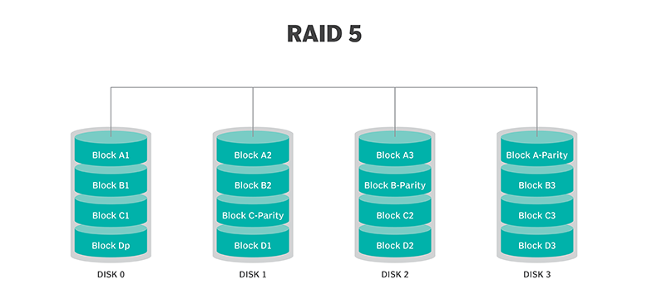[17]
To protect data from any failure, a parity is created for each block, and these parity blocks need to be divided into different disks. This protects the storage system from multiple disk failures.
As an example, based on the picture could be. That disk 0 fails, which makes block A1, block B1, block C1, and block D parity unavailable for access. However, the system can still work as the data can be recovered from the block C parity, block B parity, block A parity, and block D from the other disks. Nevertheless, if a failure happens in two disks, the data could take a longer time to recover, or some data can be partially lost.

In the case of multiple disk failure, the RAID 6 is a good option. It is similar to RAID 5, with the difference that instead of having one parity for each block in the disk, it has two parity blocks that help recover data from a multiple disk failure. The disposition of the blocks is like the image shown below, where each disk is divided into five blocks, and the disks are increased in one.
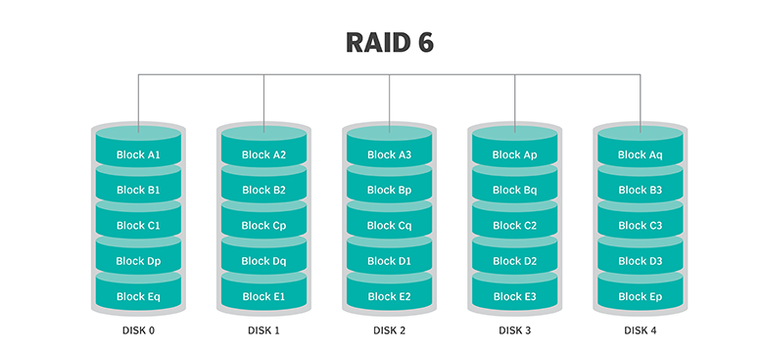[17]
A case example could be that disk one fails, which affects the block A2, block B2, block C parity, Block D parity two, and block E1, then disk 3 fails, affecting block A parity, Block B parity two, block C2, block D2 and block E3. As each block has two parity blocks, all the data can be recovered as one parity block for A, B, C, and D still available, and in the case of block E, the two parity blocks still available.

Conclusion.
In conclusion, for ABC, SAN is an excellent option to be implemented in their data centers as it can keep the data safer and the data recovery. At the time of implementing the storage arrays for SAN, this one needs to follow the RAID model to avoid any failure in the system in case that any disk fails or any data will be exposed to corruption. As well, SAN dives the flow concerning LAN, as LAN has a network for the end-users, and the data is stored in another network which avoids that any failure inside the LAN affects the data stored in SAN.

References
[1]IBM Cloud Education, "virtualization-a-complete-guide," Ibm.com, Jun. 19, 2019. https://www.ibm.com/cloud/learn/virtualization-a-complete-guide (accessed May 02, 2021).
[2]“What is a hypervisor?," Redhat.com, 2021. https://www.redhat.com/en/topics/virtualization/what-is-a-hypervisor (accessed May 02, 2021).
[3]“What is virtualization?," Opensource.com, 2021. https://opensource.com/resources/virtualization (accessed May 02, 2021).
[4]C. Mathias, "What is virtualization? Far more than just virtual machines," Network World, Oct. 26, 2017. https://www.networkworld.com/article/3234795/what-is-virtualization-definition-virtual-machine-hypervisor.html (accessed May 02, 2021).
[5]“What is Virtualization? - Virtualization Definition - Citrix United Kingdom," Citrix.com, 2021. https://www.citrix.com/en-gb/glossary/what-is-virtualization.html (accessed May 02, 2021).
[6]“Hypervisor," VMware, 2021. https://www.vmware.com/topics/glossary/content/hypervisor (accessed May 02, 2021).
[7]HigherGround, "Virtualization: Flexibility and Scalability," higherground, Oct. 10, 2018. https://www.higherground.com/post/2018/10/10/virtualization-flexibility-and-scalability (accessed May 03, 2021).
[8]A. Goller, "Scaling Up vs Scaling Out your Security Segmentation (via Passle)," Passle, Jul. 2019. https://insights.illumio.com/post/102foor/scaling-up-vs-scaling-out-your-security-segmentation (accessed May 03, 2021).
[9]L. Schoeb, "Cloud Scalability: Scale Up vs Scale Out," Turbonomic.com, 2018. https://blog.turbonomic.com/blog/on-technology/cloud-scalability-scale-vs-scale (accessed May 03, 2021).
[10]“Data Centre Design & Architecture," Interxion.com, Oct. 28, 2020. https://www.interxion.com/uk/blogs/data-centre-design?gclid=Cj0KCQjwvr6EBhDOARIsAPpqUPHXpv8HjRsFiFapoB07cpgVKe3zZBCTupI2pL1PkMCo5spEBeHOSwAaAsGMEALw_wcB (accessed May 04, 2021).
[11]https://www.facebook.com/BrainKart-678754188988648, “Levels of Virtualization Implementation,” BrainKart, 2017. https://www.brainkart.com/article/Levels-of-Virtualization-Implementation_11329/#:~:text=Common%20virtualization%20layers%20include%20the,level%20(see%20Figure%203.2).&text=At%20the%20ISA%20level%2C%20virtualization,ISA%20of%20the%20host%20machine. (accessed May 04, 2021).
[12]K. Taylor, "Exploring the 5 Levels of Implementing Virtualization," HitechNectar, Dec. 04, 2020. https://www.hitechnectar.com/blogs/virtualization-implementation-levels/ (accessed May 04, 2021).
[13]“How universities have to adapt under the new EU General Data Protection Regulation (GDPR)," Fullfabric.com, Nov. 2017. https://blog.fullfabric.com/how-universities-have-to-adapt-under-the-new-eu-general-data-protection-regulation-gdpr (accessed May 04, 2021).
[14]C. Fisher, "Cloud versus On-Premise Computing," American Journal of Industrial and Business Management, vol. 08, no. 09, pp. 1991–2006, 2018, doi: 10.4236/ajibm.2018.89133.
[15]BECA, "The Advantages of a Storage Area Network (SAN)," BECA, Nov. 07, 2019. https://www.becacorp.com/the-advantages-of-a-storage-area-network/ (accessed May 04, 2021).
[16]Flackbox, "The 11 Top Benefits of SAN and NAS Storage," FlackBox, Apr. 12, 2019. https://www.flackbox.com/11-top-benefits-san-nas-storage (accessed May 04, 2021).
[17]A. S. Gillis, “RAID (redundant array of independent disks),” SearchStorage, 2017. https://searchstorage.techtarget.com/definition/RAID#:~:text=RAID%20(redundant%20array%20of%20independent%20disks)%20is%20a%20way%20of,the%20goal%20of%20providing%20redundancy (accessed May 04, 2021).

