

BA (Hons) Business Management
Module: Entrepreneurship
Module code: LCBB5001
Module Leader/Lecturer: Dr Said Usman Amer Kareem
Component 1: Written Report
Student: Florin Claudiu Visan
Student ID: 2247386

Table of Contents

Introduction 3
3. Overview of the business idea, product/s and/or service of speciality Green 3
4. Legal format of the startup company of Speciality Green 4
5. Management of the company of Speciality Green 5
6. Evaluation of the business idea by using the SWOT analysis model 7
7. The 4Ps of marketing of Speciality Green 8
8. A cash flow forecast for the first 12 months. Startup funding cannot exceed £25,000. 10
Conclusion 11
9. Reference 13

Introduction
The report aims to focus on different aspects of new business startups. The startup company has a specific legal format that will be discussed in this report. How the new startup company manages its employees and meets the requirements of other parts of the company will be evaluated in this report. The report will also explain the SWOT analysis of new startup business ideas widely. How 4P helps the new business idea to enhance their business marketing with a larger area will be evaluated in this report. The first 12-month cash flow forecast of teh new startup business will be explained in this report. Specialty Green is the new start-up company that will be explained in this report.
3. Overview of the business idea
Specialty Green is a biodegradable packaging company would focuses on creating environmentally friendly packaging solutions that decompose naturally, reducing waste and environmental impact. With rising awareness of climate change and pollution, consumers and businesses are shifting towards sustainable practices. Biodegradable materials such as bioplastics, plant-based fibers, bamboo, cornstarch, and other compostable materials like mushrooms mycelium, or seaweed are the main components for biodegradable packaging (Worldwildlife, 2024). The new startup company specialty Green would produce products like food containers, shopping bags, wraps, cutlery, and protective packaging by using such biodegradable components.
The company can cater to various sectors including food, retail, and e-commerce. There are environmental benefits for this new startup company by offering eco-friendly packaging that minimizes the environmental footprint. Biodegradable companies collaborate with various companies such as food and beverage, retailers, and e-commerce which would increase business activity and profit as well (Ecofreek, 2024). The specialty Green company would make products by busing recycled paper or plant fibers and treated with non-toxic, compostable coatings, this material works well for containers, bags, and other forms of rigid packaging.
There are various benefits of biodegradable products such as cost effective and environment friendly. Many of these products can decompose in home composts within a few months especially items like bags and cutlery (Polystar Plastics, 2022). Specialty green is designed to be as functional as conventional packing in terms of strength, moisture resistance, and insulation and ensures it meets the industry’s standards. Some packaging items especially thicker materials are designed for industrial composting facilities and decompose faster under high heat. The Speciality green company would make smart biodegradable packaging with the help of an embedded sensor that changes the color when the content is no longer fresh and make the product with high-quality ingredients.
4. Legal format of the startup company of Speciality Green
The new startup company related to biodegradable packaging will be a limited liability company. In a limited liability company, the owners have limited personal liability for business debts and obligations. This means that their personal asset is generally protected from company-insured debt or face legal issues. A limited company can have one or more members and these members can be individuals, corporations, or other limited companies. Limited companies are typically pass-through entities, meaning the business itself does not pay federal income taxes (Corporate Finance, 2023). Specialty Green Company would be a limited company that helps to improve the operational management system of the company and the personal assets of the owner would be protected as a limited company.
There are various benefits of a limited liability company for a biodegradable packaging company. In the biodegradable company, limited members are protected from personal liability for the company’s debts, making it safer for owners if the business encounters financial or legal issues. This is particularly important in manufacturing and production where debt for equipment and raw materials is common. This type of company allows the biodegradable packaging company to choose a structure that minimizes taxes which can be beneficial as the company grows (Freedman, 2000). The new start-up business idea is a specialty green company limited which has fewer administrative requirements than the corporation. This helps the specialty green company to reduce its operational costs and there are fewer meetings allowing teh owner to focus on growing the business.

5. Management of the company of Speciality Green
Position | Degree | Experiences | Skills and Knowledge | Contribution
Chief executive officer | Strong educational background that combines business, environmental, and technical expertise. | Experiences in industries such as environmental management, green manufacturing, and renewable materials. | Strategic vision and strategic planning, effective leadership and team management skills, and knowledge of biodegradable material. | CEOs would create teams in the Speciality green company to manage several industrial tasks by using their experiences.
Production manager | Production managers need a degree in teh field of manufacturing and industrial engineering. | The production managers are experienced in managing and overseeing manufacturing processes, environments focused on Packaging or similar industries. | Problem-solving, effective communication, data analysis, metrics monitoring, and time management are the key skills. And knowledge of the product  lifecycle. | Optimizing the production process, will maintain the quality of the product and sustainability initiatives for biodegradable packaging are the key contributions.
Sales and marketing specialist | Marketing specialists need a degree of BBA or MBA that focuses on marketing. | Sales and marketing specialists who have practical experience in sales, market research, and customer engagement. | Sales skills, digital marketing, communication skills, decision-making, and project management skills and knowledge are required. | Marketing specialists will contribute to increasing sales and building brand awareness and customer relationship management in biodegradable company specialty green.
Environmental compliance officer | Degree A bachelor's in environmental policy or environmental law is needed for this position. | The environmental compliance officer is responsible for ensuring that a company adheres to environmental laws and regulations. | Analytical skills, risk management, communication skills, environmental reporting, and technological knowledge are required. | Environmental compliance offices will help the company to maintain environmental policy and laws effectively.
Supply chain manager | To become a supply chain manager needs a bachelor's degree in supply chain management or logistics. | Supply chain managers are involved in overring and optimizing the entire supply chain process from raw metal to product delivery. | Strategic thinking, team management, negotiation skills customer service skills, and knowledge relating to inventory and warehouse management. | Enhanced customer satisfaction, and productivity will be improve and maintained supplier relationship of the company.

6. Evaluation of the business idea by using the SWOT analysis model
Strengths
Eco-friendly product offerings are one of the strengths of specialty green biodegradable companies. Market demand shift towards sustainability is accelerating globally, governments, businesses, and consumers are increasingly prioritizing environmental issues, particularly the reduction of single-use plastics. Being a startup specializing in biodegradable packaging allows the company to carve out a niche in an expanding market. Specialty green companies would get support from the government and various investors interested in investing in sustainable packaging industries. Government support would be strengthened by reducing taxes or by prodigy incentives as an eco-friendly company. All of these are the strengths of specialty green companies.
Weakness
High production and raw material costs would be the major weakness of the specialty green biodegradable company. Biodegradable packaging often requires unique materials that are not as cost-effective or readily available as traditional plastic materials. High-quality biodegradable material would lead to higher production costs for the company. Limited brand awareness would be another major weakness of teh speciality green company. As a startup, the company will face challenges in building brand recognition and trust. Supply chain vulnerability would be the weakness of the company. A sustainable supply chain for biodegradable materials will be more complex. Sometimes the company will face challenges due to a shortage of raw materials..
Opportunities
Rising global environmental regulation for bans on plastic will be beneficial for the specialty green as a biodegradable packaging company. Most of the countries will focus on waste reduction and recycling goals which would be great opportunities for the company to expand its business across the world. With the help of the government, the company will increase educational campaigns and customer engagement which will also increase the brand awareness of the company. Consumers' awareness will be effective in switching consumers toward biodegradable products. The company will expand their business with larger area easily.
Threats
Price sensitivity will be the major threat for the specialty green biodegradable company in the future. Consumers will be increasingly environmentally conscious, many small business organizations may prioritize cost over sustainability, and they will offer their plastic products at a cheap rate that would limit the growth potential of biodegradable packaging companies. Inctrsede. High marketing costs would be the other teeth of the company. As a new start-up company, the organization needs to advertise and market its brand name to the customer which will lead to higher marketing costs.
7. The 4Ps of marketing of Speciality Green
Product: The product is the core of the marketing strategy. The product is the good or service being marketed to a targeted audience. Generally, successful products fill a need not currently being met in the marketplace. Products come in different varieties such as digital and physical products (Forbes, 2024). Specialty green companies produce a high-quality product that comes in physical form. The product is an eco-friendly biodegradable product. Different high-quality raw materials such as biodegradable materials and recycled materials are used by the company to improve their product quality.
Price: Pricing is a critical aspect of teh marketing strategy, especially for a startup. The piece of the product directly influences the sales of the product, demand, business profit, and pricing trend among competitors (Goi, 2009). The specialty green company needs to analyze competitors' pricing strategies that would be helpful for peising. The first time the company needs to offer discounts on some products to attract customers and capture the market. Some products would be sale high prices for their premium quality, the company focuses on that matter. The price of the product needs to very high or low that is the pricing strategy for the company.
Place: Place refers to how the product will reach customers, ensuring that it's available to those who need it. Place is about the distribution channels used to get a product to customers and the physical location stores (Eneizan et al. 2015). The biodegradable packaging company especially Green needs to expand its business in various locations as well as online stores that will be more beneficial for the company to increase its business across the world. The company needs to build relationships with various business sector organizations to meet the demands of the customer.
Promotion: Promotion is the key part of the marketing mix that helps distinguish a product from its competitors and connect with customers. The goal of pornmotion is to reach the target audience with the right message at teh right time (Dominici, 2009). The specialty green company needs to use technology such as social media to advertise products and services and hire celebrities to promote brand names and products to customers. The company needs to always look into the trending products in the market. This experience may used in digital advertisement.
8. Cash flow forecast for Speciality Green
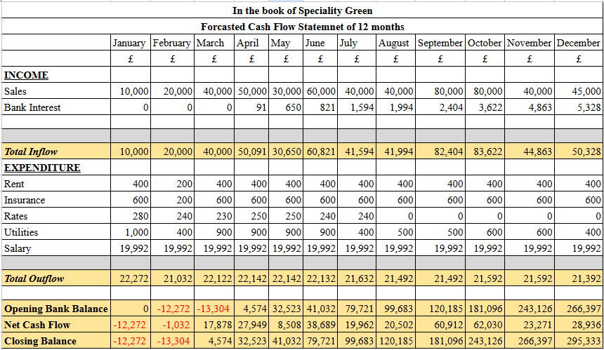
Figure 1: 12-month Forecasted cash flow statement of Speciality Green
(Sources: Self-Created, 2024).
The above statement leads to showing the forecasted cash flow statement of the organization named Speciality Green for the 12 months which start from January to December. Through the above analysis, it is found that the organization faced negative cash flow at the beginning of the first month but was able to generate positive cash flow in subsequent months. In the first month, the closing cash flow of the organization was found to be -£12,272 followed by -£13,304 in the second month which is February. From this month the organization generated a positive cash flow which steadily increased. It was found that the highest cash outflow of the organization was derived in the last month which was £295,333. This leads to shows that the organisation leads towards a positive cash flow which indicates the growth of the business.
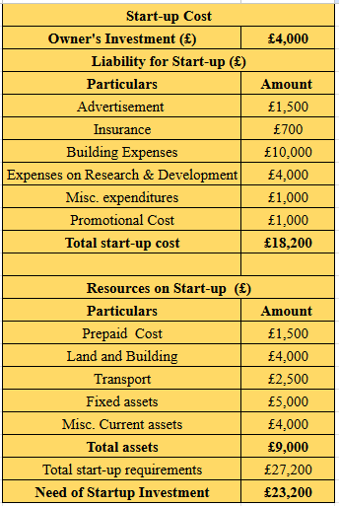
Figure 2: Start-up Cost of Speciality Green
(Sources: Self-Created, 2024)
The above-presented statement leads to show the startup cost of Speciality Green in which the contribution made by the owner was £4,000. The amount of total start-up cost and the asset were found to be £18,200 and £9,000 respectively. The organization needs a startup investment of £23,200 which can be raised through different sources like bank loans and the issue of shares. This amount can help the organization in enhancing the operation and making efforts toward growth as well.
Conclusion
Biodegradable packaging with a specialty green company cloud highlights the increasing demand for sustainable solutions in the [pavckeginhg industries. Growing consumer awareness about environmental issues and the shift toward eco-friendly practices. This business is well positioned to meet the needs of industries aiming to reduce their carbon footprint, with innovation in biodegradable materials, the company can act to a diverse range of clients, from food and beverage businesses to rentals and e-commerce offering environmentally responsive alternative4s. SWOT analysis of the company shows the strengths, weaknesses, opportunities, and that of the company for running their business.

9. Reference
Corporate Finance (2023) Types of businesses, Corporate Finance Institute. Available at: https://corporatefinanceinstitute.com/resources/management/types-of-businesses/ (Accessed: 09 November 2024).
Dominici, G., 2009. From marketing mix to e-marketing mix: a literature overview and classification. International journal of business and management, 4(9), pp.17-24.
Ecofreek (2024) 11 biodegradable materials that will save the planet, 11 Biodegradable Materials That Will Save The Planet. Available at: https://ecofreek.com/biodegradable/biodegradable-materials/ (Accessed: 09 November 2024).
Eneizan, B.M., Wahab, K.A. and Bustaman, U.S.A., 2015. Effects of green marketing strategy 4ps on firm performance. International Journal of Applied Research, 1(12), pp.821-824. Link: https://www.researchgate.net/profile/Bilal-Eneizan/publication/333530461_Impact_Factor_52_IJAR/links/5cf1e2f4299bf1fb184e8215/Impact-Factor-52-IJAR.pdf?__cf_chl_tk=eC8k5fvjXpaBpG47LWRhm7hE.NZhyIQskkigdIlXjTg-1731166483-1.0.1.1-CMi0fke9pVmkLVxgCJ2_ekbw4.FWpGyIhEKPl.Ip34Y
Forbes (2024) The 4 PS of Marketing, Forbes. Available at: https://www.forbes.com/advisor/business/4-ps-marketing/ (Accessed: 09 November 2024).
Freedman, J., 2000. Limited liability: large company theory and small firms. The Modern Law Review, 63(3), pp.317-354. Link: https://d1wqtxts1xzle7.cloudfront.net/87324670/10453577-libre.pdf?1654901290=&response-content-disposition=inline%3B+filename%3DLimited_Liability_Large_Company_Theory_a.pdf&Expires=1731157709&Signature=BHtxqaO5hR9lUmsAsQ7qpiQbuZvAlu73OGPsFT-H0AS-v0t35bEcsgHikrnDVn1BEMRZjPiC2VrJ6CPs6yCdMeF2Yae7Cwg5rLT8pOQ6RRvIBY2aoGj-OVPBP1SgedpEMXTySVAxsd9gRqwdn2kdQqCh52PNl2SoB3672rBD~YeIJxiaixvOZOUYkaTNrKWJvf1pdCjxMsxyV8OiEZ5r4GLN-avneOwR2oVWPf6HiBLbR8FCXX6An3o~0Qv-~UOJOF9u39WH7cDc5yiuySmG0iuBD6qxpdCCay6vpsLjvxe6fx8vEaULpU1CTuKKszNGemz0aG1ZJbwaacPmtaeOSw__&Key-Pair-Id=APKAJLOHF5GGSLRBV4ZA
Goi, C.L., 2009. A review of marketing mix: 4Ps or more. International journal of marketing studies, 1(1), pp.2-15. Link: https://pdfs.semanticscholar.org/006a/f4780f1cff9f7075ab5b7073f4cebb32c3d5.pdf/1000
Polystar Plastics (2022) The 7 benefits of biodegradable bags: Polystar Plastics ✓, Polystar Plastics. Available at: https://www.polystar.co.uk/news/seven-benefits-of-biodegradable-bags/ (Accessed: 09 November 2024).
World wildlife (2024) Is biodegradable and compostable plastic good for the environment? Not necessarily | blog posts | WWF. Available at: https://www.worldwildlife.org/blogs/sustainability-works/posts/is-biodegradable-and-compostable-plastic-good-for-the-environment-not-necessarily (Accessed: 09 November 2024).

