Dictating a Scene: Composition and Camera Angle
2509 words

Student Name: Sophie McCallum
Student ID Number: 1907466
Programme of Study: BA Film & TV
Module: Research in Practice
Module Code: ADAD5004

This essay will explore the ways in which cinematography can influence viewers’ emotions and attitudes towards film and the characters within it. Understanding the nuances behind how viewers absorb visual information and how this can be used by a cinematographer is crucial to my own practice as a cinematographer, especially as I develop my own personal style. Exploring this topic can help me reflect on my past work and allow me to improve my future practice.

As a cinematographer who is drawn towards the human psyche and an interest in the psychological behaviours of characters, I will be researching the ways in which cinematography can portray and exaggerate their traits and mannerisms. This will allow me to develop the knowledge and techniques to influence the viewer’s perspective and bias towards the character in the favour of the director. On top of this, exploring how the power dynamic between characters can be depicted with cinematography can help me further develop my work within dark, psychological thriller and horror genres. An example of these genres I’m interested would be The Devil All the Time (2020), and Good Time (2017).

By the end of this essay, I am hoping to discover new or previously unnoticed techniques and understand how I can apply these to my own practice. More specifically, I will work towards developing a better understanding of how a cinematographer can capture the power a character holds, how the emotional aspect of the film can be influenced by specific camera techniques, and what needs to be taken into consideration before developing a visual story.

When on the topic of giving characters power through composition, Renee (2019) explains how there is power in placement, for example with centre framing: “The balance that it produces guides viewers' eyes directly toward it and offers it more authority than elements on the sides of the frame.” In other words, placing the subject of interest in the centre of the frame draws viewers’ focus towards it. Here, the “authority”, or “power”, is subjective and depends on both the Director of Photography (DOP) and the character that is the focus in the shot. The latter can control the emotion in a shot, through acting. The DOP, however, has the ability to enhance this emotion through composition. For example, placing a character in centre frame, where they are surrounded by negative space, increases the focus on the character and the emotions they are portraying. If the character is centre frame in a busy environment, and there is a shallow depth of field, it intensifies the experience for the viewer and they can become engrossed in the characters situation, which creates a more authentic emotional experience for the viewer.

Photographer Nicolas Bruno (2021) created a dream journal in which he documented his experiences with sleep paralysis, and his composition is mostly consistent throughout – the main subject of focus in centre frame, surrounded by wet or marsh-like environments which act as negative space.
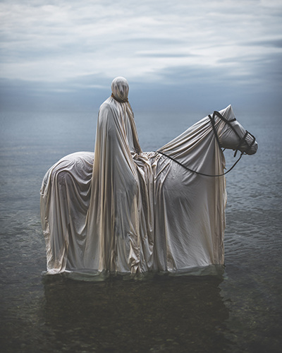
"The Somnia Tarot"

Despite the character not showing any emotion due to their face being covered, the composition of this shot forms the desired theme. The character and its horse are centre frame, and they are surrounded by a vast negative space, so all focus is on them.

Even though the character and his horse are in centre frame together, the character itself is actually slightly left to the centre. This purported centre framing is an almost untraditional alignment of objects which can subconsciously create an uneasy viewing experience for the viewer, almost forcing the feeling that Bruno had experienced when having these dreams. This particular manipulation of viewers’ emotions and how they receive visual information provided to them is something which inspires me. This what I will work towards in my own work. As my own theme is focused on the human psyche, and therefore best suited to psychological themed projects, I will take inspiration from Nicolas Bruno’s unconventional composition, as it is clear from his work that the slightest deviation from conforming standards within composition is enough to provide viewers with the desired effect.

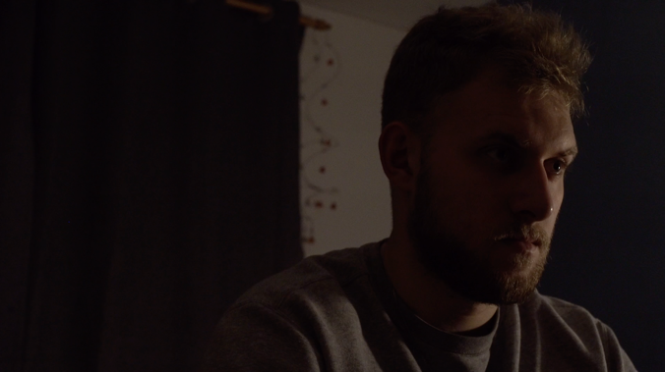
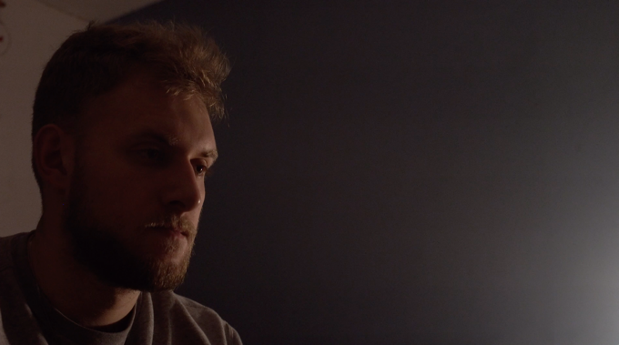
I have used this unconventional composition method within my submission for the ADFM5018 ‘Learn to Love Solitude’ module.
Picture A
Picture B

In these two shots I have used two different compositions for the subject, picture “A” (McCallum, 2021) has the character on the left of the screen, and picture “B” (McCallum, 2021) has the character on the right. Both are surrounded by negative space. In order to distinguish the effects these different compositions have on the viewer; we must first understand the way we view art.

Ruthie V of the Seattle Artist League (2017) describes how we interpret art “we often interpret things happening at the top or left side as beginning, and as they move towards the lower and the right side, they are perceived as ending”. Just like how we read a book, we start at the left and move to the right. So, when the subject of focus is on the right of the shot, what effect does that bring to the audience?

Picture “B” shows the character on the right of the screen, surrounded by dark negative space. This is a more extreme example of an untraditional composition that gives viewers an uneasy feel. Naturally, a viewer will look to the left of the screen to absorb what is being shown to them, but Picture “B” almost forces the attention to the right first, which as Ruthie V states, represents an “end”. This gives a dark and sombre feel to the shot, as the character is at the compositional “end”.

Contrastingly, the composition in picture “A” can give a feel of hope, despite the acting, lighting, and set being the same. Placing the character on the left, where the viewers look first, gives them a more comfortable viewing experience. This is also placing the character in the compositional “beginning” suggests that there is more to come, and that there is hope for the character.

Whilst filming for the Learn to Love Solitude module, I shot this scene multiple times using different angles, composition, and lighting. This was in order to capture the best shot for the theme I was working towards, which was loneliness. Upon analysing composition and how Nicolas Bruno uses it, I applied the affect his work has and ultimately chose the shot shown in picture A. This is because I wanted the character to come across as isolated, but the vast negative space in the middle and right of the shot can, to the viewer, subconsciously portray hope, and that there is more to come.

Interestingly, despite comparing these shots to Bruno’s work, I created these effects unintentionally, or in other words, I was not aware of how the different composition, lighting, or camera settings were affecting my shots. Considering Ruthie V (2017) has helped me explore and reflect on my previous practice and become more knowledgeable on these factors in cinematography. This has increased my confidence as a cinematographer as now I can apply these to my own practice and work towards a specific theme or feel that I or the director wish for.

Composition not only dictates emotions within the viewer but can also portray power dynamics between characters. Scott (2021) suggests that in dialogue scenes that contain two characters, “you might establish a disproportionate power dynamic by framing one character with a low angle shot and the other with an eye level shot.” Power dynamic is created by the cinematographer for the audience and is done by altering the way in which viewers are perceiving these characters. An eye level shot is a relatively “safe” angle, or as described on Adobe.com “a neutral camera angle, its function is not to distort or over-dramatise a scene”. It can be argued that despite being neutral and used in order not to dramatise a scene, it can help viewers connect with characters in a somewhat intimate way. This is because an eye level shot often allows a cinematographer to create focus purely on the character and the emotions they are showing, without the various subtle distractions that could be caused with an off centre shot. An eye level shot allows the character to become more relatable and gives the audience the answer and indication as to how the character is feeling or thinking.

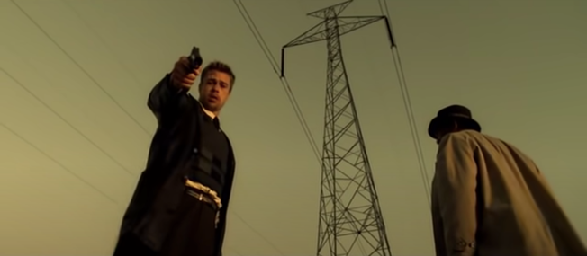
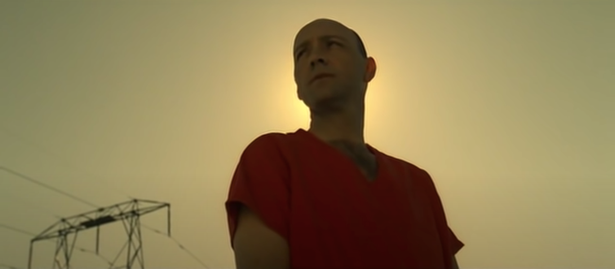
The low angle, however, is a versatile shot that can portray power or vulnerability. This can be seen in the final scene of “Se7en” (1995). In the beginning of this scene, seen in picture “C” below, Kevin Spacey’s character “John Doe” is shown from a low angle. This represents the power he has over Brad Pitt’s character “David Mills” whilst he is withholding information on the final two deadly sins. The warm glow of light behind him represents his self-proclaimed martyrdom and connection with a “higher power”. Picture “D” shows the switch of the power dynamic between these two characters; “David Mills” is now shown from a low angle, signifying his new-founded power over the one who once held it. This shot can also depict the vulnerability of “John Doe” as it shows the viewers the scene from his perspective.
Picture C
Picture D

In my submission for ADFM4025 ‘Applied Storytelling Practice 1’, I used composition and camera angles to create a disproportionate power dynamic between the two characters, as well as a switch in power between them. The beginning of the submitted scene, shown in pictures E and F (McCallum, 2021), one character is shot from a slight low angle and the other at eye level. The minor discrepancy between the composition has viewers feeling subconsciously “safe” with the character in picture “F” and “unsafe” with the character in picture “E”. As stated above, an eye level shot is relatively safe and allows the character to become relatable to the viewer, whereas the low angle can create an uneasy feeling and cause distrust towards the character from the viewer. The low angle makes the character seem more foreboding as they are looming over the level at which the audience is viewing them.
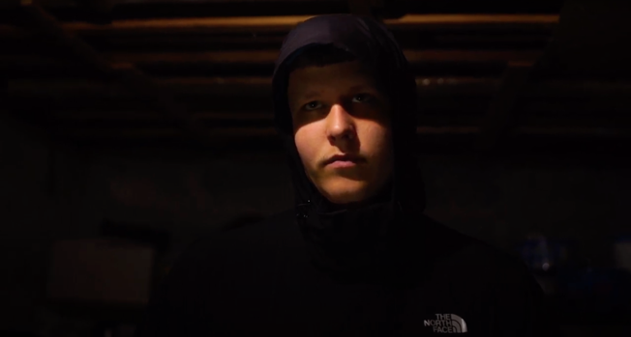
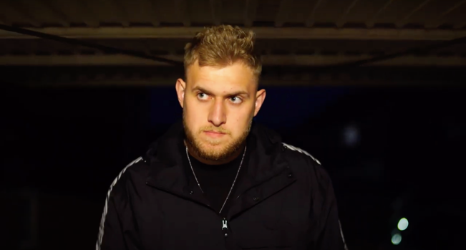
Picture F
Picture E

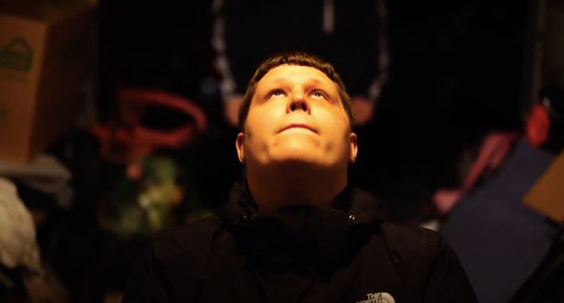
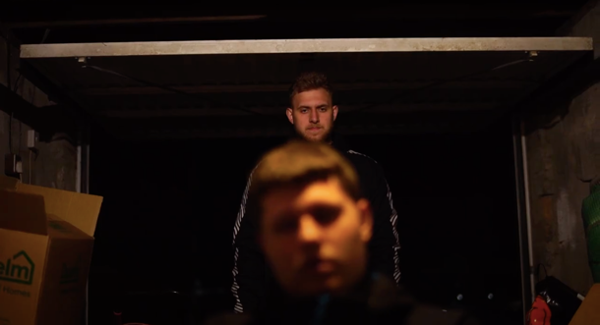
Picture H
Picture G

Towards the end of the scene, I created a shift in the power dynamic as seen in picture “G” (McCallum, 2021). I did this by placing the two characters in the same frame, one in the top half and the other in the bottom half. The character that was once in the position of power is now in a more vulnerable position, especially with his back to the character who is looming over him in the background.

Picture “H” (McCallum, 2021) shows the newfound vulnerability in the character that was once shown in a threatening nature. Unlike picture “C”, where the light was surrounding “John Doe’s” silhouette, I chose to place a soft warm light onto the character’s face from above, signifying his soon-to-be connection or unification with God. This high angle contributes to how I wanted the viewers to feel that is sympathy towards a character who at the beginning of the scene I captured in an intimidating and “distrustful” nature.

When reflecting upon my own work and that of Se7en (1995) I’ve come to understand the importance of composition and angles when filming, especially for my future work if I am to continue creating in the theme of the human psyche and psychological thrillers. In my future work I will take into consideration what the shot is telling the viewers and how I or the director wish for them to respond to it.

Whilst I am on the topic of taking into consideration of how viewers will respond, I will next analyse Ellen Kuras’s work, and that of her thought process when approaching a project. Kuras often emphasises the importance of how you approach filmmaking “every single shot has a story to it. Every single time you pan the camera, there’s a reason for it… it looks like a cool shot? Maybe. But then, what does it mean?” (Nord, 2017). Upon reading this, and after analysing my past submissions, it has come to my attention that I have fallen victim to using a shot because it looks “cool” instead creating a shot to compliment the theme and acting.
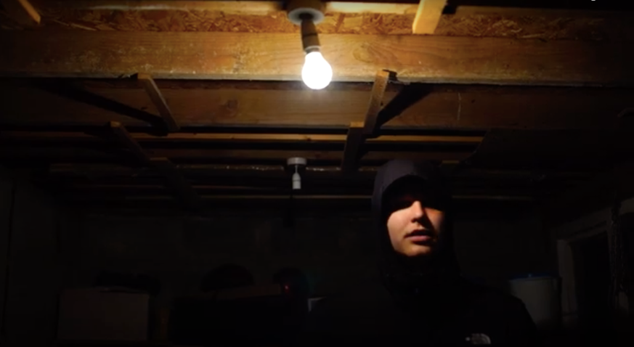
Picture I

Picture “I” (McCallum, 2021) shown above, while effectively shows power through composition, angle, and lighting, doesn’t “flow” with the rest of the scene; I chose it purely because of how it looked visually, not for how it spoke to the audience. If you compare this shot from those shown above (pictures “E”, “F”, “G”, “H”), you can see it doesn’t quite “fit in”. I believe this is because in the scene I submitted, the majority of shots use central composition which helped create tension as viewers could become immersed in the scene and how the character is feeling. Suddenly having a different composition in the middle of the scene unintentionally halted the tenseness and therefore stopped the desired effect taking place within the audience, or in other words as stated previously, it stopped the “flow” of the scene.

Whilst a sudden change in composition can be beneficial, I believe that in this scene the change was too extreme to create a subtle unease within the audience. Whilst reviewing and analysing my work I have come to understand how my lack of knowledge on composition had restricted my potential when creating a scene on power between characters. Taking Ellen Kuras’s outlook and approach to cinematography into account when creating shots can possibly improve my work greatly. Something as simple as asking myself “what does this shot tell the viewer” can help me create more powerful and meaningful shots that work with the story being told, rather than just adding whatever I think looks “good”. In the case of picture “I”, perhaps it would have been more effective for me to place the actor slightly more central to what he is, so not to create such an extreme difference in composition. In doing this, I would be keeping the “flow” of the scene whilst still creating that “uneasy” feeling within viewers from the composition.

In terms of how the content of this essay has informed my practice, I believe I have come to the realisation of how I worked in past projects, and mainly how most of my outcomes are credited to luck, instead of knowledge and practice. This essay has allowed me to explore the strengths, but mostly the weaknesses, within my past work and had led me to analyse work from successful creators both within and outside of the film industry. I believe that the analysis of others’ work and the reflection of my own has given me more confidence and knowledge as a cinematographer, especially when it comes to working towards my own theme – conveying the human psyche and psychological thrillers. I am confident that the heavy analysis on composition and what effect it has on the audience will allow me to find the right shot for the desired effect or theme in my future practice.

Reference:
Adobe. What is an eye level shot in film? Available at: https://www.adobe.com/creativecloud/video/hub/ideas/what-is-an-eye-level-shot-in-film (Accessed: March 17, 2022).
Bruno, N., 2021. The Somnia Tarot, Available at: https://www.nicolasbrunophotography.com/ (Accessed: March 17, 2022).
Good Time (2017) Directed by Benny Safdie and Josh Safdie [Film] Cinema.
McCallum, S., (2021) Learn to Love Solitude. [Film]. (Accessed: March 17, 2022)
McCallum, S., (2021) The Cursed. [Film]. (Accessed: March 17, 2022).
Nord, L., 2017. 7 secrets to successful cinematography from master DP Ellen Kuras. Available at: https://nofilmschool.com/2017/07/ellen-kuras-cinematography-masterclass#:~:text=%22Allow%20yourself%20to%20feel%20something,emotional%20when%20you're%20shooting. (Accessed: March 17, 2022).
Renée, V., 2019. How to give characters power through composition. Available at: https://nofilmschool.com/give-characters-power-through-composition (Accessed: March 17, 2022).
Scott, M., 2021. Power dynamics in film: The impact of a low angle shot. Available at: https://www.soundstripe.com/blogs/low-angle-shot (Accessed: March 17, 2022).
Se7en (1995) Directed by David Fincher [Film] Cinema.
The Devil All the Time (2020) Directed by Antonio Campos [Film] Netflix.
V, R., 2017. Left vs right: Sense of time in composition. Available at: https://seattleartistleague.com/2017/11/27/left-vs-right-sense-time-composition/ (Accessed: March 17, 2022).

