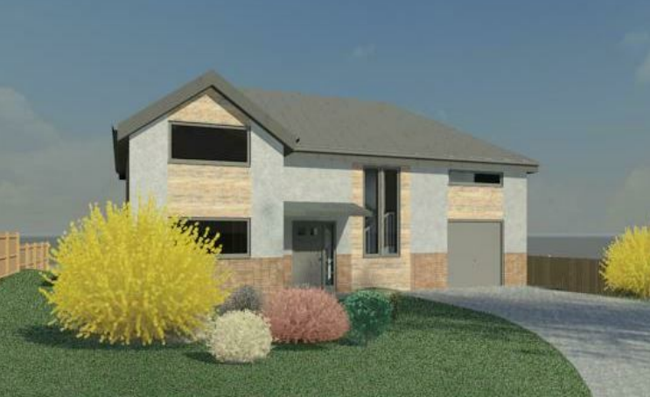

Module Code – ACBA4001

New Build Dwelling – Technical Report With Drawings

Cerith Edwards - 2219938

A report focussing on:

New Build Dwelling – Technical Report with Drawings

Prepared for:

Mr Gavin Traylor

Created by:
Mr Cerith Edwards (2219938) – Trainee Quantity Surveyor for Premier Forecourt and Construction

Date completed:
27/04/23

Word Count: 2499 Module Code – ACBA4001

Table of Contents

Introduction 4
Proposed plan/ Construction drawings 5
Ground and first floor plan 5
Elevations 5
Sections 6
House Views 6
The Ground floor Construction, detailing and junctions with external walls. (20%) 7
ii) A detailed section and plan detail showing a window opening in the external wall (20%) 9
iii) Eaves detailing and roof covering – indicating appropriate weathering, fixing and laps. (20%) 11
iv) The main roof structure. Construction, detailing and fixing. (20%) 12
Attic Room. 14
Offsite Construction 16
Panelised systems 16
Volumetric systems 16
sub-assemblies and components 17
Hybrid systems 17
References 17

Introduction

A client has approached me after receiving planning consent for a single, detached two storey domestic house. The client is not familiar with timber frame construction and has requested that I create a technical study to address some of the necessary construction aspects. The plans I received are attached below.

A brief description of the proposed build is that the house is going to be a timber frame build, erected on a raft foundation. The outer skin will consist of a stack bonded facing brick work and blockwork with a smooth render finish. The house will contain underfloor heating, have triple glazed windows. Windows and doors are to be powder coated aluminium. The roof is going to be a made of trussed rafters with a metal profile sheeting finish. The client has mentioned an attic conversion, I will also look at the options of the conversion in my report.

The client has asked me to produce proportionate and suitably annotated drawings for certain sections of the house. These are:

- Ground floor
- Window opening in the external wall
- Eaves detail and roof covering
- The main roof structure

The option of off-site construction is very possible during this construction project. The client is not aware of the terminology of off-site construction, I will also describe what offsite construction is and describe main categories available through offsite construction.

Proposed plan/ Construction drawings

Ground and first floor plan

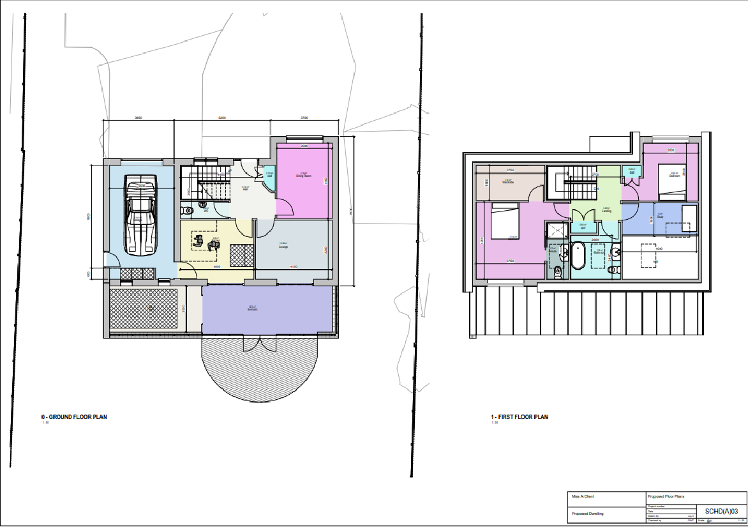

Elevations
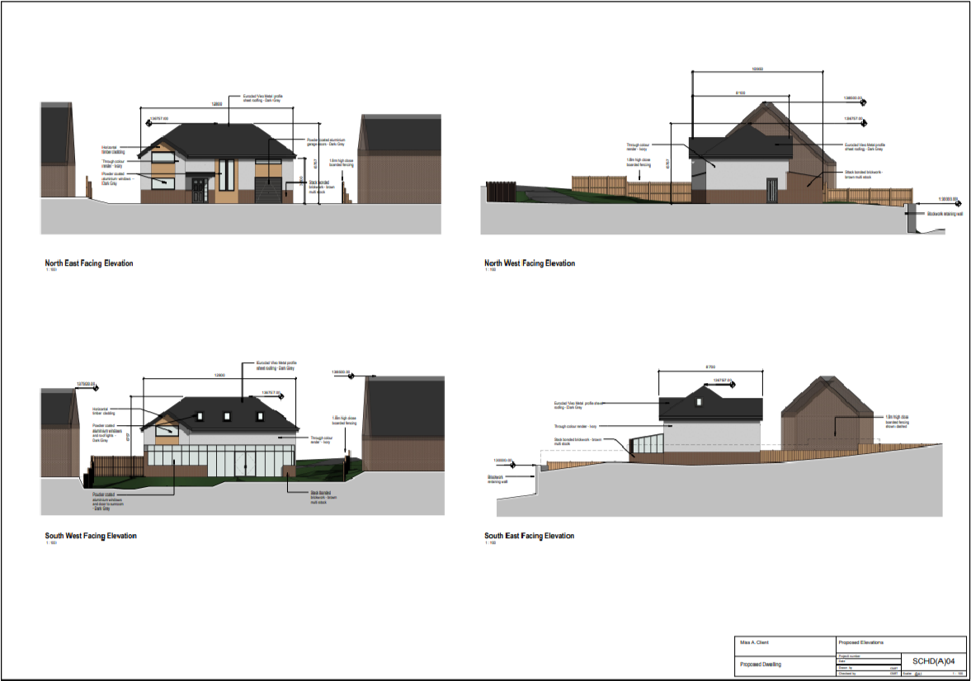

Sections
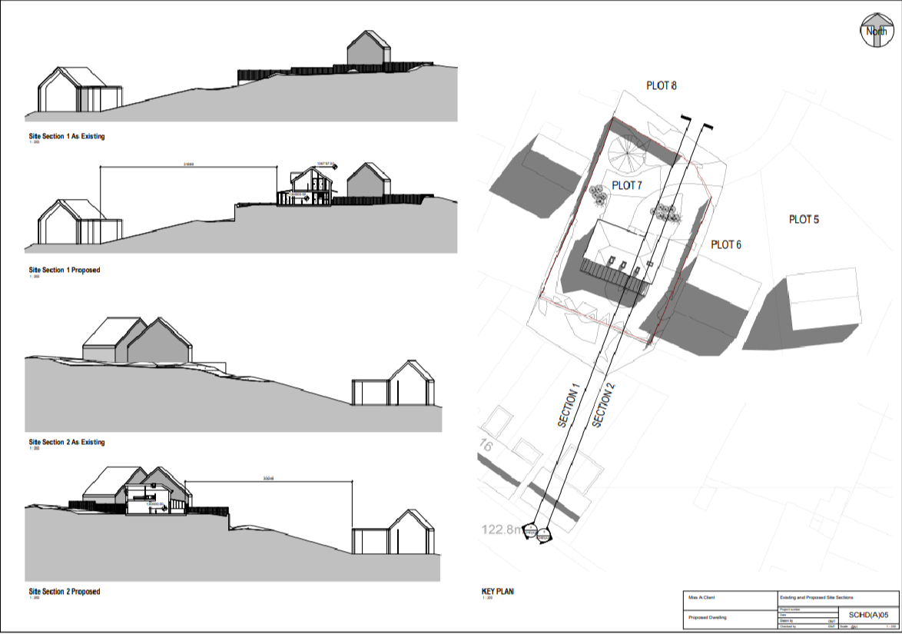

House Views

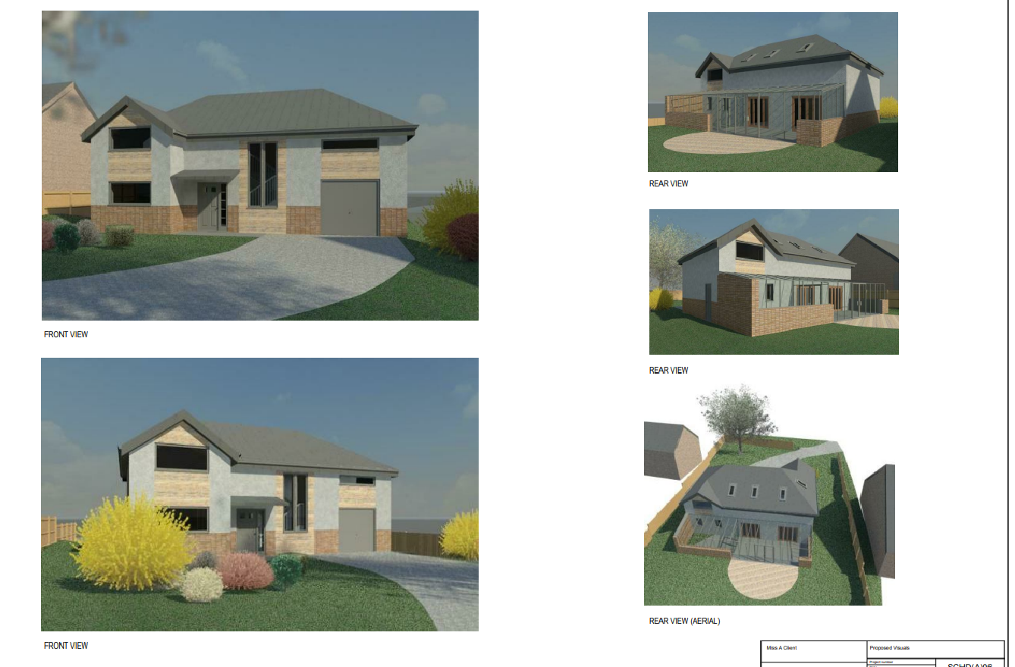

The Ground floor Construction, detailing and junctions with external walls. (20%)

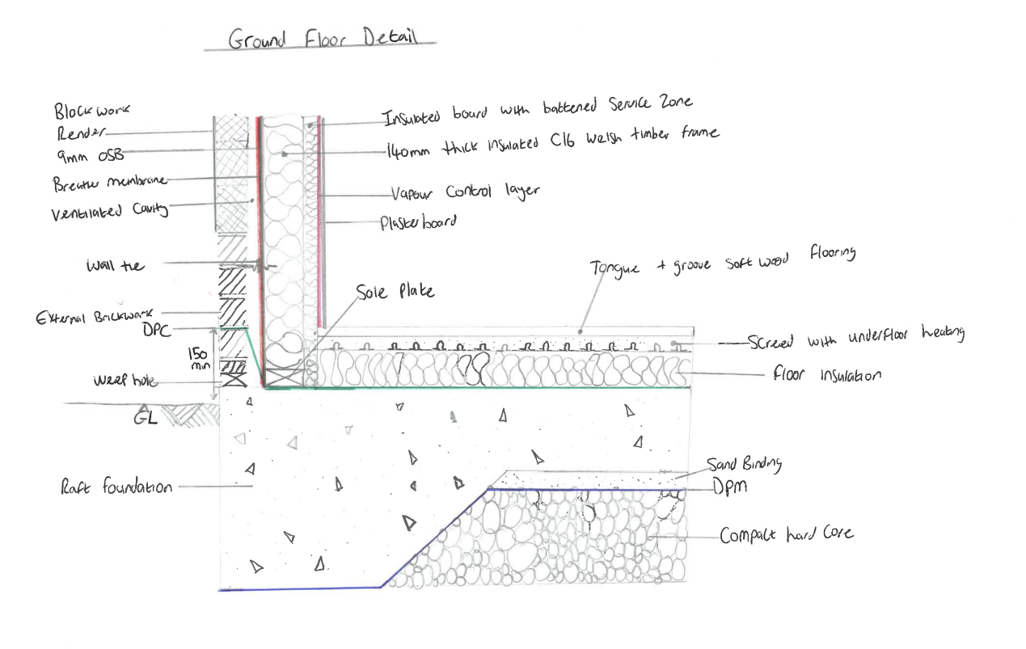

Taking the detail supplied by the client I have ensured that all the detail is included in my drawing of the ground floor. I have also ensured my design will provide excellent human comfort. This design ensures that human comfort can be controlled throughout the year, keeping the house cool during warmer temperatures, whilst keeping the heat in during the colder months. The house will have enough thermal insulation to meet the building regulations (Part L) while maintaining a comfortable temperature, achieving the relevant U values. I have ensured that the DPC level is at least 150mm above the ground. I have added a weep hole at the bottom of the drawing this would be just above the cavity tray, this will prevent the flooding of the cavities above the DPC.

The foundation is a raft foundation, this is due to the house being constructed on reclaimed ground. Building regulations Part A are relevant for the foundation. A raft foundation is a reinforced concrete slab that supports the entire structure of the building. This foundation lowers the pressure on the earth by dispersing the weight of the building across a broader area than other foundations allow. (LABC, 2018) When constructing the raft foundation. The concrete for the raft must be of a suitable mix that provides the necessary strength and resistance to chemical and frost action. It must be correctly, cured, placed, and mixed. It must Achieve the required strength. When applicable it should be carried out in one pour, whilst ensuring weather conditions and daylight is suitable. (NHBC, 2022). Although not included in my drawing, steel should be added to the foundation to increase strength, this will be included with a structural engineers’ report, whilst also undertaking site visits.

As per detail provided alongside building regulations Part L I have ensured that the timber frame of the construction has at least 140mm of insulation; this layer of insulation will be effective with the external wall and the 50mm cavity. This insulation must be installed in accordance with building regulations both during installation and during construction. In the floor detail I have included 100mm of insulation, this must meet the minimum energy efficient values. (GOV.Wales, 2023). The underfloor heating will also be beneficial for human comfort. This covers more surface area than a typical radiator, which will help the house heat up quicker, allowing the heat to rise throughout the house. The internal skin has a 50mm insulated battened service zone, again assisting with controlling the temperature more efficiently. In between the plaster board and the service zone there will be a vapour control layer (VCL). “This will restrict the movement of warm, moist air from inside a property into the fabric of the building”. (Setherton, 2023) Bs 5250 gives further guidance on this. There is also a breather membrane included in my drawing, this will “allow water vapour to escape from inside a building without the need for ventilation” (Kingspan, 2022). I have included wall ties in my drawing, these must also comply with BS EN845-1 (NHBC, 2022)

Acoustic insulation also plays a part in modern builds. Externally to internally the design will show as the following.

Render – 100mm Block/brick – 70mm cavity – Breather membrane – 9mm OSB – 140mm Thick insulated c16 Welsh timber frame – 50mm insulated battened service zone – VCL – plasterboard.

This will assist with meeting Part E of the building regulation ensuring that the house will be resistant to the passage of sound. The home will be soundproof thanks to the external brick wall and its two levels of insulation on the walls.

The render will also protect the house against the climate, due to being water repellent. This can also aid with the efficiency of the property, whilst protecting it from dampness.

ii) A detailed section and plan detail showing a window opening in the external wall (20%)

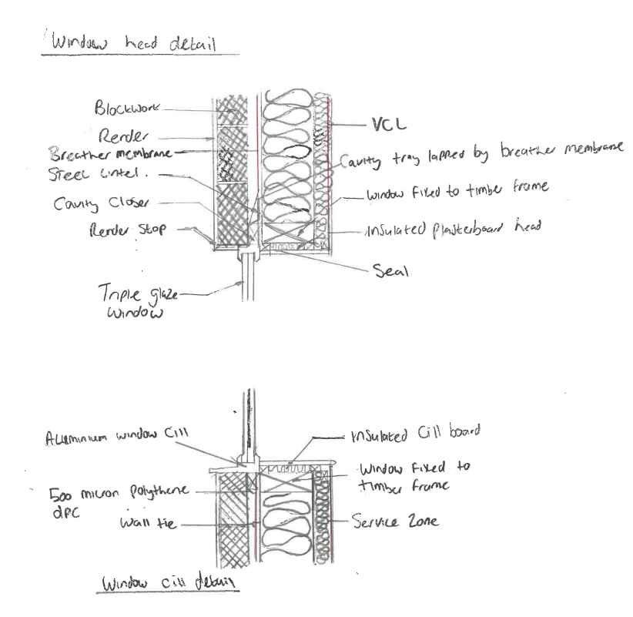

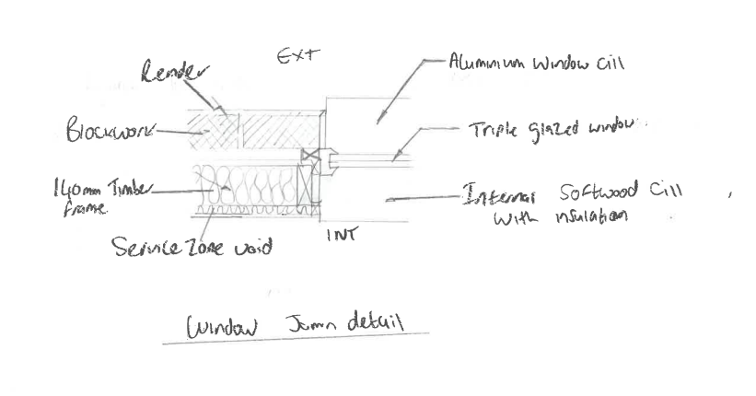

Taking the detail supplied by the client I have ensured that all the detail is included in my drawing of the window detail. The aluminium frame's structure must be well-insulated to stop cold from the outside from penetrating inside, to avoid damp or condensation. Windows just like doors must be planned and defined to provide appropriate in-service performance. They must be tested and classified for air permeability, watertightness, and wind resistance in accordance with the following standards.

Figure 1 - NHBC Standards
To bear operating loads, windows and their fittings should be strong enough. The UK-appropriate features and performance classifications are outlined in BS 6375-2.

As the windows for this house are Aluminium, these should meet standards BS4873. The glass for the window (triple glazed) should always be inspected before install. This will rule out any possible failings of the window/glass. Each window should also be installed with securely fixed locks or multi point locking systems. (NHBC, 2023)

iii) Eaves detailing and roof covering – indicating appropriate weathering, fixing and laps. (20%)
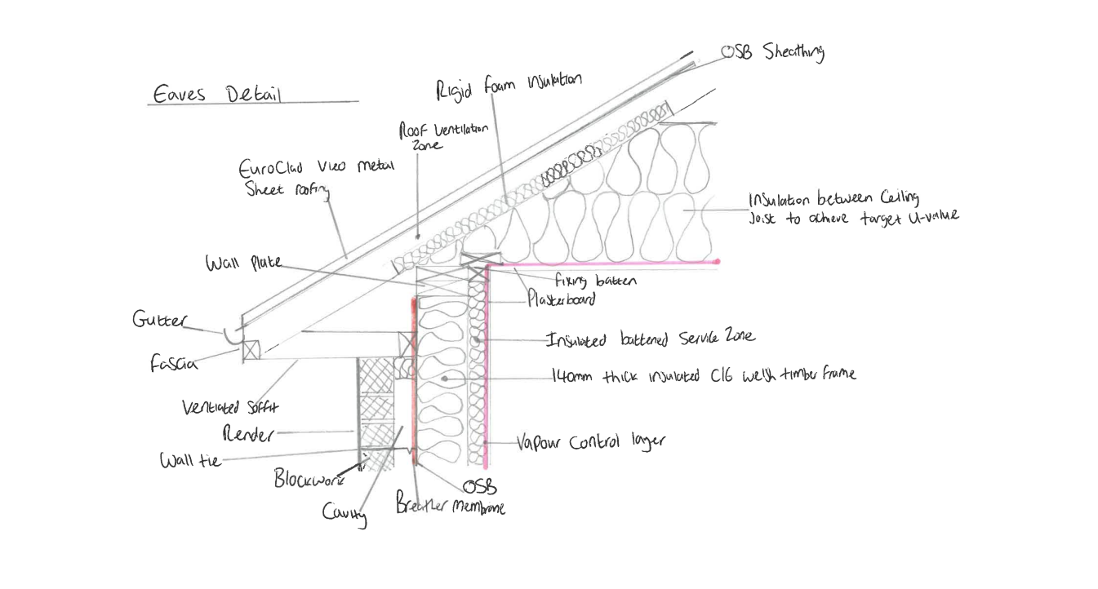
Full information on the new roof, including its materials, dimensions, and performance characteristics, will be required to establish compliance with the Building Regulations. Taking the detail supplied by the client I have ensured that all the detail is included in my eaves detail drawing.
Building regulations state the materials used to construct the roof should be strong and able to withstand the elements. (Gov.Wales, 2022) The house has a proposed Euroclad Vieo metal sheet as the roof finish. This has excellent durability, while being fire resistant. This also has an exceptional life span offering excellent durability and can offer cost saving with easy installation. (Euroclad, 2023)
Ventilation is required as I have designed a cold roof. Air should be allowed to enter a roof ventilation system at one end and pass through to the other end, where it may depart. (Gov.Wales, 2022) I have taken this into consideration with my drawing. Air can simply travel through the Vented soffits and run alongside the OSB sheathing. This will allow plenty of ventilation as per part F of the building regulations. The insulation will be placed between the ceiling joists as defined in Building regulations document L1B.
Please note that as per building regulations that the gutter should discharge and fall towards the nearest outlet. There are many other rules for guttering you can obtain in document H of the building regulations.
The eaves have been designed to assist with the provision of light. The overhang of the eaves will assist with protecting the house from direct sunlight. The eaves will maximise your home's exposure to sunshine, shield it from dampness, and add to its overall look.

iv) The main roof structure. Construction, detailing and fixing. (20%)

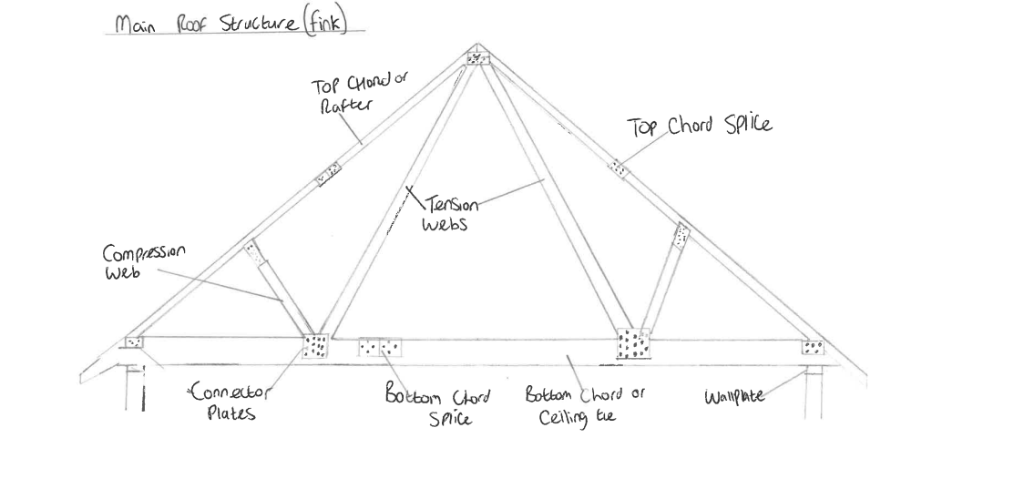

Taking the detail supplied by the client I have ensured that all the detail is included in my drawing for the main roof. I have decided on a standard Fink truss. As you can see in my drawing the Fink truss is made up of many triangles. This offers great strength to support the roof structure. It also allows for spans from around 5m to 9m which will be compliant in the proposed plans. It is a simple design that can be adapted while typically being quite cost efficient. The structural design should be in accordance with BS 5268. When compared to other kinds of wall construction, the roof of a timber frame structure is not particularly different. I would recommend treating the timber of the trusses with a suitable protection layer to avoid any infestation.
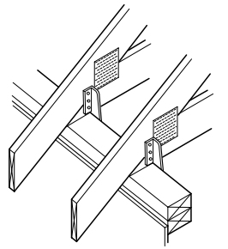
Figure 3 Trada, 2022
Using proprietary truss fixing clips, trussed rafters should be fastened to the top timber. These parts, which support the trussed rafters ought to be at least 75mm wide. The house design allows for a method of roof bracing that uses OSB sheathing that will be secured to the top face of the rafters. Trussed rafters should not be modified without the correct approval. (TRADA, 2012)
Building regulations state that when constructing a new roof. The roof must be weather resistant, resist the spread of fire from one property to the other (not applicable for this house – single), be able to support loads, resist heat loss while being ventilated to protect condensation. The roof must also have acceptable drainage. (Gov.Wales, 2022)

Attic Room.

An attic room is an option for the client. To do this I would recommend changing the proposed fink truss to an attic truss. This can be done by modifying the fink truss to an A shaped truss as below.

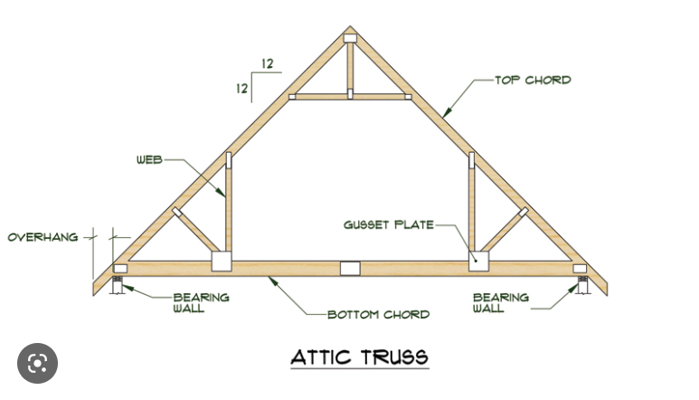

The fink truss comes with limitations, it does not allow for space in the attic. The issue with a fink truss is that the beams take up most of the room in the attic. Truss rafters are far from ideal for a conversion; however they are adaptable with the correct team/specialists.
The attic truss allows plenty of habitable space. Changing the design of the attic can be costly and often requires a structural engineers input. It is probable that any existing roof will also need to be inspected for suitability in terms of weather resistance and thermal insulation (depending if the house is installed with a fink truss or not first). Ventilation is key for an attic room, however for this house it will already be well ventilated as per eaves section above. Adding the attic room will also mean that the stairs will have to lead down top the exit door. The attic will also have to be sound proofed and meet the insulation requirement as per building regulations.

Advantages of a Attic truss
- Strong load bearing capacity
- Versatile adaptive design
- Can be constructed off site.
- Easily insulated.
- Longevity
Disadvantage of an attic truss
- Timber can warp
- Timber invites pests
- If being converted to a attic truss – this can be costly. Also increases labour cost.
- A structural engineer would be required and new plans would need to be drawn up
- Start to finish of a conversion can be very timely.

Offsite Construction.

Off-site construction involves manufacturing and pre-assembling components, pieces, or modules in a factory before installing them in their selected location. When building off-site or other comparable setting, it is built more efficiently and to a higher standard than when building on-site. It is typically constructed in sections to make it simple to transport to the location and quickly assemble once there. There are many advantages to offsite construction, a good example of this is that it is often constructed in a factory. A simple advantage of this would be that weather will never delay the assembly time, although it may impact the install. The factory also guarantees higher quality, more predictable product behaviour, whilst also in a clean environment. This significantly increases the value of the finished product. Although delivery to site can often be very expensive, I would prefer the offsite option as it usually saves time (no need to build onsite), whilst usually supplying a better product (often machine made, reducing the risk of human error).
Kier also states offsite construction is safer, often eliminating the human factor of working at height. This can lessen the requirement for scaffolding and other site infrastructure while typically producing products at bench height. (Kier, 2020)

There are four main types of offsite construction, these are panelised systems, volumetric systems, sub-assemblies and components and Hybrid systems. These can be typically constructed out of most materials such as timber, concrete, steel or hybrid.

Panelised systems

The panelised method has advantages in terms of quicker overall construction timelines, more adaptability, and usually provided better value to the customer. Panelised method often refers to wall, floor, or ceiling components that are made in a factory and assembled on-site into a building. Mechanical and electrical services, such as pipes or light switch fittings, can be pre-installed in these panels. (modularize.com, n/a). panelised systems would be a viable option for the proposed house, it would be beneficial for the structure of the timber frame. As a timber-frame building, this might be used to accelerate the interior fit out of the house. These panels also come with a “closed” option. This would include “insulation, a service zone and sheeting on both sides. This could be further enhanced with the addition of cladding, doors, windows or additional services, again a time saving option.

Volumetric systems

Buildings are put up using a method known as volumetric modular construction, which involves linking a number of relatively large pre-built parts, or "modules," to make the final structure. Volumetric systems are prefabricated, three-dimensional components that can be delivered to place a fully constructed and form a functioning room. Often these are already fully furnished internally. Often referred to as pods these are used for bathrooms, roof top services and plant rooms. I would not recommend using these for the proposed house due to the lack of quality often associated with it. (Builderspace, 2023)

sub-assemblies and components

I would recommend using sub- assemblies and components on the proposed house. This would speed up the project schedule and guarantee that everything is constructed to the highest standards. These are the prefabricated components, such as joists, windows, doors, and staircases, that do not fit into the other two categories of off-site construction mentioned. These components include prefabricated parts, building materials, tools, and equipment. (Theconstructor, n.d.)

Hybrid systems

“Hybrid construction combines both volumetric and panellised approaches in order to develop a single building. Hence this construction is also called semi-volumetric.”
(Theconstructor, n.d.)
A hybrid system is a concept that is frequently used to describe a wide range of construction techniques. Typically, these techniques are blended, using several materials and systems to accomplish a certain function.

References
Builderspace, 2023. builderspace. [Online]
Available at: https://www.builderspace.com/modular-construction-16-pros-and-cons
[Accessed 12 April 2023].
Euroclad, 2023. Curtismoore. [Online]
Available at: https://www.curtismoore.co.uk/wp-content/uploads/2014/08/Euroclad-Vieo.pdf
[Accessed 20 April 2023].
Gov.Wales, 2022. Building regulations: roof. [Online]
Available at: https://www.gov.wales/building-regulations-roof/constructing-new-roof-eg-extension
[Accessed 20 April 2023].
GOV.Wales, 2023. Building regulations - Insulation. [Online]
Available at: https://www.gov.wales/building-regulations-insulation
[Accessed 20 April 2023].
Kier, 2020. Kier -MMC Brochure. [Online]
Available at: https://www.kier.co.uk/media/3011/brochure-offsite-mmc-brochure-2020-digital.pdf
[Accessed 12 February 2023].
Kingspan, 2022. What is the Difference Between a 'Breather Membrane' and a 'VCL' (Vapour Control Layer)?. [Online]
Available at: https://www.kingspan.com/gb/en/knowledge-articles/the-difference-between-a-breather-membrance-and-a-vcl/#:~:text=%27Breather%20membranes%27%20are%20installed%20to,tries%20to%20enter%20the%20building.
[Accessed 20 April 2023].
LABC, 2018. Raft Foundation basics. [Online]
Available at: https://www.labc.co.uk/news/raft-foundation-basics#:~:text=A%20raft%20foundation%20is%20a,the%20pressure%20on%20the%20ground.
[Accessed 20 April 2023].
modularize.com, n/a. modularize. [Online]
Available at: http://www.modularize.co.uk/documents/A%20Brief%20Guide%20to%20Offsite%20Construction.pdf
[Accessed 12 April 2023].
NHBC, 2022. Raft, pile, pier and beam foundations. [Online]
Available at: https://nhbc-standards.co.uk/2022/4-foundations/4-4-raft-pile-pier-and-beam-foundations/4-4-11-concrete/
[Accessed 20 April 2023].
NHBC, 2022. Wall Ties. [Online]
Available at: https://nhbc-standards.co.uk/2022/5-substructure-ground-floors-drainage-and-basements/5-1-substructure-and-ground-bearing-floors/5-1-15-wall-ties/
[Accessed 20 April 2023].
NHBC, 2023. [Online]
Available at: https://nhbc-standards.co.uk/6-superstructure-excluding-roofs/6-7-doors-windows-and-glazing/
[Accessed 24 April 2023].
Setherton, G., 2023. How to install a Vapour control layer. [Online]
Available at: https://www.permagard.co.uk/advice/installing-vcl-vapour-control-layer#:~:text=A%20Vapour%20Control%20Layer%2C%20or,wall%27s%20cavity%2C%20behind%20the%20insulation.
[Accessed 20 April 2023].
Theconstructor, n.d. what is offsite constructiom. [Online]
Available at: https://theconstructor.org/building/offsite-construction-features-methods/38319/
[Accessed 12 April 2023].
TRADA, 2012. Timber frame construction. 5th Edition ed. s.l.:Trada Technology.

