

Information Engineering

Student ID: 1909223

Module Leader: Sadeque Shaikh
Module Code: ACCC4004

Table of Contents
Introduction 3
Entity Relationship Diagram 3
Documentation 5
Tables 13
Forms 22
Reports 25
Relationships 27
Add records to tables using SQL 32
Creating relationship (FK) using SQL 35
Reproducing a report from a query 38
Working of main menu and form navigation 39
Calculating in a report 40
Master and Embedded forms 40
Menu displayed immediately database opens 41
User documentation 42
Conclusion 43
References 43
Appendix 44

Introduction
Traditionally data was stored in paper documents and then to file management systems. These forms of data storage did not permit manipulation of data into different forms of output. However, with introduction of database management systems (DBMS), data is able to be recorded, stored, manipulated and retrieved in any required form. There are many types of DBMS tools such as MS Access, SQL and MySQL among others which allow for storage and manipulation of digital data. This report looks at the development and implementation of DBMS for Universal Sports which look forward to switching from the tradition form of data storage using papers to use of a more advanced database able to store, manipulate and retrieve data in any desired form.

Entity Relationship Diagram
ERD is a tool used for planning, designing and modelling of a database (Davis and Yen, 2019). They start with entities followed by data normalisation where the two tools can be used in verifying each other. In an ERD models, the entities, attributes and their relations map smoothly to give the analysis a clear and high level view of data. When used alongside flow diagrams, ERD models gives a logical view of the system hence an excellent starting point of database system modelling (Davis and Yen, 2019).
In the Universal Sports analysis reveals various tables which have their attributes. These attributes are related in one another in different ways thus creating relationship between different tables. The ERD design below shows these relationships using crow foot annotations.
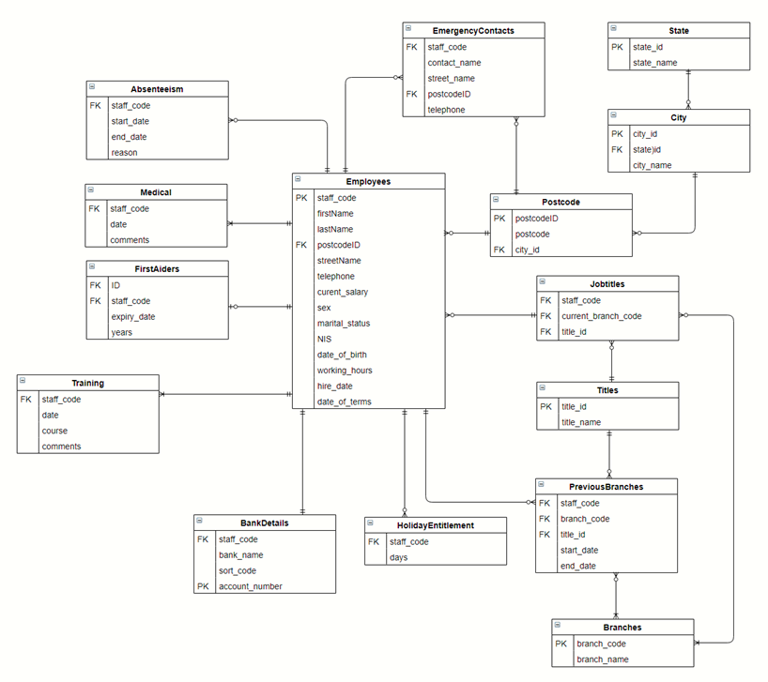
ERD without attributes

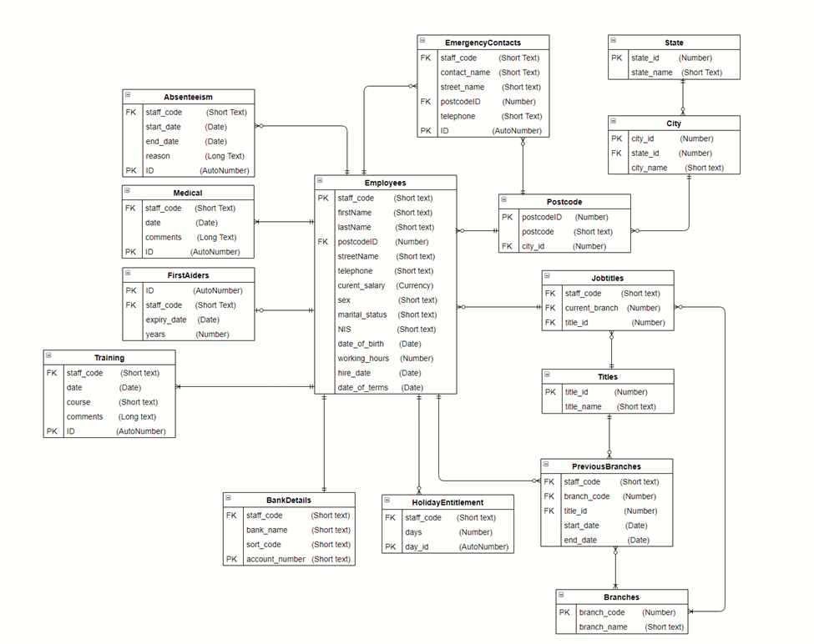
ERD with entities and attributes

Documentation
Table Name | Employee
User requirements | It contains the personal information of employees
Fields | Staff_code, firstName, lastName, postcode, streetName, telephone, current_salary, sex, marital_status, NIS, date_of_birth, working_hours, hire_data and date_of_terms.
Foreign Keys | postcode
Relationships | It is a parent table of other tables including Absenteeism, Medical, FirstAiders, Training, BankDetails, HolidayEntitlement, EmergencyContacts, Postcode and Job Titles.  The table has one to many relationships with Absenteeism, Medical, Training, EmergencyContacts, HolidayEntitlement and PreviousBranches sub-tablees.

Table | Absenteeism
Fields | Staff_code, start_date, end_date, reason and ID
Foreign Keys | Staff code
Relationships | Absenteeism table is a child table of parent table Employees and has a one to many relationships with the latter.
User requirements | It holds the information of absenteeism of the Employees

Table | Medical
Fields | staff_code, data, comments an ID
Foreign Keys | staff_code
Relationships | It is a child class of Employees table with a one to many relationship
User requirements | It holds the medical information of the Employees

Table | FirstAiders
Fields | ID, staff_code, expiry data and years
Foreign Keys | saff_code
Relationships | It is a subtable of the Employees table having a one to many relationship with the Employee table.
User requirements | It contains information of all employees who have been trained and holds certificate on first aid and can carry out first aid

Table | Training
Fields | staff_code, data, course, comments and ID
Foreign Keys | staff_code
Relationships | It has a one to many relationship with the Employees table
User requirements | It holds information on the training of all club members

Table | BankDetails
Fields | staff_code, bank_name, sort_code and account_number
Foreign Keys | staff_code
Relationships | It has one to many relationship with Employee table
User requirements | It holds the bank details of employees

Table | HolidayEntitlement
Fields | staff_code, days and day_id
Foreign Keys | Staff_code
Relationships | It is a child class of Employees class and has a one to many relationship with the parent table.
User requirements | It contains the information of holidays each employee is entitled to.

Table | EmergencyContacts
Fields | staff_code, contact_name, street_name, postcodeID, telephone and ID
Foreign Keys | staff_codeand postcodeID
Relationships | It is a subclass of Employees class
User requirements | It holds information on all employee emergency contacts

Table | HolidayEntitlement
Fields | staff_code, days and day_id
Foreign Keys | Staff_code
Relationships | It has one to many relationship with employee table
User requirements | It contains information of all holidays gone by employees

Table | PreviousBranches
Fields | Staff_code, branch_code, title_id, start_date and end_date
Foreign Keys | staff_code, branch_code and title_id
Relationships | It has one to many relationshop with the Employees table. It is a linking table between the Employees table and the Titles table as well as the branches table
User requirements | It holds information on employees’ duration of staying in various branches

Table | Braches
Fields | branch_code and branch_name
Foreign Keys
Relationships | It has one to many relationships with the PreviousBranches and Job Titles. It is a linking table between the PreviousBranches and the JobTitles tables.
User requirements | It holds all names of the club branches

Table | Titles
Fields | title_id and title_name
Foreign Keys
Relationships | It has one to many relationships with the JobTitles table and PreviousBranches
User requirements | It holds names of titles at the club

Table | JobTitles
Fields | Staff_code, current_branch and title_id
Foreign Keys | Staff_code, current_branch and title_id
Relationships | It has one to many relationships with employees table and branches table
User requirements | Holds titles of all employees in the club and their current branches

Table | Postcode
Fields | postcodeID, postcode and city_id
Foreign Keys | city_id
Relationships | It has one to many relationships with the Employees table, city and EmergencyContacts
User requirements | It contains information of postcodes and the cities

Table | City
Fields | City_id, state_id, city_name
Foreign Keys | State_id
Relationships | it has one to many relationship with state and postcode tables
User requirements | It holds information of all cities and their countries

Table | State
Fields | State_id and state_name
Foreign Keys
Relationships | It has one to many relationship with city table
User requirements | It holds names of all states

3NF
This is majorly aimed at removing all fields that can be derived from data that is contained in other fields of the table or fields in other tables in the database (Alexander and Kusleika, 2019)
UNF | 1NF | 2NF | 3NF | ENTITY
Employee Information | Staff code (PK) | Staff code (PK) | Staff code (PK) | Employees
 | First name | First name | First name
 | Last name | Last name | Last name
 | Street name | Street name | Street name
 | Postcode | Postcode ID (FK) | Postcode ID (FK)
 | City | Telephone number | Telephone number
 | State | Current salary | Current salary
 | Telephone number | Sex | Sex
 | Current Salary | Marital status | Marital status
 | Sex | NIS | NIS
 | Marital status | Date of birth | Date of birth
 | NIS | Working hour | Working hour
 | Date of birth | Hire date | Hire date
 | Working hours | Date of terms | Date of terms
 | Hire date
 | Date of terms
Job title Information | Staff code (FK) | Staff code (FK) | Staff code (FK) | Job titles
 | Current Branch (FK) | Current Branch (FK) | Branch code (FK)
 | title id (FK) | title id (FK) | title id (FK)
Bank Details Information | Staff code (FK) | Staff code (FK) | Staff code (FK) | Bank Details
 | Bank name | Bank name | Bank name
 | Sort code | Sort code | Sort code
 | Account no (PK) | Account no (PK) | Account no (PK)
Previous branches Information | Staff code (FK) | Staff code (FK) | Staff code (FK) | Previous branches
 | Branch code (FK) | Branch code (FK) | Branch code (FK)
 | title id (FK) | title id (FK) | title id (FK)
 | Start date | Start date | Start date
 | End date | End date | End date
absenteeism Information | Staff code (FK) | Staff code (FK) | Staff code (FK) | Absenteeism
 | Start date | Start date | Start date
 | End date | End date | End date
 | Reason | Reason | Reason
emergencyContactsInformation | Staff code (FK) | Staff code (FK) | Staff code (FK) | Emergency Contacts
 | Contact name | Contact name | Contact name
 | Street name | Street name | Street name
 | Postcode | Postcode ID (FK) | Postcode ID (FK)
 | City | Telephone number | Telephone number
 | State
 | Telephone number
firstAiderInformation | Id (PK) | Id (PK) | Id (PK) | First Aiders
 | Staff code (FK) | Staff code (FK) | Staff code (FK)
 | Expiry date | Expiry date | Expiry date
 | Years | Years | Years
Medical Information | Staff code (FK) | Staff code (FK) | Staff code (FK) | Medical
 | date | Date | Date
 | Comments | Comments | Comments
Training Information | Staff code (FK) | Staff code (FK) | Staff code (FK) | Training
 | date | Date | Date
 | course | Course | course
 | comments | comments | comments
Holiday Information |  | Staff code (FK) | Staff code (FK) | Holidays
 |  | Days | Days
Branches Information |  | Branch code (PK) | Branch code (PK) | Branches
 |  | Branch name | Branch name
Postcode Information |  | Postcode ID (PK) | Postcode ID (PK) | Postcode
 |  | Postcode | Postcode
 |  | City ID (FK) | City ID (FK)
City Information |  | City ID (PK) | City ID (PK) | City
 |  | State id (FK) | State id (FK)
 |  | City Name | City Name
State Information |  | State id (PK) | State id (PK) | State
 |  | State Name | State Name
title Information |  | title id (PK) | title id (PK) | titles
 |  | title Name | title Name

Assumption made in making ERD
1.Every employee has one and only one bank account with its details included hence there will be only one record in bank details table that matches in staff_code in employees table
2.Each employee can have more than one medical and training records.
3.At any given time an employee can be first aider only once or not be a first aider

Tables
In DBMS, tables serve the purpose of holding data, however, this data can be inserted in the tables in various ways. One of the ways involves use of CREATE TABLE SQL command. Inserting data is a critical process when it comes to ensuring accountability and hence must follow quality-designed procedures of insertion to avoid errors and incomplete information resulting from the table commonly referred to as garbage in garbage out (Zygiaris, 2018).
Using the CREATE TABLE SQL command, various tables have been created as identified in the ERD shown below.
All tables created
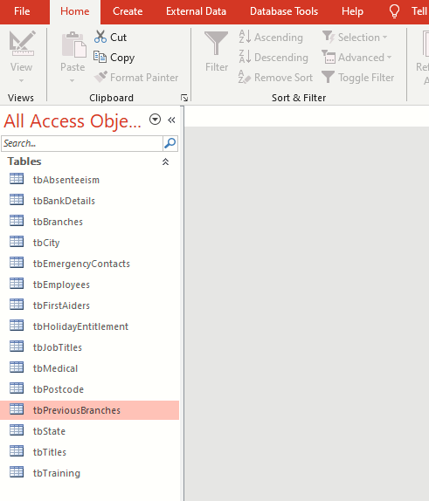
Employees table
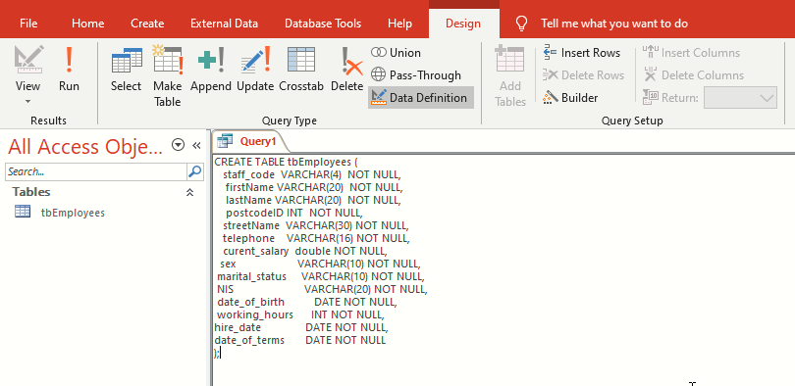
Query for creating Employees table
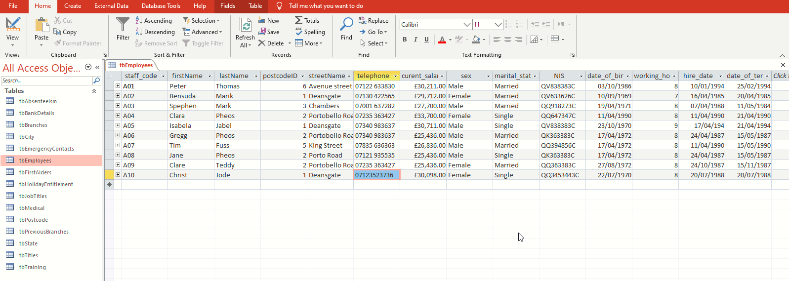
Employees table

Absenteeism table
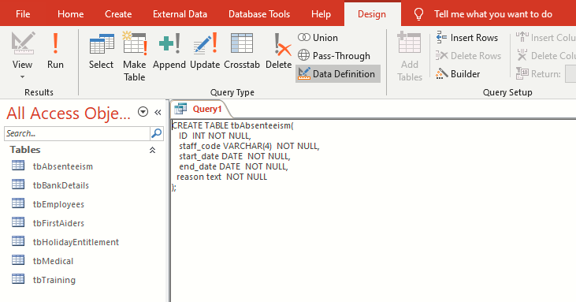
Query for creating Absenteeism table
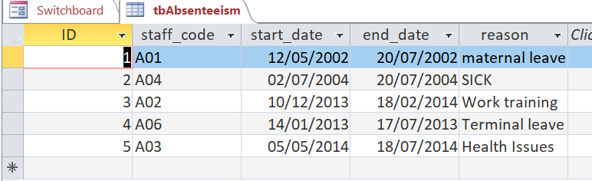
Absenteeism table
Medical table
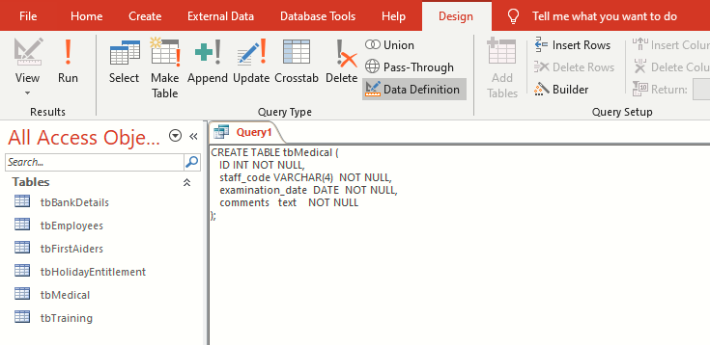
Query for creating Medical table
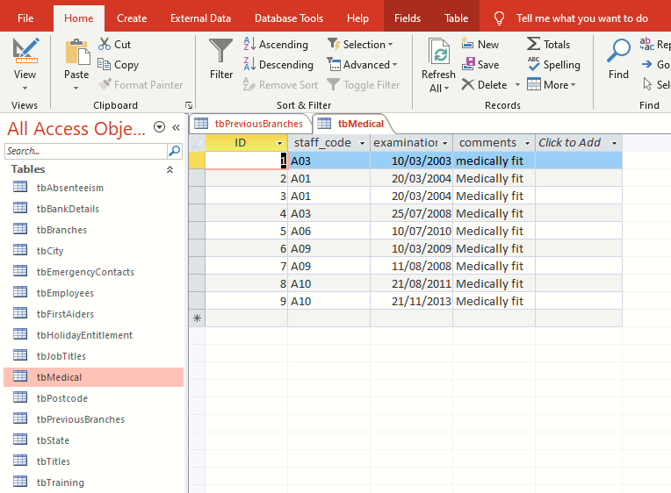
Medical table

Training table
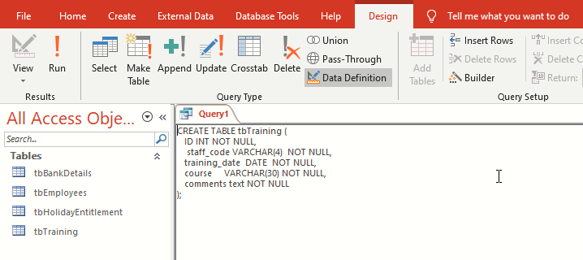
Query for creating Training table
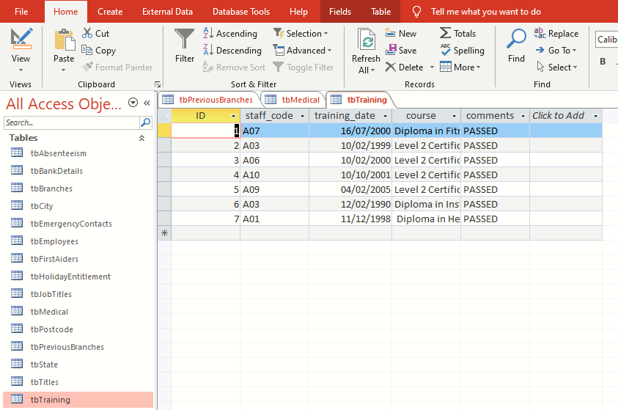
Training table

BankDetails table
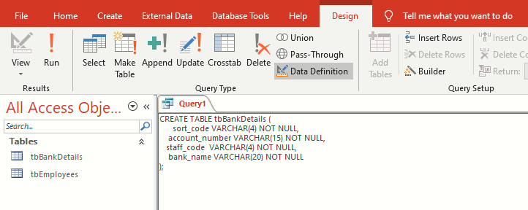
Query for creating BankDetails table
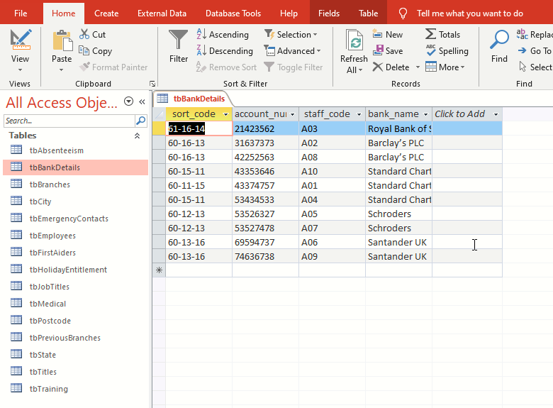
BankDetails table

HolidayEntitlement table
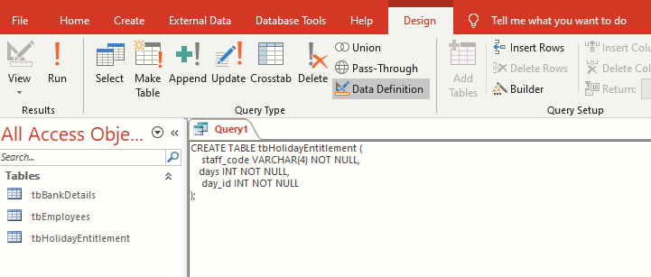
Query for creating HolidayEntitlement table
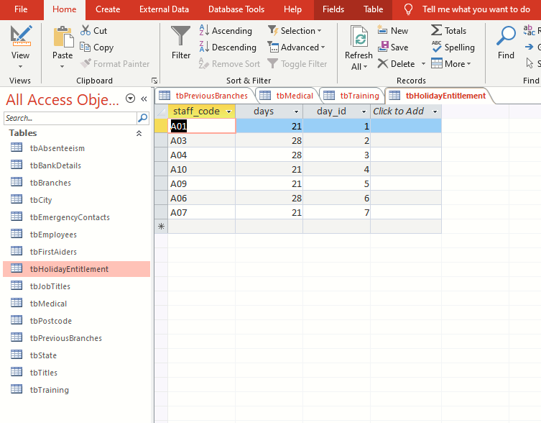
HolidayEntitlement table

EmergencyContacts table
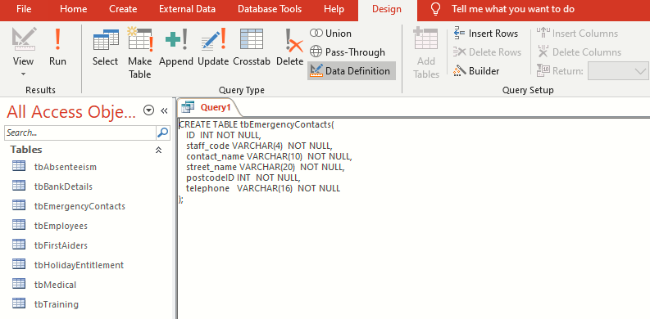
Query for creating EmergencyContact table
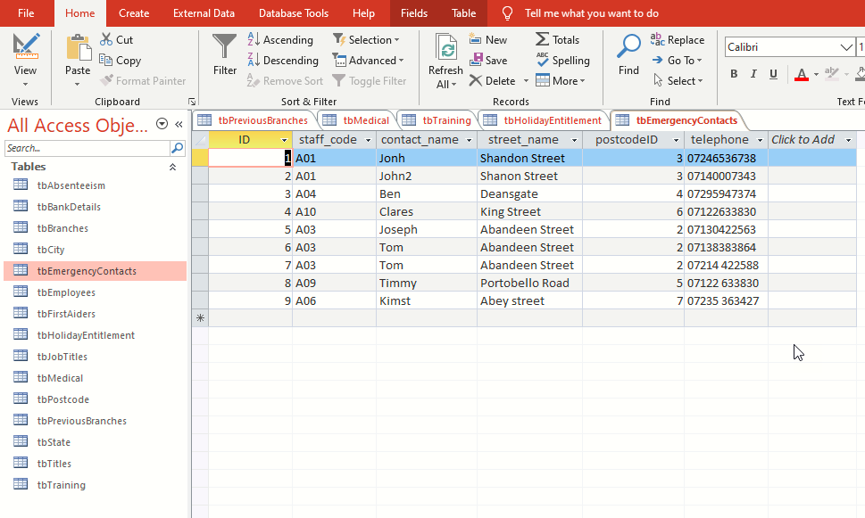
EmergencyContact table

Branches
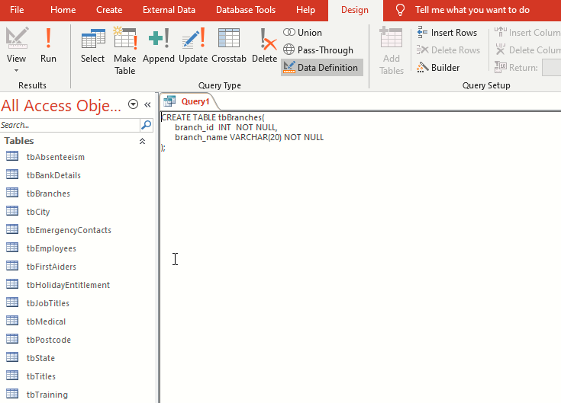
Query for creating Branches table
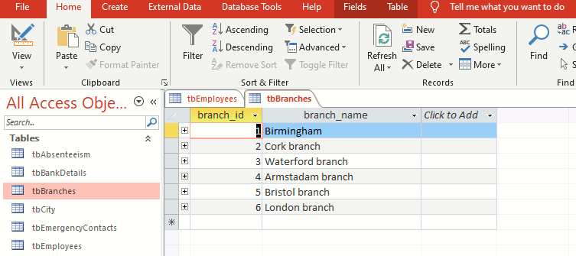
Branches table

Forms
Forms in Access, are used in viewing, modifying and entering new records in the database in an interactive graphical way. Forms can also be used in navigating when used as a navigation dialogue box in accessing other forms and running queries (Bhattacharya, 2014). In the Universal Sports database, various forms have been created for various uses like input and outputing the various details of employees as shown below.
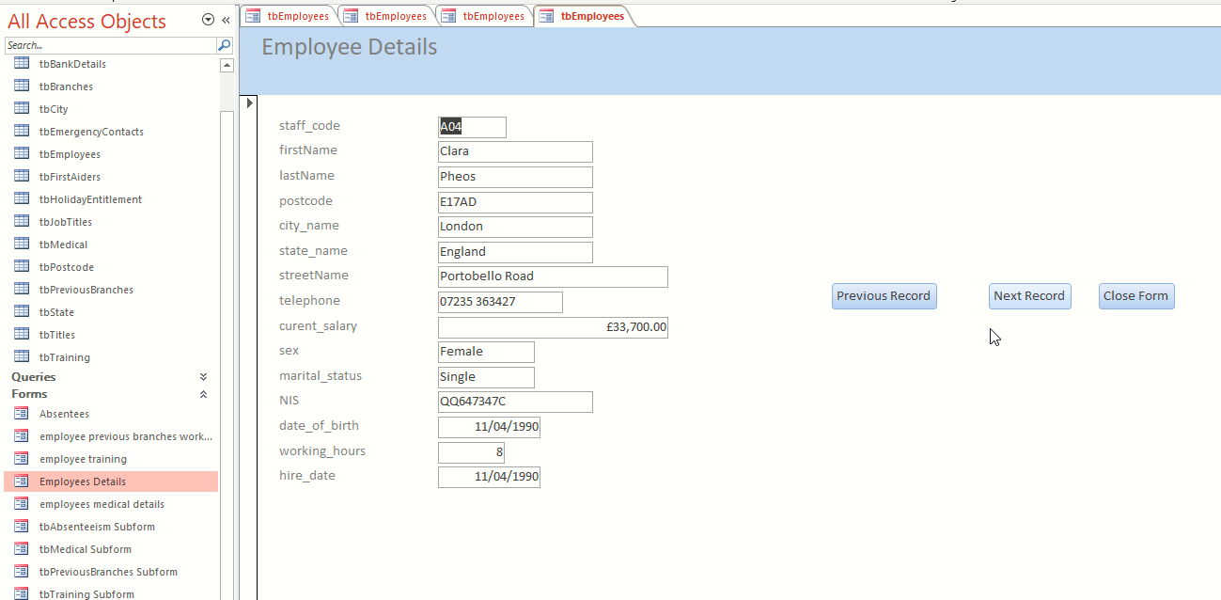
Employee Details form is used for inputting and editing the personal details of all employees in the club.

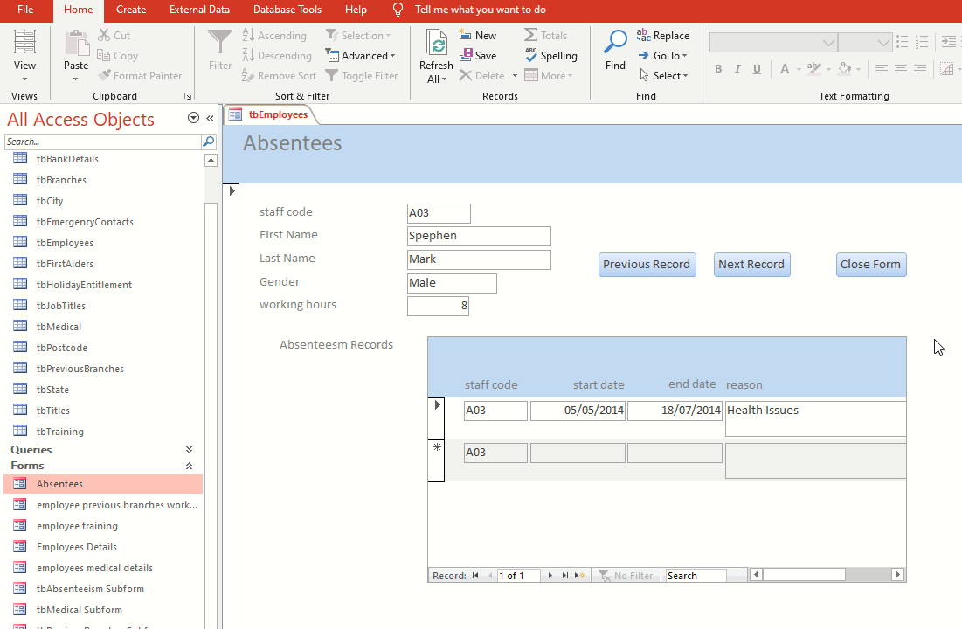
Absentees form is used to input the details of employees’ absenteeism

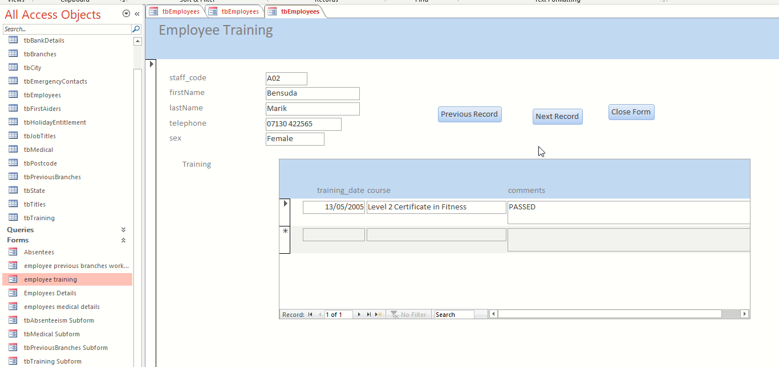
The Employee Training form is used to input and edit details of employees’ trainings undertaken
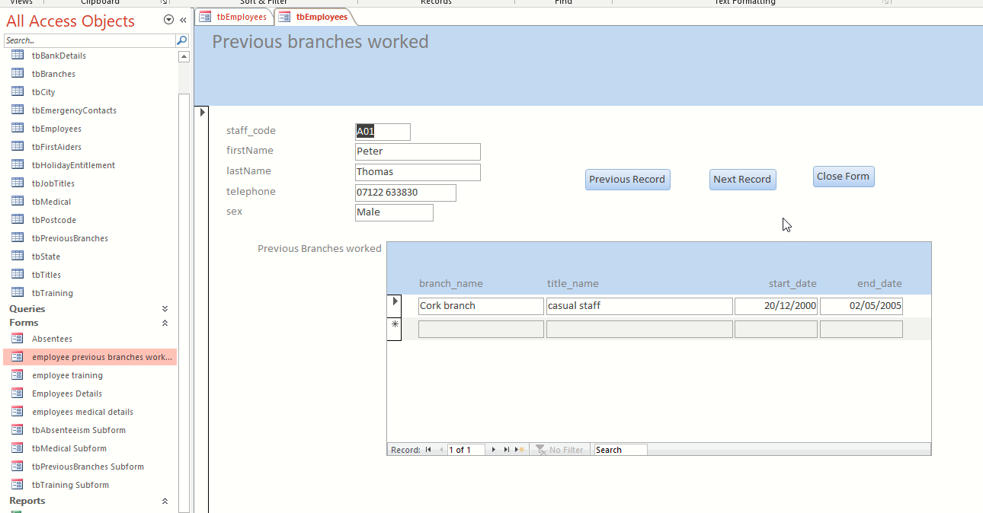
The Previous branches worked form shows all the Universal Sports branches where particular employees have worked before.

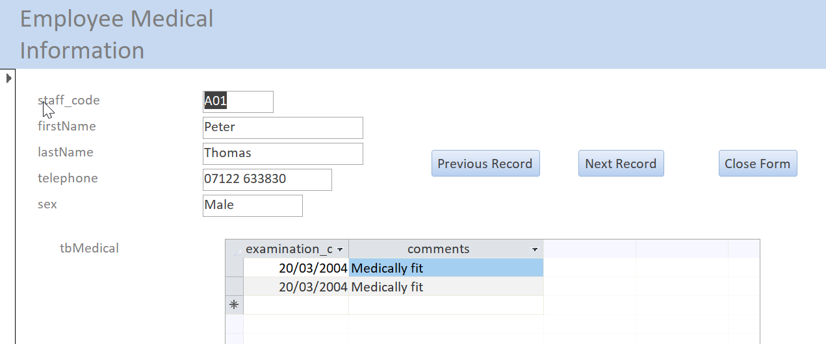
Employee medical information form is used for inputting the medical details of employees.

Reports
Reports are primary objects used in printing database contents due to their ability to provide formatting layouts and options for summary (Friedrichsen, 2016). They are means through which information can be output from database according to the needs of the user.
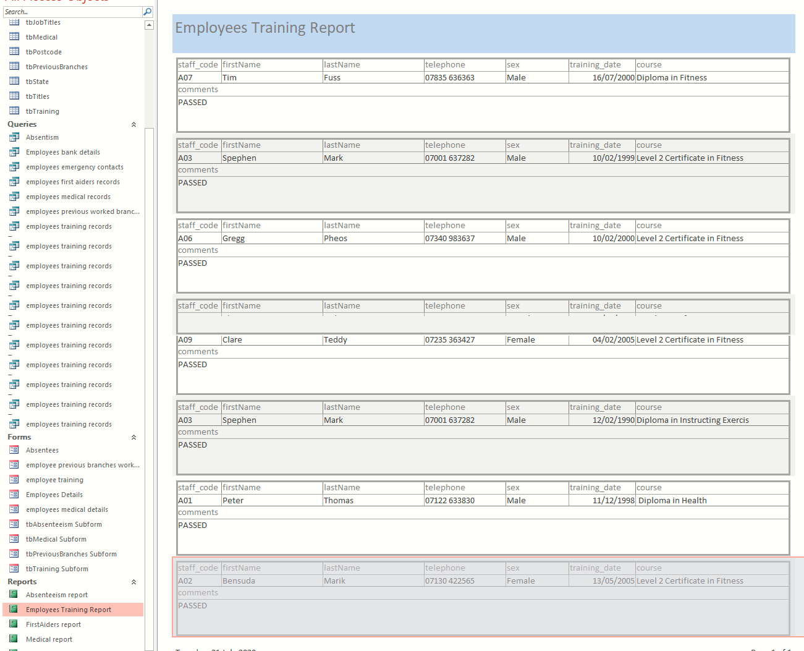
Employees training report showing different areas that particular employees have trained into.
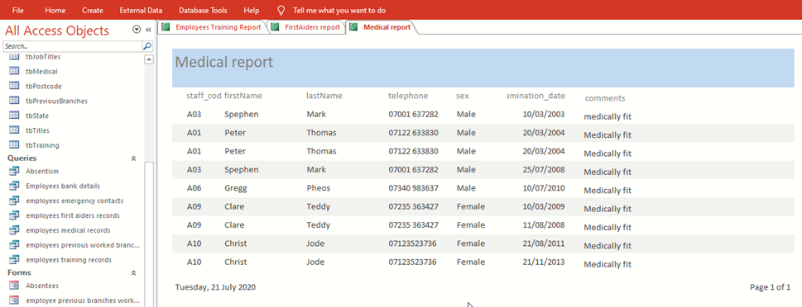
Medical report showing the different medical examinations that various employees have undergone

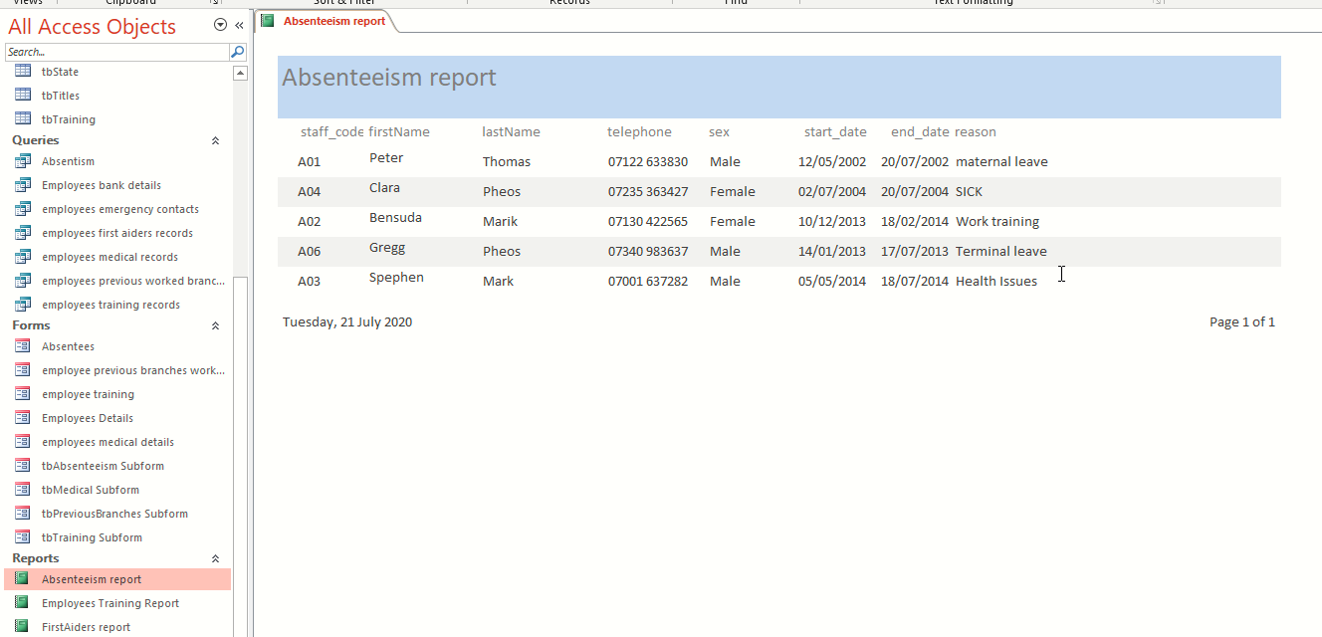
Absenteeism report showing members that have been absent, dates and reasons for absenteeism

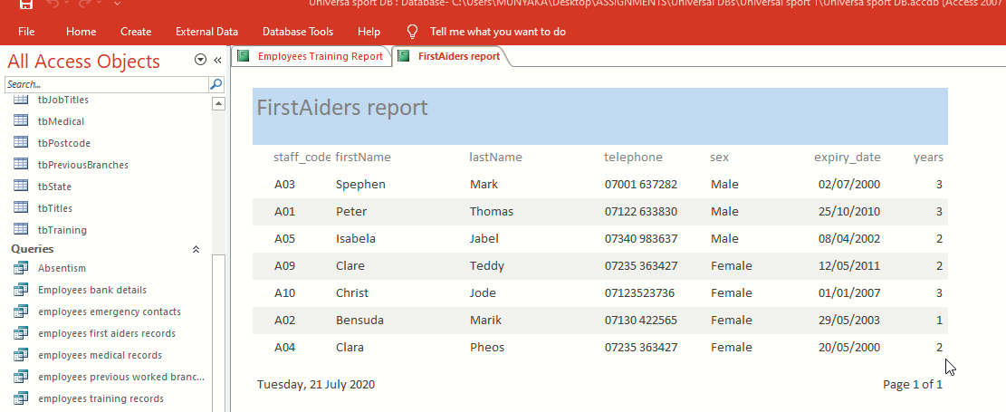
A first aiders report showing members that have trained and qualified in first aid

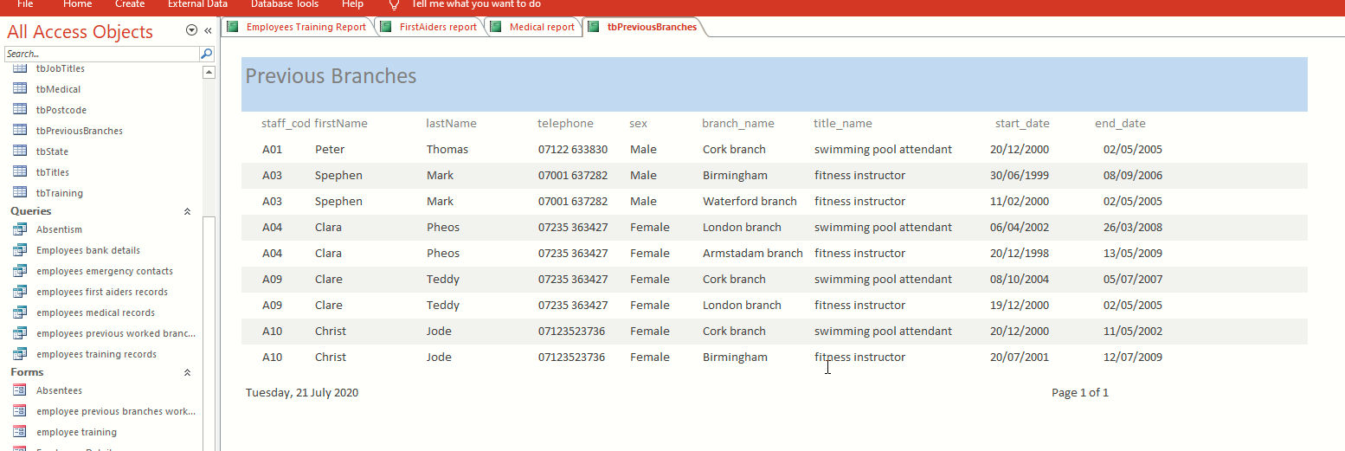
A report showing the branches of Universal Sports that every member belongs to

Relationships
Access has a provision for creating and visualizing of relationships between different tables and also querying data that is stored in multiple tables (Eckstein and Schultz, 2018).
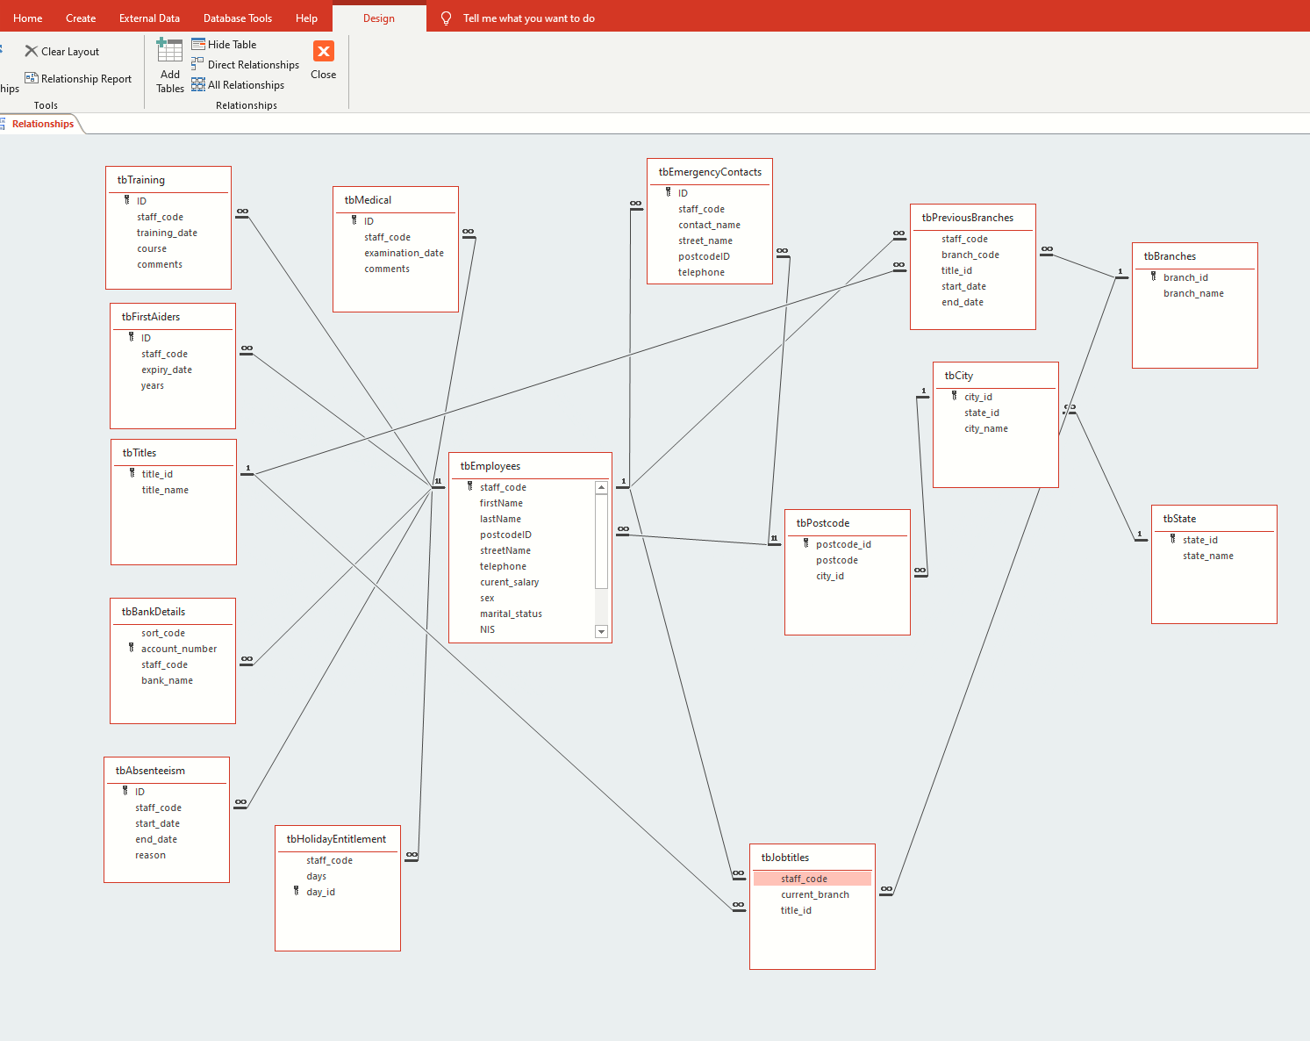
Creating relationship using SQL
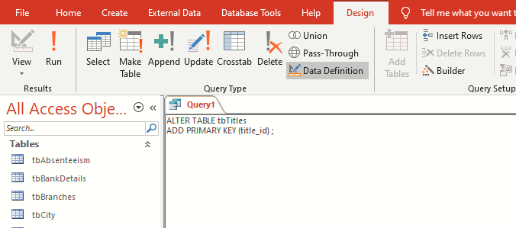
Adding relationship to Titles table
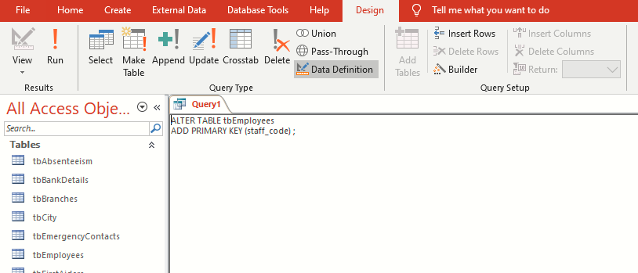
Adding relationship to Employees tables
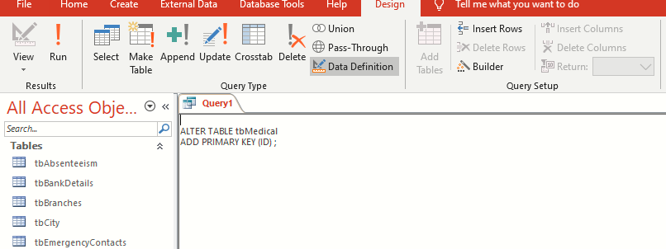

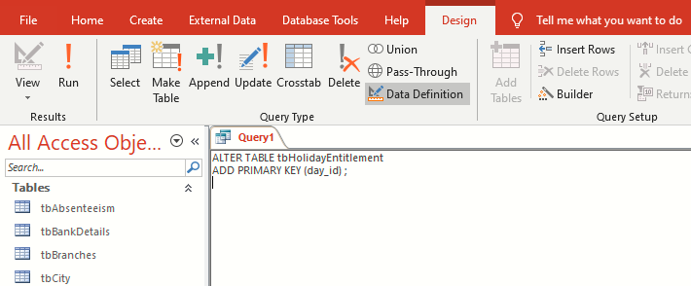
Adding relationship to HolidayEntitlement table

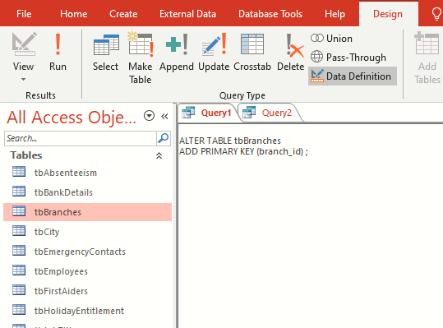
Adding relationship to Branches table
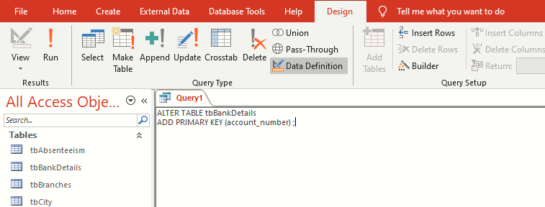
Adding relationship to BankDetails table

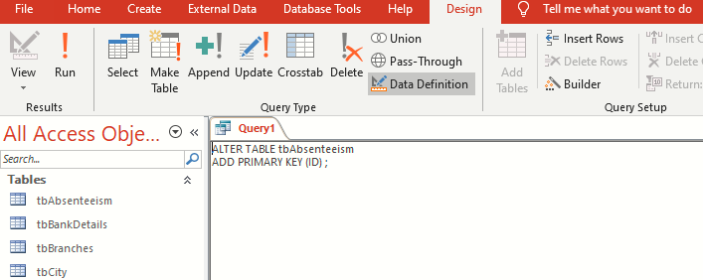
Adding relationship to Absenteeism table

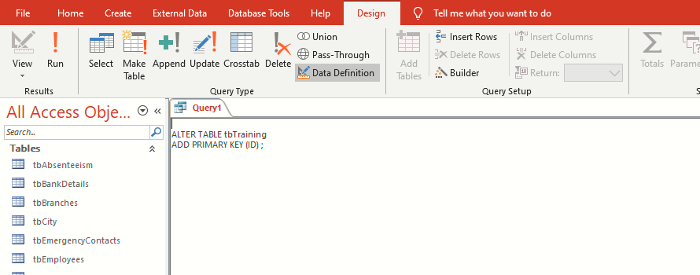
Adding relationship to Training table

Add records to tables using SQL
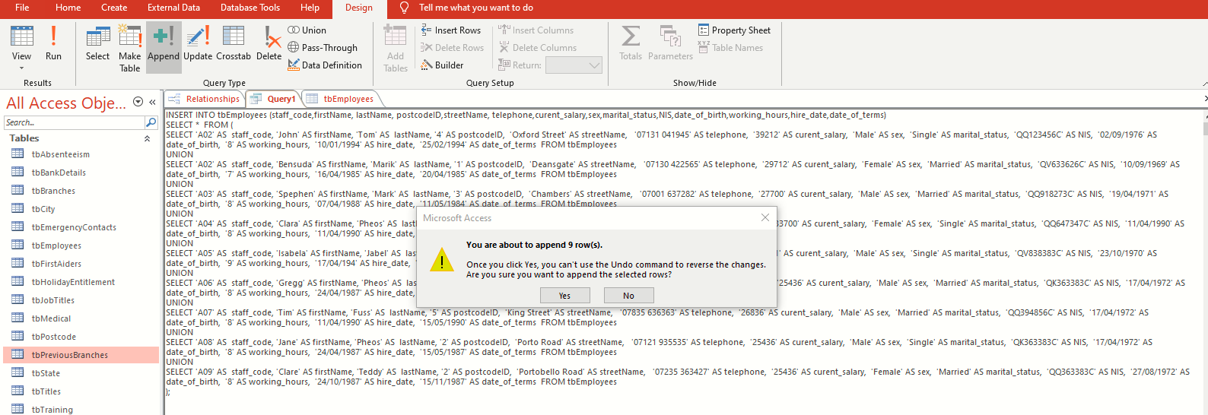

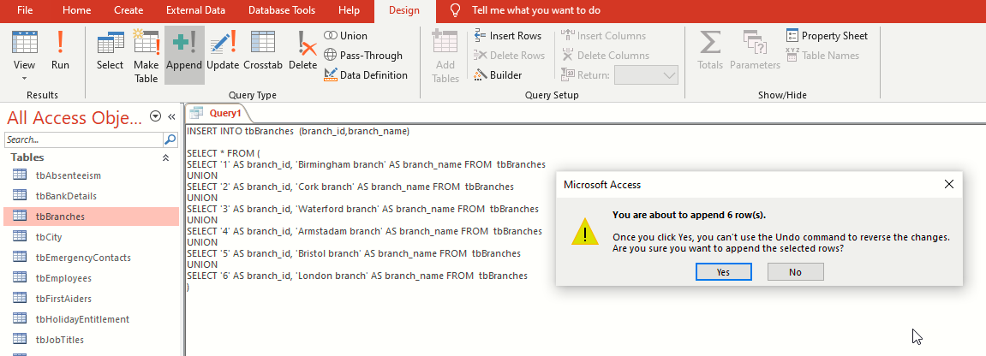

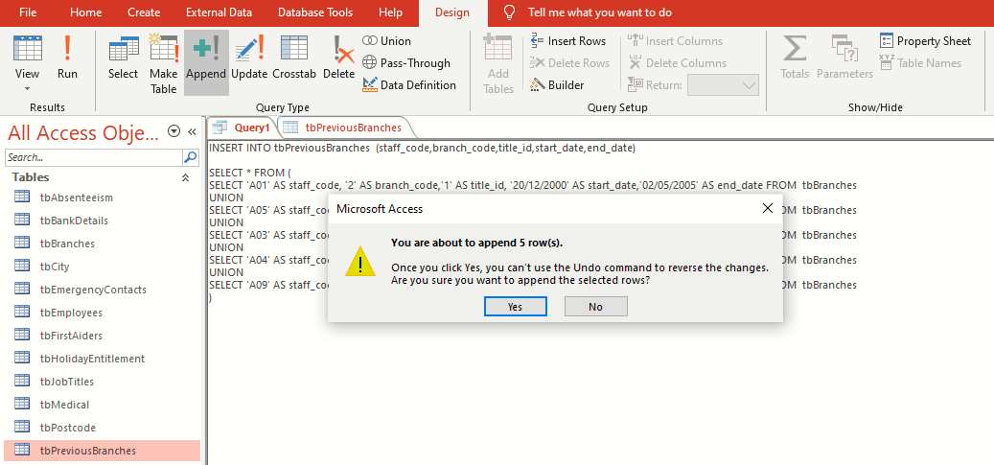

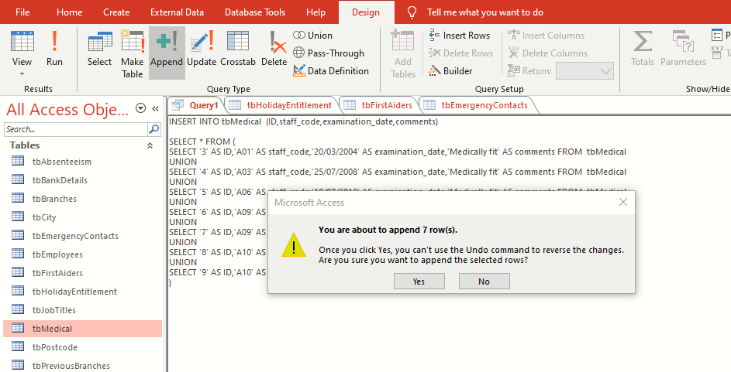

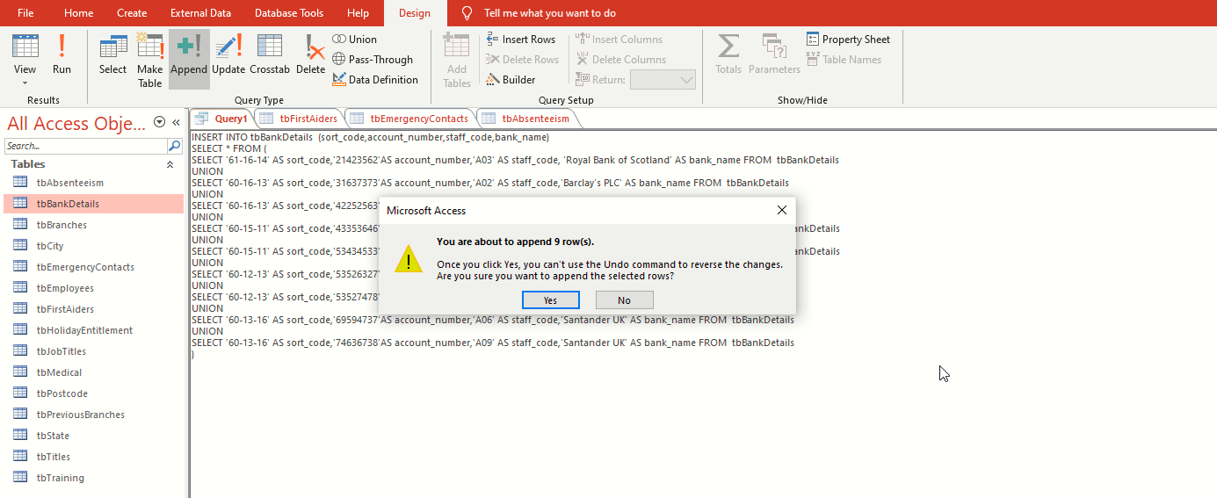

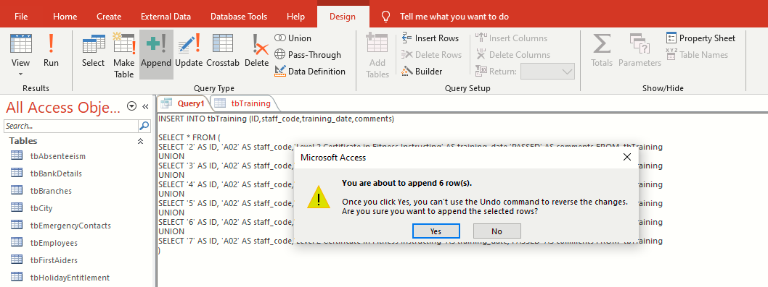

Creating relationship (FK) using SQL
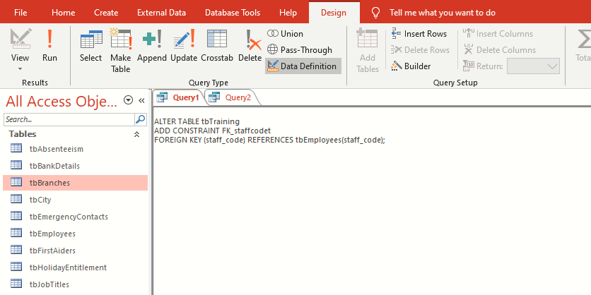

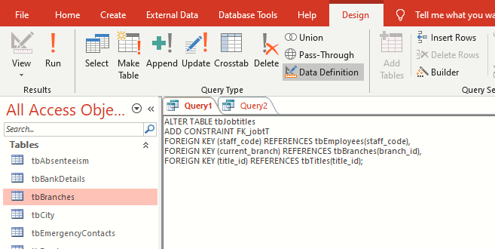
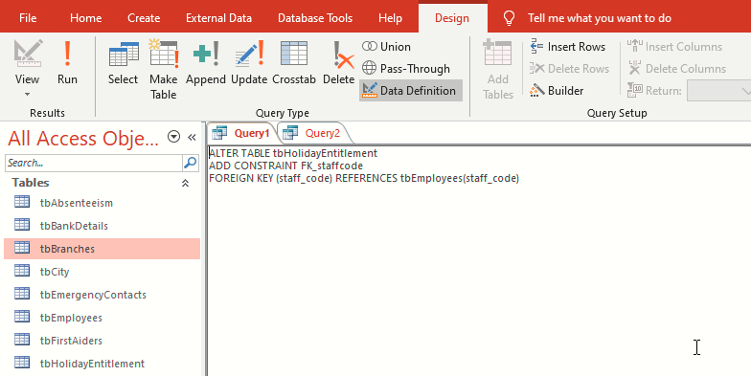

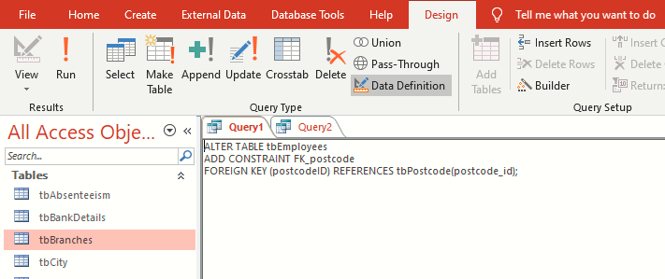

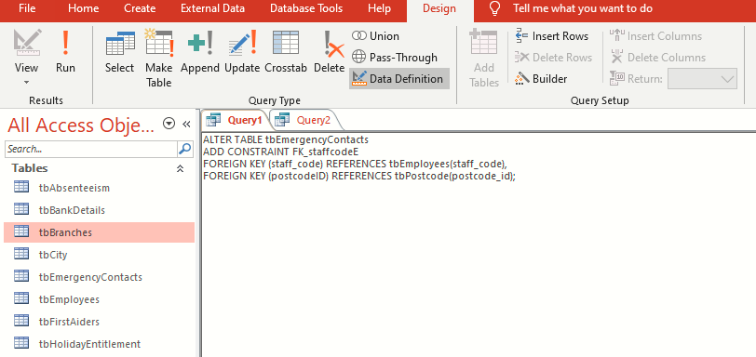

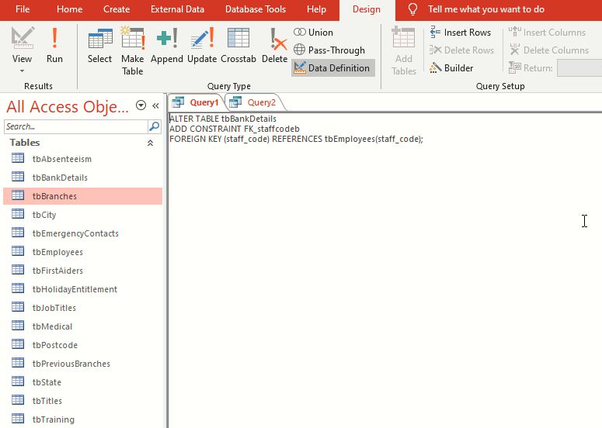
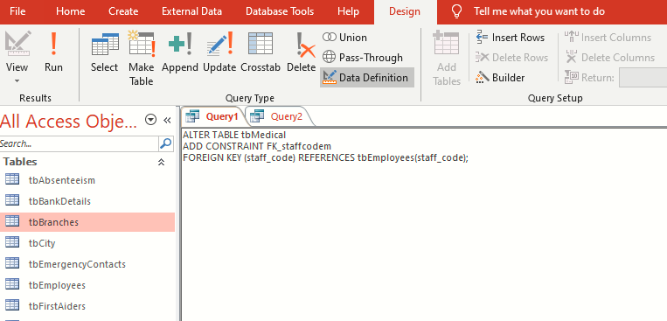

Reproducing a report from a query
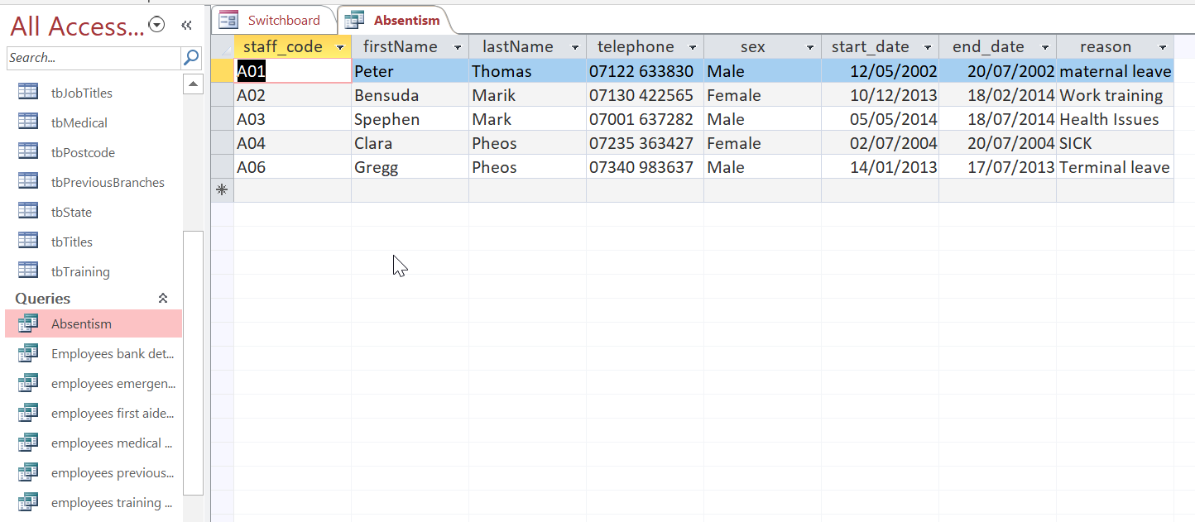
Absenteeism query
Absenteeism report

Working of main menu and form navigation
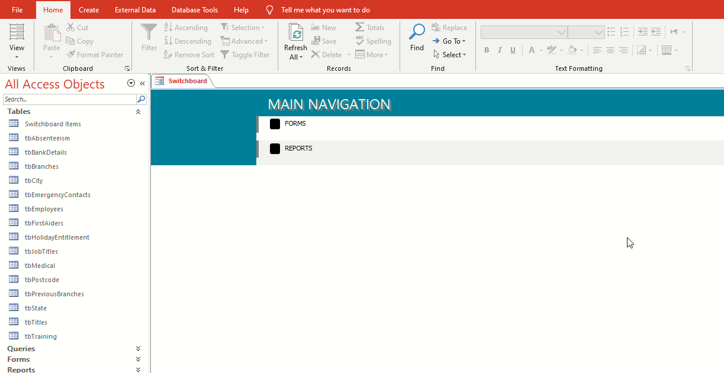

Main navigation menu
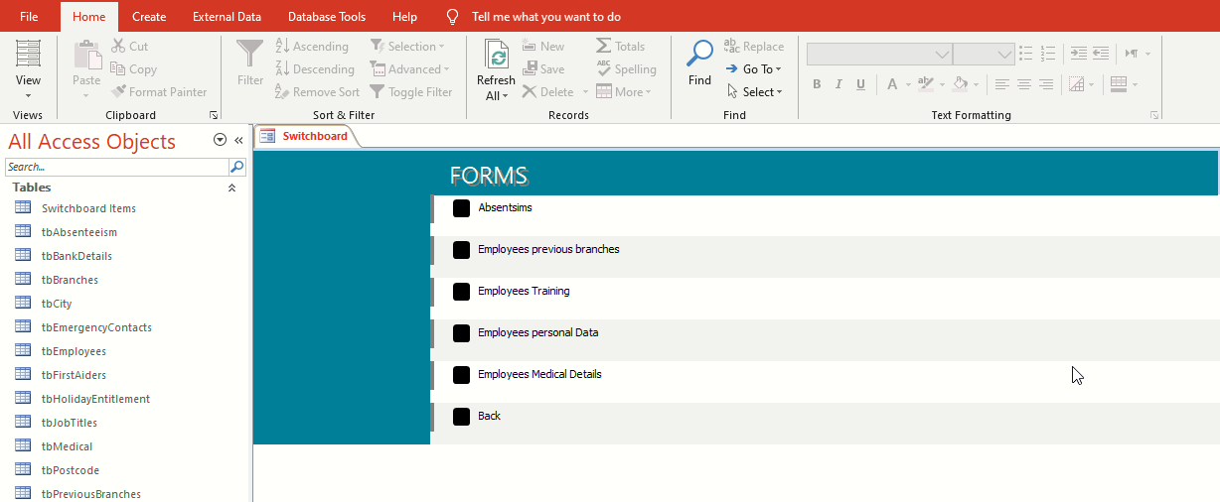
Form navigation menu

Calculating in a report
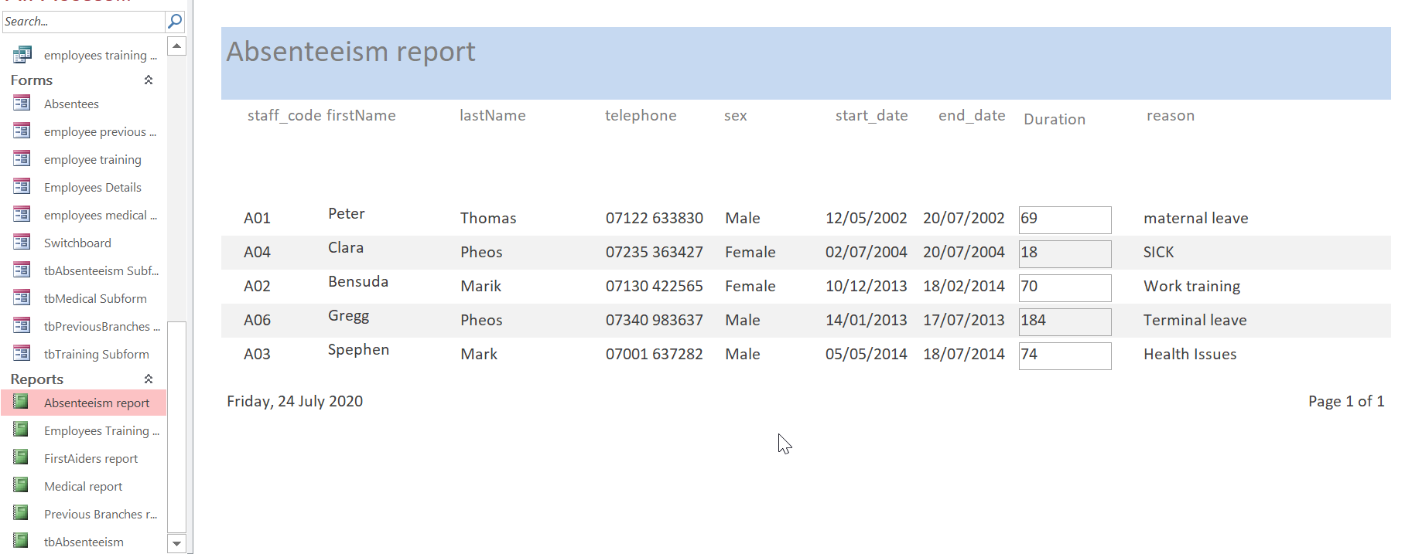
Absenteeism with calculation of absent duration

Master and Embedded forms
Forms can be designed to have both Master form and embedded forms. Access uses the LinkMasterFieds and LinkChildFields to choose the records in the embedded or subform which are related to the master form. This is to ensure that whenever there are changes in the main form’s link field, there is an automatic re-query of the subform (Groh et al, 2011).

Menu displayed immediately database opens
When the user clicks on the database, it will open to display the main navigation menu as shown below.
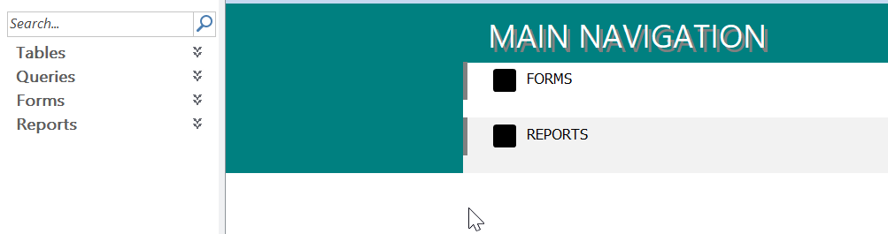

User documentation
The main menu contains forms as the major input interface as well as the reports as the major output interface. Selecting the option of forms will take the user to various forms and depending on the input information required the user will select the most appropriate forms as shown below and input the required information before closing.
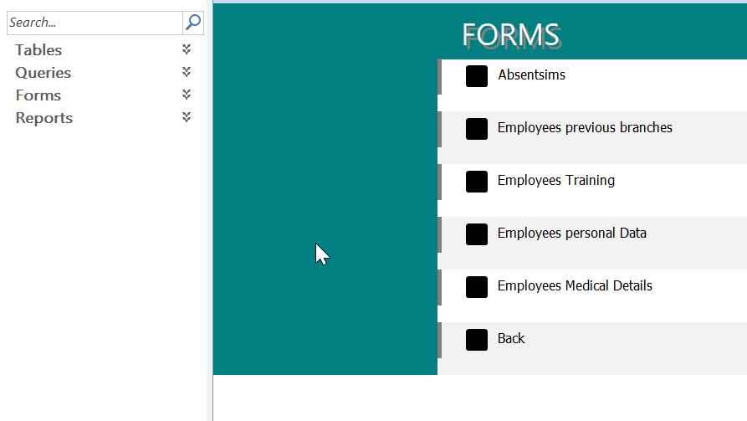
The user is also able to go back to the main menu by selecting the “Back” option.
In order to view output data, the user will select the “Report” option from the main navigation menu. This will display various reports as shown below.
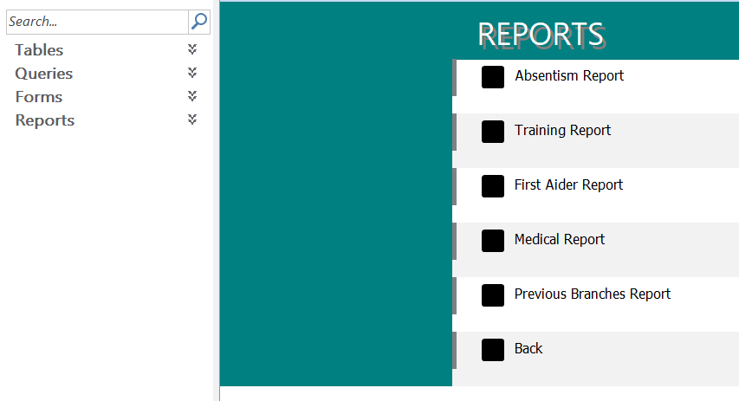
The user is also to go back to the main menu by selecting the “Back” option from the reports menu.

Conclusion
Database management systems displays vast benefits when it comes to other forms of data management systems. However, this robustness in data management is based on the detailed design and development of the DBMS which follows specified procedures. Just like any other database tool, MS Access required initial analysis of user requirements and design of the system using such techniques as ERD to have a clear picture of what the system should look like.

References
Alexander, M. and Kusleika, D. (2019). Access 2019 Bible. Indianapolis, IN: John Wiley & Sons, Inc.
Bhattacharya, J. (2014). Rudiments of Computer Science. Kolkata: Academic Publishers.
Davis, W. and Yen, D. C. (2019). The Information System Consultant's Handbook: Systems Analysis and Design. Boca Raton, FL: CRC Press.
Eckstein, J. and Schultz, B. R. (2018). Introductory Relational Database Design for Business, with Microsoft Access. Hoboken, NJ: John Wiley & Sons Ltd.
Friedrichsen, L. (2016). Enhanced Microsoft Access 2013. Boston, MA: Cengage Learning.
Groh, M. R., Stockman, J. C., Powell, G., Prague, C. N., Irwin, M. R. and Reardon, J. (2011). Access 2007 Bible. Indianapolis, IN: Wiley Publishing, Inc.
Zygiaris, S. (2018). Database Management Systems: A Business-Oriented Approach Using Oracle, MySQL, and MS Access. Bingley: Emerald Publishing Ltd.

Appendix

