Becky Mckay
Student Number 1602218
With reference to educational theories and classroom observations demonstrate an understanding of three educational theories.

This scrapbook will look at three theorists, their theories and how those theories are observed in classroom practices today. The three theorists that will be looked at are: Leo Vygotsky, Jerome Bruner and Maria Montessori.

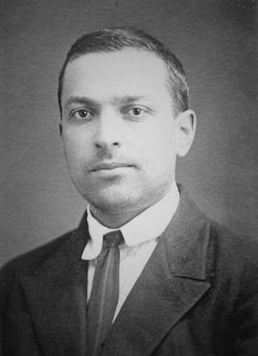
Leo Vygotsky 1896-1934
Born in Russia, Vygotsky was only thirty-eight when he died of tuberculosis. Vygotsky stated that “Education must be orientated not towards the yesterdays of a child’s development but towards its tomorrow”. The writer observes this in the classroom daily. Children are armed with prior knowledge and are steered towards the next task and the next step in their learning. However, for those children who need additional help, may find retaining information a struggle this can be a difficult task as they often need continual reinforcement of ‘yesterday’s work’ and without this repetition will be unable to move on in their learning.
Vygotsky’s view was that language is vital for children to be able to think. He felt that through talk, and with the help of either peers or adults and their structured talk we can review and increase our own knowledge and understanding of a given subject. Vygotsky referred to this as the Zone of Proximal development. It is the bridge in what a child can do on their own and what they can achieve or learn with interested others. This is observed in a classroom with mixed ability grouping. Where more able and talented children can share their knowledge with others to enable them to learn. Children working together not only get supported in their thought and language development but gain emotional support which will in turn encourage their sense of self-worth and self-belief. Vygotsky believed that learning is to do with understanding and forming new concepts, this happens most productively when adults or peers support the learner through the learning process
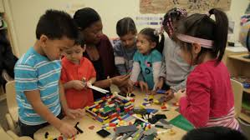
Mixed ability groups however do appear to have their drawbacks and are not always conducive to all children within a group. It has been observed by the writer that some children, particularly those who are more withdrawn or for those whom English is an additional language appear to participate less in group work than others. There are natural leaders within each group and those who will remain in the background. In the writer’s classroom observations, mixed ability groups are continually changed so within any half term, all children with the class have worked with every other child at least once. As the academic year progresses and the teachers and support staff become more familiar with the children, when friendships groups and different personalities are considered, it becomes evident which groups and which children work better together to get the best out of one another academically.
Vygotsky’s influence throughout education is evident. The writer agrees with Vygotsky’s theory that collaboration between children is vital and conducive to deeper thinking and understanding. Circle time and Turn to Your Partner activities benefit the learner’s language development and emotional security and enable those who would not normally do so to participate. Witnessing the collaborative process in action the writer sees that it creates deeper thinking and a greater success for the children. They can make connections and elaborate on previous knowledge and even the most reluctant begin to participate.

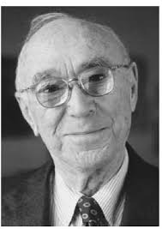
Jerome Bruner 1915-2016
Born in New York and educated in Harvard University, Jerome Bruner developed theories on learning, memory and perception in children.
Bruner divided his learning theory for children into three stages of development. Enactive – this stage can loosely be allocated into the Early Years Foundation Stage, moving, manipulation and learning through play. Iconic – this stage can be attached to Key Stage 1 where children are beginning to learn about representation, numbers etc. The final stage is Symbolic where children will use abstract thinking to complete tasks and evaluate their work and the work of their peers. Unlike Jean Piaget, Bruner did not attach any age groups to his stages of development. This allows for more flexibility for those children who are deemed more able and talented or below average ability. It does not only cater for the children who are categorised as average intelligence.
Vygotsky’s influence on Bruner can again be seen in his further work, where he discusses the importance of language and culture. Bruner’s theories discuss that children should be taught in a way that is appropriate to the stage not the child’s age and should be taught in a meaningful context. However, it does appear that Bruner did not always follow in his agreement of Vygotsky’s theories. Where-as Vygotsky stated that education must be orientated forwards not towards ‘the yesterdays’ of a child’s development, Bruner’s theory discusses the spiral curriculum, where schools and teachers continually revisits topics and concepts. This theory of Bruner’s is especially evident in schools today. The writer observes that in Foundation Phase daily routines which are embedded in each class continually revisit concepts. Examples of this can be seen in the Nursery class each morning during registration and carpet time. Songs which include the days of the week, the weather are sung to ensure familiarity. The children count how many there are in the class each day both in English and in Welsh. Numicon is used throughout the day in various activities, again to familiarise the resource to the nursery class, this should enable the children to use the resource in a more formal way as they progress through the school.
Bruner’s theory of scaffolding was influenced by the works of Leo Vygotsky. Vygotsky states that children learn best in a social environment where they build meaning through work and play with others. At the start of a new topic children will require help from teachers or support staff. Scaffolding is effective as a teaching method.
As children become more confident and knowledgeable the amount of support given can gradually be reduced and the child is able to work independently to complete the work set by the class teacher.

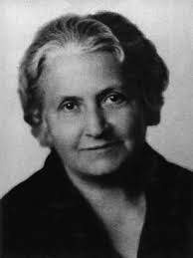
Maria Montessori 1870-1952
Maria Montessori was born in Italy. Originally a student of engineering, followed by medicine, Maria moved onto a career in mental health. It was here that she developed her theories to aid children’s learning and educational development.
The Montessori theory on children’s learning is based on independence, active learning, co-operation and learning in harmony with one another. Children can choose what they wish to learn and how they will learn it from the wide variety of resources that have been made available by the class teacher.

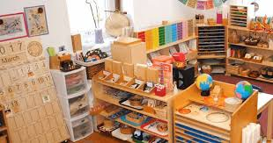
A Montessori learning environment offers children the freedom to move freely around the classroom. There is no central area and the teacher is not the focus in the classroom. The various areas of the classroom allow its pupils to discover answers for themselves, this creates a deeper learning experience. The main difference between Montessori schools and mainstream education in Wales is Montessori allows its pupils the freedom of choice and teachers are free from curriculum constraints and can offer this choice. However, mainstream schools in Wales are governed by the Welsh National Curriculum and the Welsh Government Literacy and Numeracy Framework.
The Montessori method of teaching seems especially prevalent in Foundation Phase in mainstream schools. Pupils have the option to choose between alternative areas of enhanced provision and which activity that they do. Child-led learning is becoming increasingly popular in the writer’s educational environment. Pupils are asked which topics they would like to cover and what resources and areas in the enhanced provision they would like to see. However, all choices are governed by the Welsh National Curriculum and the Literacy and Numeracy Framework.
In conclusion, it appears that although the education and learning theories of Bruner, Montessori and Vygotsky are more than one hundred years old they are still relevant in today’s twenty first century modern education system. Modern theorist Chris Watkins author of ‘Learning – a sense makers guide’ published in 2003 discusses education moving towards ‘learning centred classroom’ similar to those used in Montessori schools. His theories appear to encompass the three theorists this scrapbook has looked at in detail. Watkins (2003) quotes ‘the teacher can act as a formative guide to learning in young people’s lives’. In turn these formative guides can create effective learning and effective self-directed learners.

References

Palmer,J. (2001) Fifty Modern Thinkers on Education from Piaget to the Present. London: Routledge.
Watkins,C. (2003) Learning, a sense makers guide. University of London: Association of Teachers and Lecturers.
Montessori Education. http://www.montessorieducation.org/?q+who-was-maria-montessori. Accessed 9/11/2017

