

Programme: MSc Public Health and Social Care in Practice
Module: Population Health and Digital Health Promotion
Module code: LCHS7009
Assignment Title: Component 1 (2 Blogs)

Student Name: Ramani Krupali Hasmukhbhai
Student ID: 2520812
Total Words: 1070

Table of Contents
Blog 1 (Existing Digital Technology) 3
Introduction 3
Using Digital Physiotherapy for Health Promotion 3
Evidence of Effectiveness 4
Critical Discussion: Benefits and Challenges of Digital Physiotherapy Apps 5
Addressing the Shortfalls 6
Conclusion 6
Blog 2 (Designed Digital Technology) 7
Introduction 7
Osteoarthritis as a Public Health Problem 7
Introducing OA Smart Coach: The Designed Technology 8
OA Smart Coach Promotes Health 8
Potential Impact: Benefits and Opportunities 9
Limitations and Challenges 9
Recommendations for Improvement 9
Conclusion 10
Reference List 11

Blog 1 (Existing Digital Technology)
Title: Impact of Digital Physiotherapy Apps on the Improvement of Osteoarthritis Management in the UK

Introduction
Osteoarthritisor OA stands as a disease of the joints that leads to pain, stiffness, as well as restricted mobility (Wojcieszek et al., 2022). This disease affects about 10.8 million individuals within the UK and therefore represents an important health issue (Swain et al., 2020; Parliament UK, 2026).
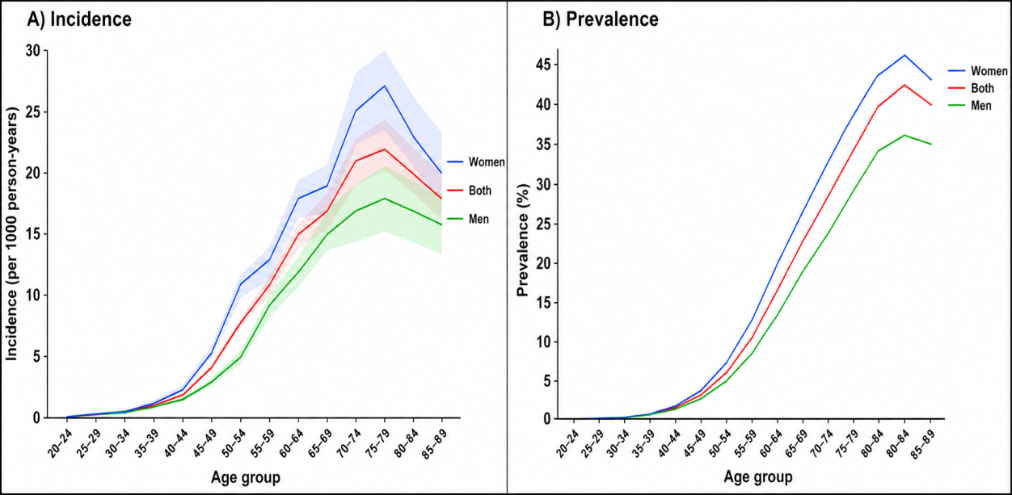
Figure 1: Incidence and Prevalence of OA in UK
(Source: Swain et al., 2020)

Using Digital Physiotherapy for Health Promotion
The development of digital physiotherapy applications such as Joint Academy, getUBetter and Hinge Health has come up accordingly in this landscape for helping people through scientifically proven self-management applications for treating OA remotely (NICE, 2025).
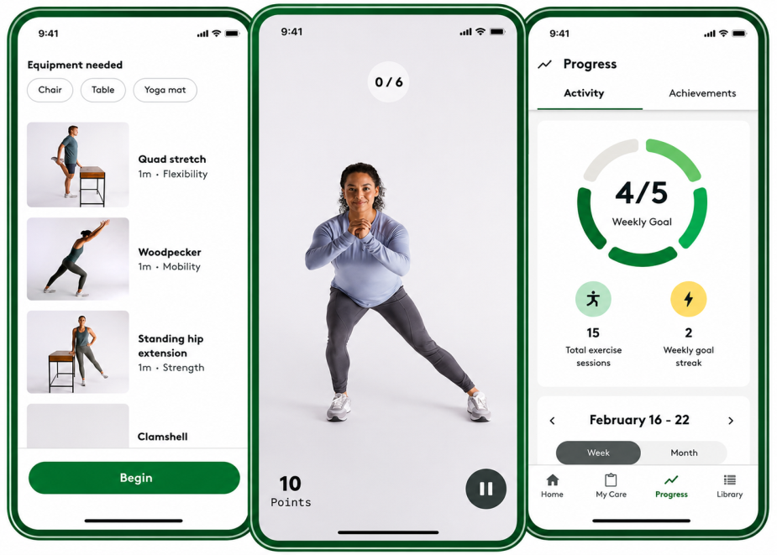
Figure 2: Physiotherapy Apps Used in UK
(Source: Hingehealth.com, 2024)
Physiotherapy applications using digital platforms may help in improving patient knowledge, self-efficacy, as well as skills, leading to healthier behaviours and a more sustainable approach towards disease management (Taylor, Murray and Stanton, 2022).

Evidence of Effectiveness
Physiotherapy applications through digital media can contribute to improvements in health care results among individuals suffering from osteoarthritis (OA). Based on existing studies, exercising with the help of digital applications can result in increased levels of physical activity and reduction of pain along with the enhancement of joint function (Safari, Jackson and Sheffield, 2020).
A review demonstrated that digital self-management interventions provided substantial improvement of pain and physical functioning among individuals with knee OA for 12 months following the intervention period (Safari, Jackson and Sheffield, 2020). Results indicated that mobile app usage had a positive impact on adherence to the exercise plan and enhanced functional results compared with the control group (Melbourne School of Health Sciences, 2026; Stevenson et al., 2024).

Critical Discussion: Benefits and Challenges of Digital Physiotherapy Apps
Advantages
Physiotherapy Apps which are digital act as one such convenient way of managing OA symptoms such as Joint Academy as well as Hinge Health provide an education programme, monitoring for pain, along with access to clinicians through digital platforms (NICE, 2025).
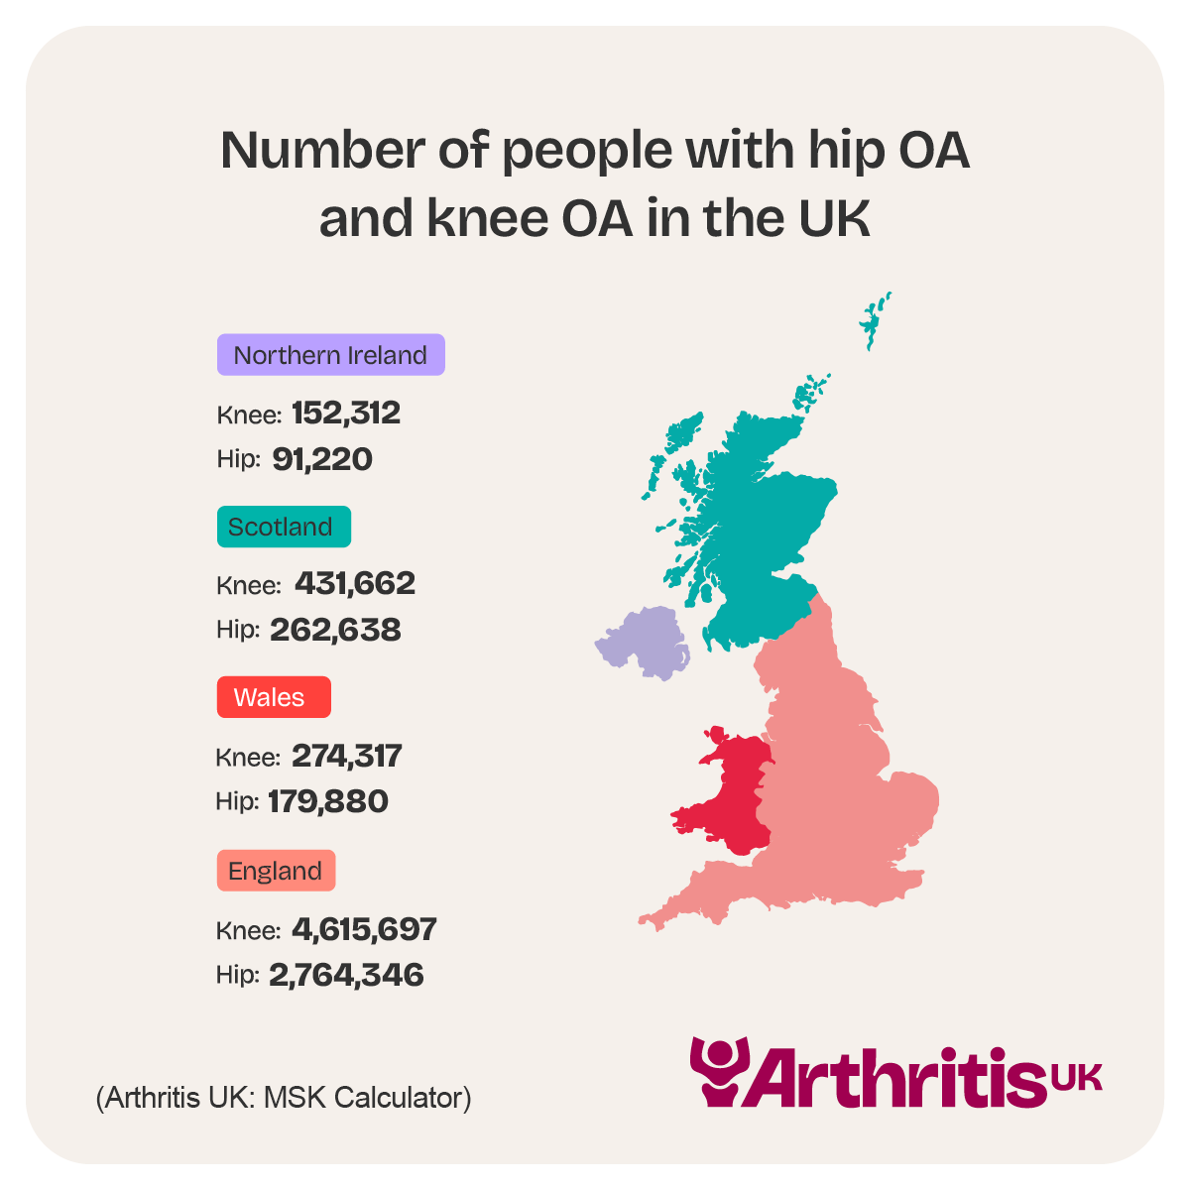
Figure 3: Number of People with OA in the UK
(Source: Arthritis UK, 2024)
Limitations
Although there are several benefits of digital physiotherapy apps, these devices could also particularly contribute to health inequalities. Such an issue of poor digital skills along with failure to harness the benefits of smartphone-based approaches is likely to be experienced by older patients, who suffer from osteoarthritis in higher proportions (Berry et al., 2025; Jönsson et al., 2022). In addition, such an interaction between the patient and the practitioner could be negatively influenced by limited face-to-face contact (Taylor, Murray, and Stanton, 2022).

Addressing the Shortfalls
The programs for digital literacy could help users gain confidence and proficiency in the use of health technology, particularly in older patients (Saadati, Yousefi and Saadati, 2023). On the other hand, user-friendly designs could improve the ease of use among various target groups (Jönsson et al., 2022). In addition, to address digital exclusion, NHS England (2023) may provide support through a program that helps in terms of the provision of devices, internet, and community-based assistance programs.

Conclusion
The condition of OA continues to be a major issue in the field of public health despite the number of individuals who are thereby suffering from this condition being in the millions and the stress on the health care facilities.

Blog 2 (Designed Digital Technology)
Title – OA Smart Coach: Designing an AI-Powered Digital Health Intervention for Osteoarthritis Prevention and Management

Introduction
Osteoarthritis (OA) is one of the commonest forms of arthritis that also happens to be a serious public health concern in the UK (Quicke et al., 2022). This blog aims at introducing and critically examining OA Smart Coach, which is an application powered through AI for the prevention and treatment of OA.

Osteoarthritis as a Public Health Problem
Osteoarthritis is considered as a degenerative joint disease that results in pain, rigidity, and limited mobility. It is estimated that in the UK, around 10 million individuals who suffer from musculoskeletal disorders, with most of them having OA (Arthritis UK, 2024). Prevention and self-management of chronic diseases are important issues of public health because of the rise in the ageing population (Pérez-Saiz et al., 2023).
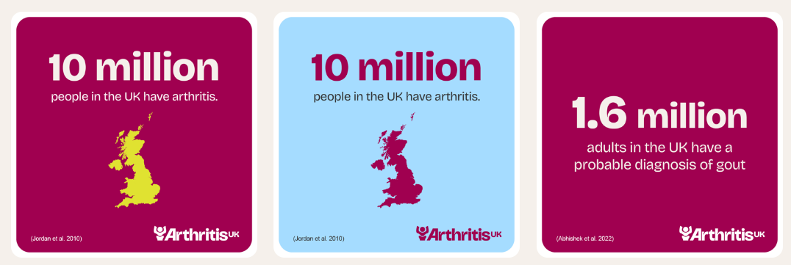
Figure 4: Rate of People Having Arthritis in UK
(Source: Arthritis UK, 2024)
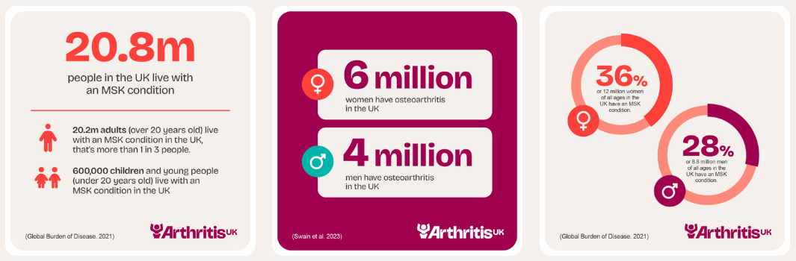
Figure 5: Growing Aging Population in UK suffering from Arthritis
(Source: Arthritis UK, 2024)

Introducing OA Smart Coach: The Designed Technology
OA Smart Coach is a physiotherapy app which has enhanced by technology of AI (Alfahad and Alothaim, 2025). The mobile application focuses on providing personalised exercise procedures, symptom tracking, alerts of medication, educational information, wristband devices integration, chatbot powered through AI, and progress trackers for health promotion (Teke et al., 2025).The findings show that physiotherapy apps using digital technology have great potential to help with health promotion goals such as physical activity, empowerment, and sustained physical activity.

OA Smart Coach Promotes Health
Through the educational content offered by the app, self-management is promoted along with making healthier choices in lifestyles such as controlling weight and pain (Babatunde et al., 2023). The app follows the concepts of Self-Efficacy Theory, specifically focusing on developing the self-management skills of the users and providing opportunities to track symptoms early.
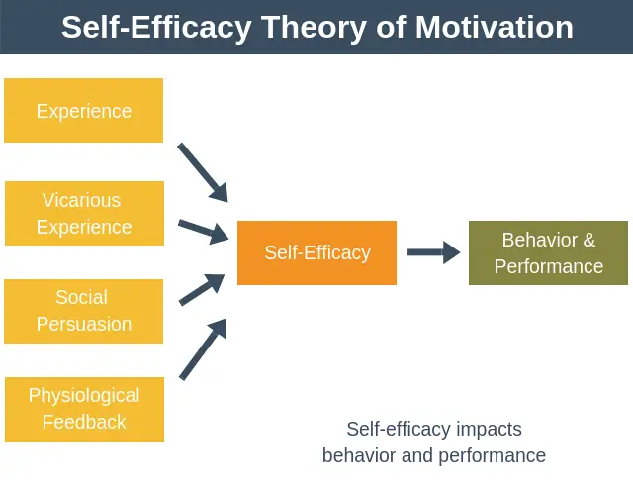
Figure 6: Self-Efficacy Theory
(Source: Babatunde et al., 2023)

Potential Impact: Benefits and Opportunities
The application of OA Smart Coach has the possibility of improving access to support and increasing the engagement of the patients. The continuous monitoring can result in higher treatment adherence and perhaps reduce the burden on physiotherapy services of the NHS (Stern et al., 2022).

Limitations and Challenges
Even though there are various benefits, digital divide among elderly, privacy concerns and data safety, as well as the requirement for internet usage alongside inaccuracy associated with AI suggestions, can be obstacles in achieving effectiveness (Chu et al., 2022).

Recommendations for Improvement
The identified limitations can be addressed by digital literacy education, clinician oversight of the recommendations provided by the AI program, data protection under the framework of GDPR, and through providing access to a hybrid delivery method that would make the treatment both digital and traditional for seniors (Costa, 2024).

Conclusion
In summary, OA Smart Coach highlights the importance of using the mentioned interventions as a means of improving OA prevention and management. However, digital technologies should not become substitutes for professional medical care in order to deliver safe, inclusive, and effective treatment to patients.

Reference List
Blog 1
Berry, E.C., Sculthorpe, N.F., Warner, A., Mather, J.D., Sanal-Hayes, N.E. and Hayes, L.D., (2025). A scoping review of the feasibility, usability, and efficacy of digital interventions in older adults concerning physical activity and/or exercise. Frontiers in Aging, 6, p.1516481.https://www.frontiersin.org/journals/aging/articles/10.3389/fragi.2025.1516481/pdf
Hingehealth.com (2024). How to Get the Hinge Health App. [online] Available at: https://www.hingehealth.com/resources/support/mobile-app-support/. (Accessed: 16 June 2026).
Jönsson, T., Dell’Isola, A., Lohmander, L.S., Wagner, P. and Cronström, A., (2022). Comparison of face-to-face vs digital delivery of an osteoarthritis treatment program for hip or knee osteoarthritis. JAMA Network Open, 5(11), p.e2240126.https://jamanetwork.com/journals/jamanetworkopen/articlepdf/2798148/jnsson_2022_oi_221136_1666890208.06033.pdf
Melbourne School of Health Sciences. (2026). Mobile app to support home exercise adherence in knee osteoarthritis. [online] Available at: https://healthsciences.unimelb.edu.au/departments/physiotherapy/chesm/research-overview/mobile-app-to-support-home-exercise-adherence-in-knee-osteoarthritis (Accessed: 16 June 2026).
NHS England (2023). Inclusive Digital healthcare: a Framework for NHS Action on Digital Inclusion. [online] NHS England. Available at: https://www.england.nhs.uk/long-read/inclusive-digital-healthcare-a-framework-for-nhs-action-on-digital-inclusion/. (Accessed: 16 June 2026).
NICE (2025). GID-HTE10057 Digital Technologies for Managing Mild to Moderate Hip or Knee osteoarthritis: Early Value Assessment. [online] NATIONAL INSTITUTE FOR HEALTH AND CARE EXCELLENCE. Available at: https://www.nice.org.uk/guidance/htg766/documents/final-scope. (Accessed: 16 June 2026).
Parliament UK (2026). House of Lords - the Long-term Sustainability of the NHS and Adult Social Care - Select Committee on the Long-term Sustainability of the NHS. [online] publications.parliament.uk. Available at: https://publications.parliament.uk/pa/ld201617/ldselect/ldnhssus/151/15109.htm. (Accessed: 16 June 2026).
Saadati, N., Yousefi, Z. and Saadati, S.A., (2023). E-health literacy and older adults: Challenges, opportunities, and support needs.https://www.sid.ir/en/VEWSSID/J_pdf/40526-294070-en-1403636.pdf
Safari, R., Jackson, J. and Sheffield, D., (2020). Digital self-management interventions for people with osteoarthritis: systematic review with meta-analysis. Journal of medical Internet research, 22(7), p.e15365.https://www.jmir.org/2020/7/e15365/
Stevenson, R.D., Chowdhury, E.A., Inza, V.B., Western, M.J., Walsh, N.E., Jones, S.L. and Bilzon, J.L., (2024). Development of the intelligent knee osteoarthritis lifestyle app: a person-based approach. BMC musculoskeletal disorders, 25(1), p.189.https://link.springer.com/content/pdf/10.1186/s12891-024-07313-4.pdf
Swain, S., Sarmanova, A., Mallen, C., Kuo, C.F., Coupland, C., Doherty, M. and Zhang, W., (2020). Trends in incidence and prevalence of osteoarthritis in the United Kingdom: findings from the Clinical Practice Research Datalink (CPRD). Osteoarthritis and cartilage, 28(6), pp.792-801.https://www.sciencedirect.com/science/article/pii/S1063458420309183
Taylor, C.E., Murray, C.M. and Stanton, T.R., (2022). Patient perspectives of pain and function after knee replacement: a systematic review and meta-synthesis of qualitative studies. Pain reports, 7(3), p.e1006.https://journals.lww.com/painrpts/fulltext/2022/06000/Patient_perspectives_of_pain_and_function_after.11.aspx?context=LatestArticles
Wojcieszek, A., Kurowska, A., Majda, A., Liszka, H. and Gądek, A., (2022). The impact of chronic pain, stiffness and difficulties in performing daily activities on the quality of life of older patients with knee osteoarthritis. International journal of environmental research and public health, 19(24), p.16815.https://www.mdpi.com/1660-4601/19/24/16815

Blog 2:
Alfahad, N.R. and Alothaim, H.F., (2025). Artificial Intelligence and Machine Learning Applications in Orthopedic Physiotherapy. Journal of Pharmaceutical Research and Integrated Medical Sciences, pp.47-60.https://aktpublication.com/index.php/jprims/article/download/157/152
Arthritis UK (2024). The State of MSK Report infographics. [online] Arthritis UK. Available at: https://www.arthritis-uk.org/policy-and-data/health-intelligence/the-state-of-musculoskeletal-health-report-infographics/ (Accessed: 16 June 2026).
Babatunde, O.O., Corp, N., Shivji, N., Rowlands, G., Quicke, J., Healey, E.L., Protheroe, J. and van der Windt, D.A., (2023). Interventions for supporting self-management in people with musculoskeletal pain, including focus on varying levels of health literacy: A systematic overview of reviews. Health Open Research, 5, p.2.https://healthopenresearch.org/articles/5-2/pdf
Chu, C.H., Nyrup, R., Leslie, K., Shi, J., Bianchi, A., Lyn, A., McNicholl, M., Khan, S., Rahimi, S. and Grenier, A., (2022). Digital ageism: challenges and opportunities in artificial intelligence for older adults. The Gerontologist, 62(7), pp.947-955.https://academic.oup.com/gerontologist/article-pdf/62/7/947/45370579/gnab167.pdf
Costa, J., (2024). Final report on digital innovation and implementation.https://run.unl.pt/bitstreams/f6f2a821-bb78-47c3-8636-efc8a2e86440/download
EPM (2022). Self-Efficacy Theory of Motivation. [online] Expert Program Management. Available at: https://expertprogrammanagement.com/2018/10/self-efficacy-theory-of-motivation/ (Accessed: 16 June 2026).
Pérez-Saiz, L., Ferri Sanz, M., Ferrando, M., Salido, M.F., Alhambra-Borrás, T., Ferrer, J.G. and Dix, R., (2023). Health access, health promotion, and health self-management: barriers when building comprehensive ageing communities. International Journal of Environmental Research and Public Health, 20(19), p.6880.https://www.mdpi.com/1660-4601/20/19/6880
Quicke, J.G., Conaghan, P.G., Corp, N. and Peat, G., (2022). Osteoarthritis year in review 2021: epidemiology & therapy. Osteoarthritis and cartilage, 30(2), pp.196-206.https://www.sciencedirect.com/science/article/pii/S1063458421009341
Stern, B.Z., Pila, S., Joseph, L.I., Rothrock, N.E. and Franklin, P.D., (2022). Patients’ perspectives on the benefits of feedback on patient-reported outcome measures in a web-based personalized decision report for hip and knee osteoarthritis. BMC Musculoskeletal Disorders, 23(1), p.806.https://link.springer.com/content/pdf/10.1186/s12891-022-05764-1.pdf
Teke, J., Msiska, M., Adanini, O.A., Egbon, E., Osborne, A. and Olawade, D.B., (2025). Artificial intelligence for obesity management: a review of applications, opportunities, and challenges. Obesity Medicine, p.100657.https://www.sciencedirect.com/science/article/pii/S2451847625000776

