University of Wales Trinity Saint David

Ordnance, Munitions and Explosives



Modelling of Shaped Charges
Advanced Physics of OME (ACDB5015)

Ewan Simpson

2115523
November 2023

Lecturer: Kelvin Donne

Contents

- Abstract (3)
- Introduction (3)
  - Gurney Theory (4)
- Literature Review (4)
- Method (6)
- Results (8)
- Discussion (10)
- Conclusion (11)
- References (11)

Abstract:
A shaped charge is an explosive charge that is designed to concentrate all of the charge’s energy into a small surface area [1] in order to cause a high penetrative force, capable of piercing armour, cutting and forming metal and initiating nuclear weapons. When the explosive is detonated, the liner is compressed and gets shot forward at a high velocity, causing a jet that will penetrate through steel, concrete and other materials. They can be used widely in military applications, such as high-explosive anti-tank projectiles, RPGs, and IEDs. They also have commercial uses, such as cutting metal, initiating nuclear weapons, and perforating wells in the oil and gas industry.
The liner at the bottom of the charge is hollow and usually shaped like a cone or hemisphere. The material is normally a ductile metal [2] such as copper, however, they can be made from a range of materials and glass [3]. This allows the liner to be compressed and squeezed forward when the shaped charge is detonated [4], which forms the high-velocity jet that is so penetrative.
After doing the simulations, the 2D model was found to have a maximum principal stress of approximately 1.671x10¹⁰ and the maximum velocity of the jet was approximately 6.5kms⁻¹. The 3D model was found to have a maximum principal stress of approximately 6.79x10⁹ and the maximum velocity of the jet was approximately 2kms⁻¹. The maximum shear stress for the 3D model was 6.505x10⁸.
Introduction:
Shaped charges are greatly effective weapons, particularly against armoured and concrete targets [5]. They are often used for military application in devices such as antitank weapons, grenades and military explosives [6]. The phenomenon that occurs when an explosive penetrates a surface such as concrete or metal, is known as the Munroe effect [7]. This was first discovered in 1888 by Charles Munroe, who found that when a hollow charge of dynamite was detonated onto a metal plate, a hole of three inches in diameter was blown through the plate.
The design of a shaped charge is to focus the effect of the explosive’s energy. By having a hollow cone-shaped liner, when the shaped charge is detonated, the middle is shot forward first, creating the jet that penetrates the armour. There are various designs that can be used for a shaped charge, with different designs having different purposes and requirements. The conical shaped charge is the most basic design and consists of a conical metal liner surrounding an explosive core. Upon detonation, the pressure generated by the explosive material causes the liner to collapse from the centre, forming a high velocity jet of metal [8]. The hemispherical shaped charge design is similar to the conical design, apart from the liner being a hemisphere rather than a cone. The spherical shape is to create a more concentrated and focused jet. By doing this, the penetration is improved and more damaging. The tandem shaped charge utilizes multiple explosive layers and liners in tandem. The first shaped charge detonates, weakening the armour, and then the subsequent charges are able to penetrate deeper. This was developed as a result of improved armour, so the tandem shaped charge can cause a deeper penetration [9]. The linear shaped charge design consists of a long, thin metal liner and is used for cutting or breaching applications such as demolition or cutting metal [10].
Gurney Theory:
Gurney theory was first developed during World War II, by physicist Ronald Gurney. It provides a fundamental understanding of the behaviour of the metal jets formed by explosives devices. Gurney’s work laid the groundwork for understanding the dynamics of shaped charges and their applications.
The Gurney equations are a set of mathematical formulas that are used to calculate the acceleration of a metal jet caused by a shaped charge/how fast the metal liner of a shaped charge will collapse [11]. They were first developed in the 1940s but have since been expanded on significantly. When an explosive is detonated, any metal casing or other solid materials that are adjacent to the explosive, is shot out at a high velocity. First by the initial shock wave and then by the pressure from the gaseous products that are created by the detonation. In a shaped charge, this is the metal casing that forms a jet. Gurney was able to develop a formula based on the conservation laws of momentum and energy which show how the energy was distributed between the casing/liner and the gases which are formed.

Literature Review:
As part of the assignment, a literature review on relevant research of shaped charges and their modelling was to be done, looking at the material models that they used. The first research paper that was reviewed was a paper by Zhao Zhang and Wei-Wei Jin and was a paper on ‘finite element modelling of the shaped charge jet and design of the reusable perforating gun’ [12]. In this paper, they used the finite element method to study the finite element method to study the formations of the penetration jet, the bulge and the burr in the designed reusable perforating gun. Finite element analysis (FEA) is a numerical technique used to analyse the behaviour of physical systems and structures. It is a computational method that breaks down complex structures into smaller and simpler elements in order to simulate and predict their response to different, real-world conditions [13]. One example of FEA is ABAQUS. The author presents a detailed finite element model of the jet created by the shaped charge, as well as the reusable perforating gun. A perforating gun is a piece of equipment used in oil and gas industries to carry shaped charges downhole where they are then detonated to create tunnels [14]. The model is used to study the effects that different parameters have on the performance of the shaped charge jet and perforating gun.
The results indicate that the shaped charge jet is initially formed in the centre of the shaped charge liner and then the material of the liner is driven to the centre as well by the detonation wave. The attachment of the soft metal layer of the perforator gun could be beneficial in controlling the bulge height. As well as that, the increase in the liner angle causes the penetration width on the cement wall to increase. This paper presents a detailed finite element model of the shaped charge jet and the reusable perforating gun. The authors use a Johnson-Cook material model to describe the behaviour of the solid phase in the shaped charge jet formation process. The paper investigates the formation of the penetration jet, the bulge, and the burr in the designed reusable perforating gun. The authors study the attached layer of the soft metal on the perforator for controlling the bulge height on the casing of the reusable perforating gun.
The second paper that was reviewed was ‘A high-resolution Eulerian method for numerical simulation of shaped charge jet including solid–fluid coexistence and interaction’ by Qianyi Chen and Kaixin Liu [15]. presents a numerical method that can simulate the entire process from jet formation to penetrating a target. The method is designed to address large distortion problems and track the variation of multi-material interfaces. The authors demonstrate the feasibility and reliability of their method for optimizing the structure of shaped charge jet to dramatically improve its tip velocity and penetration capability. The paper uses a Eulerian method to simulate the shaped charge jet formation process. The Eulerian approach is better suited for modelling fluid dynamics, and in this method the mesh is fixed and the material flows through the mesh [16]. The authors also investigate the interaction between the solid and fluid phases in the shaped charge jet formation process. The method is capable of simulating the entire process from jet formation to penetrating a target. The authors demonstrate the feasibility and reliability of their method for optimizing the structure of shaped charge jet to dramatically improve its tip velocity and penetration capability. The method is designed to address large distortion problems and track the variation of multi-material interfaces.
In summary, both papers are related to the numerical simulation of shaped charge jets, but they differ in the material models used for the simulation. The first paper uses a finite element method, while the second paper proposes a high-resolution Eulerian method. They do, however, both use the johnson-cook material model. This is a specific material model which is a type of Mises plasticity model with analytical forms of the hardening law and rate dependence. It describes the rate-dependent inelastic behaviour of solids and is suitable for high strain-rate deformation of most materials, including most metals [17]. It has proven to be useful in describing material behaviour with high strain-rates and temperatures.
Model:
For the simulation, ABAQUS was used. ABAQUS is a type of finite element analysis (FEA) software used by engineers and analysts to simulate complex, real-world problems. To begin with, a 2D model was designed first. Once the 2D model had been through the simulation, the 3D model was then designed. The design is shown below. The photo shows a screenshot of the 3D model, but this was the same design used for the 2D as well.
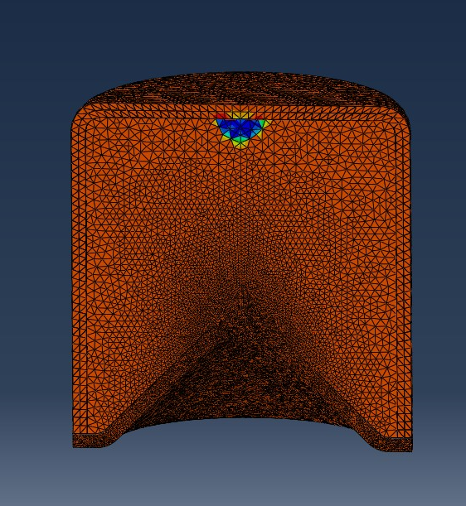

Figure 1 - 3D model

The area of blue shows the detonation point for reference. After making the design, the next step was to assign materials. TNT was used as the explosive material. TNT is a good choice for the energetic material for a number of reasons. It is a reasonably stable explosive, meaning that it is less likely to detonate prematurely and is much safer when handling during manufacture and operation [18]. HMX would have been a better option. This is because it can be pressed to achieve maximum density which makes it an ideal choice [19]. It also has a much higher detonation velocity compared to TNT, 9,100ms⁻¹ compared to 6900ms⁻¹ [20]. Composition B, which typically consists of TNT mixed with RDX, is often used in shaped charges due to its detonation velocity and high energy output. It also has high stability and a suitable density and is very versatile. This wasn’t chosen due to it being difficult to find values for it, compared to TNT which has readily available data.
The casing was made from steel. For the shaped charge, it is essential that the liner is shot forward quicker than the casing, in order to form the jet. Therefore, the casing needs to be less ductile and less dense. Steel is a good option for the casing because of its strength, durability and it can withstand the high pressure generated by the explosion. This allows the shaped charge to maintain its shape until the liner is shot forward and the jet is formed. The casing could also be made from zinc, but steel is stronger and more durable and can withstand a higher pressure [21].
The material for the liner was decided to be copper. Copper was chosen due to its high density. This means that it can produce a heavier, more penetrating projectile than other metals. It is also very ductile, which means it can compress and deform easily to form the jet. As well as that, it has a high thermal conductivity meaning it won’t melt and is cheap and readily available [22]. The design for this shaped charge used a trapezoid cross-section for the liner. This was to increase the radial velocity of the jet [23]. It does not necessarily improve the performance of the shaped charge, however.
For this model, the materials used a Johnson-cook model. The Johnson-cook model provides an easy way to predict material response under extreme conditions. It is a model used in solid mechanics and material science to estimate the behaviour of materials under extreme conditions such as high temperature, high strain-rates and large deformations. The Johnson–Cook model aims to predict how a material responds when subjected to dynamic loading, such as impact or explosion, or high-temperature environments, such as machining or welding. The model combines thermal softening, strain-rate sensitivity and damage evolution. Specifically, we used the Jones-Wilkins-Lee (JWL) model. The JWL equation of state is a material model commonly used to describe the pressure-volume relationship of explosive materials [24]. The JWL model characterizes the behavior of high-explosive charges. It relates the pressure and volume of an explosive material during detonation. The JWL equation accounts for the energy release and compression effects within the explosive. It is used in fields such as explosives research, ballistics and impact simulations. It helps predict the behaviour of explosives under extreme conditions. It specifically addresses the explosives behaviour during detonation.

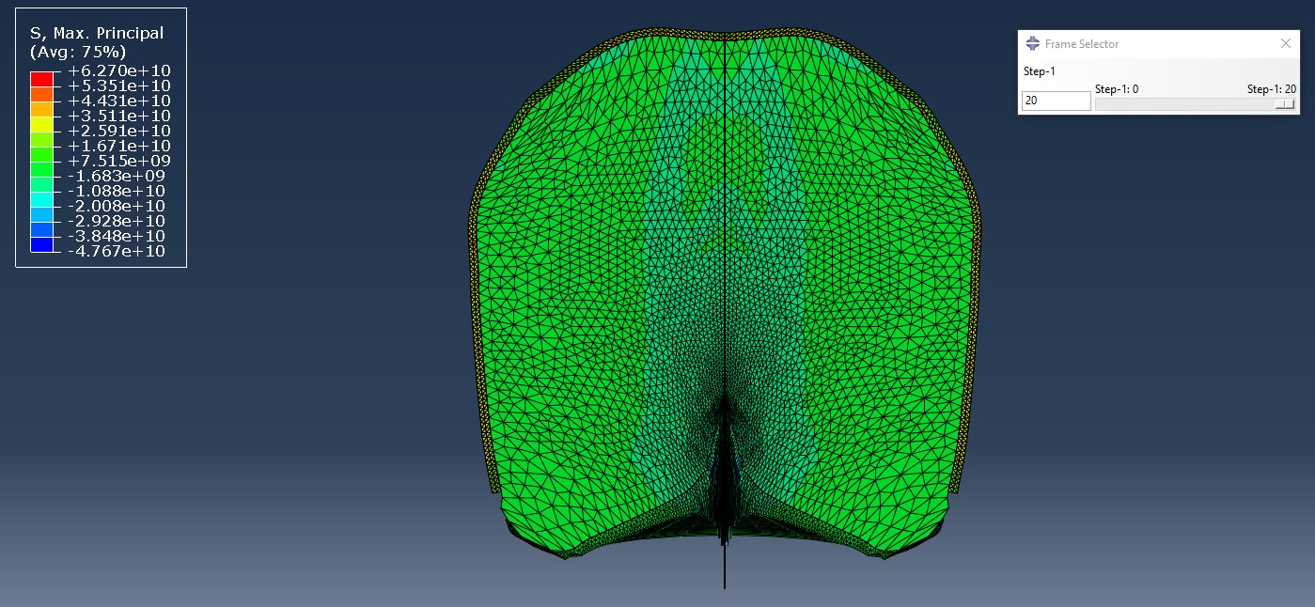
Results:
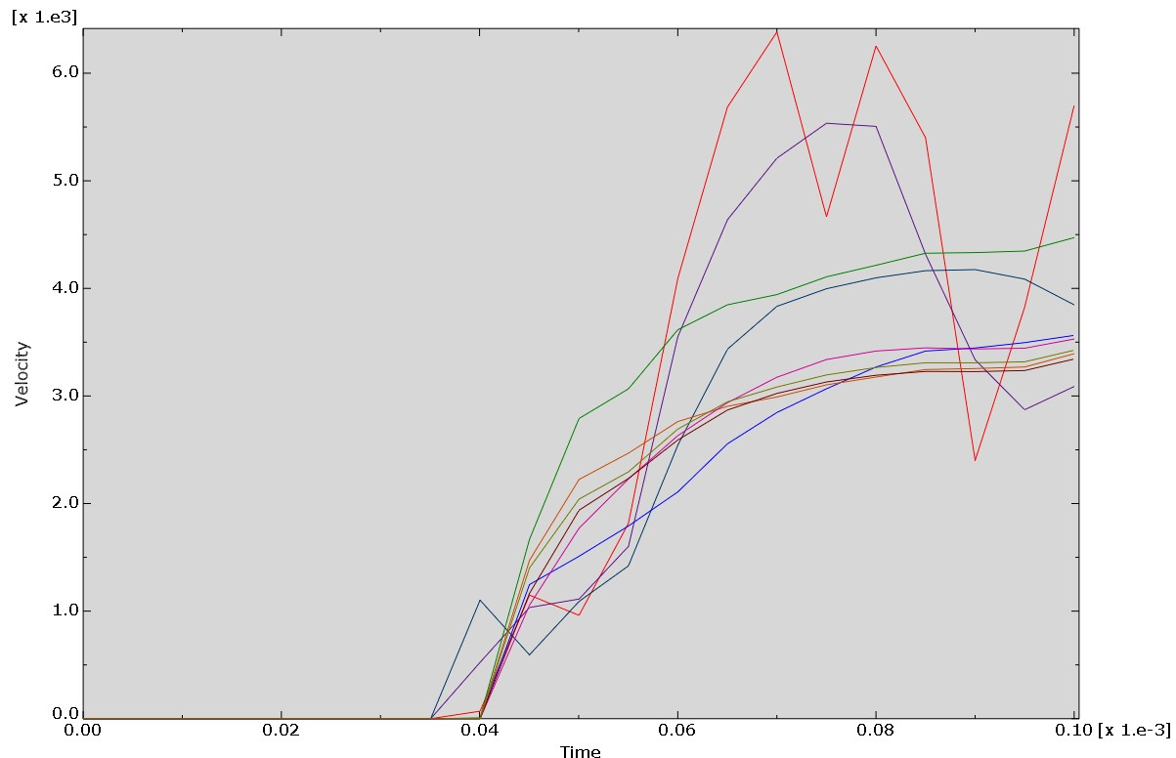
Figure 2 - 2D Simulation
Figure 3 - 2D Velocity / Time Graph
The screenshots above show the results from the 2D simulation. This shows the maximum principal stress to be around 1.671x10¹⁰. The velocity / time graph shows the maximum velocity to be approximately 6.5kms⁻¹.

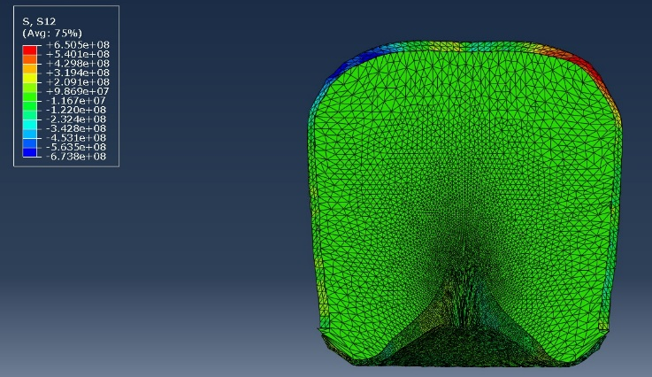
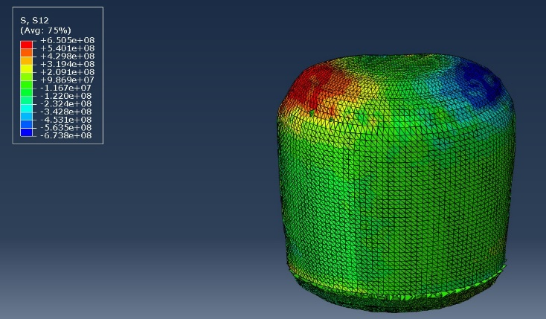
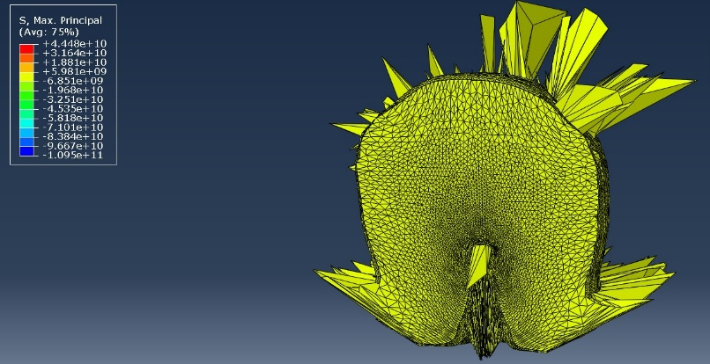
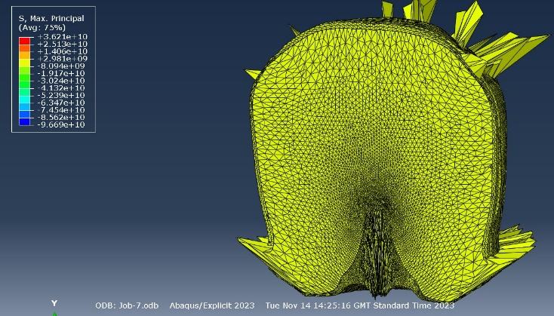
Figure 4 - 3D model with the scale showing stress on the shaped charge
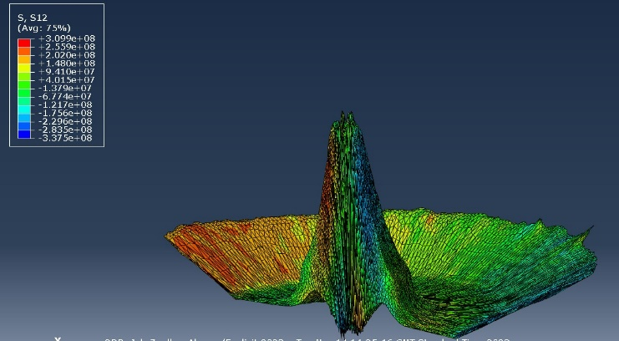
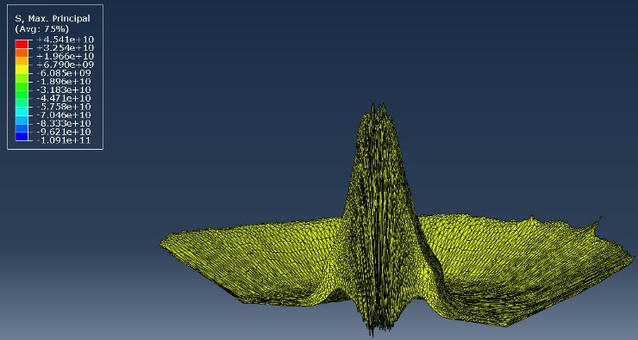
Figure 5 - 3D model with the scale showing the shear stress on the shaped charge.
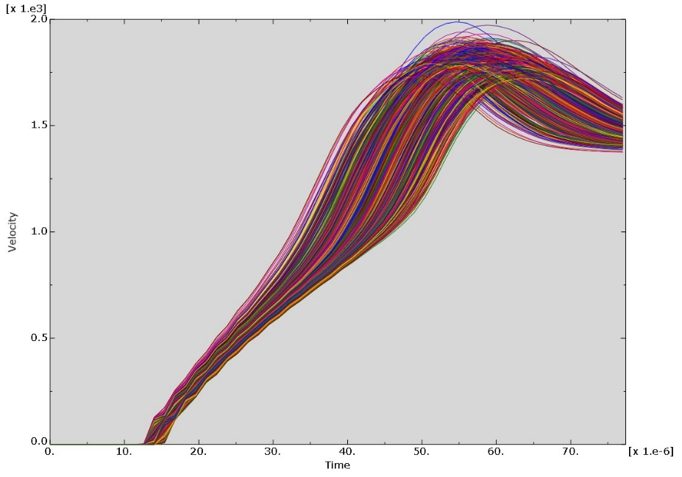
Figure 6 - 3D model of the liner only
Figure 7 - 3D Model Velocity / Time Graph
These are the screenshots from the 3D simulation. As shown by the screenshots, the results of the 3D simulation were very different to the 2D simulation. The screenshots of the liner on its own show that the maximum principal stress reached approximately 6.79x10⁹. This is considerably smaller than the maximum principal stress achieved in the 2D simulation. The velocity / time graph also shows that the maximum velocity only reached approximately 2kms⁻¹ in the 3D simulation which is about three times slower than what was achieved in the 2D simulation. The maximum shear stress was approximately 6.505x10⁸.

Discussion:
Starting off with the 2D simulation, it was stated that the maximum principal stress reached approximately 1.671x10¹⁰. The velocity reached around 6.5kms⁻¹. This is about what is expected of the maximum detonation velocity of a shaped charge. Given that TNT is the explosive that was used, it is probably about right given that TNT detonates at 6900ms⁻¹ [20] or 6.9kms⁻¹. One way of improving this would’ve been to use a more powerful explosive. For example, RDX detonates at approximately 8.5kms⁻¹, and HMX detonates at approximately 9.1kms⁻¹. Alternatively, Composition B is a mixture of RDX, TNT and a plasticiser such as wax or oil [25]. It is commonly used in shaped charges and has a high energy output, is relatively safe and is moderately priced. It also has a detonation velocity of approximately 8kms⁻¹.
If the simulation was to take place again, one change that could be made could be for the simulation to run longer in order to get more of a jet. It would also be beneficial to have more steps in the simulation. This would help to get smaller changes per step and have a better understanding of the progression of the jet.
Looking at the 3D model, the maximum principal stress only reached approximately 6.79x10⁹. The shear stress, acting on a plane with normal in the 1-direction and parallel to the 2-direction, reached a maximum of approximately 6.505x10⁸. Finally, the velocity / time graph shows that the maximum velocity reached approximately 2kms⁻¹. One thing that is noticeable is the big difference between the 2D values and the 3D values. The 2D simulation had a much bigger maximum principal stress and the detonation velocity was much quicker. The detonation velocity for the 3D simulation was quite slow compared to what it should’ve been which could have been down to a number of things. This is the same for the maximum principal stress being much lower than the 2D simulation. One thing that was noticeable from the 3D simulation is that the jet that is formed from the liner of the shaped charge is a much stronger jet. It progresses further as shown from the graph, all the nodes that were selected are travelling at a very similar speed. The velocity / time graph for the 2D simulation was considerably more inconsistent compared to the 3D velocity / time graph. In the shear stress measurements of the 3D simulation, there is a view of the back of the shaped charge. This gives a much better representation of the stress acting on the casing compared to the other screenshots. This screenshot shows that the top corners of the casing experience the highest level of shear stress in the 3D simulation. This is likely due to the detonation point being at the top of the charge, and the casing having to remain in place as well as possible in order to push the detonation wave down towards the liner. The screenshot shows one side suffering a much higher shear stress than the other, but this is probably a mistake as the design is symmetrical and should really be the same on both sides.
If the simulation was repeated, the materials used could be changed to test out the differences between the materials that were tested. Firstly, Composition B might have been a better explosive filling due to its increased detonation velocity. The liner could have also been changed in order to get a better jet. Another improvement that could have been made could have been to run the simulation for longer. However, the jet velocity had probably reached the maximum at the point that was tested as it had started to dip, but it could have given a better formation of the jet if the simulation was ran for longer.
Conclusion:
In conclusion, the simulation of the shaped charge produced a maximum principal stress of approximately 6.79x10⁹. The shear stress, acting on a plane with normal in the 1-direction and parallel to the 2-direction, reached a maximum of approximately 6.505x10⁸, and the velocity / time graph shows that the maximum velocity reached approximately 2kms⁻¹. This was for the 3D model and was rather successful and gave reliable figures. The 2D model gave a maximum principal stress of approximately 1.671x10¹⁰ and the jet velocity reached approximately 6.5kms⁻¹. The values for the 2D simulation were probably more similar to a real life shaped charge detonation, but the 3D simulation was more complex and there were a lot more variable factors that could have impacted the simulation. The conical shaped charge design was the most suitable for this simulation hence why it was chosen. The design meant that the liner collapsed from the centre upon detonation, due to the pressure generated by the explosive material upon detonation, forming a high velocity jet of metal.

References

[1] | "Shaped Charge," Military Wiki, [Online]. Available: https://military-history.fandom.com/wiki/Shaped_charge. [Accessed 4 December 2023].
[2] | "Primer on a Shaped Charge," Small Arms Review, [Online]. Available: https://smallarmsreview.com/a-primer-on-shaped-charges/. [Accessed 13 December 2023].
[3] | S. M. Buc, "Liner Materials: Resources, Processes, Properties, Costs and Applications," 1991.
[4] | "Shaped Charge," Global Security, 6 December 2017. [Online]. Available: https://www.globalsecurity.org/military/systems/munitions/bullets2-shaped-charge.htm. [Accessed 10 December 2023].
[5] | e. a. Zhengxiang Huang, "Research on the Formation Characteristics of the Shaped Charge Jet from the Shaped Charge with a Trapezoid Cross-Section," 2022.
[6] | "Shaped Charge," Britannica, [Online]. Available: https://www.britannica.com/technology/shaped-charge. [Accessed 14 December 2023].
[7] | "Munroe Effect," Merriam-Webster, [Online]. Available: https://www.merriam-webster.com/dictionary/Munroe%20effect. [Accessed 18 December 2023].
[8] | "Conical Shaped Charge," Ensign-Bickford Aerospace & Defence, [Online]. Available: https://www.ebad.com/conical-shaped-charge-csc/. [Accessed 16 December 2023].
[9] | H. Zhengxiang, "Study On Tandem Shaped Charges Technique," 2007.
[10] | "Linear Shaped Charge," Ensign-Bickford Aeorspace & Defense, [Online]. Available: https://www.ebad.com/linear-shaped-charge-lsc/. [Accessed 16 December 2023].
[11] | "Gurney Equations Explained," Everything Explained Today, [Online]. Available: https://everything.explained.today/Gurney_equations/. [Accessed 2 January 2024].
[12] | W. J. Zhao Zhang, "Finite element modeling of the shaped charge jet and design of the reusable perforating gun," 2020.
[13] | "What is Finite Element Analysis (FEA)," TWI Global, [Online]. Available: https://www.twi-global.com/technical-knowledge/faqs/finite-element-analysis. [Accessed 3 January 2024].
[14] | T. Smithson, "Perforating Fundamentals," SLB, pp. 1-2.
[15] | K. L. Qianyi Chen, "A high-resolution Eulerian method for numerical simulation of shaped charge jet including solid–fluid coexistence and interaction," Science Direct, vol. 56, pp. 92-101, 2012.
[16] | "Overview of Eulerian analyses," [Online]. Available: https://docs.software.vt.edu/abaqusv2022/English/SIMACAECAERefMap/simacae-t-adveulerianoverview.htm. [Accessed 3 January 2024].
[17] | e. a. Sohail Akram, "Numerical and experimental investigation of Johnson–Cook material models for aluminum (Al 6061-T6) alloy using orthogonal machining approach," 2018.
[18] | "Trinitrotoluene - TNT," Ch.ic, [Online]. Available: https://www.ch.ic.ac.uk/vchemlib/mim/bristol/tnt/tnt_text.htm. [Accessed 19 December 2023].
[19] | D. Hambling, "The All-or-Nothing Bomb Test That Built a Better Bunker-Buster," Popular Mechanics, 2016.
[20] | "Table of explosive detonation velocities," Wikipedia, [Online]. Available: https://en.wikipedia.org/wiki/Table_of_explosive_detonation_velocities. [Accessed 8 January 2024].
[21] | e. a. C Han, "Effect of Shaped Charge Case Materials on Perforating Guns," 2010.
[22] | e. a. Hossein Mehmannavaz, "Theoretical, numerical and experimental analysis of bimetallic Cu–Al shaped charge’s liners and its influence on the penetration depth and the crater diameter of steel targets," Journal of the Brazilian Society of Mechanical Sciences and Engineering, 2019.
[23] | e. a. Bin Ma, "Research on the Formation Characteristics of the Shaped Charge Jet from the Shaped Charge with a Trapezoid Cross-Section," 2022.
[24] | A. Shrot and M. Bäker, "How To Identify Johnson‐Cook Parameters From Machining Simulations," AIP Publishing, vol. 1353, no. 1, 2011.
[25] | "Composition B Explosive," Global Ordnance, [Online]. Available: https://www.global-ordnance.com/wp-content/uploads/2019/12/Global-Data-Sheet-Explosive-Comp-B.pdf. [Accessed 7 January 2024].

