The assignment title: Planning and Delivering an International Meeting/Event.

The module title: International Meetings Management BMIH6007

Student name: Claudia Butnariu

Student ID: 2239415

Lecturer name: Kathryn Flynn

AI Acknowledgement
I confirm that I have not used any Al tools in the research and creation of this assignment. l confirm that I have not presented any Al generated materials as my own Work. I confirm I have copies of my drafts, notes, and other resources that I have used, which may be asked to provide in evidence.
TABLE OF CONTENTS
Introduction 2
The Event Cycle 2
Event Concept 3
Aim and Objectives 6
Event Management 7
Event Budget 8
Industry Trends / Issues / Impacts 9
Situational and Cultural Considerations 9
Conclusion 10
References 12
Appendix 15
Appendix 1: Presentation Slides 15

Introduction
The seven-day cultural celebration, taking place at Cardiff Castle as part of Visit Wales’ 2025 ‘Year of Croeso’ campaign, is the ‘Height of Summer’ event. The word ‘Croeso’, which in Welsh means ‘welcome’, is an example of the nation’s hospitality and cultural pride. The reason for selecting this event is its ability to reveal the strategic focus that Wales places on promoting international tourism through displaying its heritage, music, cuisine, and landscape to European and Asian visitors. As the event’s central location is Cardiff, it is easily accessible area which maximises exposure with the revenue generation and guest retention as a result of having a history and infrastructure to boast of. The service aims for appealing to high-value cultural tourists looking for an authentic and immersive tourism and cross-cultural experiences. The Height of Summer event serves as a strong business case for investment, cultural exchange in addition with economic development through aligning with Visit Wales’ branding and stakeholder objectives. Its location, timing, and focus on guest-centric strategies have led themselves to the exceptional platform from which they can deliver a culturally appealing international portrait.

The Event Cycle
The Event Cycle is a systematic planning tool to control event managers over multiple delivery stages of an event. It involves five key stages which are widely referenced and include Plan, Organise, Measure, Analyse, and Share (Ludwig et al. 2023). A structured and reflective approach to the successful implementation of the event is supported in each stage.
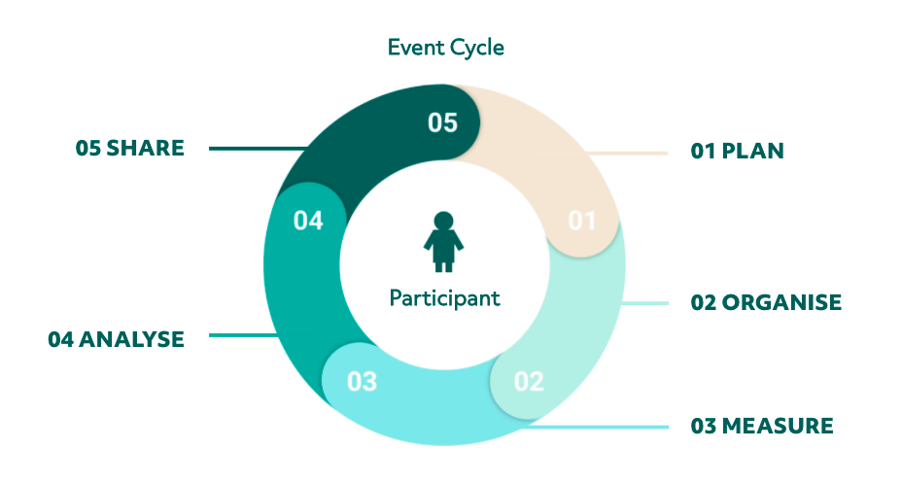
Figure 1: Event cycle
(Source: Ludwig et al. 2023)
Plan: This is the initial plan and it determines the use of feasibility studies, stakeholder consultations, and market analysis to make various strategic and technical decisions for a project. The Height of Summer event was planned by segmenting the target audience as international tourists falling in the age group 22-52. In addition, the initial plans included setting clear objectives congruent with Year of Croeso by Visit Wales, choosing Cardiff Castle as venue, and forecasting the budget as £380,000, and an expected return of £500,000. In this stage the risk assessments alongside sustainability planning also takes place.
Organise: This stage helps to transform the strategy into action through organising. In this manner, staff will be recruited, suppliers will be contracted, permits will be arranged and scheduling will be executed. Tasks such as developing events itinerary with heritage, performance and cuisine tours and assigning Event Manager, Cultural Coordinator, and AV technician will also be accomplished in this stage (Bowdin et al. 2023). At this phase, digital and traditional channel marketing campaigns can be launched too.
Measure: Visitor numbers will be captured in real time during the event via a series of KPIs, including visitor satisfaction, app engagement as well as on-site spending (Souifi et al. 2022). Collecting feedback by way of QR-coded surveys and mobile interactions will allow data for being captured when the experience is still fresh.
Analyse: Collected data will be analysed after the event in terms of SMART objectives (Radoglou-Grammatikis et al. 2021). However, if the profitability was reached, and the 90% satisfaction target was met, this evaluation will determine the successes and the places where improvements can be made.
Share: The last stage consists of conveying results to stakeholders. Outcomes, lessons learned and recommendations for future iterations of the program will be contained in a post-event report (Zhan et al. 2024). It will further enhance transparency and fosters continuous improvement and the strategic value creation for Visit Wales and partners.
By repeating this process, the event provides thoughtful design, responsive delivery and lasting legacy value.

Event Concept
During seven days of encounter at Cardiff Castle, the Height of Summer - Year of Croeso 2025 provides an immersive, multi-sensory journey of Welsh culture, heritage and hospitality (Cardiffmusiccity.wales, 2025). Each day delegates the operations and guests will follow a curated itinerary that incorporates historical interpretation, firsthand learning, cultural exchange and entertainment. Inclusivity, sustainability and international engagement were taken into consideration for increasing customer’s experiences.

Figure 2: Year of Croeso
(Source: Cardiffmusiccity.wales, 2025)
Day 1: Welsh Welcome
09:30- Arrival and Registration with bilingual hosts, welcome guests, distribute maps, QR code guides together with the Welsh souvenirs.
10:00- Opening ceremony featuring performance by harp, traditional dance and comments from Visit Wales officials, round off with a male voice choir rendition of the national anthem.
11:30- Expert-guided Heritage Tour of the medieval chambers of Cardiff Castle, Roman ruins and mythological exhibits (Visitcardiff.com, 2025).
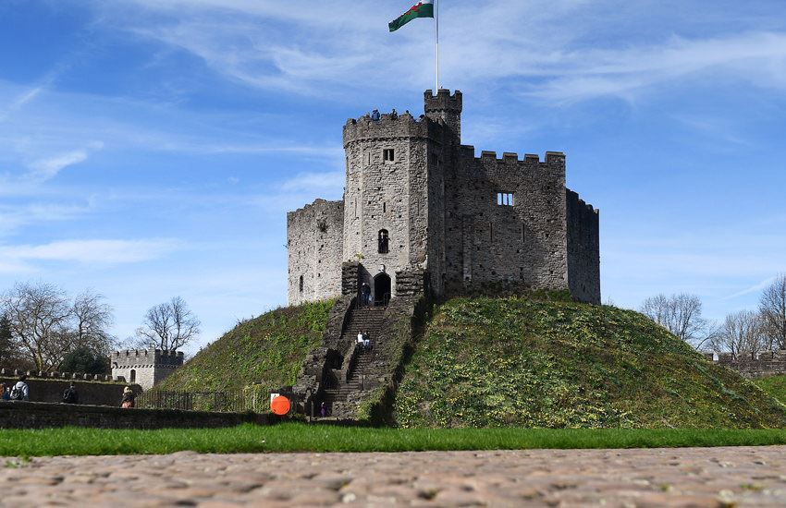
Figure 3: Cardiff Castle
(Source: Visitcardiff.com, 2025)
13:00- Taste of Wales with Luncheon, which is a sampling of cawl, Welsh rarebit and dishes from around the world, prepared by guest chefs, including Istrian Pasta, Slavonian kulen, etc.
14:30- Cultural Panel Discussion from artists and historians to international delegates, artists, historians and international delegates discuss what hospitality means and how it can be interpreted in a global context.
14:00- Craft workshops and artisan market stalls, traditional demonstrations and VR Zip World Penrhyn/Tongareva Quarry simulation.
18:00- Networking and Whisky Tasting in the informal courtyard reception, including Penderyn Welsh whisky, international networking (Wineindustryadvisor.com, 2025).
20:00- Magic of Wales’ Light and Sound Show which projected imagery onto castle walls and an orchestra and a choir telling Welsh legend tales.
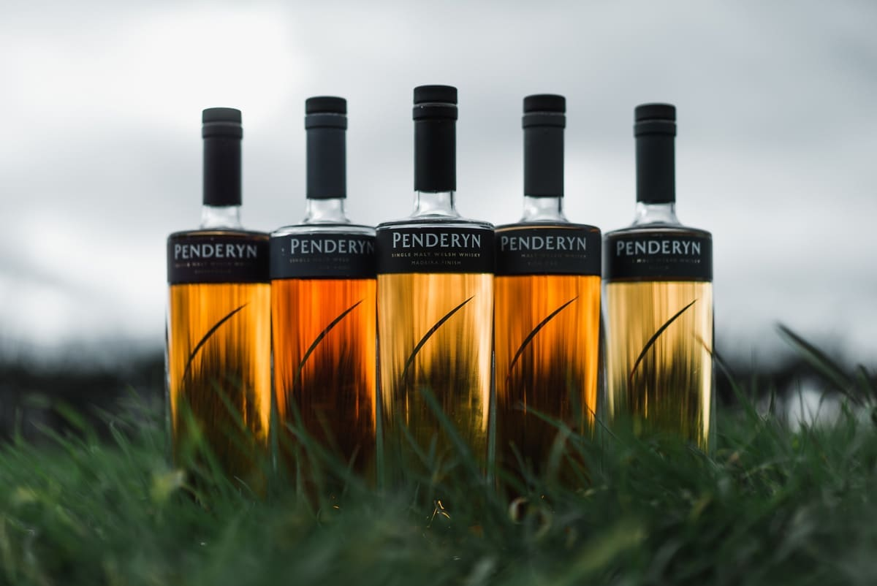
Figure 4: Penderyn Welsh whisky
(Source: Wineindustryadvisor.com, 2025)
Days 2-7 Overview
Day 2 - Eco-tourism talks, Zip World VR, canal cruising simulation and evening stargazing.
Day 3 - Culinary Fusion includes live Welsh-Asian fusion demos, an open-air food market and storytelling dinners (Visitwales.com, 2025).
Day 4 - Arts and Eisteddfod like Poetry/song contests, language workshops, and an all-bilingual folk jam.
Day 5 - Global Cultures Exchange with family workshops, dance workshops, panel discussion on Tourism Beyond Borders and global film night (Hudson and Hudson,2023).
Day 6 - Tech zone where the smart-tourism demos will be hosted, a youth pitch contest and a renewable-energy concert.
Day 7 - Feedback will help in the evaluation of the satisfaction of guests and crew, legacy tree planting, awards brunch, and digital memory-book launch.

Aim and Objectives
Aim
The aim of Height of Summer - Year of Croeso 2025 is to celebrate and endorse Wales’ rich cultural heritage, hospitality and international appeal by delivering a high-quality, inclusive experience. Furthermore, this initiative will also increase Wales’ profile as a leading cultural tourism destination.
SMART Objectives
Specific | Measurable | Achievable | Relevant | Time-bound
Cardiff Castle attracts 15,000 ticketed visitor of which 60% are international tourists from Europe and Asia. | Digital ticketing and registration systems delivered the additional measurement. | Data of previous campaigns and tourist interest taken from Visit Wales. | Matches Visit Wales’ 2025 Year of Croeso similar aims to raise global engagement shall be promoted. | In the period between 11-18 June 2025
Deliver 90+% visitor satisfaction on the quality of the event, the service and cultural content. | The QR-coded feedback forms together with the mobile app interactions are evaluated. | Data from the past shows that planned improvements make satisfaction targets realistic. | Ensures the enhancement of Wales’ cultural brand and tourism standards continue to improve. | Surveyed results till 25 June 2025
Net Profit of £100,000 through a variety of diverse sources of income (ticket sales, grants, sponsorship, food and merchandise) | The revenue tracked through financial software and the profit confirmed after the event. | As the budgeted income is £500,000 as against expenditure £380,000, the target surplus is supported. | The financial viability for the event as a tourism investment initiative, is reflected in the event. | 30 June 2025 Financial Report
Table 1: SMART Goals

Event Management
For the successful execution of the Height of Summer - Year of Croeso 2025 event to take place, it will necessitate the collaboration of professional skills from operational, planning, and marketing areas to foster strategic planning and resource allocation.
Operation
Logistics, safety, hospitality and real-time event execution are all part of operational management. Logistics coordinators, safety officers, AV technicians, hospitality managers and accessibility stewards are some of the key staff (Kulshrestha et al. 2022). Time management, problem solving and interpersonal communication are essential skills required. There are essential resources like Cardiff Castle venue facilities, signage, seating, first aid stations, sanitation units, and transport arrangements including eco-friendly transports (Paul, 2023). Live operations also include on-site catering, crowd control systems and real-time data tracking such as visitor numbers in addition with the app usage.
Planning
Months in advance strategic planning was underway and project managers, budget analysts, and content curators were involved. Skills that are required include stakeholder engagement, financial planning, compliance knowledge, team coordination, among others. The resources related to planning are venue contracts, supplier agreements, event insurance, etc., and also includes contingency plans (Yung et al. 2022). Early booking and coordination were needed with local and international partners on event-specific programming such as light shows, cultural performances and culinary experiences.
Marketing
Reaching the international target audience is a crucial role of marketing. SEO, social media, working with influencers and email campaigns are all methods that will be employed by digital marketers, graphic designers and public relations officers (Gupta, 2022). Poster, press release, and travel partnerships are efforts will take place as offline marketing methods. Supporting visibility and branding will be provided by resources such as a multilingual event website, booking platforms, media kits and promotional merchandises. Audience engagements and feedback will be achieved using QR-code surveys and mobile apps.

Event Budget
Core operational areas are estimated to spend £380,000 in the Height of Summer - Year of Croeso 2025 event. Venue rental (£100,000), accommodation and transport (£70,000), logistics and staff (£60,000), marketing (£25,000), decoration (£80,000), sound and lighting (£15,000) and medical and safety services (£10,000) are the key costs. The scale and ambition of the seven day cultural celebration at Cardiff Castle is explained by these figures.
The income is expected to take place at £500,000 through varied streams such as ticket sales (about £200,000), food and merchandises (£75,000), government grants (£100,000), and corporate sponsorships (£125,000). Various levels of ticket pricing based on local and international visitors make the museum accessible with cost-recovery support. Exploration into strategic partnership with local councils and cultural foundations that support funding through grants and cultural investment funds has taken place. The net profit predicted for an event of £120,000 means that future events can be reinvested into, as well as supporting Visit Wales future tourism goals.
Areas of investments | Amount of investments
Rent of the venue | £100,000
Lighting, and sounds | £15,000
Seating arrangements and food | £20,000
Accommodation for visitors | £70,000
Logistics charge | £60,000
Medical support | £10,000
Decoration | £80,000
Marketing | £25,000
Overall | £380,000
Expected revenue | £500,000
Predicted profitability | £120,000
Table 2: Budget

Industry Trends / Issues / Impacts
The meetings and events industry is transforming at a rapid pace because of shifting consumer expectations, increasing sustainability demands and higher levels of technology integration. There are several key trends that are shaping the way events are being managed in present time which will directly impact delivery of the Height of Summer - Year of Croeso 2025 event.
Sustainability or the ESG (Environmental, Social, Governance) standards have become non-negotiable in current scenario (Clément et al. 2022). Eco-friendly practices such as waste reduction, local sourcing and carbon-conscious transportation should be implemented by organiser (Wee et al. 2021). Consequently, the “Height of Summer event embraces green transport, digital tickets, reusable materials in line with global environmental expectations.
Post pandemic trend that has further developed is hybrid and digital engagement. This is mostly an in-person event, however QR-coded guides, AR/VR experiences (such as a Zip World simulation) and mobile app interaction have been integrated into the offering to provide digital depth and international reach (Raghu and Kumar, 2025). Cultural authenticity and inclusivity are important too. Attendees of today want an immersive, meaningful experience that is authentic and meaningful in local heritage. By celebrating Welsh culture whilst welcoming views from Europe and Asia, this event assumes a position in line with this demand for multicultural involvement (Panzera et al. 2021). In terms of challenges, inflation and an increase in supplier costs influence the budget planning, and it therefore has to be more accurate with cost control and diversified revenue strategies. Security and crowd management remain top priorities with the light of global safety concerns too. Changing audience behaviour, especially among young tourists (Gen Z, Millennials) who consider ethical tourism, interactivity and posting material that goes viral on social media, also affect the event (Rodrigues et al. 2024). Such trends are used as part of marketing campaigns for this event in terms of visual storytelling, influencer partnerships, and interactive content.

Situational and Cultural Considerations
The successful planning of such an international cultural event as Height of Summer - Year of Croeso 2025 entails wider situational and cultural factors. The PESTLE analysis, an aided technique that includes analysis of Political, Economic, Social, Technological, Legal and Environmental factors provides a structured approach to identify the above considerations.
Politics: Strong political stability of the UK and subsistence from the Welsh Government through Visit Wales contribute towards a favourable policy environment for cultural tourism (Syder et al. 2025). Government grants and tourism funding is a significant role for event feasibility.
Economic: Factors such as inflation, exchange rates, and purchasing power of consumers in terms of their spending power also influence ticket pricing and purchasing behaviour of ticket buyers, particularly of international visitors (Babin and Harris, 2023). Costs of travelling to the islands are on the increase, and so increasing value-added experiences and inclusive packages will be helpful in attracting high-value tourists.
Social: The design of the programme is influenced by social dynamics such as rising demand for authentic, localised experiences in combination with the intergenerational travel (Mair et al. 2023). Community interaction and multilingual access are given equal attention with inclusivity in culinary offerings that respect cultural diversity.
Technology: Real-time feedback and immersive experiences regarding how individuals experience heritage rely on technological advancements such as the QR-coded surveys in addition with the VR interactive heritage experiences to suit tech-savvy demographics (Sjukriana et al. 2024). Paperless ticketing and interactive maps are also part of digital tools that support the sustainability goals.
Legal: Health and safety, public liability and accessibility regulations must be legally complied with. Data collected via such things as event apps is also GDPR compliant, protecting user privacy (Ico.org.uk, 2025).
Environmental: These are of huge environmental concern. Growing pressure for eco-conscious practices, requires the event to attend to sustainable catering, waste management and carbon-reduced transport in congruence with ESG principles (Litvinenko et al. 2022). Culturally, it has been essential to understand together with respect to the traditions of both host (Welsh) and guest European or Asian communities. Inclusivity and respect are fostered by such things as multilingual signage and dietary options for a variety of religions, as well as diverse artistic representation.

Conclusion
Welsh Culture, Tourism Innovation and Global Engagement, the Height of Summer - Year of Croeso 2025 event represents Wales’ sheer commitment and determination to celebrate culture and to embrace the world. The seven-day programme has been strategically aligned with Visit Wales' Year of Croeso initiative to deliver authentic intimate and inclusive experience with international and domestic visitors. Backed by robust planning, efficient event management and a sustainable financial model, the event also deals with selected trends of the industry like cultural authenticity, environmental adherence and digital integration. Multilingual programming, culinary diversification and interactive technologies contribute to the global audience, and share Welsh identity, at this event. By applying situational and cultural factors, through the usage of tools such as PESTLE, the event sets itself up for long-term success and legacy. The Height of Summer is so much more than just a festival, it is a strategic opportunity to promote the absolute best of Wales and reinforce Wales’ position as a top-class cultural tourism destination.

References
Babin, B.J. and Harris, E.G., 2023. CB Consumer behaviour. Cengage Canada.
Bowdin, G.A., Allen, J., Harris, R., Jago, L., O'toole, W. and McDonnell, I., 2023. Events management. Routledge.
Cardiffmusiccity.wales, 2025. Year of Croeso: Weather-Proofing Fund for Tourism Attractions 2025-2026. Available at: https://cardiffmusiccity.wales/2025/05/07/year-of-croeso-weather-proofing-fund-for-tourism-attractions-2025-2026/ [Accessed on 10th June 2025]
Clément, A., Robinot, É. and Trespeuch, L., 2022. Improving ESG scores with sustainability concepts. Sustainability, 14(20), p.13154.
Gupta, V., 2022. ELECTRONIC EVENT MARKETING STRATEGIES. SAARJ Journal on Banking & Insurance Research (SJBIR)(www. saarj. com), p.32.
Hudson, S. and Hudson, L., 2023. Marketing for tourism, hospitality & events: a global & digital approach. Sage Publications Limited.
Ico.org.uk, 2025. UK GDPR | ICO. Available at: https://ico.org.uk/for-organisations/data-protection-and-the-eu/data-protection-and-the-eu-in-detail/the-uk-gdpr/. [Accessed on 10th June 2025]
Kulshrestha, R., Singh, P., Malakar, S.K. and Awasthi, A., 2022. Tourism, Event and Digital Media. OrangeBooks Publication.
Litvinenko, V., Bowbriсk, I., Naumov, I. and Zaitseva, Z., 2022. Global guidelines and requirements for professional competencies of natural resource extraction engineers: Implications for ESG principles and sustainable development goals. Journal of Cleaner Production, 338, p.130530.
Ludwig, H., Terpos, E., van de Donk, N., Mateos, M.V., Moreau, P., Dimopoulos, M.A., Delforge, M., Rodriguez-Otero, P., San-Miguel, J., Yong, K. and Gay, F., 2023. Prevention and management of adverse events during treatment with bispecific antibodies and CAR T cells in multiple myeloma: a consensus report of the European Myeloma Network. The Lancet Oncology, 24(6), pp.e255-e269.
Mair, J., Chien, P.M., Kelly, S.J. and Derrington, S., 2023. Social impacts of mega-events: A systematic narrative review and research agenda. Methodological Advancements in Social Impacts of Tourism Research, pp.140-162.
Panzera, E., de Graaff, T. and de Groot, H.L., 2021. European cultural heritage and tourism flows: The magnetic role of superstar World Heritage Sites. Papers in Regional Science, 100(1), pp.101-123.
Paul, A.K., 2023. Future of sports operations and sports event management in uncertain environment: a critical review. Sports Management in an Uncertain Environment, pp.189-218.
Radoglou-Grammatikis, P., Sarigiannidis, P., Iturbe, E., Rios, E., Martinez, S., Sarigiannidis, A., Eftathopoulos, G., Spyridis, Y., Sesis, A., Vakakis, N. and Tzovaras, D., 2021. Spear siem: A security information and event management system for the smart grid. Computer Networks, 193, p.108008.
Raghu, B. and Kumar, N., 2025. Impact of technology on event concerts. International Journal of Multidisciplinary Science Research Review, 3(1), pp.20-30.
Rodrigues, P., Sousa, A. and Pinto Borges, A., 2024. Generation Z's attitudes toward virtual tourism: the impact of implicit and explicit attitudes. EuroMed Journal of Business, 19(1), pp.21-45.
Sjukriana, J., Hanafiah, M.H., Asyraff, M.A. and Kusumah, G., 2025. Unveiling the landscape of event technology adoption in hospitality and tourism industry: insights from a systematic literature review. International Journal of Event and Festival Management, 16(2), pp.207-228.
Souifi, A., Boulanger, Z.C., Zolghadri, M., Barkallah, M. and Haddar, M., 2022. Uncertainty of key performance indicators for Industry 4.0: A methodology based on the theory of belief functions. Computers in Industry, 140, p.103666.
Syder, A., Baker, S., Bowditch, E., Carlisle, S., Finch, T., Minter, M. and Constant, N., 2025. Visioning future treescapes in upland landscapes: using deliberative processes to understand values and land-use preferences of local stakeholders. Ecosystems and People, 21(1), p.2497823.
Visitcardiff.com, 2025. CARDIFF CASTLE. Available at: https://www.visitcardiff.com/highlights/cardiff-castle/ [Accessed on 10th June 2025]
Visitwales.com, 2025. Welsh food and recipes. Available at: https://www.visitwales.com/things-do/food-and-drink/welsh-food-and-recipes [Accessed on 10th June 2025]
Wee, H., Mustapha, N.A. and Anas, M.S., 2021. Characteristic of green event practices in mice tourism: a systematic literature review. International Journal of Academic Research in Business and Social Sciences, 11(16), pp.271-291.
Wineindustryadvisor.com, 2025. Penderyn Distillery Crowned Wales’ Drinks Producer of the Year at Prestigious National Awards. Available at: https://wineindustryadvisor.com/2025/05/28/penderyn-distillery-crowned-wales-drinks-producer-of-the-year/ [Accessed on 10th June 2025]
Yung, R., Le, T.H., Moyle, B. and Arcodia, C., 2022. Towards a typology of virtual events. Tourism Management, 92, p.104560.
Zhan, Y., Xiong, Y., Han, R., Lam, H.K. and Blome, C., 2024. The impact of artificial intelligence adoption for business-to-business marketing on shareholder reaction: A social actor perspective. International journal of information management, 76, p.102768.

