The Recognition of Faces Following a Distractor Task
Rebecca Harding
1700014
University of Wales Trinity Saint David’s
Research Methods
ECPS4002

Abstract
This study intended to identify own-biased face recognition. It consisted of 29 participants (7 males and 22 female) (mean age= 18 to 60. M=27.31, SD= 10.81) completing a face recognition study by recalling images of faces they had previously seen within the study. The Hypothesis of own-biased same race face recognition. Analysis consisted of a paired sample t test, and assessed which faces were recalled accurately. Participant’s demographical information was used to determine their ethnicity, this was then used to determine the relationship between the tvalue and the results. This study failed to support the hypothesis of own-race bias face recognition and future research is needed to determine why some faces are recognised and others aren’t.

Introduction
Facial recognition is an information process of the brain based on encoding and memory. A person’s face is important to identify a person and their ethnicity, a person’s emotions and often some information socially.
Many theories have been investigated about how and why a person may recognise others or recall seeing them previously. It can be argued that there is a clear bias in recognition of same race faces more accurately than other race faces, however many studies have attempted to identify the reason for this but is still yet to be understood (Valentine 1991).
The norm-based coding model suggests that an individual will recognise same race faces more quickly than other race faces, in tasks where different race faces will be displayed. Although the multi-dimensional framework model suggests that same race faces are normally distributed, around the central tendency which suggests that due to distinctiveness, faces of other races are stored in memory and are encoded away from the central tendency.
One study conducted by Cross, Cross and Daley (1971) found that children from a white segregated community showed an own-race bias in face recognition, than other white children from integrated community, although in contrast to this Cross et al (1971) did not find the same results with black children. Brigham et al (1982) reported significant link although weak, cross-racial experience and their recognition of other race faces, which suggests that exposure to other races do play a part in the facial recognition process as suggested by Cross, Cross and Daley (1971) although Brigham and Barkowitz (1978) did not find a significant relationship between cross- racial experience, and suggested this could be down to the fact that a person does not want to be portrayed as racist which may influence a person’s results of their relationships/interactions.
Another Hypothesis that was explored was that own-race bias face recognition may be because a person may have to racial attitudes and prejudices, however this was not supported by evidence, Lavrakas, Buri and Mayzner (1976) did not find a significant correlation between racial attitudes and facial recognition.
Goldstein, (1979a, 1979b) hypothesised that it may be difficult to recognise faces of other races, although this has not been backed by any empirical findings.
Valentine and Endo (1992) found that own-race faces were recognised more accurately than other race faces. The present data reported within this paper is an attempt to try and demonstrate a finding to support that a person will recognise and identify same race faces more accurately than other ethnic groups.
The present study challenges a person’s memory by a distraction between seeing the faces and then retrieving them from memory, to test the hypothesis of own-biased same race face recognition.
Method
A total of 29 white students were recruited from a university lecture in a group setting containing (7 male and 22 females). The age range was 18 to 60 M = 27.31, SD = 10.81.
To analysis the responses a paired sample t test was conducted, it consisted on within subjects. The independent variable was the ethnicity, and the dependant variable was the number of faces present recalled correctly.
A PowerPoint presentation was used to create the study, the first slide contained instructions for the participants in what to do during the first part of the study. 12 faces were shown individually for a period of 2 seconds each (6 white faces and 6 black faces).
Part two of the study included in total of 36 faces being shown on 6 pages with 6 faces on for a total of 12 seconds each.
A response sheet was also given to participants which collected demographical data (gender and age) with space provided for participants to report their responses of what faces they recalled seeing during part 1.
The participants were firstly provided with a consent form (Appendix A) and asked to complete this before taking part in the study. The participants were then instructed to watch the screen which provided additional instructions within the PowerPoint sides. The Participants were then asked by the researcher to remain silent throughout to allow everybody to have the same opportunities to concentrate, a countdown from 3 to 0 on the presentation then began to part 1, then the presentation of the 12 initial faces began. When the first part ended a distraction in the form of the researcher introducing information about the study was given for 1 minute, participants were then asked to look back to the screen, a countdown from 3 again began and further instructions were given. A presentation of 36 faces was shown, each picture was numbered. The participants were asked to recall which of the 12 faces they had previously seen, identifying by writing down the number next to picture down in the space provided. After the presentation had finished a debrief form/infromation (Appendix B) was presented on the screen for participants to read, and informed if they wish to have their data withdrew from the study. Participants were also given an opportunity to discuss to the researcher if they wished to do so.
Results
A paired sample t test (Appendix C) was conducted to determine whether participants were able to remember more white faces than black faces following a short period of distraction. The results show that participants recalled significantly more black faces (M = 3.34m SD = 2.42) than white faces (M = 2.67, SD = 1.97): t (28) = 3.12, p < .0.5, therefore the original hypothesis that a person will recognise and identify same race faces more accurately than other race faces must be rejected.
Discussion
The main purpose of this study was to test and confirm the hypothesis that a person will recognise and identify same race faces more accurately than other race faces, after a period of distraction was given to test which race faces where encoded in memory more accurately. A paired sample t test was used to measure the differences in the scores obtained from the study. The results showed that participants recalled more black faces than white faces when presented, after the distraction was given for a minute. The most important finding here is that there, a significant difference in the recall of black faces compared to white faces during the study. As all participants where white, which is why the hypothesis is rejected as no own bias face recognition was displayed. This present study does not support the norm-based coding model, this study is more consistent with the multidimensional framework model.
This present study also does not support the findings of Cross, Cross and Daley (1971) or Goldstein, (1979a, 1979b) studies. The present study does however support the distinctiveness hypothesis, it could be because distinctiveness is more easily encoded within memory, as suggest by Valentine (1991) studies.
Although the findings weren’t predicted there were limitations within this study and could be changed for future studies, the present study only included a small number of 29 participants, which means the results cannot be generalised, whereas larger participant’s number means stronger reliability of the results which can then be transferred to estimate general population results. Another limitation identified in the present study was the setting in which the study was conducted in, as it was a group setting, future studies could be conducted in an isolated setting which allows every participant the same opportunity to concentrate, a group setting does also raise the question of reliability of participants results as it cannot illuminate the possibility that participants copies another person’s for any reason. During this present study all the participants where one ethnic group, and due to this fact, it is unable to make comparisons between different races, which Cross et al (1971) found during their studies, which could indicate as a limitation for this study. This does however give opportunity for future research. Another factor that could be changed during future studies is the differences in size of the pictures presented to the participants, section 1 of the study pictures, were significantly bigger than section 2, and as participants where in group setting some participants where sat further away from the screens, this could of raised an issue with viewing the pictures clearly and the reliability of their results due to poor view of the pictures.
In conclusion although this present data does not support the current hypothesis of own race bias presented within this paper, it does however require further research to explore the full effects of why a person may recall some faces more than others despite of race.

References
Bringham, J. C., & Barkowitz, P. (1978). Do they look alike? The effect of race, sex, experience and attitudes on the ability to recognise faces. Journal applied psychology, 8, 306-318
Bringham, J. C., Mass, A., Snyder, L. D., & Spaulding, K. (1982). Accuracy of eyewitness identification in a field setting. Journal of personality and social psychology, 42, 673-681
Chiroro, P., & Valentine, T. (1995). An investigation of the contact hypothesis of the own-race bias in face recognition. The quarterly Journal of experimental psychology. 48A, (4), 879-894
Cross, J. F., Cros, J., & Daley, J. (1971). Sex, race, age and beauty in factors in recognition of faces. Perception and pschophysis, 10, 393-396
Goldstein, A. G. (1979a). Race-related variation of facial features: Anthropometric data 1. Bulletin of the Psychonomic society, 13, 187-190
Goldstein, A. G. (1979b). Facial feature variation: Anthropometric data 2. Bulletin of the Psychonomic society, 13, 191-193
Lavrakes, P. J., Buri, J. R., & Mayzner, M. S. (1976). A perspective on the recognition of other-race faces. Perception and psychophysics, 20, 475-481
Malpass, R. S., & Kravitz, J. (1969). Recognition for faces of own and other race. Journal of personality and social psychology, 13, (4), 330-334
Valentine, T. (1991). A unified account of the effects of distinctiveness, inversion and race in face recognition. The Quarterly Journal of Experimental Psychology, 43A, 161-204
Valentine, T., & Endo, M. (1992). Towards an exemplar model of face processing: the effects of race and distinctiveness. The Quarterly Journal of Experimental Psychology. 44A, 671-703

Appendices
Appendix A – consent form. 
School of Psychology
Townhill Campus
Swansea

Study Consent Form
I understand that taking part in this research study will involve me viewing a number of faces and attempting to recall the faces I have already seen.
I understand that this study consists of two parts. Part one will take approximately two minutes and will consists of me viewing a number of faces. For part two, I understand that I need to pay attention to the faces being presented and record which faces were shown in part one.
I understand that participation in this study is entirely voluntary and I am free to withdraw at any time without giving a reason. I am aware that if I have concerns about the study I can discuss these concerns with the researcher at any time during or after the study.
I understand that the information provided by me will be used for the purpose of providing data for analysis, but that this data will be held confidentially and anonymously, with a code assigned in place of my name. These data will be stored in accordance with the Data Protection Act.
I also understand that at the end of the study I will be provided with a debrief form and the opportunity to discuss any issues with the researcher.
I, ___________________________________( NAME) consent to participate in the study conducted by Stacey Coleman, School of Psychology, University of Wales Trinity Saint David, Swansea.

Participant Signature:________________________________________________

Date:___________________
Name and signature of researcher taking consent:
Stacey Coleman
Appendix B – Debrief form/information.
Debrief information

Thank you for taking part in this study.
The main aim of this study was to explore whether people are better able to recall and identify faces that belong to the same ethnicity as them – their ‘in-group’. We specifically hypothesised that participants would be able to recall significantly more faces that belonged to their in-group than their out-group.
If you wish to withdraw your data from the study you must tell the researcher now. After this point, all of your data will remain confidential and we will not trace it back to you.

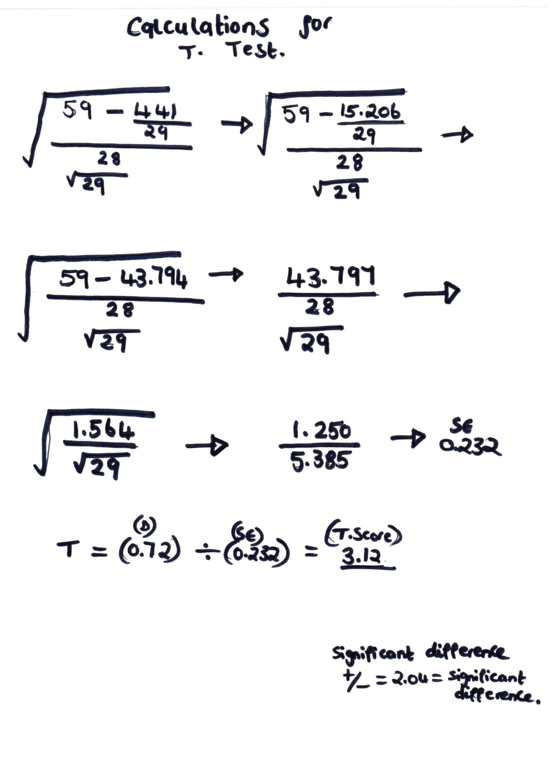
Appendix C – Calculations for T.Test.

