The Global Business Environment
Assignment 2
Student name: George Cristian Nitulescu
Student Id: 2123688
Module Name: The Global Business Environment

Table of Contents

Introduction 3
Impacts of Covid-19 on the global business environment 4
Changes in the Operations of Aston Martin Plc during COVID- 19 4
Sustainability of the Changes 6
Analysis of external environment 7
Competitive Analysis of Aston Martin Plc 8
Conclusion 10
References 11

Introduction
According to Morrison (2016), Global business is known as an international business which is a process of selling goods and services between different sovereign countries of the world. The global business environment is very significant for the global economy it helps to increase the global economy of the world and create for around the world. Global business contributes to developing infrastructure and bringing investment capital from other countries of the world. But Covid-19 pandemic negatively impacts the growth of global business it creates an unpredictable situation for the global business. In this module, we will discuss the impact of the Covid-19 pandemic on Aston Martin and changes in the operations of Aston Martin Plc during COVID- 19.

Impacts of Covid-19 on the global business environment
The infection disease Covid-19 was first identified in December 2019 in Wuhan, China which is caused by the SARS-CoV-2. These infection diseases create an unstable situation around the world and these diseases greatly impact the global business environment (Mofijur and others, 2021). Due to the Covid-19 pandemic, the international business industry faces an array of complexities and financial crises because to reduce infections almost all country's government cancelled their internal and external flights for this reason people cannot move anywhere and the result of cancelled transportation impacts on the global business industry. Due to cancelling the flight's business organisation cannot transit their products to other countries so that they face a great financial crisis. The automobile industry not only contributes to our economy but also creates huge job opportunities but this pandemic pushes global unemployment. Automobile industry related business organisations such as car manufacturing, raw material suppliers, and intermediate organisations related to global trade are cut off their manpower to overcome their losses so a huge number of people lost their job for this pandemic. In the UK about 6.7% of the gross value come from the global business organisation due to the Covid-19 pandemic this sector faces a great financial crisis. Due to the lockdown and restriction of internal and external flights international transition through flights fell by 6.8 million in February. A survey shows that greater London saw the largest fall in car demand during the first lockdown and in three months of June 2020 as compared to 2019 visitors fell by 21.5% and according to the Labour Force Survey (LFS), the Covid-19 pandemic has a great impact on the labour market about 12% people lost their job during this pandemic which has a great impact on the labour market (Saadat and others, 2020).

Changes in the Operations of Aston Martin Plc during COVID- 19
The global business industry is a vast economic sector that plays a vital role in the global economy directly and indirectly by including various economic activities (Griffiths and Stuart, 2011). Due to the Covid-19 pandemic, various global business organisations have to change their operational activities course plans, roles and regulations to sustain in the global marketplace. The change of operational management of Aston Martin is mentioned below:
Workforce reduction: During the covid-19 pandemic, Aston Martin has to face various challenges so they have to decide at various times. One of the major decisions that they take during a pandemic is reducing the workforce to decrease losses of the organisation. During the pandemic, Aston Martin decides to cut off their employers which is about 350 and take various steps to operate their business online. By reducing the workforce Aston Martin can be able to save £40 million during the pandemic. But their decision negatively impacts in labour market a huge number of labours lose their job and fall into an economic crisis.
Cut of expenditure: During the pandemic, international transition closed due to lockdown and the demand for cars is reducing day by day so Aston Martin decide to cut off intangible costs of production which help to reduce losses. The process of reducing intangible costs helps the company to save £25 million. The company also reduce marketing costs, travel cost, and advertising costs sustain in the market during a pandemic.
Change of leadership: During the pandemic, Aston Martin's revenue was reducing gradually and their business activities were reducing gradually in the global market so Aston Martin make a change in their managerial process because existing leadership failed to face challenges. New leadership help to reshape their roles and successfully equipped them to fulfil new roles during a pandemic. Change of leadership help to motivate the employees to work in new roles and increase their speed of work. Aston Martin change Tobias Moers and appointed Andy Palmer as the leader of their company during the pandemic situation.
Raising of funds: Covid-19 undetermined the global economy by reducing international trade activities. Due to Covid-19 most, the small business organisation rolled up their business because of the falling financial crisis (Li, 2022). To sustain this situation Aston Martin, rise their fund so that they can substitutive in the business. To raise their funds Aston Martin, raise their share, for example, they sell their 25% share to Lamborghini which helps to raise their funds about £400 million.
Relation with suppliers: Due to the Covid-19 pandemic the demand for Aston Martin cars is reducing gradually so they cut costs from expenditure to reduce the cost of the products. At the same time, Aston Martin has to face a financial crisis due to this pandemic so they have to keep the rest in their supplier who provides the company with raw materials. For this reason, they have to increase their relationship with the suppliers and they have to maintain regular communication with the supplier.

Sustainability of the Changes
Due to the cruel and strange characteristics of the Covid-19 pandemic, international business organisations have to face several problems and their business activities collapsed due to this pandemic. The various business organisation fails to cope with the situation so that they cannot sustain in the market and they have to roll up their business. Aston Martin is a large business organisation they have a large financial capability but during this pandemic, they have to face a financial crisis when their international transition closed due to lockdown. For this reason, Aston Martin's £4bn market share fell to £1.00bn which negatively impact the growth of the organisation. To overcome this situation Aston Martin, have to make various decisions to cope with the situation. Aston Martin makes a change in their workforce and their managerial system. They reduce the workforce from the various sector and increase their funds to subsidise various parts of the organisation. They also cut unexpected expenditures from various parts which help to reduce the cost of the production. They also make a change in their managerial operation they change the leadership process which helps the organisation effectively manage the human resource. They also conduct the organisation’s operational activities online to ensure employees' health safety. Aston Martin aligns their workplace during the Covid-19 pandemic according to the organisational purpose and strategy and they create a physical and virtual environment that reflects future workplace strategy. During the pandemic, Aston Martin designed the workplace in a customer-centric way which ensure proximity to the partners and customers. These aligning workforce and spatial utilization techniques help Aston Martin to face these pandemics and to survive in the global market environment. Due to the cutting of employees from the workforce, their productivity was comparatively reduced but they can still hold their brand image in this pandemic. Sustainability of these changes gives a positive output to the organisation and helps to operate their business effectively (Worthington and Britton, 2014).

Analysis of external environment
External business analysis is the process by which a business organisation can know the current latest trends which gives an idea about the current situation and several approaches that the organisation can use. The external business environment helps to analyse competitive advantage and help to understand threats that can affect the business organisation (Aziz and Yassin, 2010).
PESTLE analysis
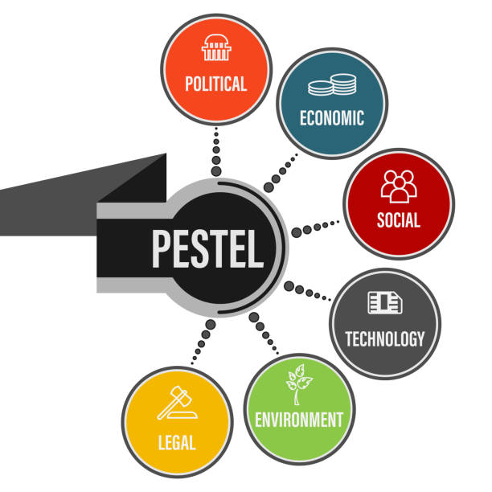
Figure: PESTLE analysis (Zalengera and others, 2014).
Political Factors: Governmental policies have a great influence on the business organisation they can hinder or foster the growth of the organisation. A stable political environment encourages the growth of the organisation and an unstable political environment decreases the growth of the organisation. An international business organisation needs to learn about its target market's political situation and policies so that it can effectively operate its business.
Economic Factors: Economic factors have a great influence on international business organisations so before operating their business in the global market Aston Martin needs to analyse its target market's economic condition. They also need to analyse the economic sustainability of that area and their trade level. Economic factors also include inflation rate, interest rate, foreign rate, economic growth pattern etc so Aston Martin needs to analyse these factors before entering the global market.
Social Factor: Social factors include demographics and cultural factors that can affect the growth of the business organisation. Social factors impact the industry environment of the unique social culture of the region. Before entering in global marketplace business organisations need to analyse buying periods, lifestyle choices, and purchasing habits of that region's people so that they can modify their business activities according to these.
Technological Factors: Technology directly or indirectly impact the growth of the organisation, for example, innovations in technology can affect the market. By implementing advanced technology business organisations can increase their productivity and can reduce their cost of production. Automation technology reduces the misery of the employees and organisations can produce a large number of products at a time with little labour. Technology increases the speed of business so Aston martin needs to be aware of technological development.
Legal & Environmental Factors: Legal and environmental factors affect both the internal and external environment of a business organisation. Legal factors refer to policies and procedures of the organisation which include employment laws, regulatory bodies, consumer protections, industry-specific regulations etc. Environmental factors include general environmental protection requirements which are very significant to operating a business effectively. A different business organisation has a different environmental requirement and Aston Martin needs to analyse these factors while operating a business globally.

Competitive Analysis of Aston Martin Plc
A global business market means the activity of buying or selling goods or services across the world and this marketplace is very competitive (Dobbs, 2014). For this reason, to sustain itself in this global environment Aston Martin need to compete with the competitors. The level of competition in the global business environment for Aston Martin is analysed below through Porter’s Five Forces model:
Porter Five Forces model
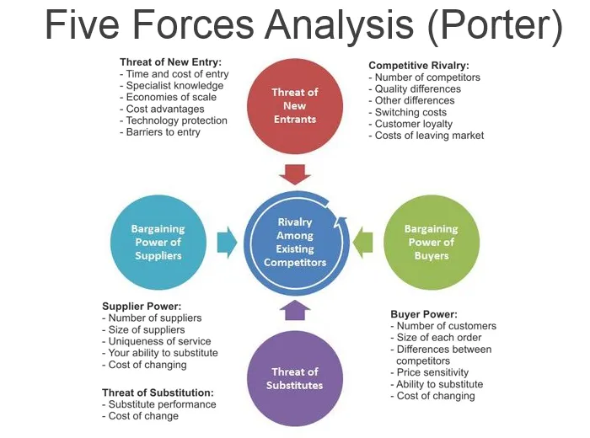
Figure: Porters Five Forces model (Indiatsy and others, 2014).
Competitive Rivalry: Competitions in the automobile industry is very high because various organisation implements various business strategy to capture the market. The most emerging competitors for Aston Martin are Ferrari, Lamborghini, Bentley Motors etc they implement various business strategies to capture the market. Lamborghini and Ferrari vying for the top position in the automobile industry and they continuously launching innovative products in the market with technological features. So, there is a threat for Aston Martin that consumers can switch their brand for this reason Aston Martin needs to focus on market research and need to launch innovative products to sustain itself in the market.
Buyer Power: The bargaining power of the buyer is strong so it is a great threat for Aston Martin because this trend can reduce the profitability of the organisation. Due to low switching costs, customers can easily shift Aston Martin to other brands and at the same time, various relatable organisations give substitutes for Aston Martin products for this reason consumers can avoid them.
Supplier Bargaining Power: The supplier bargaining power of Aston Martin is comparatively less and suppliers do not have much influence on Aston Martin because Aston Martin has a large variety of suppliers. Aston Martin follows a diversified policy of supply chain so that suppliers cannot influence the business for this reason Aston Martin need not prioritize the concerns or demands of suppliers.
Threats of Substitution: Aston Martin has a strong threat of substitution because Aston Martin collects their raw materials from various companies. Their cost of switching is less and many of these substitutes cost less than Ferrier or Lamborghini. For this reason, Aston Martin needs to invest in their company more to reduce the risk of disruption in the company.
Threats of New Entrants: Aston Martin is a strong automobile brand who are operating a business for a long period. They have a strong brand value in the market and a new brand cannot compete with the brand so there is no strong threat of new entrants but their major competitors Ferrari and Lamborghini vying to establish a dominant position in the market.

Conclusion
Globalization creates a common marketplace for the business organisation where a different business organisation can operate their business activities. But this global market is competitive and business organisations have to face different barriers while operating business in the global market. During covid-19 pandemic business organisations have to face various challenges and most business organisation rolled up their business. During this pandemic, Aston Martin lost their 50% share so to cope with this situation Aston Martin have to make a change in its workforce and managerial system which help the organisation sustain this pandemic.

References
Aziz, N.A. and Yassin, N.M., 2010. How will market orientation and external environment influence the performance among SMEs in the ago-food sector in Malaysia. International Business Research, 3(3), pp.154-164.
Dobbs, M.E., 2014. Guidelines for applying Porter's five forces framework: a set of industry analysis templates. Competitiveness review.
Griffiths, A., Stuart, W., (2011). Economics for Business and Management 3rd Edition, Prentice Hall
He, H. and Harris, L., 2020. The impact of Covid-19 pandemic on corporate social responsibility and marketing philosophy. Journal of business research, 116, pp.176-182.
Indiatsy, C.M., Mucheru, S.M., Mandere, E.N., Bichanga, J.M. and Gongera, E.G., 2014. The application of Porter’s five forces model on organization performance: A case of cooperative bank of Kenya Ltd.
Li, W., 2022, March. Research on the Effect of Change in Consumption under COVID-19. In 2022 7th International Conference on Financial Innovation and Economic Development (ICFIED 2022) (pp. 1056-1061). Atlantis Press.
Mofijur, M., Fattah, I.R., Alam, M.A., Islam, A.S., Ong, H.C., Rahman, S.A., Najafi, G., Ahmed, S.F., Uddin, M.A. and Mahlia, T.M.I., 2021. Impact of COVID-19 on the social, economic, environmental and energy domains: Lessons learnt from a global pandemic. Sustainable production and consumption, 26, pp.343-359.
Morrison, J (2016) The Global Business EnvironmentChallenges and Responsibilities, 4th Edition, Palgrave.
Saadat, S., Rawtani, D. and Hussain, C.M., 2020. Environmental perspective of COVID-19. Science of the Total environment, 728, p.138870.
Worthington, I., Britton, C., (2014). The Business Environment, 7thEdition, Pearson
Zalengera, C., Blanchard, R.E., Eames, P.C., Juma, A.M., Chitawo, M.L. and Gondwe, K.T., 2014. Overview of the Malawi energy situation and A PESTLE analysis for sustainable development of renewable energy. Renewable and Sustainable Energy Reviews, 38, pp.335-347.

