
Management Economics
Name student : Alexandra Alina Tinca
Student ID :2028610
Module name : Management Economics
Lecturer name : Taye Osadiya

Executive summary
The following report has shed light on describing the business of the respective company Procter & Gamble. Procter & Gamble is basically a multinational company in America which has headquarters in the UK, Ohio. Moving ahead, the market demand as well as the equilibrium has been analysed. It has discussed the price of many aspects such as substitutes, consumer income, complements and demographics. In addition to this, some graphs have been included in order to justify the analysation.

Table of Contents
Introduction 4
Overview of the business 5
Stating the product that has been chosen 5
Highlighting the reason for choosing the product 5
Identification of market equilibrium and demand 5
Stating the price of substitutes 5
Discussing the price of the complements 6
Stating and highlighting the income of the consumer 8
Gauging the detailed explanation of consumer preferences as well as tastes 9
Analysing the expectation of the consumer over the actual price 10
Gauging the detailed explanation of the demographic and number of consumers 10
Indicating the factor that has an impact on the elasticity of the price of demand 12
Describing the effect of substitution product over the elasticity of demand of a product 12
Indicating the impact of income on the elasticity of the demand for a item 12
Gauging the pricing policy that the business needs to employ 13
Conclusion 15
References 16

Introduction
The following report will shed light on the various aspect of economics. It will basically discuss the baby wipe product of the respective business Procter and Gamble. The overview of the business and the reason for choosing the specific product will also be discussed in this context. In addition to that, the identification of market equilibrium and demand for the product will be mentioned in this report. The price of substitutes and complements of the product will be illustrated in this context. This report will reflect the income of customers and the way it influences demand for the particular product of the respective business. Apart from that, consumer preferences and the way it influences demand for the product will be discussed in this context. This will also illustrate the expectations of the consumer regarding the price of the product and the way this factor influences the demand. Moreover, this particular report will also include the way the point of view of consumers indicates whether the product is more inelastic or more elastic. The recommendation regarding the pricing policy of the respective business will be elucidated in this report.

Overview of the business

Stating the product that has been chosen
Proctor and Gamble are an American Multinational customer goods corporation and the headquarter of the business are situated in Cincinnati. It was founded by William Procter and James Gamble in 1837. They basically provide personal health, consumer health and many hygienic products. The current CEO and president of the business are Jon Moeller. The respective company basically provide their products worldwide. Moreover, the product that has been chosen for this assessment is baby wipes and the overall project has been focused on this particular product. The overall revenue of the business is about US$76.12 billion. There are approximately 101,000 employees who work for them (PG, 2023).

Highlighting the reason for choosing the product
Now a day, baby wipes are one of the important aspects of daily life for maximum families for healthy skin of the baby. Baby wipes have improved continuously to fulfil transforming consumer requirements. The healthy skin of a baby has a natural balance of pH. Moreover, untidiness from dirty diapers can enhance the pH that creates the skin of the baby more susceptible that can lead to a rash. Regularly clearing the skin with baby wipes can reduce the irritants and assist to restore a healthy, natural pH balance. This is the main reason for choosing the particular product of the respective company Proctor and Gamble (Choi et al., 2020).

Identification of market equilibrium and demand

Stating the price of substitutes
Substitute of the product:
There are various substitutions of the particular product Baby Wipes and one of them is DYMACARE Wet Wipes. It is an atmosphere-friendly alternative and plant-based, making them natural and sustainable. It is basically free of harsh ingredients like paraben, fragrances and alcohol. It is basically suitable and versatile for penetrating the skin. In addition to that, old wash clothes are soft enough fibers for protecting the delicate bottom of the baby. The substitute of the product is basically less compared to the baby wipes. Moreover, the DYMACARE Wet Wipes have antibacterial properties so that one can utilise them to clean surfaces and decreases germs easily (geeksforgeeks, 2022).
Stating the way the price of substitute influence the demand for the specific product
Demand is basically considered to slope descending: the prices increases and customers buy less. Increased price basically results in low demand and the enhancement of the demand leads to enhance supply. In this particular aspect, the price of the substitute product is cheaper than the baby wipes. Therefore, the demand for baby wipes for the respective business is automatically reduced. They need to provide particular products to their consumer at a similar price to the substitute product. It can help them to increase the demand for their product (CFI Team, 2022).

Discussing the price of the complements
Discussing the complement for the product or services
The respective company Procter & Gamble is offering baby cleansers as a complementary product for their audiences. It is basically a cleansing cream that can be used by consumers after they use baby wipes. Hence, this cleansing cream helps perfectly moisturise and soften the skin. Moreover, Procter & Gamble is also using only organic raw materials which excludes chemicals as well as harsh ingredients (pg, 2023).
Analysing if the price of the complement product is increasing or decreasing
According to some sources, it has been identified that the price of the baby cleanser product of Procter & Gamble is around £ 5.6. However, the price of baby products decreased rapidly in the year 2020 due to the sudden rise of the pandemic situation. This has been shown in the below portion with the help of the graphical representation:
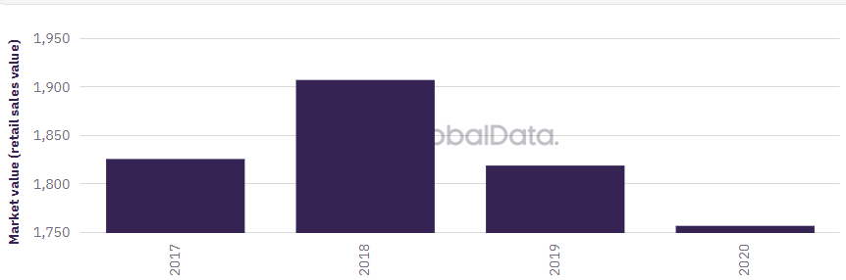
Source: (globaldata, 2023)
According to the above graph, it can be seen that in 2018 the market value of the baby cleanser has been rise most. However, during the following year, a rapid fall has been noticed for which the price of several baby products including baby cleansers was reduced. At that time due to rise of the inflation, the prices of the products have been enhanced immensely and it became hard for a large number of people in acquiring that particular product (globaldata, 2023).
Discussing the way, the price of complement influences the demand for the stated product
The demand for the baby wipes of Procter & Gamble has immensely increased after the hit of the pandemic as the stated company is also serving a complementary product of cleanser. Due to the pandemic people of has become more concerned about hygiene for which they are looking for the best product in the low range. This has enhanced the demand for baby wipes across the UK market (tradingeconomics, 2023).

Stating and highlighting the income of the consumer
Discussing if the income of the consumers is decreasing or increasing
The income of the household people or the consumers of the UK has been changed at a massive rate. As per some sources (tradingeconomics, 2023), it has been identified that the income of the UK people has been massively reduced at the time of 2022. The main reason for this rapid fall has been detected as an increasing rate of inflation.
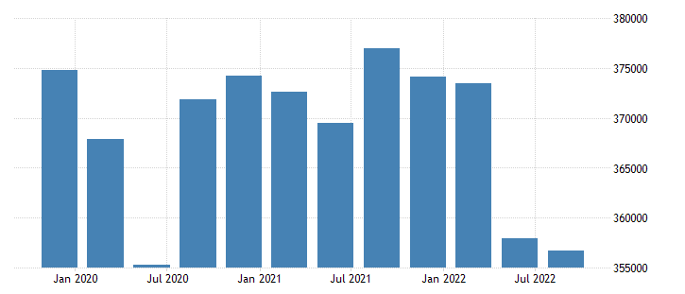
Source: (tradingeconomics, 2023)
The above graph is presenting that in 2020 the rate of consumer income has been falling under 355000. Moreover, after the years though the UK people have been able to develop their income. However, in 2022 it has again dropped below 360000.
Analysing the impact on the demand of the specific product as per change in the income of the customers
The profit of a business organisation is mainly depending on the sales of their product or services which totally relies on the consumers. Hence, as per the above analysation that has been declared in the above portion is indicating that due to the rapid fall in the income level of consumers, the level of demand for baby wipes has been reduced. The rise in inflation has forced the respective company Procter & Gamble to develop their actual prices of the products (pg, 2023).

Gauging the detailed explanation of consumer preferences as well as tastes
Discussing the change that can be seen in the tastes and preferences of the consumers
Recent global events such as the increasing rate of unemployment, inflation and pandemic have changed the choices and preferences about the product and services. Hence, Procter & Gamble has also experienced these changes in their customers for which they are trying to develop the quality of the product which is baby wipes (mckinsey, 2022).
Analysing the impact on the demand of the specific product as per change in the tastes and preferences of the consumers
The change in tastes along with preferences has the greatest ability in changing the activity of the business. In the present situation, people have become more focused along with concerned about the quality, quantity and price of the product which they choose to consume. Therefore, as a result, due to inflation consumers are recently seeking lower-range products with good quality. Hence, Procter & Gamble is offering lower prices of baby wipes for their customers.

Analysing the expectation of the consumer over the actual price
Discussing if the price of the specific product needs to be increased or decreased as per the expectation of the consumers
The stated company Procter & Gamble is offering a complementary product to their main product baby wipes. Therefore, for which the price of the product has been set as £ 5.6. However, considering the recent events that have taken place the expectation of the customers is to get lower prices (Baker, 2003).
Analysing the impact on the demand of the specific product as per the expectation of the consumer over price
The demand of the consumers may get hampered if the stated company do not meet their price level of expectation. However, Procter & Gamble is already offering their product at a cheaper rate in comparison to their customers (globaldata, 2023).

Gauging the detailed explanation of the demographic and number of consumers
Critically identifying if the actual number of consumers is increasing or decreasing and impacts the demand
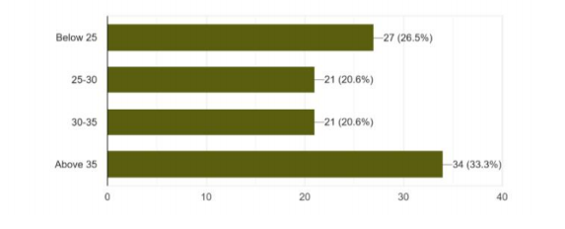
According to the above survey, it can be seen that the demand of the customers for the baby wipes of the respective company has been identified most for the age group of 35 years old. A total of 34 or 33.3 % of people of that particular age are more interested in purchasing the particular product. However, recent global and economic incidents have reduced the number of customers. Therefore, as a result, the demand for baby wipes among customers has been reduced (Bagwell, 2005).

Indicating the factor that has an impact on the elasticity of the price of demand

Describing the effect of substitution product over the elasticity of demand of a product
The meaning substitution effect generally considers the condition when the sale of a particular product is decreasing when the consumer purchases another substitute item at a cheap price. Due to this, the demand for the main item is reducing and the other close substitute demand is increasing continuously (Wu et al., 2020). For example, the baby wipe of Procter and Gamble suffered from the issue of declining demand due to the Presence of another substitute item at a cheap value.
Reflecting the necessity of the mentioned item and the characteristics of demand related to the factor of substitution effect
From the point of view of the consumer the mentioned item of Procter and Gamble is a necessary product for maintaining a hygienic lifestyle for children. It is considered a relevant item to maintain cleanliness in a family which have a small baby (Zubritskiy et al., 2019). The factors of substitution products for the baby wipe of Porter and Gamble are reflected that the demand for the product being more elastic over the period of time. This respective item has several close substitute products available in the market and this also has a high necessity in society.

Indicating the impact of income on the elasticity of the demand for a item
The term economics is indicated the continuous interchange of the demand that is created by the alteration in the level of consumer buying behaviour regarding the sum value of earnings over a period of time. This improvement in the entire income of an individual makes a prediction about the enhancement of the demand for a particular item. For example, the baby wipes of Procter and Gamble are a product and the higher management of the business is supposed to incline in the level of demand of this due to the improvement in the earnings (corporatefinanceinstitute, 2022).
Reflecting the usage of income portion for consuming the mentioned item and the characteristics of demand related to the factor of earning an effect
According to the discussion over the topic clearly, it can be understood that the baby wipe is a kind of item that is quite relevant to live a healthy lifestyle. The consumer of the marketplace uses a small percentage of the earnings to consume the product over a period of time (Gilroy et al., 2020). Due to the importance of this mentioned item, the certain interchange in the total volume of income cannot affect the demand for the item. This means the demand for the baby wipe product of Procter and Gamble is more inelastic as if the price increases the behaviors of the users also the same for the item also. Due to the nature of the necessity of the items the sudden decline in earning cannot affect the demand directly.

Gauging the pricing policy that the business needs to employ
The respective business company Proctor and Gamble need to follow a competitive bidding pricing policy for them (Perego, 2019). In competitive bidding, the higher administration undertakes and the public sector business requests tenders for possible suppliers by internet and newspaper. Along with this, they need to employ a research and development department by which they can able to know the price of their competitors. It can help them to know the price of the products of their competitors. On the basis of their price, the respective company can select the product prices that can help them to maintain sustainability in the market. After making the bases of prices, management can start improving their strategy of pricing goals, like enhancing long-term and short-term profits, enlarging cash flow and stabilizing prices. Moreover, the management of the business also needs to look after the current market situation while developing their pricing strategies to make sure that the rates they select fit the condition of the market (encyclopedia, 2023).

Conclusion
Managerial economics is basically defined as the stream of the study of management that highlights solving the problem of business by using the theories in macro and microeconomics. This report has been focused on a specific product of the respective business Proctor and Gamble. The particular product is baby wipes which the whole report has discussed. Moreover, the substitute of the product and the way it influences the demand for baby wipes has been reflected in this report. It has also highlighted the complement of the product and the way it influences the demand as well. The income of the consumer plays an effective role in the demand for the product that has been demonstrated in this particular context. It has also elucidated the way consumer changes are transforming. In addition to that, the demographic profile of the respective business for their particular product has been illustrated in this report. This report has elucidated whether their demand for the product is more inelastic or more elastic. The pricing policy that needs to be employed by the respective company has been reflected in this context.

References

Bagwell, K. (2005) The Economic Analysis of Advertising. Columbia University Discussion Papers No. : 0506-01
Baker, J. (2003) Competitive Price Discrimination: The Exercise of Market Power Without Anticompetitive Effects (Comment on Klein and Wiley). Articles in Law Reviews & Other Academic Journals. Paper 278.
CFI Team, (2022). Substitute Products. [Online] Available at: https://corporatefinanceinstitute.com/resources/economics/substitute-products/ [Accessed 1 January 2022].
Choi, T.M., Guo, S., Liu, N. and Shi, X., (2020). Optimal pricing in on-demand-service-platform-operations with hired agents and risk-sensitive customers in the blockchain era. European Journal of Operational Research, 284(3), pp.1031-1042.
corporatefinanceinstitute, (2022). Price Elasticity. [Online] Available at: https://corporatefinanceinstitute.com/resources/economics/price-elasticity/ [Accessed 2 January 2023].
encyclopedia, (2023). Pricing Policy and Strategy. [Online] Available at: https://www.encyclopedia.com/management/encyclopedias-almanacs-transcripts-and-maps/pricing-policy-and-strategy [Accessed 1 January 2023].
geeksforgeeks, (2022). Individual and Market Demand. [Online] Available at: https://www.geeksforgeeks.org/individual-and-market-demand/ [Accessed 1 January 2022].
Gilroy, S.P., Kaplan, B.A. and Reed, D.D., (2020). Interpretation (s) of elasticity in operant demand. Journal of the Experimental Analysis of Behavior, 114(1), pp.106-115.
globaldata, (2023). The Market value (retail sales value) of Baby Care Industry in United Kingdom (2017 - 2025, USD Millions). [Online] Available at: https://www.globaldata.com/data-insights/consumer/the-market-value-retail-sales-value-of-baby-care-industry-in-united-kingdom-208351/ [Accessed 3 January 2023].
mckinsey, (2022). How current events are shaping UK consumer behavior. [Online] Available at: https://www.mckinsey.com/capabilities/growth-marketing-and-sales/our-insights/survey-uk-consumer-sentiment-during-the-coronavirus-crisis [Accessed 3 January 2023].
Perego, V.M., (2019). Crop prices and the demand for titled land: Evidence from Uganda. Journal of Development Economics, 137, pp.93-109.
pg, (2023). BRANDS. [Online] Available at: https://in.pg.com/brands/?brand-search__input=cleanser# [Accessed 3 January 2023].
PG, (2023). Citizenship. [Online] Available at: https://us.pg.com/ [Accessed 1 January 2023].
tradingeconomics, (2023). United Kingdom Households Disposable Income. [Online] Available at: https://tradingeconomics.com/united-kingdom/disposable-personal-income [Accessed 2 January 2023].
Wu, M., Chen, J., Ma, Y., Yan, B., Pan, M., Peng, Q., Wang, W., Han, L., Liu, J. and Zeng, H., (2020). Ultra elastic, stretchable, self-healing conductive hydrogels with tunable optical properties for highly sensitive soft electronic sensors. Journal of Materials Chemistry A, 8(46), pp.24718-24733.
Zubritskiy, M.A., Ushakov, O.Y. and Sabitov, L.S., (2019), July. Performance-based seismic evaluation methods for the estimation of inelastic deformation demands. In IOP Conference Series: Materials Science and Engineering (Vol. 570, No. 1, p. 012108). IOP Publishing.

