Organizational culture Marin Karakolev ID 2029731
Definition of organizational culture Organizational culture determines how employees interact with each other and how they perform their tasks. The cultural matrix is composed of various values, beliefs, and symbols that guide employee behaviour, engagement, and performance. There are various levels of culture: National culture. It is about cultural dynamics and nationality models. Organizational culture: This culture applies to the cultural dynamics of an organization. Group culture: It deals with the diversity of different groups based on gender, ethnicity, generation, and religion. Functional culture: This culture deals with the effectiveness of work between different groups with different cultures. Team culture: This shows how different cultures should collaborate and work as a team. Individual culture: It expresses the basic elements of culture, both interpersonal and interpersonal.
With a strong corporate culture, employees have similar ethical values and beliefs and act in unison. The task of management is to align these beliefs and values with the company's goals to help build highly effective teams. The company staff knows what is expected of them, how their contribution will be evaluated, and what they can get as a bonus. Organizational culture affects the motivation and performance of the employee in different ways. When the employee feels that he is part of the company environment, he works harder to achieve company goals. The different cultures in the organization influence the performance of the workers. When recruiting, organizations should seek to attract employees who share similar values and beliefs as those of the corporate culture. This is a guarantee for easier assimilation of the new employee and strengthens the organizational culture.
Vodafone‘s organizational culture 
Companies around the world are striving to be more global and mobile. One of the few companies to take advantage of this is Vodafone, one of the leading international telecommunications companies. It is important to note in them how they creatively use the space to create a new work culture. Vodafone's management strives to create a workplace as an example of a mobile style of work, to use the power of common knowledge, to retain the best talents, attract new ones, and demonstrate the strength of Vodafone as a brand.
“We needed to make a big step forward in our work space to break out from tradi­tional offices to something fresh, new, even heretical,”
JENS SCHULTE BOCKUM CEO of Vodafone NL (Vodafone: Fostering a New Work Culture - Steelcase, 2022)
Vodafone has selected a large consulting company, Steelcase Applied Research & Consulting (ARC), to advise them on this major transition in work culture and help them find new alternative work strategies (AWS).
AWS uses mobility and knowledge to improve real estate and employee efficiency in parallel, but this leads to major organizational changes and the question arises: for what changes the organization is ready. Many organizations are not ready to change the essence of their organization. If an organization really wants to make big changes, it must follow some rules: management to be actively involved in the process, staff to be involved at all levels, a decision on the workplace taken before implementation, the transition to be managed effectively. The ARC team works with Vodafone's staff and management using its own methods of diagnosis and customer engagement to test whether the company is willing and ready for a change in technology, the work process, and human resources. An important part of the planning process was the assessment of staff contributions through seminars, interviews, and studies conducted by the ARC. ARC identifies in detail the company's culture, considered by each stakeholder in the organization, in order to determine the culture, they prefer and to identify gaps between the perceptions of staff and management. Vodafone's management and staff focused more on innovation and teamwork than on market-oriented culture. They emphasized: promoting communication and cooperation, experiencing the brand by highlighting Vodafone's products, creating a neighborhood atmosphere, offering social interaction, a healthy lifestyle, offering a "wow" factor.
Vodafone strives to be a trusted partner. To achieve this, people working for the company must be restless, work to make the lives of customers, colleagues, and communities better. To be open to new ideas and to offer solutions that will appeal to their customers. It all starts with the company's staff, no matter where they work at Vodafone, they are as a whole and create a workplace where everyone can be themselves. The commitment to inclusion is at every level from the top management to each colleague and is part of the culture of the company "Spirit of Vodafone".
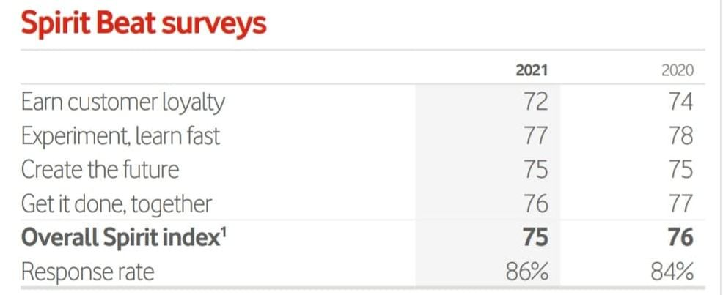
(Investors.vodafone.com. 2022)
“The Spirit of Vodafone outlines the beliefs we stand for and the key behaviors that help us to make our strategy and purpose reality. Our Spirit is our catalyst for change, underpinning the successful and sustainable delivery of our transformation.” (People and culture, 2022)

(People and culture, 2022)
Vodafone is known for its technology, but in fact, humanity is the factor that moves the company's business forward. During the global pandemic, many questions arose about the technology brand and outlined the leading role that the company should play. Here are some big questions for the company: Does she do enough to make sure no one is abandoned. Have you taken care to reduce your impact on the planet? Does he do his best to move society forward? The new position of the company- Together we can - is a reflection of Vodafone's vision that working together technology and humanity find solutions to create a better future for humanity.
Vodafone ‘s culture is inclusive for all. Creating a culture that includes people, values, and respects individual differences between them, will benefit customers, employees, business partners, shareholders, and the communities with which Vodafone works.
‘’Our new positioning – Together We Can – reflects our belief that, when working together, humanity and technology can find the answers and create a better future for all.’’ (Together we can, 2022)
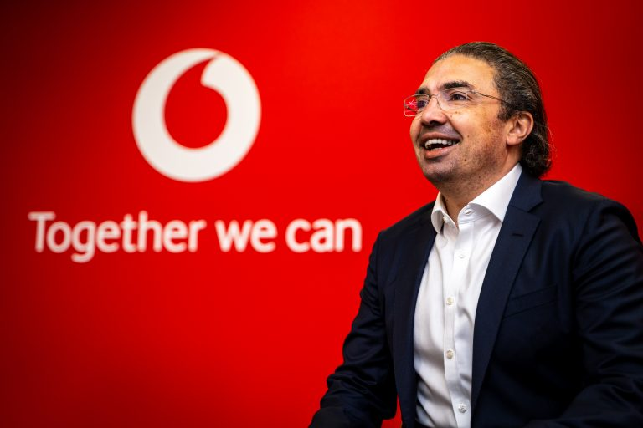
(Together we can, 2022)
They do not tolerate any kind of injustice and are for equal opportunities in employment and progress, regardless of gender, marital status, age, race, nationality, religion, and sexual orientation.
Vodafone encourages people from different backgrounds to apply for a job at the company. The company creates an inclusive and collaborative work culture, where the trust, speed, and simplicity of employees are a priority, and this leads to a better experience for our customers.

References
Investors.vodafone.com. 2022. [online] Available at: <https://investors.vodafone.com/sites/vodafone-ir/files/2021-05/vodafone-annual-report-2021.pdf> [Accessed 29 March 2022].
Steelcase. 2022. Vodafone: Fostering a New Work Culture - Steelcase. [online] Available at: <https://www.steelcase.com/eu-en/research/articles/topics/employee-engagement/hallo-amsterdam/> [Accessed 14 March 2022].

Vodafone.com. 2022. People and culture. [online] Available at: <https://www.vodafone.com/about-vodafone/who-we-are/people-and-culture> [Accessed 15 March 2022].

Vodafone.com. 2022. Together we can. [online] Available at: <https://www.vodafone.com/about-vodafone/who-we-are/together-we-can> [Accessed 15 March 2022].

: Pallavi Pahuja (2017), “WORK CULTURE MARKETING – A CASE OF VODAFONE LTD. BEHIND EVERY SUCCESSFUL COMPANY, THERE IS A SATISFIED EMPLOYEE-THE VODAFONE WAY”, International Journal of Marketing & Financial Management, ISSN: 2348 –3954 (online) ISSN: 2349 –2546 (print), Volume 5,(Issue7, Jul-2017), pp 72-79, DOI URL:

Businessballs.com. 2022. Organisational Culture and Employee Performance. [online] Available at: <https://www.businessballs.com/organisational-culture/organisational-culture-and-employee-performance/> [Accessed 16 March 2022].

