Theme 2

Sustainability in Terms of Food Waste and its Efficacy in the Hotel and Hospitality Sector

Lecturer Name: Chris Wilkin
Module Code: BMIH6001
Student Name: Zakaria Chowdhury
Student Number: 2222623
Word Count: 2500

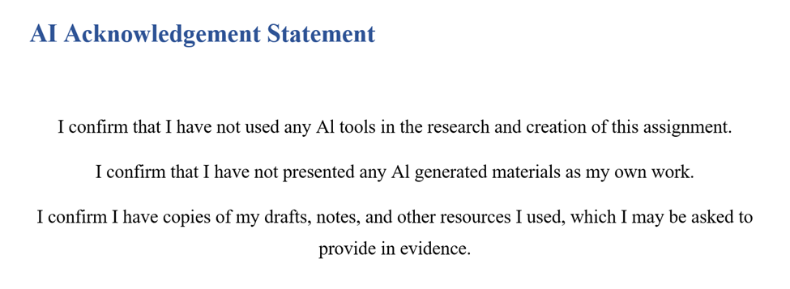
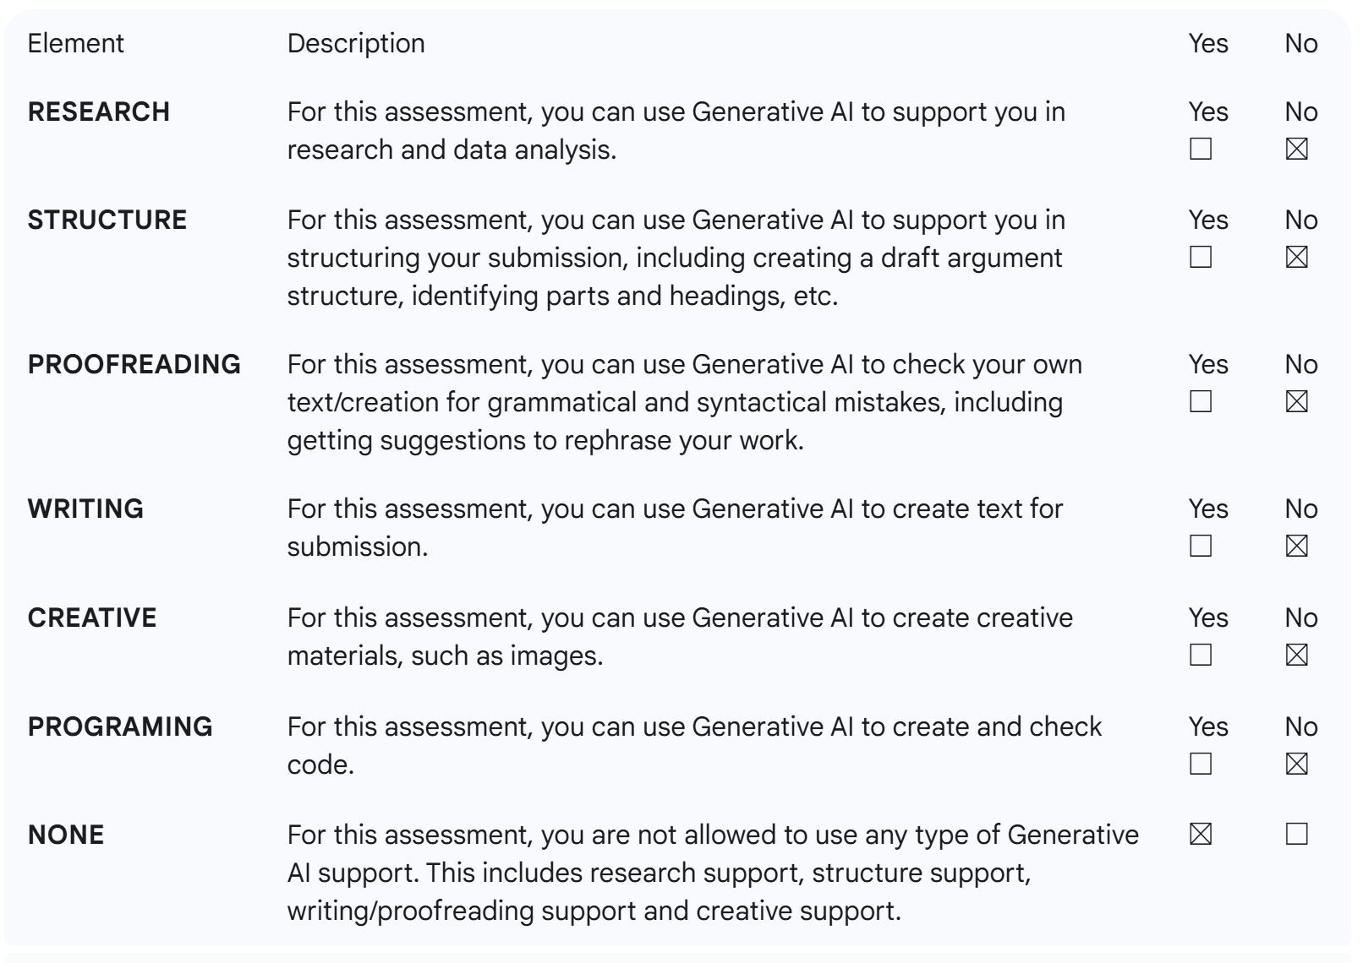

Abstract
Food waste has become one of the sustainability challenges that has continued to worry the hospitality industry in the world. As the industry pursues meeting international sustainability targets, minimisation of food waste is critical towards attaining environmental responsibility, operational efficiency, as well as social accountability. The hotel industry constitutes the largest part of food waste in the world (approximately 12 per cent), which is mainly attributed to buffet overproduction, poor forecasting, and staff training (UNEP, 2024). This paper discusses ways in which hotels can better deal with food waste by implementing technological, operational, and social interventions to fight the challenge. Based on the Triple Bottom Line (TBL) system, the study examines the relationship between the economic, environmental, and social aspects of sustainability in food waste. The experience of the International hotel chains like Hilton and Marriott presents empirical evidence in the way that data-driven innovation, staff engagement, and intersectoral collaboration can make significant cuts. In the analysis, it incorporates the PEAS (Problem, Evidence, Analysis, Solution) model in order to critically assess the effectiveness and importance of various waste-reduction measures. Results indicate the game-changer nature of artificial intelligence (AI) and partnerships in the local redistribution as well as portion control as scalable channels on the way to sustainability in the hospitality sector.

Contents
Abstract 2
1. Introduction 4
Literature Review 4
2.1 Food Waste Challenges in Hotels 4
2.2 The Triple Bottom Line (TBL) Framework in Food Waste Management 4
2.3 Technological Interventions: AI and Data Analytics and Smart Systems 5
2.4 Dimensions of Organisational and Behaviour 6
2.5 Research Gap and Summary 6
3. Method 6
4. Theme Impact Analysis (PEAS) 7
4.1 Problem 7
4.2 Evidence 7
4.3 Analysis 8
4.4 Solution 9
5. Conclusion 9
6. Recommendations 10
Reference List 12

1. Introduction
Food waste is one of the most immediate issues of concern in the context of the whole environment (Mill, 2012). According to the estimations of the United Nations Environment Programme (UNEP), it is estimated that the hospitality industry produces about 12 per cent of all food waste globally, which is a significant source of the global greenhouse effect and the loss of global resources (UNEP, 2024). Within the hotel setting, buffet overproduction, incorrect predictions of demand, exaggerated portions, and poor employee training are commonly linked to food waste (Okumus et al., 2020; Robson, 2016). These operational inefficiencies not only lead to the loss of economies but are also against the promises of the sector to be net-zero carbon emitting and are in line with practising sustainable tourism (Costa and Costa, 2022; Santos and Silva, 2019). In the case of hotels, management of food waste has become a sustainability requirement as well as a strategic compulsion (Sharma, Singh and Tyagi, 2024; Wahab and Cooper, 2005). This study is aimed at investigating the role of food waste minimisation as a force behind the hotel industry's sustainability.

Literature Review

2.1 Food Waste Challenges in Hotels
Gustavsson et al. (2011) found food waste to be a system failure in the supply and consumption chain, whereas Quested et al. (2013) found it remarkable how difficult it is to quantify in service-based businesses such as hotels. The perishable nature of the inventory held by the hospitality sector, the vagaries of demand, and the demands of a service further increase the situation. Research has shown that the hotel buffets themselves are capable of causing up to 50 per cent of the overall food waste, mainly because of excessive production and aesthetic presentation norms (Okumus et al., 2020). Recent research points to the poly-dimensionality of the issue. Food waste swells procurement and disposal expenses, pulling down profit margins, economically (Costa and Costa, 2022). It pollutes the environment by causing methane and wasting water, and socially, the ridiculousness between plenty and famine is represented (UNEP, 2024).

2.2 The Triple Bottom Line (TBL) Framework in Food Waste Management
Elkington's (1997) theory TBL gives an ordered method of evaluating the sustainability performance with three mutually linked pillars, which are economic, environmental, and social performance. The TBL model is applied in the hospitality business to assess financial, ethical, and ecological duties of the hotels as well (Costa and Costa, 2022).
In terms of economics, the waste of food will decrease the cost directly. Research, including Waaje et al. (2024), has concluded that the use of waste measuring systems can help hotels cut their procurement expenses by up to 15% of the money. In like manner, Sigala (2025) showed that waste-monitoring innovations such as Winnow and Leanpath were shown to assist large hotel chains in saving more than 25 per cent of the waste, saving them considerable amounts.
With regard to the environment, food waste reduces carbon footprint and landfill reliance. The UNEP (2024) stated that the food loss issue in the world results in a GHG emission that is 8-10 per cent of the total. Composting, redistributing or anaerobic digesting the waste streams of the hotels decreases their environmental load and improves their ESG ratings (Antwi, 2025). From a social perspective, food redistribution programs are of community good. As an example, Marriott International partners with the local food banks to give excess food, which can be considered as the direct social payoff of the sustainability investment (Marriott, 2024).

2.3 Technological Interventions: AI and Data Analytics, and Smart Systems
Hospitality Waste management has been transformed by technology. It has introduced AI-based solutions like Winnow, Leanpath, and KITRO that have become the key solutions (Oluwafunmise and Olajide, 2024). The services will operate based on machine learning and image recognition, enabling tracking and analysis of the food discarded in order to detect trends in overproduction and consumption (Clark et al., 2025). Transformed data can help a hotel to maximise procurement, portion sizes, and menu planning. As an illustration, Hilton Worldwide introduced the LightStay platform, which introduced the concept of waste monitoring using AI to its sustainability management system. The program called Green Breakfast produced 62 per cent of food waste reduction among pilot hotels (Hilton, 2024).
Nevertheless, technology and organisational obstacles are also mentioned as threats in the literature. Small hotels are not always able to invest in larger capital and technical background to change to more advanced systems (Clark et al., 2025). The resistance of the staff, inconsistency of data entries, and problems of integration with the old systems may decrease the effectiveness of AI platforms (Sigala, 2025).

2.4 Dimensions of Organisational and Behaviour
In addition to the aspect of technology, it is the human factors that determine whether food waste will be minimised. It has been found that effective implementation is impossible without staff training and awareness (Appel, 2025). The behaviour of the employees is in sync with the objectives of sustainability when they know the cost and environmental impacts of waste. In one instance, Waaje et al. (2024) recorded that waste had gone down by 20 per cent following targeted staff engagement programs in a case study hotel. At the organisational level, there is a need to have the commitment of top management. According to Clegg, Skyttermoen, and Vaagaasar (2021), sustainability should be integrated with the value creation approach in a hospitality business and not as a binding obligation. Generating sustainability metrics into the employee KPIs further enhances accountability and the long-term behavioural change (Costa and Costa, 2022).

2.5 Research Gap and Summary
Although the available body of evidence has strong arguments on the environmental and financial gains of food waste reduction, there are two large gaps. To begin with, most studies have placed more emphasis on environmental metrics at the expense of the social aspect of redistribution and the effect on the community. Second, there is no representation of smaller independent operators in most of the interventions (Clark et al., 2025). Thus, the investigations are valuable in the sense that they can use a model such as the PEAS model to evaluate the effectiveness of food waste management models comprehensively. The results would be used to suggest scalable, inclusive and economically viable models that can be applied in different hotel environments.

3. Method
This research is secondary in nature. The main sources of data are peer-reviewed journal articles, authoritative reports (FAO; UNEP), corporate sustainability reports (Hilton LightStay; Marriott press releases), and a whitepaper by a vendor/technology provider (Winnow, Leanpath, KITRO). The selection criteria were recent empirical research and proven industry cases that directly related to interventions of the hotel food waste. The analytical procedures will involve (1) qualitative evidence summarised thematically to determine recurring drivers, interventions and outcomes; (2) Triple Bottom Line (TBL) and (3) PEAS framework (Problem, Evidence, Analysis, Solution) used to put structure on the theme impact analysis (3). All the sources are cross-checked in order to ensure the validity of data, and at the same time, a mix of academic and organisational sources is used to make it scholarly and practical in nature.

4. Theme Impact Analysis (PEAS)

4.1 Problem
Hotel food waste is a complex operations issue because it mainly occurs due to excess production, poor forecasting of demand, poor portioning and inefficient redistribution. Over-preparation is often encouraged by buffet-style meal formats, combined with low expectations of their guests, and the inability of centralised procurement systems and lack of data in the kitchen to predict demand means significant amounts of food go to waste (Okumus et al., 2020). Smaller and independent hotels do not have organised systems to redistribute excess food and which increases environmental and social expenditures. The economic aspects of such inefficiencies are very high, and they include the wastage of procurement, handling costs, and disposal costs. The disposal of food also leads to greenhouse gas emissions, for example, methane in landfills, as well as socially, the unallocated surplus is the lack of an opportunity to reduce the food insecurity of the area (Gustavsson et al., 2011; Antwi, 2025).

4.2 Evidence
The sources of information on food waste in hotels emphasise the scale and causes of food waste in the hotel industry. According to UNEP (2024), the hospitality industry is a significant source of food waste across the world, and buffet service and the back-of-house activities are losing their weight disproportionately (Waaje et al., 2024). Interventions which are based on technology have proven to have quantifiable effects. Optimising the functioning of the kitchen follows AI-based monitoring systems like Winnow, Leanpath, and KITRO have helped hotels monitor the discards of the kitchen in real-time to develop data useful in procurement, menu planning, and staff training (Nu, Belavina and Girotra, 2024). Peer-reviewed papers cite that with full application plus staff participation, such systems can save 20-35 per cent in food industry waste, with specific pilots showing wastage of over 60 per cent (Clark, 2025; Sigala, 2025; Hilton, 2024).
Another example of possible benefits is social and circular interventions. Food banks and charities collaborate with such chains as Marriott to sell excess meals, which, in turn, means turning operational efficiency into a practical social contribution, but the effectiveness of such steps is limited because of logistical issues, regulatory obligations and food safety demands (Marriott, 2024). Composting and anaerobic digestion have a complementary capacity to support the environment and mitigate emissions of gases such as methane and salvage nutrients, although they demand capital investments and continual operations (Antwi, 2025).

4.3 Analysis
The literature and industry practice lead to four broad intervention strategies, all of which are measured on the Triple Bottom Line framework. First, AI monitoring and employee training have high economic and environmental benefits, such as less overproduction and more resource-efficient production, and indirectly, a social impact through redistribution (clinched when logistic regimes permit) (Clark et al., 2025). The strategy, however, entails the initial cost of technology, integration difficulties, the necessity of personnel adoption, and therefore, scaling amongst smaller hotels becomes complicated (Nu, Belavina and Girotra, 2024). Second, intelligent inventory control and AI-based demand forecasting maximise the procurement, minimise spoilages and minimise embodied emissions. Although efficient with respect to the environment and economy, the social impact is lesser, and the implementation can only be successful when systems are integrated and the supplier collaborates (Costa and Costa, 2022). Third, low-tech interventions like portion control, buffet redesign, and behavioural nudge are priced strategies that can be applied in small operation facilities (Chang, Lin and Hsiao, 2022). These actions yield mediocre returns and benefits on economic, environmental, and social aspects, depending on the regular participation of staff and adherence of guests (Sigala, 2025). Lastly, redistribution alliances and non-toxic production (such as compost and anaerobic digestion) generate the most social and moderate benefits to the environment, but logistics, policies, and operational complexities prevent their use in remote or resource-constrained locations (Marriott, 2024).
An integration of these analyses has shown that a combination of technology, behavioural and redistribution measures to produce hybrid policies has the most balanced TBL. In the case of large hotel chains, an emphasis on AI-enhanced surveillance coupled with procurement analytics and redistribution relationships offers a good economic and environmental-level performance and, nevertheless, the ability to impact the social space measurably. In case of smaller properties, also less prohibitive solutions such as portion control and behavioural nudges, with the help of manual tracking and redistribution in the area, can provide viable ways of sustainable food management (Nu, Belavina and Girotra, 2024).

4.4 Solution
The proposed solution is a levelled, hybrid solution based on the size and resources of the hotel. The implementation of AI tracking systems associated with procurement and menu planning, as well as sustaining redistribution relations, should be implemented by large chains to provide social benefits. Implementation and evaluation should be guided by clear KPIs, including the number of kilograms of waste/guest-night and savings of procurement costs (Quested et al., 2013). Smaller hotels are to concentrate on low-cost changes of operation, and they are: portion control, buffet redesign, and dirt monitors led by staff and even local redistribution where possible (Pirani and Arafat, 2016). In any environment, it is necessary to embed food waste KPIs into the corporate performance management, motivate employees, and unify reporting systems to achieve a similar impact and allow benchmarking across different properties (Pirani and Arafat, 2016).
This balanced approach to strategies combines technological solutions with high capital intensities to scale cost-effective behavioural and social interventions to facilitate scalability of this strategy among various types of hotels (Zhu and Liu, 2024). Among the limitations are regulatory barriers to the redistribution, the first and initial investment to use AI solutions, and the necessity to maintain staff training and engagement to maintain behavioural change.

5. Conclusion
To reduce food waste in hotels is a complex issue, which has serious economic, environmental and social consequences and, therefore, in order to solve it, it is necessary to use an all-encompassing and evidence-based strategy. It has been supported by research and industry evidence that AI-based food waste and procurement tracking systems provide the greatest benefits of food waste reduction and the related decrease in procurement cost and food waste, even in large, resource-intensive hotels (Clark et al., 2025; Hilton, 2024). In the case of smaller and independent hotels, operational solutions, including portion control, buffet redesign, and behavioural nudges, provide viable cost-minimising avenues to the minimisation of waste and operational efficiency, in addition to encouraging staff engagement (Sigala, 2025). The redistribution and composting interventions also improve the social and environmental aspects of sustainability by transforming the overproduction food to community gains, and the biodegradation of landfill emissions (Marriott, 2024).

6. Recommendations
Judging by the evidence and analysis made, a tiered implementation strategy is advisable to maximise food waste management in the hotel and hospitality industry. In the case of large chains, the implementation of AI-based waste-management software like Winnow, Leanpath, or KITRO ought to be tested in sample properties over six to twelve months (Clark et al., 2025). These systems, to make sure that actionable insights are created, should be built on procurement, menu planning, and inventory management processes, and the outcomes should guide the portfolio-wide rollout and the development of business cases (Clark et al., 2025; Hilton, 2024). In conjunction with the implementation of technology, there is a need to have a structured staff training program to help change the analytics into actual interventions in the kitchen (Zhu and Liu, 2024). Accountability can be enhanced through the appointment of waste champions at every single property. The incidence of food waste Key Performance Indicators (KPIs) in performance appraisals can support behavioural change (Appel, 2025).
In the case of smaller or stand-alone hotels, cheap operational control measures will provide viable options. Portion control, buffet remodelling, live cooking stations and hand-weighed backs result in immediate food waste reduction with little capital investment as well as creating a culture of sustainability among employees and guests (Sigala, 2025). Unless otherwise, redistribution on a local basis with food banks, charities, or municipal composting services should be introduced in order to make sure that excess food produces social and ecological value (Marriott, 2024). In areas where redistribution is not an option, on-site or local composting and anaerobic digestion provide them with a round-trip solution that would decrease landfill methane emissions.
Measures and report standardisation are essential in evaluating the effectiveness of interventions at different properties. Measurements based on food waste per guest-night in kilograms, procurement expenses reduction and food donation should be regularly monitored as well as reported annually to both internal and external stakeholders to ensure transparency and accountability (Quested et al., 2013). It should also focus on procurement and supplier coordination, which makes it possible to manage dynamic purchasing and change of orders daily based on the real-time data and thus lessening overstocking and spoilage (Costa and Costa, 2022).
Lastly, institutionalisation of continuous improvement ought to be done by partnerships with academic institutions, industry associations and technology providers in order to appraise interventions, track long-term outcomes and scale best practices (Cejas, 2025). A combination of technology-based monitoring, operational change guided by human values, and strategic alliances can help hotels of any size significantly cut food waste, promote sustainability, create substantive social engagement, as part of an even greater environmental purpose and competitiveness of the hospitality industry (Cejas, 2025).

Reference List
Antwi, C. O. (2025). Enhancing the sustainability of food waste management in emerging economies. International Journal of Hospitality Management.
Cejas, R. (2025). Food Waste Reduction AI Technologies in Restaurant Management: An MS-TORO Approach. Processes, 13(8), pp.2419–2419. doi:https://doi.org/10.3390/pr13082419.
Chang, Y.Y.-C., Lin, J.-H. and Hsiao, C.-H. (2022). Examining effective means to reduce food waste behaviour in buffet restaurants. International Journal of Gastronomy and Food Science, 29(08), p.100554. doi:https://doi.org/10.1016/j.ijgfs.2022.100554.
Clark, Q. M., et al. (2025). Exploring the potential of AI-driven food waste management: lessons from hotels. Frontiers in Artificial Intelligence.
Clegg, S. R., Skyttermoen, T., and Vaagaasar, A. L. (2021). Project Management: A Value Creation Approach. SAGE.
Costa, V., and Costa, C. (Eds.). (2022). Sustainability and Competitiveness in the Hospitality Industry. Business Science Reference.
Dawson, J., Lemelin, H., and Stewart, E. (2012). Last Chance Tourism: Adapting Tourism Opportunities in a Changing World. Routledge.
Elkington, J. (1997). Accounting for the Triple Bottom Line. Measuring Business Excellence, [online] 2(3), pp.1–6. Available at: https://www.johnelkington.com/archive/TBL-elkington-chapter.pdf.
Gustavsson, J., Cederberg, C., and Sonesson, U. (2011). Global food losses and food waste – extent, causes and prevention (FAO). FAO.
Hilton. (2024). Travel with Purpose — LightStay and Food Waste initiatives. Hilton Corporate Sustainability. Available at: https://travelwithpurpose.hilton.com/wp-content/uploads/sites/4/2025/06/2024Report.pdf [Accessed: 23rd October 2025]
Marriott International. (2024). Sustainability initiatives and food donation partnerships. Marriott Press Releases. Available at: (https://serve360.marriott.com/) [Accessed: 23rd October 2025]
Mill, R. (2012) Resorts Management and Operations. 3rd edn. London: Wiley.
Nu, Y., Belavina, E. and Girotra, K. (2024). Using Artificial Intelligence To Reduce Food Waste. Social Science Research Network, 1(4). doi:https://doi.org/10.2139/ssrn.4826777.
Okumus, B., Taheri, B., Giritlioglu, I. and Gannon, M.J. (2020). Tackling food waste in all-inclusive resort hotels. International Journal of Hospitality Management, 88(1), p.102543. doi:https://doi.org/10.1016/j.ijhm.2020.102543.
Oluwafunmise, F. and Olajide, H.E. (2024). Addressing Food Waste through Innovative Industrial Management and Technological Solutions. SSRN, [online] 1(4). doi:https://doi.org/10.2139/ssrn.4980497.
Pirani, S.I. and Arafat, H.A. (2016). Reduction of food waste generation in the hospitality industry. Journal of Cleaner Production, 132(17), pp.129–145. doi:https://doi.org/10.1016/j.jclepro.2015.07.146.
Quested, T.E., Marsh, E., Stunell, D. and Parry, A.D. (2013). Spaghetti soup: The complex world of food waste behaviours. Resources, Conservation and Recycling, 79(79), pp.43–51. doi:https://doi.org/10.1016/j.resconrec.2013.04.011.
Robson, C. (2016) Real World Research. Chichester: Wiley.
Santos, J.D. and Silva, Ó.L. (2019) Digital Marketing Strategies for Tourism, Hospitality, and Airline Industries. 1st edn. Hershey: IGI Global.
Sharma, M., Singh, A. K., and Tyagi, P. (2024). Proceedings of the International Conference on Innovation and Regenerative Trends in Tourism and Hospitality Industry (IRTTHI 2024). Atlantis Press.
Sigala, E. G. (2025). Reducing food waste in the HORECA sector using AI: an evaluation study. Journal of Cleaner Production.
UN Environment Programme (UNEP). (2024). World squanders over 1 billion meals a day — press release/report summary. UNEP. Available at: (https://www.unep.org/news-and-stories/press-release/world-squanders-over-1-billion-meals-day-un-report) [Accessed: 10th October 2025]
Waaje, A., Karim, R., Roshid, Md.M. and Meem, T.N. (2024). Minimizing Waste in the Hospitality Industry. Advances in hospitality, tourism and the services industry (AHTSI) book series, [online] 11(4), pp.125–166. doi:https://doi.org/10.4018/979-8-3693-6110-8.ch006.
Wahab, S. and Cooper, C. (2005) Tourism in the Age of Globalisation. Abingdon: Routledge.
Zhu, Q. (Jacqueline) and Liu, P. (2024). Exploring factors influencing consumer behavior towards food waste reduction in buffet style restaurants. British Food Journal, 2(3). doi:https://doi.org/10.1108/bfj-06-2024-0592.

