

LOCATION: Swansea | LLEOLIAD: abertawe
LEVEL 6 | LEFEL 6
EXAMINATION PERIOD | CYFNOD ARHOLIADAU
Mock 1 | Mock 1
MODULE CODE: ACCA6023
Enterprise Networking, Security and Automation

Student Name: _______________________________

STUDENT ID: _________________________________

TIME: 2 HOURS (you might need to research and make your own notes)
answer all questions

This is an individual practical lab-test, held under examination conditions. You will be assigned three Routers, TWO Switches and Two PCS. configure these devices based on the following specifications. (since it’s a mock you can do in pairs and share notes and ideas)
The routerS ARE R1,r2 and R3. the switchES are s1 and S2. and the PCs are PC1, PC2.

NB : Before the exam
Erase all devices and reload
Up on completion, -Check instructions on the last page.
Any issues with devices will be given extra time. But if anything, you introduced no extra time. Troubleshooting is part of the assessment.
Task 1: Network Configuration (85 Marks)

Topology

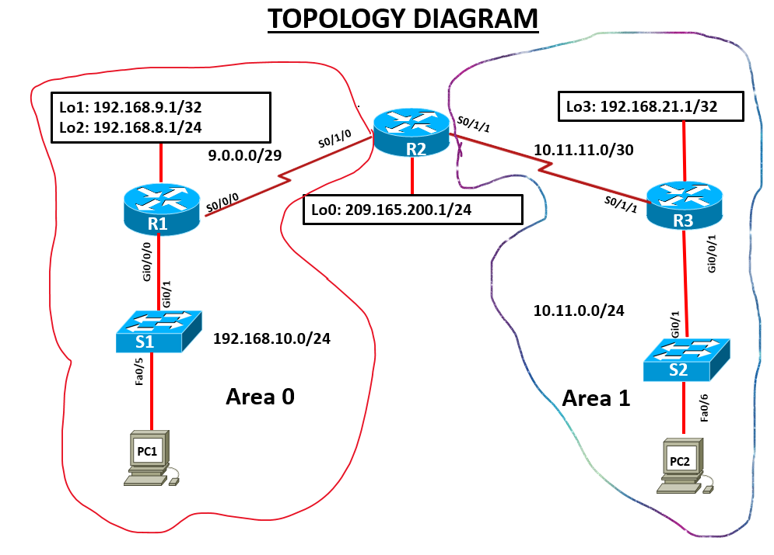

Addressing Table

Device | Interface | IP Address | Subnet Mask | Default Gateway
R1 | G0/0/0 |  |  | N/A
R1 | Se0/0/0 |  |  | N/A
 | Lo1 (Web Server) |  |  | N/A
R1 | Lo2 (LAN) |  |  | N/A
R2 | Se0/1/0 |  |  | N/A
R2 | Se0/1/1 |  |  | N/A
R2 | Lo0 (Internet) |  |  | N/A
R3 | Se0/1/1 |  |  | N/A
R3 | Gig 0/0/1 |  |  | N/A
R3 | L03 |  |  | N/A
S1 | VLAN 1
S2 | VLAN 1
PC1 | NIC
PC2 | NIC

Step 1
- Please complete above table with valid IP addresses and default gateway addresses ( 12 marks)
- Physically cable the network as shown in the topology diagram. (4 marks)

Examiner Comments and Signature:
Signature:

Configure the routers. ( 25 marks)
Configuration tasks for R1,R2 and R3 include the following:
It is essential that you complete a 'show ip interfaces brief' on the routers before you commence. Some will have Gi0/0 & Gi0/1 interfaces, while others will have Gi0/0/0 & Gi0/0/1, depending on the model used in each Cisco Academy. Interfaces for switches might also differ depending on the model.

- Disable DNS lookup, configure all routers with hostname R1,R2,or R3 as appropriate.
- Configure IP addresses according to the Addressing Table, setting appropriate Descriptions on the Interfaces and make sure the interfaces are activated
- Configure Multi-area OSPF with Process ID 20 on all routers, and Areas 0 and 1 as shown on the topology. Use Router IDs 1.1.1.1, 2.2.2.2 and 3.3.3.3 for R1,R2 and R3 respectively. NB : R2 Lo0 network should be included in the OSPF process although is not the norm
- Set LAN and Loopback interfaces to Passive
- On R1 and R2 only , set VTY lines to accept SSH connections only
1. Configure the username Admin with an encrypted password of Cisco123
2.The routers domain name should be set to ensajan.com
3. The key modulus should be 2048 bits use SSH version 2

Configure S1 and S2. ( 4 marks)
Configuration tasks for the switches include the following:

- Disable DNS lookup, configure all Switches with hostname S1 or S2 as appropriate.
- Configure IP addresses according to the Addressing Table, setting appropriate Descriptions on the Interfaces , make sure the interfaces are activated

Configure host computers and Test for Connectivity(5 marks)
Configure the host computers PC1 and PC2 with IPv4 addresses from the addressing table
Description | PC1 | PC2
IP Address | Fill in | Fill in
Subnet Mask | Fill in | Fill in
Default Gateway | Fill in | Fill in

Before performing connectivity tests, enable the HTTPS functionality on R2 by entering the following command:
R2(config)# ip http secure-server
After configuring each host computer, perform the following tests;
Source | Target | Protocol | Expected Result
PC1 | R1 (Lo1) | Ping | Success
PC1 | R2(S0/1/1) | ping | Success
PC2 | PC1 | ping | Success
PC1 | http://209.165.200.1 | https | Success

Examiner Comments and Signature:
Signature:

Optimize Multi-Area OSPFv2 (5 marks)
- Configure Lo3 on R3 as a point-to-point network for OSPF
- On all the Routers ,configure the hello time for 30 seconds
- Configure a static default route with Lo0 on R2 as the exit interface, then share the default information with R1 and R2.

Configure Access Control List (10 marks)
Create and apply access control list(s) of your choice to do the following:

- Controlling HTTP and HTTPS traffic by allowing only traffic for the network 192.168.10.0/24 on R1 to access R2
- Never allowing SSH traffic to the IP address 209.165.200.1
- Allow SSH traffic to the IP address of R2(S0/1/1) from PC1 only
- All other traffic, regardless of protocol, should be allowed to move freely
After configuring and applying the ACL, perform the following tests:
Source | Target | Protocol | Expected Result
PC1 | PC2 | Ping | Success
PC1 | https://209.165.200.1 | HTTPS | Success
PC2 | http://209.165.200.1 | HTTP | Failure
PC1 | R2 (S0/1/1) | SSH | Success
PC2 | R2 (S0/1/1) | SSH | Failure
If you get different results, double check your ACL configuration and application.
Examiner Comments and Signature:
Note: Ask the invigilator to check and sign off the step 2 task. If not signed off by the invigilator, marks will not be awarded for this step.
Network Connectivity Verification:

Signature:

Configure NAT ( 10 marks)
You have been advised to implement NAT to a sample network 192.168.10.0 /24 from R1 and Lo1 (Web Server) from the same router.

- Remove 192.168.10.0/24 from OSPF process. Hint remove the appropriate network statement at R1.
- Create an ACL that matches the 192.168.10.0 /24 to identify hosts allowed to be translated.
- Implement Dynamic NAT using a pool of public addresses (9.0.0.3/29 – 9.0.0.6 /29)
- Implement Static NAT by mapping 192.168.9.1/24 of Lo1 (Web Server) to 9.0.0.9 /32
- Specify inside or outside on the appropriate interfaces of R1 involved in NAT

Configure CDP,LLDP,and NTP ( 10 marks)

- Disable CDP globally on R1 and S1
- Enable LLDP globally on R1 and s1
- On R1, configure the link to S1 to only receive LLDP messages.
- On S1 switch, configure the link to R1 router to only send, not receive, LLDP messages.
- Disable LLDP completely on access port fa 0/6 that is in use.
- Display the current time on R1
- Set the time on R1 , time entered should be in UTC
- Configure R1 to be the NTP master with a stratum level of 1
- Configure S1 as NTP client. Use the appropriate NTP commands to obtain time from R1’s G0/0/0 interface , as well as to periodically update the calendar or hardware clock on the switch.
- Use appropriate show command to verify that S1 is synchronized with R1

Saving and Cleanup

Submission Requirement:
For each device you configured, a txt file containing the following outputs must be submitted on Moodle. The file name should be StudentID_devicename.txt
show run
show ip int brief
show ip protocols (NB:for routers only)
show vlan brief
show ip route
Show ntp status
All documentation for your solution should be submitted electronically on Moodle within the time allocated. It is your responsibility that you copy all the files correctly. Any files submitted after the deadline will be capped at 40%

Diwedd/End

