  Component One:  What are the key skills required when working in the housekeeping team? 750 words (+/- 10%)  Contribution to Overall Module Assessment: 25% | Student No: | 2215562
 | Module Title: | Operating Hotel Facilities
 | Module Code: | BMIH4006
 | Lecturer: | Muhammad Cassamo
Introduction
Working effectively in a housekeeping team requires a set of essential skills that are vital for achieving success in the role (Singh and Jaykumar, 2019). With my theoretical knowledge and understanding of the hospitality industry, I am able to offer valuable insights into how these skills are being applied in practical situations and emphasize their importance within the field.

Discussion
Having expertise in cleaning techniques and understanding the suitable cleaning products is crucial for upholding cleanliness and sanitation (Kim and Han, 2022). My experience and training have provided me with an understanding of different cleaning methods, including effective stain removal and proper surface disinfection. This knowledge equips me with the ability to apply the appropriate techniques and utilize the correct products while working in the industry. Cleanliness holds paramount importance in the hospitality industry as it directly influences guest satisfaction and overall experience (Bhatnagar and Dheeraj, 2019). Guests have high expectations for clean and well-maintained accommodations, and meeting those expectations is crucial. A proficient housekeeping team that excels in cleaning and sanitization not only ensures guest comfort but also plays a significant role in upholding the establishment's reputation. It is imperative for housekeeping personnel to have a comprehensive grasp of diverse techniques like dusting, mopping, vacuuming, and disinfection. Familiarity with various cleaning products and their proper utilization is also essential to ensure efficacy and safety in cleaning procedures. Moreover, the significance of upholding cleanliness and sanitation cannot be overstated, as it plays a pivotal role in preventing the transmission of infections and diseases. Hence, this proficiency holds immense importance in the realm of housekeeping. Paying meticulous attention to detail is considered as another utmost important in the field of housekeeping (Bardi, 2021). It empowers team members to identify areas in need of cleaning, leaving no aspect overlooked. Personally, I have honed my ability to pay close attention to detail through my academic endeavours and training activities. This skill helps me to discern even the most-minute stains, specks of dust, or misplaced items, ensuring a comprehensive and thorough approach to cleaning. In the perspective of hospitality industry, it places great importance on meticulous attention to detail (Mmutle and Shonhe, 2017). It is minute particulars that have the potential to significantly impact the experience of guest. By ensuring that every detail is attended to, such as maintaining a clean and well-organised room, a positive impression is created and guest satisfaction is increased.

Moreover, adaptability holds immense significance in the dynamic setting of the hospitality industry (Melian-Alzola, Fernandez-Monroy and Hidalgo-Penate, 2020). Taking into account my theoretical knowledge and exposure of an industry, I comprehend the value of being flexible and readily adjusting to unforeseen circumstances or sudden demands. This skill enables me to adapt schedules and tasks as necessary, ensuring seamless operations and a continuous flow of service. Due to its dynamic nature, the hospitality industry often presents unforeseen situations that require housekeeping staff to be prepared (John-eke and Bayo, 2021). For instance, a guest may request an early check-in or a room may encounter an unexpected spill or maintenance issue. By demonstrating adaptability, housekeeping teams effectively tackle such challenges and ensure the satisfaction of guest (Giousmpasoglou, Marinakou and Zopiatis, 2021). Being flexible allows them to swiftly address and resolve these situations, ensuring a seamless and enjoyable experience for guests. Employee engagement plays a vital role in the hospitality industry, even within the housekeeping team (Chathoth et al., 2020). Effective communication skills are crucial for success within a housekeeping team. The ability to communicate clearly and efficiently with team members, supervisors, and other departments is essential for ensuring smooth coordination. Through my personal experience, I have gained an understanding of various communication techniques and strategies, enabling me to convey information in a clear and concise manner and actively listen to others. Effective communication serves as the foundation for teamwork and streamlined operations in the hospitality industry (Bardi, 2021). Within the housekeeping team, it is imperative for staff members to collaborate effectively with their colleagues, keep supervisors informed about progress, and promptly address guest requests and concerns. By maintaining clear lines of communication, tasks are executed according to expectations, issues are swiftly resolved, and overall guest satisfaction is upheld. Health and well-being in the industry of hospitality are considered important for guests (Sohaib et al., 2022). It should be given top priority in the hospitality industry. It is being accomplished by delivering comfortable and pristine accommodations, implementing rigorous sanitation and hygiene practices, and offering a range of wellness amenities and services.
Conclusion
To sum up, a successful career in the housekeeping team of the hospitality industry necessitates a range of skills and attributes. These include expertise in cleaning and sanitization methods, meticulous attention to detail, adaptability to changing circumstances, and effective communication abilities. These skills are not only instrumental in maintaining the team's operational efficiency but also have a direct impact on guest satisfaction and overall experience. By embodying these skills, housekeeping professionals can ensure a high standard of cleanliness, create a welcoming atmosphere, and leave a positive impression on guests, thereby contributing to the overall success and reputation of the establishment.

Word Count | 849

Component Two:
Contribution to Overall Module Assessment: 25%
In this scenario – You have just been promoted to team leader for a floor within the hotel. A guest complains that on their arrival, their room had not been properly cleaned. Create an action plan and answer the following questions.

Problem | Why did it happen? | What are you going to do? | How will you prevent this from happening in the future? | What measures would you introduce to improve team effectiveness?
Lack of effective communication | There have been a breakdown in communication between the previous team of housekeeping and the front desk staff. It leads to the room not being properly assigned for cleaning. | I would sincerely apologize to the guest for the inconvenience caused by the improper cleaning of their room. I would assure them that their concerns will be addressed promptly and take immediate action to rectify the situation. | I would gather information by speaking with the guest, inspecting the room, and consulting with the housekeeping staff involved. This investigation will help identify the specific reasons behind the lapse in cleanliness. | Establish a guest feedback system where guests can report any issues with room cleanliness or any other concerns. This system will enable quick resolution of issues and provide valuable insights for continuous improvement.
Time constraints | The housekeeping team have been under time pressure due to a high volume of check-ins or unexpected staff shortages, resulting in a rushed cleaning process. | Assess the current staffing levels in the housekeeping team and determine if any adjustments or additional resources are needed. If there are frequent instances of unexpected staff shortages, it is necessary to hire additional staff members or implement backup plans for such situations. | Depending on the severity of the cleanliness issue, I would arrange for a thorough cleaning of the room or offer the guest an alternative room if available. It is crucial to ensure that the guest's comfort and satisfaction are prioritized. | Provide ongoing training and development opportunities for the housekeeping team. This can include sessions on time management, effective cleaning techniques, and stress management. Equipping team members with the necessary skills and resources can help them work efficiently and effectively, even under time constraints.
Inadequate Training | The housekeeping team members have not received sufficient training on the proper cleaning procedures or the importance of thoroughness and attention to detail. | Arrange refresher training sessions for existing team members to reinforce their knowledge and skills. These sessions focuses on specific areas where improvement is needed, address any changes in cleaning protocols or products, and provide opportunities for team members to ask questions and share experiences. | I would assess the training needs of the housekeeping team and provide additional training on proper cleaning procedures, attention to detail, and the importance of meeting cleanliness standards. Regular refresher training sessions can help reinforce these practices. | I would implement or strengthen supervision and quality control measures. This could involve regular inspections of cleaned rooms, using checklists or standardized procedures, and conducting random spot checks to ensure consistent quality.
Insufficient supervision | There have been a lack of adequate supervision and quality control measures in place to ensure that all rooms are cleaned to the required standards. | Foster a culture of teamwork and accountability within the housekeeping team. Promote open communication, encourage team members to support each other, and emphasize the importance of taking pride in their work. | I would implement or strengthen supervision and quality control measures. This could involve regular inspections of cleaned rooms, using checklists or standardized procedures, and conducting random spot checks to ensure consistent quality. | Establish a clear hierarchy within the housekeeping team, clearly defining roles and responsibilities. Assign a designated supervisor or team leader who will be responsible for overseeing the team's activities, ensuring proper supervision, and addressing any issues or concerns.
Employee morale and motivation | There have been low morale or lack of motivation within the team of housekeeping that impacts their performance and attention to detail. | I would promote a culture of continuous improvement within the housekeeping team by encouraging feedback, recognizing exceptional performance, and implementing suggestions for enhancing efficiency and guest satisfaction. | Regular training and professional development opportunities would be provided to enhance the skills and knowledge of team members. | Implement a system to recognize and appreciate the efforts and achievements of individual team members. This can include acknowledging their hard work through verbal praise, written commendations, or small rewards. Recognizing their contributions will boost morale and motivation.

Component Three:
Contribution to Overall Module Assessment: 50%
Your task is to create and prepare a presentation following the detailed scenario provided below.

As the floor housekeeping manager and given the recent guest complaints you need to put together a basic training presentation for your colleagues within the housekeeping team to get the best out of them, ensure that brand standard is being achieved and that Health and Safety procedures are also being followed.

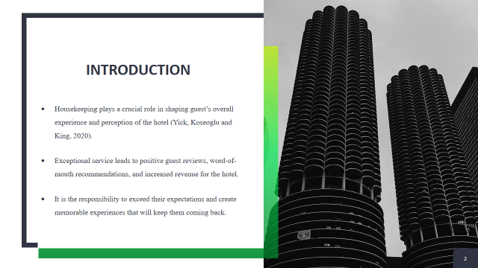
Training Notes:
Good morning/afternoon, everyone. Thank you for joining this training session today. My name is [Your Name], and I am the floor housekeeping manager here at [Hotel Name]. I am excited to have this opportunity to discuss the importance of providing exceptional service, maintaining brand standards, and ensuring the health and safety of our guests and team members. Housekeeping plays a crucial role in shaping guests' overall experience and perception of our hotel (Yick, Koseoglu and King, 2020). By upholding high standards and prioritizing the well-being of our guests and team members, we can establish a strong reputation and maintain customer loyalty.
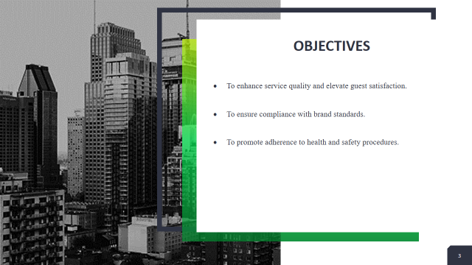
Training Notes:
In this training presentation, our primary objectives are to enhance service quality, ensure compliance with brand standards, and promote adherence to health and safety procedures. By focusing on these objectives, we can deliver exceptional experiences to our guests while maintaining the reputation and integrity of our hotel. Our first objective is to enhance service quality and elevate guest satisfaction. We will explore strategies and best practices to exceed guest expectations, provide personalized service, and create memorable experiences. By consistently delivering exceptional service, we can cultivate guest loyalty and positive reviews, driving our hotel's success. Our second objective is to ensure compliance with brand standards. We will review the specific brand standards that apply to our housekeeping operations and discuss how to consistently meet and exceed them. Maintaining brand standards guarantees a consistent experience for our guests, strengthens our brand reputation, and sets us apart from competitors. Our third objective is to promote adherence to health and safety procedures. We will emphasize the importance of following established protocols to create a safe environment for our guests and team members. We will cover topics such as proper cleaning and sanitization techniques, handling of chemicals, and the use of personal protective equipment (PPE).
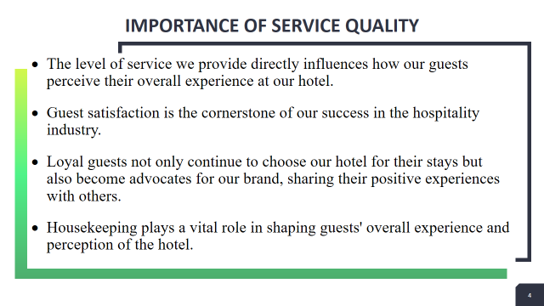
Training Notes:
Service quality has a profound impact on guest satisfaction, loyalty, and positive reviews (Fernandes, 2018). The level of service we provide directly influences how our guests perceive their overall experience at our hotel. When guests receive exceptional service, they feel valued, cared for, and satisfied with their stay. Satisfied guests are more likely to become loyal customers, choosing our hotel for future stays and recommending it to others (Paulose and Shakeel, 2022).They contribute to our revenue stream, support our occupancy rates, and provide a stable customer base even during slower seasons. Positive reviews play a crucial role in attracting new guests and building our online reputation (Kwok, Xie and Richards, 2017). Housekeeping's attention to detail and commitment to maintaining high standards reflect our dedication to providing exceptional service.
Slide 4: Brand Standards
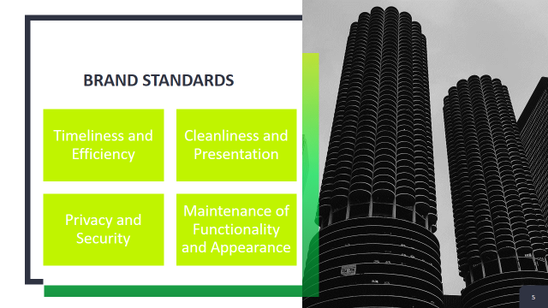
Training Notes:
Timeliness and efficiency ensure that guests' needs are met promptly and allow for proper planning and coordination with other departments (Nikolskaya et al., 2020). Housekeeping tasks, such as room cleaning, turndown service, and responding to guest requests, should be completed within the established timeframes. Attention to detail should not compromise the speed and efficiency of our operations. Cleanliness and presentation are fundamental brand standards in housekeeping (Pillai et al., 2021). Every room should be thoroughly cleaned, free of dust, stains, and odors, to create a welcoming environment for our guests. Guests' personal information and belongings must be respected and protected at all times. Team members should follow established protocols to ensure the security of guests' belongings and maintain their privacy during cleaning and turndown service. Proper use of key cards, locking mechanisms, and secure storage of lost and found items are essential aspects of upholding these brand standards. All equipment, such as TVs, air conditioning units, and lights, should be in proper working condition. Fixtures, fittings, and furniture should be well-maintained, without any signs of wear and tear. Guests should feel confident that every aspect of their room is functional and comfortable.
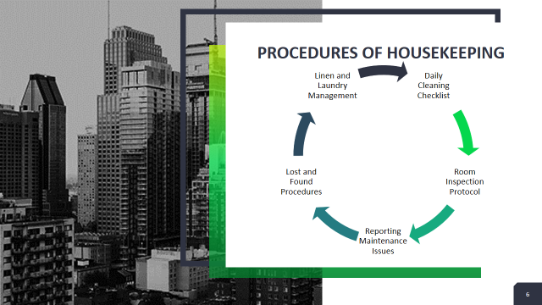
Training Notes:
To ensure efficient and effective housekeeping operations, it is important to establish clear procedures. The primary duty of individuals engaged in housekeeping is to ensure thorough cleanliness in every aspect of the room (Thebaud, Kornrich and Ruppanner, 2021). This encompasses not only the main room but also the bathroom and any additional storage spaces, leaving no traces of previous guests behind. In the aspect of room inspection protocol, the floor housekeeping manager is responsible for inspecting all rooms on their assigned floor, which includes vacant rooms, departing rooms, expected arrivals, VIP arrivals, group arrivals, blocked rooms, and rooms under repair. Maintenance in the hospitality industry refers to the regular unkeep and servicing of various systems and components essential for the smooth operation of the establishment (Poudel and Thapa, 2019). These systems encompass general building operations such as heating, ventilation, and air conditioning, electrical systems, and plumbing. Whenever an unattended guest belonging is discovered anywhere within the hotel premises, the housekeeping department is promptly notified and becomes the primary point of contact. Subsequently, the item is then transferred to the housekeeping supervisor or manager for safekeeping and further handling. It is the responsibility of floor housekeeping manager to oversees the processes of receiving, cleaning, and returning laundry items.

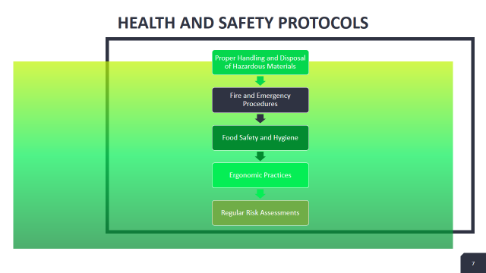

Training Notes:
In the hospitality industry, it is crucial to have health and safety protocols in place to protect the safety and well-being of both guests and employees (Gupta and Sahu, 2021). These protocols consist of various measures designed to prevent accidents, ensure cleanliness, and establish a secure environment. Several important health and safety protocols in the hospitality industry include:
- It is important to conduct regular inspections and maintenance in the hospitality industry to identify and address potential hazards (Pillai et al., 2021). Routine inspections of the premises help identify issues like malfunctioning electrical equipment, damaged handrails, or slippery floors.
- Fire safety is a crucial aspect in the hospitality industry, involving the implementation of measures like smoke detectors, fire extinguishers, and clear emergency exit signs (Kodur, Kumar and Rafi, 2020).
- Maintaining food safety and hygiene is paramount, and this includes adhering to strict practices for food storage, handling, and preparation (Kamboj et al., 2020).
- To safeguard the well-being of employees, the provision of suitable personal protective equipment (PPE) such as gloves, masks, and safety shoes is essential, particularly in areas where they may be exposed to hazardous substances or conditions.
- Regular risk assessments are carried out in the hospitality industry to identify potential hazards and develop strategies to minimize these risks (Brown et al., 2017).
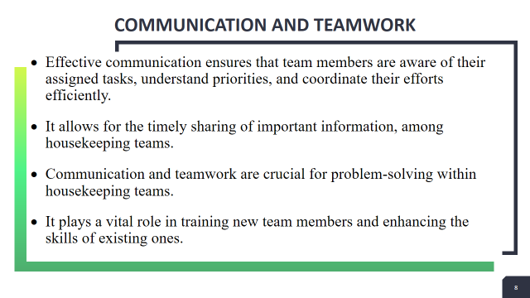
Training Notes:
Effective communication and strong teamwork are vital components in the functioning of housekeeping teams (De Vries and Van der Poll, 2018). These teams are tasked with upholding cleanliness, order, and organization in different settings like hotels, hospitals, and office buildings. The smooth execution of housekeeping duties and the attainment of top-notch outcomes heavily rely on communication and collaboration among team members. Regular team meetings and training sessions enable the dissemination of best practices, updates on cleaning techniques, and the sharing of feedback for continuous improvement.
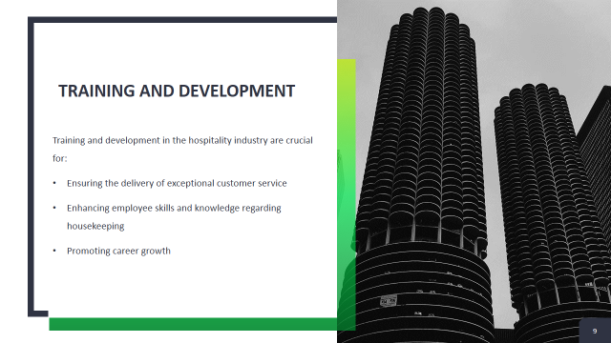
Training Notes:
Hospitality training focuses on developing excellent customer service skills among employees (Sheehan, Grant and Garavan, 2018). This includes teaching employees how to engage with guests, handle inquiries and complaints, provide personalized service, and create positive experiences. The hospitality industry encompasses various roles and departments, each requiring specific technical skills (Singjai, Winata and Kummer, 2018). Training programs provide instruction on job-specific skills, such as front desk operations, food and beverage service, housekeeping techniques, event planning, revenue management, and more. Continuous learning and professional development are encouraged in the hospitality industry (Amin et al., 2017). Organizations often provide opportunities for employees to participate in workshops, seminars, industry conferences, and online courses to enhance their skills and stay updated with industry trends.
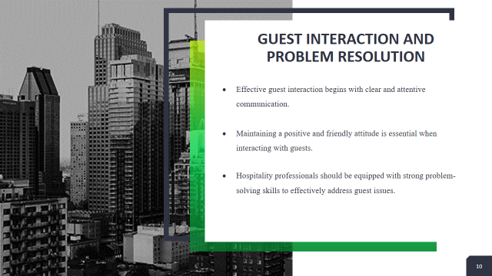
Training Notes:
Guest interaction and problem resolution are crucial aspects of the hospitality industry (Ali et al., 2021). Ensuring positive guest experiences and effectively addressing any issues or concerns they may have can greatly impact a hotel or establishment's reputation. Staff members should actively listen to guests, allowing them to express their needs, concerns, or complaints fully. Active listening involves paying attention, maintaining eye contact, and demonstrating empathy towards the guest's perspective (Wang, Luo and Tai, 2017). Hospitality professionals should greet guests warmly, display a genuine interest in their needs, and provide assistance with a smile. A positive attitude helps create a welcoming and comfortable environment for guests. Hospitality professionals should be equipped with strong problem-solving skills to effectively address guest issues (Marneros, Papageorgiou and Efstathiades, 2020). This involves analysing the problem, identifying potential solutions, and implementing the most appropriate course of action. Creative thinking and flexibility are valuable in finding resolutions that satisfy the guest while adhering to organizational policies.
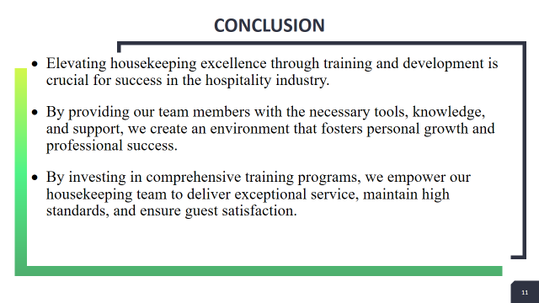
Training Notes:
Throughout this presentation, we have explored the various benefits of training and development, including improved efficiency, enhanced skills, and increased employee engagement. We have also discussed the importance of ongoing learning and the role it plays in adapting to industry trends and guest expectations. Training programs should cover a wide range of topics, including cleaning techniques, customer service, time management, and problem-solving skills. Thank you for your attention and dedication to elevating housekeeping excellence. Let us embrace the power of training and development as we work towards a successful future in the hospitality industry.

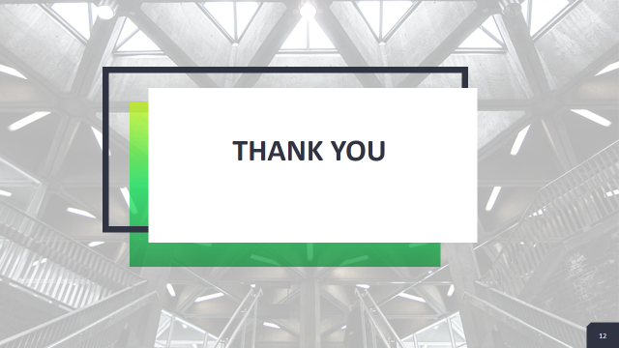

References

Ali, Bayad Jamal, Bayar Gardi, Baban Jabbar Othman, Shahla Ali Ahmed, Nechirwan Burhan Ismael, Pshdar Abdalla Hamza, Hassan Mahmood Aziz, Bawan Yassin Sabir, Sarhang Sorguli, and Govand Anwar. "Hotel service quality: The impact of service quality on customer satisfaction in hospitality." Ali, BJ, Gardi, B., Othman, BJ, Ahmed, SA, Ismael, NB, Hamza, PA, Aziz, HM, Sabir, BY, Anwar, G.(2021). Hotel Service Quality: The Impact of Service Quality on Customer Satisfaction in Hospitality. International Journal of Engineering, Business and Management 5, no. 3 (2021): 14-28.
Amin, M., Aldakhil, A.M., Wu, C., Rezaei, S. and Cobanoglu, C., 2017. The structural relationship between TQM, employee satisfaction and hotel performance. International Journal of Contemporary Hospitality Management.
Bardi, J.A., 2021. Hotel-Front-Office-Management.
Bhatnagar, E. and Dheeraj, N., 2019. Impact of housekeeping services and practices on customer satisfaction and repeat business. Prabandhan: Indian Journal of Management, 12(8), pp.46-57.
Brown, N.A., Rovins, J.E., Feldmann-Jensen, S., Orchiston, C. and Johnston, D., 2017. Exploring disaster resilience within the hotel sector: A systematic review of literature. International Journal of Disaster Risk Reduction, 22, pp.362-370.
Chathoth, P.K., Harrington, R.J., Chan, E.S., Okumus, F. and Song, Z., 2020. Situational and personal factors influencing hospitality employee engagement in value co-creation. International Journal of Hospitality Management, 91, p.102687.
De Vries, H. and Van der Poll, H.M., 2018. Cellular and organisational team formations for effective Lean transformations. Production & Manufacturing Research, 6(1), pp.284-307.
Fernandes, A.A.R., 2018. The mediation effect of customer satisfaction in the relationship between service quality, service orientation, and marketing mix strategy to customer loyalty. Journal of Management Development, 37(1), pp.76-87.
Giousmpasoglou, C., Marinakou, E. and Zopiatis, A., 2021. Hospitality managers in turbulent times: the COVID-19 crisis. International Journal of Contemporary Hospitality Management, 33(4), pp.1297-1318.
Gupta, V. and Sahu, G., 2021. Reviving the Indian hospitality industry after the Covid-19 pandemic: the role of innovation in training. Worldwide hospitality and tourism themes, 13(5), pp.599-609.
John-eke, E.C. and Bayo, P.L., 2021. Crisis management and corporate resil-ience in hotel presidential: the theoretical perspective. Int J Econom Bus Manag, 7(3), pp.21-34.
Kamboj, S., Gupta, N., Bandral, J.D., Gandotra, G. and Anjum, N., 2020. Food safety and hygiene: a review. International Journal of Chemical Studies, 8(2), pp.358-368.
Kim, J.J. and Han, H., 2022. Saving the hotel industry: Strategic response to the COVID-19 pandemic, hotel selection analysis, and customer retention. International Journal of Hospitality Management, 102, p.103163.
Kodur, V., Kumar, P. and Rafi, M.M., 2020. Fire hazard in buildings: review, assessment and strategies for improving fire safety. PSU research review, 4(1), pp.1-23.
Kwok, L., Xie, K.L. and Richards, T., 2017. Thematic framework of online review research: A systematic analysis of contemporary literature on seven major hospitality and tourism journals. International Journal of Contemporary Hospitality Management.
Marneros, S., Papageorgiou, G. and Efstathiades, A., 2020. Identifying key success competencies for the hospitality industry: The perspectives of professionals. Journal of Teaching in Travel & Tourism, 20(4), pp.237-261.
Melián-Alzola, L., Fernández-Monroy, M. and Hidalgo-Peñate, M., 2020. Hotels in contexts of uncertainty: Measuring organisational resilience. Tourism management perspectives, 36, p.100747.
Mmutle, T. and Shonhe, L., 2017. Customers’ perception of service quality and its impact on reputation in the hospitality industry. African Journal of Hospitality, Tourism and Leisure, 6(3), pp.1-25.
Nikolskaya, E.Y., Romanova, M.M., Pasko, O.V., Uspenskaya, M.E. and Saadulaeva, T.A., 2020. Formulation of development strategy for tourism and hospitality industry. International Journal of Management (IJM), 11(3), pp.467-474.
Paulose, D. and Shakeel, A., 2022. Perceived experience, perceived value and customer satisfaction as antecedents to loyalty among hotel guests. Journal of Quality Assurance in Hospitality & Tourism, 23(2), pp.447-481.
Pillai, S.G., Haldorai, K., Seo, W.S. and Kim, W.G., 2021. COVID-19 and hospitality 5.0: Redefining hospitality operations. International Journal of Hospitality Management, 94, p.102869.
POUDEL, R. and THAPA, S., 2019. Hospitality Industry and Customer Service.
Sheehan, M., Grant, K. and Garavan, T., 2018. Strategic talent management: A macro and micro analysis of current issues in hospitality and tourism. Worldwide Hospitality and Tourism Themes.
Singh, A. and Jaykumar, P., 2019. On the road to consensus: key soft skills required for youth employment in the service sector. Worldwide Hospitality and Tourism Themes.
Singjai, K., Winata, L. and Kummer, T.F., 2018. Green initiatives and their competitive advantage for the hotel industry in developing countries. International Journal of Hospitality Management, 75, pp.131-143.
Sohaib, M., Wang, Y., Iqbal, K. and Han, H., 2022. Nature-based solutions, mental health, well-being, price fairness, attitude, loyalty, and evangelism for green brands in the hotel context. International Journal of Hospitality Management, 101, p.103126.
Thébaud, S., Kornrich, S. and Ruppanner, L., 2021. Good housekeeping, great expectations: Gender and housework norms. Sociological Methods & Research, 50(3), pp.1186-1214.
Wang, Y.C., Luo, C.C. and Tai, Y.F., 2017. Implementation of delightful services: From the perspective of frontline service employees. Journal of Hospitality and Tourism Management, 31, pp.90-104.
Yick, M.Y.Y., Köseoglu, M.A. and King, B., 2020. Gazing at hotel guests: Deconstructing elements of the host-gaze. International Journal of Hospitality Management, 87, p.102508.

