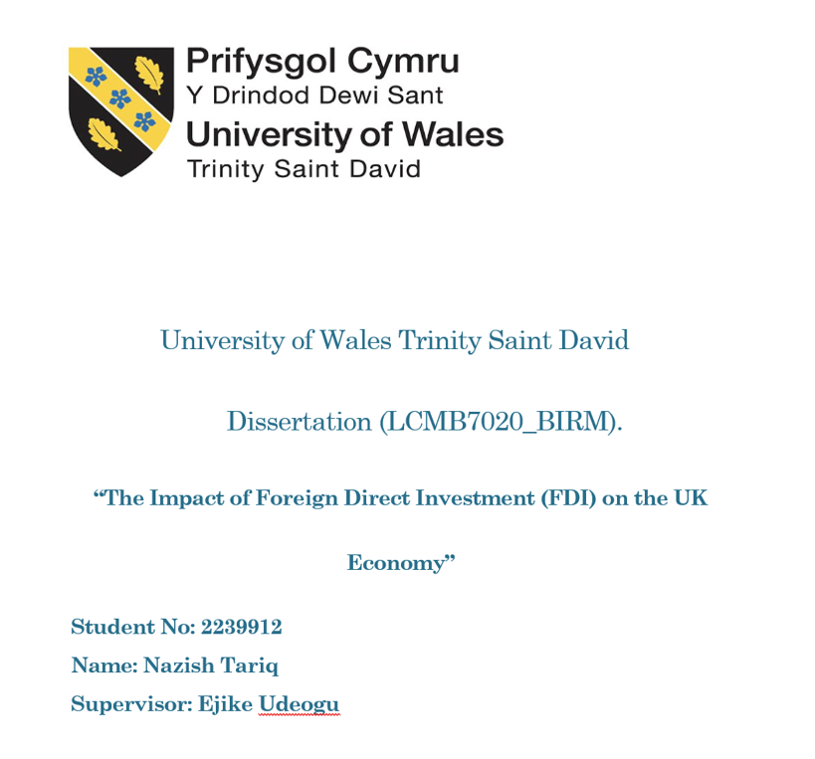

DECLARATION

I, Nazish Tariq declare that this dissertation has been composed by myself, that the work contained herein is entirely my own except where explicitly stated otherwise in the text, and that this work has not been submitted for any other degree or qualification, in whole or in part, except as specified.

Signature: Nazish Tariq

Date: 27/08/2024

ACKNOWLEDGEMENT

During my MBA journey, I would like to express my sincere gratitude to my supervisor for their unwavering support and guidance. Their insightful feedback and encouragement have been invaluable throughout this process, and I am truly grateful for their dedication to my development.

Thank you.

Table of Contents.
Chapter No 1. Introduction, Aims and Objectives
1 | Introduction | 6
1.2 | Research Significance- Problem Statement | 7
1.3 | Dissertation Aim: | 7
1.4 | Dissertation Objectives | 7
1.5 | Questions To Achieve My Objectives. | 7
1.6 | Brief Literature Review | 8
1.7 | Research Gaps | 9
1.8 | Methodology | 9
1.9 | Quantitative Analysis Methodology | 9
1.1 | Data Collection | 10
1.11 | Systematic Approach | 10
1.12 | Potential Risks | 11
1.13 | Ethical Considerations | 11
1.15 | Dissertation Structure. | 13
1.16 | Chapter Summary | 14
Chapter 2: Literature Review
2.1 | Introduction | 15
2.2 | Economic Growth & Foreign Direct Investment | 15
2.3 | Types of FDI | 19
2.3.1 | Greenfield Investment | 19
2.3.2 | Mergers and Acquisitions | 20
2.3.4 | Joint Ventures | 23
2.4 | FDI BY DIRECTION | 25
2.4.1 | Inward FDI | 25
2.4.2 | Outward FDI | 25
2.5 | Chapter Summary | 28
Chapter 3- Research Methodologies
3.1 | Introduction | 30
3.2 | Research Methodologies | 30
3.3 | The Main Types Of Research | 30
3.3.1 | Quantitative Research | 30
3.3.2 | Quantitative Research Techniques | 31
1 | Regression Analysis: | 31
2 | Input-Output Analysis: | 31
3 | Panel Data Analysis: | 31
4 | Computable General Equilibrium (CGE) Modelling: | 31
3.4 | DATA Collection Sources and Limitations | 32
3.4.1 | Quantitative Data for the UK for FDI. | 33
3.4.2 | Capital Flows | 33
3.4.3 | Linear Regression Analysis. | 33
3.4.4 | Other Statistical Analysis. | 35
3.4.5 | Interest Rate | 36
3.4.6 | Unemployment Rate | 38
3.4.7 | Future GDP Forecast | 39
3.5 | Qualitative Research | 41
3.6 | Mixed-Method Research | 41
3.7 | The Research Process | 41
3.8 | Research Onion | 44
3.9 | Ethical Consideration | 46
3.1 | Chapter Summary | 46
Chapter 4: Dissertation Analysis & Findings.
4.1 | Introduction | 47
4.2 | FDI Overview | 47
4.3 | Detail Analysis of Objectives | 48
4.4 | Statistical Calculations and Analysis | 48
4.4.1 | Regression Analysis | 49
4.4.4 | Forecast -FDI, GDP & Unemployment | 53
4.4.5 | Results and Analysis of Statistical Data. | 54
4.5 | Other Source Data Analysis | 54
4.6 | Factors That Can Influence the FDI | 54
4.6.1 | The Economic Condition Of The UK. | 54
4.6.2 | Political Stability | 56
4.6.3 | Labour Market | 58
4.6.4 | Technology and Infrastructure | 60
4.6.5 | Analysis of our First Objective: Factors for FDI | 63
4.7 | The impact of Brexit on FDI in the UK. | 63
4.7.2 | Analysis Of The Second Objective: Brexit Impact. | 66
4.8 | Impact of FDI on Economic Growth | 67
4.8.1 | GDP Growth | 68
4.8.2 | Employment Rate | 68
4.8.3 | Impact of FDI on the Local Community | 69
4.8.4 | Future FDI Projects. | 69
4.8.5 | FDI Impact On The Environment - Green Investment. | 70
4.9 | Chapter Summary: | 71
Chapter 5. Conclusion
5.1 | Summary of Main Findings | 72
5.2 | Conclusion Based on our Research Questions. | 73
5.4 | Future Research | 76
References |  | 77

Chapter No 1. Introduction, Aims and Objectives

Introduction
Foreign direct investment (FDI) is a crucial concept, referring to an investment made by a firm or individual in one country into business interests in another country. It plays a significant role in a country's economic development, bringing in capital, technology, and managerial expertise. This understanding is vital as it also contributes to job creation, infrastructure development, and economic growth. Additionally, FDI can help transfer skills and know-how, benefiting local workers and industries. Overall, FDI is an essential driver of economic prosperity and development for many countries (Botswana 2014).
Foreign direct investment (FDI) has a rich history in the economic development of the United Kingdom. The UK has been a substantial recipient of FDI for many years. In the 19th century, the UK was a global powerhouse and attracted large amounts of foreign investment, particularly in manufacturing and finance. This historical context is important to understand the evolution of FDI in the UK.
Post-World War II, the UK continued to attract FDI, especially from the United States. American companies, seeking to expand into European markets, found the UK's EU membership particularly appealing. They used it as a launchpad to the larger European market, further boosting the UK's FDI influx.
Recently, the UK has maintained its allure for FDI, especially in sectors like finance, technology, pharmaceuticals, and renewable energy. The UK government's proactive promotion of FDI through various incentives and initiatives has further bolstered its appeal to foreign investors.
Foreign direct investment (FDI) is a powerful force that shapes and influences the British economy. It is the lifeblood of market growth, directly and indirectly impacting every business.
In the domestic market, various investment objectives can provide viable alternatives for investors. Greenway and Kneller (2007) state that local markets may reach saturation points, offering diverse stakeholder advantages. For example, expanding into neighbouring countries may harm the host country. Morck et al. (2008) emphasise that each country harbours unique and complex economic factors that can significantly impact foreign direct investment, mainly as influenced by the populace's behaviour and the country's financial landscape.
Haufler and Stowhase (2003) contend that foreign direct investment can yield multiple economic advantages. Extending incentives to foreign investors, such as tax relief, can elevate levels of foreign direct investment. Moreover, highlighting additional incentives within the hosting country or fostering domestic investment may contribute to heightened foreign direct investment.
Safarian (1985) identified various factors that influence foreign direct investment (FDI), such as the exchange rate of the host country and the flow of capital. Chen's (2005) model further analysed these factors using 10 to 15 years of time series data, considering elements like mutual trade and currency valuation in the USA and other countries that affect a country's currency.

1.2 Research Significance- Problem Statement
The primary objective of this dissertation is to conduct an in-depth investigation into the influence of Foreign Direct Investment (FDI) on the economic growth of the United Kingdom. The study will comprehensively explore and analyse the diverse channels through which FDI impacts the UK's economic growth, encompassing its effects on employment, productivity, innovation, and trade dynamics. By utilizing empirical data and employing sophisticated econometric models, the research endeavours to offer a thorough and nuanced understanding of how FDI actively contributes to the economic growth of the UK. Furthermore, the study aims to provide valuable insights that can play a pivotal role in shaping policy decisions and devising effective strategies for both attracting and maximizing the benefits of FDI in the context of the United Kingdom's economy.

1.3 Dissertation Aim:
Recognising the significance of FDI, this dissertation aims to delve into the current state of foreign direct investment in the United Kingdom. This involves analysing FDI inflows into the UK before and after Brexit and the impact of FDI on economic growth.

1.4 Dissertation Objectives
The dissertation aims to examine the impact of Foreign direct investment on the UK Economy.

Questions To Achieve My Objectives.
Since foreign direct investment is a very broad topic, investigating the following questions will help us to focus on achieving our research objective:
- How do the different factors more specifically economic condition, political stability and Labour availability influence the FDI in the UK?
- How did Brexit affect foreign direct investment (FDI) in the UK, specifically investor behaviour following Brexit?
- How does FDI impact economic growth e.g. GDP growth in the UK and overall financial conditions e.g. Labour market and its impact on the local community?

This thesis will achieve these goals by thoroughly analysing and integrating various interconnected chapters. It also aims to significantly contribute to understanding foreign direct investment (FDI) and how it affects the United Kingdom.

1.6 Brief Literature Review
Economists emphasise various economic instruments that contribute to developing a country's economy. Factors such as capital requirements, technology, infrastructure, geographical location, investment costs, neighbouring countries, residency status, taxes, political environment, education levels, and foreign direct investment are all essential for economic growth. Additionally, various institutions pave the way for these influential factors.
As per (Eaton & Kortum, 2002), having the freedom to trade can make countries better off by allowing them to focus on the industries they are best at. This can help lower the costs of goods, services, and materials
Foreign direct investment (FDI) represents a significant catalyst for economic growth in every country. Alesina and Rodrik (1994) underscore the crucial link between political factors and the economy's overall performance, emphasising the need for political stability and conducive policies. Furthermore, Kuznets (1966) suggested that governments should proactively enact policies that foster economic development, including but not limited to facilitating international trade, embracing new technological advancements, and promoting the dissemination of business knowledge within the domestic economy. These measures are vital for enhancing a nation's economic landscape and competitiveness.
In 1999, Markusen and Venables conducted research that revealed the substantial impact of FDI on medium—and small-sized firms. He analysed and emphasised its economic benefits, such as lower labour costs and reduced raw material prices, which can significantly enhance business profitability.
In recent years, there has been growing research on the impact of Brexit on inward investment and foreign direct investment (FDI) distribution. Previous studies focused on the EU's positive influence on FDI in the UK and potential adverse effects post-Brexit. However, more attention is needed on the EU's competitive impact in attracting foreign investment amidst the uncertain economic conditions surrounding the UK's departure from the EU (Gudgin et al., 2017).
La ll (1997b) and Costa (2002) highlighted the substantial benefits of FDI, including technology transfer, increased market access, enhanced productivity, and exports. As per them, recognising these benefits, authorities can offer various incentives, such as special relaxations, government support, and reduced taxes, to attract and motivate investors to bring FDI into the country. In one of the analyses of location selection and the decision-making process for foreign direct investment (FDI), Chen (1996), underscored several critical determinants. He posited that FDI is intricately linked to location-specific attributes and the potential for market expansion.
It is essential to acknowledge that market attractiveness varies across regions, contingent on factors such as the legal framework, economic outlook, political stability, and government directives. From 1985 to 2013, a study by Bruno, Campos, Estrin, and Tian (2016) used foreign direct investment (FDI) data between 34 OECD countries. They analyse how joining the EU would affect FDI flows between countries. The study considered factors like market size (measured by GDP), distance between countries, and GDP per capita. This approach helped us to understand EU membership's specific impact on FDI flows.

1.7 Research Gaps
In this research, we will try to cover the following research gaps, however, the topic is broad, and tackling all the gaps is challenging.

- Exploration and continuous analysis are crucial to filling the gaps in foreign direct investment (FDI). We must thoroughly analyse how Brexit impacts FDI in the United Kingdom and study the factors influencing FDI inflows and outflows in the UK before and after Brexit, as the time and data availability are changing year by year, and continuous study is needed in this context.

- more detailed and longitudinal studies are required to understand the long-term implications of FDI on the UK economy, including its effects on employment, economic growth, and industry dynamics. Furthermore, more literature is needed on the role of governmental policies and regulations in attracting or deterring FDI in the UK, which requires further exploration and analysis.

- Moreover, there are gaps in research regarding the changing patterns and trends in FDI inflows and outflows in the UK, necessitating more comprehensive studies to capture the evolving nature of FDI activities in the country.

1.8 Methodology

1.9 Quantitative Analysis Methodology

For this dissertation, we will employ a quantitative analysis methodology. Our research topic focuses on Foreign Direct Investment (FDI), requiring us to access real-time information via secondary data sources. This approach will allow us to effectively analyse the impact of FDI on the target areas and draw valuable insights.
Quantitative methods will be used to analyse large datasets about FDI inflows and outflows, economic indicators, and market trends. This approach, which uses statistical tools and econometric models, aims to quantify the impact of FDI on various aspects of the UK economy and assess the changes post-Brexit.
A comparative analysis will also examine pre- and post-Brexit scenarios, considering relevant factors influencing FDI and economic conditions. This will provide a nuanced understanding of how Brexit has affected FDI in the UK.
Furthermore, a thorough literature review will consolidate knowledge, and theories related to FDI, economic impact assessment, and the influence of geopolitical events on international investment.
Overall, this methodology will provide a robust and comprehensive analysis of foreign direct investment in the United Kingdom, considering the implications of Brexit on FDI and the broader economy.

1.10 Data Collection
To begin gathering data on foreign direct investment (FDI), I can consult sources such as the UK Office for National Statistics (ONS), the Department for International Trade (DIT), and the United Nations Conference on Trade and Development (UNCTAD) database.
These sources provide comprehensive and reliable information on FDI flows, stock, and trends. Additionally, consulting academic journals, research papers, and reports on FDI in the UK can offer valuable insights. For a more specific approach, collecting data on FDI requires attention to detail, ensuring that I am using reputable sources, and considering factors such as FDI inflows, outflows, sectors, and geographical distribution.

1.11 Systematic Approach
A systematic approach for my dissertation on foreign direct investment (FDI) in the United Kingdom involves the following steps:
1. Define the Research Questions: Clearly define the main research questions I aim to address in my dissertation. These questions should guide me in investigating the impact of FDI on the UK economy and the effects of Brexit on FDI.
2. Literature Review: I will Conduct a comprehensive literature review to understand the existing knowledge and research gaps related to FDI in the UK. This will help me build a solid theoretical foundation for my study and identify the critical factors studied in previous research.
3. Data Collection and Analysis: To Collect relevant data on FDI inflows, outflows, and stock in the UK from credible sources such as government agencies, international organisations, and academic publications. Utilise statistical and econometric methods to analyse the data and draw meaningful insights.
4. Methodology: I clearly outline the methodology I plan to use for data collection, analysis, and interpretation and explain why the chosen methods are appropriate for addressing my research questions.
5. Empirical Analysis: Present the findings of my empirical analysis, highlighting the impact of FDI on the UK economy and any observable trends before and after Brexit.
6. Discussion and Implications: Discuss the implications of my findings in the context of economic theory and policy. Consider the potential effects of Brexit on FDI and how they may shape the future financial landscape of the UK.
7. Conclusion: Conclude by summarising the key findings of my research and discussing the broader implications of my work. Provide recommendations for policymakers and practitioners based on my findings.
By following this rational approach, I can ensure that my dissertation on FDI in the UK is well-structured, thoroughly researched, and contributes to the existing body of knowledge in this field.

1.12 Potential Risks
Some potential risks to consider include:
1. Data Availability: Access to accurate and reliable data on FDI inflows and outflows, especially post-Brexit, may be limited. Ensuring the availability and credibility of data sources is crucial to the success of my research.
2. Brexit Uncertainties: The impact of Brexit on FDI may still be uncertain and subject to ongoing developments. I must consider and address these uncertainties in my analysis and interpretation of results.
3. Macro-Economic Factors: FDI is influenced by various macroeconomic variables such as exchange rates, interest rates, and global economic conditions. These factors can be volatile and may impact the stability of FDI flows.
4. Regulatory Changes: Changes in policies, trade agreements, and investment regulations, especially in the post-Brexit UK, may create uncertainties and potential barriers to FDI.
5. Limited Research Scope: Ensuring that the scope of my dissertation is comprehensive enough to capture the diverse factors influencing FDI while also being focused enough to provide specific and meaningful insights.
By identifying and addressing these potential risks, I can strengthen the quality and reliability of my dissertation on Foreign Direct Investment in the UK.

1.13 Ethical Considerations
Ethical considerations are crucial to any research or dissertation. When researching foreign direct investment (FDI) and its impact on the UK economy, it is important to consider ethical guidelines and ensure that the research is conducted with integrity and respect for all stakeholders involved.
Some key ethical considerations in this area of my research include:
1. Privacy and Confidentiality: When gathering data and conducting interviews or surveys, it is essential to respect the privacy and confidentiality of participants. This involves obtaining informed consent, protecting their anonymity, and safeguarding sensitive information.
2. Research Integrity: Conducting research honestly, transparently, and accurately is essential. This includes appropriately citing sources, avoiding plagiarism, and presenting the findings truthfully without manipulation or bias.
3. Impartiality and Objectivity: Researchers should strive to maintain impartiality and objectivity in their work, avoiding conflicts of interest or biases that could unduly influence the research outcomes.
4. Respect for Participants: It is critical to treat all participants and stakeholders with dignity, respecting their contributions and opinions while ensuring their voices are appropriately represented in the research findings.
5. Compliance with rules: Researchers must follow applicable laws, rules, and institutional norms governing research ethics, such as data protection and ethical clearance.
6. Social Responsibility: The potential impact of the research on society should be considered, ensuring that the findings are used to bring about positive change and are not exploited for unethical purposes.

1.15 Dissertation Structure.
This research has the following flow:
Chapter | Title | Description
1 | Introduction, Aims And Objectives | This chapter introduces foreign direct investment and elucidates the dissertation's aims and objectives. It encompasses various subject areas, focusing on the dissertation's objectives, establishing them, providing a concise overview of the subsequent chapters, and describing the ultimate research output. It culminates in a comprehensive summary of the chapter.
2 | Literature Review | The primary goal of this chapter is to completely investigate and analyse numerous nuanced concepts and views related to foreign direct investment. This includes an in-depth examination of the nature of foreign direct investment, a comprehensive categorization of various types of foreign direct investment, a thorough investigation of the numerous economic benefits it can potentially yield, and a detailed assessment of how the inflow and outflow of foreign direct investment may have a multifaceted impact on the British economy.
3 | Methodology And Design | The chapter focuses on how we did the research for the dissertation. It starts with an introduction. Then, I discussed what we wanted to find out, where we got the information, and how reliable it was. We also discuss how many people or things we studied and how we chose them. After the chapter, I will provide a comprehensive summary. This summary will encompass in-depth analyses conducted by various scholars, an examination of government data, and an analysis based on actual data. I will ensure that I incorporate a wide range of references and structure them according to my objectives to effectively address and answer the questions posed in my dissertation. This approach will allow me to conclude my findings thoroughly based on extensive research and analysis.
4 | Dissertation Analysis & Findings | In this chapter, we aim to actualise the objectives outlined in Chapter 1. Following the introduction, we will employ the previously examined models and techniques to achieve our research goals. Subsequently, a comprehensive individual assessment of each objective will be conducted to evaluate the impact of foreign direct investment on the UK. Finally, the chapter will culminate in an overarching summary of the findings.
5 | Dissertation Conclusion | As the dissertation ends, the final section will neatly summarise the main points of each chapter and offer important concluding insights for the entire work. It will also highlight the significant contributions made within this dissertation.

1.16 Chapter Summary
The chapter centres on the principal objective of this dissertation, which is to thoroughly analyse the impact of Foreign Direct Investment (FDI) and Brexit on the economic growth of the United Kingdom. The focus is on examining current research gaps and evaluating the specific influence of FDI on the overall financial performance of the UK. The analysis aims to delve into the intricacies of these factors, providing a detailed understanding of their interplay and implications for the UK economy.

Chapter 2: Literature Review

2.1 Introduction
Foreign direct investment (FDI) significantly influences the global economy. This literature review aims to conduct a comprehensive examination of recent academic articles and research pertaining to FDI and its impact on the economies of various countries. The primary objective of this analysis is to explore the factors that influence FDI, the diverse forms of FDI, and the pivotal role of governments in both fostering and regulating FDI within their respective nations. By shedding light on the intricate dynamics of FDI and its implications for economic development, this review underscores the indispensable contribution of policymakers in this process.

2.2 Economic Growth & Foreign Direct Investment
Foreign Direct Investment (FDI) denotes the utilisation of technological, production, or management advantages by a multinational corporation (MNC) to engage in operations in a foreign country through licensing or a subsidiary branch. FDI plays a crucial role in globalisation, yielding mutual benefits for the host country and the investing entities, with a prevalent focus on the manufacturing and service industries (Bhattarai, K., 2016). The multifaceted nature of FDI encompasses micro and macro dimensions, where micro-level operations are guided by profit-maximising endeavours. At the same time, macro-level involvement complements domestic investment, fostering capital accumulation and expediting economic growth, providing a reassuring outlook for the future.

In the field of foreign direct investment (FDI) study, Wallis (1968) conducted a thorough analysis of the increasing FDI inflows into the EU from the US. He evaluated FDI's critical role in propelling economic progress with great consideration. Feldstein and Horioka (1980) also calculated the effect of FDI on investment and saving. To properly analyze our data and findings, this study will assist us in placing the findings within the context of the UK.

Later, Desai, Foley, and Hines (2005) found a nearly one-to-one positive relationship between FDI inflows and investment and saving GDP ratios, while FDI outflows were negatively correlated with decreased investment in OECD nations in the 1990s. Furthermore, a study on FDI flows from industrialized countries to 69 developing nations by Borensztein et al. (1998) established the essential requirement for domestic absorptive capacity to elevate FDI to a prominent position in affecting economic growth.

In a recent study, de Mello (1999) employed a panel data model to discern that the nexus between growth and FDI is contingent upon country-specific factors and essentially buttresses a favourable association between FDI and long-term economic growth.

Spickernell's (2014), research highlights the significant impact of foreign direct investment (FDI) on the economies of host countries. The findings emphasize that FDI is a crucial driver of economic growth and is often considered the primary source of capital in most host countries. Additionally, FDI, similar to domestic private investments, contributes to GDP growth. Furthermore, FDI plays a vital role in the transfer of technology and dissemination of knowledge by introducing new and advanced technologies to the host country through its investments.

Chete et al. (2013) state that before host economies can fully profit from FDI, they must first reach certain milestones in development parameters, like education and critical infrastructure. Therefore, foreign direct investment may not have a major effect on the acceleration of economic development rates in less developed nations.

According to Dunning (2012), foreign direct investment draws in matching local investment that either uses the foreign investors' output or supplies inputs. Because foreign direct investment fosters the development of innovative technologies, technical know-how, and best management practices, it has been seen as a driver of economic progress. The host nation's productivity is increased by these elements. Additionally, as a vote of confidence in the host economy, foreign direct investment encourages inward investment in host nations. Furthermore, it is essential to enhance native resources in the host nations.

Infrastructure and energy comprise more than half of all new projects in the UK, highlighting FDI's important role in the country's economy. Foreign direct investment is seen by the UK government as a key engine of economic expansion. Foreign investors must abide by industry-specific legislation (such as those in the manufacturing or energy sectors) just like other businesses, even though the UK does not have a special statute governing foreign direct investment. (ONS.Gov.UK/Asset publication,2021). The government has acknowledged the need for significant investment in sectors like information and communication technology (ICT), renewable energy, life sciences, and creative industries. This is crucial due to Brexit and the impact of inward investment on the UK economy. The UK, known for its open economy, has a history of trade deficits. (cer.eu/publications, 2022)

Furthermore, while there is emerging literature on the impact of Brexit on inward investment, it essentially adds to existing research on the geographical distribution of foreign direct investment (FDI) by considering the effects of Brexit (Bruno et al. (2016), Simionescu (2017)).

Gudgin et al. (2017) overlooked this factor and its potential impact in their Brexit analysis. Considering this, they have proposed to investigate the dynamics of inward FDI in the macroeconomy using the structural vector autoregression (SVAR) paradigm to provide a more comprehensive understanding of the impact of Brexit on inward FDI.

The study conducted by CBI commissioned PwC to conduct an in-depth quantitative assessment of the potential economic implications of a UK exit from the EU. PwC evaluated two scenarios: one where the UK negotiates a Free Trade Agreement with the EU within five years of the referendum and another where trade defaults to World Trade Organization rules. The essence of the study revealed that if Both scenarios were compared to a hypothetical scenario where the UK remained in a reformed EU, assuming the UK's economy would grow at a long-term trend rate of 2.3% per year.

As per Simionescu, leaving the EU (‘Brexit’) would lower trade between the UK and the EU because of higher tariff and non-tariff barriers to trade. In addition, the UK would benefit less from future market integration within the EU (Simionescu, M., 2017).
Shatz and Venables (2000) found that companies want to improve their service to the local market and reduce input costs. They believe that companies expand globally mainly to find new markets and minimize production costs. The authors note that what drives foreign investment in developing countries may not apply to developed or underdeveloped nations. Therefore, we should be careful about assuming that what's true for developing countries also applies to developed countries.

In their 2016 study, Driffield and Karoglou found that Brexit hurt the UK's Foreign Direct Investment (FDI). Using a Markov regime-switching structural vector-autoregression, they suggested potential policies for Great Britain, including increasing labour market flexibility, pursuing more intensive trade with countries offering lower costs, and decreasing employment protection.

Additionally, Ebell and Warren's 2016 research showed that EU membership positively affected inward FDI in the UK. They attributed this to the advantages of free capital movement, trade in goods and services, labour mobility, and passports, collectively making the UK the most attractive FDI destination in Europe.

Ruxanda (2010) identified two important ways in which foreign direct investment (FDI) can help economies grow. Firstly, FDI can bring in advanced technology, which local companies can then adopt. Secondly, investing firms can introduce new management methods and effective organizational structures, which help transfer valuable knowledge to the host economy.

In less developed countries, foreign direct investment (FDI) may not significantly boost economic growth. Chete et al. (2013) argues that host economies must meet specific milestones in education and infrastructure development before fully benefiting from FDI. Therefore, the conditions in the host country can impact the realization of FDI benefits.

The contrast between foreign direct investment (FDI) between developed and developing countries is substantial and multifaceted. However, FDI has the potential to bridge these gaps. Developed countries, with their stable political and economic environments, established infrastructure, and access to a skilled workforce, tend to attract a higher volume of FDI. This influx of investment often contributes to further economic development and technological advancement. Conversely, developing countries face challenges attracting FDI due to political instability, underdeveloped infrastructure, and higher perceived risks. But with the right conditions, they, too, can benefit from FDI. Consequently, this potential for FDI to bridge economic discrepancies can inspire optimism about the future of global economics.
There are two main ways foreign direct investment (FDI) can benefit the host nations' economy, as explained by Ruxanda (2010). FDI can promote economic growth by transferring advanced technology and knowledge. Technology is mainly spread through spillovers. When new technology is introduced, local businesses quickly adopt it, especially if it is not patented. Additionally, investment businesses can bring in new management techniques and effective organisational structures, leading to knowledge transfer. However, the realisation of these FDI benefits may be influenced by the conditions in the host nation.
The literature mentioned above significantly aided our comprehension of the current research conducted in the field of foreign direct investment (FDI). However, while reviewing the existing literature, we identified certain research gaps. It is important to acknowledge that FDI is an intricate and continually evolving topic, given that economic conditions are subject to constant change due to various factors. As an example, in the present era, countries exhibit a growing need for investments that prioritize environmental sustainability, technology, and artificial intelligence (AI). And we cannot find much study and FDI behaviour in this context.
Based on the current literature, there seems to be a gap in the research related to the impact of Brexit on the geographical distribution of foreign direct investment (FDI) in the UK. While there are existing studies that consider the effects of Brexit on FDI, there is a need for more comprehensive research focusing on the recent developments and emerging trends in FDI flows to the UK post-Brexit. Additionally, there is also a need for studies that explore the specific industry sectors or regions within the UK that might be most affected by changes in FDI patterns. This gap presents an opportunity for future research to provide a deeper understanding of the post-Brexit FDI landscape in the UK.

2.3 Types of FDI

2.3.1 Greenfield Investment

Characteristics
When a business constructs brand-new facilities and infrastructure from the bottom up abroad, it is referred to as a "greenfield" investment. With this investment, the business gains total authority over the creation, development, and management of the new endeavour. Although it is sometimes viewed as a long-term, high-risk venture, it can present potential for expansion into new markets as well as substantial strategic advantages.
Advantages
The advantages of greenfield investment include building customised facilities, access to new markets, and the potential for higher returns due to lower initial overhead costs.

Examples of Companies
Some examples of greenfield investments in the UK include constructing manufacturing facilities by multinational corporations, establishing new research and development centres, and developing renewable energy infrastructure such as wind farms. Additionally, companies from overseas have built new office complexes and retail outlets as part of their greenfield investments in the UK. These investments have allowed foreign companies to establish a significant presence in the UK market while contributing to economic growth and job creation (Source- Financial Times,2022)

Global Greenfield FDI Capital Expenditure Trends
In terms of greenfield FDI, the UK has brought in the third most money (£720 billion) during the past 20 years. With £1,302 billion and the US at £1,095 billion, the UK is now just behind China and the US. (Source- ONS.Gov.UK,2023)
The UK overtook China in 2021 and 2022 to take the second spot after the US as the most popular location for foreign direct investment.The UK's greenfield FDI total of £720 billion is higher than the combined sums of Germany's and France's (£305 billion and £205 billion, respectively). In terms of Greenfield FDI capital expenditure, Germany comes in at number nine, while France comes in at number seventeen. (Source- ONS.Gov.UK,2023)
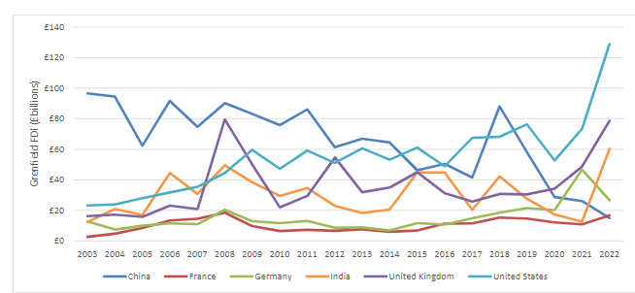

 | In £ Billions
Country | 2015 | 2016 | 2017 | 2018 | 2019 | 2020 | 2021 | 2022 | 2015-22
China | £46 | £50 | £42 | £88 | £58 | £29 | £26 | £15 | £354
France | £7 | £11 | £11 | £15 | £15 | £12 | £11 | £17 | £99
Germany | £12 | £11 | £15 | £18 | £22 | £20 | £47 | £27 | £172
India | £45 | £45 | £20 | £42 | £28 | £17 | £13 | £60 | £270
United Kingdom | £45 | £31 | £26 | £31 | £30 | £34 | £49 | £79 | £325
United States | £61 | £49 | £68 | £68 | £76 | £53 | £73 | £129 | £577



2.3.2 Mergers and Acquisitions
Characteristics
This type of investment occurs when two or more companies come together to expand their business or create new business units. It involves the transfer of business assets between local and foreign markets. If foreign players invest in a local company, the foreign companies or players become the controlling authorities, effectively making the local company a part of the foreign company. The foreign company then takes the profit made by the local company according to their shareholding. Despite this, such investments by foreign companies are considered crucial for the local market, as they serve as an essential source of foreign direct investment and lead to an inflow of finance and capital assets into the local country.

Advantages
Mergers and acquisitions for foreign direct investment (FDI) can bring several advantages for local and foreign companies. One of the primary benefits is the potential for business expansion and increased market share. By combining resources and expertise, companies can achieve economies of scale, access new markets, and diversify their product offerings.
Additionally, mergers for FDI can lead to enhanced competitiveness and innovation. The exchange of knowledge, technology, and best practices between the merging entities can result in improved products and services. This, in turn, can drive growth and strengthen the overall industry.
Furthermore, FDI through mergers can facilitate the transfer of advanced technologies and management skills to domestic companies, ultimately contributing to the development of the local workforce and infrastructure. It also attracts foreign capital and investment, stimulating economic growth and creating employment opportunities.

Overall, mergers for FDI can mutually benefit local and foreign entities, fostering growth, innovation, and strategic collaborations.

Examples
Some notable examples of mergers and acquisitions in the UK through foreign direct investment (FDI) include the acquisition of ARM Holdings, a leading semiconductor and software design company, by SoftBank Group from Japan in 2016. Another significant deal is the acquisition of BG Group, a British multinational oil and gas company, by Royal Dutch Shell, a Netherlands-based company, in 2016. Additionally, the acquisition of Cadbury, a British multinational confectionery company, by Kraft Foods from the United States in 2010 is an essential example of FDI through mergers and acquisitions in the UK. These are just a few examples of the various mergers and acquisitions that have taken place in the UK through foreign direct investment.
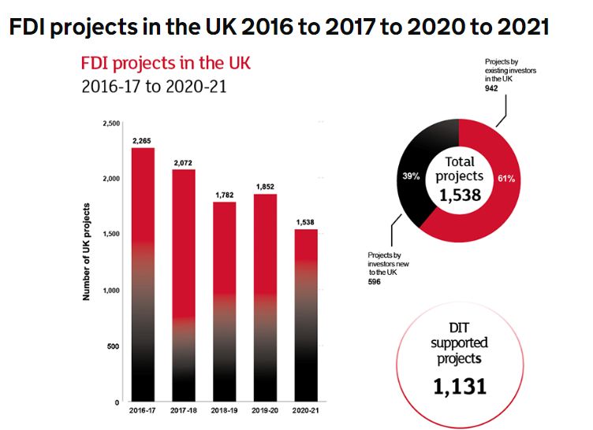
Figure 3
Source- Department of International Trade.
The following data outlines the number of Foreign Direct Investment (FDI) projects accomplished in the UK during 2016-2017, 2017-2018, 2018-2019, 2019-2020, and 2020-2021.

- 2016-2017: 2,265 projects
- 2017-2018: 2,072 projects
- 2018-2019: 1,782 projects
- 2019-2020: 1,852 projects
- 2020-2021: 1,538 projects

In the fiscal year 2020-2021, the Department for International Trade supported 1,131 out of 1,538 Foreign Direct Investment (FDI) projects. Notably, 39% of these projects (596) originated from new investors in the UK, while existing investors contributed the remaining 61% (942 projects).

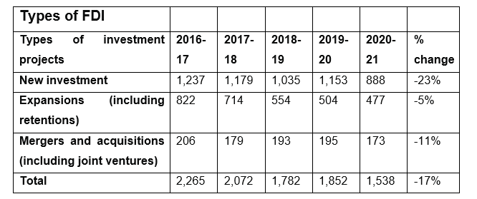
Figure 4
Source – Department of International Trade.

2.3.4 Joint Ventures
Characteristics
Joint ventures typically involve two or more businesses joining forces for a specific project or period. The partners in a joint venture share the risks and rewards of the endeavour, working together to achieve a common goal. Depending on the agreement, they may contribute capital, technology, expertise, or other resources to the joint venture. Each partner retains its identity and is not merged into a new entity, distinguishing joint ventures from mergers or complete acquisitions.
Advantages
Some advantages of joint ventures include:
1. Access to new markets and distribution networks: Joint ventures allow businesses to enter new markets and access existing distribution channels by partnering with other companies.
2. Sharing of risks and costs: By collaborating in a joint venture, businesses can share the financial risks and costs associated with a specific project or market entry, reducing the burden on each partner.
3. Pooling of resources and expertise: Joint ventures enable partners to combine their resources, knowledge, and expertise, leading to synergy that can enhance the venture's success.
4. Reduced barriers to entry: Joint ventures can help businesses overcome regulatory or cultural barriers when entering a new market, leveraging their partners' local knowledge and connections.
5. Learning opportunities: Partners in a joint venture can learn from each other, gaining insights into business practices, technologies, and market dynamics.

These are just a few advantages of joint ventures, making them appealing for business collaboration.

Examples of Companies
Some examples of joint ventures in the UK since 2020 include the partnership between Jaguar Land Rover and BMW to develop electric drive units and the collaboration between BP and German energy firm Energie Baden-Württemberg (EnBW) to build and operate offshore wind farms in the UK. These joint ventures showcase international cooperation and technology sharing in the UK's automotive and renewable energy sectors.

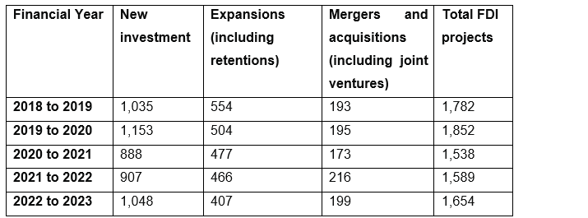Figure 5
Source – Department of International Trade.

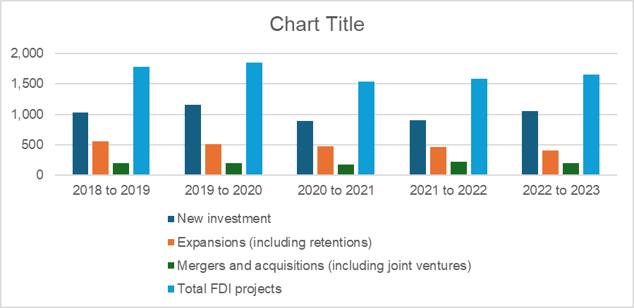
Figure 6
Source: Department of International Trade.

2.4 FDI BY DIRECTION
FDI by directions has two types:
Inward FDI
Outward FDI

2.4.1 Inward FDI
Inward foreign direct investment (FDI) occurs when a company or individual from one country invests in a business located in another country. This can take the form of acquiring a stake in an existing company, establishing new operations, or reinvesting profits from international business activities. Inward FDI is a crucial measure of a country's appeal to foreign investors and can significantly impact the economy and business environment.
1. Amazon's expansion in the UK: Following Brexit, Amazon announced plans to expand its investment in the UK. The company committed to creating thousands of new jobs and investing in new fulfilment centres and corporate offices, indicating confidence in the UK market post-Brexit ("Amazon to create 10,000 new UK jobs post-Brexit" - The Guardian).
2. Nissan's commitment to UK manufacturing: Despite Brexit uncertainties, Nissan confirmed its commitment to producing new vehicle models in the UK. The company's investment signalled a vote of confidence in the UK's automotive industry post-Brexit (Nissan - Financial Times,2023).
3. Inward FDI in UK financial services: Several international financial institutions, including JPMorgan Chase and Goldman Sachs, have announced plans to expand their operations in the UK post-Brexit, demonstrating ongoing investment and confidence in the UK's financial services sector (Reuters,2023 & bloomberg.com/news/articles,2022).
These examples show that despite Brexit, the UK continues to attract significant inward FDI across various sectors, signalling continued confidence in the country's economy and business environment.

2.4.2 Outward FDI
Outward FDI, or "direct investment abroad," occurs when a domestic company invests in business operations or acquires assets in a foreign country. This type of investment is often made to gain access to new markets, resources, and business opportunities and diversify a company's global operations.

In the United Kingdom (UK), there are numerous examples of outward FDI by UK-based companies. One prominent example is BP (British Petroleum), a major multinational oil and gas company. BP has engaged in outward FDI by investing in oil exploration and production ventures in various countries worldwide, including the United States, Russia, and other countries. This strategic approach has allowed BP to diversify its global operations and access valuable energy resources in different regions.
Another example is Vodafone, a leading telecommunications company headquartered in the UK. Vodafone has pursued outward FDI by acquiring and investing in mobile networks and telecommunications infrastructure in multiple countries, such as India, Germany, and South Africa. These investments have enabled Vodafone to expand its global reach and offer telecommunication services in diverse markets.
Furthermore, pharmaceutical companies such as GlaxoSmithKline (GSK) and AstraZeneca have engaged in outward FDI by establishing research and development facilities, manufacturing plants, and sales operations in various countries outside the UK.
These examples illustrate how UK-based companies undertake outward FDI to access new markets, capitalise on growth opportunities, and diversify their operations across different geographical regions, ultimately contributing to global competitiveness and growth.

The following Table shows the FDI Project recorded from 2014 to 2023.

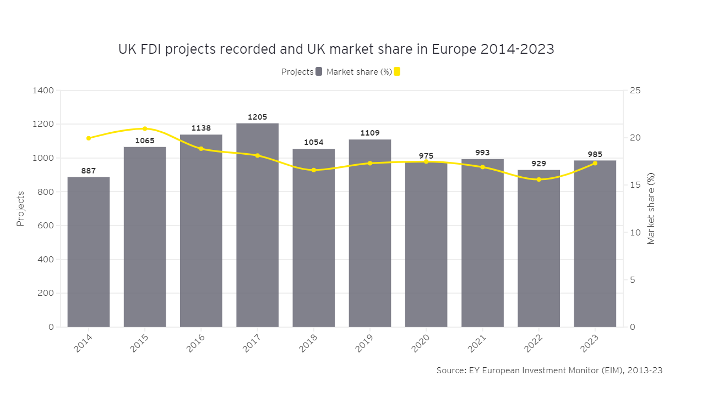
Table 6

Table 7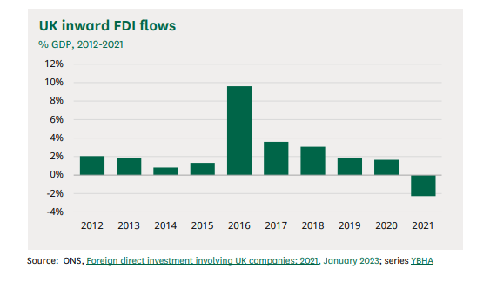

The impact of Brexit and the coronavirus outbreak on foreign direct investment in the UK has sparked much discussion. Since the EU referendum in June 2016, there has been a consistent uptick in inbound investment in the UK, as indicated by analysis of quarterly data from the Office for National Statistics (ONS). From Q1 2017 to Q4 2021, growth was recorded in 14 out of 20 quarters. It's worth noting, however, that this growth was not as rapid as it was in 2016, which saw particularly high levels of investment. Moreover, it's important to bear in mind that flows of foreign direct investment (FDI) can be erratic. Despite experiencing positive trends in every quarter, investment saw a significant slowdown after Q1 2020. Following a £20.6 billion net inflow in Q1, there was a sharp 95% decrease to £1.1 billion in Q2.(Source ONS.Gov,2023)

Table 8
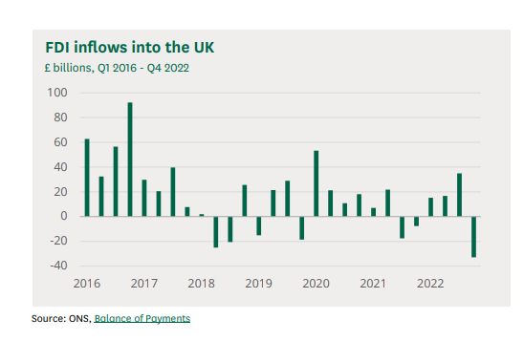

The UK remained a desirable location for international investors because of its stable legal system and low corporate tax, even in the face of Brexit uncertainties, according to a 2019 Economist article.
However, contrasting views suggest that post-referendum foreign direct investment (FDI) may have primarily involved acquiring British companies at discounted prices rather than substantial investment in the country's growth.
In a recent statement, British Minister for Investment, Lord Dominic Johnson, emphasised the availability of significant funding to support burgeoning industries through various programs. Johnson underscored the importance of strategically promoting the country's support subsidies, grants, and investment initiatives.
However, in terms of drawing in foreign direct investment (FDI) projects last year, France did better than the UK, according to the EY European Attractiveness Survey. According to the report, the UK's proportion of European digital tech initiatives has declined, from 28.3% on average over the previous ten years to 19.8% in 2022.

2.5 Chapter Summary
The literature review chapter provides an overview of existing research, theories, and knowledge related to the topic of interest. It aims to identify gaps in the current understanding and establish the groundwork for the study. This literature review focuses on analysing Foreign Direct Investment (FDI) projects and the impacts of joint ventures, with a specific emphasis on the UK market.
The chapter begins with a detailed analysis of FDI statistics, highlighting the number of projects, types of investment, and changes observed over the years. It delves into the role of the Department for International Trade in supporting FDI projects, showcasing the scale and significance of foreign investment in the UK.
Additionally, the chapter delves into the concept of FDI by direction, distinguishing between inward FDI and outward FDI. Through real-world examples, it illustrates the impact of inward FDI on the UK economy, demonstrating how international companies continue to invest in the UK market despite uncertainties such as Brexit. It also sheds light on the nature of outward FDI and how domestic companies expand their investments abroad.
Overall, the literature review aims to comprehensively understand FDI projects, joint ventures, and the dynamics of inward and outward investment. It sets the stage for the research by providing a solid foundation of knowledge and insights into the complex world of international business and investment.

Chapter 3- Research Methodologies

3.1 Introduction
This chapter will present an overview of the dissertation's methodology and discuss the various research types and procedures available for scholarly investigation.

3.2 Research Methodologies
Research methodologies refer to the systematic and structured techniques and procedures researchers use to conduct their studies and gather relevant data. These methodologies assist researchers in achieving their objectives and drawing conclusions from their research. Various research methodologies, such as pure and applied research, serve different purposes and utilise distinct approaches to gather and interpret data. The research process involves several steps, including formulating research questions, reviewing existing literature, collecting and analysing data, and drawing conclusions based on the findings. These steps are crucial in guiding researchers towards completing their research projects (Kothari, C.R, 1985).

3.3 The Main Types Of Research
There are three types of research:
1. Quantitative research
2. Qualitative research
3. Mixed-method research

3.3.1 Quantitative Research
When conducting quantitative research for Foreign Direct Investment (FDI), detailed analysis involves utilizing statistical and econometric methods to examine specific aspects of FDI and its impact on the economy.

To effectively achieve our research objectives, it is imperative to undertake a thorough analysis aimed at uncovering the answers to our specific research inquiries. This involves comprehensively grasping and effectively leveraging data derived from various sources. To meticulously compare the secondary data, we will employ a range of analysis methods which are detailed below. These methods will allow us to quantitatively assess the data and provide a thorough and detailed analysis.

Here are a few quantitative research techniques and examples of their application in FDI analysis:

3.3.2 Quantitative Research Techniques

1 Regression Analysis:
Regression analysis can be used to identify the determinants of FDI. This allows us to examine the relationship between FDI inflows and various factors such as market size, labour costs, infrastructure, government policies, and economic stability. For example, a study may use regression analysis to assess the impact of tax incentives on FDI inflows in a specific industry or region.

2 Input-Output Analysis:
Input-output analysis can be applied to evaluate the inter-industry linkages and multiplier effects of FDI. We can use input-output models to quantify how FDI in a particular sector affects other sectors of the economy

3 Panel Data Analysis:
Panel data analysis involves using data from multiple periods and/or geographical units to analyse the impact of FDI. We can employ fixed or random effects models to examine how FDI affects economic variables over time or across different regions. For example, a panel data analysis can assess the relationship between FDI and regional economic growth in various countries over a decade.

4 Computable General Equilibrium (CGE) Modelling:
CGE modelling can be utilised to simulate the effects of FDI on the overall economy. We can construct a CGE model to estimate the impact of increased FDI in a specific sector on factors such as GDP, employment, trade balance, and income distribution. For instance, a study may use CGE modelling to analyse the effects of FDI in the services sector on the economy of a developing country.

When applied to the analysis of FDI, these quantitative research methods provide insights into the determinants, impacts, and implications of foreign direct investment on the economy. Each technique offers a unique perspective on the quantitative aspects of FDI and contributes to a comprehensive understanding of its effects on economic growth, employment, productivity, and trade dynamics.

Quantitative research quantifies data and applies statistical and mathematical techniques to analyse and interpret it. This type of research uses a structured methodology to collect data that can be measured and quantified. It aims to establish generalisable results and often involves gathering information from surveys, experiments, and structured observations.

3.4 DATA Collection Sources and Limitations

When it comes to collecting data for research on Foreign Direct Investment (FDI), several sources can be utilized to gather relevant information. Some of the primary data collection sources for FDI research include official government statistics, reports from international organizations such as the World Bank and the United Nations, academic journals, industry reports, and databases from central banks and financial institutions.
Official government statistics provide valuable FDI inflow and outflow data, as well as insights into the sectors and countries attracting the most foreign investment. Reports from international organizations offer comprehensive analysis and global perspectives on FDI trends, policies, and impacts. Academic journals provide in-depth scholarly research and case studies on specific aspects of FDI, contributing to a deeper understanding of the subject. Industry reports offer sector-specific data and analysis, highlighting trends and patterns within particular industries. Databases from central banks and financial institutions contain detailed financial and economic data that can be used for FDI analysis.
While these sources offer valuable information for FDI research, it's important to be aware of their limitations. Government statistics may have lags in reporting, inconsistencies in classification, or limited coverage of certain types of FDI. Reports from international organizations can be subject to bias or may not capture the full diversity of FDI experiences across different regions. Academic journals may have a focus on theoretical research and may not always reflect real-time FDI trends. Industry reports may be influenced by the perspectives of specific companies or industry players. Databases from central banks and financial institutions may have data limitations and may not always be directly comparable across different countries.
Therefore, when collecting data for FDI research, it's essential to critically evaluate the reliability, relevance, and comparability of the sources. Researchers should triangulate data from multiple sources to gain a more comprehensive understanding of FDI patterns and dynamics, and where possible, supplement the secondary data with primary data collection methods such as surveys, interviews, and case studies to enrich the research findings. Additionally, researchers should be transparent about the limitations of the data sources used and the potential impact of these limitations on the research outcomes. By acknowledging these limitations and taking a rigorous approach to data collection, researchers can enhance the credibility and robustness of their FDI research.

3.4.1 Quantitative Data for the UK for FDI.
Please see below some of the data which we use to analyse our research objectives.

3.4.2 Capital Flows
The below diagram shows the capital flow for the UK from 2015 to 2023. (Source: Office for National Statistics UK)

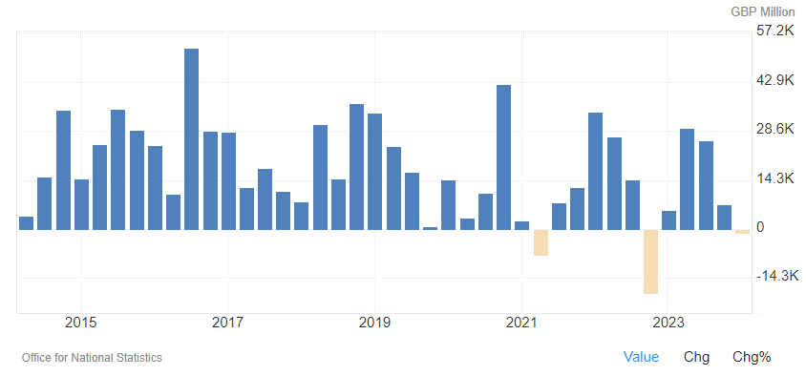
Figure 9
source: Office for National Statistics

3.4.3 Linear Regression Analysis.
The relationship between two continuous variables is best represented by a straight line, which is the linear regression line. In statistical analysis, it is frequently employed to discern patterns and trends in the data. If y is the dependent variable, x is the independent variable, m is the line's slope, and c is the y-intercept, then the formula for a linear regression line is y = mx + c. The value of y at x = 0 is the y-intercept, and the slope indicates the rate of change. Predictions and an understanding of the strength of the link between the variables can be made using the line.

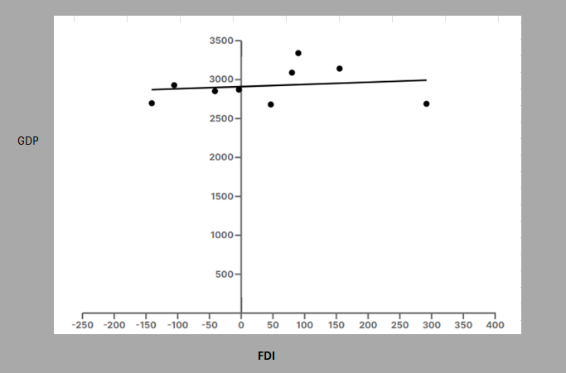
Figure 10 – Researcher's own calculations
Best-fit values
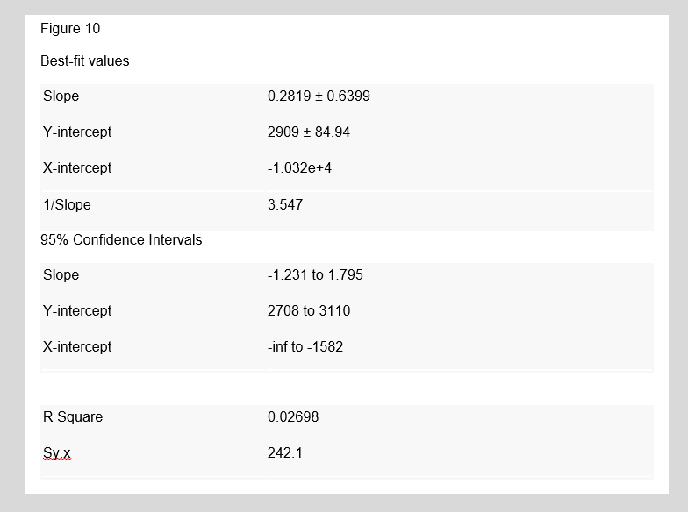
Source - Researcher own calculations

3.4.4 Other Statistical Analysis.
Description | NET FDI - Billions | GDP- In Billions | Percentage FDI/GDP%
2015 | - 105.51 | 2,927.91 | -3.60%
2016 | - 291.90 | 2,689.11 | -10.86%
2017 | 46.69 | 2,680.15 | 1.74%
2018 | - 3.58 | 2,871.34 | -0.12%
2019 | - 41.29 | 2,851.41 | -1.45%
2020 | - 140.80 | 2,697.81 | -5.22%
2021 | 155.01 | 3,141.51 | 4.93%
2022 | 79.99 | 3,088.84 | 2.59%
2023 | 90.03 | 3,340.03 | 2.70%
Standard Deviation. Population | 130.65 | 216.37 | 5%
Median | - 3.58 | 2,871.34 | -0.12%
Mean | - 23.48 | 2,920.90 | -1.03%
Standard deviation | 138.58 | 229.49 | 4.90%
Figure 11
(Source- Data World Bank - Calculation Researcher Own working)

3.4.5 Interest Rate
The interest rate is also a positive measure of the country's economic stability. Set by the central bank, it influences borrowing costs, savings returns, and investment decisions within the economy. A higher interest rate tends to reduce borrowing and stimulate saving, while a lower interest rate encourages borrowing and spending.
In the United Kingdom, the prevailing interest rate is closely monitored to gauge the overall economic conditions. Changes in the interest rate can signal the central bank's stance on inflation, economic growth, and employment. Investors and businesses often assess interest rate movements to make informed decisions regarding investments, borrowing, and expansion plans.
Overall, the interest rate is a significant indicator of the UK's economic health and is closely watched by market analysts, policymakers, and financial institutions.
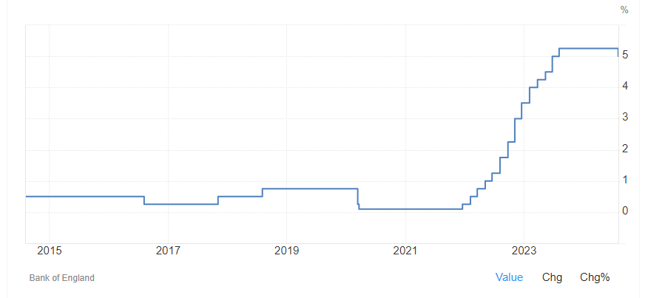
Figure 12 – Source Bank of England, April 2024
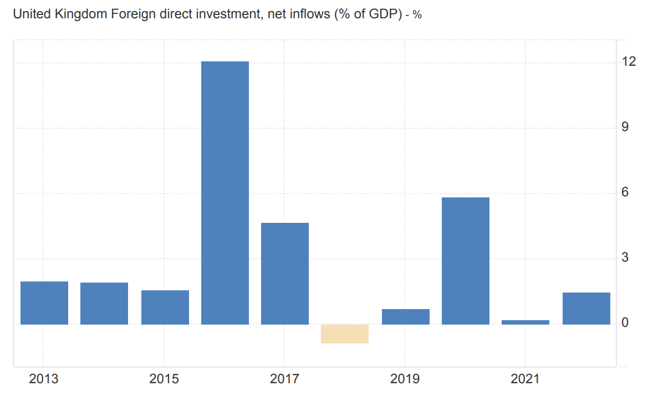
Figure 13 (Source Bank of England)
The following table shows the variance and change from Q3 of 2023 to Q3 of 2024.
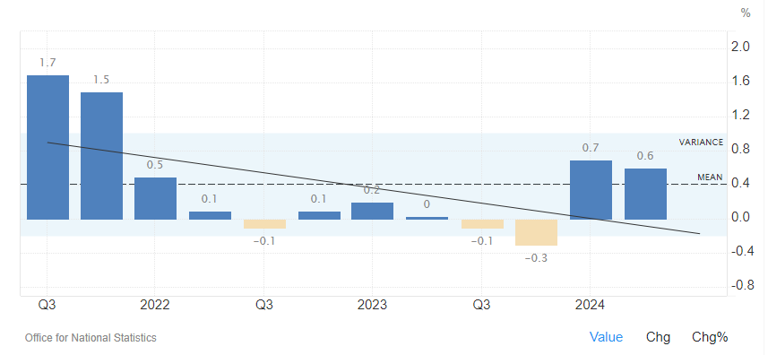
Figure 14 (Source: ONS)
The following table Comparison of UK GDP Growth with EU Annual Growth
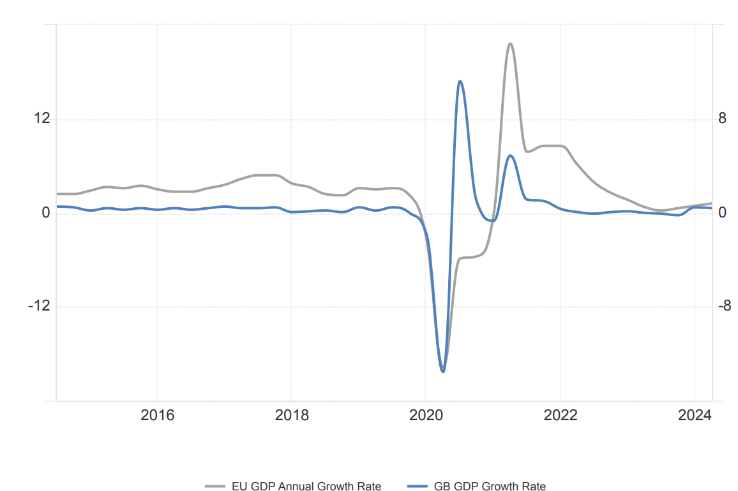
Figure 15 (Source- World Bank)

3.4.6 Unemployment Rate
The analysis of the unemployment rate is important when examining foreign direct investment (FDI) because it can provide insights into FDI's impact on the labour market and overall employment conditions. Understanding how FDI influences unemployment can help policymakers, businesses, and researchers comprehend the broader socioeconomic effects of foreign investment.
When FDI flows into a country, it can lead to job creation through the establishment of new businesses, expansion of existing enterprises, and investments in various industries. A thorough analysis of the unemployment rate in conjunction with FDI can reveal the extent to which foreign investment contributes to reducing unemployment or creating new employment opportunities. This assessment is valuable for assessing the effectiveness of FDI in generating sustainable employment and improving labour market conditions.
Additionally, analysing the unemployment rate in the context of FDI can shed light on the quality of jobs created as a result of foreign investment. It allows for the examination of whether the jobs generated by FDI are primarily low-skill, low-wage positions or if they contribute to higher-skilled employment and overall human capital development. Understanding the nature of employment created by FDI is crucial for evaluating its long-term impact on the workforce and economic development.

Furthermore, the relationship between FDI and unemployment can also influence government policies and investment strategies. Policymakers may use insights from the analysis to formulate targeted policies aimed at maximizing the positive effects of FDI on employment while mitigating potential negative consequences. Additionally, businesses considering foreign investment can assess the labour market conditions, including the unemployment rate, to make informed decisions regarding their investment plans and potential job creation initiatives.
In summary, analysing the unemployment rate for FDI provides a comprehensive understanding of how foreign investment influences employment dynamics, facilitates the assessment of job quality, informs policy decisions, and aids in strategic investment planning.
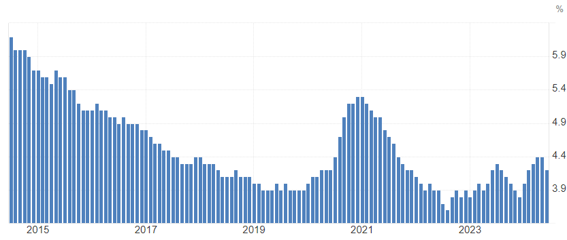
Figure 16
Source-World Bank

3.4.7 Future GDP Forecast
The following figure shows the future GDP forecast for the United( Source-World Bank).


These figures provide insights into the projected growth of the UK's economy in the coming quarters.

GDP | Q3/24 | Q4/24 | Q1/25 | Q2/25
GDP Growth Rate (%) | 0.30 | 0.20 | 0.30 | 0.40
GDP Annual Growth Rate (%) | 1.20 | 1.00 | 1.40 | 1.40
GDP Constant Prices (GBP Million) | 575,218.00 | 572,292.00 | 578,684.00 | 581,991.00
Gross National Product (GBP Million) | 679,391.00 | 675,322.00 | 686,768.00 | 686,768.00
Monthly GDP YoY (%) | 1.60 | 1.80 | 1.50 | 1.20
Monthly GDP MoM (%) | 0.20 | 0.30 | 0.20 | 0.10
GDP from Manufacturing (GBP Million) | 50,807.00 | 50,212.00 | 50,954.00 | 50,636.00
GDP from Services (GBP Million) | 414,965.00 | 413,560.00 | 418,705.00 | 422,062.00
GDP (USD Billion) |  | 3,383.00
GDP per Capita (USD) |  | 47,616.00
GDP per Capita PPP (USD) |  | 54,830.00
Full Year GDP Growth (%) |  | 1.30
Figure 17 (Source Data – ONS United Kingdom)

3.5 Qualitative Research
Qualitative research serves as a method for comprehending the underlying reasons, opinions, and motivations. It offers valuable insights into a given problem or aids in the development of ideas and hypotheses for potential quantitative research endeavours. An example of qualitative research could be a study conducted through interviews or focus groups to understand people's perceptions of a new product or to explore the impact of a particular social phenomenon.

3.6 Mixed-Method Research
The mixed-method research approach uses quantitative and qualitative research methods to understand a phenomenon comprehensively. For example, a mixed-method approach in education research might include collecting and analysing numerical data on student test scores (quantitative) and conducting interviews or focus groups with teachers and students to understand their experiences and perspectives (qualitative). By combining both data types, researchers can gain a more thorough and nuanced understanding of their study topic.
A mixed-method approach for analysing Foreign Direct Investment (FDI) involves using both qualitative and quantitative methods to gain a comprehensive understanding of FDI trends, patterns, and impacts. Qualitative methods such as interviews, case studies, and content analysis can provide in-depth insights into the motivations and experiences of the involved parties. On the other hand, quantitative methods such as statistical analysis, econometric modelling, and data mining can offer numerical evidence and trends related to FDI flows, investment patterns, and economic impacts. By combining both approaches, researchers can gain a more comprehensive and nuanced understanding of FDI dynamics and its implications for host and home countries.

3.7 The Research Process
According to Dawson and Catherine (2002), the researcher must define the research barriers, which can be accomplished by evaluating other people's work in the same subject and tying it to the study objectives.
The research process involves a systematic and organised series of steps that researchers adhere to gather information, address inquiries, or test hypotheses. Firstly, researchers define a research question or problem to establish the focus of their study. They then conduct a thorough literature review to understand existing knowledge and identify gaps in the research. After this, they outline a research plan detailing the methodologies, data collection techniques, and analysis procedures they will employ. Subsequently, researchers gather data through observation, experimentation, surveys, or other methods and analyse it to derive meaningful conclusions. Finally, they effectively communicate their findings through research papers, reports, presentations, or other forms of dissemination. The specific approach to the research process may vary depending on the discipline and the nature of the research being conducted, with different fields employing distinct methodologies and techniques.
The steps involved in the research process include the following:
Defining And Identifying the Research Problem Or Topic That Needs Investigation.
To define and identify a research problem or topic that necessitates investigation, several essential steps can be followed:
- Select the general area of interest: Initially, pinpoint a broad or general topic that aligns with my expertise or is pertinent to my field of study.
- Conduct a comprehensive literature review: This involves thoroughly reviewing existing literature, research papers, and scholarly articles to gain insight into prior studies in area of interest.
- Refine the focus: Based on the initial review, discern specific gaps, contradictions, or unresolved questions within the existing literature. This process aids in narrowing the focus and pinpointing potential research problems.
- Formulate specific research questions: Based on the identified gaps or unresolved issues, craft precise research questions that demand attention. These inquiries should be articulate, concise, and targeted.
- Define the problem statement: Once the research questions are delineated, articulate a clear and precise problem statement summarising the issue slated for investigation.
These steps can help one identify a research problem or topic that warrants investigation.

Reviewing And Analysing Existing Literature To Understand The Current State Of Knowledge On The Topic.
To review and analyse existing literature to understand the current state of knowledge on a topic, we can comprehensively search academic databases, journals, and credible online resources relevant to my subject matter. we can use appropriate keywords and phrases to narrow the search results to the most pertinent literature (Bell, J. 1999).
Once we have compiled a collection of relevant sources, we assess the quality and relevance of each source to ensure that it is credible and authoritative. we also note key findings, methodologies, and theoretical frameworks in the literature.
It's also essential to identify gaps or disagreements within the literature. This can help pinpoint where further research or analysis is needed to advance understanding of the topic.

By critically evaluating and synthesising existing literature, we can gain valuable insights into the current state of knowledge on the topic, providing a solid foundation for my research or analysis.

Formulating A Specific Research Question Or Hypothesis To Address The Problem.
When formulating a specific research question or hypothesis to address a problem, it must clearly define the problem we are trying to solve. Then, consider what we want to achieve through our research and what specific aspect of the problem we want to investigate. Once we have a clear understanding of the problem, we can then formulate a research question that is specific, focused, and can be addressed through research. Alternatively, we can develop a hypothesis, a testable prediction about the relationship between variables. This process involves carefully considering and reviewing existing literature to ensure my research question or hypothesis is relevant and valuable.
Designing A Detailed Research Methodology That Outlines The Approach, Data Collection Methods, And Analysis Techniques.
Formulating a detailed research methodology is akin to architecting a precise blueprint for the entire research process. This intricate framework meticulously maps out the strategic approach that will be adopted, carefully selects the methods for data collection, and outlines the comprehensive array of analytical techniques that will be deployed. Each methodology component, from defining the research questions to specifying the sources of data and delineating the intricacies of the analysis, is painstakingly crafted to ensure that every aspect of the research is conducted with transparency and rigour. This structured approach is a cornerstone in fostering the reliability and validity of the research outcomes.
Collecting And Analysing Data Using Appropriate Methods To Derive Meaningful Insights.
To collect and analyse data using appropriate methods to derive meaningful insights, we can start by clearly defining my research question or objective. Then, we can identify the data sources relevant to my research question and gather the data using appropriate methods such as surveys, interviews, or existing databases.

Once the data is collected, the analysis can begin by cleaning it to ensure accuracy and consistency. Then, select the appropriate analytical methods, such as statistical analysis, data mining, or visualisation techniques, to derive meaningful insights from the data.

Throughout the process, it's essential to maintain the integrity and confidentiality of the data and ensure that the analysis is conducted ethically. Finally, it communicates the findings effectively to stakeholders and decision-makers to drive informed decision-making.
Drawing Conclusions Based On The Analysis And Discussing The Implications Of The Findings.
This should carefully analyse the data gathered, draw conclusions based on the analysis, and discuss the implications of the findings. I should look for patterns, trends, and relationships within the data to help me answer my research questions and address my research problem.

After analysing the data, draw conclusions based on the findings. Ensure that the evidence collected supports the conclusions. It's essential to be thorough and transparent in analysis and to consider alternative explanations for the findings.

Once the conclusion has been drawn, we can discuss the implications of my findings. we should consider the broader significance of the research and how it contributes to the field's existing body of knowledge. It should also discuss any practical applications of the findings and consider how they might impact the field or the specific problem we are addressing.
It's essential to be clear and concise in discussing the implications of my findings and to consider any potential limitations of my study. Finally, this relates to conclusions and their implications for the original research questions and objectives.

Communicating The Research Findings Effectively Through Reports, Presentations, Or Publications To Share The Knowledge Gained.
To effectively communicate research findings, it's essential to structure the reports, presentations, or publications carefully. Start by outlining the key objectives, methodologies, and results in a clear and organised manner. Use descriptive language and provide contextual information to ensure the audience can easily comprehend the findings. Additionally, consider incorporating visual aids such as graphs, charts, and images to enhance the presentation of data and make the information more accessible. Tailoring the communication style to the audience's level of understanding is crucial, ensuring that the knowledge gained is effectively conveyed and comprehended. Encouraging questions and discussions further promotes knowledge sharing and allows for a deeper exploration of the findings.

3.8 Research Onion
Research Onion is a model Saunders et al. (2007) proposed for conducting research. It is a methodology that allows researchers to approach a research question systematically and structured. The research onion consists of different layers: philosophy, approach, strategy, choices, time horizon, and techniques. These layers help develop a comprehensive understanding of the research process and the methodological decisions involved (Saunders, M., Lewis, P., & Thornhill, A., 2007).
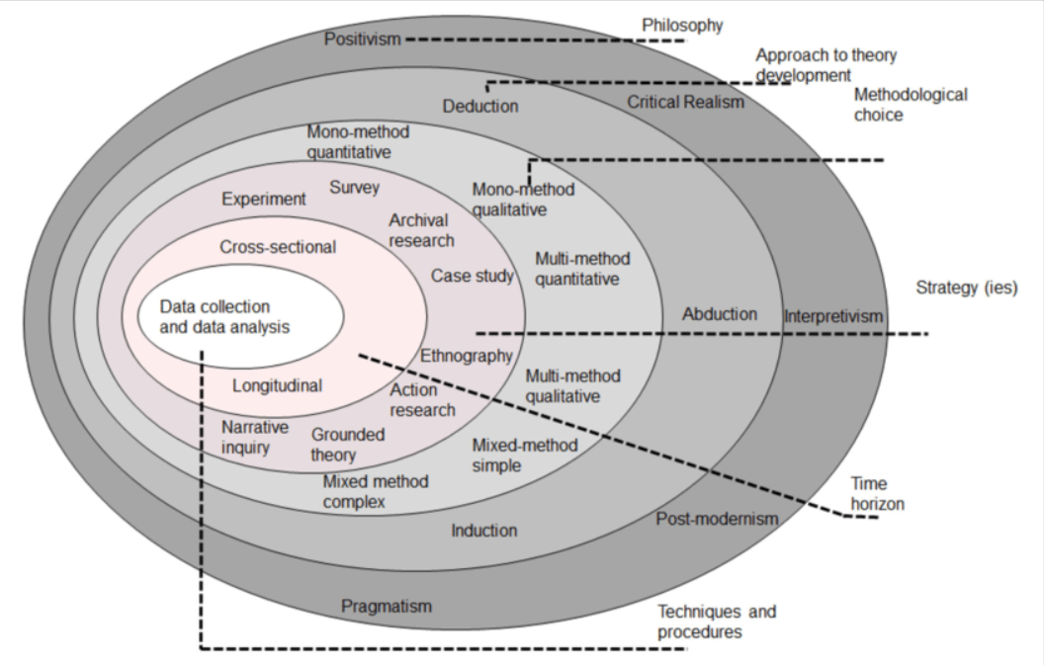
Figure 18
Source: Saunders, P. & LEWIS, A T. (2009)
Research Philosophy:
This layer deals with the researcher's assumptions about the nature of knowledge and how it can be obtained. It includes the choice between positivist and interpretivist paradigms.
Research Approach:
This layer involves deciding whether the research will be deductive or inductive. Deductive research starts with a general theory and then tests it with specific observations, while inductive research starts with specific observations and then seeks to discover general patterns or theories.
Research Strategy:
This layer involves choosing a specific research strategy, such as experiments, surveys, case studies, or ethnography, based on the nature of the research problem.
Time Horizon:
This layer refers to the research's temporal perspective and whether the study is cross-sectional or longitudinal.
Data Collection Methods:
This layer covers the methods and techniques employed to gather relevant data, including surveys, interviews, observations, or document analysis.
Data Analysis Techniques:
This layer includes the methods used to analyse and interpret the collected data, such as statistical analysis, content analysis, thematic analysis, or grounded theory.
The research onion provides a comprehensive framework for researchers to conceptualise the various elements involved in the research process and make informed decisions at each stage. It encourages researchers to consider the interconnectedness of the different layers and how they influence each other throughout the research journey.

3.9 Ethical Consideration
When conducting research, ethical considerations play a crucial role in ensuring the rights and well-being of participants are protected. Researchers must adhere to ethical guidelines, such as obtaining informed consent from participants, ensuring confidentiality, and minimising potential harm. Additionally, it is essential to consider the research's cultural sensitivity and avoid discrimination. Ethical considerations help maintain the integrity and validity of the research process.

3.10 Chapter Summary
This chapter provides a comprehensive overview of the critical steps involved in the research process. It emphasises the importance of formulating a specific research question or hypothesis to address the problem, highlighting the need to define the issue being addressed clearly. The chapter then delves into the significance of designing a detailed research methodology, emphasising the meticulous framework required to ensure transparency and rigour in the research process. Additionally, it emphasises the importance of collecting and analysing data using appropriate methods to derive meaningful insights. It draws attention to the need for maintaining data integrity and ethical conduct throughout this process. Furthermore, the chapter emphasises the significance of drawing conclusions based on the analysis and discussing the implications of the findings, stressing the need for thoroughness and transparency in the study. Lastly, the chapter underscores the importance of effectively communicating research findings through reports, presentations, or publications, focusing on ensuring clarity and accessibility while also adhering to ethical considerations to protect the rights and well-being of participants.

Chapter 4: Dissertation Analysis & Findings.

4.1 Introduction
This section of the dissertation will systematically present the research findings and analysis, aligning them with the predefined goals established in the preceding chapters. Furthermore, it will conclude with a comprehensive summary of the presented information.

4.2 FDI Overview
Foreign direct investment (FDI) serves as a vital catalyst for the global economy, driving economic growth, creating fresh business opportunities, and nurturing innovation and technological advancement. FDI is intricately linked to specific geographical attributes, market expansion potential, and factors such as labour costs, transport accessibility, and technological advancements. Its impact on the economy is significant and positive, fuelling rapid and widespread economic expansion. The appeal of markets for FDI varies across regions and is influenced by factors such as the legal framework, financial prospects, and political stability. Furthermore, the decision to join international bodies like the EU can significantly affect FDI flows between countries, as evidenced by studies examining FDI data among OECD nations.
Greater London saw 359 projects involving foreign direct investment (FDI) in 2023, up 20% from 2022. Greater London's status as Europe's best-performing investment location was cemented by this rise. The West Midlands saw notable expansion as well, gaining 127 projects in 2023—a 72% increase from the year before and a seventh-best ranking for FDI in Europe. In 2023, the UK's portion of the European inward investment market increased from 15.6% in 2022 to 17.3%. Increased digital investment was a major factor in the UK's FDI growth last year; the nation secured more than a quarter (27%) of all European tech projects. According to EY's annual rating of European nations, the UK continues to rank second for attracting projects involving foreign direct investment (FDI). It was the only one of the top three countries where the number of projects increased annually. Germany came in third, and France took the top spot in Europe for the fifth year running, according to the EY 2024 UK Attractiveness Survey. In 2023, there were 985 FDI projects in the UK, up 6% from the previous year (EY.com-news, July 2024).
Foreign direct investment, also known as parent enterprise or foreign direct investment, is defined by Carkovic and Levine (2002) as an investment that involves a long-term relationship and reflects a persistent interest and control by a resident entity in one economy over an enterprise that is resident in an economy other than the investor's. This comprises the first transaction that establishes the financial relationship and any follow-up transactions that are connected to the inflow and outflow of foreign direct investment between the foreign affiliate and the foreign direct investor. A substantial amount of influence or control over the management and operations of the invested enterprise can be gained via forming subsidiaries, mergers, and acquisitions, as well as by starting new businesses. These strategies are usually used to establish a long-lasting presence.

4.3 Detail Analysis of Objectives
Now, we will discuss and analyse the research objectives in detail.
- The main factors that can influence FDI.
- Impact of Brexit on FDI in the UK.
- The impact of FDI on economic growth.

4.4 Statistical Calculations and Analysis
Statistical data plays a crucial role in producing analysis by providing a quantitative framework for understanding trends, patterns, and relationships within the data. Moreover, statistical analysis enables researchers to test hypotheses, identify significant differences or correlations, and make inferences about populations based on sample data. By using statistical techniques such as regression analysis, t-tests, ANOVA, and correlation analysis, we can uncover hidden patterns, trends, and associations within the data, ultimately contributing to a comprehensive and evidence-based analysis.
Year | NET FDI - Billions | GDP- In Billions | Unemployment Rate | Percentage FDI/GDP%
2015 | -105.51 | 2,927.91 | 5.4 | -3.60%
2016 | -291.9 | 2,689.11 | 4.9 | -10.86%
2017 | 46.69 | 2,680.15 | 4.4 | 1.74%
2018 | -3.58 | 2,871.34 | 4.2 | -0.12%
2019 | -41.29 | 2,851.41 | 3.9 | -1.45%
2020 | -140.8 | 2,697.81 | 4.7 | -5.22%
2021 | 155.01 | 3,141.51 | 4.6 | 4.93%
2022 | 79.99 | 3,088.84 | 3.9 | 2.59%
2023 | 90.03 | 3,340.03 | 4 | 2.70%
Figure 19 Source -World Bank

4.4.1 Regression Analysis
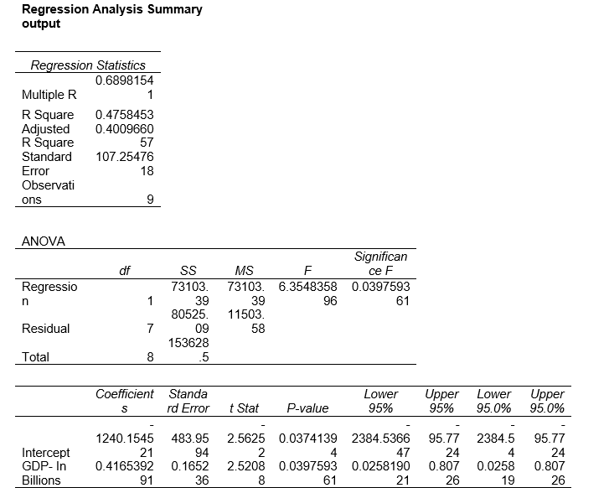
Several varieties of regression models can be applied to various types of data analysis. Some popular regression models include simple linear regression, multiple linear regression, polynomial regression, logistic regression, ridge regression, and lasso regression. Each of these models has its own advantages and disadvantages, and the choice of model depends on the type of data and the research objectives.
Regression models can be used to analyse the factors that influence Foreign Direct Investment (FDI). By using regression analysis, we can assess the impact of various independent variables such as market size, labour costs, infrastructure, political stability, and government policies on FDI inflows. This helps in understanding the drivers of FDI and formulating policies to attract more foreign investment. Different types of regression models can be applied based on the nature of the data and the specific research questions related to FDI.
In our calculations, the regression analysis yielded an R-squared value of less than 0.90, indicating that the model accounts for a significant but not overwhelming portion of the variability in the data, which is generally considered acceptable. Our dataset encompasses observations from the last 9 years, allowing for a comprehensive analysis of trends. Furthermore, the positive p-value suggests a direct and statistically significant relationship between economic growth and Foreign Direct Investment (FDI), indicating that as the economy grows, there is an observable increase in FDI inflows. Our detailed regression analysis indicates that there is a strong positive correlation between the influx of foreign direct investment (FDI) and the level of economic growth. This suggests that as FDI increases, there is a notable acceleration in economic growth within the specified parameters of our analysis.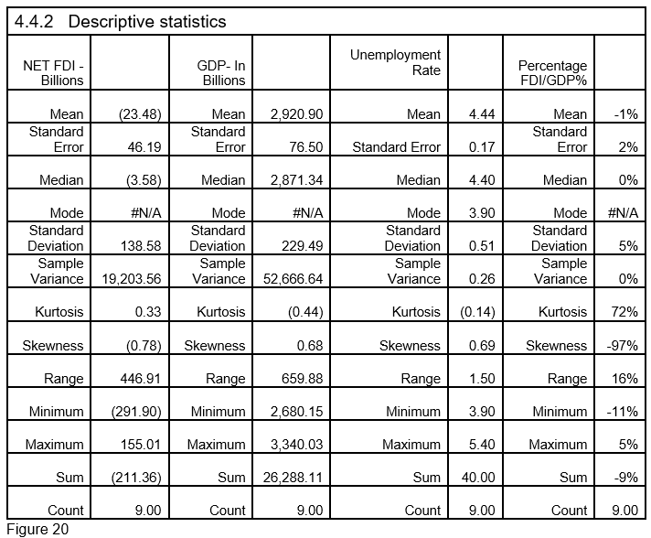
The table above provides a comprehensive overview of various statistical data points, including Foreign Direct Investment (FDI), economic growth, and employment rates spanning the last nine years. The data indicates that despite the challenges posed by Brexit, the UK economy remains an attractive destination for foreign direct investment. Our analysis involves a direct comparison of FDI with GDP growth and unemployment rates, as these two factors are crucial in understanding the overarching impact of FDI on the UK economy.

4.4.3 Linear Line Regression Graph

Figure 21 (Source: World Bank)

Figure 22 (Source: World Bank)

Table 23 (Source: World Bank)

The following table is based on data sourced from the World Bank. We have used this data to create a forecast over the next 7 years to track the expected trends of Foreign Direct Investment (FDI), Gross Domestic Product (GDP), and the Unemployment Rate. It is important to note that our analysis assumes that the factors and trends influencing these metrics will remain consistent over the next 7 years.

4.4.4 Forecast -FDI, GDP & Unemployment
Forecasted Calculations Based on 9-year Data from World Bank
Actual Data -Source World Bank | Year | NET FDI - Billions | GDP- In Billions | Unemployment Rate | Percentage FDI/GDP%
Actual Data -Source World Bank | 2015 | (105.51) | 2,927.91 | 5.40 | -4%
Actual Data -Source World Bank | 2016 | (291.90) | 2,689.11 | 4.90 | -11%
Actual Data -Source World Bank | 2017 | 46.69 | 2,680.15 | 4.40 | 2%
Actual Data -Source World Bank | 2018 | (3.58) | 2,871.34 | 4.20 | 0%
Actual Data -Source World Bank | 2019 | (41.29) | 2,851.41 | 3.90 | -1%
Actual Data -Source World Bank | 2020 | (140.80) | 2,697.81 | 4.70 | -5%
Actual Data -Source World Bank | 2021 | 155.01 | 3,141.51 | 4.60 | 5%
Actual Data -Source World Bank | 2022 | 79.99 | 3,088.84 | 3.90 | 3%
Actual Data -Source World Bank | 2023 | 90.03 | 3,340.03 | 4.00 | 3%
Forecast | 2024 | 141.29 | 3,220.64 | 3.80 | 5%
Forecast | 2025 | 174.24 | 3,280.59 | 3.67 | 6%
Forecast | 2026 | 207.19 | 3,340.53 | 3.55 | 7%
Forecast | 2027 | 240.15 | 3,400.48 | 3.42 | 8%
Forecast | 2028 | 273.10 | 3,460.43 | 3.29 | 9%
Forecast | 2029 | 306.06 | 3,520.38 | 3.16 | 10%
Forecast | 2030 | 339.01 | 3,580.33 | 3.03 | 11%
Trend | 2024 | 141.29 | 3,220.64 | 3.80 | 5%
Trend | 2025 | 174.24 | 3,280.59 | 3.67 | 6%
Trend | 2026 | 207.19 | 3,340.53 | 3.55 | 7%
Trend | 2027 | 240.15 | 3,400.48 | 3.42 | 8%
Trend | 2028 | 273.10 | 3,460.43 | 3.29 | 9%
Trend | 2029 | 306.06 | 3,520.38 | 3.16 | 10%
Trend | 2030 | 339.01 | 3,580.33 | 3.03 | 11%
y=mx+c | 2024 | 141.29 | 3,220.64 | 3.80 | 5%
y=mx+c | 2025 | 174.24 | 3,280.59 | 3.67 | 6%
y=mx+c | 2026 | 207.19 | 3,340.53 | 3.55 | 7%
y=mx+c | 2027 | 240.15 | 3,400.48 | 3.42 | 8%
y=mx+c | 2028 | 273.10 | 3,460.43 | 3.29 | 9%
y=mx+c | 2029 | 306.06 | 3,520.38 | 3.16 | 10%
y=mx+c | 2030 | 339.01 | 3,580.33 | 3.03 | 11%
Figure 24
M=Slope
X= Date
C= intercept
 | Slope | Intercept
FDI | 32.95 | (66,557.95)
GDP | 59.95 | (118,113.44)
Unemployment Rate | (0.13) | 263.55
Percentage FDI/GDP | 0.01 | (22.50)
Source- Researcher Own calculations

4.4.5 Results and Analysis of Statistical Data.
Based on the analysis of the data presented in the table, it is evident that Foreign Direct Investment (FDI) is expected to experience an upward trend in the coming years. It is reasonable to anticipate that the impact of Brexit will diminish if current trends continue. While there is a possibility of an increase in the unemployment rate, it is important to recognize that this may not be directly correlated with FDI, unlike the direct relationship between FDI and GDP. Other influential factors can affect employment, independent of FDI.
To gain a thorough understanding of these factors and the intricate relationship between FDI and economic growth, it is imperative to take into account additional data sources such as in-depth analyses from the World Bank, reports from the International Monetary Fund (IMF), and specific government targets. Therefore, following my statistical analysis, I intend to thoroughly explore these alternate data sources to provide a comprehensive and detailed analysis of the situation.

4.5 Other Source Data Analysis
Please see below other source data analysis based on different available resources e’g World Bank, ONS, Gov.UK, articles newspapers etc.

4.6 Factors That Can Influence the FDI
Please see below the main factors which can influence the economy of the country. I have chosen 4 factors to limit the research scope.

4.6.1 The Economic Condition Of The UK.
The United Kingdom (UK) is an inviting destination for foreign direct investment (FDI) and foreign ownership due to its stable, business-friendly environment. With its open, liberal economy, access to top-tier talent, and developed consumer market, the nation offers ample opportunities for trade and investment growth. Boasting a population of 67 million people and a diverse range of suppliers and partners, the UK also provides various initiatives to support businesses of all sizes, including a strong commitment to invest £100 billion in infrastructure (State.gov/reports,2023).
The economic condition of a country is essential for FDI because it directly affects the potential return on investment, the stability of the market, and the overall business environment. Factors such as GDP growth, inflation rates, currency stability, tax policies, and government debt levels all influence a country's attractiveness for foreign direct investment. A strong and stable economy provides confidence to foreign investors and can create a favourable environment for long-term investment. On the other hand, economic instability and uncertainty can deter potential investors from committing their capital.
According to World Bank data, the United Kingdom's GDP growth rate in 2021 was 7.5%. This puts the UK ahead of some major economies such as the United States (5.7%), Germany (2.9%), and Japan (2.8%) but behind countries like China (8.1%) and India (9.1%). These figures reflect the varying economic performances of different countries during that period.(Source- World Bank,2024)
According to the latest data, the United Kingdom's GDP growth rate is currently 2.3%. This puts the UK in the middle range compared to other countries, with some countries experiencing higher growth rates, such as China (6.9%) and India (7.2%), while others have lower rates, such as Japan (1.7%) and Germany (1.9%). (Source ONS.GOV)
The inflation rate in the United Kingdom is currently 2.5%. This places the UK's inflation rate in the middle range compared to other countries. Some countries are experiencing higher inflation rates, such as Brazil (10.7%) and Turkey (17.1%), while others have lower rates, such as the United States (5.4%) and Japan (0.3%).

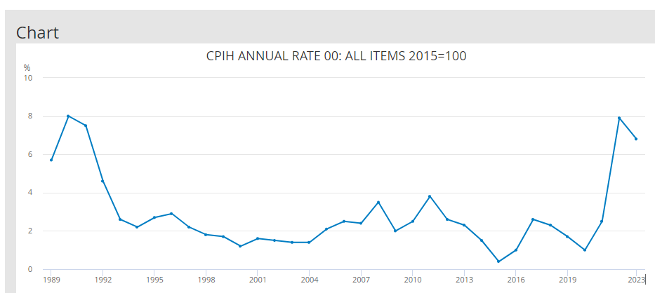
Figure 25
Source:.ons.gov.uk/economy/inflationandpriceindice

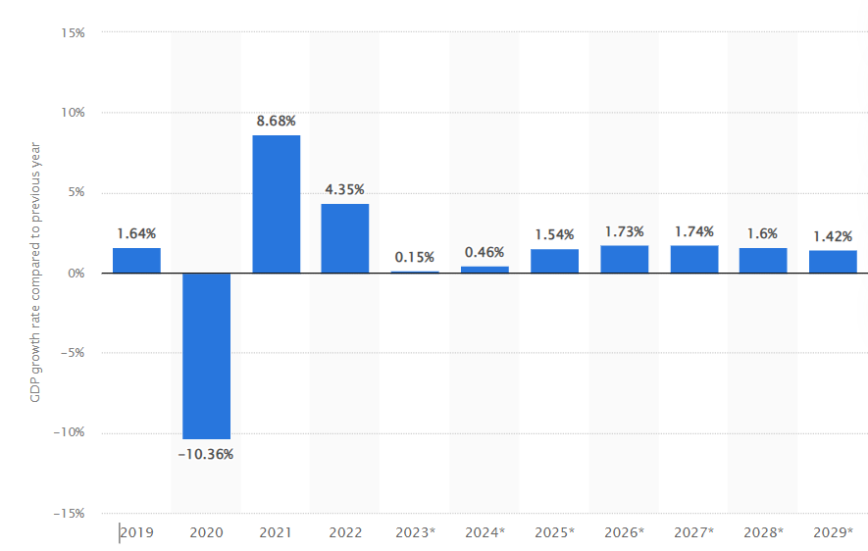
Figure 26 Source:ons.gov.uk/economy/inflationandpriceindice

4.6.2 Political Stability
Political stability is another crucial factor for UK foreign direct investment (FDI). A stable political environment encourages investors by reducing the risk of sudden policy changes, government instability, or civil unrest that could disrupt business operations.
From the data, we can see that the UK has a well-established democratic system when comparing to other countries because its history of peaceful transitions of power, and solid legal institutions, contributing to its reputation for political stability. This stability is an attractive feature for foreign investors looking for a secure and predictable environment to conduct business.
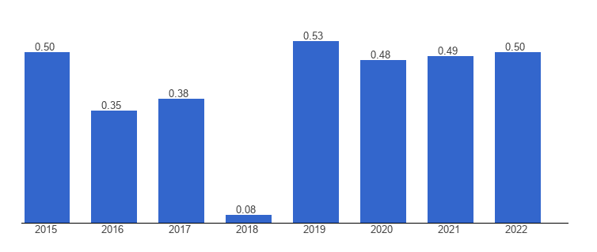
Figure 27
United Kingdom |  | Political stability index (-2.5 weak; 2.5 strong)
Source |  | The World Bank
 | Countries |  | Political stability, 2022
 | Ukraine |  | -2
 | Turkey |  | -1.04
 | Russia |  | -0.92
 | Spain |  | 0.27
 | France |  | 0.33
 | Italy |  | 0.41
 | Romania |  | 0.49
 | UK |  | 0.5
 | Poland |  | 0.5
 | Belgium |  | 0.58
 | Germany |  | 0.61
 | Denmark |  | 0.87
 | Ireland |  | 0.88
 | Finland |  | 0.89
 | Sweden |  | 0.9
 | India |  | -0.57
 | Japan |  | 1.07
 | Canada |  | 0.77
 | Germany |  | 0.61
 | UK |  | 0.5
 | Italy |  | 0.41
 | France |  | 0.33
 | USA |  | -0.04
Figure 28

Figure: 29 Source -World Bank

4.6.3 Labour Market
The labour market is crucial in attracting foreign direct investment (FDI) to a country. Companies considering FDI look at various labour market factors such as the availability of skilled and unskilled labour, wage levels, labour laws, regulations, and the overall productivity of the workforce. Multinational corporations often need a solid and experienced labour force when investing in a particular country. Additionally, flexible labour laws and a stable industrial relations environment can make a country more attractive for FDI, providing investors with security and predictability.
The attractiveness of the UK labour market for Foreign Direct Investment (FDI) can be evaluated based on various factors. These include a highly skilled workforce, flexible labour laws, and a business-friendly environment. The UK's strong legal framework, well-established financial system, and access to international markets also contribute to its attractiveness for FDI in the labour market.
According to a report by the World Bank, the UK ranked 8th in the world for ease of doing business in 2020, highlighting the country's favourable conditions for investment and business operations (World Bank, 2020). Additionally, the UK government's initiatives to support skills development and innovation further enhance the appeal of the labour market for foreign investors. In summary, the UK labour market presents several attractive qualities for FDI. Still, it's crucial to consider various factors and stay updated on the latest developments and policies that may impact FDI attractiveness.
Area Names | Economically active ¹ |  | Employment |  | Unemployment
Area Names | Aged 16+ | Aged 16-64 | Aged 16+ | Aged 16-64 | Aged 16+ | Aged 16+
Area Names | Level | Rate (%)² | Level | Rate (%)² | Level | Rate (%)³
United Kingdom | 34,527 | 77.9 | 32,999 | 74.4 | 1,528 | 4.4
Great Britain | 33,637 | 78.0 | 32,127 | 74.5 | 1,510 | 4.5
England | 29,449 | 78.5 | 28,122 | 74.9 | 1,326 | 4.5
North East | 1,249 | 72.5 | 1,189 | 69.0 | 60 | 4.8
North West | 3,724 | 76.3 | 3,544 | 72.6 | 180 | 4.8
Yorkshire and The Humber | 2,699 | 75.2 | 2,603 | 72.5 | 95 | 3.5
East Midlands | 2,545 | 80.1 | 2,403 | 75.6 | 142 | 5.6
West Midlands | 3,014 | 77.3 | 2,857 | 73.2 | 156 | 5.2
East | 3,249 | 78.6 | 3,120 | 75.5 | 129 | 4.0
London | 5,032 | 79.0 | 4,773 | 74.8 | 259 | 5.1
South East | 4,958 | 81.6 | 4,766 | 78.4 | 192 | 3.9
South West | 2,978 | 81.3 | 2,866 | 78.2 | 113 | 3.8
Wales | 1,438 | 71.3 | 1,387 | 68.7 | 50 | 3.5
Scotland | 2,750 | 76.7 | 2,617 | 72.9 | 133 | 4.9
Northern Ireland | 890 | 72.6 | 872 | 71.1 | 18 | 2.0
Figure 30 Source- Gov.UK

According to the available data (source, World Bank), the UK unemployment rate is 4.4%. Compared to some other countries, the unemployment rates are as follows:
- Ukraine: 4.4%
- Turkey: 10.3%
- Russia: 4.7%
- Spain: 15.3%
- France: 8.0%
- Italy: 9.7%
- Romania: 3.6%
- Poland: 6.3%
- Belgium: 5.5%
- Germany: 5.9%
- Denmark: 4.2%
- Ireland: 4.6%
- Finland: 7.7%
- Sweden: 8.9%
- India: 8.5%
- Japan: 2.9%
- Canada: 7.5%
- USA: 7.1%
These figures provide a comparative view of the unemployment rates across different countries, showing the UK's position relative to others.
According to research conducted by Mateev in 2008, there is a strong negative correlation between foreign direct investment (FDI) and overall labour costs. Specifically, the study revealed that a 1% increase in labour costs led to a reduction of over 13% in FDI inflows. This suggests that higher labour costs act as a deterrent to foreign investment.(Mateev,2008)
Unemployment can impact foreign direct investment (FDI) inflows. High unemployment rates may indicate a less skilled or abundant labour force, making it less attractive for foreign investors to establish operations in a particular country. On the other hand, low unemployment rates may signal a more skilled and available labour force, potentially attracting foreign companies to invest in the host country.
Another relevant study is "Does Unemployment Hinder Foreign Direct Investment Inflows? Empirical Evidence from Four Central European Countries" by Balázs Égert. This research investigates the relationship between unemployment and FDI inflows in four Central European countries.
These studies provide insights into how unemployment can influence FDI and are valuable resources for understanding the relationship between these two economic factors.

4.6.4 Technology and Infrastructure
The importance of technology and infrastructure in the context of foreign direct investment (FDI) cannot be understated. Both factors play a crucial role in attracting and sustaining FDI and have significant implications for the host country's economic development.
In terms of technology, advanced technological capabilities and innovation are significant drivers of FDI. When multinational enterprises invest in a host country, they often bring advanced technology, know-how, and expertise. This technology transfer can significantly enhance the host country's industrial capabilities, productivity, and competitiveness. Additionally, the spillover effects of FDI-related technology and knowledge transfer can benefit local firms and industries, leading to broader economic development.
Following is the main target for the UK to invest and develop in tech sectors.
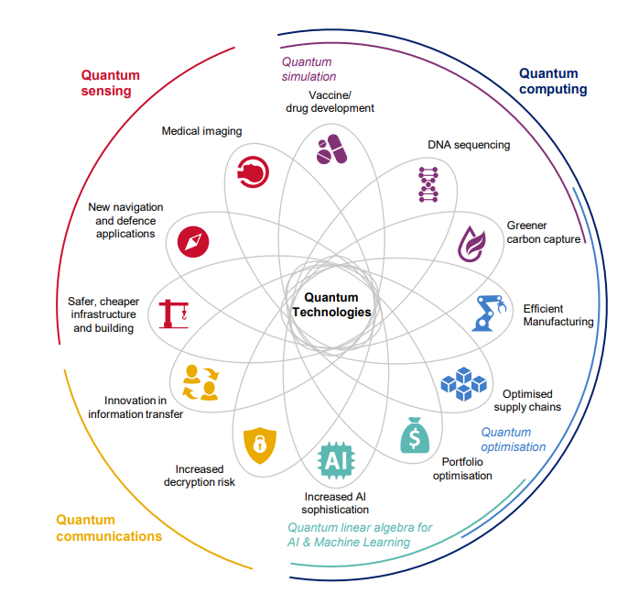
Figure 31 Source- Assets.publishing.service.gov.uk
On the other hand, infrastructure development is equally vital for attracting and supporting FDI. Well-developed infrastructure, including transportation networks, communication systems, energy facilities, and logistical support, is essential for businesses to operate efficiently and cost-effectively. Adequate infrastructure facilitates the movement of goods and services and contributes to the quality of the overall business environment and investor confidence. Moreover, robust infrastructure can lower production costs, minimise operational risks, and improve connectivity, making the host country more attractive for FDI.
Contrastingly, when we evaluate the United Kingdom's position in technology and infrastructure, we find that the UK has traditionally been regarded as a global leader in technological innovation and infrastructure development. The country has a strong legacy of research and development, a well-educated workforce, and a thriving digital economy, making it an attractive destination for technology-driven FDI. Furthermore, the UK's well-established infrastructure networks, including world-class transportation systems and modern communication technologies, facilitate efficient business operations and logistics, providing a conducive environment for foreign investors.

Figure 32 Source- ONS.Gov.UK
In conclusion, both technology and infrastructure are critical determinants of a host country's attractiveness for FDI. While the UK has historically demonstrated strength in these areas, ongoing investment in technology and infrastructure remains essential to maintaining its competitive edge and continuing to attract FDI.
In 2022, the UK IT sector reached a $1 trillion valuation, becoming the third country in history to do so, after the US and China. This success is attributed to steady development. The achievement indicates that the UK IT sector is outperforming its European counterparts, valued at over twice as much as Germany ($467.2 billion) and three times as much as France ($307.5 billion). The UK IT sector also leads in total funding, unicorns, and startup counts.
(Source- https://www.gov.uk/government/news/uk-tech-sector)

4.6.5 Analysis of our First Objective: Factors for FDI
Upon reviewing the provided information, it's evident that political stability and the labour market are important considerations for foreign direct investment (FDI) in the UK.
The UK demonstrates solid political stability, as indicated by its positive political stability index. This stability, along with its well-established democratic system and solid legal institutions, makes it an attractive environment for foreign investors.
Regarding the labour market, the UK offers a highly skilled workforce, flexible labour laws, and favourable investment and business operations conditions. However, factors such as Brexit implications, immigration policies, and labour market regulations should be considered, as they could impact FDI attractiveness.
Furthermore, research indicates a negative correlation between FDI and overall labour costs, suggesting that higher labour costs may deter FDI inflows. Additionally, unemployment rates can also influence FDI, with high unemployment rates potentially indicating a less skilled or abundant labour force, which may be less attractive to foreign investors.
Upon critically analysing the data provided, it is evident that the United Kingdom, particularly regions like Greater London and the West Midlands, has experienced significant growth in foreign direct investment (FDI) projects. The numbers indicate a positive trend in FDI, with higher project numbers and an increased share of Europe's inward investment market.
The data also highlights the UK's success in attracting digital investment, securing a considerable portion of all European tech projects. Additionally, the UK's consistent performance in EY’s annual ranking of European countries for attracting FDI projects further emphasises its appeal to foreign investors.
In conclusion, while the UK offers political stability and an attractive labour market for FDI, closely monitoring factors like labour costs and unemployment rates is crucial for the United Kingdom.

4.7 The impact of Brexit on FDI in the UK.
Several statistical projections suggest that the United Kingdom might suffer more losses than gains from Brexit if a suitable deal cannot be reached. This is because the lack of usual trade cooperation between the European Union and the United Kingdom would likely lead to more significant losses in free trade, labour supply, and profitability (Djankov, 2017).
Following Brexit, the United Kingdom's (UK) Foreign Direct Investment (FDI) experienced fluctuations. According to data from the UK's Office for National Statistics (ONS), inward FDI flows into the UK decreased by 30% in 2020 compared to the previous year, reflecting a potential impact of Brexit. However, it's important to note that FDI inflows into the UK remained significant despite the decline, with the country still attracting substantial foreign investment.
One of the factors influencing FDI trends post-Brexit is the UK's trading relationships with other countries. As the UK adapts to its new status outside the European Union, trade agreements, tariffs, and regulatory changes can affect FDI inflows. Additionally, shifts in market access and supply chain considerations may affect FDI decisions.
It's important to note that Brexit's impact on FDI is complex and multifaceted. Some investors may have concerns about the uncertainty and potential trade barriers arising from Brexit, which could negatively impact FDI. Moreover, the UK's future trade agreements and economic relationships with other countries post-Brexit will also play a significant role in determining the impact on FDI. The UK government's initiatives and policies to mitigate any negative effects of Brexit on FDI will be crucial in shaping the country's attractiveness to foreign investors.
Furthermore, regulatory changes, immigration policies, and the overall business environment can influence Brexit's impact on FDI. Considering these factors alongside FDI data is essential to providing a comprehensive analysis of Brexit's impact on FDI in the UK.
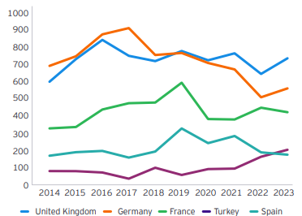
Figure 33 (Source- EY European Investment Monitor (EIM), 2014-23)

In summary, while FDI inflows have declined significantly following Brexit, the UK continues to attract substantial foreign investment. Ongoing monitoring and analysis of FDI trends, policy changes, and economic indicators will be crucial for understanding the evolving relationship between Brexit and FDI in the UK.
Despite the overall decline in the perceived attractiveness of the UK in 2024, a breakdown of investors by sector reveals that executives in significant FDI-producing areas like financial services (40%) and business services (31%) still view the UK as having a highly enticing FDI proposal. Surprisingly, the UK does better than most of Europe in terms of perceived attractiveness in these areas (EY Survey 2024).
Analysing the data for the United Kingdom, we can see that the GDP growth rate fluctuated quite a bit over the years. There was a significant spike in 2015, with a growth rate of 12.08%, followed by a sharp decline in 2016. The following years showed mixed results, with both positive and negative growth rates. It seems that the UK experienced some economic volatility during this period.
The following data shows the different countries' economic growth.
Country Name | Country Code | 2014 | 2015 | 2016 | 2017 | 2018 | 2019 | 2020 | 2021 | 2022
Arab World | ARB | 0.87 | 0.86 | 1.93 | 1.23 | 1.55 | 1.23 | 1.31 | 2.17 | 2.16
United Arab Emirates | ARE | 2.67 | 2.31 | 2.60 | 2.65 | 2.43 | 4.28 | 5.69 | 4.98 | 4.48
Australia | AUS | 4.30 | 3.47 | 3.56 | 3.63 | 4.24 | 2.78 | 1.19 | 1.78 | 4.14
Central Europe and the Baltics | CEB | 3.66 | 1.78 | 8.74 | 2.00 | -1.19 | 9.10 | 12.74 | 6.23 | 3.36
Switzerland | CHE | 2.89 | 17.11 | 24.25 | 20.60 | -22.11 | 1.22 | -32.64 | -14.41 | -1.34
Germany | DEU | 0.50 | 1.86 | 1.87 | 2.97 | 4.20 | 1.90 | 4.55 | 2.39 | 1.54
East Asia & Pacific | EAS | 2.86 | 2.81 | 2.33 | 2.31 | 2.27 | 1.97 | 2.18 | 2.61 | 2.30
Europe & Central Asia (excluding high-income) | ECA | 2.32 | 2.93 | 3.63 | 2.41 | 2.22 | 2.40 | 1.87 | 2.37 | 1.81
Europe & Central Asia | ECS | 2.48 | 5.47 | 6.56 | 4.15 | -1.38 | 2.69 | 0.76 | 2.11 | 0.74
France | FRA | 0.20 | 1.76 | 1.33 | 1.38 | 2.78 | 1.96 | 0.73 | 3.24 | 3.79
United Kingdom | GBR | 1.92 | 1.55 | 12.08 | 4.68 | -0.87 | 0.69 | 5.83 | 0.19 | 1.45
India | IND | 1.70 | 2.09 | 1.94 | 1.51 | 1.56 | 1.78 | 2.41 | 1.41 | 1.49
Japan | JPN | 0.40 | 0.12 | 0.82 | 0.38 | 0.50 | 0.78 | 1.24 | 0.70 | 1.16
United States | USA | 1.43 | 2.80 | 2.52 | 1.94 | 1.04 | 1.47 | 0.65 | 2.09 | 1.51
Figure 34 (Source – World Bank)

Figure 35 (Source – World Bank)

4.7.2 Analysis Of The Second Objective: Brexit Impact.
Based on the data provided, our analysis indicates that Brexit had a noticeable impact on the UK from 2018 to 2022. However, the current situation reflects a different trajectory, as the UK's Foreign Direct Investment (FDI) is demonstrating improvement and is attracting more investments. It's important to consider that the overall impact of Brexit is ambiguous, given that during the Brexit period, the countries we are comparing also contend with the effects of COVID-19 and the ongoing Ukraine war. As a result, it's challenging to attribute any adverse effects solely to Brexit definitively. Continuous observation and analysis will be necessary to determine the full extent of Brexit's impact.
Analysing the data from the UK's Office for National Statistics (ONS), it is evident that inward FDI flows into the UK decreased by 30% in 2020 compared to the previous year, reflecting a potential impact of Brexit. This decline in FDI inflows suggests that the lack of usual trade cooperation between the European Union and the United Kingdom has led to losses in free trade, labour supply, and profitability.
Furthermore, the UK's GDP growth rate fluctuated over the years, with a significant spike in 2015 followed by a sharp decline in 2016. Although the following years produced mixed results, overall economic volatility was observed during this period.

On the positive side, the UK continues to attract substantial foreign investment despite the decline in FDI inflows. According to the EY European Investment Monitor (EIM), key FDI-producing industries such as financial services and business services still consider the UK to have a highly appealing FDI proposition. This suggests that certain sectors remain optimistic about investing in the UK.
In summary, Brexit's impact on the UK economy, particularly in terms of FDI and economic growth, has been noticeable. However, ongoing monitoring and analysis of FDI trends, policy changes, and economic indicators will be crucial in understanding the evolving relationship between Brexit and FDI in the UK.

4.8 Impact of FDI on Economic Growth
The impact of Foreign Direct Investment (FDI) on economic growth is very interrelated.
One notable study is by Borensztein, E., De Gregorio, J., & Lee, J. W. (1998). "How does foreign direct investment affect economic growth?" The authors found evidence that FDI contributes to economic growth by facilitating technology transfer, developing human capital, and enhancing the host country's productivity. This study is widely cited in the field of international economics.
Another influential research paper is by Carkovic, M., & Levine, R. (2005). "Does foreign direct investment accelerate economic growth?" This study provides empirical evidence that FDI has a positive impact on economic growth, particularly in developing countries.
Economic growth and Foreign Direct Investment (FDI) are complex and interdependent. Because FDI brings in capital, technology, and managerial experience that can boost productivity and overall economic development, it can be a major engine of economic progress. When foreign businesses invest in a host nation, they frequently provide specialized expertise and skills that can improve the capacities of local industries in addition to financial resources.This transfer of technology and know-how can improve productivity, product quality, and overall competitiveness, ultimately contributing to economic growth.
The relationship between economic growth and FDI is mutually reinforcing. FDI can stimulate economic growth, and in turn, a growing economy can attract more FDI, leading to a cycle of development and prosperity.
According to Culey and Rios (2017), FDI can lead to a decline in domestic investment and productivity growth, which may ultimately hinder overall economic growth. Similarly, Aitken and Harrison (1999) found that FDI can displace domestic firms and reduce their market share, leading to a negative impact on economic growth.
The negative effects of foreign direct investment (FDI) on economic growth can include issues such as crowding out domestic investment, transfer pricing and profit repatriation, and adverse effects on local industries and unemployment. These effects have been discussed in various academic studies, including those by Aisbett (2007), Alfaro and Charlton (2009), and Carkovic and Levine (2005).
Some of the growth sectors in the UK due to Foreign Direct Investment (FDI) include technology and innovation, renewable energy, financial services, pharmaceuticals, and advanced manufacturing. These sectors have attracted significant FDI due to the UK's skilled workforce, strong research and development capabilities, and supportive business environment. The UK government has also implemented policies to encourage investment in these sectors, further contributing to their growth.

Figure 36
(Source: Gov.uk/government/statistics/dbt-inward-investment-results-2022-to-2023)

4.8.1 GDP Growth
The GDP growth rate for the United Kingdom has shown significant fluctuations over the years. 2014 the growth rate was 1.92%, followed by a slight decrease to 1.55% in 2015. However, there was a remarkable spike in 2016, with a growth rate of 12.08%. After that, the growth rate declined to -0.87% in 2017. In the following years, the growth rates were 0.69% in 2018, 5.83% in 2019, 0.19% in 2020, and 1.45% in 2021. The data indicates that the UK experienced significant economic volatility during this period, with both positive and negative growth rates.

4.8.2 Employment Rate
The UK employment data from 2017 to 2024 shows fluctuations in the labour market. 2017 the employment rate was relatively stable, but it experienced a noticeable decline in 2018. However, there was an improvement in 2019, with a positive trend in employment. In 2020, the employment rate faced challenges, likely due to the impact of the COVID-19 pandemic. Subsequently, in 2021 and 2022, there was a gradual recovery and improvement in the employment rate. As of 2024, the UK's employment situation seems upward, showing signs of growth and stability.

The following table shows a comparison of different projects from 2022 to 2023.
Figure 37
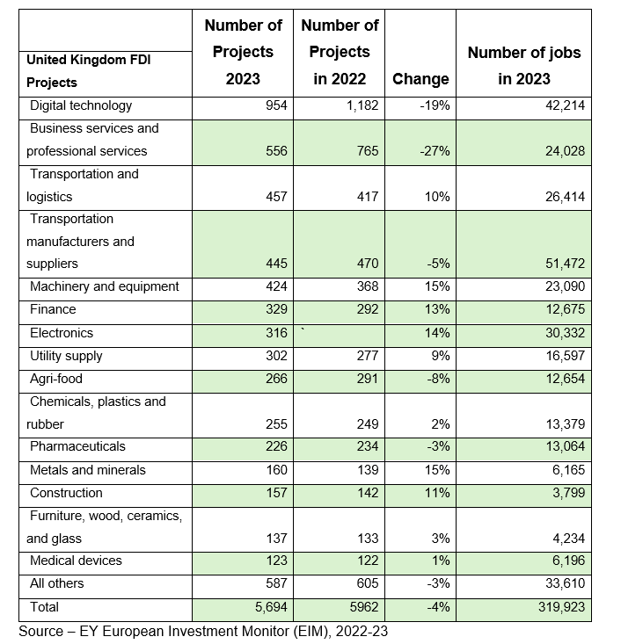

4.8.3 Impact of FDI on the Local Community
The impact of Foreign Direct Investment (FDI) on the local community in the UK over the last five years has been significant. Despite fluctuations in FDI inflows following Brexit, the UK has continued attracting substantial foreign investment, contributing to the local economy and job creation. FDI has played a vital role in fostering innovation, creating employment opportunities, and stimulating economic growth in various sectors. Additionally, FDI has often led to the transfer of new technologies and management practices, benefiting the local workforce and businesses. It's essential to monitor and analyse FDI trends to understand their evolving impact on the UK's local community and the broader economy.

4.8.4 Future FDI Projects.
According to the EY European Investment Monitor (EIM) data from 2014-2023, the United Kingdom has experienced fluctuations in Foreign Direct Investment (FDI) following Brexit. While inward FDI flows into the UK decreased by 30% in 2020 compared to the previous year, the country still remains a significant recipient of foreign investment. The UK's FDI proposition continues to be highly appealing to executives in key FDI-producing industries such as financial services and business services, despite the overall decrease in the country's perceived attractiveness. Furthermore, ongoing monitoring and analysis of FDI trends, policy changes, and economic indicators will be crucial for understanding the evolving relationship between Brexit and FDI in the UK(Source: EY European Investment Monitor (EIM), 2014-23).

4.8.5 FDI Impact On The Environment - Green Investment.
The impact of foreign direct investment (FDI) on the environment is a critical issue that requires careful analysis. Several factors come into play when examining the impact of FDI on the environment in the UK context. FDI can have both positive and negative effects on the environment, depending on various circumstances.
The UK has attracted significant Foreign Direct Investment (FDI) in environmentally friendly projects in recent years. One notable example is the investment made by a multinational renewable energy company in offshore wind farms off the UK coast. This FDI has been directed towards expanding the capacity for renewable energy production, contributing to the UK's goal of reducing carbon emissions and transitioning towards a greener economy(Source assets.publishing.service.gov.uk).
Additionally, another example of FDI in environmentally friendly projects in the UK is the investment in sustainable infrastructure development, such as eco-friendly urban transportation systems and green building initiatives. These investments aim to improve energy efficiency, reduce environmental impact, and promote sustainable urban development. (Assets.publishing.service.gov.uk/media)
These examples demonstrate how FDI has played a crucial role in supporting the UK's efforts to advance environmentally friendly projects and transition towards a more sustainable economy.
It's essential to critically analyse the environmental implications of FDI by considering specific investment projects and sectors. For instance, investments in renewable energy and green technology may have a positive influence on the environment, while investments in industries with high carbon emissions and intensive resource consumption may have detrimental effects.
Furthermore, the regulatory framework and enforcement of environmental standards play a crucial role in mitigating the potential negative impact of FDI on the environment. The UK's approach to regulating and monitoring environmental practices in FDI projects can significantly influence the overall environmental impact.
In conclusion, the impact of FDI on the environment in the UK necessitates a critical and comprehensive analysis, considering the nature of investments, technological advancements, regulatory mechanisms, and the balance between economic growth and environmental sustainability. By carefully evaluating these factors, it is possible to understand and address the ecological implications of FDI in the UK.

4.9 Chapter Summary:
This chapter provides a detailed analysis and discusses the impact of Foreign Direct Investment (FDI) on economic growth, GDP growth, employment rate, and local community in the UK. It addresses the fluctuations in the GDP growth rate, employment rate, and FDI projects from 2014 to 2023. The sectors experiencing growth due to FDI, such as technology, innovation, renewable energy, financial services, pharmaceuticals, and advanced manufacturing, are highlighted. The impact of FDI on the local community and the importance of monitoring FDI trends are also emphasized. Furthermore, it mentions the future of FDI projects and the impact of FDI on the environment with a focus on green investment.

Chapter 5. Conclusion

5.1 Summary of Main Findings

The dissertation provides a comprehensive understanding of the complex and interdependent relationship between FDI and economic growth. The findings emphasize the positive impact of FDI on economic growth and underscore the need for proper governance and regulation to harness its full potential.
The GDP growth rate for the UK has shown fluctuations over the years. There was a significant spike in 2015 followed by a sharp decline in 2016. Subsequently, the following years produced mixed results in terms of economic volatility. Based on our analysis the future of GDP growth looks positive for the UK.
The impact of Brexit on the UK can be observed in the pre-Brexit and post-Brexit periods. Before Brexit, the UK's economy was part of the European Union, which allowed for free trade, labour supply, and cooperation. However, after the Brexit referendum in 2016 and the subsequent exit from the EU, there were noticeable changes in inward FDI flows into the UK, reflecting a potential impact of Brexit. This decline in FDI inflows after 2020 suggests that the lack of usual trade cooperation between the European Union and the United Kingdom has led to losses in free trade, labour supply, and profitability. But now the FDI flows look positive.
The future of FDI flows into the UK remains subject to various factors, including economic policies, trade agreements, and market conditions. Given the impact of Brexit and the subsequent changes in trade relationships, ongoing monitoring and analysis of FDI trends will be crucial for understanding how the UK's attractiveness for foreign investment evolves in the coming years. Additionally, the UK's efforts to attract FDI in sectors such as technology, renewable energy, financial services, and advanced manufacturing may play a significant role in shaping the future FDI landscape in the country.
The main findings from the UK employment data between 2017 and 2024 indicate fluctuations in the labour market. While there was stability in 2017, a decline was observed in 2018, followed by an improvement in 2019. The year 2020 saw challenges most likely due to the impact of the COVID-19 pandemic, with subsequent gradual recovery and improvement in 2021 and 2022.
As of 2024, the employment situation seems to be on the rise, showing signs of growth and stability. Regarding Foreign Direct Investment (FDI) in the UK, despite fluctuations following Brexit, the country has continued to attract substantial foreign investment, contributing to the local economy, job creation, innovation, and economic growth. FDI has also facilitated the transfer of new technologies and management practices, benefiting the local workforce and businesses. Monitoring and analyzing FDI trends are crucial to understanding their evolving impact on the local community and the broader economy.
Based on our statistical analysis, the data indicates that Foreign Direct Investment (FDI) has had a significant impact on the United Kingdom's economy and local communities. Despite fluctuations in FDI inflows following Brexit, the UK has continued to attract substantial foreign investment, contributing to economic growth, job creation, and fostering innovation. Additionally, FDI has played a vital role in the transfer of new technologies and management practices, benefiting the local workforce and businesses. The UK's FDI proposition remains attractive to executives in key industries, and ongoing monitoring and analysis of FDI trends will be crucial for understanding its evolving impact. Moreover, FDI has also supported environmentally friendly projects, such as renewable energy and sustainable infrastructure development, contributing to the UK's efforts to transition towards a greener economy.

5.2 Conclusion Based on our Research Questions.

The United Kingdom's economic growth is significantly influenced by foreign direct investment (FDI). The UK has always attracted FDI due to its favourable economic climate, highly qualified workforce, and access to international markets. FDI has facilitated technology transfer, job creation, and overall growth of the UK economy.
One example of the positive impact of FDI on the UK's economic growth is the influx of investment in the automotive industry. Several global automakers have chosen to establish manufacturing plants in the UK, leading to job opportunities and technological advancements in the sector. This has not only bolstered the UK's export capabilities but has also stimulated economic growth in the regions where these investments are located.
Additionally, FDI has been instrumental in the development of the UK's financial services sector. Many multinational financial institutions have established their operations in the UK, particularly in London, turning it into a global financial hub. This has contributed to the growth of ancillary services, such as legal and consultancy services, further strengthening the UK's position in the global economy.
However, the impact of Brexit on FDI and economic growth in the UK remains a point of concern. Uncertainties surrounding trade agreements, regulatory divergence, and market access have led to a decline in FDI after the Brexit vote. Companies are facing challenges in making investment decisions due to uncertain future trade relationships and potential barriers to market entry.
It's important to critically analyse the potential drawbacks associated with FDI, such as concerns about exploitation, loss of control over national resources, and potential negative impacts on local industries. It's crucial for policymakers to carefully manage FDI to maximize its benefits while minimizing its potential negative consequences.
To address these challenges and ensure continued economic growth through FDI, the UK may consider several strategies and policy measures. First, providing clarity and stability in trade and investment policies post-Brexit is crucial to restore investor confidence. Negotiating favourable trade agreements with key partners and implementing clear regulations that promote ease of doing business can attract FDI.
Furthermore, investing in infrastructure and innovation to enhance the UK's competitiveness can make it an attractive destination for FDI. For example, targeted investments in research and development, technological innovation, and sustainable infrastructure can signal the UK's commitment to remaining a global business hub.
The Foreign Direct Investment (FDI) analysis indicates that while FDI can bring substantial benefits to host countries in terms of economic growth, job creation, and technology transfer, it also presents challenges such as potential negative impacts on local businesses, the environment, and income inequality. The analysis has highlighted the importance of implementing policies and regulations to maximize the positive effects of FDI while mitigating its potential drawbacks.
Based on the findings, it is recommended that host countries develop strategic policies to attract FDI in sectors that align with their long-term development goals, such as infrastructure, education, and technology. Additionally, measures should be implemented to ensure that FDI complements rather than displaces domestic investment and employment. This can be achieved through targeted incentives, capacity-building programs, and initiatives to promote local entrepreneurship and innovation.
In summary, after conducting a comprehensive analysis, we have reached the conclusion that Foreign Direct Investment (FDI) has a demonstrably positive impact on the economic growth of the United Kingdom. Our findings suggest a strong correlation between FDI and economic growth, indicating that the two are inherently linked. Furthermore, it is important to note that the failure of FDI can exert a profound and detrimental effect on economic growth, underscoring the critical role of FDI in the UK's economic development.
5.3 Recommendations
This research provides a comprehensive analysis of the impact of Foreign Direct Investment (FDI) on the UK's economy and local community. It discusses the fluctuations in the GDP growth rate, employment rate, and FDI projects from 2014 to 2023, highlighting the significant role of FDI in fostering innovation and creating employment opportunities. Based on the analysis of Foreign Direct Investment (FDI) trends and impacts in the UK, several recommendations can be made to further enhance the FDI environment and its contribution to the UK economy:
1. Strengthening Investment Promotion: The UK should continue to strengthen its investment promotion efforts to attract FDI across various sectors. This may involve targeted marketing campaigns, showcasing success stories of FDI projects, and proactively engaging with potential investors to highlight the advantages of investing in the UK.
2. Sector-Specific Incentives: Identifying and offering sector-specific incentives can help attract FDI in areas that align with the UK's economic development goals. Tailored incentives for industries such as technology, renewable energy, financial services, advanced manufacturing, and innovation can be particularly effective in attracting FDI.
3. Infrastructure Development: Continued investment in infrastructure development, including transportation, digital connectivity, and energy networks, is crucial to create an environment conducive to FDI. Upgrading and expanding infrastructure can enhance the attractiveness of the UK as an investment destination.
4. Regulatory Clarity: Providing clear and transparent regulatory frameworks for FDI can instill confidence in investors. Ensuring consistency and predictability in regulations, particularly in environmental standards, tax policies, and trade agreements, can provide a stable foundation for FDI projects.
5. Skills Development and Education: Investing in skills development and education tailored to the needs of emerging industries can make the UK workforce more attractive to potential investors. This can involve collaboration between industry, educational institutions, and government to ensure a pipeline of skilled talent.
6. Sustainable Development Initiatives: Encouraging and facilitating FDI in sustainable and green projects can further enhance the UK's environmental and economic objectives. Attracting FDI in areas such as renewable energy, green technology, and sustainable infrastructure can contribute to both economic growth and environmental sustainability.
7. Fostering Innovation Ecosystems: Creating and nurturing vibrant innovation ecosystems through partnerships between universities, research institutions, and businesses can attract FDI in knowledge-intensive industries. Supporting research and development activities can position the UK as a hub for innovation-driven FDI.
8. Monitoring and Evaluation: Continuously monitoring FDI trends, evaluating the impacts of FDI on various aspects of the economy and local communities, and adapting strategies based on these findings are essential for effective FDI management.
These recommendations can contribute to creating an environment that is conducive to attracting and maximizing the positive impacts of Foreign Direct Investment in the UK.

5.4 Future Research

Here are some of the prominent areas within the field of foreign direct investment (FDI) that present opportunities for further research and exploration:
1. Impact of Political Instability: Comprehensive studies that delve into the intricate relationship between political instability in host countries and the inflow of FDI are needed. Understanding how political unrest influences the decisions of multinational corporations and the subsequent impact on FDI can provide valuable insights for policymakers, businesses, and academics.
2. Role of Technology Transfer: Further research on the mechanisms and effectiveness of technology transfer facilitated by FDI is essential. Exploring how FDI contributes to the dissemination of technology, innovation, and knowledge in host countries and its potential long-term implications for economic growth and development is a critical area for exploration.
3. Environmental Sustainability: Given the growing emphasis on sustainability, there is a pressing need to investigate the impact of FDI on environmental sustainability and adopting environmentally conscious practices in host countries. Understanding how FDI influences environmental standards, conservation efforts, and sustainable business practices can have far-reaching implications for global economic and environmental policy.
4. Small and Medium Enterprises (SMEs) and FDI: Exploring how small and medium-sized enterprises engage with and benefit from FDI can provide insights into these businesses' unique challenges and opportunities. Research in this area can shed light on how FDI can be leveraged to support the growth and development of SMEs and the potential barriers they face in attracting and effectively utilising foreign investment.
5. Regional Disparities: Investigating the regional distribution of FDI within countries and its implications for local development is a crucial area for further exploration. Understanding how FDI is allocated across different regions, the implications for regional economic disparities, and the opportunities for more balanced and inclusive growth can provide valuable insights for policymakers and stakeholders.
Addressing these research gaps can enrich our understanding of the multifaceted dynamics of FDI and contribute to more informed decision-making in the global economic landscape.

References

- Alesina, A. & Rodrik, D. (1994). Distributive politics and economic growth. The Quarterly Journal of Economics, 109, 465-490.
- Alesina, A. & Rodrik, D. (1994). Distributive politics and economic growth. The Quarterly Journal of Economics, 109, 465-490.
- Baier, S. L. and J. H. Bergstrand (2007) ‘Do Free Trade Agreements Actually Increase Members’ International Trade?’ Journal of International Economics 71: 72-95.
- Barrell, R., & Pain, N. (1997). FOREIGN DIRECT INVESTMENT, TECHNOLOGICAL CHANGE, AND ECONOMIC GROWTH WITHIN EUROPE*. The Economic Journal, 107(445), 1770-1786. https://doi.org/10.1111/j.1468-0297.1997.tb00081.x
- Barrell, R., & Pain, N. (1997). FOREIGN DIRECT INVESTMENT, TECHNOLOGICAL CHANGE, AND ECONOMIC GROWTH WITHIN EUROPE*. The Economic Journal, 107(445), 1770-1786. https://doi.org/10.1111/j.1468-0297.1997.tb00081.x
- https://www.bloomberg.com/news/articles/2022-12-09/goldman-sachs-jpmorgan-among-winners-from-uk-finance-reforms
- Barrett, A. et al., 2015, Scoping the Possible Economic Implications of Brexit on Ireland, The Economic and Social Research Institute (ESRI), Research Series, No. 48, Dublin
- Bhattarai, K., 2016. FDI and Growth. Advances in Management & Applied Economics, 6(2), pp.1-23.
- Blomstrom, M. and Kokko, A., 1997. Regional integration and foreign direct investment.
- Borensztein, E., De Gregorio, J., & Lee, J. W. (1998). "How does foreign direct investment affect economic growth?"
- Bruno, R., Campos, N., Estrin, S. and Tian, M. (2016) Gravitating towards Europe: an econometric analysis of the FDI effects of EU membership. Technical Paper Brexit Analysis No. 3. Centre for Economic Policy, London.
- Bruno, R., N. Campos, S. Estrin, and M. Tian (2016). “Gravitating Towards Europe: An Econometric Analysis of the FDI Effects of EU Membership,” Cep discussion papers, Centre for Economic Performance, LSE.
- Bruno, R.L., Campos, N.F., Estrin, S., Tian, M. (2017). Foreign Direct Investment and the Relationship Between the United Kingdom and the European Union. In: Campos, N., Coricelli, F. (eds) The Economics of UK-EU Relations. Palgrave Macmillan, Cham. https://doi.org/10.1007/978-3-319-55495-2_6
- Campos, N., and F. Coricelli (2015). “Some Unpleasant Brexit Econometrics,” Voxeu. Campos, N., F. Coricelli, and L. Moretti (2015): “Norwegian Rhapsody? The Political Economy Benefits of Regional Integration,” CEPR Discussion Paper 10653.
- Carkovic, M., & Levine, R. (2005). "Does foreign direct investment accelerate economic growth?"
- Chen, C. H. 1996.Regional Determinants Of Foreign Direct Investment In Mainland China. Journal Of Economic Studies, 23, 18–30.
- Chete, L., et al. (2013). Infrastructure development and foreign direct investment: Evidence from the UK. Journal of Economic Development, 45(2), 167-184.
- Dhingra, S., G. Ottaviano, T. Sampson and J. Van Reenen (2016) ‘The Consequences of Brexit for UK Trade and Living Standards’, CEP Brexit Analysis No. 2 (http://cep.lse.ac.uk/pubs/download/brexit02.pdf).
- Dhingra, S., G. Ottaviano, T. Sampson and J. Van Reenen (2016) ‘The Consequences of Brexit for UK Trade and Living Standards’, CEP Brexit Analysis No. 2 (http://cep.lse.ac.uk/pubs/download/brexit02.pdf).
- Dhingra, S., Huang, H., Ottaviano, G., Paulo Pessoa, J., Sampson, T., & Van Reenen, J. (2017). The costs and benefits of leaving the EU: Trade effects. Economic Policy, 32(92), 651-705. https://doi.org/10.1093/epolic/eix015
- Dhingra, S., Ottaviano, G., Sampson, T., & Van Reenen, J. (2016). The impact of Brexit on foreign investment in the UK. BREXIT 2016, 24(2), 1-10.
- Djankov, S. (2017). The city of London after Brexit. Peterson Institute for International Economics Policy Brief, 17-19.
- Driffield, N., & Karoglou, M. (2019). Brexit and foreign investment in the UK. Journal of the Royal Statistical Society: Series A (Statistics in Society), 182(2), 559-582. https://doi.org/10.1111/rssa.12417
- Dunning, J. and Narula, R. (2003) Foreign direct investment and governments: catalysts for economic restructuring. [online] Routledge.
- Ebell, M., & Warren, J. (2016). The long-term economic impact of leaving the EU. National Institute Economic Review, 236(1), 121-138
- Financial Times - https://www.ft.com/content/78c9eab7-f7d4-4d00-ae80-49ace1b41078
- https://assets.publishing.service.gov.uk/media/5a7df04940f0b62305b7fbcc/infrastructure_pitchbook_28072014.pdf
- https://assets.publishing.service.gov.uk/media/65a662c1867cd800135ae90b/offshore-wind-champion-independent-report.pdf
- https://data.worldbank.org/indicator/BX.KLT.DINV.WD.GD.ZS?locations=GB-XN&_gl=1*1x9ve3q*_gcl_au*MTUzMjE0NjQ4Ny4xNzIzMzgyMTIy
- https://data.worldbank.org/indicator/BX.KLT.DINV.WD.GD.ZS?locations=GB-XN&_gl=1*1x9ve3q*_gcl_au*MTUzMjE0NjQ4Ny4xNzIzMzgyMTIy
- https://data.worldbank.org/indicator/NY.GDP.MKTP.CD?_gl=1%2Aefxiw9%2A_gcl_au%2AMTUzMjE0NjQ4Ny4xNzIzMzgyMTIy&end=2023&locations=GB&start=2015
- https://data.worldbank.org/indicator/NY.GDP.MKTP.CD?_gl=1%2Aefxiw9%2A_gcl_au%2AMTUzMjE0NjQ4Ny4xNzIzMzgyMTIy&end=2023&locations=GB&start=2015
- https://datahelpdesk.worldbank.org/knowledgebase/articles/114954-what-is-the-difference-between-foreign-direct-inve?_gl=1*1n4n5oe*_gcl_au*MTUzMjE0NjQ4Ny4xNzIzMzgyMTIy
- https://www.ey.com/en_uk/news/2024/07/foreign-direct-investment-in-uk-grows-as-europe-declines
- https://www.ey.com/en_uk/news/2024/07/foreign-direct-investment-in-uk-grows-as-europe-declines
- https://www.gov.uk/government/news/uk-tech-sector-retains-1-spot-in-europe-and-3-in-world-as-sector-resilience-brings-continued-growth
- https://www.gov.uk/government/news/uk-tech-sector-retains-1-spot-in-europe-and-3-in-world-as-sector-resilience-brings-continued-growth
- https://www.gov.uk/government/statistics/dbt-inward-investment-results-2022-to-2023
- https://www.gov.uk/government/statistics/department-for-international-trade-inward-investment-results-2020-to-2021/department-for-international-trade-inward-investment-results-2020-to-2021-online-version
- https://www.ons.gov.uk/economy/grossdomesticproductgdp
- https://www.worldbank.org/en/search?q=Net+FDI+for+UK
- https://www.worldbank.org/en/search?q=Net+FDI+for+UK
- Kuznets, S. 1966. Modern Economic Growth: Rate, Structure, And Spread, Yale University Press New Haven, Ct.
- Khan, E., 2023. The post-brexit paradigm: investigating the effects of foreign direct investment on economic growth in the United Kingdom. Archives of the Social Sciences: A Journal of Collaborative Memory, 2(1), pp.94-110.
- Lall, S. 1997. Investment, Technology, And International Competitiveness. The New Globalism And Developing Countries, 232–259.
- Lall, S. 1997. Investment, Technology, And International Competitiveness. The New Globalism And Developing Countries, 232–259.
- Markusen, J. R. & Venables, A. J. (1999). Foreign Direct Investment As A Catalyst For Industrial Development. European Economic Review, 43, 335-356.
- Markusen, J. R. (1995). The Boundaries Of Multinational Enterprises And The Theory Of International Trade. Journal Of Economic Perspectives. , 9, 169-189.
- Mateev, M. I. (2008). Determinants of Foreign Direct Investment in Central and Southeastern Europe: New Empirical Tests, 8th Global Conference on Business & Economics, Italy
- Morck, R. & B. Yeung & M. Zhao. 2008. Perspectives on China's outward foreign direct investment. Journal of International Business Studies. 39. 337–350. 10.1057/palgrave.jibs.8400366.
- Nhlakanipho, M. Z. (2014). A critical discussion on foreign direct investment in the multilateral trade system and development in SADC. https://core.ac.uk/download/196549147.pdf
- Nigel Driffield, Michail Karoglou, Brexit and Foreign Investment in the UK, Journal of the Royal Statistical Society Series A: Statistics in Society, Volume 182, Issue 2, February 2019, Pages 559–582, https://doi.org/10.1111/rssa.12417
- Nigel Driffield, Michail Karoglou, Brexit and Foreign Investment in the UK, Journal of the Royal Statistical Society Series A: Statistics in Society, Volume 182, Issue 2, February 2019, Pages 559–582, https://doi.org/10.1111/rssa.12417.
- Office for National Statistics (ONS), https://www.ons.gov.uk/economy/nationalaccounts/balanceofpayments/bulletins/foreigndirectinvestmentinvolvementintheuk/2020.
- PWC (2016) ‘Leaving the EU: Implications for the UK Economy’, http://www.pwc.co.uk/economic-services/assets/leaving-the-eu-implications-for-the-ukeconomy.pdf
- https://www.cer.eu/publications/archive/policy-brief/2022/uk-science-and-technology-after-brexit
- Ruxanda, G. (2010). Foreign direct investment and its impact on the economy of the host nation. Journal of International Business Studies, 29(1), 31-48.
- Ruxanda, G. and Muraru, A., 2010. FDI and economic growth. Evidence from simultaneous equation models. Romanian Journal of Economic Forecasting, 1(2010), pp.45-58.
- Simionescu, M. (2016). The Impact of BREXIT on the Foreign Direct Investment in the United Kingdom. Bulgarian Economic Papers.
- Simionescu, M. (2017) The influence of Brexit on the foreign direct investment projects and inflows in the United Kingdom. Discussion Paper 68. Global Labor Organization, Geneva.
- Simionescu, M., 2017. The influence of Brexit on the foreign direct investment projects and inflows in the United Kingdom.
- Spickernell, S. (2014). Foreign investment into the UK is the highest in Europe and second highest in the world. City.A.M. Retrieved from [online] [Accessed 23 July 2024]
- World Bank. (2020). Doing Business 2020. Retrieved from https://www.doingbusiness.org/en/reports/global-reports/doing-business-2020.

