
Why is discrimination a threat to human kind?
What is discrimination?
Discrimination is the unfair or unfavourable treatment of certain individuals and or groups on the basis of traits like race, gender, age, or sexual orientation.
(Nixon, 2021)

More often or not discrimination emanates from someone of the older generation such as a parent/guardian, other family members and sometimes our peers. From very early on in life our brains learn to categorise obvious differences such as gender, every child knows how to distinguish between girls and boys, but other characteristics are learnt and sometimes taught by those who are older or are more popular in the group.
Discrimination can have a significant impact on individuals and can cause them to feel isolated, helpless and marginalised due to this it can lead to them developing mental health issues such as anxiety and depression, not only this but it can cause other stress and physical issues as well as some behavioural changes. Due to this it can result in the individual experiencing said discrimination to start having negative emotional responses, this can then cause them to partake in things such as smoking, increased alcohol use and substance abuse, things like this can also have a detrimental impact to simple activities regular sleeping patterns.
The different types of discrimination.
- Race.
  - This is where the individual is judged by the colour of their skin or their ethnicity. The Equality Act 2010 states that it is against the law to be treated unfairly because of their colour and ethnic origins. These characteristics are one that is protected by the Equality Act.
- Disability.
  - This type of discrimination refers to situations in which someone is mistreated or places as a disadvantage, not specifically as a direct result of their disability bit rather because of something else impacted by their disability.
- Sexual orientation.
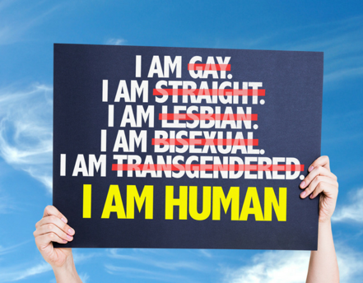
  - This occurs when you are given a different treatment in one of the circumstances specified by the Equality Act due to your sexual orientation. A law or policy based on sexual orientation may have caused the treatment, or it could have been a one-time occurrence.

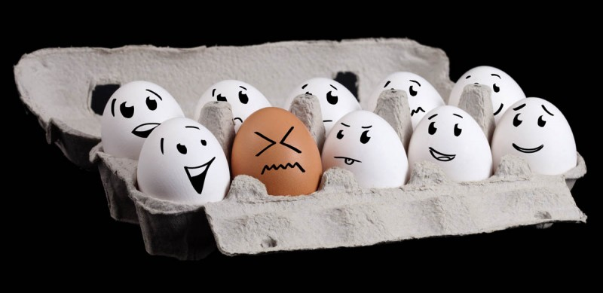
(Shutterstock, n.d.)

(Swartz-Swidler, 2019)
(TSP Legal, n.d.)

As a dance coach I have witnessed one of my younger dancers’ experiences one of these forms of discrimination. The young individual had to go through and is still going through sexual orientation discrimination. He used to be a she and made the brave decision to take the leap and come out as a transgender male, since then he has had to deal with people calling him names and assuming all kinds of things. Seeing and hearing the things that he is going through is heart wrenching, but he takes it in his stride and always sees the positives like finally living the life that he thought was never going to happen, it is like he has a new lease on life.
I understand this is not the same for everyone and it can be extremely difficult for an individual to see the positives in such a difficult situation.

How to deal with discrimination in education?
What is discrimination in education?
Discrimination in education is where an individual or individuals are treated unfairly simply because of who they are, this could be their appearance or origins. This can manifest in many different ways such as discrimination in grading, being denied educational chances, or being bullied by peers or teachers. This can have an adverse impact on the child itself leading to long term negative impacts to their education and their mental health. In the United Kingdom discrimination is an individual treated unfairly due to what the Equality Act 2010 refers to as protected characteristics. At any stage of a person’s education including entrance and access to extracurricular activities, they cannot be discriminated against or treated any differently.

Steps to use to help tackle discrimination in education
To help tackle and promote dealing with discrimination in today’s education system there are multiple different this that we can all do. These include things like knowledge, understanding, empathy and communication skills.
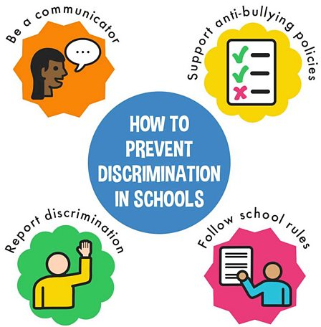
One of the first thing that can be done is to acknowledge that there is discrimination in education and include more inclusivity in the teaching curriculum. An easy way to do this is to make sure that facilities available, such as books, toys and posters include a wide range of diversity like different race, genders, and disabilities. We can also celebrate different ethnic groups festivals from across the world especially if there is an individual attending the school, this could make them feel more included. LGBT+ content could be brought in to in the form of books and make sure that teachers and other staff are aware of any changes.
Policies could be put into place or amended to support the cause. It can be difficult to detect subtle forms of discrimination. Each member of the school staff must be self-aware and take into account their own typical responses, procedures, and practises. Additionally required is a culture of reflection and confrontation of actions, speech, and attitudes. Strong links with local organisation and training are essential for helping children from all various sorts of communities. Anti-bulling policies are a great thing to be put in place and that it is followed by all, educators need to be on top of this and make sure they are aware of any happenings.
(What is discrimination?, n.d.)

It is also important to empathise and show compassion to those who may be discriminated against and be able to communicate with them effectively and respectfully with them about their experience. This means actively listening to them and responding to them in the correct manner and in a caring and supportive way.
After looking at some if the ways we can promote dealing with discrimination I believe that the easiest way for us as people to tackle the threat that us still ongoing in today’s society is:
- To make sure all staff and children have the knowledge and understanding needed about said topic.
- There is empathy and compassion at all times towards all individuals in need.
- There is communication in place to spread the awareness.
- Policies are made and amended in order to accommodate for everyone of every gender, race and ethic origins.

The merits and shortcomings of design thinking that deal with contemporary challenges in education.
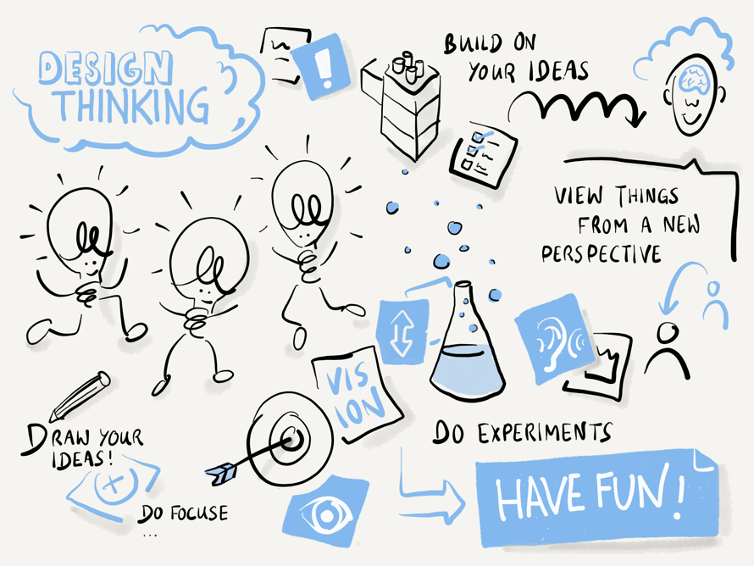
What is design thinking?
first off, I think we need to understand what design thinking is. Design thinking is a non-linear, problem solving approach to something that focuses on understanding the needs of its users. It generates creative ideas and interesting solutions to many things along with it redefining the problems faced trying to get to the final product. Although design thinking has been effectively incorporated into a number of industries, such as business and product development, its use in education has both advantages and disadvantages.
(Leukhardt, 2019)

There are five key aspects to design thinking, and these are.
- Empathise.
- Define.
- Ideate.
- Prototype.
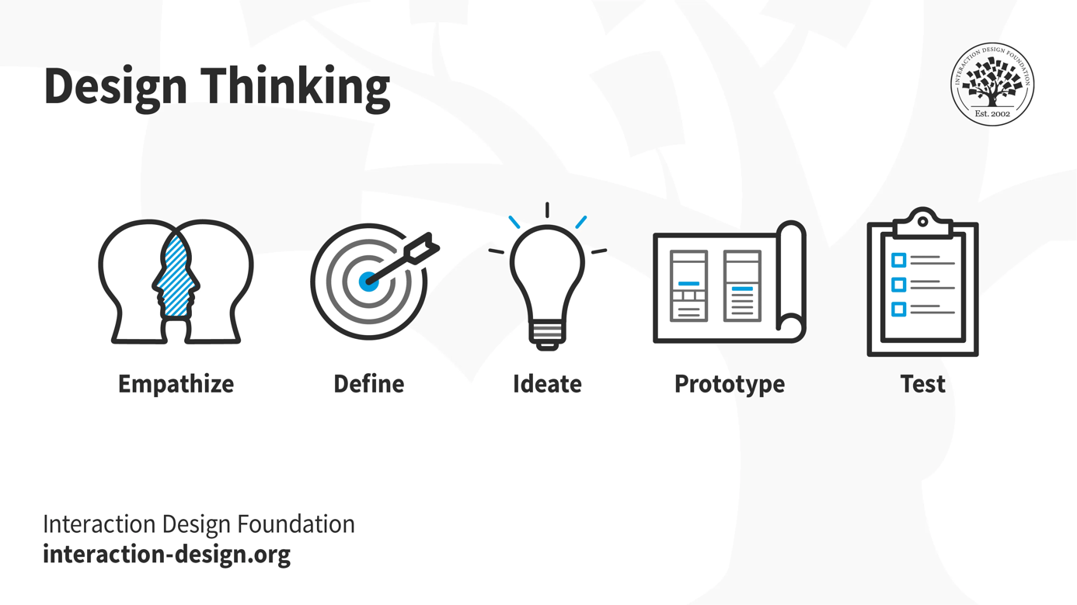
- Test.
(Yu Siang, 2009)

From the research I have conducted I have gathered some merits and shortcomings of design thinking in education.
Merits.
It is very diverse and centred around the students as it prioritises their needs while also pushing them to answer complex questions and try to solve real life problems. By actively engaging them in these activities it allows their learning to be genuine. Having these real world problems to solve all individuals can create different and original solutions to them, giving them more confidence and sense of accomplishment. It can also trigger a lot of critical thinking and give them wider range of inspiration.
Another advantage is that students can benefit from design thinking as they will be learning critical life skills including leadership, cooperation, and communication. The group work aspects will also teach them how to collaborate with one another and communicate clearly.
Shortcomings
It can be a very hard and confusing thing to learn and tackle as there is so much involved in the design thinking process. Because of this it can cause the student to lose interest in said task as the simply do not understand. It can also cause tension between groups as there could potentially be a misunderstanding while trying to come up with a final decision, this can then destroy the team itself as team work is extremely important in partaking in a design thinking task as it must have multiple different views and in order for the task to be projected in the correct manner.
Another disadvantage to design thinking would that it is extremely time consuming and cannot be done in one day, even small segments of research can take up to a week to find an understanding.
My view on design thinking in education.
In my opinion, while design thinking has a great number of advantages within education it should be used very wisely as if it is done in a fast paced environment it can cause the whole project to crumble. Teaching staff need to ensure that they overlook the groups doing design thinking tasks whilst giving them the freedom to do it alone and feed off each other’s ideas in order to achieve their final goals.

References.
ACAS (2022). Types of disability discrimination: Disability discrimination at work - Acas. [online] www.acas.org.uk. Available at: https://www.acas.org.uk/disability-discrimination/types-of-disability-discrimination [Accessed 26 Mar. 2023].
American Psychological Association (2019). Discrimination: What it is, and how to cope. [online] Apa.org. Available at: https://www.apa.org/topics/racism-bias-discrimination/types-stress [Accessed 26 Mar. 2023].
Chattertons Solicitors. (2022). Discrimination in education - can you make a claim? - Chattertons Solicitors in Lincolnshire. [online] Available at: https://www.chattertons.com/site/blog/dispute-resolution/discrimination-in-education-can-you-make-a-claim [Accessed 30 Mar. 2023].
Equality and Human Rights Commission (2016). Sexual orientation discrimination | Equality and Human Rights Commission. [online] Equalityhumanrights.com. Available at: https://www.equalityhumanrights.com/en/advice-and-guidance/sexual-orientation-discrimination [Accessed 26 Mar. 2023].
Gov.uk (2010). Equality Act 2010. [online] Legislation.gov.uk. Available at: https://www.legislation.gov.uk/ukpga/2010/15/contents [Accessed 26 Mar. 2023].
Leukhardt, S. (2019). Design Thinking – how to integrate new ways of working. [online] www.ibsolution.com. Available at: https://www.ibsolution.com/academy/blog_en/design-thinking-how-to-integrate-new-ways-of-working-into-your-daily-routine [Accessed 7 Apr. 2023].
Nixon, K. (2021). Instances of discrimination at work | Law Blog | McPartland & Sons Solicitors. [online] Harry McPartland & Sons Solicitors. Available at: https://hmcpartlandandsons.co.uk/instances-of-discrimination-at-work/ [Accessed 26 Mar. 2023].
Preventing and tackling discrimination in primary schools. (n.d.). Available at: https://mentallyhealthyschools.org.uk/media/1729/mentally-healthy-schools_preventing-and-tackling-discrimination-in-primary-schools.pdf [Accessed 30 Mar. 2023].
Razali, N.H., Ali, N.N.N., Safiyuddin, S.K. and Khalid, F. (2022). Design Thinking Approaches in Education and Their Challenges: A Systematic Literature Review. Creative Education, 13(07), pp.2289–2299. doi:https://doi.org/10.4236/ce.2022.137145.
Shutterstock. (n.d.). 4,008 Disability Discrimination Images, Stock Photos & Vectors. [online] Available at: https://www.shutterstock.com/search/disability-discrimination [Accessed 26 Mar. 2023].
Swartz-Swidler. (2019). Sexual Orientation Discrimination In The Workplace | Discrimination Law. [online] Available at: https://swartz-legal.com/employment-law-resources/sexual-orientation-discrimination-workplace/ [Accessed 26 Mar. 2023].
Tsoi, J. (2021). What are the flaws of Design Thinking? [online] Medium. Available at: https://uxdesign.cc/what-are-the-flaws-of-design-thinking-83e22213232a [Accessed 8 Apr. 2023].

TSP Legal. (n.d.). Race Discrimination - Solicitors for Employees in Colchester and Clacton. [online] Available at: https://www.tsplegal.com/service/employment-law-employees/discrimination/race-discrimination/ [Accessed 25 Mar. 2023].
What is discrimination? (n.d.). BBC Bitesize. [online] Available at: https://www.bbc.co.uk/bitesize/topics/zyg2xbk/articles/z8yjdp3 [Accessed 26 Mar. 2023].
www.citizensadvice.org.uk. (n.d.). Race discrimination. [online] Available at: https://www.citizensadvice.org.uk/law-and-courts/discrimination/check-if-youre-protected-from-discrimination/race-discrimination/ [Accessed 26 Mar. 2023].
www.creativeans.com. (2022). Why Design Thinking Matters In Education And The Benefits. [online] Available at: https://www.creativeans.com/resources/why-design-thinking-matters-in-education-nurturing-creative-confidence-and-divergent-thinking/ [Accessed 5 Apr. 2023].
Yu Siang, T. (2009). What is Design Thinking? [online] The Interaction Design Foundation. Available at: https://www.interaction-design.org/literature/topics/design-thinking [Accessed 4 Apr. 2023].
‌

