
Supporting and Developing Autistic Learners in Primary School Settings. Resource Book for Teaching Assistants
(Invictus Roofing, 2020)

Rhian Williams
Amanda Howland
Lesley Martin
Itinerary

08:45 Registration served with welcome teas and coffees
09:00 Health and safety
09:15 Introduction – Amanda Howland
09:20 Introduction – Rhian Williams
09:25 Introduction – Lesley Martin
09:30 Supporting and Developing Communication
10:30 Visual Support Structure Tasks
11:00 Break served with teas and coffees
11:15 Lesley Martin
12:45 Lunch
13:15 Amanda Howland
14:15 Amanda Howland Tasks
14:45 Break served with teas and coffee
15:00 Question and answer session followed by course evaluation
15:15 Presentation of certificates
15:30 Finish

Supporting and Developing Communication

Rhian Williams


(Psychology Today, 2020).

Communication Difficulties for Children with Autism – Rhian Williams

Children with autism often possess severe communication difficulties. Using the ‘Triad of Impairments of Social Interaction’, communication difficulties was identified as one of three criteria which must be exhibited in children when identifying autism. Children with autism often present themselves as possessing difficulties which affects their non-verbal and verbal communication. As a result, some children communicate via their behavioural actions, as they find it difficult to communicate through spoken language. However, with additional support, children can establish practical communication (Elks and McLachlan, 2009).
According to the Department of Health (2002), a best practice approach would be to teach the child to communicate utilising visual support structures. The Department for Education (2017), have supported this notion by also recommending the utilisation of visual support structures as a means of best practice, to provide support to children with autism who possess communication difficulties. In conjunction, both authorities also support early identification alongside collaboration between schools, the family home and the wider professional community as a means of best practice (Department for Education, 2017) and (Department of Health, 2002).
Children with autism experiences difficulties with both non-verbal and verbal communication. They find gestures, body language, eye contact, facial expressions and intonation confusing which heightens their difficulties with communication. Children experiencing difficulties with: understanding, expressive language and pragmatics which can also effect their social development and therefore every day life.

Understanding difficulties

Children may experience the following difficulties:
- Distracted easily by noise which affects their ability to concentrate.
- Unable to interpret the communication meaning as everything is literally taken.
- Words which possess double meanings.
- Understanding word puns and verbal jokes.
- Unable to focus on the picture as a whole.
- Unable to make appropriate predictions.
- Following a command sequence.
- Making inferences.
- Understanding tasks which involve verbal reasoning (Elks and McLachlan, 2009).

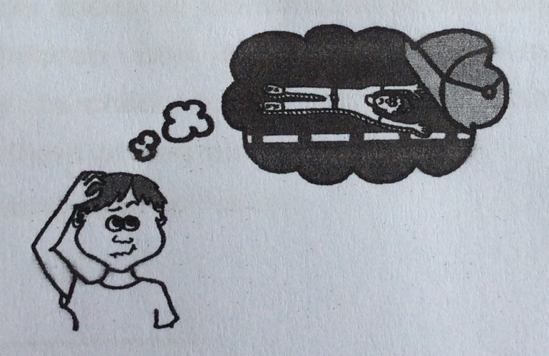

(Elks and McLachlan, 2009).

Expressive language difficulties – Rhian Williams

Expressive language difficulties can involve:
- Establishing words into longer sentences.
- Utilising creative language.
- Immediate echolalia.

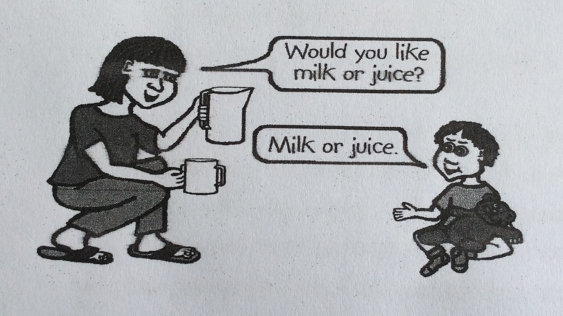
(Elks and McLachlan, 2009).

- Delayed echolalia.
- Utilisation of pronouns.

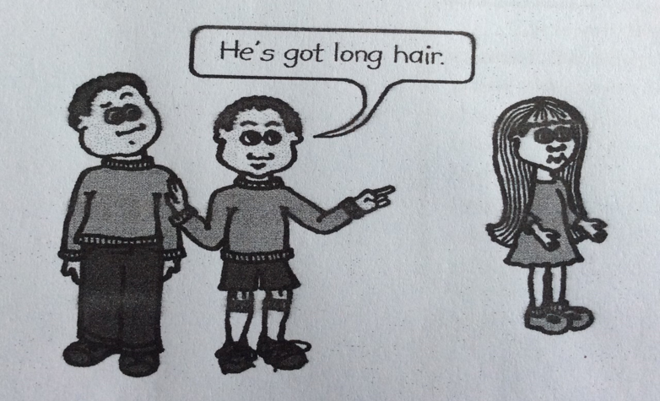
(Elks and McLachlan, 2009).

Pragmatics

A child with autism may possess difficulties using appropriate language:
- Difficulty using and understanding social greetings.
- Pedantic speech which utilises a different accent.
- Frequent interruptions during conversation.
- Go off on tangents whilst being verbose.
- Needs support to engage in conversations.
- Difficulties using non-verbal communication.
- A lack of awareness for their peers.
- No differentiations made between adult and child.
- Unable to maintain eye contact.
- Finds initiating, maintaining and closing a conversation difficult (Elks and McLachlan, 2009).

Additional points to be aware of: (Rhian Williams)

Receptive language in normal development occurs before expressive which allows children to gain an understanding of the language they utilise which is used to provide them with the ability to talk and engage in conversations. Children with autism often display the opposite having better expressive to receptive language. This is normally achieved as children with autism possess excellent memory skills which allow them to remember blocks of language without possessing the ability to understand it. Therefore, they become adept at learning phrases and words which can be deceived easily, allowing them to overuse non-specific vocabulary and phrases. As a result, it is recommended that a child’s understanding level should be checked to avoid the inappropriate use of phrases and words.

The Effects of Communication Difficulties on Social Development

Communication is utilised as a means to establish relationships. Without communication, social development in children with autism could be impaired affecting their ability to:
- Understand language which is connected to emotion.
- Share emotive feelings with others.
- Understand the use of appropriate language which could inhibit their social development.
- Engage in conversational language.
- Understand the effects of their behaviour towards others.
- Utilise appropriate language to create and maintain friendships.
- Avoid domination in conversations.
- Understand and use non-verbal communication (Elks and McLachlan, 2009).

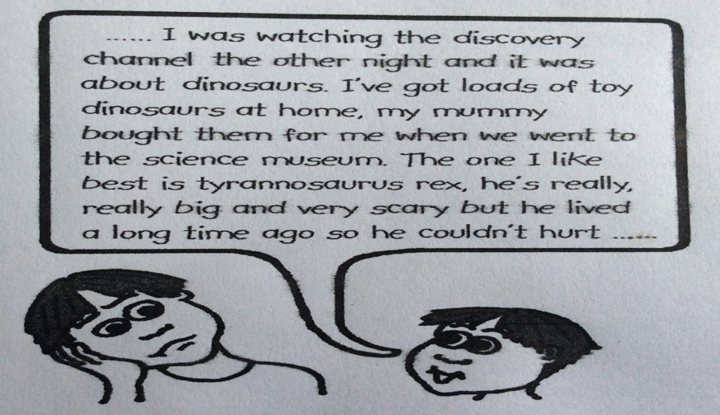

(Elks and McLachlan, 2009).

Advice for Utilising Visual Structures for Children with Autism – Rhian W

- Always assess the level of understanding that the child possesses to determine which visual support structure is most appropriate.

- Teach the purpose of visual supports before they are actually required to ensure they understand the purpose of them.

- Use the schedules to teach the language of sequencing.

- Use ‘First and Then boards’ as a motivator to reinforce sequencing language.

- Encourage the child’s success by using structures at an appropriate level which reflects their understanding.

- Create the schedule in advance.

- Only introduce a ‘change card’ when you know the child will adapt.

- The schedule should be displayed in a position which is easily accessible to the child.

- Do not remove the visual structure whilst the child is coping.

- If you offer a reward as a means of motivation then it must be adhered to (Elks and McLachlan, 2009).

Autism Task 1 – First/Then Cards – Rhian Williams

Using the picture cards from task one and following the instructions below, please create a first and then picture board which you could use in class to support your pupil when doing a specific task. Remember that the task goes first, followed by the reward.

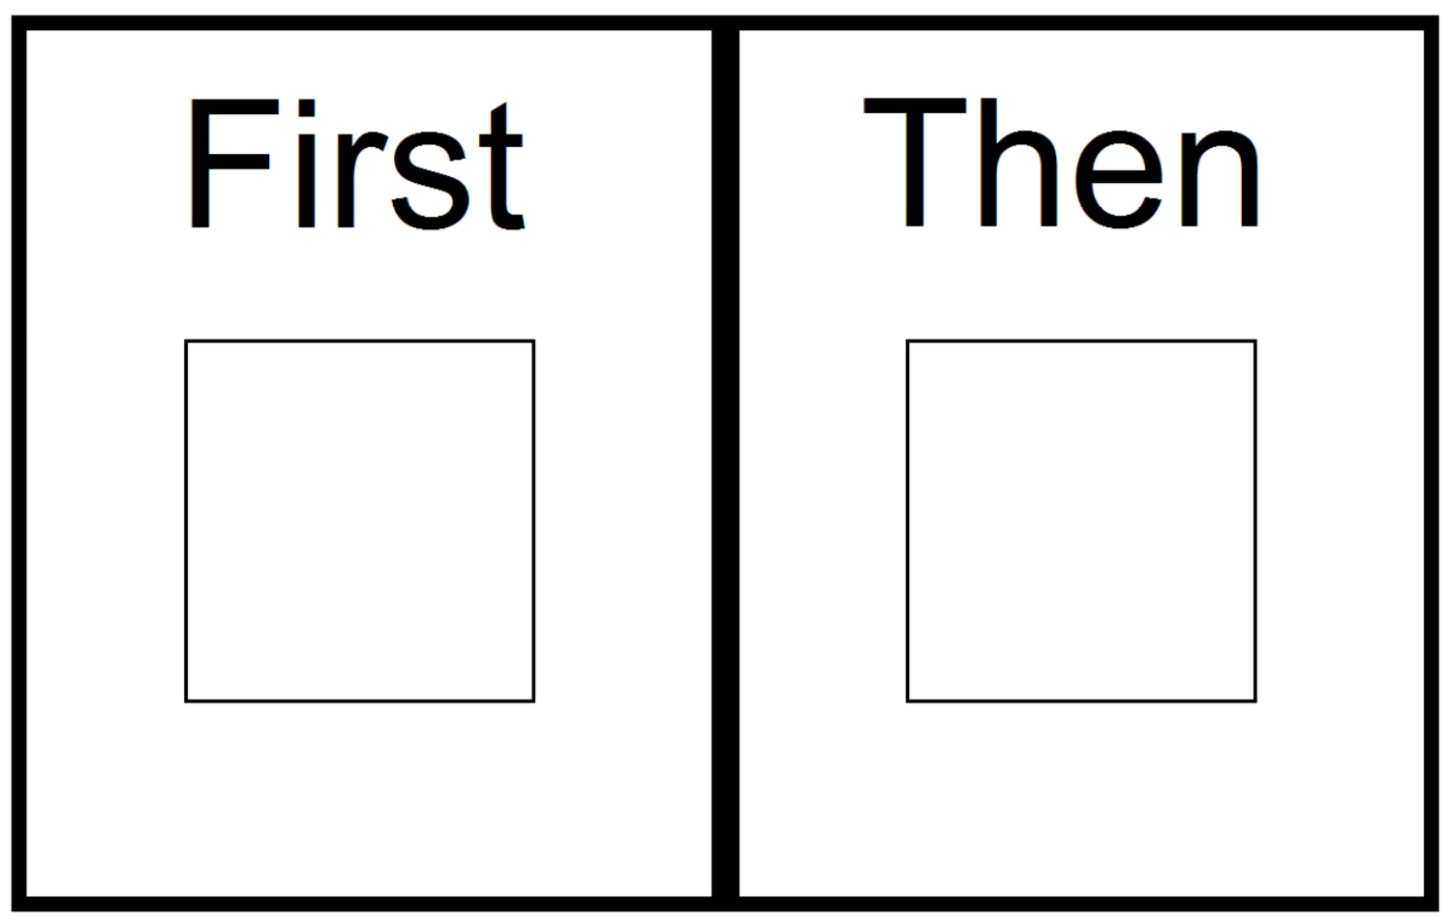
(Autism Circuit (2020)

Instructions for use.

- Introduce the first/then card to the pupil pointing towards the pictures whilst saying “First (Activity 1), then (Activity 2)”. If the students goes off task during the process, reinforce the instruction by visually showing them the card again, repeating the instructions.
- When the focused task is complete, introduce the first/then card again whilst saying “(Activity 1) finished, now (Activity 2)” and pointing to the pictures accordingly.
- Start Activity 2 immediately (Autism Circuit, 2020).

Autism Task 2 – Visual Timetables – Rhian Williams

Please create a visual timetable for a pupil in your class, which will assist with their daily routine whilst at school. You could incorporate the daily learning activities alongside break and lunch times, to assist the child. Please order them in accordance with the daily timetable.

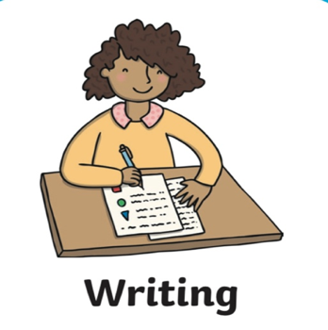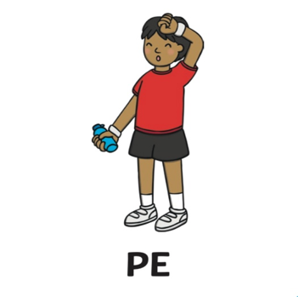

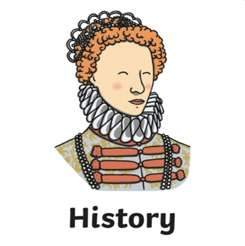

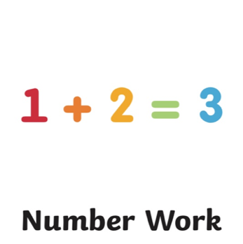

 (Twinkl, 2020).
Autism Task 2 – Visual Timetables – Rhian Williams





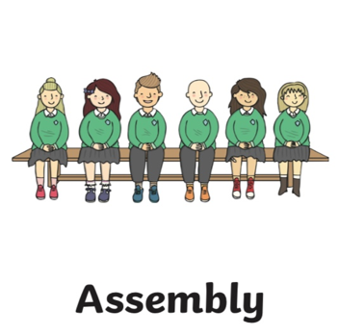

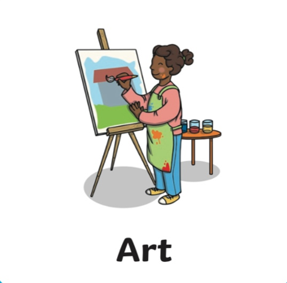



(Twinkl, 2020).
Autism Task 2 – Visual Timetables – Rhian Williams





(Twinkl, 2020).
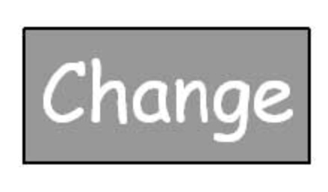
(Indiana Resource Center for Autism, 2020).

Autism Task 3 – Mind Maps Activity – Rhian Williams

Instructions for creating a Mind Map.

- Collect a piece of A4 plain paper and some coloured pens or pencils.
- Turing the paper sideways, draw a central shape.
- Inside the shape, include either a topic headline or an image.
- Colour the picture or inside the shape.
- From the central image, draw thick curved branch lines in an outward direction.
- Each branch should represent one of your main subject ideas.
- On the lines, write the main topic headlines which are now representing key words.
- Include on the lines a topic picture.
- In an outward direction from the branches, draw sub branches which are thinner in appearance.
- Each branch and connecting sub branch should be represented by a different colour.
- Add singular words to the branches and sub branches, to help build a picture consisting of words and images representing your topic.
- Pictures and words encourage both sides of the brain whilst engaging in learning activities.
- Throughout the above actions, continue to engage with your pupil verbally.
- Upon completion, encourage your pupil to engage in verbal conversation by asking simple questions which can be answered by utilising the mind map.
- Praise and motivate your pupil throughout (Elks and McLachlan, 2009).

Tips for using Mind Maps in class

Mind maps are tools which can be used in the classroom due to their flexibility. They can:
- Help to build memory skills by asking the child to draw his own topic related Mind Map.
- Record appropriate information from the beginning of the lesson.
- Be displayed on the class wall as attractive visual displays which promote independent learning.
- Represent as much information as the child wishes to record.
- They can be adapted at any time by adding additional relevant information.
- Encourage communication skills by engaging the pupil with his class peers and teachers.
- Can be used to describe any given topic including academic, social and emotional topic (Elks and McLachlan, 2009).

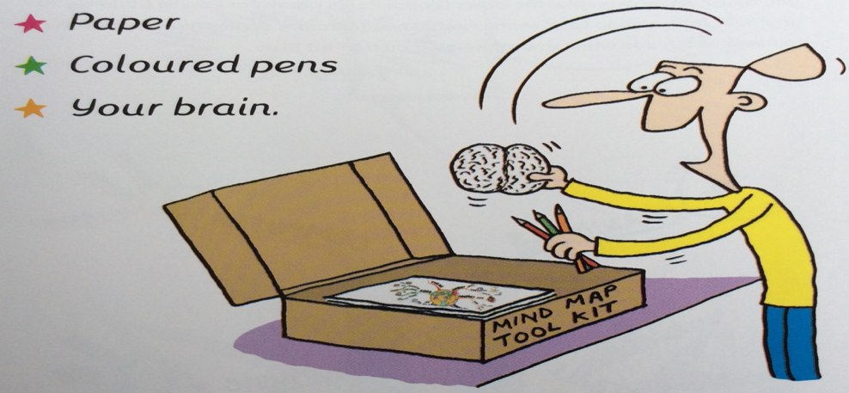

(Buzan, 2003).

Autism Task 3 – Mind Maps Activity – Rhian Williams

Utilising ‘The Victorians’ picture below, please create a mind map to use with your pupil in class, to support their learning.

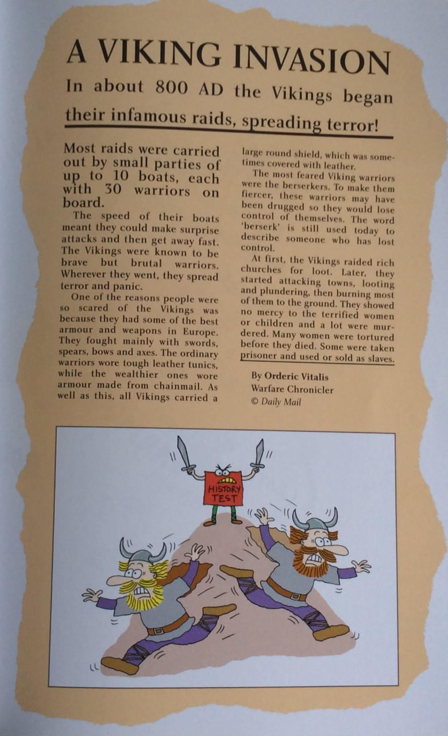

(Buzan, 2003).

Please see additional resources for examples of mind maps which have already been created.

Additional Resources – Rhian Williams

9 Reasons To Use Visuals

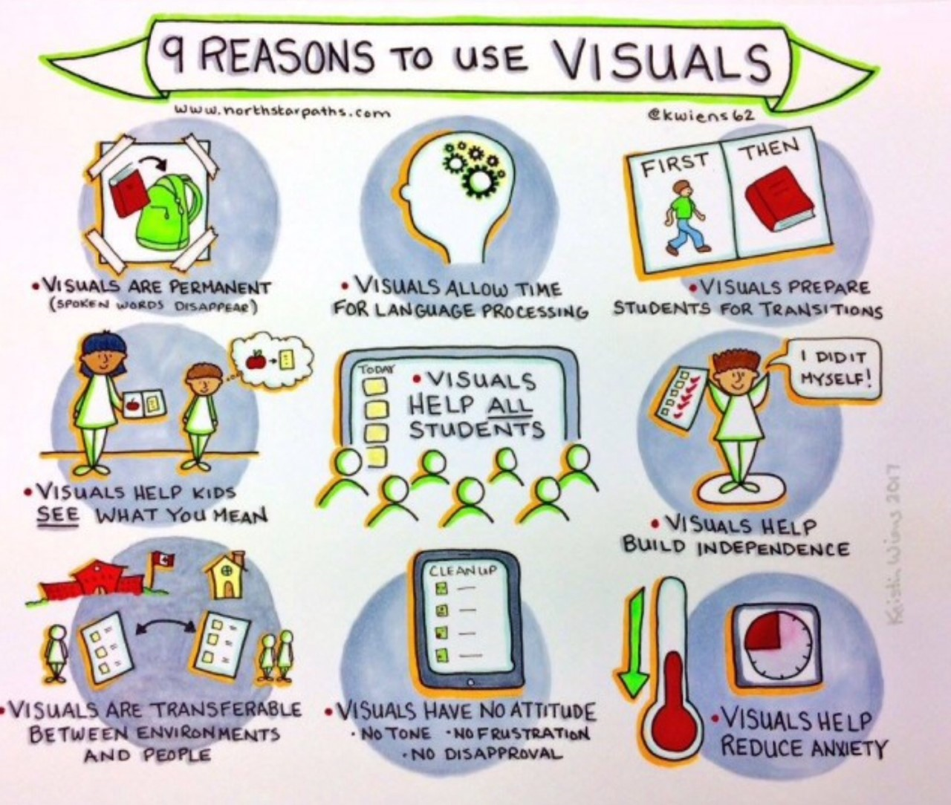
(Reachout ASC, 2020).

Guidelines for Utilising Visual Supports – Rhian Williams

- Determine the purpose and goal of utilising visual supports to:
Anticipate what activity is coming next.
Understand the environment and availability of choices.
Understand behaviour expectations.
- Determine the most appropriate type of visual support.
- Assess the appropriateness of selected visual support – Not all visual supports work with every child so a period os experimentation may be required until the correct form is identified.
- Set up the visual support – Consider the portability and durability when selecting materials for usage (see useful links for further details).
- Teach your pupil how to utilise the visual support – Provide the child with time to practice the connections between the image on the support and the routine.
- Assess the visual support and adjust accordingly – Assess how effective the support is and evaluate its impact. Make modifications and adjustments accordingly (Fettig et al., 2011).

Additional Resources – Rhian Williams

Visual Timetable Pictures for Use at Home

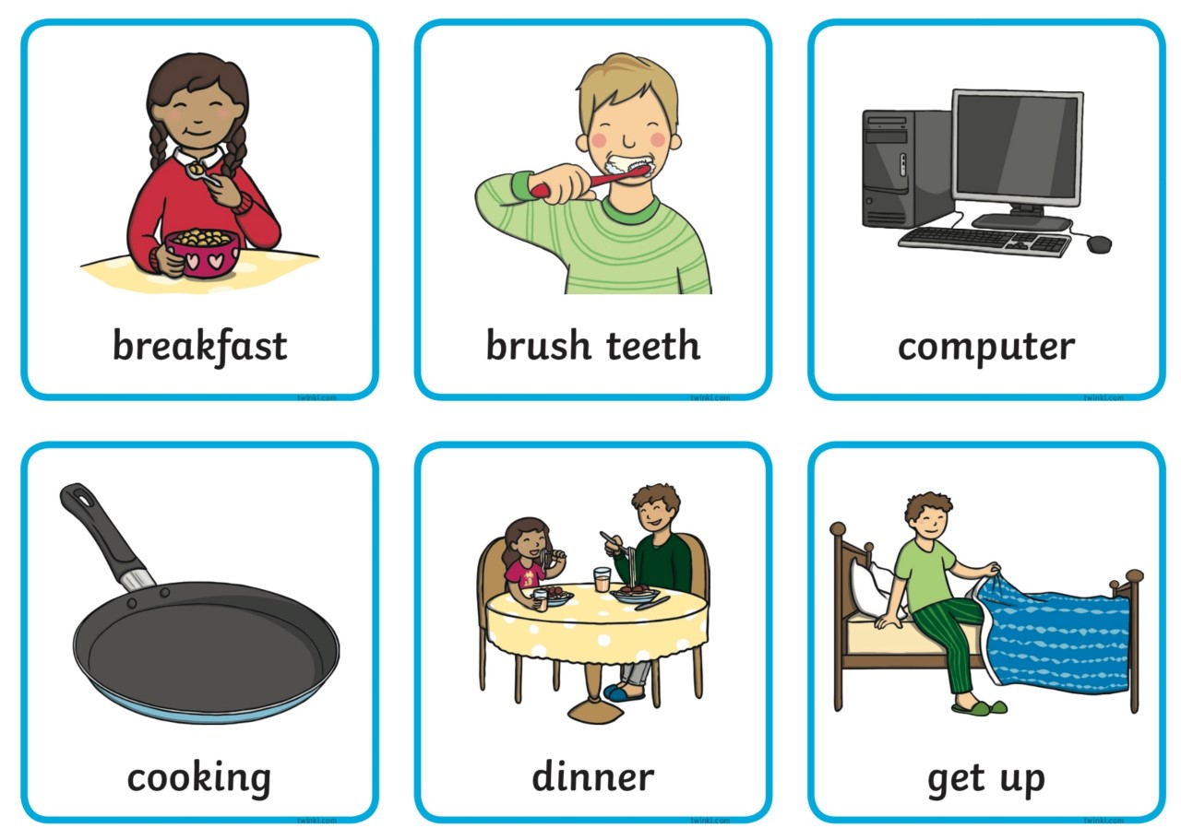

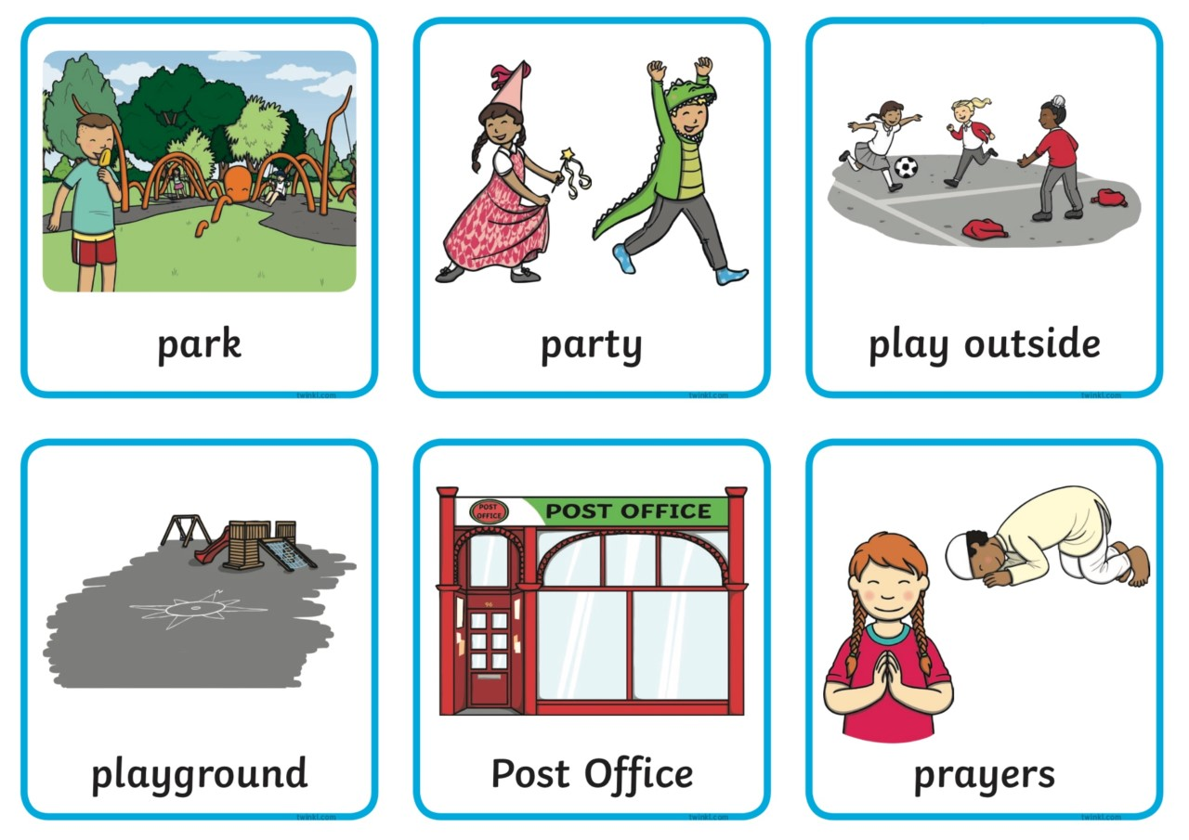

(Twinkl, 2020).

Additional Resources – Rhian Williams

Visual Timetable Pictures for Use at Home

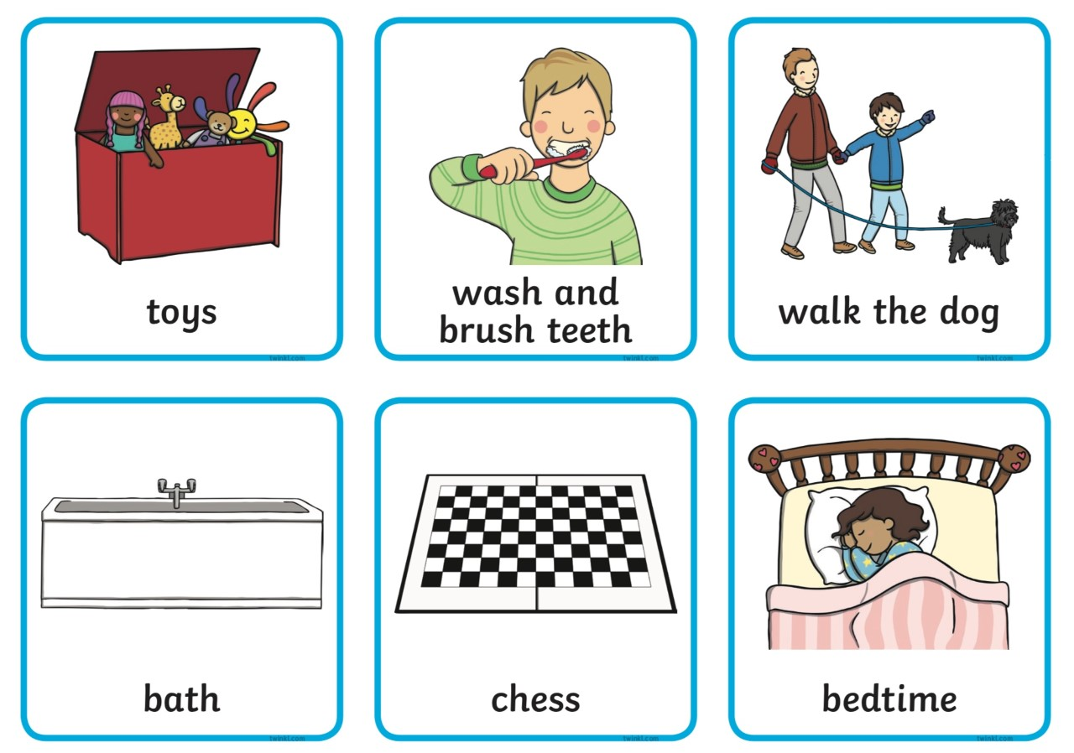

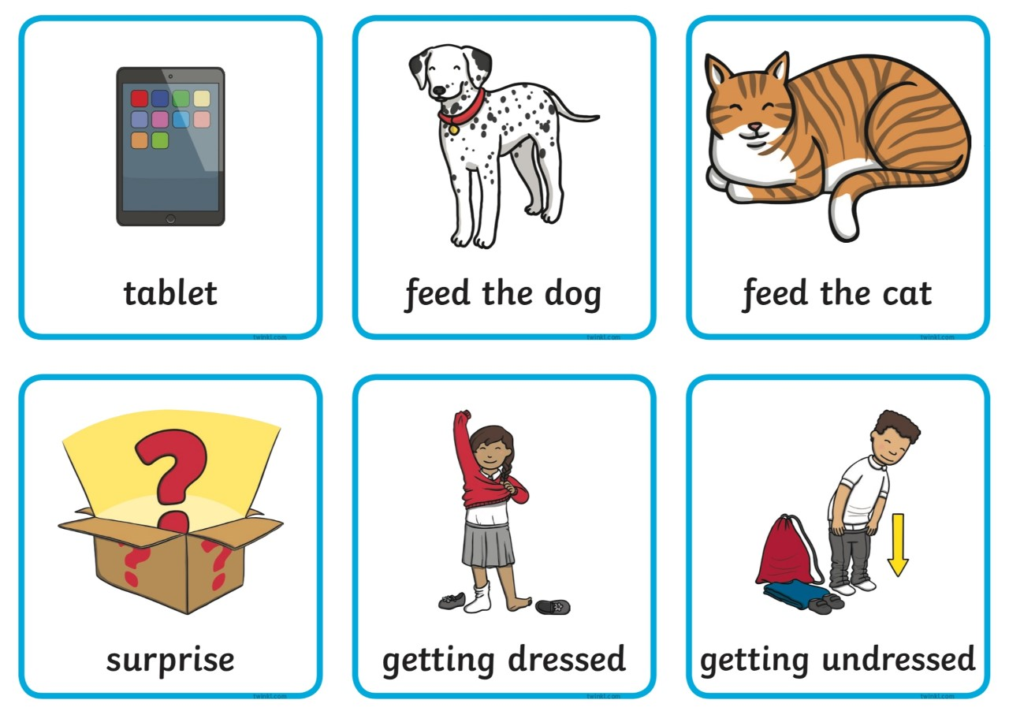

(Twinkl, 2020).

Additional Resources – Rhian Williams

Visual Timetable Pictures for Use at Home

(Twinkl, 2020).

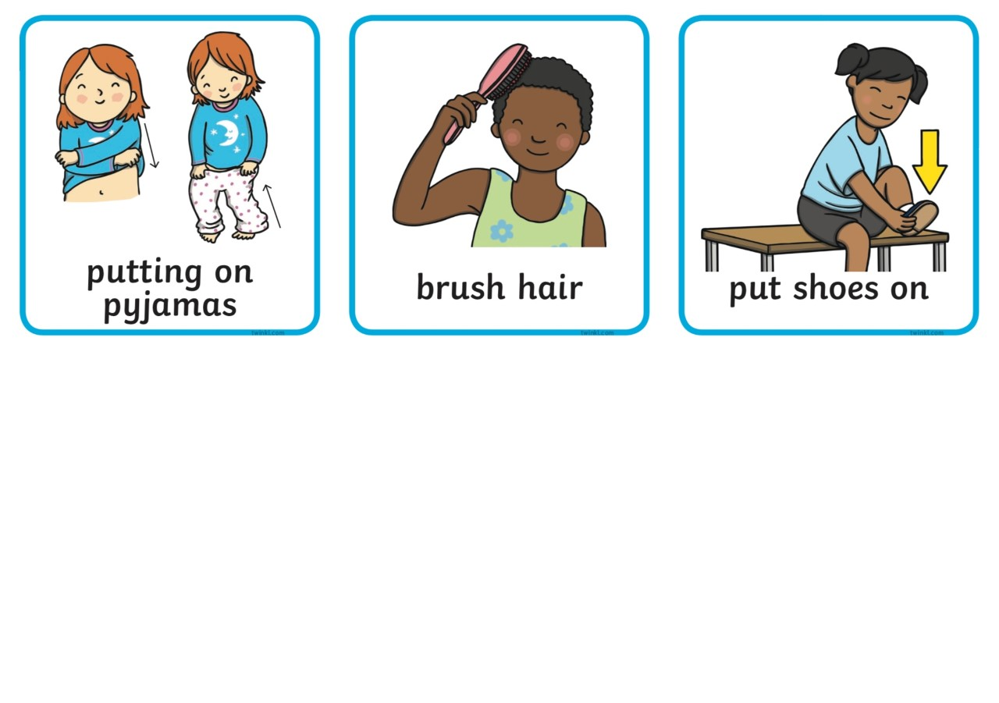

Additional Resources – Rhian Williams

Example of a Visual Timetable for Use at Home

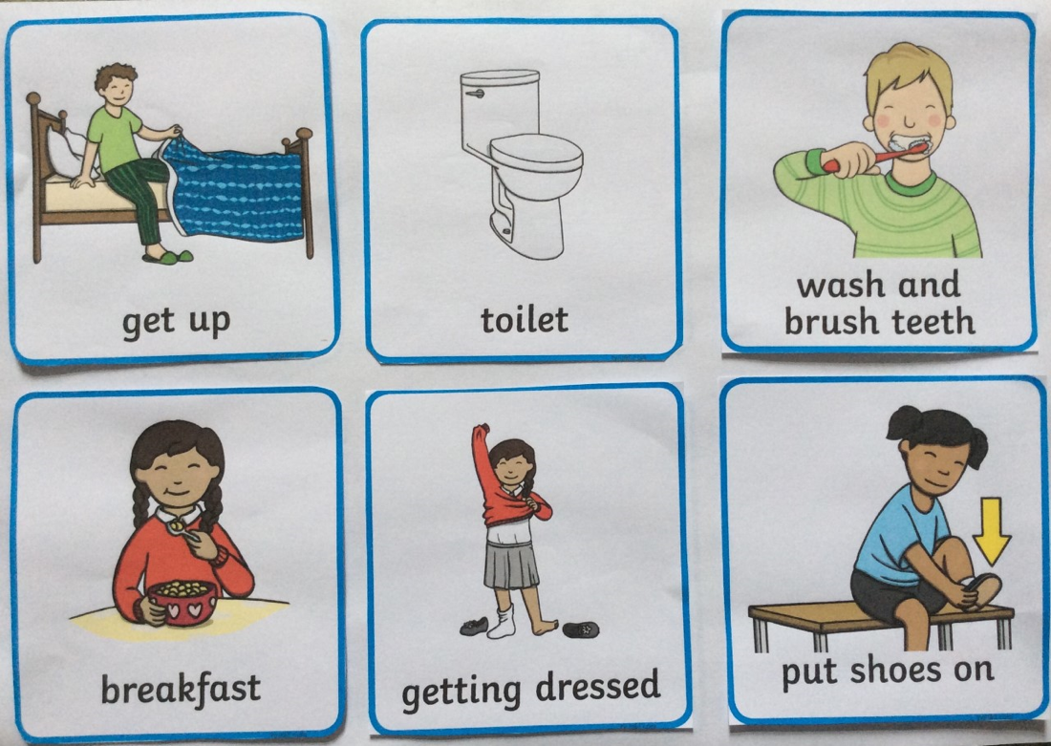

(Twinkl, 2020).

Additional Resources – Examples of Mind Maps – Rhian Williams

‘The Victorians’ Mind Map

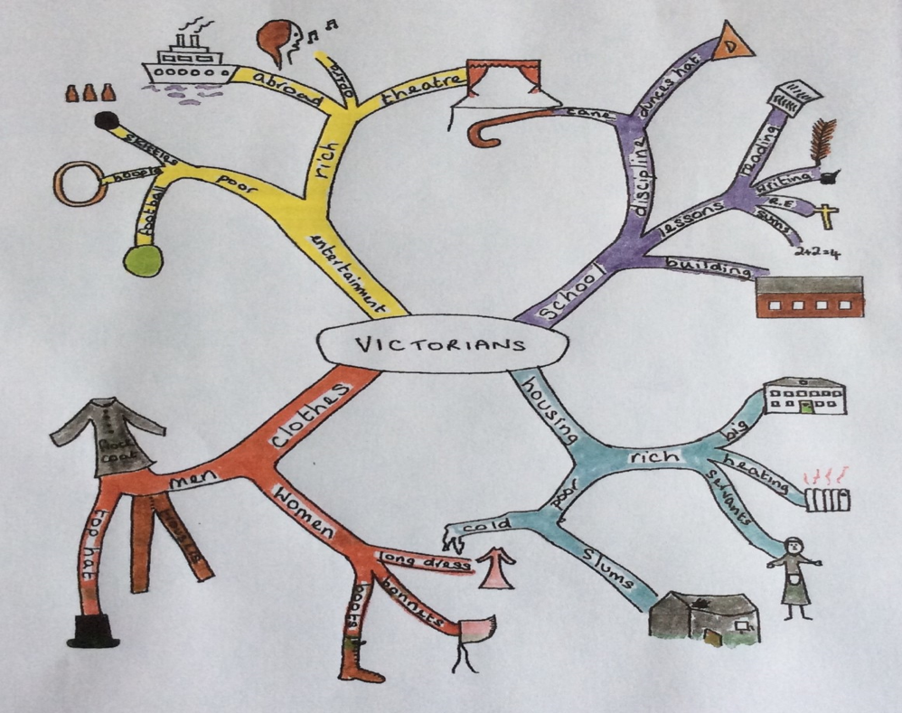

(Elks and McLachlan, 2008).

A ‘Feelings’ Mind Map

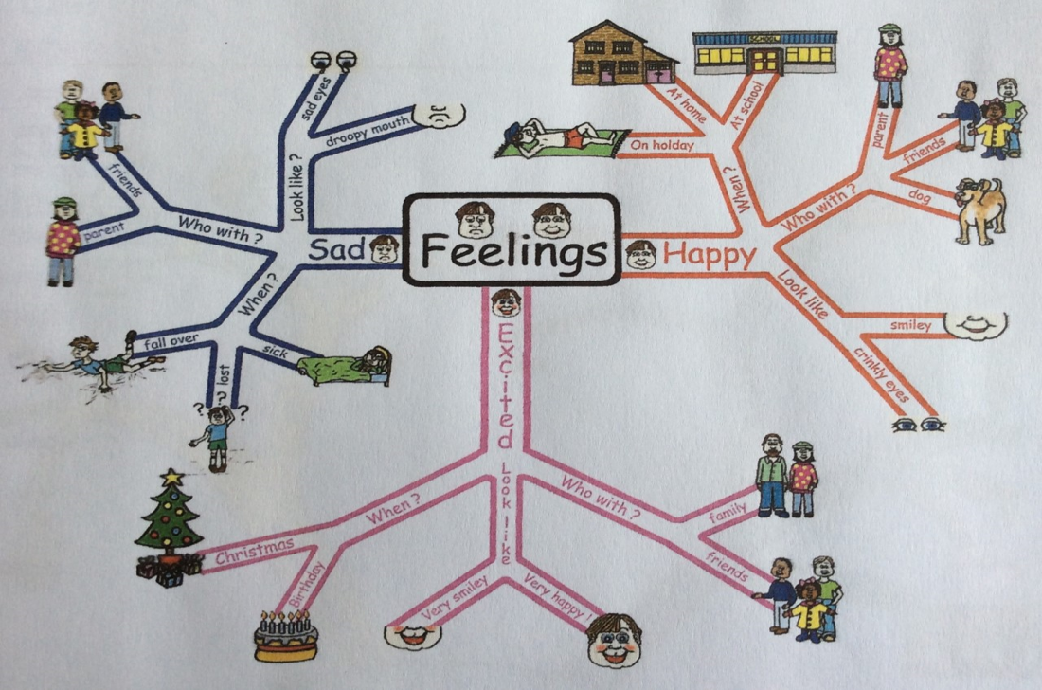

(Elks and McLachlan, 2009).

Communication and Behaviour Advice Sheet – Rhian Williams

- What is the child trying to communicate?
Try to be attentive to the child whilst he is trying to communicate via his behavioural actions. ‘Look’ to see if you can make out what he is trying to say.
- Utilise statements which are positive
Instead of saying ‘Do not run’, try ‘Please walk in the classroom’.
- Be conscious of your own behavioural actions.
Model appropriate behaviour when responding to incidents of inappropriate behaviour by using positive language.
- Recognise the behaviour antecedents
- Does the child understand the task requirements?
Ensure you level of language is appropriate when checking to see if the child understands the tasks requirements.
- Utilise visual structure
Establish the nature of the visual structure and assess its level of appropriateness, according to the level of understanding and communication that the child possesses.
- Avoid unnecessary stress!
Emotions affect autistic children’s levels of communication, making it harder for them to project their words and thoughts. Always use appropriate language and communication to avoid unnecessary behaviour.
- Select an appropriate strategy
Do not choose behavioural strategies which are based upon pleasing others. A child with autism is only focused on their individual needs and requirements (Elks and McLachlan, 2009).

Useful Website Links: (Rhian Williams)

Autism Circuit – Tools And Techniques For Students On The Autism Spectrum. Available at: http://autismcircuit.net

Autism Spectrum Disorder: Good Practice Guidance. Available at: https://cyps.northyorks.gov.uk/sites/default/files/SEND/Autism/Appendix_D_-_Autism_Best_Practice_Guidance.mht.pdf

Elklan. Available at: https://www.elklan.co.uk

FOCUS – Mind Mapping for Children with ASD: Uses and Benefits. Available at: https://www.mindmeister.com/blog/mind-mapping-for-children-with-asd/

National Autistic Society – About Autism. Available at: https://www.autism.org.uk/about.aspx

National Autistic Society – Autism and Education: Good Practice Guide. Available at: https://www.autism.org.uk/~/media/nas/professionals/teachers/nas_education_good_practice_guide_web_final.ashx?la=en-gb

National Autistic Society – Visual Supports. Available at: https://www.autism.org.uk/about/strategies/visual-supports.aspx

Tips and Ideas for Making Visuals to Support Young Children. Available at: http://csefel.vanderbilt.edu/modules/module3b/handout2.pdf

What is Good Practice in Autism Education? Available at:
https://research-management.mq.edu.au/ws/portalfiles/portal/83300571/82950951.pdf

References

Autism Circuit (2020) First/Then Card. Available at: http://www.autismcircuit.net/assets/uploads/docs/first-then.pdf (Accessed: 29th April 2020).
Autism Circuit (2020) First/Then Card. Available at: http://www.autismcircuit.net/tool/first-then-card (Accessed: 29th April 2020).
Buzan, T. (2003) Mind Maps for kids. London: Harper Collins Publishers.
Department for Education (2017) SEN support: research evidence on effective approaches and examples of current practice in good and outstanding schools and colleges. Available at: https://www.sendgateway.org.uk/download.sen-support-research-evidence-on-effective-approaches-and-examples-of-current-practice-in-good-and-outstanding-schools-and-colleges.html (Accessed: 3rd May 2020).
Department of Health (2002) Autism Spectrum Disorders: Good Practice Guidelines. Available at: https://cyps.northyorks.gov.uk/sites/default/files/SEND/Autism/Appendix_D_-_Autism_Best_Practice_Guidance.mht.pdf (Accessed: 3rd May 2020).
Elks, L. and McLachlan, H. (2008) Language Builders: Advice and activities to encourage children’s communication skills. Elklan: Cornwall.
Elks, L. and McLachlan, H. (2009) Language Builders for Verbal ASD: Advice and activities to support verbal children with autism spectrum disorder. Elklan: Cornwall.
Fettig, A. et al. (2011) ‘Using Visual Supports With Young Children With Autism Spectrum Disorder’, Teaching Children, 43(6), pp. 28-35. Available at: LANCUK (2020) Autistic Spectrum Disorder. Available at:
https://journal.sagepub.com/doi/pdf/10.1177/004005991104300603 (Accessed 5th May 2020).
Indiana Resource Center for Autism (2020) Change is Good! Supporting Students on the Autism Spectrum when Introducing Novelty. Available at: https://www.iidc.indiana.edu/irca/articles/change-is-good.html (Accessed: 29th April 2020).
Invictus Roofing (2020) Autism Awareness. Available at: https://www.invictusroofing.co.uk/april-2018-world-autism-awareness-month/ (Accessed: 27th April 2020).
Psychology Today (2020) How Does Communication Work? Available at: https://www.psychologytoday.com/hk/blog/language-in-the-mind/202001/how-does-communication-work (Accessed: 1st May 2020).
Reachout ASC (2020) The right way to use Visual Timetables. Available at: https://www.reachoutasc.com/blog/the-right-way-to-use-visual-timetables (Accessed: 29th April 2020).
Twinkl (2020) Visual Timetable. Available at: https://www.twinkl.co.uk/resource/au-c-097-australia---ks1-visual-timetable (Accessed: 25th April 2020).

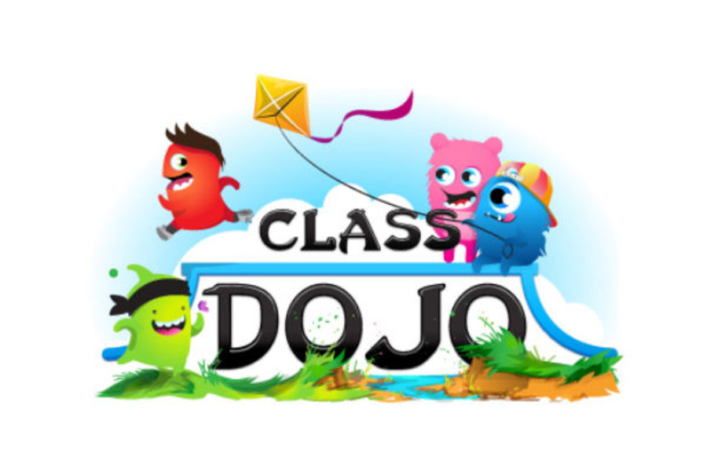
( The Christian Science Monitor 2013)

Dojo is a way of communication between families and teaching staff. A great way to communicate the progress in the classroom as well as any important information the teacher may have to relay.
Here is a link for you to see how class Dojo works
https://youtu.be/pXnRG_gnrCk

Video modeling.
It is as I explained a great instrument to use in the classroom with children that are on the spectrum. They learn best visually and this method is using exactly that. Below is a link that you can access to see an example of how it works and how it can be implemented in your classroom.
https://youtu.be/zC8pKt4LhKE
The video explains ways in which you can edit out the parts that shows the adult giving assistance.

TASK 1
Brainstorm
What is it like to be a teaching assistant of a child with ASD?

Task 2
We have been told by a parent that their child loves the topic of Space/Planets. What could you do as a teaching assistant to bring that special interest into lessons to assist the learning and focus within the classroom?

Task 3 What does Autism mean to you and what have you learned today?

References

The Christian Monitor (2013) class dojo Available at: https://www.csmonitor.com/The-Culture/Family/2013/1129/Class-Dojo-app-offers-parents-window-into-child-s-behavior Accessed 6th May 2020

https://youtu.be/zC8pKt4LhKE

