

University of Wales Trinity St David
School of Engineering

Valve Train Dynamics and Intake/Exhaust Pulse Tuning

Corey Davies
(1702838)

Motorsport Engineering HND/BSC

26/04/2020

Powertrain Technology
(M5X02200)
Contents Page:

Introduction…

Research…

Methodology…

Analysis…

Conclusions…

References…

Introduction
The purpose of this assignment is to investigate engine intake and exhaust systems and to report on factors which influences the design and operation of the induction and exhaust manifolds. Also, to calculate and analyse valve train dynamics.

Research
Valve Float
When an internal combustion engine (ICE) experiences valve float, the lifters/rockers are not following the profile of the camshaft properly. This can be cause by several things the most common being poor or weak valve springs. During valve float, the valves in the cylinder head are not closing completely causing the engine to misfire and therefore lose power. Valve float can result in piston, valve and camshaft damage. Extended periods of valve float can lead to catastrophic engine failure.
The camshaft has been called the brain of an internal combustion engine, and the specific grind or profile of the camshaft determines the power output of the engine as well as the power curve. As the camshaft turns inside of the engine, the lifters ride on the cam lobes and use push rods to operate the rocker arms. The rocker arms push on the valve stem tips and open and close the valves to allow an air/fuel mixture into the combustion chamber and let the exhaust out. Powerful springs attached to the valve stems are the only method of keeping the valves closed. As stated by (wiseGEEK, NA)
The intake valve must already be open before TDC before the piston begins moving down on its intake stroke. If the valve were closed, the piston would drag against the resistance presented by the unopened valve port, especially at higher speed. The specification for intake opening for stock applications is listed in most service literature. The piston must start and stop at the beginning and the end of each stroke. During the intake stroke the connecting rod spins, whipping the piston down into the bore. At higher speeds, the piston accelerates very quickly, causing a big gulp of air when it reaches its maximum velocity at 90° of rod angle. As stated by (Gilles, 2011)
Valve lift describes the distance a valve is opened. Increased valve lift allows more air and fuel flow. Unlike an increase in duration, which keeps valves open longer, valve lift does not cause a rough idle or ruin low end performance. Do not confuse valve lift with lobe lift, which, depending on engine design, is sometimes a considerably smaller measurement. Measuring valve lift is discussed later in the chapter. As stated by (Gilles, 2011)
The most efficient and dependable race engines are able to hit the sweet spot in the triangle created between strength of the valve spring, weight of the valvetrain components (lifters, pushrods, rocker arms, valves, retainers, locks, and springs), and the engine's peak rpm levels. In order to maintain good valve control at higher rpm levels, many engine builders have begun reducing valvetrain weight (and therefore the overall valvetrain mass) by using beehive-shaped springs.
Comp Cams is leading the development of high-performance beehive springs, and the results have been good so far. The beehive-shaped spring has several advantages when used correctly. First, its conical shape makes it smaller at the top. This reduces mass in the area of the springs that moves the most every time the valve is opened. Second, the smaller size means that a smaller retainer is also used, reducing mass there as well. Third, the beehive spring is a single-spring design by necessity, and while it cannot be made with as much spring pressure as a more conventional, double-nested design, the simpler design makes it much lighter. Beehive springs are also used in GM's LS1 and LS2 engine designs, making it legal where rule books require "stock-type components only". As stated by (Huneycutt, 2007)
The lighter overall weight means that a smart engine builder has more options available for his build, such as using less spring pressure to get the same results. He can also maintain spring pressure to increase engine rpm before valve float occurs. Or he can experiment with even more radical camshaft designs that weren't possible with conventional springs. The one thing that must be remembered, however, is that while beehive springs can help offset the effects of valve float, it is still possible to float a valve when the right conditions are reached. As stated by (Huneycutt, 2007)

Methodology
The methods used to complete this assignment were to research into engine intake and exhaust systems, as well as research around engines in general. First an excel spreadsheet was produced with the following values such as crank angle, cam angle and valve lift which were given. The valve velocity’s, accelerations and contact forces then had to be calculated for 2000RPM, 4000RPM, 6000RPM, 8000RPM and 10,000RPM. After the calculation’s graphs were produced for valve velocity against crank angle, valve acceleration against crank angle and intake force against crank angle. Following from the first calculations suggestions and research was done to allow the RPM to increase to 12,000RPM with minimal to zero valve float.

Analysis
The graph above shows valve velocity against crank angle for different points in the rev range such as 2000RPM, 4000RPM etc all the way up to 10,000RPM. The valve velocities were calculated in (MM/Degree). To get the valve velocity, the valve lift was taking away from the cam angle e.g. 1.100E-11 – 0 or by example of the cells C3 – C2. This process was then repeated for all the crank angle. To get the valve velocity’s for different points in the rev range the valve velocity in (MM/Degree) at 1 degree of cam angle was multiplied by 6 and then half of the RPM e.g. 2000/2 = 1000 for which desired RPM, this was then repeated for all the crank angles and RPM ranges. From the graph it shows that the valve opening, and closing is consistent and reaches a maximum opening velocity at around 5800+03. And its maximum opening point is at 108 degrees.
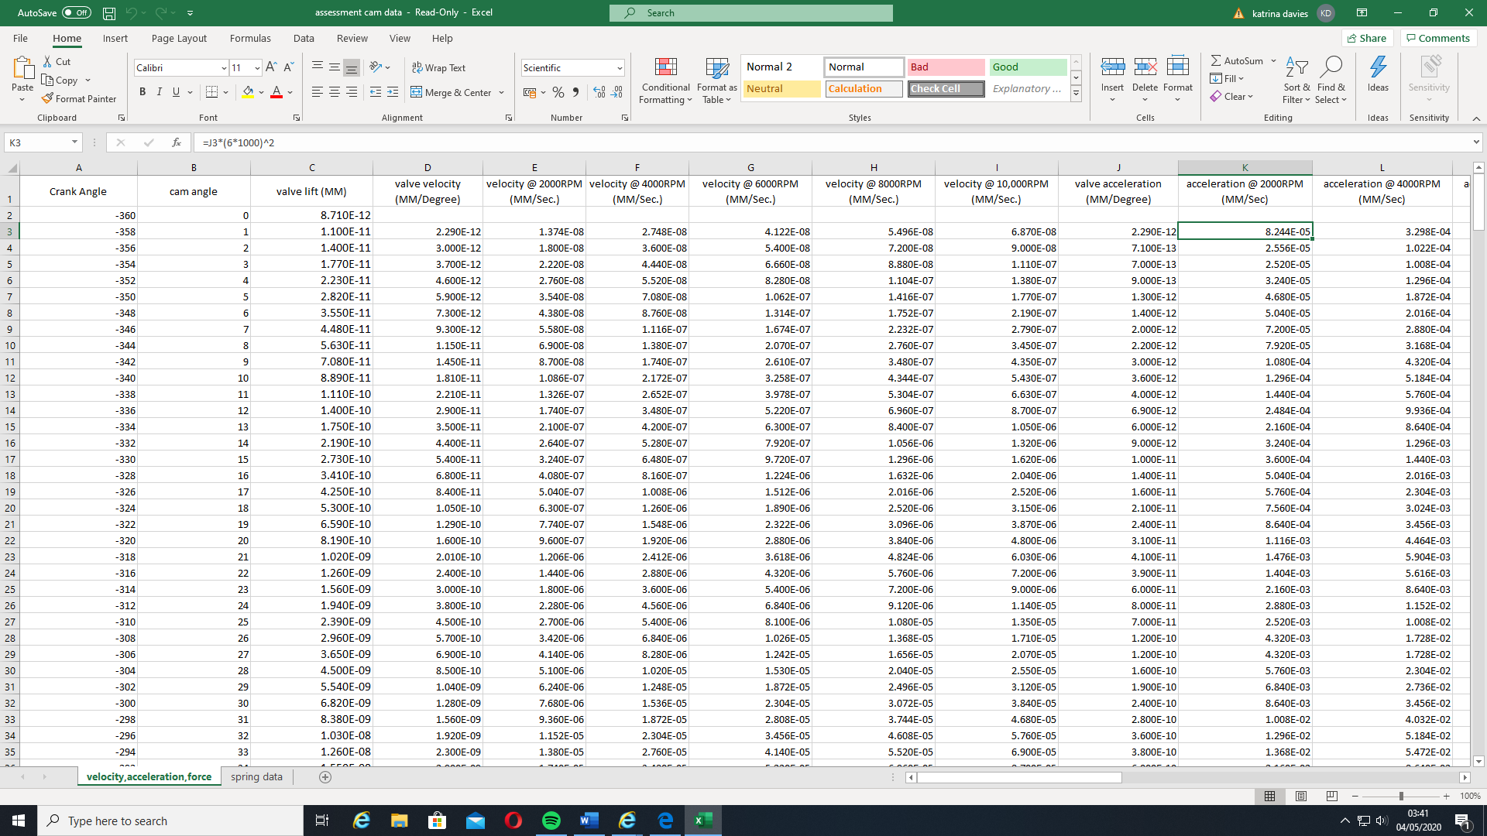
The graph above shows valve acceleration against crank angle for different points in the rev range such as 2000RPM, 4000RPM etc all the way up to 10,000RPM. The valve accelerations were calculated in (MM/Degree) by taking the velocity in (MM/Degree) from the previous velocity e.g. 2.290 – 0 = 2.290 and that’s the first acceleration at 1 degree of cam angle, this was then repeated for the rest. The Valve acceleration for the desired RPM was then calculated with this calculation
This was repeated for all the crank angles and desired RPMs also.
Towards the end of this graph there is some distorted lines which could be due to incorrect or inaccurate data or possibly vibrations within the components.

The graph above shows the contact force between the cam lobe and the valve. When the force is positive it means the cam lobe is in contact with the valve, therefore in operation. When the force is negative it means there is no force being applied to the valve hence valve float is occurring at that time.

The Modifications that could take the engine revolutions up to 12000 RPM with minimal to zero valve float would be to decrease the amount of mass that moves, e.g. such as a different material for the valve to a lighter and stronger material, this would allow for the same amount of air flow and would allow for better closing with the same valve spring stiffness. This will also take the same if not less energy being produced from the engine. The valve springs could be replaced with stiffer or thicker material springs, this would increase the force available to close the valves and would produce more contact force between the spring and the camshaft lobe. This method would have the downside of making the camshaft work harder to open the valves and in turn take more energy from the engine decreasing that maximum power. To combat the power losses other methods to use are dual valve springs or progressive-sprung valve springs.

330/2 x 108/360 x 60/10,000 = 0.297m -> 297mm long intake length.
330/2 x 108/360 x 60/12,000 = 0.2475m -> 247.5mm short intake length.
Above are the ideal lengths for the inlet runners. The longest inlet runner should be no more than 349.2 millimetres for the best torque applications at ten thousand RPM. For maximum top end speed, the inlet runners should be short and no longer than 291 millimetres this will allow the engine to hit its peak RPM at twelve thousand.

S1) 330/2 x 1 x 0.2475 x 108/360 x 60 =12,000
L1) 330/2 x 1 x 0.297 x 108/360 x 60 = 10,000
S2) 330/2 x 2 x 0.2475 x 108/360 x 60 = 6,000
L2) 330/2 x 2 x 0.297 x 108/360 x 60 =5,000
S3) 330/2 x 3 x 0.2475 x 108/360 x 60 =4,000
L3) 330/2 x 3 x 0.297 x 108/360 x 60 = 3,333.3
S4) 330/2 x 4 x 0.2475 x 108/360 x 60 =3,000
L4) 330/2 x 4 x 0.297 x 108/360 x 60 = 2,500
S5) 330/2 x 5 x 0.2475 x 108/360 x 60 =2,400
L5) 330/2 x 5 x 0.297 x 108/360 x 60 = 2,000
The calculations above are for the harmonics produced through the intake runners at the lengths stated in the last paragraph which are 0.297m long intake length and 0.2475m short intake length, as you can see from the calculations above the first harmonics are the only ones needed to help the positive air fuel mixture flow.
These were calculated for an intake system running at ten and twelve thousand RPM with an intake cam duration of 280° and a maximum opening point at 108° after top dead centre.

385/2 x 80/360 x 60/10,000 = 0.2566
385/2 x 80/360 x 60/12,000 = 0.21388

S1) 385/2 x 1 x 0.21388x 80/360 x 60 =12,000.49872
L1) 385/2 x 1 x 0.2566 x 80/360 x 60 = 10,002.59808
S2) 385/2 x 2 x 0.21388x 80/360 x 60 = 6,000.249361
L2) 385/2 x 2 x 0.2566x 80/360 x 60 =5,001.299039
S3) 385/2 x 3 x 0.21388x 80/360 x 60 =4,000.166241
L3) 385/2 x 3 x 0.2566x 80/360 x 60 = 3,334.199359
S4) 385/2 x 4 x 0.21388x 80/360 x 60 =3,000.124681
L4) 385/2 x 4 x 0.2566 x 80/360 x 60 = 2,500.649519
S5) 385/2 x 5 x 0.21388x 80/360 x 60 =2,400.099744
L5) 385/2 x 5 x 0.2566x 80/360 x 60 = 2,000.519615
These were calculated for an intake system running at ten and twelve thousand RPM with an intake cam duration of 305° and a maximum opening point at 80° after top dead centre.

Conclusion
To conclude this assignment for this engine to produce its max torque at ten thousand RPM and its peak power at twelve thousand RPM with no valve float lighter valves should be used such as titanium. Titanium (chemical symbol Ti) offers the highest strength-to-weight ratio of any known metal. In an un-alloyed condition, Ti is as strong as some steel materials but about 45% lighter. When used to manufacture automotive valves, titanium is alloyed with small percentages of various materials, including copper and molybdenum. Titanium is a fairly hard material and can be challenging to machine, as it can gall if tooling isn’t hard and sharp enough, and if the material isn’t cooled properly during machining. As stated by (Mavrigian, NA)
Nimonic is a nickel-chromium alloy. A specific grade of this material, Nimonic 90, is used by some makers for producing high performance valves. Nimonic 90 is a “super” alloy comprised of nickel-chromium-cobalt, which offers high strength and especially an ability to withstand extremely high temperatures, reportedly well within the 2000 degree F range, without distortion. This material is also widely used in aerospace industries for applications such as valves in turbo motors and blades and discs in gas turbines. Success has been noted by the aftermarket industry in such extreme applications as nitromethane and high-boost turbo applications such as multipleturbo tractor-pull engines. As stated by (Mavrigian, NA)
Also I believe that further research into the design of the valves would be massively beneficial as well as other material options as there is an abundance of material options some listed above as well as different designs like stellite which is a hard coating applied to valve stem tips and faces to provide a hard surface, to minimize wear. Stellite alloy is a non-magnetic and non-corrosive cobalt-chromium alloy that may also contain a tungsten element. It resists embrittlement and annealing at higher temperatures.
Ultimately the lighter and stronger the material which the engine components are made from will give it the best performance efficiency, but not necessarily the best reliability.
References
https://www.wisegeek.com/what-is-a-valve-float.htm
https://learnmechanical.com/internal-combustion-engine/
https://www.hotrod.com/articles/ctrp-0708-fixing-valve-float/
file:///C:/Users/User/AppData/Local/Microsoft/Windows/INetCache/IE/1Z8BS2KB/performance_engine_valve_technology_materials_and_designs.pdf

Gilles, T. (2011). Automotive Engines: Diagnosis, Repair, Rebuilding. Santa Barbara City College: Delmar.

