Financial Management for the Hotel Industry
Business Report - Comparison of Two Hospitality Organisations
Student Name: Alina Cristina Ionita
Student ID: 2246123
Lecturer: Ernest Wavei

Executive Summary
The report covered a comparison of two hospitality organisations that are named as Premier Inn and Shangri-La Hotels. Making revenue-based comparisons, it was observed that Shangri-la has earned higher revenue compared to Premier Inn and has a better growth potential in the global market. the financial commitment towards CSR actions includes making charitable donations and achieving net-zero emissions. The recommendations for Premier Inn include diversification of their revenue streams and for Shangri-la, they can adopt to a digital transformation strategy.

Table of Contents
Introduction 4
Comparison 5
Total Revenue 5
Market Position 7
Growth Potential 9
Financial Commitment to CSR (Corporate Social Responsibility) 10
Recommendations 10
Conclusion 11
References 12
Appendices 15
Appendix 1 - Financial statements of Shangri-la Hotels 15
Appendix 2 - Financial Statements of Premier Inn 18

Introduction
Financial accounting in an organisation is mainly concerned with providing information to the shareholders and creditors who live outside of the organisation (Seal et al., 2018, p.5). The first section aims to cover a comparison of the trends of revenue of both Premier Inn and Shangri-la hotels along with the market position of both the organisations. The next section aims to highlight the growth potential of both the organisations such as expansion strategies, opportunities of market and potential growth barriers. Lastly, financial commitment towards CSR practices and recommendations based on the issues are also to be highlighted.

Comparison

Total Revenue
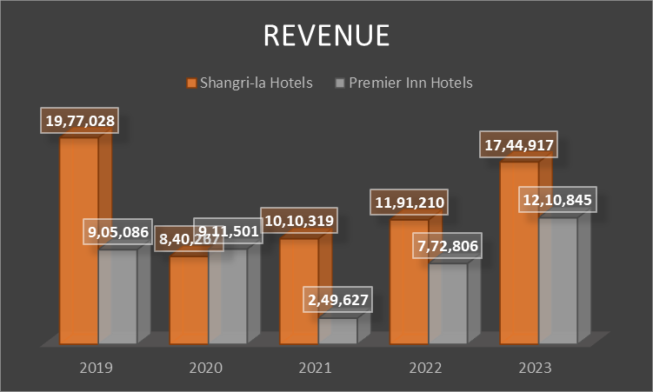
Figure 1: Revenue of Premier Inn and Shangri-La Hotels
(Source: Created by the learner)
During the pre-covid era, that is in 2019, the company earned a total revenue of $2,431,216 (£1,977,028) thousand which significantly fell to $1,033,431 (£840,267) thousand in 2020, that is the covid era (Hkexnews, 2020). In contrast, the revenue of Premier Inn was £905,086 thousand in 2019 that increased to £911,501 thousand in 2020 (Gov, 2025). This is an indication that Premier Inn gained a competitive advantage during the first year of the pandemic by undergoing a growth in its revenue in contrast to Shangri-la whose operations crumbled significantly. After the fall in 2020, the revenue figures increased significantly in 2021 that resulted in $1,241,049 (£1,010,319) thousand (Shangrila, 2021).
Post Covid, these figures further enhanced to $1,462,145 (£1,191,210) thousand and $2,141,790 (£17,44,917) thousand in 2022 and 2023 respectively indicating a growth of 46.48% (Shangrila, 2023). For the monitoring of a company’s financial performance, the accountant in an organisation is responsible for presenting reports to the managers for decision-making process (Drury, 2018, p.8). On the other hand, the revenue figures of Premier Inn in 2021 fell significantly to £249,627 thousand in 2021 and somehow recovered to £772,806 thousand (Gov, 2025). Also, the revenue of Premier Inn increased significantly to £1,210,845 and £1,357,054 in 2023 and 2024 respectively.
The total costs observed from the income statement of Shangri La Hotels before Covid, that is in 2019 is $2,536,427 (£20,65,247) thousand that increased to $2,702,776 (£2,201,855) thousand in the following year (Hkexnews, 2020). In comparison, the costs of Premier Inn were significantly lower at £730,209 thousand before the pandemic and increased to £785,480 thousand during the pandemic, that is in 2020, being less than 10% increase (Gov, 2025). The costs of Shangri La Hotels decreased to $1,804,204 (£1,469,001) thousand in 2021 which is the second year of the pandemic (Shangrila, 2021). Post-pandemic, the costs increased to $3,753,486 (£3,055,776) thousand and $2,272,982 (£1,850,776) thousand respectively in 2022 and 2023 (Shangrila, 2023). In comparison, Premier Inn had costs of £542,413 and £735,194 thousand in the post-pandemic period that was observed in 2021 and 2022 respectively. However, these figures increased to £941,870 and £1,067,615 thousand in 2022 and 2023 respectively (Gov, 2025). All the revenue and cost figures have been indicated in the income statements of Shangri-la and Premier Inn Hotels as represented in appendices 1 and 2 respectively.
Shangri-La Hotels main sources of revenue are selling hotel rooms, food and non-alcoholic beverages, conference and banquets (Shangri, 2024). There is an upward revenue trend in the business after the Covid period mainly due to leisure travelling and corporate gatherings. The revenue of premier inn is derived from beverages, accommodation services and food. The accommodation services of Premier Inn include direct bookings, usage of software that matches rates to demand and increasing the availability of its inventory on the online platform by giving a boost to family bookings. Revenue trends for the Premier Inn are also on an upward trend owing to a strong recovery led by domestic stays and competitive pricing. Some of the drivers which have led to the increase in revenue for Premier Inn are the expansion of more hotels and the closeness to their clientele base.

Market Position
Market Position of Shangri-La Hotels
Market Share: Shangri-La Hotels has a small presence in the UK, by having only 1 hotel in the UK market which is named as Shangri-La the Shard in London. Also, the company has nearly 100 hotels in more than 76 destinations (Shangrila, 2024).
Customer Demographics: Shangri-La targets its services at the higher-end clientele such as, business travellers from different countries and other enriched tourists (Shangri, 2024). The targeted guest services and differentiated accommodations make the appeal wider than merely the necessity of lodging; it targets a market that favours luxury as well as exclusivity.
Brand Perception: The Shangri-La Hotels are most commonly associated with values such as luxury, elegance, high quality and superior service within the context of the hospitality market. This perception implies an image which favours lucrative travellers in search of elite holidays and close treatment. The theory of demand indicates that as there is an increase in the price of a good, the quantity demanded for that good gradually decreases. The theory of supply indicates that the increase of the price of a product also results in the supply of that product. These theories can be applied at Shangri-La through the use of high-end pricing for better quality products to increase additional revenues.
Market Position of Premier Inn
Market Share: Premier Inn has a market share of 12% in the UK market as of 2022 that includes 357 hotels (Whitebread, 2022). This presence is primarily a result of them being cost-conscious, durable and easy to access which makes them suitable for virtually every individual who is travelling.
Customer Demographics: The management of the firm mainly targets the customers such as families, business people, leisure travellers and so on. In order to target the budget conscious customers, the company also provides weekend savings where the company’s lowest rates are often on Friday and Sunday nights (Premierinn, 2025).
Brand Perception: Premier Inn is especially famous for its durable quality and the best budget hotel which will be well suited for the people who are looking for the cheap hotels (PremierInn.com, 2024).
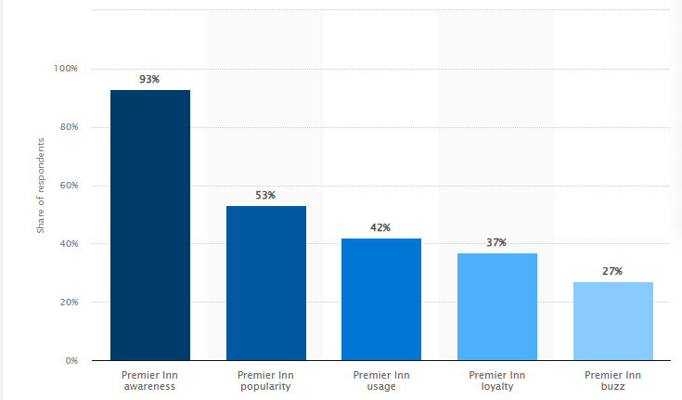
Figure 2: Brand Perception of Premier Inn in UK
(Source: Statista, 2023)
The brand awareness of Premier Inn is 93% followed by popularity levels being at 53% (Statista, 2023). In alignment with Bowman’s Strategy Clock, price vs value implies the ways through which Premier Inn is able to create a balance between the affordability and the quality of their rooms. The company also provides high-quality budget hotels for middle-income consumers that relates to a differentiation strategy. Komarek et al. (2021) states that price elasticity of demand is represented as the ratio that portrays how much change in demand has been observed with respect to the changes in prices for that specific product. To increase their revenue, Premier Inn uses economic theory in their business operation especially the price elasticity of demand. On one hand, they set low prices and organise special offers to attract the price-sensitive guests and keep the quality high to increase guest returns which led to high occupancy rates.
Henceforth, Premier Inn has a better market position than Shangri-La hotels in the hotel industry of the United Kingdom.

Growth Potential
Growth Potential: Shangri-La Hotels
Shangri-La Hotels have significant growth opportunities which are largely due to its focus on growth initiatives that leverage strategic growth on international markets. The brand plans for the growth by targeting the rising need for the luxury hospitality services in the developing economies of Asia-Pacific and Middle East region. There are several market opportunities for businesses while expanding to foreign markets such as partnerships with local businesses and tourism boards (Guimarães et al., 2021). Following these strategies can be helpful for Shangri-la to enhance its global presence followed by acquisition of the local hotels which can also be adopted through the introduction of proper training programmes for better decision-making procedure. There are threats that could limit the growth of Shangri-La such as high competition in the global market of luxury hotel chains, economic upheavals, and geopolitical risks in some parts of the world (Benabed and Moncea, 2024). Other issues include escalating operating expenses and issues of sustainability which are becoming more and more popular with the clients.
Growth Potential: Premier Inn
Premier Inn reveals the benchmark of the company and its expansion strategies which is a good sign of growth in the hotel business primarily due to its large position in the budget hotel industry. The brand aims at increasing its penetration in the UK and they have a market opportunity in contemplating global markets especially in Europe where there is growing need for budget accommodation. As supporting evidence, the company was responsible for adding around 13 new locations across the entire Germany after the acquisition from the Centro Hotel Group (Whitebread, 2020). Moreover, expansion programmes will be extended to existing sites to upgrade them through renewed interiors and technologies that will boost guest’s satisfaction and convenience as well as the chain's internal functions. There are continuing legal issues for hospitality organisations while expanding into the foreign markets (Walker, 2017, p.75). This can have a negative impact on the operations of Premier Inn.

Financial Commitment to CSR (Corporate Social Responsibility)
Shangri-La Hotels has a clear-sighted financial commitment when it comes to CSR by spending £4 million in charitable donations and sustainability. The organisation has put its goal to cut down the emission level to 15% till 2025 (Shangri, 2024). This obligation not only is in line with environmental objectives at the global level but can also be seen as a well-considered business decision in order to positively influence brand image and customer satisfaction. On the other hand, Premier Inn is also equally committed in its financial aspect towards CSR. The hotel chain has pledged £25,026 to the Health Foundation by 2027 to help children with chronic pain and is committed to fighting social problems. Moreover, Premier Inn has announced a goal of reaching the net-zero carbon emission level by 2040 in its sustainability policy (Premierinn, 2024). Based on the ESG framework of Premier Inn, the company has been responsible for the reduction of both Scope 1 and 2 carbon intensity from the base year by 52.5%. Also, a total of 2.6 million was raised for Premier Inn’s charity partners. A total amount of £504 million was done for the allocation of green bonds (Whitebread, 2023). In the context of their corporate strategy, both organisations appreciate the compliance to CSR standards to improve their corporate image and their sustainability (Alam and Islam, 2021).

Recommendations
Shangri-La Hotels: For its continued development and effective sustainability management, the management of Shangri-La Hotels should adopt a full-fledged digital transformation strategy (Sundaram et al., 2020). With the help of artificial intelligence and data analytics, the brand gets opportunities to enhance the guest satisfaction, effective pricing policy and innovations in organisational management. This investment on technology can help grab the attention and engagement of their clients and this leads to revenue drive, especially in developing markets (de-Lima-Santos et al., 2022). Moreover, incorporating sustainability to their digital marketing plan can help support the company’s objective to cut emissions and also strengthen the brand’s image as being friendly to the environment. This can have a positive impact on the organisation’s financial performance since it will attract environmentally conscious customers and enhance the brand reputation, thus, reducing the operational costs.
Premier Inn: Premier Inn should diversify their revenue streams and consider branching out into the wellness tourism market. Furthermore, by introducing new services, for instance, health retreats, fitness classes and healthy eating, Premier Inn is poised to tap a new market of customers with regard to their overall well-being. It not only complies with the antidote of current trends associated with the orientation towards a healthy lifestyle, but also creates a competitive advantage for a brand compared to its rivals in terms of the affordable price segment. Wellness tourism is on the rise currently, and customers are willing to spend their hard-earned money to improve their health. The launch of Wellbeing drives for both guests and staff can ensure that Premier Inn is focusing on the overall importance of quality sleep to improve the satisfaction levels of the stakeholders.

Conclusion
The comparison of Shangri-La Hotels and Premier Inn demonstrates or indicates the differences in market segments, revenues and growth opportunities. Shangri-La is a hotel that incorporates luxury and sustainable development concepts while carrying out business activities and pays attention to social justice. On the other hand, Premier Inn is a budget segment player and has posted high revenues and increased its market standing. Moreover, both firms have sound plans for their growth and socially responsible programmes that foster their image. In order to sustain the competitive advantage, Shangri-La must pursue digitalisation, and on the other hand, Premier Inn could expand the offer to the wellness segment, guaranteeing further continued success and the fulfilment of shifting consumers demands.

References
Alam, S.S. and Islam, K.Z. (2021) ‘Examining the role of environmental corporate social responsibility in building green corporate image and green competitive advantage.’ International Journal of Corporate Social Responsibility, 6(1), p.8. Available at: https://doi.org/10.1186/s40991-021-00062-w
Benabed, A. and Moncea, M. (2024) ‘Slowbalization: Rising Trends for the Global Economy and Business.’ In Proceedings of the International Conference on Business Excellence (Vol. 18, No. 1, pp. 283-294). Available at: 10.2478/picbe-2024-0024
de-Lima-Santos, M.F., Mesquita, L., de Melo Peixoto, J.G. and Camargo, I. (2022) ‘Digital news business models in the age of industry 4.0: Digital Brazilian news players find in technology new ways to bring revenue and competitive advantage.’ Digital Journalism, pp.1-25. Available at: https://doi.org/10.1080/21670811.2022.2037444
Drury, C. (2018) Management and Cost Accounting, 10th Edition. London, Prentice Hall.
Gov (2025) PREMIER INN HOTELS LIMITED [Online] Available at: <https://find-and-update.company-information.service.gov.uk/company/05137608/filing-history> [Accessed on 3 February 2025]
Guimarães, L.G.D.A., Blanchet, P. and Cimon, Y. (2021) ‘Collaboration among small and medium-sized enterprises as part of internationalization: A systematic review.’ Administrative Sciences, 11(4), p.153. Available at: https://doi.org/10.3390/admsci11040153
Hkexnews (2020) Annual Report 2020 [Online] Available at: <https://www.hkexnews.hk/listedco/listconews/sehk/2021/0426/2021042601471.pdf> [Accessed on 3 February 2025]
Komarek, A.M., Dunston, S., Enahoro, D., Godfray, H.C.J., Herrero, M., Mason-D'Croz, D., Rich, K.M., Scarborough, P., Springmann, M., Sulser, T.B. and Wiebe, K. (2021) ‘Income, consumer preferences, and the future of livestock-derived food demand.’ Global Environmental Change, 70, p.102343. Available at: https://doi.org/10.1016/j.gloenvcha.2021.102343
Premierinn (2024) Net zero carbon emissions, Net zero carbon emissions | News | 2021 | Premier Inn. Available at: https://www.premierinn.com/gb/en/news/2021/net-zero-carbon-emissions.html#:~:text=Our%20pledge%20to%20reach%20net,proud%20to%20lead%20the%20charge. (Accessed: 07 October 2024).
Premierinn (2025) Premier Inn offers [Online] Available at: <https://www.premierinn.com/gb/en/offers.html> [Accessed on 3 February 2025]
PremierInn.com (2023) FY23 results. Available at: https://cdn.whitbread.co.uk/media/2023/04/Final-FY23-RNS-Final-Combined.pdf (Accessed: 07 October 2024).
Seal, W., Rohde, C., Garrison, R. and Noreen, E. (2018) Management Accounting, 6e. McGraw-Hill Education (UK).
Shangri (2024) Luxury escape at best rate: Shangri-La Hotels and Resorts, Shangri. Available at: https://www.shangri-la.com/ (Accessed: 07 October 2024).
Shangri (2024b) Shangri-La Kuala Lumpur’s Commitment, Shangri. Available at: https://www.shangri-la.com/kualalumpur/shangrila/about/corporate-social-responsibility/shangrila-kuala-lumpur-commitment-to-corporate-social-responsibility/#:~:text=Shangri%2DLa%20Kuala%20Lumpur's%20annual,children%20through%20this%20charity%20project. (Accessed: 07 October 2024).
Shangrila (2021) Annual Report 2021 [Online] Available at: <https://sitecore-cd.shangri-la.com/-/media/Project/Shangri-La-Group/Investor/Files/Public-Disclosures/Latest-Top-Publications/2021_Annual-Report_E.pdf> [Accessed on 3 February 2025]
Shangrila (2023) Annual Report 2023 [Online] Available at: <https://sitecore-cd.shangri-la.com/-/media/Project/Shangri-La-Group/Investor/Files/Public-Disclosures/Latest-Top-Publications/2023_Annual_Report_E.pdf> [Accessed on 3 February 2025]
Shangrila (2024) Shangri-La Group Releases 2023 Full Year Results [Online] Available at: <https://www.shangri-la.com/group/media/media_post?post=Shangri-La%20Group%20Releases%202023%20Full%20Year%20Results> [Accessed on 3 February 2025]
Statista (2023) Premier Inn brand awareness, usage, popularity, loyalty, and buzz among hotel customers in the UK in 2022 [Online] Available at: <https://www.statista.com/forecasts/1335699/premier-inn-hotels-brand-profile-in-the-uk> [Accessed on 3 February 2025]
Sundaram, R., Sharma, D.R. and Shakya, D.A. (2020) ‘Digital transformation of business models: A systematic review of impact on revenue and supply chain.’ International Journal of Management, 11(5). Available at: 10.34218/IJM.11.5.2020.002
Walker, J. (2017) Introduction to Hospitality. 7th Edition. Harlow, Pearson.
Whitebread (2020) Premier Inn adds 13 new locations across Germany as it completes acquisition from Centro Hotel Group [Online] Available at: <https://www.whitbread.co.uk/premier-inn-adds-13-new-locations-across-germany-as-it-completes-acquisition-from-centro-hotel-group/> [Accessed on 3 February 2025]
Whitebread (2022) The Economic Impact of Premier Inn Hotels [Online] Available at: <https://cdn.whitbread.co.uk/media/2023/08/The-Economic-Impact-of-Premier-Inn-hotels_2022-study_final.pdf> [Accessed on 3 February 2025]
Whitebread (2023) Environmental, Social and Governance Report 2022/23 [Online] Available at: <https://cdn.whitbread.co.uk/media/2023/07/Whitbread_ESG_Report_2022.pdf> [Accessed on 3 February 2025]

Appendices

Appendix 1 - Financial statements of Shangri-la Hotels
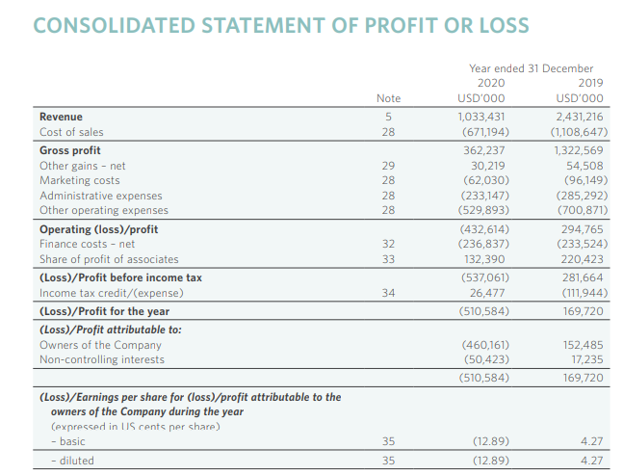
Figure 3: Profit and Loss statement of Shangri-la Hotels for the year 2019 and 2020
(Source: Hkexnews, 2020)
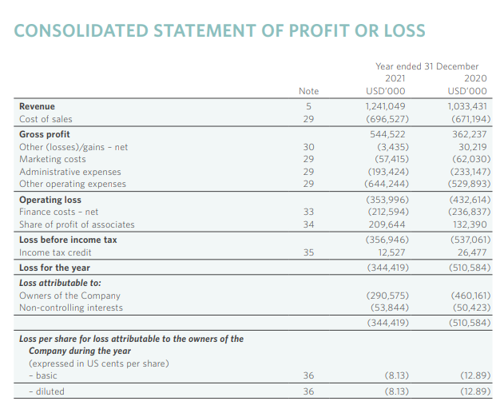
Figure 4: Profit and Loss statement of Shangri-la Hotels for the year 2020 and 2021
(Source: Shangrila, 2021)
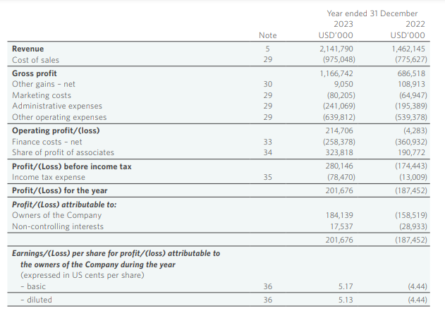
Figure 5: Profit and Loss statement of Shangri-la Hotels for the year 2022 and 2023
(Source: Shangrila, 2021)

Appendix 2 - Financial Statements of Premier Inn
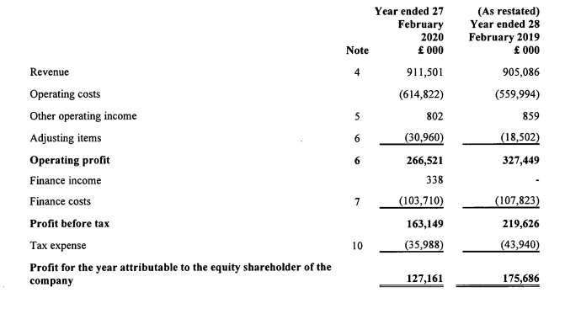
Figure 6: Income statement of Premier Inn as of 2020
(Source: Gov, 2025)
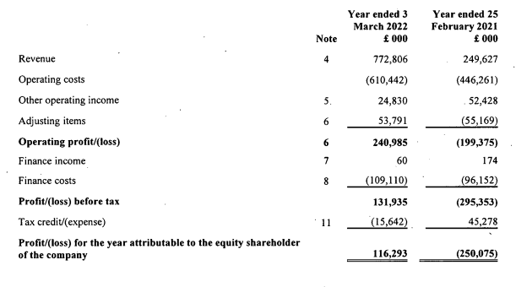
Figure 7: Income statement of Premier Inn as of 2022
(Source: Gov, 2025)
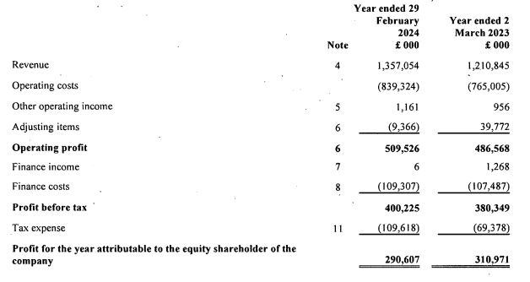
Figure 8: Income statement of Premier Inn as of 2024
(Source: Gov, 2025)

