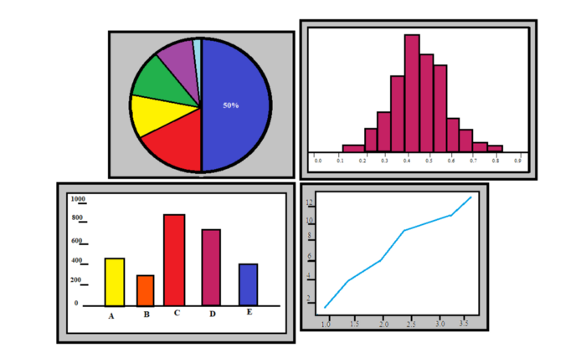
Data Analysis & Visualisation

Name:Nikola Nikolov
Studend ID:2014060

Contents

PART 1 3
Introduction 3
Data Pre-Processing 3
Data Analysis 5
Data Visualisation 6
Sales (2009-2012) 6
Profit (2009-2012) 7
Part 2 8
2.1 How many students like vanilla flavour? 8
2.2: Males Vs females 9
2.3: Mean and Median for Chocolate and Strawberry Preferences 9
2.4 Clustering: Two Step Clustering 11
2.5: Data and text mining methods 12
2.6: Advantages and limitations of SPSS and Microsoft Excel 13
Conclusion 14
References 14

PART 1

Introduction
Microsoft Excel is one of the most frequently used software for data manipulation and analysis. The programs provide various functionalities that data analysts can use to perform simple and complex tasks using small and large datasets. The program also prepares data before exporting it to other programs for advanced and complex analysis. For example, in business or organisational, multiple data collection points exist. Making sense of this data requires robust analysis methods to garner actionable insights for decision-making (Winston, 2016).
Additionally, such data can be used to evaluate historical data to assess existing strategies for efficacy and effectiveness. The program allows various analysis options depending on the information sought and the data type involved(Winston, 2016). In this regard, the software package can be used for data preprocessing, analysis, and visualisation. The superstore data provided will demonstrate how different approaches to these data manipulation methods are used. The analysis will evaluate sales and profits recorded from 2009 to 2012 in the provided data set.

Data Preprocessing
Organisations rely on data from different sources and data collection points. When such data is consolidated into spreadsheets, it is essential to evaluate the accuracy and quality of the data. Such data cannot be subjected to data analysis without comprehensive preprocessing. Such raw data needs to be preprocessed for it to be subjected to analysis using different programs. In this regard, data preprocessing can be defined as transforming raw data into consistent formats that can effectively be analysed logically (García et al., 2015). In this regard, it seeks to enhance uniformity and regularity and completeness. The accuracy and reliability of the results of analysed data are dependent on the authenticity of the input or raw data. Therefore, if there are errors, inconsistencies or omissions in the input data, the final findings are also likely to be inaccurate. However, this is consistent with the ‘garbage in, garbage out concept. In this regard, data-driven decisions based on poorly consolidated data are likely to result in poor decisions.
It is also crucial to explain the types of data features involved. The first aspect is the categorical features contained in datasets. Categorical features describe a set of variables or entries (García et al., 2015). For example, for the superstore data set, categorical data includes order quantity, sales, discounts, profit, sales, region, customer segment, product category etc. These subjects give meaning to the numerical data entered in the spreadsheet.
In most cases, categorical data is given in text formats. On the other hand, numerical features relate to data entered in the form of numbers. This may be in whole numbers, fractions or percentages (García et al., 2015). Therefore, in data preprocessing, it is essential to use that such features are well-defined and logical. This is also important for machine learning processes that recognise such features when analysing data.
In the subject superstore case, several data preprocessing approaches can be used. The first approach is data quality assessment. This seeks to identify if the data has any anomalies such as missing values, mixed data and outliers. Using Microsoft Excel, one of the ways to establish this is by using the ‘Count’ function’ this can help establish whether the data has some missing values and can be done in a new cell to determine the exact number of the flown per category. For instance, the number of dates recorded should match sales and profits. In this case, the process shows that the total number of transactions for the four years was 8399, which was uniform for all interest categories.This, confirms that the data quality is sufficient for further preprocessing and analysis. Data quality can also be assessed by checking mismatched data types where text may be mixed with numbers. In other cases, mixed data values and outliers may also exist alongside missing data. While the ‘count ‘function can help check such anomalies, other functions like ‘Filter’ can be used. This function can help identify any anomalies within a specific category.
The next step in data preprocessing is data cleaning. Data cleaning involves correcting the anomalies identified when assessing data quality, which may involve filling in the missing data or eliminating affected fields. Correcting such inconsistencies is critical to the eventual results attained (Zhang et al., 2016). Data cleaning also involves addressing noisy data using approaches such as regression and clustering, which standardise data sets for easier and more accurate analysis (Alasadi and Bhaya, 2017). In the case of the superstore sales, no further data cleaning was necessary as all checks confirmed that the data was complete and ready for further analysis. Approaches such as data transformation can also be used in data preprocessing. This entails converting the cleaned data into preferred formats for more straightforward analysis. Data transformation can be done through aggregation, normalisation, hierarchy generation and feature selection (Alasadi and Bhaya, 2017). Therefore all are determined by the scope of data analysis sought. Additional approaches include data reduction where data where conciseness is sought through approaches like attribute selection and dimensionality reduction. In the current superstore case, the applied ‘ Count ‘ and ‘filter ’functions were adequate for the data preprocessing

Data Analysis
Data analysis after preprocessing is significantly simplified in Microsoft Excel. A wide range of options exist for analysis and are informed by the insights sought from a data set. For instance, in the subject case, the aim is to show how sales or profits declined within the four years presented in the dataset. In this regard, the date set was confirmed to be of good quality with no inconsistencies or missing data. Therefore, no further preprocessing was necessary. Data analysis using excel primarily utilises mathematical and statistical approaches. This is meant to arrive at specific results from huge data sets. For instance, the subject case had more than 8000 transactions over 4 years. Aggregating the sales manually not only tedious but illogical. However, Microsoft excel has the capability to automatically calculate the totals using different formulas and functions.
One of the functionalities that can analyse such huge data sets is the use of Pivot tables. Pivot tables provide a robust approach to data summarising especially when dealing with multiple entries and categories in a dataset (Winston, 2019). From the different categories indicated in the superstore case, pivot tables allow data to be compared based on selected categories. Additionally, the data can also be split to represent information only relevant to a specific year. For instance, using pivot tables the aggregated sales and profits can be obtained for every year. Excel automatically identified entries that were recorded for specific years (e.g., 2009) and aggregates the values to give the total revenue obtained in the year. The same can be done for profits and other variables of interest. The analysis process can also be customised to give different results (Winston, 2019). For instance, the analysis can establish the best performing products and rank them accordingly. Aspects such as the most repeat customers and the average order value can also be easily obtained from the analysis process. Pivot tables also eliminate the need to have multiple data subsets from the original set. In this regard, the following summaries with regards to sales and profits were obtained from the pivot tables.

Year | Sales | Profit
2009 | £ 4,209,896.8 | £ 434,096
2010 | £ 3,560,087.0 | £ 364,917
2011 | £ 3,429,945.0 | £ 380,311
2012 | £ 3,715,672.0 | £ 342,444
Totals | £ 14,915,600.8 | £ 1,521,768.0

At a glance, it is can be noted that the sales and profits dropped, comparing the year 2009 and 2012. The Pivot table function allows the more than 8000 entries to be summarised in the table above. In this regard, quick lessons can be garnered, and decisions can also be made from such data. Data analysis using Excel simplifies vast data sets and provides accurate insights that can be relied on to inform business strategies and alternatives (Winston, 2019). Additionally, such information is useful when appraising past decisions and strategies. Businesses can establish what aspects of strategy worked and which should be improved.
Additionally, such information is critical in making forecasts that can help businesses be better prepared for observed trends. Businesses can also prepare better for expected changes in business operations, as observed from the data (Winston, 2019). For instance, a business can establish the most profitable or slowest months in a year and prepare accordingly. Another important role data analysis plays in organisations is preparing financial and accounting reports. Some of the reports are statutory requirements and summarise all transactions within a financial period. In such scenarios, multiple organisations rely on the programs to aggregate transactions that are then finally used to produce the final accounts.

Data Visualisation
Data analysis provides summaries and collective insights from data sets. However, further manipulation using visual aids can provide a clear picture of what the data presents. In addition, paters and trends can be defined better for easier understanding and presentation purposes
(Po et al., 2020). In most cases, data visualisation is used for a presentation where massive data sets can be explained using simplified pictorials and visuals. Common types of visualisations include charts, graphs, tables and infographics. Visualisation allows patterns, relationships and trends to be summarised graphically, which is more appealing and easier to comprehend ( Kosara, 2016). Complex relationships can also be displayed and easily comprehended.
Moreover, they are more engaging as opposed to plain figures or numbers. For instance, in the superstore case, data visualisation can show how sales performed for the four years. The same can also be done for profits recorded.

Sales (2009-2012)
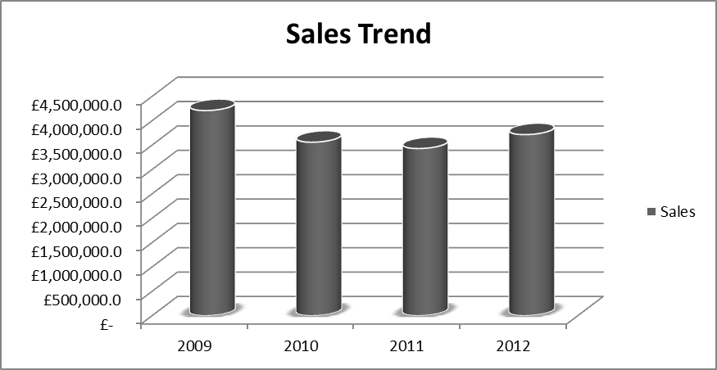

Profit (2009-2012)
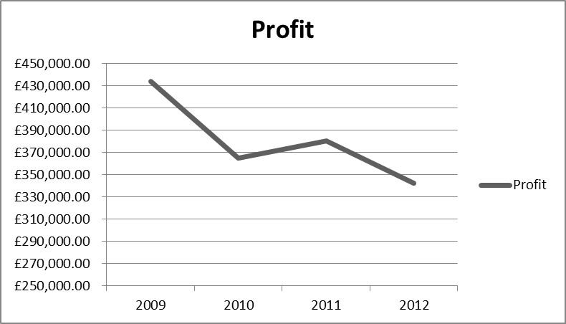
From the data visualisation, a bar graph and a line chart, sales and profits declined in the four years under consideration. In the case of sales, 2009 recorded the highest figure, which declined consecutively in 2010 and 2011. However, the trend reversed in 2012 which recorded higher sales than 2011 but still lower than 2009. On the other hand, the highest profits were recorded in 2009 and the lowest in 2012. The chart shows that profits were on a declining trend as well. From the visualisation it is clear that performance in the superstore has been on the decline based on the sales and profit variables or indicators. The visualisation summarises the more than 8000transactions recorded in the four years to simple visuals that are more engaging and easier to understand.

Part 2
This dataset contained information on 200 high school students subjected to two tests. The first test was on a video game and the second one was on a puzzle. The data was then presented against the students ‘ ice cream flavour preference. The flavours considered for the analysis were chocolate, vanilla and strawberry—the analysis aimed at establishing whether any forms of relationships existed based on these variables.

2.1 How many students like vanilla flavour?
Simple descriptive statistics in PSS can be used to compute this figure. As shown below the information can also be presented in the form of graphs or charts for visualisation.

Statistics
Ice-cream
N | Valid | 200
N | Missing | 0
Sum |  | 363

Ice-cream
 |  | Frequency | Percent | Valid Percent | Cumulative Percent
Valid | Vanilla | 95 | 47.5 | 47.5 | 47.5
Valid | Chocolate | 47 | 23.5 | 23.5 | 71.0
Valid | Strawberry | 58 | 29.0 | 29.0 | 100.0
Valid | Total | 200 | 100.0 | 100.0

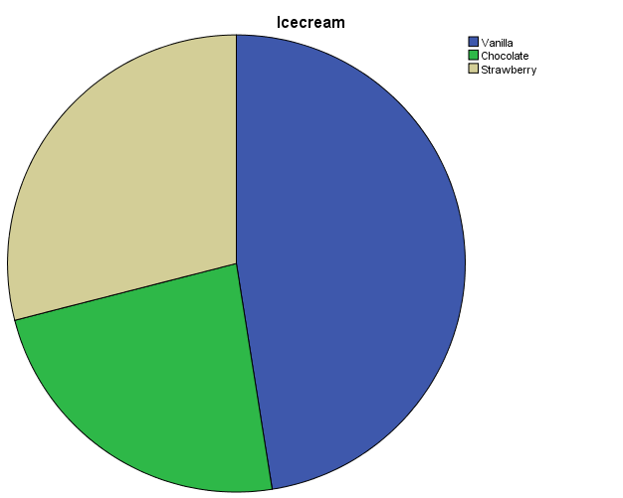
From the analysis, the vanilla ice-cream flavour had 95 students, representing 47.5% of the total 200 students.

2.2: Males Vs females
Using the same SPSS processes, the number of males and females from the 200 samples can easily be computed. The analysis shows that out of the 200 students, 91 were male and 109 were female.

Statistics
Ice-cream
N | Valid | 200
N | Missing | 0
Sum |  | 363

Gender
 |  | Frequency | Percent | Valid Percent | Cumulative Percent
Valid | Male | 91 | 45.5 | 45.5 | 45.5
Valid | Female | 109 | 54.5 | 54.5 | 100.0
Valid | Total | 200 | 100.0 | 100.0

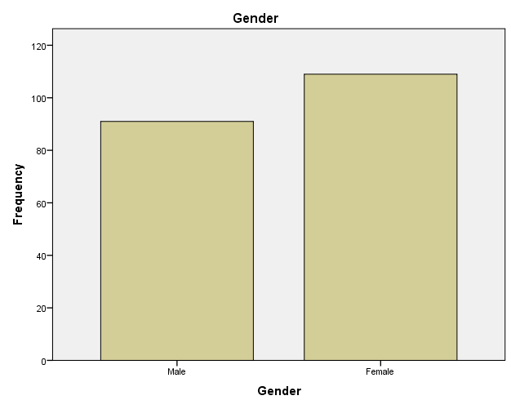

2.3: Mean and Median for Chocolate and Strawberry Preferences
The mean and median scores for participants can also be computed using SPSS. The computation considers the scores for the different clusters or categories based on ice-cream flavour preference.

Mean Median Report
Ice-cream |  | Video | Puzzle
Vanilla | Mean | 51.71 | 52.03
Vanilla | N | 95 | 95
Vanilla | Median | 53.00 | 51.00
Chocolate | Mean | 47.70 | 47.32
Chocolate | N | 47 | 47
Chocolate | Median | 47.00 | 46.00
Strawberry | Mean | 55.45 | 57.14
Strawberry | N | 58 | 58
Strawberry | Median | 58.00 | 61.00
Total | Mean | 51.85 | 52.40
Total | N | 200 | 200
Total | Median | 53.00 | 52.00

The analysis can be done by first filtering the individual clusters and then computing the mean and median scores. However, SPSS allows the data to be analysed by comparing the means and median option using the (analyse- compare means), which yields the summary above. In this regard, the mean score for the students who preferred the chocolate flavour was 55.45 for the video game test and 57.14 for the puzzle tests. On the other hand, the median score for those who preferred the chocolate flavour was 47 for the video game test and 46.00 for the puzzle test. Regarding the strawberry flavour the mean score was 51.58 for the video game test and 52.40 for the puzzle test. The median score for strawberry preference was 85.00 for the video test and 61.00 for the puzzle test. Similar scores could also be obtained for the total mean and median scores alongside the vanilla flavour.

2.4 Clustering: Two Step Clustering
Two-step clustering can be used to establish the number of groupings or clusters within a data set or variable (Tkaczynski, 2017). Such subsets may not have previously been known until the clustering is done. In this case, the clustering focused on flavour preference and test scores. The ice cream flavour is selected as the categorical variable, and the test scores as the continuous variables. The clustering yields 3 clusters as shown in the graphs. The output shows that the size of the largest cluster 47.5% while the smallest is 23.5. The model summary further shows that this clustering is good, where test scores can be grouped based on participant preference for different ice-cream flavours.

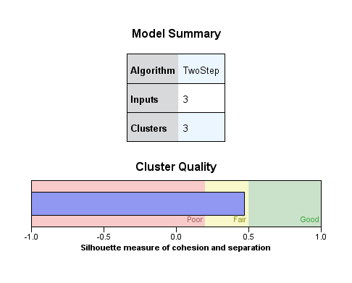

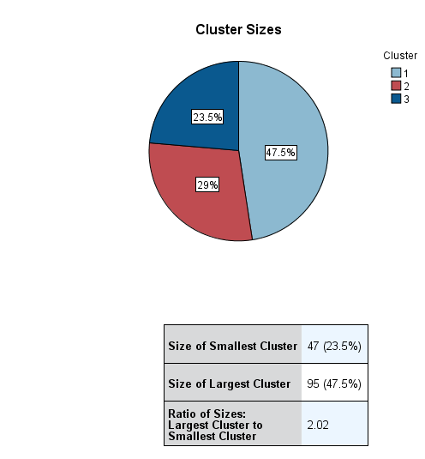

2.5: Data and text mining methods
Data and text mining allow the preparation of large datasets to generate valuable insights that can be used for decision-making and making sense of the data. Data and text mining approaches involve sorting such data to identify possible patterns and trends that can point to critical decision-making and strategy development (Maksood and Achuthan, 2016).
Therefore, different mining approaches can be used to sieve data in different formats and sizes. For example, clustering, cleaning, association, tokenisation and stemming are often used.
Data clustering primarily involves grouping or categorising data into sets that have similar or preferable characteristics (Zong, et al, 2021). For instance, data can be clustered in a business context based on elements such as sales, production, or product category. A business can also organise data based on different levels of demand and buyer demographics.
Data cleaning seeks to enhance dataset quality, accuracy, and authenticity (Swapna et al., 2016). Due to the multiple data collection points, errors and omissions are bound to occur. In other instances, data may contain outlier resulting from one-off transactions, which may skew the summaries obtained. In this regard, data cleaning seeks to identify such cases and apply corrective measures.
Data association. Data analysts also use data association in mining. The approach simply identifies correlations or relationships within different variables in data sets. Different variables can be associated and subjected to further analysis to generate preferred insights. Association can be made to determine how such variables affect one another and their impact on business strategies and processes (Shmueli, et al., 2019).
Text mining transforms raw text data into logical formats so that meaningful insights can be derived. Different text mining techniques such as tokenisation, term frequency, stemming and lemmatisation are often used.
Tokenisation breaks down raw data text into smaller units/tokens which may be single words or phrases (Jo, 2018). This breakdown seeks to identify patterns contained in the text. The approach can help in the establishment of pertinent themes within huge data texts for further analysis.
Term frequency on the other hand, determines how often a text or phrases appear in text data being analysed (Jo, 2018). This helps in determining the significance of such texts in under analysis or mining. For instance, term frequency can be used to analyse social media posts relating to specific issues of discussion or trending events to ascertain importance or relevance.
Stemming is also used in text mining to reduce inflection in words to root status. This involves removing affixes in words to their basic form (Jo, 2018). This form of data mining is commonly used in text processes to match natural language. It can be used in search engines in huge databases or datasets to locate specific texts of interest.

2.6: Advantages and limitations of SPSS and Microsoft Excel
SPSS and Microsoft Excel are robust data analysis, management and visualisation tools. They have multiple functionalities that can be utilised for different data manipulation needs. Microsoft Excel is mainly used for simple data storage and analysis, while SPPS is used for more complex functions (Abbott, 2016). Even though most functionalities can be done using the two platforms, they may require additional knowledge in data analysis and statistics
SPSS
Advantages | Limitations
Multiple mathematical and statistical functionalities | Requires additional knowledge in statistics and data analysis
Robust data visualisation and manipulation options | Uses multiple windows and databases during analysis
Can run on multiple operating systems Linux, Windows and iOS | Can be expensive due to licence and add purchase requirements
Effective social sciences data analysis | Incompatibility for data storage formats
Applies a Graphics user interface program

Microsoft excel
Advantages | Disadvantages
Easy to use for simple data analysis tasks | May require additional knowledge for advanced functionalities
Multiple functionalities for the free version | Prone to bugs and viruses
Diverse data analysis and visualisation capabilities | Prone to human errors
Compatibility with other data analysis programs | Not effective agile data driven decision making
Easy data storage for huge datasets

Conclusion

Microsoft Excel and SPSS are potent data analysis processing tools that are widely used for different functions. They can be used for data preprocessing, analysis and visualisation. However, using the superstore case, different Microsoft excel functionalities were used and yielded the final graph and chart visualisations. Similar approaches were used for SPSS analysis. Furthermore, this is important in data mining, where approaches such as data clustering are used.
Consequently, the two programs have some advantages and disadvantages, which make them effective for some applications over others. In addition, data preprocessing aims at preparing raw data for analysis and visualisation. Therefore, it enhances data quality by eliminating inconsistencies, omissions, and redundancies. Similarly, this is especially important for unstructured data characteristic of most datasets within organisations. The process also allows effective use of approaches like machine learning, which requires accurate information to garner accurate and actionable insights.
Furthermore, data preprocessing is commonly informed by the scope of insights sought and the intended use of the analysed data. Programs like Excel and SPSS are effective in these processes, where the quality of datasets can be evaluated, and corrective measures are taken. Intended analyses can then be carried out using different functionalities available in the programs. The programs also provide a wide array of visualisation options to users. For example, SPSS provides a wide range of analysis options, such as descriptive statistics and measures of central tendency. These can easily be computed and visualised.
Additionally, it provides clustering options that can be sued to establish the scope of the relationship within variables in the data set. Such approaches include K-Means and two-step clustering. These are data mining methods alongside other approaches like data cleaning and association. Some approaches like stemming and tokenisation are also available for text data.

References

Abbott, M.L. (2016). Using statistics in the social and health sciences with SPSS and excel. John Wiley & Sons.
Alasadi, S.A. and Bhaya, W.S.( 2017). Review of data preprocessing techniques in data mining. Journal of Engineering and Applied Sciences, 12(16), pp.4102-4107.
García, S., Luengo, J. and Herrera, F. (2015). Data preprocessing in data mining (Vol. 72, pp. 59-139). Cham, Switzerland: Springer International Publishing.
Jo, T. (2018). Text mining: Concepts, implementation, and big data challenge (Vol. 45). New York: Springer.
Kosara, R. (2016). Presentation-oriented visualisation techniques. IEEE computer graphics and applications, 36(1), pp.80-85.
Maksood, F.Z. and Achuthan, G. (2016). Analysis of data mining techniques and its applications. International Journal of Computer Applications, 140(3), pp.6-14.
Po, L., Bikakis, N., Desimoni, F. and Papastefanatos, G. (2020). Linked data visualisation: techniques, tools, and big data. Synthesis Lectures on Semantic Web: Theory and Technology, 10(1), pp.1-157.
Shmueli, G., Bruce, P.C., Yahav, I., Patel, N.R. and Lichtendahl Jr, K.C. (2017). Data mining for business analytics: concepts, techniques, and applications in R. New York: John Wiley & Sons.
Swapna, S., Niranjan, P., Srinivas, B. and Swapna, R. (2016), March. Data cleaning for data quality. In 2016 3rd International Conference on Computing for Sustainable Global Development (INDIACom) (pp. 344-348). IEEE.
Tkaczynski, A. (2017). Segmentation using two-step cluster analysis. In Segmentation in social marketing (pp. 109-125). Springer, Singapore.
Winston, W. (2016). Microsoft Excel data analysis and business modeling. Microsoft press.
Winston, W. (2019). Microsoft Excel data analysis and business modeling. Microsoft press.
Zhang, A., Song, S. and Wang, J. (2016), June. Sequential data cleaning: A statistical approach. In Proceedings of the 2016 International Conference on Management of Data (pp. 909-924).
Zong, C., Xia, R. and Zhang, J. (2021). Text Data Mining (Vol. 711, p. 712). Singapore: Springer.

