Cloud-Based Web Services - Assignment 2

Name: Kai Strand-Regan

(ACCA6024)

Lecturer: Mike Dacey & Tim Bashford

Date Submitted: May 7th, 2021

Contents
1. Introduction 3
2. Cloud Computing 3
2.1. What is Cloud Computing? 3
2.2. How Does it Work? 3
2.3. What Are The Costs? 4
2.3.1. Cost Reducing Methods 5
2.3.1.1. Unused Resources 5
2.3.1.2. Automation 5
2.3.1.3. Right Size Computing Services 6
2.3.1.4. Load Balancing 6
2.4. Security 6
2.4.1. Advantages 6
2.4.2. Disadvantages 7
2.5. Reliability & Scalability 8
2.6. Legalities of Cloud Computing 8
2.7. Virtualisation 9
2.7.1. Hypervisor 9
2.7.2. Containerisation 10
2.7.3. Docker 12
2.7.4. So, which approach is better? 13
2.8. Evaluation of Development 13
2.8.1. Node.js 13
2.8.1.1. TypeScript 14
2.8.1.2. Express 14
2.8.1.3. Axios 16
3. Conclusion 19
4. Bibliography 20

Introduction
This report looks to explain what cloud computing is along with detailing the advantages and disadvantages associated with cloud computing.
Cost is a big focus of the report as it looks to demonstrate examples of where cloud computing should and should not be used.
Reliability and scalability are important factors to consider this report will detail why and what to be aware of.

Cloud Computing
This section will begin with a look at the term ‘cloud computing’ and expand on what this means.

What is Cloud Computing?
Cloud computing is “on-demand delivery of IT resources over the Internet with pay-as-you-go pricing” [1]. The cloud takes away the need for the huge hardware costs that come with owning an ‘in-house’ data centre.

How Does it Work?
The technical side of the cloud is often a daunting prospect for new companies that are not familiar with the idea.
The cloud works with a provider which has a vast supply of data servers, storage, networking and data centre operation hardware [2]. Clients can then connect to these via the internet. Files can be manually or automatically sent and stored at the data centre and accessed by anyone (with permission) who has an internet connection.

What Are The Costs?
The priority for companies is cost management, this is likely the reason that companies tend to worry about the costs of adopting cloud-based web services especially the idea of ‘hidden costs’ with a reported 80% of chief information officers (CIO’s) being concerned about this [3]. It is important to note that this survey was conducted in 2013 and that attitudes have likely changed to look at cloud computing in a more positive light. However, costs are always a concern and providers know this which is why they are constantly trying to reduce the cost of their services.
“As of 2020, 81% of organisations have at least one application running on the cloud” [4]. To understand why this is so high it’s important to understand what the cost of a privately run data centre is. These range “from $10 million to $25 million” to fun per year [5].
Companies like Amazon Web Services (AWS) offer scalable virtual machines which can dynamically adjust the number of machines based on the clients needs. The result is often a far cheaper solution especially for companies with a high flow of traffic such as Facebook. However, this is not to say that smaller companies will not benefit from a cloud-based infrastructure as the scalability makes cloud computing a very compelling service.

Features like Google’s Cloud Pricing Calculator (GCPC) really helps to understand the cost of what a cloud service might be. Figure 1 shows the monthly cost of one node for VMware Engine this is the minimum number of nodes to create a private cloud [6]. From the monthly calculation the annual cost would be approximately £59,000 which is considerably less than the $10 million listed as a minimum for a private data centre.
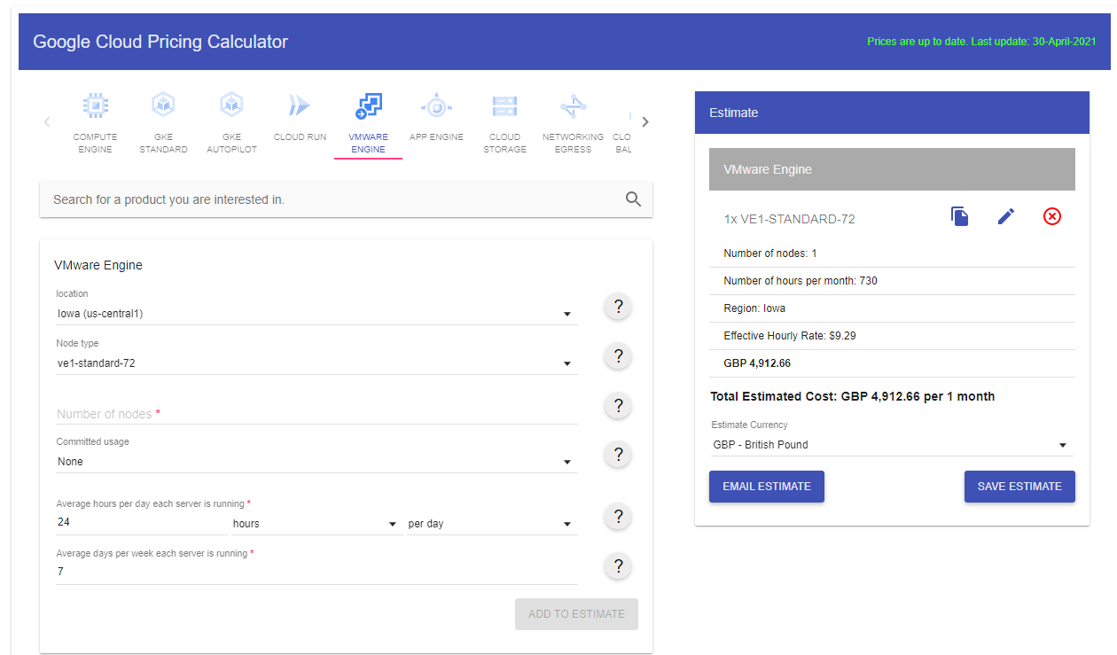

Figure 1: (GCPC)
Source: [22]

Cost Reducing Methods
The cost of cloud computing has been shown to be cheaper than a private run operation. However, there are by no means cheap and any approach that can be taken to cutting costs without impacting performance should be understood.

Unused Resources
The first step to cost reduction is to ensure all unused resources are not running in the background. This might occur when an employee needs to use a temporary server but then forgets to turn it off once they are done. This could quickly become an issue as the cost of that server will still be charged even if the user only needed it once. Training workers good practises for using the cloud servers should reduce the risk of unnecessary charges occurring each month.

Automation
Automation can really help reduce costs in more than one way. If VM’s can be automatically shut down after use it greatly reduces the risk of wasting resources. The use of a “heat map” can be used to determine when a server can be safely shut down for example they may not be in use on the weekends [7]. The fact that this is automated will also save money from a labour perspective as less manual interaction results in further cost saved on labour.

Right Size Computing Services
Choosing the appropriate systems can be very difficult not least because these requirements will likely change overtime depending on the company’s success. “Right sizing is the process of matching instance types and sizes to your workload performance and capacity requirements at the lowest possible cost” [8]. This is a practise which should be taken seriously as it can be excellent for saving costs. Purchasing a VM which is too small makes the migration process much harder when space runs out, with the right sizing analytics predicting the largest VM required without wasted expense becomes much simpler.

Load Balancing
Load balancing has the potential to be an effective solution for accessing better performances at a lower cost. AWS, Microsoft Azure and Rackspace all offer types of cloud load balancing.
One study which investigated cloud load balancing concluded that there is a “lot of issues still open in load balancing process which can be bridged in future by applying an efficient and sophisticated load balancing algorithm” [9]. If these issues are resolved load balancing appears to be a very effective method and given large organisations already offer these services, there does appear to be some costs being saved.

Security
So far costs have been the focus of why cloud computing can be a good choice for businesses, it is important to understand there are more areas in which cloud computing excels.

Advantages
Automatic backup is a very useful feature which is likely included in the subscription. Additionally, the data backup can be customised to make save points regularly if a company requires.
The “responsibility of the provider” means that depending on the agreement when signing up the provider can be accountable for any data leaks that may occur. This can save a company from lawsuits and other implications that they would be responsible for if the service was privately run. The Service Level Agreement (SLA) and Non-Disclosure Agreement (NDA) determines the access the “client’s data the provider can get” [10].

Disadvantages
A disadvantage of a cloud system is that there be “Insufficient security of internet channels” [10]. This may come down to the provider not having a “sufficiently reliable authentication” system which can result in passwords and other personal data being breached [10]. Ensuring that the connection from the provider to the personal computer is secure will resolve this issue.
Data which is stored at rest (housed physically on computer) should be automatically encrypted, Google state that “all customer content stored at rest, without any action from the customer” [11]. However, one study has found that the dangers of implementing data encryption can be very high if not done so by “experienced specialists” [12]. This was part of a study from 2008 and it is very possible that as more people have become trained in this field the less likely it will be for inexperience to occur. Regardless, data that has been encrypted without ensuring the access is possible if something goes wrong will result in a loss of data which could be very damaging to the company.

Reliability & Scalability
The cost and security implications have been established; it is important to emphasise the role in which scalability plays when it comes to all business adopting cloud computing.
The reliability of cloud computing refers to what is expected and achievable from the cloud services. The cloud is expected to be running at 100% performance, but this is not always the case, ensuring that the application is thoroughly tested before being deployed is essential and with more and more companies transferring to a cloud structure the understanding of reliability issues should be increasing.
The fact that the machines are virtual allows for companies to scale the resources based on their needs. This was mentioned as part of the cost saving features as that is one of the main reasons to choose cloud services.
The ability to increase resources almost instantly and to then be able to dial them back just as fast allows for companies to quickly adjust the number of systems without the need for installing them physically.
Vertical and horizontal scaling refers to the way in which systems can be upgraded. Vertical scaling would be when a single resource is upgraded such as RAM. This can require the hardware to be shutdown and result in the services being unavailable in that time which is why cloud elasticity is so important this refers to “how well your cloud services are able to add and remove resources on demand” [13]. Horizontal scaling is when “building out” a system this is a better approach for cloud system as it involves linking servers together which interferes less while still increasing performance.

Legalities of Cloud Computing
With cloud computing becoming increasingly common for businesses the handling of data becomes more of a concern. Data laws differ between regions and as such can result in difficulties when trying to accommodate a customer base from multiple regions.
Cloud based services such as AWS and Microsoft Azure offer the ability to save the data separately without the need for the client to be involved this saves time and potential lawsuits. The EU has recently taken data protection very seriously and promises hefty fines for those who do not comply which can be up to €20 million. The EU General Data Protection Regulation has been described as “the toughest privacy and security law in the world” [14]. This implies that the importance for international companies with operations in the EU must be aware of these laws and subsequently other regions.

Virtualisation
The cost of a private server has been shown to be extremely high, cloud computing appears to be the best option for companies to save money along with some other benefits when it come to security and liability.
What virtualisation is and how it works is important to understand when looking at cloud computing as it refers to the method used for accessing virtual machines (VM’s).

Hypervisor
A hypervisor can be either type 1 (bare metal) or type 2 (hosted) the most common and secure is a type 1 hypervisor as it runs directly on the server and it is “isolated from the attack-prone operating system” [15].
There are several different types of hypervisors such as VmWare, Hyper V and Xen which range from commercial to open source.

The hypervisor works by “abstracting a computer’s software from its hardware” [15]. This then allows for multiple virtual machines to be created from just one set of hardware these allow for fast, flexible, and portable machines for clients. The ability to create a new machine when needed makes it a very useful service, a user might run into an error on one machine which can be deleted and a new one provided almost instantly. Fail over refers to the ability of a virtual machine being transferred to another blade server if something goes wrong which essentially guarantees 24/7 operation.

Containerisation
Containerisation looks to achieve virtualisation but does not use hypervisors, instead a container will work at an operating-system-level by “abstracting the user space” [16].
Using containers reduces the hardware load that hypervisors demand, figure two describes the different components of the two systems. The right side of the image describes how containers work and as the diagram shows there is no need for a guest OS and that instead it only requires the host OS to operate.
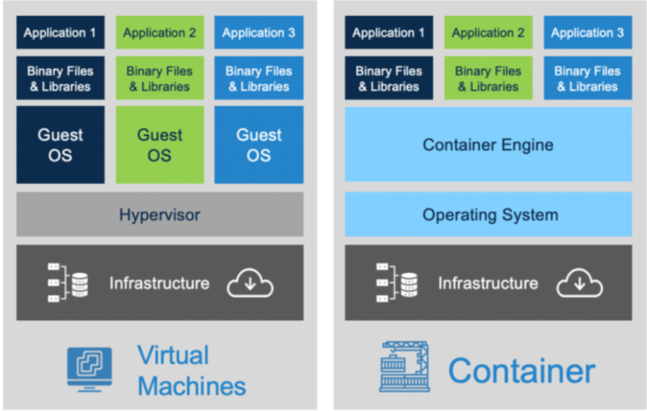
Another advantage of containers is they are incredibly modular, in fact if a user wanted to add a third party API to the system (perhaps created in Python), with a hypervisor method the resources would have to be reduced by removing a component. Using the figure, application 3 would need to adopt the task of the Python application to allow for the API. However, with containers the load is less intensive and so a new application can be added to accommodate the API and any leftover resource will be evenly distributed between the operations.
Figure 2: Virtual Machine (Left) Container (Right)
Source: [23]

Docker
Docker, like other VM’s uses images which are files that have a set of instructions for the program to complete tasks. These images consist of layers and containers.
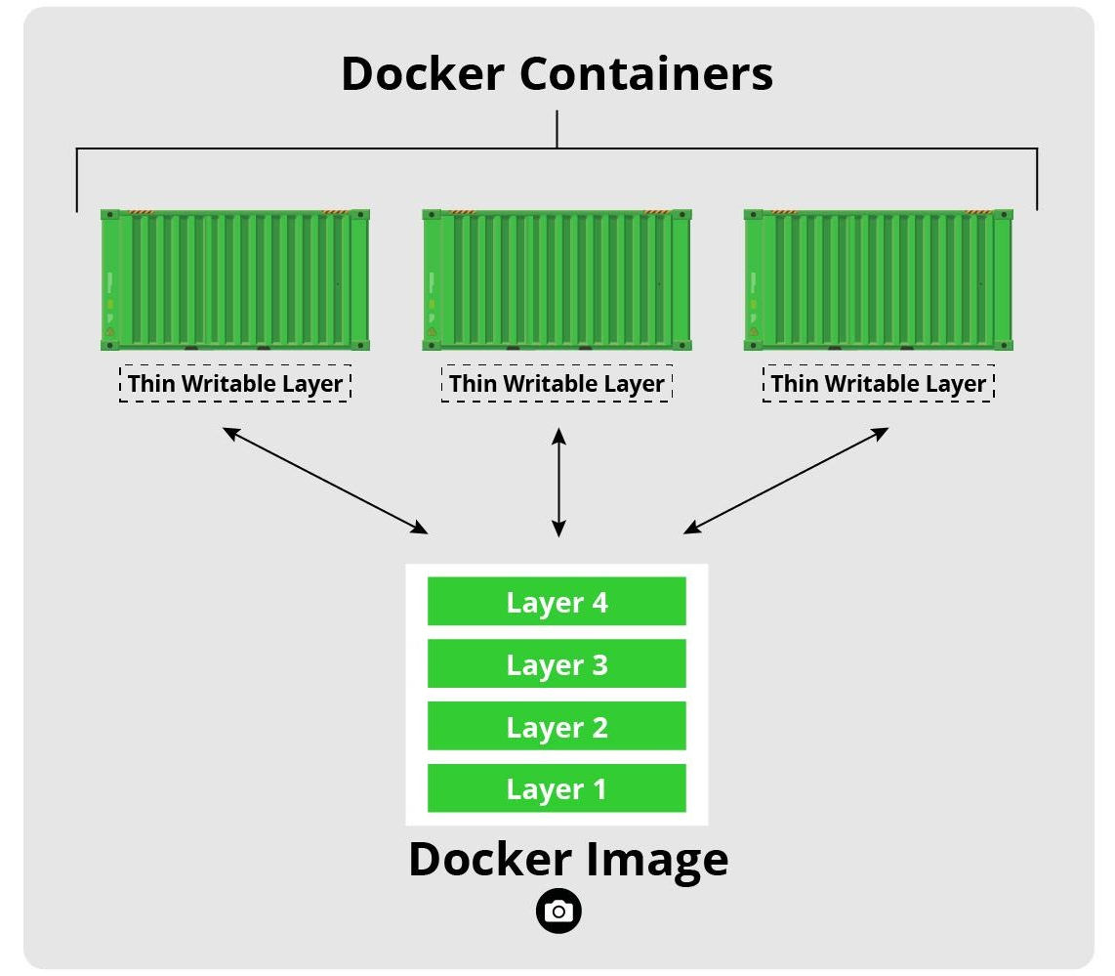

Figure 3: Docker Image
Source: [17]

Docker is the bridge for the container approach as it has made it easier for anyone to create these virtual environments that will be the same no matter the hardware. This used to be an issue as some issues could occur when a dev team worked on one OS such as Apple and then the application was deployed to Windows then errors might start to appear.
Docker is fast, scalable and has a ‘Docker Hub’ which is a list of docker images created by the community. This allows for the completion of simple tasks to be done much faster so the development team can focus on the important parts of the project unique to the clients needs.

So, which approach is better?
One is not necessarily better than the other, they both play role in cloud computing. However, for smaller projects containers and therefore Docker can be a great low-cost alternative to the hypervisor approach.

Evaluation of Development
This section will evaluate the tasks performed in class to show an understanding of Node, Docker and how they can be used for cloud development.

Node.js
Node.js is an open source cross platform JavaScript environment running on v8. Node can work with applications such as Docker to create comprehensive cloud applications and was an important development tool.
Node package manager (npm) is the way in which most commands for node will start, figure 4 and 5 is an example of setting up a node application at the start. The npm init command creates the package.json file which stores the metadata for the project.
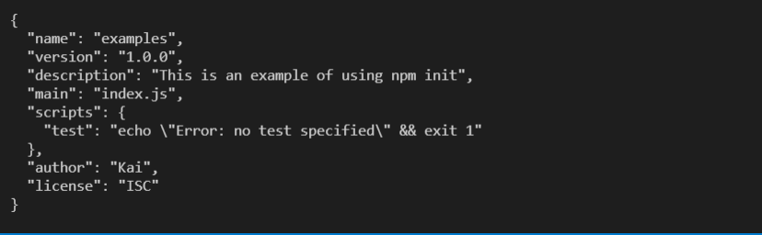
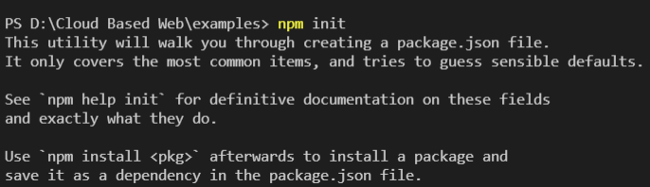
Figure 4: Entering file description, name etc…
Source: Author
Figure 5: npm init
Source: Author

The next step is to add some packages such as typescript, express and Axios.

TypeScript
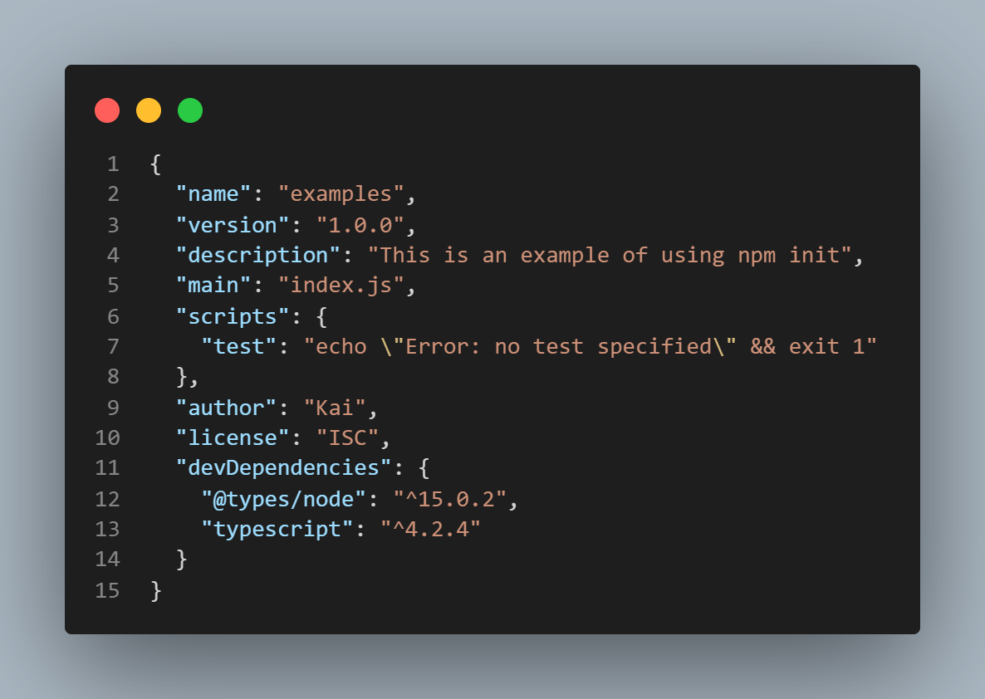
“TypeScript simplifies JavaScript code, making it easier to read and debug” [18]. This is one of the many reasons to use TypeScript as it is an open source package designed to enhance JS.
Figure 6: package.json file updates to show that the TypeScript has been added
Source: Author

Express
“The primary use of Express is to provide server-side logic for web and mobile applications, and as such it’s used all over the place” [19]. Express is essential to any web/mobile application when working with Node as it bridges the gap for many libraries to be used. Express is also an ‘unopinionated framework’ meaning there is no ‘right way’ to do things. This gives developers options to complete tasks in their own way assuming they can find the appropriate components.
Figure 7 shows a basic express file commonly app or in this case server. The command to run the app is ‘node server.js’, figure 8 is what is shown when http://127.0.0.1:8081/ is entered into the URL.
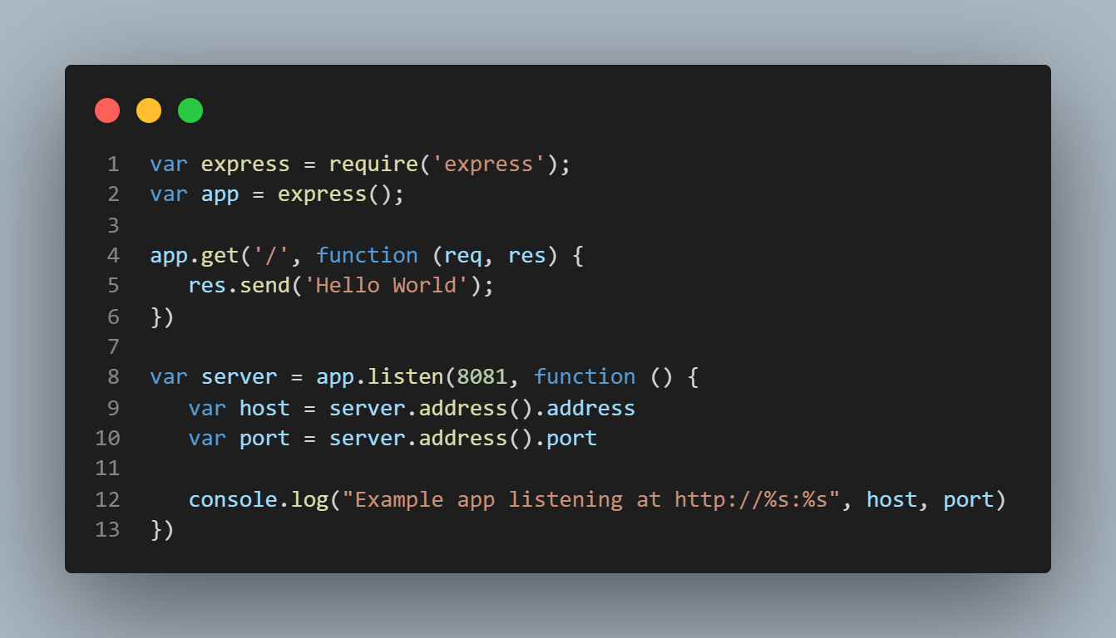
Figure 7: Basic code example of Express
Source: Author
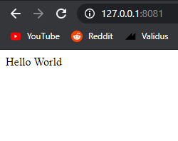

Figure 8: Hello world example in Chrome Source: Author

Axios
Axios is useful great for making XMLHttpRequests from the browser as it provides a great way to perform the get, post patch, and delete commands along with more. Axios offers a simple way to work with a RESTFUL API by installing it and applying it to the application.
Figure 9 shows some open source code that demonstrates the various functions that can be utilised. In this figure a ‘GET’ request has been made and the data of the users appears.
This code has been accessed through GetHub which is another great reason for using packages like Node as the amount of open source code available really reduces development time.
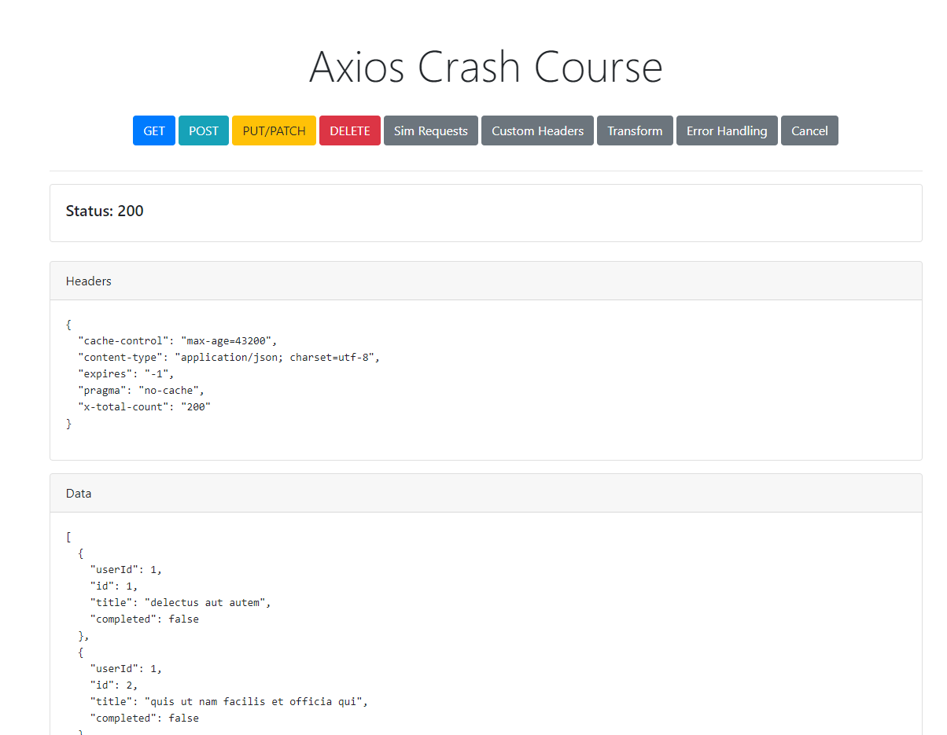

Figure 9: Axios example
Source: [24]
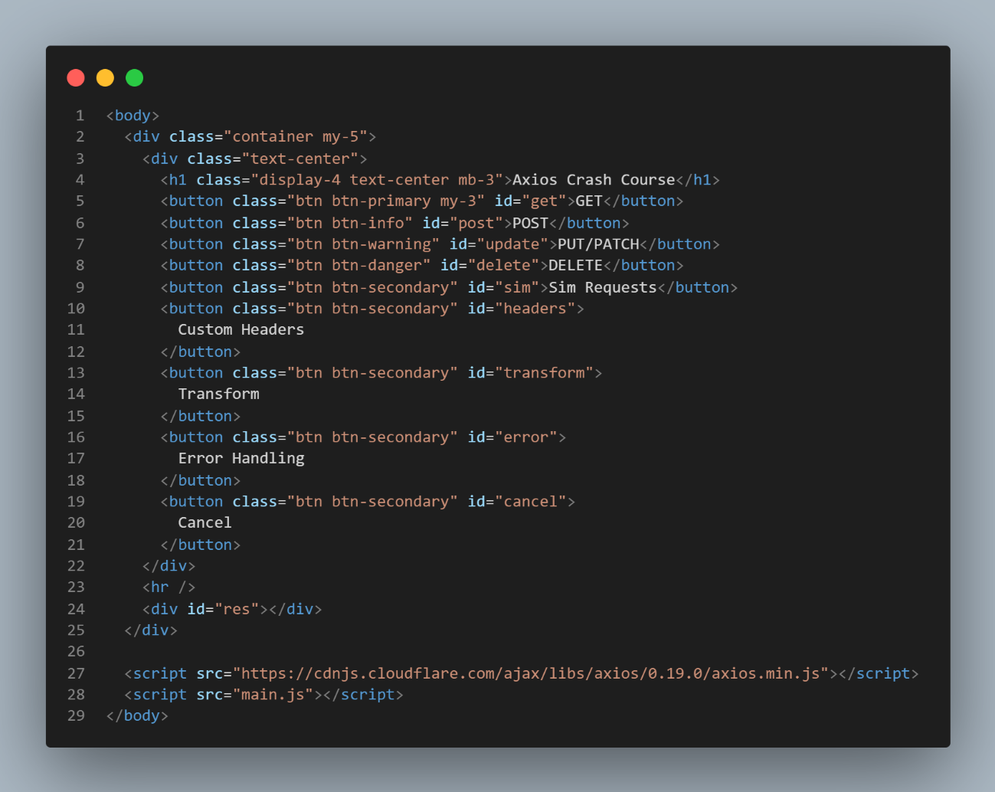
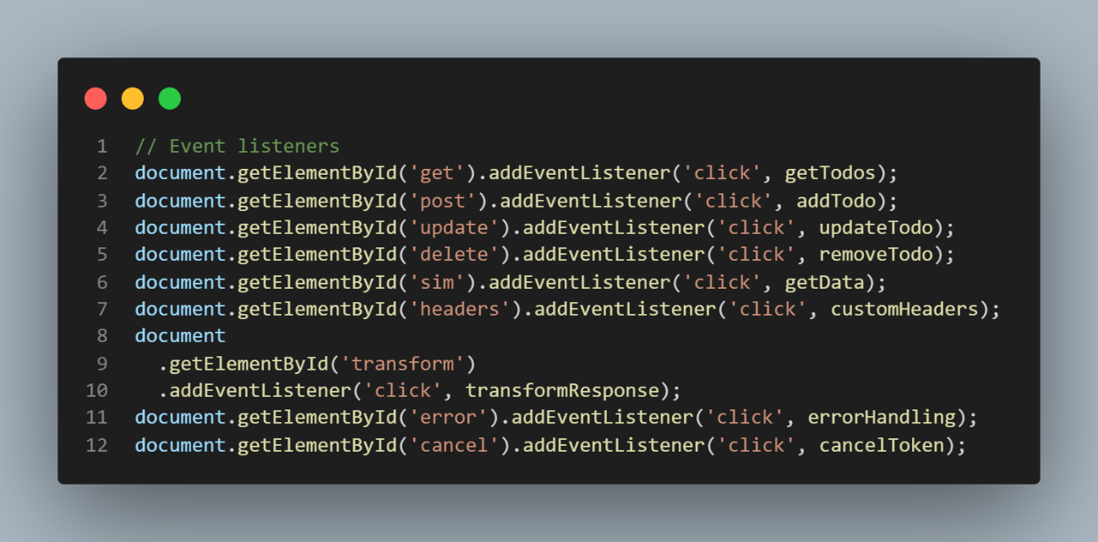
Figure 10 looks to show how the event listeners are interacting with the HTML buttons to trigger the actions Axios
The id matches the EventListner id
Accessing the Axios library
Figure 10: EventListeners for actions
Source: [24]

Figure 11: HTML counterpart to the EventListners
Source: [24]

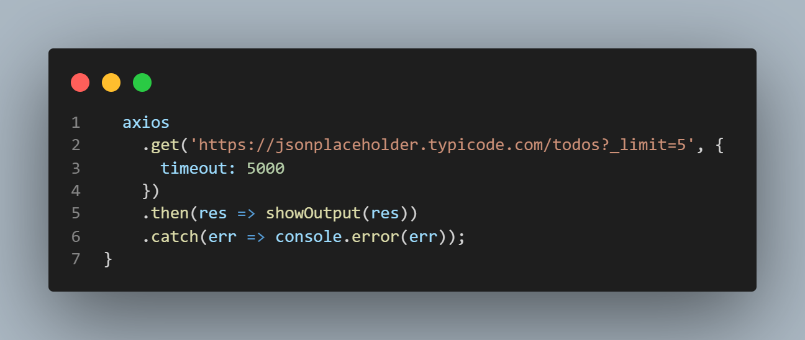
Figure 12: Json todo API example data
Source: [20]
Figure 12 is the get function using Axios to retrieve the fake Jason dat, in this case it has been limited to 5 users.
Axios allows for these CRUD functions to be done, it is seen as bette than HTTP requests for a number of reasons including the fact it “Performs automatic transformations of JSON data” [21]. This saves extra steps and simplifies the process. Axios is more secure, has better error handling and a wider range of browser support along with many more advantages.

Conclusion
This report has provided an in-depth look at Cloud computing and the role it plays for the future of computing. From the cost saving to security advantages the report established the advantages and disadvantages that come with adopting a cloud service.
A look at how cloud computing works and the different approaches such as hypervisors, containers and how Docker has made cloud computing so much more accessible for developers.
A look at Node and the packages it offers was also shown using code examples and research to understand the importance of understanding the Node.js package.

Bibliography

[1] | AWS, “What is cloud computing?,” Amazon, [Online]. Available: https://aws.amazon.com/what-is-cloud-computing/?nc2=h_ql_le_int_cc. [Accessed 01 05 2021].
[2] | Techopedia, Techopedia, [Online]. Available: https://www.techopedia.com/definition/4192/data-server-ds. [Accessed 02 05 2021].
[3] | 62 CBS Detroit, “Compuware Study: CIOs Fear Poor User Experience, Hidden Costs In Cloud Computing,” 62 CBS Detroit, 16 07 2013. [Online]. Available: https://detroit.cbslocal.com/2013/07/16/compuware-study-cios-fear-poor-user-experience-hidden-costs-in-cloud-computing/. [Accessed 01 05 2021].
[4] | J. Bulao, “How Many Companies Use Cloud Computing in 2021? All You Need To Know,” techjury, 30 04 2021. [Online]. Available: https://techjury.net/blog/how-many-companies-use-cloud-computing/. [Accessed 01 05 2021].
[5] | Stream Data Centers, “DATA CENTER COST,” Stream Data Centers, [Online]. Available: https://www.streamdatacenters.com/glossary/data-center-cost/#:~:text=The%20average%20yearly%20cost%20to,maintenance%20of%20applications%20and%20infrastructure.. [Accessed 01 05 2021].
[6] | Google Cloud, “Private cloud VMware components,” Google, [Online]. Available: https://cloud.google.com/vmware-engine/docs/concepts-vmware-components. [Accessed 1 05 2021].
[7] | CloudCheckr, “Cloud Cost Optimization: 7 Best Practices For Reducing Your Cloud Bills,” CloudCheckr, [Online]. Available: https://cloudcheckr.com/cloud-cost-management/cloud-cost-management-cost-optimization-best-practices-for-reducing-cloud-bills/. [Accessed 02 05 2021].
[8] | AWS, “Right Sizing is an Ongoing Process,” Amazon, [Online]. Available: https://aws.amazon.com/aws-cost-management/aws-cost-optimization/right-sizing/. [Accessed 03 05 2021].
[9] | S. A. &. G. Kavitha, “Load balancing in cloud computing – A hierarchical taxonomical classification,” Springer Open, 23 12 2019. [Online]. Available: https://journalofcloudcomputing.springeropen.com/articles/10.1186/s13677-019-0146-7. [Accessed 03 05 2021].
[10] | C. Young, “Advantages and Disadvantages of Cloud Security: Main Benefits, Current Risks, and the Way to Avoid Them,” PenTest, [Online]. Available: https://pentestmag.com/advantages-and-disadvantages-of-cloud-security-main-benefits-current-risks-and-the-way-to-avoid-them/. [Accessed 03 05 2021].
[11] | Google, [Online]. Available: https://cloud.google.com/security/encryption-at-rest/default-encryption. [Accessed 03 05 2021].
[12] | M. N. Jay Heiser, “Assessing the Security Risks of Cloud Computing,” Garther, 03 06 2008. [Online]. Available: https://files.transtutors.com/cdn/uploadassignments/2651971_2_assessing-the-security-risks-of-cloud-computing-1-.pdf. [Accessed 03 05 2021].
[13] | Lucid Content Team, “Cloud computing 101: The interrelationship of scalability, reliability, and availability,” Lucidchart, [Online]. Available: https://www.lucidchart.com/blog/reliability-availability-in-cloud-computing. [Accessed 03 05 2021].
[14] | GDPR, “What is the GDPR?,” GDPR, [Online]. Available: https://gdpr.eu/what-is-gdpr/. [Accessed 03 05 2021].
[15] | VMware, “What is a hypervisor?,” VMware, [Online]. Available: https://www.vmware.com/topics/glossary/content/hypervisor. [Accessed 04 05 2021].
[16] | FreeCodeCamp, “A Beginner-Friendly Introduction to Containers, VMs and Docker,” FreeCodeCamp, [Online]. Available: https://www.freecodecamp.org/news/a-beginner-friendly-introduction-to-containers-vms-and-docker-79a9e3e119b/. [Accessed 04 05 2021].
[17] | E. Kisller, “A Beginner’s Guide to Understanding and Building Docker Images,” JFrogs, 04 05 2021. [Online]. Available: https://jfrog.com/knowledge-base/a-beginners-guide-to-understanding-and-building-docker-images/. [Accessed 05 05 2021].
[18] | A. Sharma, “Why You Should Use TypeScript for Developing Web Applications,” DZone, 10 10 2018. [Online]. Available: ypeScript simplifies JavaScript code, making it easier to read and debug.. [Accessed 05 05 2021].
[19] | M. Short, “Express JS: A Guide for Beginners,” Course Report, 07 12 2018. [Online]. Available: https://www.coursereport.com/blog/what-is-express#:~:text=The%20primary%20use%20of%20Express,used%20all%20over%20the%20place.. [Accessed 05 05 2021].
[20] | Json, “jsonplaceholder,” Retool, Mockend, [Online]. Available: https://jsonplaceholder.typicode.com/todos?. [Accessed 06 05 2021].
[21] | J. Lewis, “HTTP Requests Compared: Why Axios Is Better Than Node-Fetch (Automatic Transformations, More Secure, Can Handle Errors Better, Interceptor Support, And More Browser Friendly),” Medium, 19 07 2018. [Online]. Available: https://medium.com/@jeffrey.allen.lewis/http-requests-compared-why-axios-is-better-than-node-fetch-more-secure-can-handle-errors-better-39fde869a4a6. [Accessed 06 05 2021].
[22] | Google, “Google Cloud Pricing Calculator,” Google, 2021. [Online]. Available: https://cloud.google.com/products/calculator#id=bb459910-92ee-4d17-a407-a013efe51b21. [Accessed 01 05 2021].
[23] | AFK, “WHAT'S THE DIFFERENCE BETWEEN VMS & CONTAINERS?,” AFK, 29 05 2019. [Online]. Available: https://akfpartners.com/growth-blog/vms-vs-containers. [Accessed 05 05 2021].
[24] | Bradtraversy, “Axios Crash Course,” GetHub, 25 10 2019. [Online]. Available: https://github.com/bradtraversy/axios-crash. [Accessed 06 05 2021].

