Report: Destination Management: Tenby

Student: William Thorpe

Moodle: BMIH5006

Lecturer: Huw Thomas

Table of contents:

Introduction | 2
Main findings, methods of research | 2
Butler's life cycle | 3
Doxey's irredixt | 4
Research on sustainable tourism | 5
Conclusion | Page Numbers: 6
Recommendations | 7
References | 8

`

Introduction:
This report aims to research sustainable tourism in a destination popular seaside town, Tenby. a seasonal tourist destaination with a wall town 15 th century nornan history it generally has an influx of 60 thousand holiday makers, in the summer and there is a bit of development and over tourism and triffic and transportation is always during the school holidays it is aporplar attraction espacilly amoungest families and has potantail to devolop but there are limitations people in wales practice recycling and sustainbablity awareness.

Main findings:
Method of research on tourism destination Tenby:
March, (2005) suggested the increasing impacts of climate change on open space and water. In contrast, water is important for the environment on which we depend and can often help manage the surface water in cities, restoring rivers and green spaces (Johnson, 2009), therefore, argues the risk of flooding, thus creating important new habitats. Regulating temperatures helps to facilitate walking or cycling for the recreation of a healthier lifestyle. Most importantly, it reinstates the flood water in the storage capacity and manages the risk of flooding.
Although (Morris 2020) from the Guardian researches Tenby's residence, they have mixed emotions about welcoming tourists back to their town because tourists bring COVID; however, when the travel in Wales was lifted, whereas being a small town with a small population of 5500 people. Second, homeowners and day trippers realise that the residents will see an influx of 6000 tourists overcrowding their towns and seaside; moreover, the residents and the businesses can not do without tourism because their lively hoods depend on tourism.
Jones (2021) from BBC Wales reports that the Welsh tourism businesses and locals have been affected financially, especially when many businesses closed their doors. Furthermore, the lengthy lockdowns have caused havoc for the locals and the businesses while watching their finances drain away. However, the post-pandemic brought about a tourism tax in Wales and mixed reactions among businesses. Some businesses feared the Welsh Government had to review their idea about the tourism tax as it would thwart tourists from holidaying in wales. Furthermore, other businesses were in favour of tourism tax. Moreover, the question arose whether revenue generated from the tourism tax could go towards tourism development, building new roads and improving the infrastructure.
The Walsh government rebuilt and developed affordable housing, the innovation housing programme, which combines economic stimulus with the provision of new environmentally friendly social homes for people across Wales and town centres to help businesses on the verge of a closing pre-pandemic. Moreover, fund climate change, around 5o additional projects will contribute towards green recovery, where there are no viable uses for derelict sites, and enable the creation of new green spaces. Furthermore, to support and develop the infrastructure of tourism, hospitality and transportation.
Research on Butler's life cycle mode TALC and mass tourism destination management. The impact of the local's tourists.

Tourism development affects many perceptions; however, no single formula can connect Sustainability and business success. Moreover, strategies positively perceive sustainable service and culture (Ross 2006), suggesting that global hotels are eco-friendly. These niche properties cater to customers but share the same problem of finding the right employees to keep business travellers happy. Therefore, human resource management has difficulty solving employee issues, such as skilled workers. They can only survey the long term if they recruit and motivate the employee to respond to future challenges.
Although (Pembrokeshire's local development plan 2020) states that there is concern over the development in Tenby. However, Tenby tourism experienced stagnation decline and stated that a decline in tourism could be a devastating impact on the community at some stage relating to (Butler 1980) life cycle model TALC, where Tenby seasonal tourism and how tourism impacts communities. Moreover, there has been limited development of affordable housing, and awareness of traffic management raises concerns; furthermore, during the summer months, over-tourism and being in employment all year round are non-existence. However, climate change is a concern for the environment. Furthermore, the sea level is rising.
Research has shown that declining destinations and refined a destination with a certain tradition in providing tourism, however, are characterised by one or more navigating trends; therefore, the increased perception of the local people and the negative impacts towards sustainable tourism. In principle, when expecting increased numbers of tourists will contribute to the destination's decline. However, tourism trends change over time and characterise a series of stages of tourism development exploration, involvement, development, consolidation, stagnation, decline and rejuvenation. In addition, (Berry 2006)also suggests the various development stages and describes Butler's TALC model.
To identify and critically analyse (Butler. 2006) research that in all tourism destinations, curring compassed is multi-dimensional in the tourism setting; however, it encompasses not only the amount of tourism that perhaps sustained by the natural and social environment but also the amount of tourism that probably in a destination before losing its attractiveness nonetheless carrying capacity is a crucial element of Sustainability.
Although (Butler. 1980) elaborated, there was criticism of the TALC model by mentioning it was too simplistic; therefore, it perhaps is identified as being intuitive and uncontrolled tourism can not go uncontrolled without resulting in direct economic, social and environmental consequences.

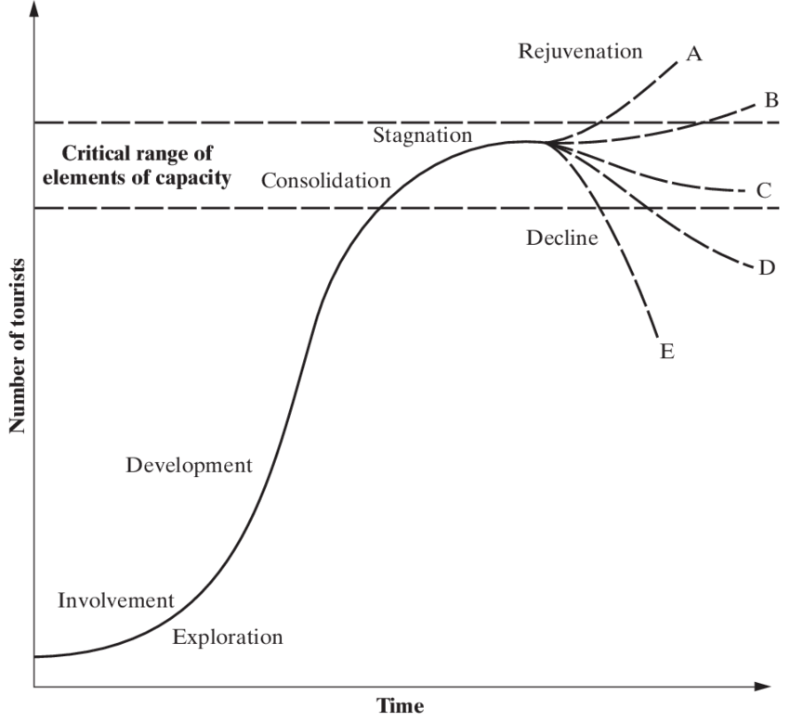
Butler's life cycle model and nine stages linked to Tenby:
1 Exploration stage
2 Involvement
3 Development
4 Consolidation
5 Stagnation
6 Decline and stage (6) Rejuvenuvenation

Baron
Life Cycle Butler's life cycle model and nine stages linked to Tenby

Butler
Theory


ges in
Doxey Irridex Model
Tourism
Development
Integrated Model
of Tourism
Social Exchange Theory
Model
Psychocentric
Model
Tourism Authenticity
Model
Butler's Talc
Model Explained
Plogs Model
of Tourist
Tourist Area
Life Cycle
Europe Tourism Stage
On Talc Model
Induced Tourism
Film
Relationship of Plogs Theory and Butler's
Model

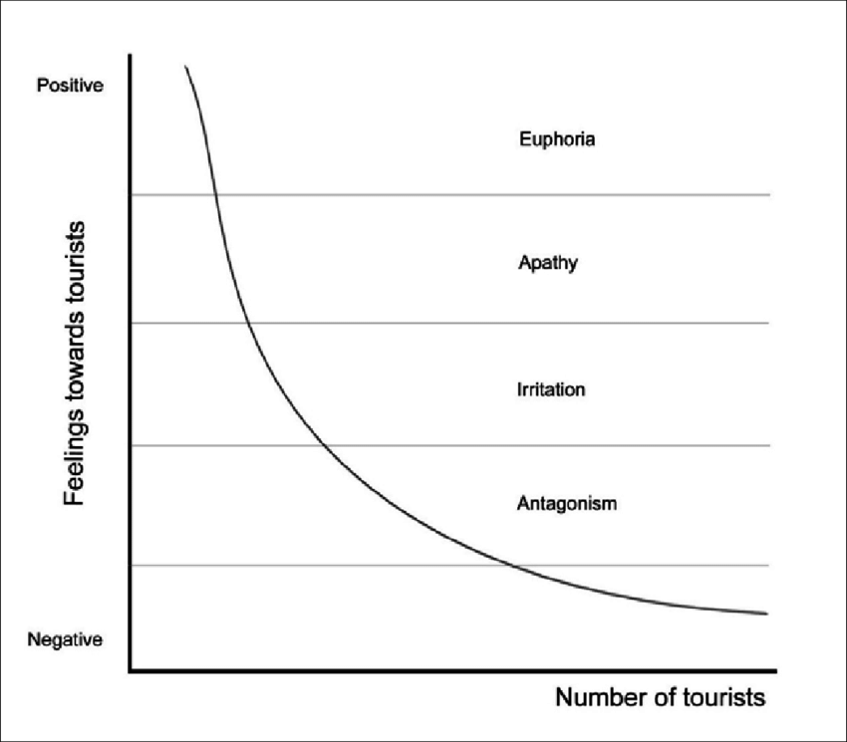

Dorey's irritation:

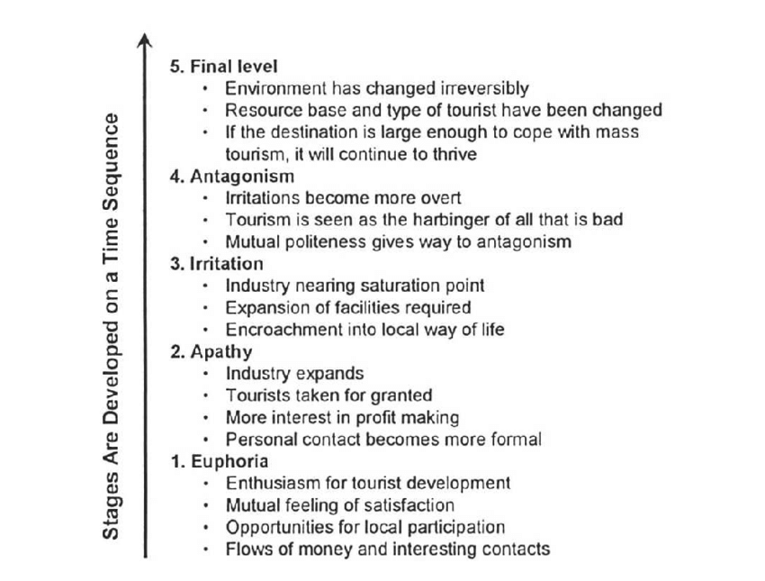

Relating to local community reactions to the development of tourism have been a subject of interest relating to ( Doxey 1975). The work envisaged a positive linear number of growing tourism and the residents. This occurs for many reasons that, include instruction on daily living patterns, increasing prices and the potential loss of local resources. Therefore, the locals witness an entrepreneur moving into the area. Moreover, the market are controlled by companies outside of the region by overseas tour operator

Research on Sustainability and tourism
Research on Sustainability and innovations of Eco-friendly hotels (Horng et al 2017) pointed that to underpin decentralised organisational environments to strengthen the effect of innovation drives environmental marketing strategy. Nevertheless, decentralised organisations' structure aids hotels and responds to dynamic environmental marketing strategy changes. However, by adopting a minimum hierarchical structure, the organisation freely communicate; therefore, these attributes encourage entrepreneurially. In contrast, enabling employees to be more flexible and encouraging cognitive thinking impacts the organisation's innovative performance.
The three pillars that measure Sustainability in tourism destination management support economic, environmental and sociocultural tourism impact (Lee. 2013), suggesting measuring economic impacts to show the standard of living, employment and business opportunities for infrastructure development. However, development impacts water waste and pollution. Moreover, tourism during the season affects the local culture where the tourist destination is traffic congestion, crime, tourist conflicts, tourist crowding and the over-commercialisation of historical attractions
Scandic hotels were on the verge of collapsing in the 1990s. Research shows that the CEO turned the organisation around. Nonetheless, the CEO changed the management style from a central to a decentralised one, giving employees more authority to carry out their daily tasks without clarifying with the head office. Moreover, the main focus was on the customers and the environment; opportunities for sustainable development. However, travel was disrupted because of the war in the Gulf. Therefore, the CEO spearheaded change initiatives that resulted in rapid growth and were rolling out hotels in new countries with no control over the efficiency of each investment; therefore, a new management strategy aimed to build customer loyalty and hence financial stability by establishing emotional ties with customers to based on common desires for environmental improvements, innovative and train employees to adopts a culture and supports sustainable practices, seeking to attract and retain customers and employees, such as awareness of the environment (Goodman A. 2000), suggesting that implementing sustainable strategies was collaborating with suppliers to achieve environmental innovation. Moreover, the hotel's principle and core value of decentralised management allow employees freely to interact with customers
Hospitality and tourism organisations (Lonergan and Sawers. 2022) elaborate that businesses will support climate change policies in the transition to a low-carbon economy to deploy friendly technology and to facilitate the withdrawal or improve the energy efficiency of carbon-intensive assets; however, the effect of climate change mitigation and policies depend on their design their behaviours only if they have a legal obligation to do so, or if it is cheaper or a better way or if it conforms with their social norms and if is profitable economically.
Sustainable Transportation developments:
The Walsh government set out sustainable modern methods of travel to achieve net zero carbon by 2030 (Waters. 2022) suggested that, working with stakeholders and partners to deliver value for money, maxing investments and reliable, integrated Transport For Wales, nonetheless it will deliver expert advice to their customers and encourage people to make decisions and to play its part in meeting TFW long term climate target. Moreover, the focus towards a sustainable goal such as TfW's can achive Net Zero for Wale's ambition to reduce the number of car miles travelled per person to 10% by 2030 and to increase the proposition of trips by sustainable modes to 39% by 2030. However, TfW's cooperative strategy required support and encouraged people to make smarter travel decisions to reduce congestion.
Transport infrastructure is dangerously at risk of damage from gradual climatic changes and EWEs (Koks et al., 2019; WTO, 2019). Increasing temperatures can cause roads, bridges, runways and railway tracks to depreciate faster. Transport infrastructure and inland waterways can become partially or completely inoperable due to EWEs, and sea level rises in coastal regions (EEA, 2017; IPCC, 2014b). Climate change will increase infrastructure maintenance and repair costs, indirectly adding to trade costs. The unpredictability of damages related to EWEs is a source of uncertainties and high operational risks that can increase disruptions and delays and in turn create additional costs, such as requirements for freight insurance (Barrot and Sauvagnat, 2016; Boehm, Flaaen and Pandalai-Nayar, 2019; WTO, 2021c). In particular, climate change can affect strategically important junctures on transport routes through which exceptional volumes of trade pass in the global trade network,4 and this can create vulnerabilities for the trade system (Bailey and Wel

Conclusion:
This report has concluded with the assumption of what I have reached in this report we can come to concludtion that the Walsh Government is playing their by servicing TfW sustainable transport building sustainable housing tourism development and understanding Butlers life cycle models where has Tenby is full devoloped and tourism is their way of life it brings employment and revenue to this smalltown

Recommendation:
Tenby is an attraction to most visitors with its beautiful countryside and several golf courses; therefore, Tenby is regarded as a town that will always bounce back after a disaster or crisis. however, business is always a success in Tenby.

Barry T. (2006) 'Local perceptions of tourism as indicators of destination decline', Tourism Management, 30(4), pp. 512-521. doi: 10.1016/j.tourman.2008.10.009.
Goodman, A. (2000) 'Implementing Sustainability in service operations at Scandic Hotels', Interfaces, 30(3), pp. 202-214.
Huimin, G. and Ryan, C. (2012) 'Tourism destination evolution: a comparative study of Shi Cha Hai Beijing Hutong businesses' and residents' attitudes', Journal of sustainable tourism, 20(1), pp. 23-40. doi: 10.1080/09669582.2011.610511.
I understand the sustainable development of tourism (2010) Woodeaton, Oxford: Goodfellow.
J.-S. Horng, C.-H. Liu, S.-F. Chou, C.-Y. Tsai, (2017) 'Service innovativeness and the structuring of organisations: The moderating roles of learning orientation and inter-functional coordination, International Journal of Hospitality Management, 65, pp. 100-114. doi: 10.1016/j.ijhm.2017.06.010
Lee T H. (2013) impacts Bled'Journal of destination marketing & management residents, 6(3), pp. 196-206. doi: 10.1016/j.jdmm.2016.03.007.
Lonergan, E. and Sawers, C. (2022), Supercharge Me: Net Zero Faster, Newcastles (UK): Agenda Publishing
Marris S. (2020) The Tenby residents feel mixed emotions about tourists' return. The Guardian
Maughan, G., Price, T.J., Probert, S.D. and Rushton, G. (1997) 'Transportation policy—How acting locally can be beneficial: The Rhymney Valley, South Wales as an example', Applied Energy, 58(1), pp. 1-56. doi: 10.1016/S0306-2619(97)00031-7.
Pembrokeshire Coast National Park Local Development Plan 2 (Replacement) - end date 2031 Adopted Local Development Plan September 2020Draft Community Involvement Statement (July 05) (pembrokeshirecoast.wales)
References:
Rodriguez, J.R.O., Parra-Lopez, E. and Yanes-Estevez, V. (2008) 'The Sustainability of island destinations: Tourism area life cycle and teleological perspectives. The case of Tenerife', Tourism management (1982), 29(1), pp. 53-65. doi: 10.1016/j.tourman.2007.04.007.
Sarah Nicklson Kate Organ, Beth Cummings'Planning for sustainable tourism development in Wales: an analysis of destination management plans', (2021) Welsh Economic Review, 28, pp. 23-32. doi: 10.18573/wer.257.
Waters L. (2022). Transport for Wales is a wholly-owned, not-for-profit company providing support and expertise to the Welsh Government's transport projects. Transport for Wales has a separate website https://gov.wales/transport-wales

'Welsh Government's plan to rebuild Wales after the pandemic', (2020) South Wales Echo, 6.

Young, S., & Dhanda, K. (2013). Sustainability. SAGE, https://dx.doi.org/10.4135/9781544308432

