I cannot keep, cannot hold.

Alicja Bronowska P146618

Submitted in partial fulfilment of the requirements for the degree of BA Fine Art University of Wales Trinity Saint David, Swansea.

Fine Art and Context Course
Module number M6X01791

Doctor: Time Device

Words Count: 5600.

Submitted: 13th December 2017

Chapter 1
(INTRODUCTION) (CELLAR)

All my work has been inspired by ideas about the family, home Polish life and the search for dignity.
Today in Polish society there is a sense of inertia among the people. They have seen the promises that were made to them by various institutions turn out to be empty. The promises of Communism were rejected more than twenty years ago. The promises of the Catholic Church have not filled that void. The graveyards are filled with beautiful flowers and remembrances of the dead. Similarly, the development money of the EU dealt with the surfaces of things, such as new roads etc. The people have no sense of hope within them and carry a sense of guilt that they cannot make the future better for their children. As WY life in Poland use often I, like Polish emigrant.
The only achievement of the new politics in Poland is to give a better road to a more attractive graveyard.
One of the writers who best explains the psychological condition of the people is Friedrich Nietzsche (1844-1900). In his work he deals with ideas of spiritual and metaphysical crisis and how to deal with the guilt and misery of living. He stresses the importance of correct remembering and correct forgetting to give spiritual health. In his work Thus Speke Zarathustra, Nietzsche said that after people had lost faith in God they needed faith in something and that would be in themselves, but not at the expense of other people which is how the Nazis interpreted him.
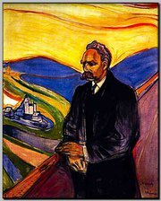
Nietzsche writes " Cheerfulness, the good conscience, the joyful deed, confidence in the future- all of them depend, in the case of an individual as of a nation, on the existence of a line dividing the bright and discernible from the illuminable and dark; on one's being just as able to forget at the right time as to remember at the right time"(Nietzsche 1874) he makes a similar point in his book," On The Genealogy of Morals" , "there could be no happiness, cheerfulness, hope, pride, immediacy, without forgetfulness." (Nietzsche 1887)
By Ron Miller – February 2011
http://www.ronmillersworld.org/just-a-thought/ was-nietzsche-right-way-back-in-1887
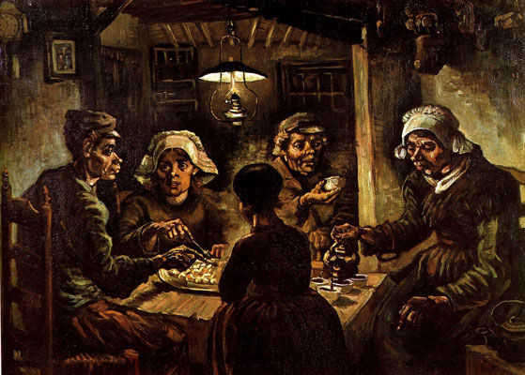
In the painting The Potato Eaters (1885) by Vincent Van Gough (1853-1890). Group of peasants sit down to a nourishing meal of potatoes.

Within the poor family a resigned father figure offers a potato to an older woman angry and embittered at her own conditions and those of her family. Perhaps within the circle of light and on the old man's face Van Gough sees the warmth of family life and the spirit of Christian renunciation. Perhaps Nietzsche would identify more with the old woman and see within her the difficulties of forgetting her bitterness.
Vincent van Gogh (1853 - 1890) De aardappeleters, April - May 1885The potato eaters Oil on canvas mounted on panel
Letter 221 Vincent van Gogh 1958
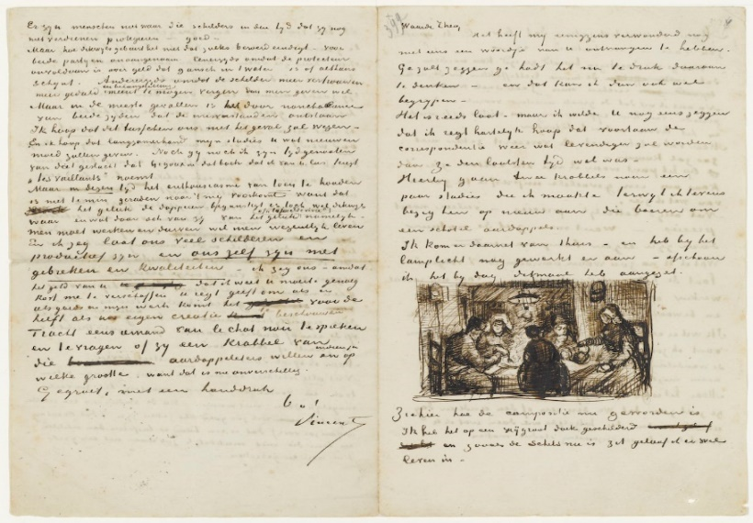
(Watch out – he can’t be trusted with money – drop him – don’t help him any more – as an art dealer I don’t see any point in it – or at any rate something in this vein. And pretended to know nothing when I said: Tersteeg, you must tone down your talk a bit; he said nothing. I was just imagining it, he said. Until one fine day he threatened me: Mauve and I will see to it that you receive no more money from Theo.... I no longer doubted it, and thought, you’re betraying me. 1v:3 because I knew what Mauve himself had said to me about it, namely that it would be very good if I could continue to receive that money from you for at least another year.)11.4 http://vangoghletters.org/vg/letters/let221/letter.html

In the cinema Andrejz Wajda (1926-2016) also looks at themes of guilt, memory and forgetting in films such as Man of Marble (1977), Man of Iron (1980) Danton (1982) and Katyn(2006) . In Man of Marble a model Polish worker is raised up by the system and then destroyed. Years later a student filmmaker tries to find out the truth. The film asks the questions what should be remembered and what should be forgotten in the story of a nation and within the people themselves.
These psychological issues that families carry due to the dislocating effects of living under Communism and having nothing satisfactory to follow it have been carried down through the generations. An artist who has faced up to the legacy of guilt is the Serbian Marina Abramovitch. She was born in Belgrade in 1946 and both of her parents were partisans and distinguished members of the Young Communist society. Using her body as her material her works reflect on questions of power and hierarchy and frequently seek to go to the heart of issues such as loss memory, pain, endurance and trust.
On the Polish side, the great pitfalls in relation to the process, also matters. In Poland, the lacunae in collective consciousness, the bank spots, as Poles themselves call them, have had harmful and disturbing consequences. In the last few years, together with a revival of interest in Jewish history, and culture, the has been a resurgence of anti-Semitic rhetoric in Poland, which is insidious in that it is rhetoric without a real object. It is if, with the lifting of Communist repression, the prewar prejudices have reemerged from their Pandora`s box, the demons and ghosts haunting the Polish psyche, need urgently to be confronted and examined.
(Hoffmann, 1998 P.378)
My interest in the Jewish people is because my grandmother saved a Jewish girl from being sent to a concentration camp.
I hope you can see film’’ Mis “(Teddy Bear) the film shows with a grain of salt the realistic of life in times of PRL. Scenes from bars, offices and shops reveal the absurdity of everyday existence.

Teddy Bear – Stanisław Bareja

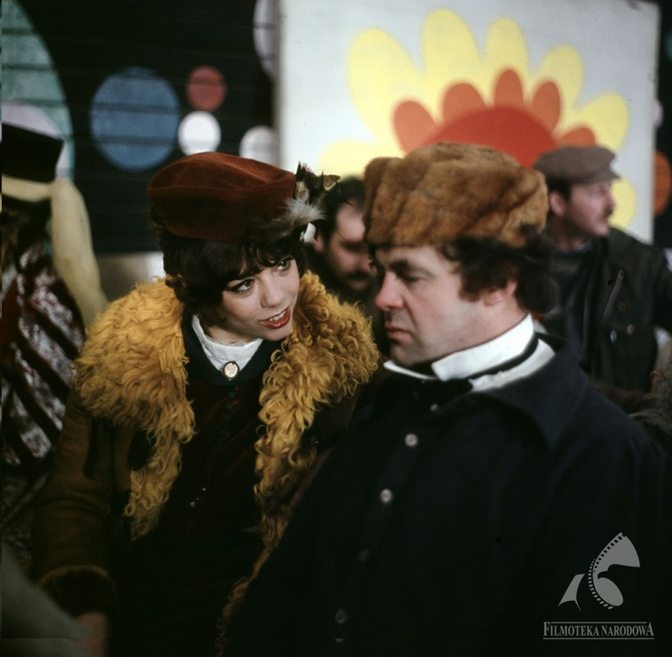
Bareja considerably augments the inanity of that time but his nearly surrealist vision is strongly based on the social reality of the period. The director ridicules everyone and everything – the idiocy of policemen, the conformity of artists, or the ubiquitous cunningness. What the satire hides is a bitter reflection – the citizens of the Polish People’s Republic were living in a haphazard world out of joint. It is no coincidence that the word ‘tradition’ incessantly recurs in the dialogues, and none of the main characters seems to be able to define it. A quality that might give some sense to the community is missing the director seems to be saying in the finale because true tradition has been replaced by artificially-constructed ‘new secular traditions’

Still from Teddy Bear, dir. by Stanisław Bareja,1980

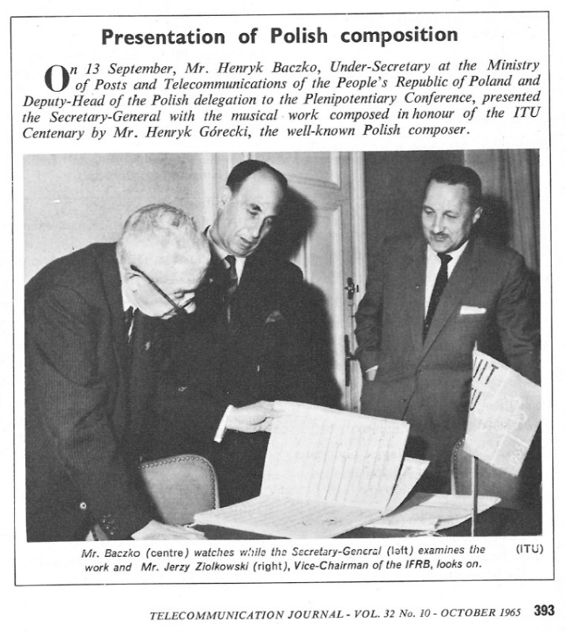
Henryk Mikilaj Górecki’s 1933 2010 was a Polish composer. One of his specializations was the adoption of religions. He had been regarded as a pioneer of modernism in his own country,” A profoundly religious man who resigned from his job in protest at the Polish government's refusal to allow John Paul II into the country in 1979, many of his later works were setting of religious texts for choir.”
In the 1970s he changed from an Avant Garde minimalist composer to one who used more melodic arrangements with a use of repetition based on folk and church music. He was trying to connect to an authentic past connected to Roman Catholicism in works such as Beatus Vir and Miserere. https://onpolishmusic.com/2013/10/27/%E2%80%A2-gorecki-refren-27-october-1965/

Chapter 2

The political class is not listening to the voices of the people.
In the past before the war came to Poland, according to my grandmother, when you travelled it was considered stylish to have a bigger and better suitcase. People put very important belongings into the suitcase and were very proud of it. If you see the belongings in a suitcase you can visualize the life of the people, they belonged to. The preciousness of those things to someone creates an emotional response in yourself. The object is not just a part of the world it carries some idea of love. Not only that, but the suitcase can also be a symbol of people protecting what they love from the bigger political forces in history. The suitcase is packed and ready to go in case you need to escape.
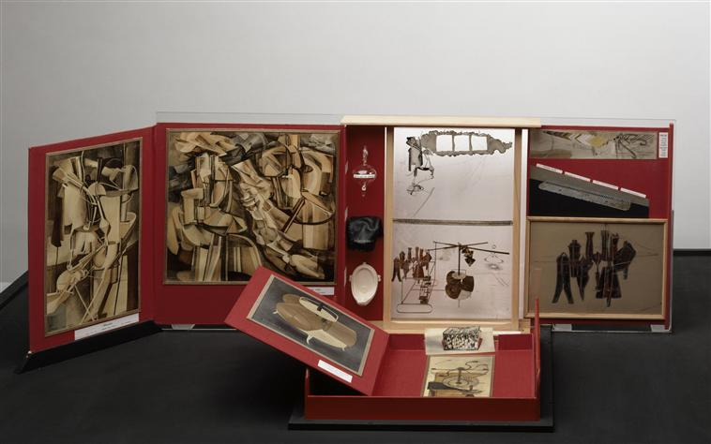
The artist Marcel Duchamp similarly had to put his most precious things in a suitcase before fleeing France in 1939. Marcel Duchamp, “Everything important that I have done can be put into a little suitcase”

.

Images for Duchamp (1936) small suitcases photography.

He put his artworks in and they became a piece of work called the boite-en-valise. So, I am struck by the idea of putting memories in a suitcase.
Two films from Poland in the 1970s and 1980s also show the way in which post World War 2 politics was damaging to the ordinary lives of the people. One film is a drama the other a comedy. The comedy is the 1980s film Mis is a popular satirical comedy film which shows how everyday life is like a satirical surrealistic comedy.
In Man of Marble a model Polish worker is raised up by the system and then destroyed. Years later a student filmmaker tries to find out the truth. The film asks the questions what should be remembered and what should be forgotten in the story of a nation and within the people themselves.
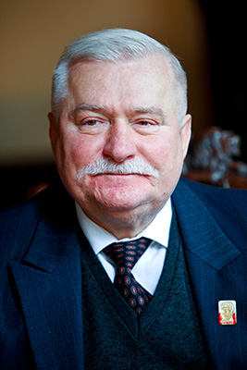
Wajda also understands that the political life of the country is contradictory and complicate. His heroes and heroines struggle with remaining idealistic in a country where idealism has been brought into question under the communist regime. In his films he shows how people struggle against history. Man, of Iron looks at the dockyard strikes of the early seventies in Gdansk in which workers were shot by police and how those same strikers returned in the 1980s with the Solidarity movement under Lech Walesa.
His film Danton was seen by Polish people to be a metaphor with Danton representation Lech Walesa and Robespierre representing Marshall Jareselkski. Wajda has been criticized for showing Nietzchean style heroes revolting against hopeless situations and trying to overcome them while trapped in very difficult political climates where you can trust nobody, and cynicism is most people’s response.
http://freedomcenter.org/IFCA/about-lech-walesa
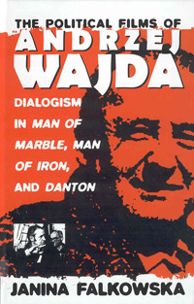
“He holds steadfastly to certain messianic idealistic romantic and patriotic elements in Polish culture, which for him are embodied in the socialist Utopian dream, even as he condemns oppressive, authoritarian, and violent revolutionary means. Thus, he is genuinely able to feel for both sides in many historical conflicts, but often with built in irony (a dialogical trait) His passions are sometimes so strong (one way or the other), however, that he tends to create “monological” because they are univocal, firmly on one side of an issue. The other side, though is ironically undercut. She calls Wajda a” mono-dialogical author because he constructs a framework for opposing voices while he includes his own “author’s” voice as well. More crucially, Wajda’s monologist rhetoric and imagery sometimes overpowers dialogical structures…It is for this reason that his detractors see him as propagandistic…In the books final two chapters, Falkowska shows how Wajda’s most interesting characters are dialogically constructed, containing pieces of many different discourses and attitudes within society.
(Eagle , 1997, 128-130) http://www.berghahnbooks.com/title/FalkowskaPolitical

But for people who are not heroes, the strength of Polish society comes from a turning inward and relying on each other expecting nothing from the outside world and seeing outsiders as a hostile force that will bring trouble or disaster to people and their families. This is explained in detail by an essay written by Frances Pine.
“I would argue that because of the opposition that existed during communism between the public world of work and the private world of domestic kinship and because of the extent to which the private world was the site of trust…Thus, everyday highly personal types of memory become entangled with “bigger” memories of politics and history, so that in some circumstances one aspect dominates, and in others the other, but it is extremely difficult if not impossible to untangle them completely”(Pine F 2004, Memories of Movement and the Stillness of Place: Kinship Memory in the Polish Highlands edited Carsten, J Ghosts of Memory 2007 Blackwell ISBN 9781405154239)
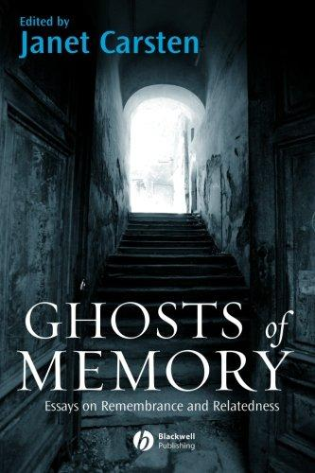
In this essay the writer looks in detail at a village in South Poland. The people in the village she studies tell her how they remember how poor everybody was in the 1950s, even the higher status people. One woman tells a story of when a salesman came around in the 1950s. She was a little girl and she very much wanted a doll he had for sale. He was willing to exchange it for one egg, but her mother would not give her an egg because her mother was too frightened of her mother-in-law and the row she would receive. The author thinks that the bitterness of the memory recalled years later is tied up with very many complex feelings. The woman and her mother had moved from the mother’s family house in the village where she had been happy, to the father’s house where the mother lived with cruel higher status in laws. The object had taken on very strong associations for her and this was very common in this society. https://www.abebooks.com/9781405154239/Ghosts-Memory-Essays-Remembrance-Relatedness-
In my own life I can think of similar feelings of bitterness and sadness that my grandmother had because of her hard life at the time. My grandmother told me of how she had to do what her mother told her to do and to be respectful of the rules of family life. The family and the village protected against the outside world, but still it was full of harsh rules that were necessary for survival in a peasant society. But in this life people couldn’t carry out career ambitions or artistic ambitions. In the essay on Southern Poland the writer shows how the way people were able to escape from these harsh structures was to move to places like America or Canada.

(MARINA ABRAMOVICH (DIGNITY)

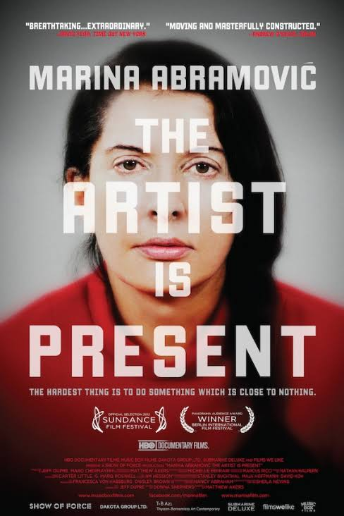
Back in the past during the war it was even worse if you didn’t have the right documents or were in the wrong place you had to work, or you could end up dead or badly beaten like my Grandmother’s sister who was beaten by the Germans and badly injured. So, for many years there was a harsh peasant life in Poland that was in some ways even worse than the life shown in the potato eaters and even today in many places in Poland this harshness continues.
My artwork thus uses the memories of my grandmother and my own memories so that they are layered together. The use of memory and dealing with the pain of memory is the focus of Marina Abramovich’s work. Because I am an exile now I have to create memories outside my community as, so many people do today who do not live in the villages or the towns or where they were born
https://www.youtube.com/watch?v=R4lp4w8lNYs.

“The commandment of the hour is thus ‘Thou shalt remember.’ It is the self that remembers, and what it remembers is itself, hence the historical transformation of memory has led to a preoccupation with individual psychology. The two phenomena are closely related – so closely that one can hardly refrain from pointing out that they coincide exactly in time. At the end of the last century, when rural society collapsed, and age-old social equilibria were disrupted, memory became a central issue in philosophical thinking with Bergson, in psychological thinking with Freud, and in autobiographical literature with Proust. The disintegration of the traditional French image of memory as rooted in the soil and the sudden emergence of memory as something central to individual society were like two sides of a single coin, as well as the beginning of a process that has today reached an explosive stage. We owe to Freud and Proust those two intimate yet universal aide de memoire, the primal scene and the celebrated petite madeleine. This transformation of memory marks a decisive shift from the historical to the psychological, from the social to the individual, from the concrete message to its subjective representation, from repetition to remembrance. Memory becomes a private affair. Because of this psychologizing, the self now stands in a new relation to the memory and the past (Nora P p64 Realms of Memory 1984 Memory Documents of Contemporary Art edited Farr I 2012)

Much of Marina Abramovich’s work deals with how to make ephemeral memories solid. How to make thoughts and the past still present.
“The Clay mirrors have the imprint of a face pressed into each surface. Here physical contact is taken into the structure of the objects themselves. Abramovic wanted the traces of people’s bodies to be visible in the Dragon pieces where they had worn away the patina. The clay mirrors show a single action in time, like Yves Klein’s body imprints. They are metaphors for a state of mind, halfway towards transformation. They have a ghostly appearance, almost like death masks and, like Klein, they respect only the center part of the body, the essence: in this case the face. The clay mirrors become residues of an ephemeral action.” (Iles p218 Cleaning the mirror in Marina Abramovic: Objects, Performance, Video, Sound Oxford Museum of Modern Art 1995 32-40, collected in Objects Documents of contemporary art edited Hudek, A 2014)

Abramovich’s work deals not only with personal memories, it also deals with the trauma of remembering in communist countries. In the former communist countries, the state itself gets between the citizen and the act of remembering. The Czech writer Millan Kundera in his book, the book of laughter and forgetting talks of how the communist leader Clement Grunwald was erased from pictures in the 1950s, but the people who erased him left his hat in the picture. The hat is both funny and sinister a reminder that people have the power to remove memories and at the same time leave a trace to let you know that they have done so.
For example, in Rhythm 10 Marina Abramovich ( 1973 )has a piece of work in which she played the knife game Abramović used a selection of knives and two tape recorders, she aimed the knife jabs between her spread fingers., and recorded it. When she had hurt herself twenty times, she played the tape back, and listened to it, and tried to repeat it. Using the tape, she was merging past and present. The political metaphors are strong with this work and relevant to my work. Using the tape recorder, the pain of past actions is carried forward into the future.” All my work now is about time. And it`s about the fact that actually by being in the present you time-you don’t think about the past or future, you`re just there, with everything turned into that idea of here and now. This is how to see Polish society after Communism. “(Abramowich Stiles 2008
Rhythm 5 is another piece of work that visualizes this struggle between the past and the present. In this performance Abramovich attempted to burn clippings from her body in a flaming Russian star she then jumped into the center of it, but became overcome with the lack of oxygen and had to be rescues. A perfect visual metaphor for the effects of communism on the individual.
Abramovich was brought up by enthusiastic communist parents in post-world war 2 Yugoslavia and was born into the new postwar communist system so she was both rejecting her political and personal background through these symbolic 1970s performances. Her parents were national heroes, but her home life was full of physical and psychological abuse. My work becomes a residue of my grandmother’s life, much like some of Marina Abramovic’s work dealt with her family life. In rhythm 10 the pain of the process is summed up in the work, the physical act of the knife game deals with the pain of her parents being part of the system, so that the work looks at social control. My work similarly looks at the social context because the pain is not just personal it is contained within the political framework.
Left Poland because I wanted to reject the pain and sense that nothing can change within the Political system. In Poland the idea was created amongst many people that it didn’t matter where you went or what you did the political system would be the same everywhere and the lack of opportunities would be the same. In the past there was no voice because of the Communist control of Poland, but then after the end of Communism the Polish worker still has no voice within Poland or outside of Poland because they are treated as cheap immigrant labor. For example, it does not matter how long you have lived here in the UK as a Pole I still won’t have a vote.
We can see in her work the hold the present has over the past, but in the former communist countries this not only operates on a personal and familial level but on the level of the entire nation. Under Communism you had a system of stasis things were stultifying, but people had equality and equal access even to consumer goods such as cars refrigerators and stereos, but the past was not talked about or was difficult to talk about, now there is no equality and the past is still difficult to talk about. The Polish people live in a haunted present. As William Faulkner wrote, “The past is never dead. It’s not even past” (Faulkner, W Requiem for a Nun)

(POTATO EATER) (DIGNITY)
What you select and what you decide to keep represents your personal visual metaphor of the past “a memory theatre” (Arasse 2006, p.226 memory). So, for me the potato is an object which takes on a personal significance. It has a symbolic role which connects the past and present. In his book on Anselm Kiefer, Daniel Arasse writes “The Nazi bathtub, inherited from his grandmother, became a personal souvenir, and part of the process of constructing a memory of Nazism and its practices “(Arasse 2006, p226 Memory) For Van Gogh the potato is not symbolic. It is just a fact of life, it is not an object of memory. I connect memory in the Van Gogh painting to the woman on the far side of the painting who is being offered the potato and looks lost in thought. Van Gogh is at this stage a realist painter who wants to simply show the condition of the poor and offer sympathy by realistic painting and drawing of their condition. “Whether in figures or in landscapes, I would like to express not something sentimentally melancholic but deep sorrow” (Van Gogh, letter 249 Complete letters of Vincent Van Gogh (Thames and Hudson 1958) “I have tried to emphasize that these people, eating their potatoes in the lamplight, have dug the earth with these very hands they put in the dish and so it speaks of manual labor, and how they have honestly earned their food.”(Van Gogh in Vincent by Himself by Bruce Bernard p65)
I mean two things by the words “can’t keep.” In the title of this essay. Firstly, I can’t keep hold of memories because everybody forgets, it’s only human. Secondly, I mean that I can’t keep to myself important memories which have been told to me. Because I think these memories should be shared and allowed to be shared with other people. In the past in Poland the Communist system did not allow this. My memories from childhood of places and objects in them have two sides. For example, the cellar saved people’s lives in the war because they could hide there, but the cellar for me was also a dark frightening place. As a young child I was sent to get the potatoes from the cellar as a punishment, because if I didn’t get them I wouldn’t have anything to eat. Every sound and movement seemed terrifying to me. I also felt guilty because if I didn’t bring the potatoes somebody else would have to do it, because my old grandmother would do it instead. But achieving this task made me feel much stronger not physically, but mentally.
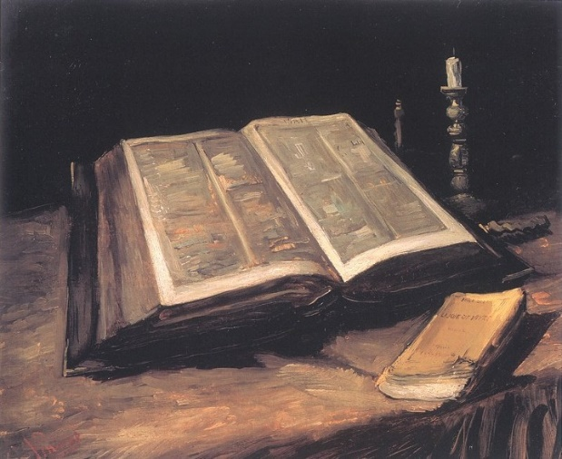
The Van Gogh painting is often interpreted as a painting of togetherness, but it can also be interpreted as an example of false comfort. The peasants can be seen as too resigned to their fate except for the embittered woman. Like Nietzsche one can feel that it is better for the spirit to be challenged and frightened in the cellar than to be happy with just avoiding starvation and grateful for what little you have. Another example of a tension in Van Gogh’s painting at this time is his picture entitled “The Bible” A painting in which the words of the bible are unclear and yet the title of a book by the French novelist Emile Zola is very clear. Van Gogh was a very well-read man and wrote approvingly of the works of Zola a famous atheistic socialist writer who wrote detailed and accurate novels of the life of the poor. There is a tension and ambiguity in this painting suggesting that Christian resignation is not enough in the face of poverty, a revolt against the miserable conditions of life. http://www.vggallery.com/painting/f_0117.jpg
I have tried to make my work truthful to my grandmother’s experience of poverty and to honor her memory. But memories of the past are complex because you cannot untangle people from the frightening circumstances of their lives. But, after you visit scary places they can be dealt with. Whether the places are real physical places or emotional places present in one’s mind. For example, there are now therapies where soldiers with Post Traumatic Stress Disorder have been given virtual reality goggles to wear and are taken back to where they were traumatized. Similarly, in a mental landscape “In that sense, how we remember is crucial not only for the sake of those who have perished, but for own sake as well. In memories, too begin responsibilities.” (Hoffmann E 1998, p378 Shtetl, Memory an Anthology edited by Harriet Harvey Wood and Byatt A S) Through revisiting the lives of my relatives through art I can carry out an act of remembering that is more honest and truthful than that which was presented to me by my family. Imagining the truth through art can be more truthful than getting a partial truth through a family full of guilt and lies. I identify with the Van Gogh painting because of his attempt to sincerely show the truth as he saw it and I respect Nietzsche’s ideas of remembering and forgetting in the right way.
For Van Gogh the potato is not symbolic and just a fact of life any symbolism it contains is indirect a part of the larger picture of the peasantry it is not an object of memory. Surely for him the idea of struggling to maintain dignity in the face of suffering is the most important thing in his painting of the potato eaters. For Van Gogh he tries to lighten the center of the painting, so it is the opposite of darkness and suffering. The people closer to the light still feel human. Even in the cellar you can still have the happiness of life. It is like sitting in a cellar waiting for the hope that never comes.
My words can’t keep all my memories from childhood, so belongings help me to remember places and these objects have two sides to them for example the cellar saved people’s lives in the war because they could hide there, but the cellar is also a dark frightening place. As a young child I was sent to get the potatoes from the cellar, because if I didn’t get them I wouldn’t have anything to eat so every sound and movement was frightening.
The idea of the underground and of being trapped is an idea that is very powerful for me. In the war Jewish children were hidden behind the photos in the cellar so the place was frightening but it was a place of refuge.

GORECKI DIGNITY
3.” Lento- Cantabile simplices
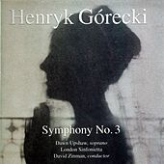
Sing for him,
Little song-birds of God,
For his mother
Cannot find him.
And God’s Little flowers,
May you bloom all around?
So that my son
May sleep happily”

(Symphony of Sorrowful Songs (1979?) Henryk Gorecki

(SECTION 4) GORECKI

Gorecksi invests her simple words "Mother, please do not cry. Queen of Heaven, virgin most pure, protect me always" with a simple dignity that is deeply affecting and maintains this mood in the third movement, the lament of a mother over her dead son; Górecki estimates that the text dates from the First World War, and the melody is from his native Opole region. The music is suffused with a sort of abstract folk feeling, like a religious experience that achieves its intensity through the simplicity of its musical means. In this it is a direct descendant of Szymanowski's Stabat Mater, inspired by similar material, and where the composer likewise conceals the complexity of his art to produce music that is very directly affecting. The Polish title of the work contains an archaism that neither English, French nor German manages to translate, but which suggests verbally the timelessness that the music evokes.
In movement three of the Gorecski Symphony of Sorrowful Songs. The cellar feels like a dungeon, people entrapped there have lost everything. People in those circumstances have lost everything. Once you are in the cellar all you have are memories and spirituality. In his work Gorescki creates a beautiful piece of music which brings back the memory of the person suffering. He tries to reflect the emotion of the person who is in prison without light or hope.
The recording of 1993 was the only popular success for the composer and the music seemed to reach out to people and address in a way people could understand about suffering. 1993 was a year after the fall of Communism and tied in with the belief that people should have human rights, that past sufferings should be addressed. For many countries the 1990s was a time in which the past could be talked about in a new way and people could look back in places such as former Communist countries, South Africa and Ireland.
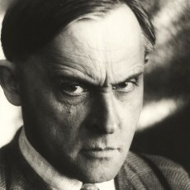
The idea of a grave and being a place of death and a place of memory is important to me. The graveyard as a public space for remembering does not appeal to me as it is something not done for personal reasons the story of the grave of Stanislaw Ignacy Witkiewicz is a good example of the absurdity of public mourning. He was a famous Polish artist and writer who committed suicide when the war broke out. Years later when the Polish Ministry of Culture and art opened the grave tests showed that it wasn’t even his body, but that of a young woman. During the war my grandmother had to hide in a graveyard for days, so for her it was both a place of death, but also a place of life much like the cellar.

http://culture.pl/ru/artist/stanislav-ignaciy-vitkevich-vitkaciy

(CONCLUSION)

My work by exploring memories draws on the idea of dignity that my grandmother showed in the face of the personal and political suffering that affected her and her family in Poland in the war, in the Post war and in Poland after the end of communism. In their political lives people would respond with irony and jokes such as in the film Mis.
I feel that most the artists I have looked at have all been influenced by the idea of dignity in the face of terrible suffering. They have looked at how people try to maintain dignity in the past and in their work, such as in the examples of Gorecki and Wajda we can see how these works are acts of memory which tell people to remember and not forget the people who did not have any choice but to survive and to rely on each other when the world had turned against them.

Van Gogh tried to show people a better world, he kept his dignity through his work because although his work was ignored by buyers and he suffered poverty and mental ill health. After he died he was taken more seriously, so he is still with us. Although in his life he was a failure by maintaining his belief and his dignity through his work he had something to show us and he gave us something to believe in. In a way he becomes a believer very much in Niestchean ideas.
Another idea which I have looked at and is very present in the work of Marina Abramovich is the construction of memory in the face of loss and pain which is linked to Nietzsche’s idea of what to remember and what to forget. In her rhythm work she deals with this issue in a performance context.

The images of the suitcase, the potato, the cellar and the graveyard all relate to memories, families, and people let down by the politics and politicians of Europe.

I think that in my actions that were influenced by my grandmother in leaving Poland and becoming a migrant to the UK I have been influenced about her ideas and by the good ideas of Nietzsche where although she had no chance to change the circumstances of her life I have had through listening to her been able to see that things are not the same everywhere and I have been able to create artwork that is influenced by her and creates good memories about her. I hope my grandmother memories in my suitcase never die.

“I believe there’s life in it." Vincent Van Gogh.

References
- Anderson, M. (1993). CD review Symphony of Sorrowful Songs. Available: http://www.classical.net/music/recs/reviews/o/oly00313a.php. Last accessed 2017.
- Birkholc, R. (2071). Teddy Bear. Available: http://culture.pl/en/work/teddy-bear-stanislaw-bareja. Last accessed 2017.
- http://culture.pl/en/work/teddy-bear-stanislaw-bareja
- Carsten, J., 2007. Ghosts of Memory. Oxford Wiley/Blackwell
- Eagle, H. (1997). Political Films of Andrejz Wajda. Slavic Review. 56 (1),
- Gorecki Henryk Darkness and Light : Spiritual Awakening and its Socio-Political context .
- Symphony of Sorrowful Songs (1979?) Henryk Gorecki
- http://etd.fcla.edu/UF/UFE0012122/cary_c.pdf

- Hoffmann, E. (1998). Shtetl. In: Harvey Wood, H and Byatt, A S. Memory:an anthology. London: Chato and Windus.
- Kiefer Anselm ARASSE, D (2001), trans WHITTALL M, (2006) ed HARVEY WOOD, H and BYATT A S Memory An Anthology (2008) 226-229
- Man, of Marble, 1977. (DVD) Wajda, Andrezj, Poland: Second Run.
- Man of Marble Wajda, Andrzej . (1977).. Available: >http://www.secondrundvd.com/release_marble.php. Last accessed 2017.
- Man, of Iron, 1981, Wajda Andrezj, Poland, Film Polski
- Man of Iron . (1981). Wajda Andrzej . Available:
- http://www.imdb.com/title/tt0082222/. Last accessed 2017.
- Nietzsche, F 1874, the Uses and Disadvantages of History for Life, Untimely Meditation
- Nietzsche, F (1887). On the Genealogy of Morality. Leipzig: Verilog Von C G Neumann. Essay 2, aphorism 1.
- Pine, F (2004) ', Memories of Movement and the Stillness of Place: Kinship Memory in the Polish Highlands ', in Carsten, J (ed.) Ghosts of Memory. Oxford. Blackwell,
- Service,T. (2010). There was more to Gorecki than the Symphony of Sorrowful Songs. Available: guardian://www.theguardian.com/music/tomserviceblog/2010/nov/12/gorecki-symphony-sorrowful-songs . Last accessed 2017.
- Stiles, K., 2017. Marina Abramović. Phaidon.p13
- Van Gogh, Vincent 1885, the Potato Eaters
- http://vincentinparis.com/item/the-potato-eaters-april-study/

- Van Gogh Vincent (1958). The complete letters of Vincent van Gogh. London: Thames and Hudson. p425.
- Van Vincent Gogh (1958). Thames and Hudson. Complete letters of Vincent van Gogh, London: London. p249.

