BSc (Hons) Computer Portfolio

Computer Forensics

ACCB5000

Synthesize a Solution to a Potential Real-Life Scenario

Julie Millard P150865

Lecturer: Dr Carlene Campbell

Contents
Table of Figures 3
Abstract 4
Task One 4
1.0 Introduction 4
1.1 Chain of Custody 4
1.2 Evidence Seizure 5
2.0 Tools and Procedures 5
2.1 Data Acquisition 5
2.1.1 Live Data 5
2.1.2 Disk Imaging Tools 5
2.1.3 Hashing 6
2.1.4 File Carving 6
2.1.5 Password Decryption Tool 6
2.1.6 Forensic Tools and Management Suites 7
• Forensic Toolkit (FTK) v 7.0.0 7
• CAINE 10.0 “INFINITY” 7
• Sans Investigative Forensic Toolkit (Sift). 7
• Belkasoft Evidence Centre 7
• Acronis Disk Director 12.5 7
• Atola Insight Forensic 7
• EaseUs 7
• Autopsy/Sleuthkit 7
• EnCase V 8.07 8
• Blade V 1.13 8
• MailXaminer 8
• Write-Blocker 8
• Faraday Equipment 8
Conclusion 8
Task Two: Case Study 9
Assumptions 9
1.0 Introduction: Terrorist Attack at Heathrow Airport. 9
1.1 Incident Handler Vs Forensic Investigator 9
2.0 Methodology 9
Conclusion 11
Reference 13
Appendix 1: FTK Report 18

Table of Figures

Figure 1:Sample Chain of Custody Form Front [16] 4
Figure 2:Sample Chain of Custody Form Back [16] 5
Figure 3: File Allocation Table [37] 6
Figure 4: Price for SafeBlock for Windows[55] 8
Figure 5: Write-Blocker Hardware [56] 8
Figure 6: Cannon PowerShot G7 X Mark II [56] 9

Abstract
This report will look at different tools used by forensic examiners in the retrieval of evidence from digital equipment. Task One outlines computer forensics and the process of recovering and documenting digital evidence. Explores software and hardware available to recover pertinent information and how evidence should be handled, transported and stored. Task Two reviews the case of a terrorist who was shot at Heathrow International Airport. The digital evidence is inspected and analyzed. A report is generated, and John’s professional opinion is stated. The information is then presented to Mr Mark Wales along with an invoice.

Task One

1.0 Introduction
Computer forensics is becoming more significant in today’s prosecution against criminals [1], as more criminals are incorporating technology into their criminal activities [2]. Whether the crimes involve theft [3], child pornography [4], terrorism [5]–[8] or even murder [9], the science of computer forensics and computer forensic investigators are using technology and science to acquire, inspect, process and preserve information that has been stored on a digital source such as a desktop computer, laptop, network, tablet or even smart phone. Furthermore, the forensic investigator must be able to present this evidence in a court of law, illustrate the authenticity and reliability of the evidence by methods that demonstrate the evidence has not been altered [10]–[12]. A forensic investigator will work on a forensic copy of the evidence so as not to contaminate the evidence. A chain of custody form accompanies the evidence.

1.1 Chain of Custody
A chain of custody form (CCF) is used from the moment evidence is seized and stays with the evidence from this point onwards [3], [13]. It records the case number, offence, how, when, where and by whom the evidence was collected, it describes the state, physical condition and mode (on, off, sleep, hibernation or hybrid sleep [14]) of the evidence, what was done with the evidence after it was seized, how and where it was stored. It will be required as proof of evidence integrity in a court of law [3]. Sleep mode allows the computer to quickly start back up where you left off. Hibernation is primarily used on laptops and it saves your open work to the hard drive and then turns off the power. Hybrid sleep is generally used on desktops it is a combination of both sleep and hibernation, saving open files to disk and allows the computer to resume quickly. They are all power-saving modes [14], [15].
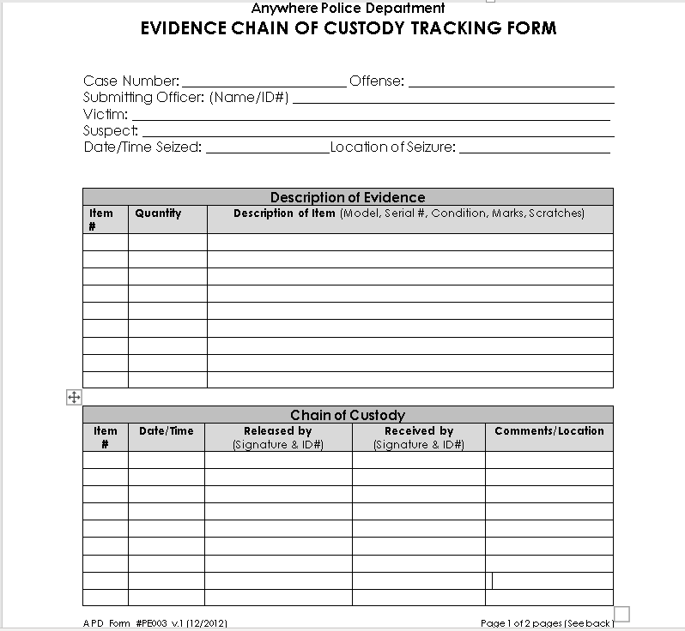
Figure 1:Sample Chain of Custody Form Front [16]
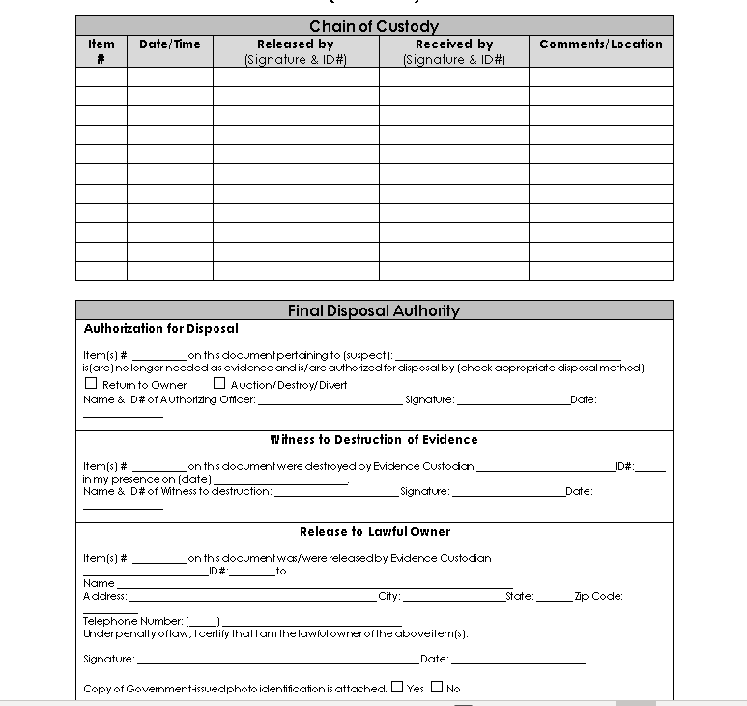
Figure 2:Sample Chain of Custody Form Back [16]

1.2 Evidence Seizure
Evidence to be seized from an alleged offender is usually carried out by Law Enforcement Agencies. This is to ensure the evidence is not tampered with, misused or destroyed, and has been collected in a lawful manor according to the Law of the Land [17]. The evidence can then be given to a Forensic Laboratory where a forensic investigator or an incident handler will examine the data. A forensic investigator has the power to present evidence in a court of law, whereas an incident handler does not. Laboratories are accredited by the United Kingdom Accreditation Service (UKAS) [18]. There are still non-accredited labs in the United Kingdom (UK) and in their reports they must disclose this fact which could potentially make their reports less credible in a Court of Law. As of October 2017, International Organization for Standardization [19] 17025 (ISO17025) was made mandatory for forensic laboratories by The UK Forensic Science Regulator Dr Gillian Tully Phd, MCSFS [20].
There are other instances where court proceedings are not necessarily the outcome such as carrying out internal checks in a company to verify misconduct, or even corroboration in disciplinary action [21]. In such cases it is still imperative the Law is not broken. Permission from the owner of the device must be given, and this should be documented before any investigation is carried out.

2.0 Tools and Procedures
There are different ways to recover the evidence and many different tools that are available to use. There are step-by-step procedures that should be followed and adhered to [22]. The modus operandi does not alter, whereas the techniques and tools differ from case to case. Tools, both hardware and software are continually being upgraded and updated.

2.1 Data Acquisition
A critical component of forensic evidence is data acquisition. Data can be retrieved from digital electronic devices where the hard drives have been corrupted, erased, have been attacked by a virus or even physically broken [23]. This can be achieved by using forensic recovery tools such as Atola Insight Forensic[23].

2.1.1 Live Data
There are two forms of data collection. Live data, and dead data. Live data is collected from volatile memory such as random-access memory (RAM), cached registry hives, Dynamic-link library (DLLs), network connections and open network sockets. This needs to be carried out as soon as possible, before the machine either runs out of battery or is switched off [12].

2.1.2 Disk Imaging Tools
Dead data can be collected using disk imaging which is replicating the contents of a hard drive, optical drive, universal serial bus (USB) flash drive, or any other device that stores digital data. It replicates the structure as well as the data [22],[24],[25]. The use of disk imaging tools in computer forensics allows for a bit-by-bit copy of the hard drive. This is also known as a sector -by-sector copy [10], [25], [26] It includes sectors that have no data, corrupted data, deleted files, slack space, hidden and residual data [10], [17], [24], [27]. A sterile computer or storage unit is used to receive the replicated image. A hash function (2.1.2) may be used to verify the size of the file both before and after the copy [28], [29]. There are numerous disk imaging tools available, many of which are free, and others which can be bought and cost differing amounts depending on the tool. Forensic Tool Kit (FTK) offer a free disk imaging tool called FTK Imager Lite. Encase Forensic Imager is also offered for free, as is Open Source Forensics (OS Forensics).

2.1.3 Hashing
Hashing is a mathematical operation (an algorithm) that is applied to data to produce a unique sum. It is called a checksum and it is used the same way as a fingerprint. It ensures the integrity of the data [30]. Any alteration to the data will produce a different outcome. Even if the data is altered, and then changed back, a different checksum will be produced. For that reason, hashing is utilized. The process is usually used at the beginning of the forensic investigation of data to get a baseline checksum. It is them usually used the middle of the investigation – to ensure the copy of the evidence is unaltered and again at the end of the investigation to prove the data has not been tampered with. There are different algorithms that can be used. The more complicated algorithms used are Message Digest 5 (MD 5) and Secure Hash Algorithms (SHA-1) [30] are the industry standards at this time [31]. Checksum Utility 2.1 is a free tool for checking MD5 and SHA-1 and SHA-256 [32]. HashMyFiles is another free tool using algorithms. This tool also used MD5, SHA-1, 256, 384 AND 512. It is a bit more sophisticated and delivers other information such as when it was created, modified , versions and size [33].

2.1.4 File Carving
File carving or data carving is another forensic procedure for finding and retrieving data. This method looks at the fragments of data stored on a disk [34]. It looks at how the files were constructed and the subject content. It then scans through the unallocated space on the drive, uses ‘metadata’ (metadata describes other data) [35] to find and reconstructs the files [36]. Microsoft Windows use two types of files systems New Technology File System (NTFS) which looks after many different types of files, and file allocation table (FAT) which uses numbers to locate data stored in cluster addresses [37].
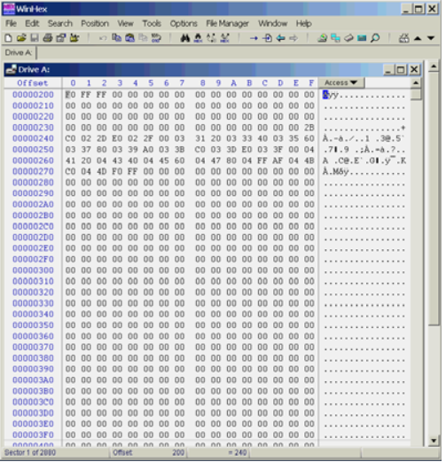
Figure 3: File Allocation Table [37]

2.1.5 Password Decryption Tool
As computer forensics are used to expose criminal intent, it would make sense that criminals would use passwords to protect the damaging information. Computer forensics therefore need to be able to decrypt passwords. The use of a password cracking tool such as RainbowCrack [38], which uses a predefined set of tables to decrypt the password, or Cain and Able, which is specifically for Microsoft Operating Systems [39] and uses a dictionary attack to find the passwords.

2.1.6 Forensic Tools and Management Suites

Forensic Toolkit (FTK) v 7.0.0
FTK is a suite of tools which includes FTK Imager Lite [40]. It has a file decryption feature, email analysis, data visualization, data carving, web viewer, a malware detection feature called Cerberus, and an optical character recognition engine [2], [26], [41]–[43]. It also generates a report. Starting price for one year with full support approximately $2,227 an exact price requires you request a quotation.

CAINE 10.0 “INFINITY”
The latest CAINE (Computer Aided Investigative Environment) version is 10.0. It is a Linux based management suite and amongst other tools it includes FTKImager Lite, Autopsy 4.9.1., Hex editor, JPEG View, NTFS Journal Viewer, PhotoRec, QuickHash, and USB WriteProtector which puts CAINE in read only mode and must be unlocked to write to disk. This software is free [44].

Sans Investigative Forensic Toolkit (Sift).
Sans Sift v 3.0 is a free workstation of tools which contains amongst other tools: The Sleuth Kit/Autopsy, ssdeep and md5deep, Wireshark, Vinetto, Foremost/Scalpel and Volatility. It uses Expert Witness format (E01) as well as RAW (dd) evidence formats and Advanced Forensic Format (AFF), while Volatility allows a system logs time-line [45].

Belkasoft Evidence Centre
Belkasoft Evidence Centre V 8.0 is a dongle-based or portable license. Individual models start at $299 for Office Document Analysis and SQLLite Viewer with a renewal price of $89 for 1-year. The initial cost for the Evidence Centre is $1,999 and is $599 for a 1-year renewal. Contact them for an individual quote [46].

Acronis Disk Director 12.5
This is a disk management suite that is solely used on Windows and can be used for any version of Windows from XP to Windows 10. It costs $49.99 for a single PC license and $79.99 for 3 PC licenses. There is also a workstation license available for $79.99 which allows support for a year and offers free upgrades. There is a free demo version available that has limited capabilities [47].

Atola Insight Forensic
Insight Forensic is a piece of hardware with software that may be used on any Windows version. It can acquire data from damaged hard disk drives [23] . Its hash calculations are: MD5, SHA1, SHA224, SHA256, SHA384, SHA512. It has a built- in write-blocker, can extract unknown passwords and weighs 20 lbs. It is not free. Contact Disk Drive Solutions for a quote.

EaseUs
There is a free addition of EaseUs 12.9 which allows recovery of up to 2 Gigabit (GB) of data. There is also a Partition Master Pro, which costs $39.95, a Todo Backup Workstation at $39.00 and a Data Recovery Professional which is regularly priced at $89.95 and was on sale for $69.95 [48].

Autopsy/Sleuthkit
Autopsy 4.10.0 can be used on Windows and Linux operating systems. Supports both 64 - and 32-bit downloads. It is part of a Management Suite called Sleuth Kit. It is an analyzing tool for hard drives and cell phones. Both Autopsy and the Sleuth Kit are free, are included in other software suites such as Sans Sift.

EnCase V 8.07
Encase is widely used by computer forensics [49] and have updated their software so that Bitlocker XTS-AES for Windows 10 now has up-to-date encryption capability, Dell Data Protection 8.17 and Symantec Pretty Good Privacy (PGP) v10.3. It is able to collect data from Apple File Systems (APFS) used on MAC operating System. The use of Volume Shadow Copies by examining the backups of Volume Shadow Snapshot (VSS). This is generated by Windows, a Microsoft product, and allows recovery of modified or deleted files [50]. EnCase costs $2,995.00 for v 8.06 [49].

Blade V 1.13
Blade forensic software is built on a module system which allows for expansion when new units become accessible. It uses Intelli-Carve for data recovery of JPEG and MPEG [51]. Some versions of Blade are free such as v1.13, Blade Professional v1.x can be purchased for £365.00 [52].

MailXaminer
MailXaminer 4.7 for Windows [53] can be downloaded for a trial period of 30 days for free, the price of purchase after the 30 days is $1600.00. MailXaminer 4.8.7 is able to inspect over 20 different email formats [54]. Contact Systools for a quote.

Write-Blocker
Write-blockers can be both hardware and software. They work by denying the ability to use the write command. This allows for a copy of a disk to be created without the ability to alter the image. Therefore, keeping the integrity of the evidence. SafeBlock is used for Windows operating systems and start at $129.00 [55] as shown in Fig 4.
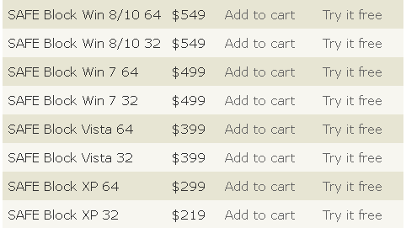
Figure 4: Price for SafeBlock for Windows[55]
The Tableau Forensic Serial attached SCSI (SAS) Bridge shown in Fig 5 below, is a write-blocker. It costs $579.00 [56].
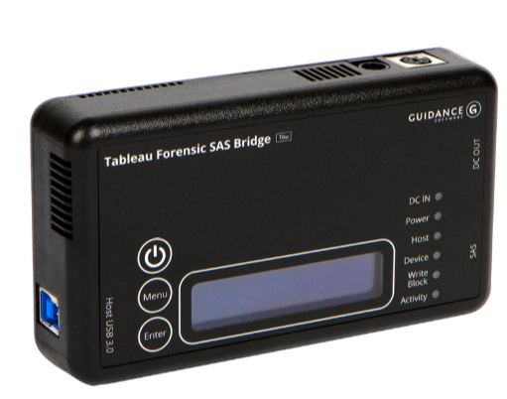
Figure 5: Write-Blocker Hardware [56]

Faraday Equipment
Faraday equipment is made protect against electromagnetic fields. Investigators use Faraday items such as gloves, bags, boxes and cages to protect against, amongst other things, anyone trying to destroy the evidence remotely. After the evidence has been identified, it should be placed in a Faraday container.

Conclusion
There are numerous steps involved in retrieving forensically sound data from digital equipment (2.0), countless tools available to create a disk image (2.1.2) and other various tools available to forensically prove the image has not been altered (2.1.3). Many programs used to carry out a digital forensic investigation can be acquired for free. They are used in conjunction with each other. Other equipment used, can be purchased. The use of forensic suites such as FTK, CAINE and SANS Sift, which have amalgamated different tools to streamline the procedure to obtain data, also keep the image unaltered. They are able to scientifically verify the authenticity. This process has made it easier, and faster to retrieve relevant data. Part of a forensic investigator’s and Incident Handler’s job is to keep abreast of new forensic tools and techniques to be able to deliver the best and most comprehensive evidence to their clients.

Task Two: Case Study

Assumptions
It is assumed that all documents and equipment (evidence) were recovered in accordance with the law and had all the relevant paperwork required to allow the investigation of said evidence to be carried out by an independent Investigation Service. It is also assumed that Mr Mark Wales can understand an FTK Report and does not expect John to appear in a court of law as an Expert Witness.

1.0 Introduction: Terrorist Attack at Heathrow Airport.
A known terrorist was apprehended at Heathrow International Airport. While trying to escape the police shot and killed him. Mr Mark Wales, Chief Investigator for the Police Department at Heathrow contacted a professional investigator service and employed them to investigate items found in a briefcase belonging to the terrorist. A detective named John took on the case.

1.1 Incident Handler Vs Forensic Investigator
It is important to note the difference between and incident handler and a forensic investigator. An incident handler will take control of the evidence in a documented manner, extract data and log all actions, analyze the data and prepare a report. They will not be called to court to give expert evidence. A forensic investigator will analyze the data and testify in a court of law giving expert testimony. John is an incident handler.

2.0 Methodology
John was given a laptop bag, a Dell Laptop, crime scene photographs and the terrorist’s fingerprints. He ascertained the evidence had not been altered at the scene. (Had the laptop been switched on/off.)
John analyzed the evidence, placed the photographs and fingerprints into evidence bags, tagged and sealed them. He then added his name to the chain of evidence forms that accompanied the items. When John received the laptop, he noticed the operating system showing on the screen was Microsoft Windows XP Professional Service Pack 2. He noted this in his log book. As the computer was still switched on, in stand-by mode, (this is when the laptop is switched on but after it has been idle for a while, goes into an energy saving mode. It wakes back up quickly when the mouse or space bar is activated (1.1), John knew he had to work on the laptop before taking it to his forensic laboratory. Below are the initial steps taken by John when he received the laptop.
- Took notes on the condition of the laptop. (What mode it was in?)
- Photographed the laptop from all angles, including the screen. John used a Cannon PowerShot G7 X Mark II High Performance Compact Digital Camera for this.

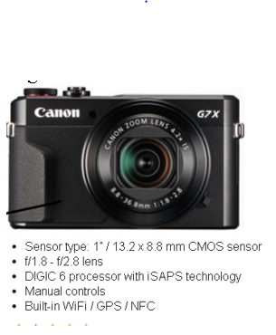
Figure 6: Cannon PowerShot G7 X Mark II [56]
- Checked to see if there were any other devices connected to the laptop.
- Made notes and sketches of the laptop.
- Inserted a write-blocker into the laptop to ensure the data would not be accidentally altered. John was wearing Faraday gloves (2.1.6) to protect the laptop.
- Sealed all ports with tape and labeled the evidence.
- John decided there may be evidence lost if the laptop were to lose power or be turned off, so he used the San Sift suite, in particular, the Volatility software to retrieve any live data. Made two copies, gave one to the authorities and kept one to work on in the laboratories (2.1.1).
- Created chain of custody forms for the evidence collected.
- Placed the laptop in a Faraday container.
- Noted all the steps taken in his log book.
- Transported the evidence to his forensic laboratory.
ISO17025 is the Code of Practice and Conduct for Digital Forensic Services [57]. In the Code of Conduct, it states that photographs should be taken of the item and the surrounding area before anything is moved. Shots of all sides of the item should be taken, including shots of the screen to record what was visible. All items are to be labeled. Any ports should be sealed with tape. Notes and sketches should be made to accompany the photographs [57]. A write blocker should be used to ensure the data cannot be altered. The item should not be powered off to ensure there is no loss of volatile data. (Volatile data is memory in a computer that requires power to maintain the data. Usually stored in random access memory (RAM) cache and registry) This volatile data should be collected in real time.
Mr Wales gave John a list of files to retrieve. John analysed the list, and along with the operating system being Windows based, determined the best way to achieve this was to use the FTK Suite. Below are the steps John took to retrieve the data.
- Used FTK to create a Physical Drive Image.
- Compared the hash value of the original against the image created using FTK check
- John used FTK to remove good data from the evidence. These are things like the operating system and programs which are used by Microsoft. These programs were measured using the hash calculator and then compared to a file hash list the National Software Reference Library (NSRL) has compiled to confirm a match [58].
- The use of Volatility gave John a time stamp to aid with timelines.
- John found Excel sheets that were password connected. A password cracker was used to open the file and reveal the contents.
- John analyzed the videos, looked at the metadata for timestamps, information on how the video was taken and what instrument was used to take the videos. John also noted the timing of important parts of the videos. All names and identifying information were also noted. John wrote a comprehensive document outlining his findings and how they related to terrorist activities.
- Documents on ‘Suicide Bombings’ and ‘How to Make a Chemical Bomb’ were found. These was documented. They would be used to build an overall image of the evidence.
- John used key word searches to follow-up on the names found in the videos.
- There was an Excel sheet that was password protected. The FTK password cracker was used to find the password file and reveal the contents, Bank account details and names.
- A word document was also password protected. This was also cracked with FTK Password Cracker. It contained a list of names. This was used to cross reference known associates.
- A text file with time and date of meeting was also found. This was assessed as highly important as the date meeting was to take place in a few days. This was passed to Mr Walsh immediately.
- MailXaminer was used to search through emails. All information was analysed and cross referenced with know terrorists and with names on the excel sheet and the contact sheet.
- FTK Social Analyser was used to further group the email to give a visual map of where and from whom the emails originated.
- FTK showed a list of files that were suspicious due to the fact they were hidden. For example, a picture of a blue rose saved as a music file, a text file saved as a picture. John used the ‘Append Appropriate Extension to filename if Bad/Absent [54]’ to correct the extension and analyze the file.

Conclusion
John, acting as an incident handler, generated a report from FTK and added the information gained from using Volatility and MailXaminer. The Visas that were found, along with all the evidence pointing to the suspect indeed being associated with terrorist groups were documented and outlined. John also considered looking for other reasons the suspect was researching information regarding suicide bombing, Jihadism, or ways to spread terror. After looking at the evidence and analyzing everything that was found, John could only summarize the suspect intended carrying out a terrorist attack at either Heathrow International Airport, Mason International Airport Fiji or both airports. This information was passed along to Mr Mark Wales along with an invoice for work completed.

Reference

[1] E. A. Vincze, “Challenges in digital forensics,” Police Pract. Res., vol. 17, no. 2, pp. 183–194, Mar. 2016.
[2] M. K. Rogers, J. Goldman, R. Mislan, T. Wedge, and S. Debrota, “Computer Forensics Field Triage Process Model,” 2006.
[3] Official Government Site, “Evidence in criminal investigations,” 2014.
[4] “The Role of Digital Forensics in Child Pornography Cases | Watson Law,” 2016. [Online]. Available: https://www.watsonlawpeoria.com/blog/2016/11/the-role-of-digital-forensics-in-child-pornography-cases.shtml. [Accessed: 17-Mar-2019].
[5] S. Gold, “CT Expo: indentifying terrorists with digital forensics,” 2014. [Online]. Available: https://www.scmagazineuk.com/ct-expo-indentifying-terrorists-digital-forensics/article/1481184. [Accessed: 17-Mar-2019].
[6] Z. Yan, N. H. Association for Computing Machinery-Digital Library., Z. ACM Special Interest Group on Multimedia., W. B. Glisson, and K.-K. R. Choo, Proceedings of the 9th EAI International Conference on Mobile Multimedia Communications. ICST (Institute for Computer Sciences, Social-Informatics and Telecommunications Engineering), 2016.
[7] NCES, “CIP user site,” 2010. [Online]. Available: https://nces.ed.gov/ipeds/cipcode/cipdetail.aspx?y=55&cipid=89404. [Accessed: 17-Mar-2019].
[8] K. Pakhtunkhwa, “Basic Training on Digital Forensics for Counter Terrorism Department Khyber Pakhtunkhwa,” 2019. [Online]. Available: https://www.unodc.org/pakistan/en/basic-training-on-digital-forensics-for-counter-terrorism-department-khyber-pakhtunkhwa.html. [Accessed: 17-Mar-2019].
[9] M. Buregess, “From Fitbit to PlayStation, the justice system is drowning in digital evidence | WIRED UK,” online, 2018. [Online]. Available: https://www.wired.co.uk/article/uk-police-courts-data-justice-trials-digital-evidence-rape-cases-cps. [Accessed: 14-Mar-2019].
[10] B. Madihah Mohd Saudi, “AN OVERVIEW OF DISK IMAGING TOOL IN COMPUTER FORENSICS,” 2001.
[11] J. Lyle, “DIGITAL FORENSIC RESEARCH CONFERENCE Testing Disk Imaging Tools,” 2002.
[12] “Creating a Forensically-Sound Image - Obsidian Forensics.” [Online]. Available: https://www.obsidianforensics.com/blog/creating-a-forensically-sound-image. [Accessed: 09-Feb-2019].
[13] “Best Practices for Computer Forensics.”
[14] W. Club, “Difference between Sleep, Hybrid Sleep, Hibernation in Windows.” [Online]. Available: https://www.thewindowsclub.com/difference-between-sleep-hybrid-sleep-and-hibernation-in-windows-7. [Accessed: 17-Mar-2019].
[15] L. Kaufman, “What’s the Difference Between Sleep and Hibernate in Windows?,” 2017. [Online]. Available: https://www.howtogeek.com/102897/whats-the-difference-between-sleep-and-hibernate-in-windows/. [Accessed: 17-Mar-2019].
[16] Moulin. Josh, “Digital Forensics / Incident Response Forms, Policies, and Procedures | JoshMoulin.com,” 2015. [Online]. Available: https://www.joshmoulin.com/digital-forensics-incident-response-forms-policies-and-procedures/. [Accessed: 14-Mar-2019].
[17] K. Kent, S. Chevalier, T. Grance, and H. Dang, “NIST SP800-86 Notes,” 2006.
[18] Official Government Site, “Codes of Practice and Conduct for forensic science providers and practitioners in the Criminal Justice System Issue 4,” 2017.
[19] “ISO - International Organization for Standardization,” 2019. [Online]. Available: https://www.iso.org/home.html. [Accessed: 08-Mar-2019].
[20] G. Tully, “Forensic Science Regulator - GOV.UK,” 2019. [Online]. Available: https://www.gov.uk/government/organisations/forensic-science-regulator. [Accessed: 18-Mar-2019].
[21] D. Forensics, “Computer Forensics Services by Experts - Digital Forensics Corporation,” 2019. [Online]. Available: https://www.digitalforensics.com/digital-forensics/computer-forensics?utm_source=google&utm_medium=cpc&utm_campaign=DF-America-DCF&utm_content=313873169279&utm_term=%2Bcomputer %2Bforensics&utm_position=1t1&utm_device=c&utm_placement=&utm_target=&gclid=. [Accessed: 17-Mar-2019].
[22] Forensicon, “What is Forensic Hard Drive Imaging? - Forensicon,” 2019. [Online]. Available: https://www.forensicon.com/resources/articles/what-is-forensic-hard-drive-imaging/. [Accessed: 10-Mar-2019].
[23] Disk Drive Solutions, “Store – Item Profile - Disk Drive Solutions,” 20198. [Online]. Available: https://www.diskdrivesolutions.com/store/insight-forensic/7072c06f-f0e7-4176-8a28-78fe7c097818?_vsrefdom=adwords&gclid=Cj0KCQjwg73kBRDVARIsAF-kEH_U3WeqnPq_NpBwonAKzIZd4VUL5iEmY6iM7MFmAcYYEPlNgKkxgNgaAg7TEALw_wcB. [Accessed: 18-Mar-2019].
[24] “&quot;Forensically Sound Duplicate&quot; | Forensic Computing.” [Online]. Available: http://forensicblog.org/forensically-sound-duplicate/. [Accessed: 05-Feb-2019].
[25] Acronis International GmbH, “Disk Imaging Software – Why It Matters – Acronis,” 2019. [Online]. Available: https://www.acronis.com/en-us/articles/imaging-software/. [Accessed: 17-Mar-2019].
[26] C. for C. Forensics, “What-is-a-Bit-Stream-Image,” 2019. [Online]. Available: http://www.computer-forensics.net/what-is-a-bit-stream-image.html. [Accessed: 17-Mar-2019].
[27] J. nLeng and T. Li, “Research on Computer System Information Hiding Anti-Forensic Technology,” in Proceedings of the 8th International Conference on Social Network, Communication and Education (SNCE 2018), 2018.
[28] TechTarget, “What is hashing? - Definition from WhatIs.com,” 2005. [Online]. Available: https://searchsqlserver.techtarget.com/definition/hashing. [Accessed: 17-Mar-2019].
[29] T. Fisher, “What Is a Cryptographic Hash Function?,” 2019. [Online]. Available: https://www.lifewire.com/cryptographic-hash-function-2625832. [Accessed: 17-Mar-2019].
[30] D. Lewis, L, “The Hash Algorithm Dilemma–Hash Value Collisions,” 2008. [Online]. Available: https://www.forensicmag.com/article/2008/12/hash-algorithm-dilemma–hash-value-collisions. [Accessed: 25-Mar-2019].
[31] D. Lewis, “The Hash Algorithm Dilemma–Hash Value Collisions,” 2008. [Online]. Available: https://www.forensicmag.com/article/2008/12/hash-algorithm-dilemma–hash-value-collisions. [Accessed: 10-Mar-2019].
[32] Raymond, “MD5 &amp; SHA Checksum Utility | Raymond’s WordPress,” Raymond’s Wordpress, 2019. [Online]. Available: https://raylin.wordpress.com/downloads/md5-sha-1-checksum-utility/. [Accessed: 25-Mar-2019].
[33] Raymon.cc, “10 Tools to Verify File Integrity Using MD5 and SHA1 Hashes • Raymond.CC,” 2017. [Online]. Available: https://www.raymond.cc/blog/7-tools-verify-file-integrity-using-md5-sha1-hashes/. [Accessed: 25-Mar-2019].
[34] C. Hope, “What is Data Carving?,” 2017. [Online]. Available: https://www.computerhope.com/jargon/d/data-carving.htm. [Accessed: 25-Mar-2019].
[35] TechTerms, “Metadata Definition,” 2019. [Online]. Available: https://techterms.com/definition/metadata. [Accessed: 25-Mar-2019].
[36] Infosec, “File Carving,” 2018. [Online]. Available: https://resources.infosecinstitute.com/file-carving/#gref. [Accessed: 25-Mar-2019].
[37] “FAT12 File Allocation Table,” 2019. [Online]. Available: http://www.c-jump.com/CIS24/Slides/FAT/F01_0230_fat12.htm. [Accessed: 25-Mar-2019].
[38] “Free Download RainbowCrack | Hacking Tools,” 2019. [Online]. Available: http://www.hackingtools.in/free-download-rainbowcrack/. [Accessed: 25-Mar-2019].
[39] Infosec, “10 Most Popular Password Cracking Tools [Updated for 2018],” 2019. [Online]. Available: https://resources.infosecinstitute.com/10-popular-password-cracking-tools/#gref. [Accessed: 25-Mar-2019].
[40] “Imaging Using FTK Imager - Obsidian Forensics.” [Online]. Available: https://www.obsidianforensics.com/blog/imaging-using-ftk-imager. [Accessed: 09-Feb-2019].
[41] C. Dodt, “Computer Forensics: FTK Forensic Toolkit Overview,” 2019. [Online]. Available: https://resources.infosecinstitute.com/category/computerforensics/introduction/commercial-computer-forensics-tools/ftk-forensic-toolkit-overview/#gref. [Accessed: 18-Mar-2019].
[42] “AccessData Forensic Toolkit (FTK) Product Review | SC Media,” 2019. [Online]. Available: https://www.scmagazine.com/review/accessdata-forensic-toolkit-ftk/. [Accessed: 25-Mar-2019].
[43] Infosec, “Computer Forensics: FTK Forensic Toolkit Overview,” 2019. [Online]. Available: https://resources.infosecinstitute.com/category/computerforensics/introduction/commercial-computer-forensics-tools/ftk-forensic-toolkit-overview/#gref. [Accessed: 25-Mar-2019].
[44] “DOWNLOADS,” 2019. [Online]. Available: https://www.caine-live.net/page5/page5.html. [Accessed: 18-Mar-2019].
[45] P. Corp, Technology, “Review: SIFT Workstation - Digital Forensics Tool Suite,” 2017. [Online]. Available: https://cybersecurityforum.com/cybersecurity-tools/reviews/sift-workstation/. [Accessed: 26-Mar-2019].
[46] “Belkasoft Evidence Center,” 2019.
[47] D. Jonas, “Disk Management Software for Windows - Acronis Disk Director,” 2019. [Online]. Available: https://www.acronis.com/en-us/personal/disk-manager/?utm_medium=affiliate&utm_source=6361382&utm_campaign=cj&utm_content=12124629&utm_term=trd-1107640692179256059&cjevent=736affad497c11e9823703710a180511. [Accessed: 18-Mar-2019].
[48] EaseUs Store, “EaseUS® Store Center - Purchase EaseUS Software Online,” 2019. [Online]. Available: https://www.easeus.com/buynow.htm. [Accessed: 18-Mar-2019].
[49] ForensicStore, “EnCase Forensic v8.06 – Forensic Store.” [Online]. Available: https://forensicstore.com/product/encase-forensic-v8-06/. [Accessed: 26-Mar-2019].
[50] O. Corp, “What’s New in EnCase Forensic 8,” 2018. [Online]. Available: https://www.guidancesoftware.com/document/product-brief/whats-new-in-encase-forensic-8. [Accessed: 26-Mar-2019].
[51] Official Website, “Blade® Forensic Data Recovery | Digital Detective,” 2019. [Online]. Available: https://www.digital-detective.net/digital-forensic-software/blade/. [Accessed: 08-Mar-2019].
[52] D. Detective, “Blade® Professional v1.x | Digital Detective.” [Online]. Available: https://www.digital-detective.net/product/blade-professional-v1/. [Accessed: 26-Mar-2019].
[53] Softpedia, “Download SysTools MailXaminer 4.7,” 2019. [Online]. Available: https://www.softpedia.com/get/Internet/E-mail/Mail-Utilities/SysTools-MailXaminer.shtml. [Accessed: 31-Mar-2019].
[54] CDFS, “MailXaminer Update 4.8.7 - CDFS,” 2017. [Online]. Available: https://cdfs.com.au/mailxaminer-update-4-8-7/. [Accessed: 31-Mar-2019].
[55] ForensicSoft, “ForensicSoft, Inc. - Software Write Blockers and Other Forensic Tools,” 2019. [Online]. Available: https://www.forensicsoft.com/safeblock.php. [Accessed: 26-Mar-2019].
[56] DigitalIntelligence, “Digital Intelligence,” 2019. [Online]. Available: https://digitalintelligence.com/store/products/w2910. [Accessed: 26-Mar-2019].
[57] “Codes of Practice and Conduct,” 2014.
[58] Official Government Website, “National Software Reference Library (NSRL) | NIST,” 2017. [Online]. Available: https://www.nist.gov/software-quality-group/national-software-reference-library-nsrl. [Accessed: 31-Mar-2019].

Appendix 1: FTK Report



