Effective Team Work and Communication

Module Code: BMSW4002

Lecture: Ejiro Esohwode
Student: Miroslav Grigorov
SID: 2120340

Table of Contents
1.0 Introduction: 3
3.0 Models of communication: 4
3.1 Transmission Model of Communication: Shannon and Weaver 1948 4
3.2 Schramm's Communication Model 1954 : 5
3.3 Berlo’s SMCR Model of Communication 1960 6
2.0 Communication skills 8
2.1 Verbal communication 8
2.2 Non-Verbal communication 8
2.3 Listening 9
2.4 Empathetic listening 9
4.0 Advantages and Disadvantages of Communication Technology 9
4.1 Advantages: 9
4.2 Disadvantages: 10
Conclusion: 10
References: 11

1.0 Introduction:
Communication is commonly defined as giving, receiving or exchanging ideas, information, signals or messages through appropriate media, enabling individuals or groups to persuade, to seek information, to give information or to express emotions effectively. Communication is one of the main ingredients for corporate success, but the problem is that the phrase ‘good communication skills’ is a term so overused that it is difficult to pinpoint what it actually means. A communication model simplifies the process by visually representing different aspect of communication. Some models describe communication in more detail, but even the most complex models fail to reproduce what we experience at the moment of a communicative encounter. It serves a valuable purpose for communication students as it allows them to review, define communication, and apply communication concept. Of being aware of how communication work’s. we can think more consciously about our communicative encounters, prepare for feature communication and learn from past communication and receive a feedback. The three models of communication described here are transmission, interaction and transaction models, and what are the advantages and disadvantages of technology in communication which can approach.

3.0 Models of communication:

3.1 Transmission Model of Communication: Shannon and Weaver 1948

Figure 01: Transmission Model of Communication: Shannon and Weaver (Al-Fedaghi, 2012)
- Sender: One who composes and transmitting a communication is known as the sender of the message.
- Encoder: Encoders are used to convert messages into signals or binary data, and the sender is known as the encoder. An explicit reference to the machine may also be made (Al-Fedaghi, 2012).
- Channel: Sending a message may be done in a number of ways.
- Decoder: The word decoder may be used to refer to either the piece of equipment that is used to turn signals or binary data into messages or the receiver that is responsible for translating signals into messages.
- Receiver: When a communication is delivered to a recipient, it is known as being delivered to a receiver. It is the responsibility of the recipient to provide feedback that is in line with the content of the communication.
- Noise: Noise refers to any physical interruption, such as an environment, people or other objects, that stops the message from being received in the exact form in which it was provided to the receiver.
Explanation to Shannon and Weaver Model
Recipients receive encrypted messages via telephone or telegraph. The message is encoded for computer reading. Sending messages uses codes. Messages must be decoded before being understood. In some cases, receptor devices can also decode (Al-Fedaghi, 2012). Channel noise and the receiver's inability to understand it will slow communication. The brain sends the message, the mouth encodes it, the air is the channel, and the ear receives it. The air carries the noise that bothers him, while his reaction serves as feedback. The model had five parts. We added noise (Drew, 2022). Shannon developed this concept to simplify technical phone conversations. It's designed to be quiet while offering the most phone capacity. Shannon Weaver named the paradigm after using it to build successful communication. Shannon's model, called information theory, is used to calculate device transmission.

3.2 Schramm's Communication Model 1954 :
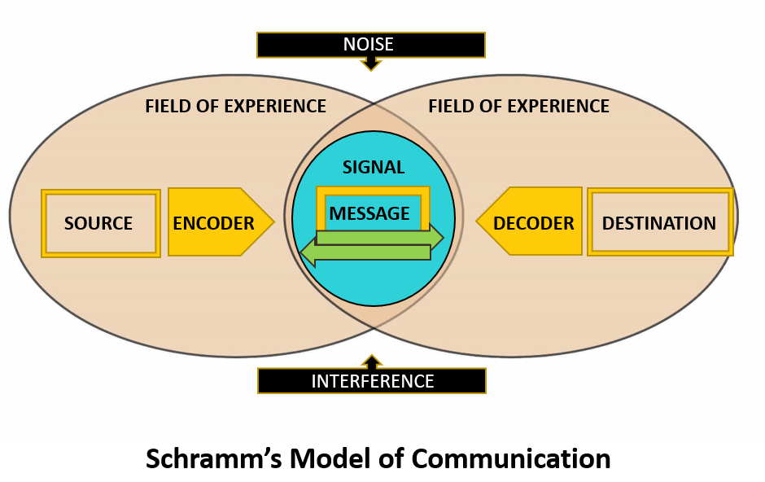
Figure 02: Schramm's Communication Model (Juneja, 2015)
Schramm's Communication model communicated in a manner that was more applicable to real-world situations as opposed to depending on the sender-receiver paradigm. This model is uncommon in comparison to others of its kind (Bhasin, 2020). The primary obligation of the receiver is to grasp the meaning of what the sender is attempting to communicate.
- Source (encoder): The person who sent the communication is referred to as the sender. The creator of a message must be able to communicate why the receiver should read it in a clear and brief manner. As a result, anybody intending to send a message must ensure that the information supplied is trustworthy, useful, and timely. Encryption is essential to guarantee that the communication can be decoded by the receiver (Bhasin, 2020). As a result, the sender and the receiver must be acquainted. The capacity to provide information in a simple yet understandable manner will determine whether or not this communication endeavor is effective. Cultural factors, viewpoints, knowledge, attitudes, experiences, and abilities all contribute to message encoding.
- Decoder (destination): A message's receiver is the individual or group to whom it was directed. A communication's decipherability is contingent on a variety of things (Bhasin, 2020). Some examples include if they are receptive to receiving messages and whether they have a positive rapport with the sender. Cultural factors, views, knowledge, attitudes, experiences, and abilities all impact how a message is perceived and interpreted by the recipient. Decoding a message requires psychological abilities. Once the signal is received, the stimulus is sent to the brain for interpretation. If applicable, message significance may be set here. This processing step is also known as decoding. An effective form of communication depends on the capacity of the receiver to accurately perceive the transmitted message.
- Message: Experts in communication and rhetoric agree that a message is only a string of information. This information may be conveyed by words, letters, or a variety of other symbols. Schramm's concept of communication recognizes the significance of all forms of communication, including verbal and nonverbal encounters. Messages delivered through email or WhatsApp, as well as phone calls and in-person conversations, all qualify as voice-containing means of communication (Bhasin, 2020). Messages may also include nonverbal components such as movements, gestures, body language, eye contact, physical touch, and time in addition to the real objects being transmitted.
- Noise: Both the message and the communication mechanism fail as a result of noise interference. When a recipient's interpretation of a message differs from the sender's original intent, a misunderstanding results (Juneja, 2015). The presence of noise may or may not allow the receiver to decipher the signals sent by the transmitter. If the message's original intent is being muddied by surrounding noise, it is quite probable that it is being misinterpreted.

3.3 Berlo’s SMCR Model of Communication 1960
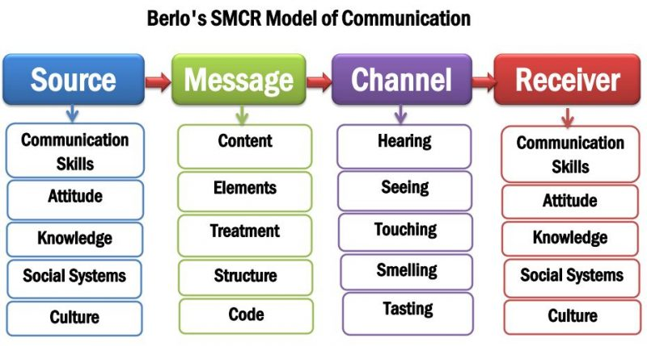
Figure 03: Berlo’s SMCR Model of Communication (Saud et al., 2014)
According to Berlo's Model, the communication process consists of four essential components. A communication is sent from one individual to another through a channel. Multiple factors affect the performance of each component.
- Source: The sender is the one who transmits the message. The message delivered by the sender is received by the receiver. Communication skills, attitude, knowledge, social structure, and culture all play a role in this.
A good communicator can speak, read, write, and listen. The significance of the communication is decided by the attitudes of the sender and the receiver. The receiver must already be acquainted with the topic matter for a message to be successful (Saud et al., 2014). A skilled communicator has a thorough understanding of the subject. Values, beliefs, rules, practices, and religion are among societal factors that impact how a message is transmitted. Individuals' communication styles are influenced by cultural differences. Something that is accepted in one culture may be offensive to someone from another.
- Message: The message sent by the source or sender of the communication to the receiver is the core content. Encoding is another word for this procedure. David Berlo adds five additional characteristics: content, components, treatment, structure, and code.
The message's substance, on the other hand, refers to the text's real contents. The whole conversation is part of its essence from beginning to conclusion. Elements are nonverbal items that accompany content, such as gestures, signs, language, and so on (Muyanga and Phiri, 2021). In the context of communication, treatment refers to how a message is received. The recipient's reaction is influenced by the treatment. The message's organizational structure or presentation has a direct impact on its effectiveness. The message is transmitted as code. It might take the shape of language, literature, cinema, or any other media.
- Channel: A channel is the medium that transports sender-receiver communication. Berlo emphasized hearing, seeing, touching, smelling, and tasting as communication tools. Listening conveys messages (Communication Theory, 2014). It's the main communication method. Humans understand visual cues. It's a key nonverbal channel. People form snap judgments based on others' looks. Touch is used for nonverbal communication. Olfactory communication is also intrapersonal. A pleasant scent boosts self-esteem. Tasting involves nonverbal communication through tasting. Tasters evaluate food's flavor.
- Receiver: The individual who is the recipient of a message is referred to as the receiver of that communication. According to this paradigm, for communication to be successful, the way of thinking as well as the other components mentioned above need to be in harmony (Muyanga and Phiri, 2021). If the communication is to have the desired impact, both the sender and the receiver should share the same understanding of its contents. A person who is a good listener is equally vital for the receiver.

2.0 Communication skills
Communication means transferring thoughts, information, emotion and ideas through gesture, voice, symbols, signs and expressions from one person to another. There are 2(two) basic type of communication: Verbal and Non-Verbal.

2.1 Verbal communication
- Verbal communication is a type of oral communication in which massages are conveyed through spoken words. Here, senders put their feelings, thoughts, ideas, and opinions into words and express them in the front of speeches, discussions, presentations and conversations.
- The effectiveness of oral communication depends on the speaker’s tone of voice, clarity of speech, volume, speed, body language and the quality of the words used in the conversation. In verbal communication, massages are sent and received simultaneously by the sender and recipient, so feedback is immediate. (Productivity, 2020)
- Successful oral communication depends not only on the ability to speak, but also on the ability to listen. How effectively you listen to a topic determines the effectiveness of your communication. Oral communication can be applied in both formal and informal situations.

2.2 Non-Verbal communication
- Non-Verbal communication is the process of conveying meaning without using written or spoken words. In other words, communication that takes place between two or more of hers using facial expressions, hand movements, gestures, postures and gestures is called Non-Verbal communication.
- Non-Verbal communication, unlike verbal communication, helps build and maintain interpersonal relationship, whereas verbal communication only helps convey external events. We use Non-Verbal language to perform rituals such as , and to emphasize our individuality.
- Non-Verbal communication in the form of signals and expressions adds meaning to the verbal and helps people, communicate more effectively. It complements everything that is said in words . When people nod and wave their hands to confirm. (Jargons, 2022)
- Helps define distance between communicators and share emotional states. It also regulates the flow of communication.
- Language can act as a barrier to effective communication because the recipient may not understand and misunderstand what the sender is trying to say.

2.3 Listening
- Listening is one of the most important skills you can have. How well you listen has a major impact on your job effectiveness and on the quality of your relationships with others.
- A deaf person can become a good listener, and person with good hearing may not be a good listener. Listening skills require the ability to take in and interpret information regardless of how it is received. (MCKAY, 2019)

2.4 Empathetic listening
- Empathetic listening is a listening style that uses active listening, reflecting emotions, and questioning techniques combined with the interpersonal skill of empathy to better understands someone intellectually emotionally. (Rekhi, 2022)
Poor communication in the Workplace leads to friction, frustration and confusion, creating a highly tense environment that discourages employee productivity and collaboration. This lack of motivation can affect employee relationship with customers and prospects. (Vdovin, 2017) For example at my workplace every morning for breakfast the kitchen have problems with the delivery and they can’t prepare the food on time. We have 2(two) chefs, which each of them order the delivery to come in different time on a daily basis which is an issue. They didn’t speak each other to coordinate the delivery on the proper time. In the case of Pedro and Maria , the confusion can be avoided if there was a feedback. Similarly with my chefs , if they correspondent on time for which time should come the delivery they will avoid confusion and proper managing of the food delivery.

4.0 Advantages and Disadvantages of Communication Technology

4.1 Advantages:
- Technology a method of communication that is not only more efficient but also more prompt in times of emergency.
- Technology help to communicate from any area in the world makes it easier to have conversations across great distances and makes communication in general simpler (Wickham, 2011).

4.2 Disadvantages:
- People of a certain age have a harder time navigating it, and it makes it easier for cyberbullying and cyber skyping to take place. It is also not always reliable, reducing the intimacy of online contact and making it impossible to know with whom one is conversing.
- The 7-38-55 rule indicates that only 7% of all communication is done through verbal communication, whereas the nonverbal component of our daily communication, such as the tonality of our voice and body language, make up 38% and 55% respectively. (Mehrabian, 1967) Potential misunderstanding in communication can approach using computer ,cell phone or other gadget ,the nuances provided by body language and voice inflection can be missed.

Conclusion:
The ability to communicate effectively is the foundation of any success. Being a purposeful communicator means actively listening, engaging, and providing feedback during massage exchange . The importance of effective communication is immense in the world of business and in personal life. Individuals who follow the communication process will have the opportunity to be more productive in all aspect of their careers. Poor communication skills, can lead to negative experience for both people, so always try to be clear and look for a feedback. Effective communication leads to understanding and integrity which generate a positive connection between the people.

References:
Al-Fedaghi, S. (2012). A Conceptual Foundation for the Shannon-Weaver Model of Communication. International Journal of Soft Computing, [online] 7(1), pp.12–19. doi:10.3923/ijscomp.2012.12.19.
Bhasin, H. (2020). Schramm model of communication | Elements, Advantages & Limitations. [online] Marketing91. Available at: https://www.marketing91.com/schramms-model-of-communication/ [Accessed 5 Aug. 2022].
Bhatti, M.W. and Ahsan, A. (2017). Effective Communication among Globally Distributed Software Development Teams. Journal of Global Information Management, 25(3), pp.40–62. doi:10.4018/jgim.2017070103.
Communication Theory. (2014). BERLO’S SMCR MODEL OF COMMUNICATION. [online] Available at: https://www.communicationtheory.org/berlos-smcr-model-of-communication/ [Accessed 5 Aug. 2022].
Drew, C. (2022). Shannon Weaver Model of Communication | 7 Key Concepts (2020). [online] Helpful Professor. Available at: https://helpfulprofessor.com/shannon-weaver-model/#:~:text=The%20Shannon%20and%20Weaver%20Model [Accessed 5 Aug. 2022].
Jargons, B. (2022). https://businessjargons.com/non-verbal-communication.html. Retrieved from https://businessjargons.com/non-verbal-communication.htm
Juneja, P. (2015). Schramm’s Model of Communication. [online] Managementstudyguide.com. Available at: https://www.managementstudyguide.com/schramm-model-of-communication.htm [Accessed 5 Aug. 2022].
Malkinson, T.J. (2001). Get to the point! writing effective email, letters, reports and proposals [Book Review]. IEEE Transactions on Professional Communication, 44(3), pp.214–215. doi:10.1109/tpc.2001.946469.
MCKAY, D. R. (2019, 5 28). https://www.thebalancecareers.com/listening-skills-524853. Retrieved from https://www.thebalancecareers.com/listening-skills-524853
Mehrabian, A. (1967). https://www.bl.uk/people/albert-mehrabian. Retrieved from https://www.bl.uk/people/albert-mehrabian
Muyanga, C.C. and Phiri, J. (2021). Assessment of Effective Communication in International Schools in Developing Countries Based on the Berlo’s SMCR Model. Open Journal of Business and Management, 09(01), pp.448–459. doi:10.4236/ojbm.2021.91024.
Productivity. (2020, 6 22). https://www.ionos.co.uk/startupguide/productivity/verbal-communication/. Retrieved from https://www.ionos.co.uk/startupguide/productivity/verbal-communication/
Rekhi, S. (2022). https://www.berkeleywellbeing.com/empathic-listening.html#:~:text=Empathic%20Listening%20Example%20Phrases&text=%E2%80%9CThank%20you%20for%20trusting%20me,with%20this%20situation%20right%20now.%E2%80%9D. Retrieved from https://www.berkeleywellbeing.com/empathic-listening.html#:~:text=Empathic%20Listening%20Example%20Phrases&text=%E2%80%9CThank%20you%20for%20trusting%20me,with%20this%20situation%20right%20now.%E2%80%9D
Rongala, A. (2015). 7 Rules of Effective Communication with Examples - Invensis Learning Blog. [online] Invensis Learning Blog. Available at: https://www.invensislearning.com/blog/7-rules-of-effective-communication-with-examples/ [Accessed 5 Aug. 2022].
Saud, S., Jufri, A., Rahman, M.A. and Salam, S. (2014). Learning Devices Development on Descriptive Writing for Foreign Language Based on Berlo’s SMCR Communication Model of Secondary School Student. Journal of Language Teaching and Research, 5(5), pp.5–10. doi:10.4304/jltr.5.5.1033-1041.
Vdovin, A. (2017, 9 21). https://www.alert-software.com/blog/the-causes-of-poor-communication-in-the-workplace#:~:text=Poor%20communications%20in%20the%20workplace,to%20clients%20and%20potential%20customers. Retrieved from https://www.alert-software.com/blog/the-causes-of-poor-communication-in-the-workplace#:~:text=Poor%20communications%20in%20the%20workplace,to%20clients%20and%20potential%20customers.
Wickham, J. (2011). Low Skill Manufacturing Work: from skill biased change to technological Regression / Niedrig qualifizierte Industriearbeit: vom qualifikationsbeeinflussten Strukturwandel zur technologischen Regression. Arbeit, 20(3), pp.15–20. doi:10.1515/arbeit-2011-0307.

