NAME: LILIANA GURALIUC
STUDENT NUMBER: 1811989
MODULE TITLE: CLOUD COMPUTING TECHNOLOGIES
ASSIGNMENT TITLE: An Overview and Recommendations Based on Specified Case Study
LECTURER: ANUPAM MAZUMDAR

Contents
Background and associated terminology for London Bike staffs to comprehend about cloud computing 3
Characteristics and benefits of adopting cloud computing 4
Service models and real-world services for cloud computing 6
Deployment models and recommended model for London Bikes Company 7
Explanation on virtualization and how it is linked to cloud computing 9
Migration strategies for cloud computing 10
Security concerns for using cloud computing 11
SAAS implementation process for London bikes limited company 13
References 16

Background and associated terminology for London Bike staffs to comprehend about cloud computing

The case study has identified that London bikes limited company and SME located in London that is engaged in selling bikes for clients. They are currently looking out for cloud computing so that they get can their records sorted and well organized, monitored, and entered to be able to meet customer needs. Their website is hosted by staff working in their office, and controlled on an internal means, i.e. quite limited in terms of its scope (Varghese & Buyya 2018). Their database system holds essential records about clients regarding their accounts, or orders executed for them, i.e. bike units being sold to them, and entire transaction details through billing and other means. All this needs fruitful monitoring, which can be possible by an effective technology like that of cloud computing, the best way to store bulk data. If cloud technology is incorporated, then it would eventually help them to focus on other areas of concern more, like better administration of works of internal in-house staffs i.e. 150 staff. Therefore, the adoption of SAAS would be beneficial for them, if they can handle it in the right manner. In this way, they will first be able to sore a huge amount of data. Secondly, they will be able to monitor it whenever they need it, as the backup will always be ready. Thirdly, the data will be kept safe and secured, free from any illicit access by any third party (Li et al., 2018). Fourthly, they will be able to stay prevented from any chances of the potential loss. In terms of cloud computing types, there are three main forms, namely the software as a service or SAAS usually used for all kinds of web applications used by clients, infrastructure as a service or IAAS, used for storage and computing concerns, and platform as a service i.e. PAAS for IT or website developers for hosting web-based services. Therefore by implementing cloud computing systems in business, they can make sure that the entire computing process associated with the daily recording of sale of bike units, and their safety monitoring using networks, servers of this limited company in-house IT systems are safely done (Abdel-Basset & Chang 2018). They will be able to look after storage patterns, all web-based applications that their website is engaged in, and effectively be able to concentrate on important development areas, retain customers and their data, and serve them effectively. It would even be best suited for interacting with customers and enhancing their experiences about how they are carrying ou5t their business. To do this, they need to have the basic components in which they require support from the consultant. There needs to be a front end platform, consisting of some fat client, thin client, and mobile device. There should be a back end platform lie some storage system where all data can be kept and some server to control the whole thing. Also, there should be a cloud-based delivery system, and a network facility with an uninterrupted internet, intranet, and inter-cloud. The staffs have to be well proficient enough to monitor overall these systems so that cloud technology can be used effectively within the workplace environment (Yang et al., 2017).

Characteristics and benefits of adopting cloud computing

Benefits:

There are several benefits associated with the use of cloud computing that London Bikes Company has to consider. First of all, all modern businesses need to maintain and keep records about the sales pattern like that of bike units getting sold every month, client transactions, and other means by adopting Cloud Computing (Langmead & Nellore 2018). They can ensure that these systems can be well managed cost-effectively. In this way, they will also be able to manage the scalability factor and other very important factors like that of maintaining their business that is it is a very important factor in business for improving the efficiency level of business. It would even bring flexibility in terms of total business and should even consider taking data and staying updated about day to day business. It is because of these reasons that cloud computing is an effective form, can be utilized in business and it is also a very important means whereby all the in-house staff of London bikes company can easily check about their data, and back up effectively. However, the data maintained can easily get shared among the internal staffs, therefore there should be IT security and safety (Griffith, 2016).

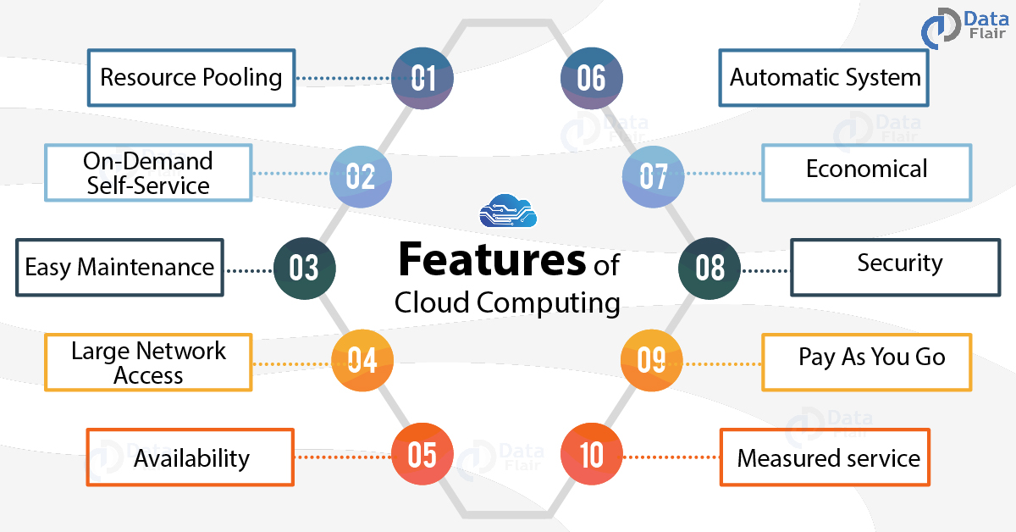

(Image Source: https://data-flair.training/blogs/features-of-cloud-computing/)
Figure 1: Features of cloud computing

Features:

There are several features associated with that of cloud computing. The first important feature is the resource pool. This is because Cloud Computing is associated with attracting and retaining several customers by making the best use of several applications at the same time. It is to increase the satisfaction level of customers and they keep them further informed about the particular brand or product like that London bikes in this case. It is even associated with providing self-service on demand of customers and this will be helpful in several ways. The data scientists or the other IT professionals who are a part of this limited company can check about other server uptime capability, network storage facilities, and other means of Cloud Computing in an effective manner. Apart from that, the kind of system is extremely easy to maintain. Therefore, in terms of its downtime in times of sending Update by to customers, it will be highly efficient. It can cater to fixing all bugs as required. Apart from that, the business will also be conducted in a fast and prompt manner because of large network access through an interrupted internet connection put in cloud technology or SAS application to work. There should be the availability of cloud-based storage systems and models well enhanced with cloud computing systems. Another important feature of this kind of automated system is that it has to be continuously monitored and controlled and checked from time to time to check the transparency factor. Other features are important concerns regarding how far it would be economical for the company because at present the company has limited funds and it is an SME. Therefore it has to keep concerns about one-time investment and not about continuous putting in of large expenditure for any new IT-based system. Therefore it has to be checked about how far it is economical, how far it is safe, and how it can be used in terms of its beneficial and service factors (Subramanian & Jeyaraj 2018).

Service models and real-world services for cloud computing

Cloud Computing based service models indicate that it can be used as a popular form of internet structure for service for cloud bursting, for multi Chain and computing, for resource pooling, as the hypervisor, and other areas to enhance elasticity and virtualized services. It can be used to provide more opportunities to all works of London Bikes Company who can make the best use for web applications facilitated through a hosted infrastructure that is further going to create better services in terms of cloud infrastructure. The service model is also associated with several benefits bringing an implementation, easy up-gradation facility, less dependency on human support mediums, and quick and helpful services towards the adoption of software. All this can better be facilitated by using SAS Cloud Computing models. therefore SAS Cloud Computing models are based on several applications which are used by several companies to generate better cloud services and better revenue and help in treating better IT application. There are several benefits associated with this kind of service like that of building scalable, affordable, secure in its means. It is because of all such reasons that London Bikes Company can afford it and access not only within their in-house unit but also in other units of business functions. The application communication transfer of all data relating to bike sale and other business records are conducted for important business affairs can now be done in a better way. It is because of several benefits as indicated that cloud computing and Cloud Computing based applications are into use everywhere. For example, Cloud Computing is not just useful for this current company based application that is the London Bike Company. It is applicable in health and social care centers and is applicable for educational institutions or manufacturing industries, or energy-based sectors. Lastly as indicated for this current case, it is one of the most important forms for the transport and logistics industries as well. For example, London Bike Company is a transport based vehicle manufacturing company, to be delivered to customers To enable this, there should be better services like location maps across efficient system panels, as an added feature for sale. Therefore the routes covered, or other operations been involved and several other means can also be monitored in addition to maintaining conformity with the database system, record client records in a day-to-day manner. Therefore Cloud computing would help to bring betterment in terms of the organizational performance of this company. In other areas also, companies like that of Shell Oil has been using Cloud Computing means to check across all geological forms of data which they can use for their business, by using and utilizing cloud infrastructure. In terms of education also, several organizations have started to work on Computer-Based coding and several NGO based organizations are taking the help of cloud technology to reach out to more students. HSC care centers are even using this to reach out to patients and their families, understand their problems and in Healthcare based applications, caregivers can now maintain a proper database about the clinical records and another history of every patient.

Deployment models and recommended model for London Bikes Company

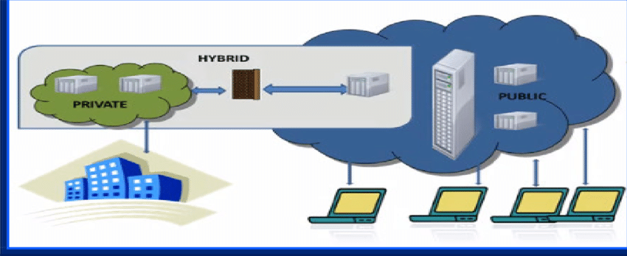

Source: https://www.researchgate.net/figure/Deployment-models-4-MODEL-OF-CLOUD-COMPUTING-41-SaaS-Software-as-a-service-model_fig2_300067198
Figure 2: SAAS Deployment model

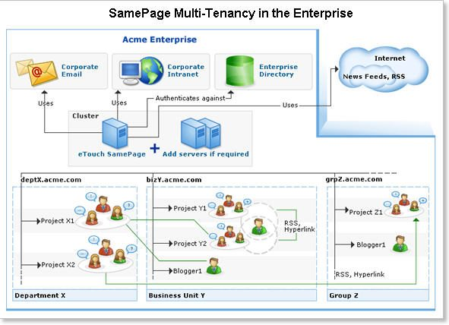

Source: https://www.cmswire.com/cms/enterprise-20/the-saas-deployment-model-offered-in-an-on-premise-wiki-003946.php
Figure 3: Recommended SAAS deployment model for London Bikes Company

At this condition, the IT-based consultant has to decide about what form of cloud computing deployment model would be best suited and most efficient for the London Bikes Company. For example, a hybrid cloud computing system may be used which would be based on onsite private cloud community, cloud public cloud outsource and other means several essentials have to be concerned while checking across what kind of deployment model would be best suited for this case (Kumar & Jelciana 2018). For example, if the current deployment model used for London bikes company is based on multistage as the image indicated, it would maintain confirmatory with the corporate emails being sent to customers or other business officials regarding sales for new bike units. There would be strong efficiency maintained either on one server on more than one servers and it could also have conformity with corporate intranet, enterprise directory, and other things computed within the organization. The operations would be segregated into separate departments where staff would be responsible for different works associated in terms of multi-action features. It would help to handle scalability, administration, flexibility, efficiency, and other essentials. There are three service models and four deployment models ie private cloud community cloud, public cloud, or hybrid cloud systems for cloud computing.
The hybrid deployment model may be used in this case because if the hybrid cloud deployment model is used for the London bike company, then it would be able to connect with on-premises private cloud services, with third-party public cloud-based services, all done across a single flexible infrastructure system. This will not only be able to work and be flexible and maintain efficient handling of data which also deals with bulk data in scale (Stergiou & Gupta 2018).

Explanation on virtualization and how it is linked to cloud computing

Virtualization based technology is directly associated with cloud computing for the London bike company which will be explained here. It is a technology that is enabled through Cloud Computing to work across IT environments by getting exposure to Physical infrastructure or work on several operating systems, working on the same machine. Data is processed or recovered, stored, and used. Because of this means, there is an entire reduction of the overall cost incurred upon such services. It is quite responsible for making the service effectively utilized, quite efficient, and flexible in its means. The best part of virtualization is that it can be used on any personal computer or any workplace or hardware available with the user. In this case, the IT consultant who has been deputed to look into how cloud computing based technology can be incorporated by London Bike Company can make use of these essentials to check on virtualization factors and develop it suiting to the current environment for various applications used by the company (Shen et al., 2017). It is in this aspect that if virtualization is completely associated with cloud computing and it can be effectively be utilized to deal with all technology-based applications that would be used by this company. Virtualization-based systems are referred to as some software that can manipulate hardware or that the business of the company is working well or not. Therefore it is an effective way to carry out manipulation by using the internet medium. It helps in the effective delivery of resources checking on the software or being used and the data that has to be retrieved for further use. There are applications and several sectors that are based on cloud computing. It has several features like that of being able to provide self-service to the workplace environment or being elastic or being capable of automated management. Further to this, it is also known for its scalability and other advantages associated with public clouds. It is not only applicable for the public cloud but also for private clouds and it can be used effectively to provide benefits for all the computers or all the hardware which are associated with these current business operations of London Bike Company. It is cost-effective, it can manage services well. It can also work in small operations like that of the present assembly enterprise being considered. Therefore it has several advantages associated with it right from outsourcing of information technology to being set up quite quickly, all being used for SAS based applications, for offloading and other means and also being scalable in its services (Li & Xiang 2018).

Migration strategies for cloud computing

A data migration strategy is an important area concerned with replicating or making a copy of the data being used from one device to another device or some other system. It may be used for other concerns. The main thing associated with this kind of data migration strategy used by cloud computing is that the additional data is not hampered and it is not disrupted in its means. However, when a copy of this data is made, it can be transferred to some other device or some other system in an effective manner (Sookhak et al., 2017). This is the basic strategy of cloud migration that takes forms of such software as a service called application, refactoring, or platforming software as a service. There are several techniques used for migration that is used by companies as suggested by the IT professionals working within the companies. For example, it may take the help of a lift and shift approach ie rehosting approach or re-platforming approach, or purchasing approach. These are dependent on several applications and need architecting or refactoring to retain data. There are other migration strategies used by companies based on the current control like for London bike. The best migration strategy has to be checked. However, migration strategies are quite helpful and they can be used for on-premise hosting and other uses. For example, while understanding the need for migration strategies in this case the London bike company, has to first understand why they needed to check the need and how they can make migration strategies possible (Boukerche & Robson 2018). There are reputed companies like that of Amazon services which are working on migration strategies. For example, Amazon has an AWS migration hub which works to track across the application programs on an unlimited basis. Therefore this kind of tracking facility in business or structure can easily be formulated. In this case, London bike is a bike company and they have to monitor across all administration means, about how sales are generated, whether they profit level from operations using IT applications are viable, how far customers are responding, how far they are satisfied, how far the sales and logistics units are performing well whether the inventory is brought into the right places, about the warehouse functions and several other means. Such factors are to be continuously tracked. It can be done through migration strategies once data is collected. Migration strategy would also make use of application discovery-based services on the Internet applications that they are working on. It would work on data migration service applicable at all times, the service catalog is presented to the staff as well as other users and also make better facilities for business and organizational transformation. It would ultimately help in adding positive business values to Amazon services functioning and make their website better and add more customers (Jonas et al., 2019).

Security concerns for using cloud computing

Cloud Computing can effectively help in business if they are used in the right manner. However, if they cannot be used in the right manner, then there can be problems that have to be further checked. For example, some of the main problems are threats from a continuous data breach by staff. To ensure protection against this threat, it has to be ensured that all the 150 number of staff who are a part of this company, do not have direct access to data equally. There should be a categorization of data and all data should be protected in one centralized form of environment where few IT officials who monitor (Noor & Sheng 2018). There may be Cloud-based attacks and IT-based professionals should be disputed for protection of these data. There should not be any case of the hijacking of accounts by any means. In most cases, it has been seen that Cloud Computing services are used, however, they cannot protect from bugs or passwords are normally not protected. There are forms of phishing, logging buffer overflow factors that are not carefully looked after even when the structure is working. Many insider threats are not looked after. Such factors have to be controlled on a day-to-day basis. There should also be secured to look after Malware injection factors which are the main threats in SAS. There should not be any inappropriate kind of behavior while using these cloud services or any in secured API for application programming, interface application programming, interface, or API associated which can anyway pose threat anytime. There should not be denied to any kind of service attack faced at any time or concerns not given concerning goals or data loss to prevent any threat from Cloud Security (Deng et al., 2016). Threats can even come from shared vulnerabilities and in case any data is shared in terms of partnership with any other Client or any other service provider, by London Bike Company, such data has to be regularly backed up and monitored to avoid all kinds of the threat of data loss. Even multinational companies like Google and other companies are not free from this kind of threat to work cloud computing and hence this has to be carefully monitored. Therefore the IT professionals who are a part of London Bikes Company have to understand that security concerns as important for all sales-related data to prevent threats to data. They need to check on the flexibility of data and for better productivity of their staff for data protection. There should not be any case of a malicious attack on computers, or servers, by these service providers and even if there are any malicious attack fro external or internal means, it should be prevented by some means of a recovery plan which should be designed. In certain forms, the key security protocols are not maintained properly which brings for access to more problems in terms of multi Factor authentication, and other problems are overlooked. Such factors are important areas of concern and therefore such factors have to be checked. There are several regulatory laws also which has to be maintained. For example, the regulatory laws functional in London based companies also have to be checked. Finally, it has to check whether the API or application programming interfaces are encrypted in their forms or not. All data should be properly maintained whether it is some data or video image or anything related to their business ie bike sales (Singh & Park 2016).

SAAS implementation process for London bikes limited company

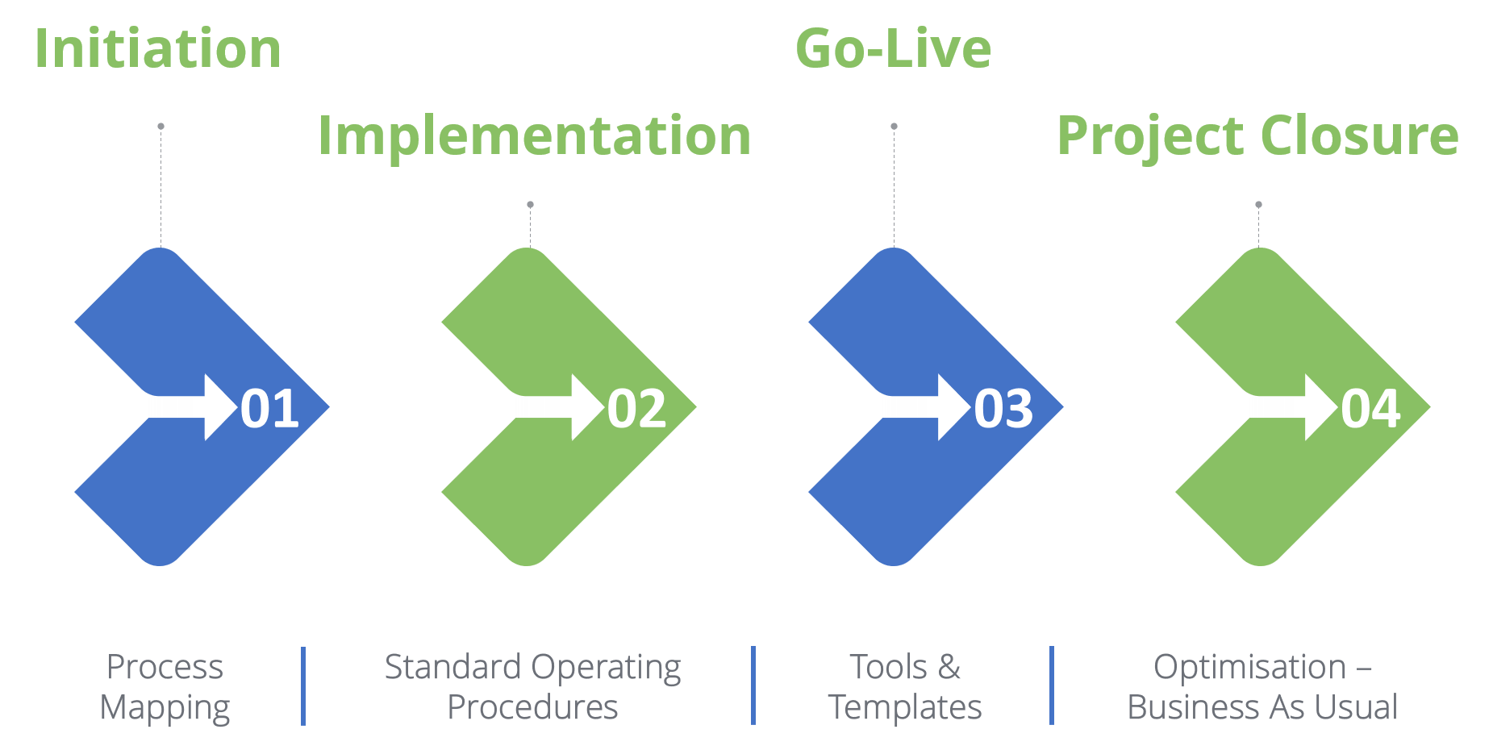

(Source: https://www.genesisahc.com/saas-implementation/)
Figure 4: SAAS implementation process

The process of implementation of the SAAS model for cloud computing involves some of the most essential factors. There are several examples of SAAS like that of zendesk, docusign,slack, hubspot. The IT professional check for several applications and check how they can implement as per the models. The first factor is to check across the immediate needs of London bike company business requirement. For example, right now they need some software solution that would be able to collect all the data records, all the data will be saved for the future, use maintain client transactions, and other factors (Navale & Bourne 2018). The hybrid model is preferred in this means. Next, all the IT developers of the company would have to work as a team and they would have to be allocated with respective tasks so that they can design some scalable infrastructure well. Once this is done, the team members would have to finalize the bandwidth and the hosting needs that they require to implement such a business model. They would further have to cross-check across all the major components which are associated with it and how far they can be managed to build them, have to check about customization accessibility of failover security, and several other issues. Once this is done, they would first have to check for the deployment of such delivery Infrastructure or by deploying the latest versions and checking across firewalls and other things. They have to check for any possibility of disaster in any means and how they can get over with by formation of a recovery plan. Once this is done, they have to look into the integration of solutions for effective monitoring and also run at an equal pace to provide customer care to all customers whenever they need it. They also have to work towards the preparation and formulation of service level agreement ie SLA, which will work hand-in-hand with the SAAS model on one hand and will also cater to London-based trade Laws and regulations on the other means. They would have to check about documentation patterns and how far they are updated on how far they have to update in this regard. After checking processes and all such factors, they have to check across the implementation approach for this would be possible by serving standardizing, automating, integrating, and transforming factor. Therefore they have to check across all the essential steps which will be important right from the initiation stage going through implementation and goal test project and closure stage. Therefore they have to check across how far the process mapping is enabled uninterruptedly, how far are standard operating procedures maintained, adopt the right tools and techniques and further optimize business needs for successful implementation of SAAS model in their business (Tao et al., 2017).
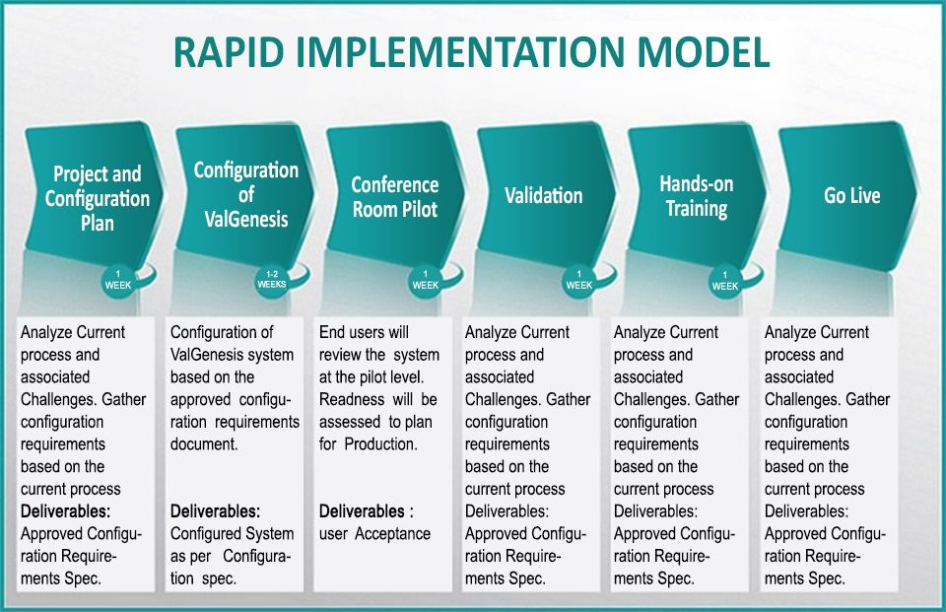

Source: https://in.pinterest.com/pin/325314773075781720/
Figure 5: SAAS Implementation model

SAAS implementation model will involve the following stages:

- Project and configuration plan. It is the first step towards following the main processes.
- Configuration of SAAS system as per the needs of the London bikes company. All requirements will have to be checked, and then met in line with available resources available, or need for other resources (if required).
- Check for conference room pilot concerns
- Check for validation
- Check for providing hands-on training to staff, as the application of these systems is to be motored by skilled IT staff and fix bugs and other threats, whenever they find any.
- Check for who live factors to get an idea about challenges if any.

References

Stergiou, C., Psannis, K. E., Kim, B. G., & Gupta, B. (2018). Secure integration of IoT and cloud computing. Future Generation Computer Systems, 78, 964-975.

Varghese, B., & Buyya, R. (2018). Next generation cloud computing: New trends and research directions. Future Generation Computer Systems, 79, 849-861.

Subramanian, N., & Jeyaraj, A. (2018). Recent security challenges in cloud computing. Computers & Electrical Engineering, 71, 28-42.

Li, P., Li, J., Huang, Z., Gao, C. Z., Chen, W. B., & Chen, K. (2018). Privacy-preserving outsourced classification in cloud computing. Cluster Computing, 21(1), 277-286.

Yang, C., Huang, Q., Li, Z., Liu, K., & Hu, F. (2017). Big Data and cloud computing: innovation opportunities and challenges. International Journal of Digital Earth, 10(1), 13-53.

Abdel-Basset, M., Mohamed, M., & Chang, V. (2018). NMCDA: A framework for evaluating cloud computing services. Future Generation Computer Systems, 86, 12-29.

Kumar, P. R., Raj, P. H., & Jelciana, P. (2018). Exploring data security issues and solutions in cloud computing. Procedia Computer Science, 125, 691-697.

Griffith, E. (2016). What is cloud computing. Retrieved from PC Mag: http://au. pcmag. com/networking-communications-software-products/29902/feature/what-is-cloud-computing.

Langmead, B., & Nellore, A. (2018). Cloud computing for genomic data analysis and collaboration. Nature Reviews Genetics, 19(4), 208.

Sookhak, M., Yu, F. R., He, Y., Talebian, H., Safa, N. S., Zhao, N., ... & Kumar, N. (2017). Fog vehicular computing: Augmentation of fog computing using vehicular cloud computing. IEEE Vehicular Technology Magazine, 12(3), 55-64.

Arunarani, A. R., Manjula, D., & Sugumaran, V. (2019). Task scheduling techniques in cloud computing: A literature survey. Future Generation Computer Systems, 91, 407-415.
(Arunarani & Sugumaran 2019)

Shen, J., Zhou, T., Chen, X., Li, J., & Susilo, W. (2017). Anonymous and traceable group data sharing in cloud computing. IEEE Transactions on Information Forensics and Security, 13(4), 912-925.

Li, J., Zhang, Y., Chen, X., & Xiang, Y. (2018). Secure attribute-based data sharing for resource-limited users in cloud computing. Computers & Security, 72, 1-12.

Boukerche, A., & Robson, E. (2018). Vehicular cloud computing: Architectures, applications, and mobility. Computer networks, 135, 171-189.

Jonas, E., Schleier-Smith, J., Sreekanti, V., Tsai, C. C., Khandelwal, A., Pu, Q., ... & Gonzalez, J. E. (2019). Cloud programming simplified: A berkeley view on serverless computing. arXiv preprint arXiv:1902.03383.

Noor, T. H., Zeadally, S., Alfazi, A., & Sheng, Q. Z. (2018). Mobile cloud computing: Challenges and future research directions. Journal of Network and Computer Applications, 115, 70-85.

Deng, R., Lu, R., Lai, C., Luan, T. H., & Liang, H. (2016). Optimal workload allocation in fog-cloud computing toward balanced delay and power consumption. IEEE internet of things journal, 3(6), 1171-1181.

Singh, S., Jeong, Y. S., & Park, J. H. (2016). A survey on cloud computing security: Issues, threats, and solutions. Journal of Network and Computer Applications, 75, 200-222.

Navale, V., & Bourne, P. E. (2018). Cloud computing applications for biomedical science: A perspective. PLoS computational biology, 14(6), e1006144.

Tao, X., Ota, K., Dong, M., Qi, H., & Li, K. (2017). Performance guaranteed computation offloading for mobile-edge cloud computing. IEEE Wireless Communications Letters, 6(6), 774-777.

