Marketing Fundamentals Analysis and Evaluation Assessment 2



Student Name: Ilie Topliceanu
Student Number: 1917164
Lectures Name: Tushara Balendra

Table of content

1. The role of marketing in creating value for customers……………………………..[3]
1.1 Definition of marketing concept…………………………………………………[3]
1.2 Brand & Branding…………………………………………………………...…..[5]
1.3 Ansoff Matrix…………………………………………………………...……….[6]
1.4 Relationship Marketing……………………………………………...………......[8]

2. Stakeholder…………………………………………………………...…..…..[8]
2.1 Reebok Stakeholders…………………………………………………..……….[10]

3. Conclusion……………………………………………...…….…...……..….[10]
4. Recommendations………………………………………………..…………..[11]
5. References………………………………………………………..……….....[12]

1. The role of marketing in creating value for customers.
1.1 Definition of marketing concept.

Philip Kotler defined marketing as "a social and managerial process by which individuals or groups of individuals obtain what they need and want by creating, offering and exchanging products and services a certain value" (Kotler 1997, page 8). In this sense, we can formulate a quick marketing concept definition and say that it represents the philosophy behind the company's efforts to fulfil its customers' needs, thus creating benefits.
In the following, I will describe the marketing strategy of Reebok. It is well known that Reebok is one of the most prominent names in the sportswear industry. With a long history behind it, Reebok has built a reputation using famous names and brands; I will give just two examples, Venus Williams and the Fc Liverpool football team. With the help of these public entities, the company tried to convince its customers to buy its products. Advertising campaigns ran on various media channels from television to the Internet. Despite these investments in promotion, Reebok has always been behind rivals from Nike or the "mother" company Adidas.
They needed something new. Most people see marketing only as advertising that runs on different media channels; you cannot blame them. They are right, considering that this component of marketing is the most visible in business. However, to develop a successful marketing strategy, you need much more. The concept shown below is based on the four pillars of marketing and can be used to develop in four steps a successful strategy (https://moodle.uwtsd.ac.uk/course, 2020).
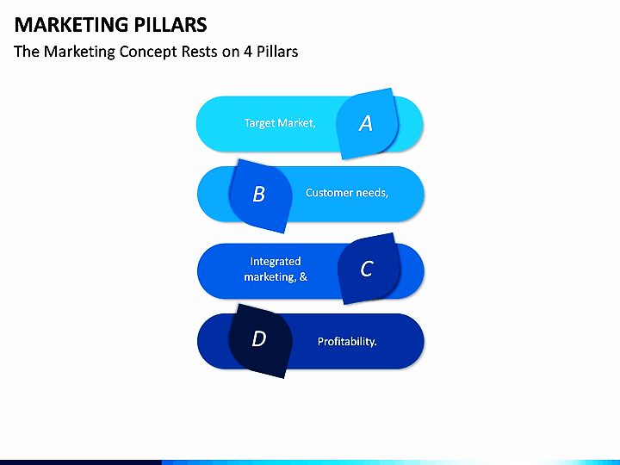[Fig1.Source:Internet]

Give the customers a voice
In the example below, I will explain how Reebok has succeeded in creating a marketing strategy that benefits both customers and the company. In 2010, Reebok signed an exclusive contract with CrossFit, becoming its exclusive supplier of fitness brand footwear, clothing, and accessories. Cross Fitters, as those who practice this sport call themselves, say that Cross fit is more than that, it is a way of life. For those who want to become active members of this lifestyle, there are CrossFit trainers and gyms located around the world that can guide you on how to learn this semi-hardcode fitness style. CrossFit followers do group exercises, thus encouraging themselves to push their limits. They are also very active on social networks such as Facebook and Instagram. With the help of these social networks they share thoughts about training and the lifestyle itself.
Reebok President Uli Becker said that “there is a shift happening today in the fitness world that is born from the idea that fitness can be a sport – with all the elements that we love about traditional sports” (https://www.businesswire.com/, 2012). Reebok's strategy was created to "change the way people perceive, define and experience fitness" and achieve the ambition of "bringing fitness into the world and being seen as the best company in the world" (https://www.businesswire.com/, 2012). Chris Froio, vice president of Reebok Western Europe, told Marketing Week that the partnership has exceeded the brand’s “wildest dreams as far as popularity and consumption with the consumer” and has allowed it to engage with the global CrossFit community through “heavy retail, social and digital” activity.
Happy customers are the best advertising vectors. Reebok seems to have struck a gold mine in their partnership with CrossFit, targeting a group of consumers who often post pictures with their gear, significantly boosting the brand's image. The reebok strategy, through which it promotes its products with the help of customers, creates mutual benefits. Customers promote Reebok on social networking sites and share opinions on product quality so that this marketing strategy is advantageous for customers.

1.2 Brand & Branding
The term brand is defined as "a name, sign, or symbol used to identify a manufacturer's products or services and differentiate it from the competition" (Kotler, 2000). While many people appreciate the brand as a logo, it needs to be specified that a brand represents so much more. A brand includes consumer confidence and loyalty. The brand identity is described as providing security to the customer and this perspective is beneficial. The brand gives people the measure of things, it is an indicator of the level of their expectations and the assurance that promises will be kept. Some would call them emotions.
Branding is the process of building a brand. Usually, this process is long-term and involves a large mass of people. Depending on how it is presented (or packaged), certain brands are built in a shorter time.
Brand and Branding Aspect of Reebok
Being an exclusively sports brand, Reebok specialized in creating products to help those who practice exercise and fitness. Most sales are aimed at Cross Fit and the main argument is that regardless of age, everyone has a chance to compete and lead an active life. They realized that the fitness market is continuously growing, and they took the opportunity. Realizing the scale of the phenomenon, they had to find someone to promote the products that CrossFit practitioners could identify with. Names like Ronda Rousey and Jon Jones, Mixed Martial Arts (MMA) fighters, signed with Reebok. Reebok understood that Cross Fit practitioners do similar training like MMA fighters.
Looking back, we can say that Reebok has always focused its efforts on innovations that increase the comfort and safety of those who practice any form of movement. No matter what movement you make, run through the park, do yoga, or dance, Reebok has always tried not to disappoint their customers. Reebok's Fit for Life slogan fits perfectly with the profile of the target audience. Recently, Reebok changed its logo [Fig. 2]. The new logo focuses on three distinct parts, each representing the changes, physical, mental, and social.

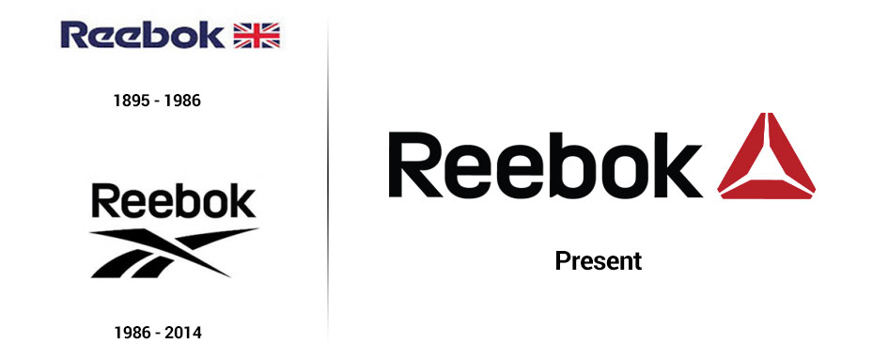
[Fig 2 .Source: https://www.brandingmag.com/2014/03/04/reebook-new-logo/]

Advantage
Brands make a difference, and this is the reason why they are significant. Brand loyalty is proof that the lowest price does not always determine consumer preferences. Brands decrease price elasticity, and this means that brands will ask for and receive higher prices because they are unique and cannot be repeated by other products or services. The Reebok brand offers customers an identity and belonging to a group. Here I refer, especially to CrossFit practitioners.

1.3 The Ansoff matrix
The Ansoff matrix is a strategic planning tool that helps managers and marketers create strategies for future growth. It was developed by the Russian-American Igor Ansoff and published in the Harvard Business Review in 1957, in an article entitled "Diversification Strategies."
Ansoff suggested that there were only two practical approaches to developing the growth strategy: selling renewal (product development) and for which it is sold (market development). When these approaches are combined as a matrix, they offer four strategic options, each with a different risk level.
• Market penetration • Product development • Market development • Diversification
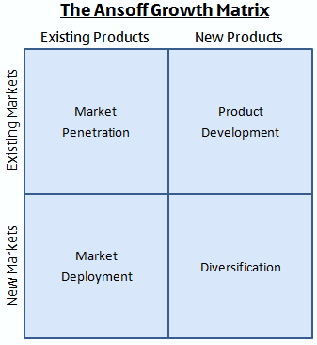
[Fig 3.Source: https://moodle.uwtsd.ac.uk/course, 2020]

Over time, Reebok has managed and succeeded in launching very innovative and popular products. Easy tone footwear, an innovative product recently launched by Reebok, tones the busts and legs of many women worldwide. Benefiting from a special design and technology, the shoe generates remarkable results. These types of products soon become very popular, and their sales grow rapidly. These products are to be sold to the existing customers in the “Market Penetration” sector.
This type of product can be sold in new countries like India, where they are not completely introduced. Reebok's existing and loyal customers would buy them. The product would see them in the “Market Development” sector of the Ansoff’s Matrix.
Reebok has successfully re-invented its classic products. For example, the classic version of the "Pump" shoe could be improved, which would create new advantages for the company and customers. This product would be in the “Product Development” sector of the Ansoff’s Matrix.
The improved "Pump" classic shoe model could be sold in new markets such as India. The product would see them in the “Diversification” sector of the Ansoff’s Matrix.

1.4 Relationship Marketing
In the early 1990s, the significant change that was to occur was foreshadowed in the field of marketing and customer orientation. In 1992, Philip Kotler proposed a new approach to organizational performance based on the concept of relationship. The renowned North American professor stated the importance of developing more relationships close with customers, distributors, suppliers, employees, unions, organizations, government, and other major players in the environment in which the organization operates. It thus emphasizes the need to move from short-term, oriented vision transactions to the long-term vision, creating and developing relationships to increase the competitiveness of organizations in local and global markets (Kotler, 1992).
Compared to the previous decades, today, customers are "moving targets" for organizations. Markets no longer have a relatively stable structure, extremely dynamic, with segments and niches whose profile evolves. Customer relationship management aims to attract and retain profitable customers through the development of relationships in the long term and by stimulating customer loyalty. An advance in technology information contributes to the substantiation of the most appropriate strategies for developing relationships with each client within the organization's portfolio.
Reebok has always strived to have a close relationship with its customers. Eleanor Carter-Silk, Reebok UK’s head of sports marketing, says, "We are our own consumers; It’s our responsibility to let people do what they’re doing anyway but to add value to them”(https://www.marketingweek.com/, 2018).
Reebok tries to build customer loyalty by giving them the chance to express their opinions about product quality through online discussions. This relationship has mutual benefits, on the one hand, Reebok can improve its products while customers can choose the product that suits them fits best.

2. Stakeholder
In the last decade of the twentieth century, the word stakeholder has become increasingly used and defines a person or organization with interests in a project or entity. In the decision-making process of institutions - including large corporations, government institutions, or non-profit organizations - the concept has come to include all parties who have an interest (or part, "stake") in the organization's projects. The concept includes not only vendors, employees and customers but also community members because their headquarters or factories can affect the local economy or the environment. Stakeholders in an organization are individuals and constituents who voluntarily or involuntarily contribute to the creation of values and, therefore, potential beneficiaries to profit or risk (Bryson (2004, page 22).
Stakeholders are classified according to their relationship with the organization and the influence they exert within it. The main way of classification is done by grouping them according to the way of interaction with the business organization, delimiting the following categories:

Internal Stakeholders
The main involvement of the business organization is determined even by the development of the business itself, respectively, by the direct relations necessary to achieve its fundamental mission: the realization of goods and services for society. This fundamental interaction of the company with the environment, in the case of market economies, is achieved through the free market, in which sales and purchase processes are carried out under the governance of the law of supply and demand. The company exists because shareholders and investors have assumed the risk of its creation and financing. Therefore, the internal stakeholders are owners, employees, board of directors, and managers. How the business organization interacts with all these entities is reflected in the strategic managerial decision.

External Stakeholders
The environmental relations of a business organization go beyond the simple, primary interaction with shareholders, employees or business partners. External stakeholders are those entities that are not part of the management of a business but are indirectly affected. These external entities that are part of the business environment are also known as secondary stakeholders. External Stakeholders do not participate in daily life but are affected by the business's actions. They deal with the business from outside. They have no information about internal problems in the business. External stakeholders are suppliers, customers, creditors, intermediaries, competitors, society and government.

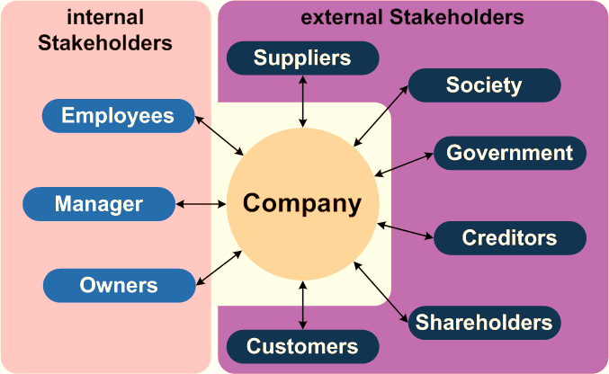
[Fig.4 Source: https://moodle.uwtsd.ac.uk/course, 2020]

2.1 Reebok Stakeholders
I will start by mentioning that although Reebok and Adidas are two different entities following the August 2015 transaction, Reebok becomes part of the German giant Adidas. Reebok stakeholders are people or organisations who influence or are affected by the business’s operations. Reebok doesn’t work in separation from society and their stakeholders have a legitimate interest in the way they do business. Below, I will show some examples of Reebok’s diverse group of stakeholders (www.reebok.com, 2020).

• Reebok employees
• Government authorities, investors; board of directors, trade associations
• Business partners; suppliers; service providers
• Opinion-forming journalists, community members, special interest groups
• Professional sports customers, distributors, retailers, consumers

In the following, I will explain how Rebook communicates with some of his stakeholders. I will start with Reebok employees. They represent a unique category of stakeholders, being directly interested in the smooth running of the organization because, for most employees, the salary is the source of income with which they pay their contributions and ensure a decent living. In order to maintain a close relationship with employees, Reebok offers them, in addition to salary rights, the power to make certain decisions. The group also rewards its employees by granting bonuses.
Secondly, Reebok tries to have as transparent a connection as possible with the authorities, for example, the governmental authorities in the countries where it operates. The company tries to develop its business by making as much profit as possible but, at the same time, respecting the legislation of each country where it operates. Here I will mention India. India is the largest democratic country in the world in terms of population. The company had to adapt to this particularity and communicate with the Indian authorities in the most efficient way possible. It should be mentioned that India is a federation of twenty-nine federal states and seven federal territories, all of which have elected governments and legislatures.
Another category of Stakeholders is customers. In Reebok's case, the clients can be professional athletes, non-professional athletes, dancers, or citizens who carry out activities that involve movement. Reebok provides the highest quality products to promote customers' sports performance. The company interacts with its customers through a commercial on electronic and print media. By buying the company's products, customers directly influence the future of Reebok. Reebok tries different strategies to attract as many customers as possible.
I will end this brief description with opinion leaders such as journalists, community members, and special interest groups. Reebok maintains contact with them through press briefings, websites and other sources. They have a fairly large influence on customers. For example, a journalist can decisively influence whether customers buy a particular product through the opinions expressed through an article. Such people like this directly influence customers' buying habits.

3. Conclusion
Based on what is stated above, I can say that a well-developed marketing concept can be the key to success. Companies develop a philosophy through which they try to satisfy the needs of customers and certainly creates benefits for consumers. Writing this essay, I realized how important communication is between all parties involved in the business. Creating healthy relationships with both those inside and outside the company creates equal benefits for all parties involved. An effective marketing strategy that will bring you as a profitable company and meet the needs of customers must consider several factors. The fact that you managed to have an advertisement on TV does not guarantee that you will succeed. Marketing involves more than what I wrote above; I proved this truth. Reebok is an international brand that has always strived to meet customer needs.

4. Recommendations
I recommend that Reebok continue to invest in new technologies to develop the most competitive products to help those with an active lifestyle. I also recommend that Reebok capture the attention of the less active by creating campaigns that support promotes an active and healthy lifestyle. Reebok is a reasonably visible brand, being active on all media channels. I recommend continuing this strategy and encouraging its customers to express their opinions in the online environment.

References

• Igor Ansoff .31 Mar. (1988) .Corporate Strategy (Business Library).
• Jo Bryson. (2004). Effective Library and Information Centre Management.
• Kotler, Philip (1997), Marketing Management, 9th Ed., Prentice Hall, New Jersey.
• Kotler, Philip. (2000). Marketing Management, The Millennium Edition. Upper Saddle River, NJ: Prentice-Hall.
• Kotler Philip (1997). Marketing Management: Analysis, Planning, Implementation, and Control.

• https://moodle.uwtsd.ac.uk/course/view.php?id=3813 (2020) [Accessed 8 August 2020]
• https://www.businesswire.com/, (2012) [Accessed 10 August 2020]
• https://www.reebok.co.uk/ (2020) [Accessed 11 August 2020]
• http://www.hoopsvibe.com/features/43977-the-history-of-reebok-in-the-sneaker(2020) [Accessed 14 August 2020]
• https://www.reebok.ca/en/customer-service-company_information.html (2020)
[Accessed 16 August 2020]

