
Word Count 7522 words

LEVEL 7 ASSESSMENT SPECIFICATION
Student name: | Yuen Wai Kuen Peter | Student ID number: | 1916081
Programmed: | DBA
Module: | Qualitative Research Methods
Module code: | HKBM7003 | Contribution to Overall Module Assessment (%): | 100%
Lecturer: | Dr. Tamara Savelyeva | Internal Verifier:
Assignment Title: | Research Article | Word count (or equivalent): | 7, 500
Submission deadline: | 6 November 2020 | Return date of provisional marks & written feedback: | 3 December 2020
Submission method: | All written assessments, where practical and possible, must be submitted via Turn tin unless otherwise instructed by the Lecturer. (Please DO NOT put this assessment specification into Turn tin or it will match many similarities with other students’ submissions.)  Alternative submission method (if applicable):  Late submission of the assessment will result in a late penalty mark. Penalties for late submission: Up to one week late, maximum mark of 50%. Over one week late, 0%. Only the Extenuating Circumstances Panel may approve a change to submission dates.
Academic honesty / referencing: | Academic honesty is required. In the main body of your submission you must give credit to authors on whose research and ideas your work is based. Append to your submission a reference list that indicates the books, articles, etc. that you have used, cited or quoted in order to complete this assessment.
APPENDIX GA36d

TABLE OF CONTENT
PART A
Overall Abstract of Research Proposal…………………….………..……..………….......... 3
“Impact of ESG’s initiatives on the financial performance and corporate leadership in listed companies in Hong Kong”
PART B
Critique of a Research Article
“Corporate governance evaluation of Chinese listed companies”
1. Abstract…………………………………………………………………………………..7
2. Background………………………………………………………………………………8
3. Critique……………………………………………………………………………….… 9
4. Methodology……………………………………………………………………………13
5. Resign Design…………………………………………………………………………..14
6. Conclusion………………………………………………………………………………17
PART C
Research Proposal
- Introduction………………………………………………………………………........... 18
2. Background…...................................................................................................................20
3. Limitation of the Research……………………………………...………………………22
4. Growing importance of ESG in Hong Kong and the world……………………..............22
5. Relation of ESG with financial performance and corporate leadership………………....23
6. Findings from the Research……………………………………………………………..28
7. Conclusion………………………………………………………………………………30
8. Recommendation………………………………………………………………………. 31
References…............................................................................................................................32
PART A
ABSTRACT
Purpose
The purpose of this project is to research on the impact of Evironmental, Social and Governance (“CSG”) Initiatives on the financial performance and corporate leadership of listed companies in Hong Kong. The obejective is to see if there are trends (whether positive or negative) between ESG and financial performance and motivation of the staff leading to good corporate leadership. The listed companies will examine the good corporate governance leading to better financial returns and transparency of ESG initiative that will enhance good leadership skills. Empirical evidence will be obtained to demonstrate that CSG has positive impact on the financial performance and corporate leadership in the listed companies in Hong Kong. ESG practices provide benefits such as enhanced efficiency and competiveness, reduced operating costs and financial risks and increased corporate reputation and consumer trust. The researcher would like to investigate if there are other ESG initiatives that can be introduced to the formulation of ESG weighting and composition to enhance good corporate governance. The specific environment in Hong Kong requires the listing companies to comply with the listing rules including ESG formulation, implementation and monitoring by the Board. The role of the Board of directors and senior management is very important to ensure that the company will set up proper procedure and framework to enhance ESG reporting and compliance. By conducting the research on the relationship between the ESG and financial performance and corporate leadership, the researcher can analysis the ESG framework to see if any new measurements to be added and new procedure to be followed to ensure that the ESG effort be utilized to the fullest for compliance and sustained growth of the Company. This is a diagnosis of the overall ESG framework of the company. The regulatory authorities, the investing public and institutional investors will exert pressure to listed companies pressing them to develop proper ESG initiative.

Study Design and Method
The researcher would use the existing literature and findings from the well-known journals and articles to start the design procedure. The research study will base on a case study approach as qualitative research method. Sample surveys (or online survey if it is difficult to contact individual stakeholder) will be sent to senior management, employees and shareholders. The company will organize focus groups to interview management staff and other stakeholders like suppliers and customers (with the extract of sample survey and interview questions listed in the Research Study Proposal) and monitor the feedback on any relationship between ESG initiatives with financial performance and corporate leadership. The data and information will be analyzed for generation of guideline and procedures for choosing suitable ESG issues so as to improve profits and reduce cost.
In the literature review, various theories such as stakeholders’ theory, legitimacy theory, signaling theory and economic theory will be explored to ascertain whether there is any relationship between ESG initiatives and financial performance and corporate leadership.
Different conceptual theories have their own assumptions and findings. The stakeholders’ theory sticks to the argument that there is impact of ESG transparency on the firms’ performance. Under the theory, it is argued that those companies which care about the interest of stakeholders will have better performance than those companies which have not taken proper ESG procedures.

Findings
The researcher bases on preliminary findings from the tests, reviews and research results from the reputable journals, newspapers and articles indicating that there is a positive relation between ESG initiative and financial performance and corporate leadership. Different ESG initiates are investigated to see if any new direction in determination of ESG composition and indexing to ensure long term sustainability of companies. The research study would allow the regulators and the companies to have a more macro-view of the ESG implementation to make sure that every dollar spent on ESG is worth the investment and for the long term benefit of the companies and the planet earth.

With the results of survey or online survey (as appropriate) and feedback from the focus groups received, the researcher would select those reputable listed companies (in area of ESG reporting and implementation) for conducting research if ESG has positive impact on financial performance and corporate leadership. The accuracy of the information depends on the selection of the sample companies, the wording of the survey and the response rate.

Conclusion
The researcher tries to constitute a clear development path and theory base for the development of ESG in this modern world. ESG is not a single classification and there is a dimension to link the three together, and that is collaboration. The stakeholders should collaborate with each other for the well-being of the company. ESG shall not only apply to listed companies, but all SME, NGOs, trust funds and charitable organization. The company shall collaboration with the stakeholders, suppliers with management, regulators with employees etc. ESGC should be the new term adopted in commercial world in next generation where everyone knows that the successful implementation of ESG items would enhance corporate governance covering enhanced financial performance and corporate leadership. The collaboration of all interested parties in the business community would expedite the development of this ESGI indexing system for evaluation of good governance of the listed companies. The future ESGC index will be more representative, internally recognized and well accepted in the global economy.

The future of ESG in the modern world is still arguable. The formulation of new ESG index for evaluation of listed companies and large enterprises are still on-going. Unless and until an internationally recognized ESG evaluation system is established, there will still be numerous ESG indexes emerge each catering for different industries with difference purpose of study. With the prevailing Covid-19 pandemic and the deterioration of global economy, the business sectors will come to the crossroad again whether to return to the traditional economic theory striving for profit maximization saving the cost spent on ESG pending economic revival or act as global citizen to implement ESG initiatives

PART B

Critique of a Research Article
Li, Weian (2018) Corporate governance evaluation of Chinese listed companies

Abstract
The paper examine the first corporate governance index (CGI) system, developed by the Evaluation Research Group (ERG) of China Academy of Corporate Governance (CACG) at Nankai University, based on the public information of Chinese listed companies (CLCs) for the evaluation of the corporate governance of Chinese listed companies in 2017. This annual review is conducted on a regular basis. The system includes six dimensions, which are governance of shareholders, governance of board of directors, governance of board of supervisors, governance of management-level, information disclosure and stakeholder governance.

The author Li tries to review the need for a corporate governance perspective so as to determine the quality of the listed companies in the area of management control and effective governance. The importance of corporate governance is growing as the regulators, investors and stakeholders have to ensure that the listed companies have adequate internal control to ensure the sustained growth. The urge for the objective and effective evaluation system for corporate governance is imminent for companies in Europe and United States and in particular, Chinese listed companies.

Corporate governance is a term often used by Western enterprises and regulators and is not widely recognized and accepted by Chinese companies as the key tools to enhance the effectiveness of companies. The author takes the bold step to review the history of the development of the corporate governance of CLCs, the emergence of corporate governance evaluation system, the stages of formulation and evaluation of such systems and the composition of index for the Chinese listed company and the various criteria used by the CGI including sample size, industry type, geographic area, board types and yearly review for analyzing the corporate governance of the companies. It is generally assumed that greater diversity in corporate governance will enhance a firm’s corporate social performance.

Background
The author conducted a review the annual evaluation of the corporate governance index of the Chinese companies in 2017. Li first gives some ideas the importance of coporate governance in the western world and the growing popularity of formulating an ESG index revealing the quality of corporate governance in individual listed companies for reference of the regulators, investors and stakeholders. Li started the research on the generally accepted dimensions of CGI and the increasing recognition of such an index on Chinese companies for enhancing corporate governance. There is a need to build a corporate governance evaluation system and evaluation index that adapts to the Chinese governance environment. Such governance environment is quite unique and has some similarities and differences with the western companies. Such evaluation system would analyze the status among Chinese companies, including the existing risks and governance performance of Chinese companies. The unique characteristics of Chinese companies of specialized corporate structure, weighted voting power for some big corporations, peculiar staff compensation system and labour rights The labour intensive nature of some Chines companies impose threat to the transformation of companies technology and restriction of transfer of shares in the market and governance dominance in the board direction and lack of anti-corruption authorities. The legal protection for listed companies are very restricted and the hierarchy on companies formation and restructure under scheme of arrangement and winding up of companies.

Li also looks at the necessity of the corporate governance of Chinese companies in a macro perspective i.e. how to integrate the Chinese companies with the international capital market. There should be an index or standard generally accepted as international standard for benchmarking for financial investors. It is generally agreed that the enhancement of corporate governance would improve sustainability of the companies. The index does not only serve as benchmark for compliance and growth indicator but also for long term survival of companies in this highly competitive commercial world. Internal control and risk management are another area for review and monitoring. Li looks at the various dimensions and come up with the assumptions that the formulation of the effective and reliable corporate governance index is not only important, but also critical for the survival of the listed companies in China.

Critique
Various corporate governance evaluation systems and indexes are explored in the article. Li noted that Chinese corporate governance environment, structure and mechanism are greatly different from those of foreign companies. The adoption of foreign evaluations system in China is not appropriate. Based on the available information, Nankai University launched the Chinese Corporate governance evaluation index system of listed companies in February 2004 and conducted subsequent review annually.

In the article, Li has carefully described the emergence of various evaluation systems in the past years. Many scholars found that there was a positive relationship between ESG index and corporate performance. It is very important to give the readers some background idea what are index systems are available in the past years and what are the shortcomings of those index system- in particular in the area of the dimensions included in the evaluation system. The author has given the reader the various researches of corporate governance index to enable them to have a brief insight on the development of the evaluation system.

The article is structured in a systematic manner and in the opinion of the researcher; the article has the purpose of introducing the importance of an effective evaluation system for ESG for Chinese listed companies. After going through stages off trial and experiment with reference to Western style index in the context of unique Chinese understanding of compliance, green initiatives and profits. It seems that the basic of thinking of the author is still Chinese-oriented without specific reference to political influence and flexible compliance to suit the enterprises’ intention and preference for achieving business targets.

Although the author tries to examine the development of CGI system in and objective and way, there are still some points or arguments need further clarification. The author relies on the public information of CLCs published the strong points of the article are not exhaustive and reliable. In fact, the CCGI (CLC CGI) was developed based on the published information. This includes the Chinese listed companies in China (Shanghai and Shenzhen Stock Exchange) only and does not include those Chinese companies listed in Europe, United States and Asia.

The author points out the importance of sample size. The author picks the number of listed companies in various provinces without reference to the specific size of the company.

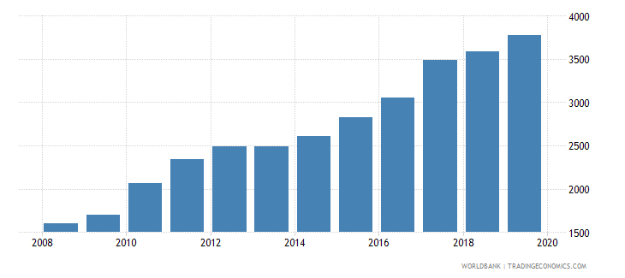

According to material provided by World Bank, China have a total of 3,777 listed companies in 2019. The author uses the sample size of 3,031, the figures that can be obtained in 2017. The author did not use the criteria to choose those companies representative of their respective industries. Large companies might have more resources to develop corporate governance whereas smaller companies have more restriction. A weighting system might be necessary to be implemented so that the results obtained from CGI will be more meaningful and representative of the quality of the listed companies in the sample.

Li pointed out that Chinese economy has undergone four phases of development of corporate governance practice. This includes concept introduction, structural reform, mechanism building and effectiveness improvement. China is in currently in phase four. The researcher does not share the same view with the author as China is still in the final stage of mechanism building and early part of effectiveness improvement. Every effort has been made to formulate an effective CGI to improve the quality of corporate governance and Chinese authority has lots of mechanism to improve before a very reliable and efficient CGI can be relied for the purpose of comparison with the corporate governance practice with western economies and form the basis for reference to the foreign investors for capital investment in China.

The political environment in China prevents the transparent disclosure of the information related to corporate governance. The data collection of the information might not truly reflect the status of the listed companies in China. There is always the tendency for the voluntary/mandatory enhancement/omission/amendment of the data making the CGI index does not accurately show the true status of the ESG position of the companies in the sample. Li has omitted to insert political and social factor in the Corporate Governance Index. In fact, it is very difficult to quantify this factor. However, it might be a great mistake by NOT inserting the political variation factor in the CGI apart from regulatory compliance. The impact of political influence on western enterprises is much less than the Chinese companies. When deciding whether to invest in a particular listed company, the investors will not only focus on the rating of the CGI, but also the inherited political risk associated with the company.

The article argues that the CGI includes six dimensions including the board of supervisors’ governance and stakeholders’ governance. These two dimensions are very difficult to measure. The board of supervisors monitors the activities of the Board and CEO as well as monitoring the financial affairs and business activities on behalf of the shareholders and often the weighting on this particular dimension should be varied under different circumstances. The authority of board of supervisors is superior to that of board of directors and the procedure of appointment and removal of supervisors are very important to ensure quality coporate governance practice. The board of supervisors does not form part of the board of directors in Hong Kong and it is a centralized authority which should bear more weight in ESG weighting
CGI not only incorporates good corporate practices but also the variation of quality of corporate governance practice. Company’s market valuation is positively related to overall CGI. Corporate governance practices are consistent with value maximization. The CLC CGI developed by Nankai University does not specifically spell out the exact relationship between good coporate governance to good financial performance. Corporate governance consists of procedures and processes where an organization can utilize to direct and control helping the company to build an environment of trust and accountability (OECD, 2015)

The author said that the Chinese corporate governance moved from “administration-oriented” governance model to an “economy-oriented” model following the principles of Chinese corporate governance reform. In fact, this is the traditional Chinese view that corporate governance only serves to enhance financial performance and attract foreign investment and not pursuing rational and ethical development of corporate governance to make more compliance yardsticks and make the business community healthier and sustainable. In the past, corporate governance serves to follow the guidance and direction of the Authorities and not of economic consideration. The scholars would not normally make reference to the information released by the Chinese listed companies. This is the reason why various corporate governance evaluation indexes have been evolved in the market to formulate a more realistic and fairer data for the reference of the investors. The emergence of CGI developed by ERG of Nankai University tries to fill the gap and demand of global investors for the enhancement of corporate governance of Chinese listed companies.

Methodology
The Research Design of the article is basically a case study design. The author tries to put forward a case of describing the history of development of corporate governance, the formulation of a CGI to enhance the quality of corporate governance, the uniqueness of Chinese type of CGI, which has gone through preliminary development stages and strive for effective management. The various types of CGI are explored with the review of the effectiveness of those systems leading the need for a universally recognized CGI for adoption in the global economy for sustained growth of the economy.

As stated in Yin, 2009 “A case study is an empirical inquiry that investigates a contemporary phenomenon in depth and within its real-life context, especially when the boundaries between phenomenon and context are not clearly evident” The author choose the case study design and it is quite appropriate. Although there are shortcomings in the sampling method and data collection, the article clearly spells out the reason of using CLC CGI and the various CGIs are also explored making it necessary in the modern world. The introduction section shows the composition of the CGI and the uniqueness of CLC CGI addressing the specific quality of Chinese listed companies.
The researcher would disagree with the author of the article that CLC CGI developed by Nankai University is a reliable and representative index for comparing the corporate governance of the Chinese listed companies. All data can only be obtained from the website of the regulatory bodies in Shenzhen and Shanghai and the accuracy of which yet to be ascertained. However, they are the official information available to the public.

Research Design
The researcher tries to map out the proposed research design for the formulation of the CGI for the Chinese listed companies. Research design is a framework for blueprint for conducting the research project. It details the procedure for obtaining the information to structure the procedure for the developing of a corporate governance evaluation system index. Qualitative information will be obtained.in the following six areas:
Shareholder governance, Board of directors’ governance, Board of supervisors’ governance, Management-level governance, Information disclosure and Stakeholder governance.

Li lists the 4 phases of development of CGI of CLC. It is a good start to explain how the CGI developed in the first instance. Phase I involves the “Research, Organize and formulate China’s corporate governance principles” Li referenced China’s Corporate Governance Principles in 2001, which was very raw materials. Li should reference the CGI developed by universally adopted institute as reference standard first and gradually incorporate new criteria for adoption in line with Chinese standard.

Phase 2 involves the construction of the corporate governance evaluation indicator system of CLC. In April 2003, after repeated revisions, the CGI system of CLC was published and after consulting experts from western world, the aforementioned six dimensions were chosen to be included in the formulation of the Index. In fact, as the researcher mentioned before, the political environment factor should be included, the weighting of supervisor governance should be adjusted and the various stakeholders’ governance (including shareholders, regulators and employee) should be monitored with care.

Phase 3 involves officially launching the CGI of CLC and China’s Corporate Governance Evaluation Report. The CGI of CLC was built and the China’s Corporate Governance Evaluation Report was issued for the first time in 2004.

Phase 4 involves the corporate governance evaluation system of CLC. It was noted that the
CGI Index was tested by various institutions including CCTV Financial 50 Index which
went public on Shenzhen Stock Exchange on 6th June 2012. In 2007, ERG used
governance evaluation criteria system for insurance companies. In 2008, SASAC delegated ERG to evaluate the corporate governance status of centrally administered SOE holding companies. ERG has also developed China’s CGI database, researched and developed China’s corporate governance stock price index.

Li was too academic in using the various types for analyzing purpose with the sole purpose of comparing the CGI of different sector showing those with high CGI showing their quality of corporate governance is better. No matter it is segment by industry, board composition or geographical area, the key points of how to put weighting on the various sectors is very important. The author has to make sure that proper classification of the various segments in industry, geographical area and board. The most difficult one might be board type classification. Such areas as independent directors, shareholders voting rights, dividend policy and distribution, rights of shareholders to speak and query the directors and the management at the annual general meeting.

The researcher does not share some of the conclusions drawn by the author at the summary section. The author said that the level of corporate governance of CLC has been improved rapidly in recent ten years and further improvement is required. In fact, the improvement of corporate governance was due to the imminent need of Chinese companies to merge with other western economies and some figures and information have been distorted. It is generally agreed that both the state- owned enterprises and private enterprises shall follow the rules and instruction of the Chinese Authorities in the implementation of CGI. The effectiveness of the evaluation system of the Chinese companies is solely relying on the accuracy and timeliness of the information of the listed companies released. The report and financial information of the independent auditors can be referred for checking of the relevant data for comparison of CGI.

Conclusion
The author admits that there are different CGI in different industries, controlling shareholders and areas. Different industries might impose different interpretation on some corporate governance issues such as safety measures, control by supervisors and anti-corruption measures. Chinese listed companies are very weak in anti-corruption and shareholders rights and the data collected is not accurate.

The findings of the author on other areas might be encouraging. It was noted that although the overall level of supervisors’ governance is still low, it has improved year after year. As mentioned earlier, the authority of supervisors is very high and the control of the supervisor to follow the corporate governance procedures is limited. Unless and until an effective political hierarchy and management structure can be established, the demand for the enhancement of the corporate governance, in particular in the area of supervisors’ governance and stakeholders’ governance is still surging.

The author also indicated that the information disclosure is above average among all the dimensions of corporate governance. In fact, this dimension is the easiest to follow as the listed companies only disclose the information to the public according the rules.
The article describes how EPR of Nankai University conducting the annual review of the CGI of CLC and the relating development of the corporate governance in China and the urge for the formulation of the index for evaluation of corporate governance of the listed companies in China. Li tries to be objective in conducting the evaluation of the Chinese listed companies. There is a clear demand to formulate an efficient and effective ESG Indexing system for the purpose of providing a common platform for comparison of the quality of the ESG and corporate governance of the companies for the reference of the investors for investing decision and the regulators for compliance needs.
PART C
Abstract
There is consensus that Environmental, Social and Governance (ESG) practices is a good corporate governance and ESG integration principles must be supported by the top down. ESG framework can be useful perspectives for companies to manage risks and face internal and external challenge. Investors and asset owners constantly demand more ESG focused investing and ESG reporting plays an important role on directing investors’ decision making in investing in listed companies, funds and trusts. The study will first cover the ESG requirement of listed companies in Hong Kong and the composition of ESG. The researcher would then investigate whether there is impact of ESG on financial performance and corporate leadership and any trend noted and would try to develop any improvement in ESG initiatives incorporating new dimension, collaboration in the ESG initiatives acting as a driver and bridge for the integration of environmental, social and governance issues.

- INTRODUCTION
As a company secretary of a listed company in Hong Kong, the proposed research proposal would help the company to determine whether the implementation of ESG apart from statutory compliance, would enhance the financial performance and corporate leadership of the listed companies. The researcher wishes to conduct a qualitative research to see if the influence of ESG on the profits and board motivation are on the macro prospective, whether the ESG policy would benefit not only the performance of the particular industry but the commercial environment in Hong Kong as a whole. Evidence supports that governance practices significantly influence the financial performance. The study will be in two-fold- theoretical perspective and empirical view of the ESG initiatives and their interactive relationship. In recent years, there is a strong international trend in research of environmental, social and governance issues. ESG is not only mandatory requirements in many stock exchanges as measures to enhance quality of corporate governance and the key to increase reputation and image. ESG indicator such as evaluation index provides reference to institutional investors to place their investment. The researcher tries to find evident that the implementation of environment and social strategies with an effective system of corporate governance in the organization strengthens corporate sustainability performance including financial performance. Corporate sustainability is achieved by combining ESG which enhance efficiency, sustainable growth and shareholder value. ESG policies and practices have a positive impact on the company’s financial performance and long term business strategy and in addition, attraction and retention of talented staff thus achieving good corporate leadership. Various aspects of ESG may be material to an individual business’s long term success. The process of identifying these areas often known as materiality assessment. The tracking and reporting of these areas will be reported in the annual ESG or CSR report contained in the Annual Report. There is a necessity to standardize the tracking mechanism across industry groups and markets. Marsh & McLennan issued a report entitled ESG as a Workforce Strategy. The report states that ESG performance can have a positive impact on workforce sentiment which can be a major competitive advantage for companies. Employers who care to understand the employee sentiment tend to achieve greater employee satisfaction leading to good corporate leadership and governance.

BACKGROUND
The Financial Services Development Council (FSDC) mentioned a number of policy recommendations for Hong Kong in its White Paper for Hong Kong to monitor so as to strengthen the Hong Kong’s status of investment hub. These include the creation of an ESG policy framework, insures’ disclosures of ESG policies, enforcing the reporting of financial and non-financial information.

There are many regulatory requirements and listing rules requirements for the listed companies in Hong Kong. ESG initiatives have been introduced by The Stock Exchange of Hong Kong Limited (“SEHK”) for more than 10 years. There are mandatory disclosures and other voluntary disclosure whether the company has complied or explain the reason of noncompliance. The ESG report shall be issued separately or contained in the Annual Report to be sent to shareholders and posted to the Company’s web-site for the information of the public. SEHK has issued the new Consultation Paper in mid-2019 and concluded that the new ESG disclosures for the compliance of the listed companies including the responsibility of the Board to oversee the formulation, implementation and monitoring of the ESG policies, the new climate change impact on companies and ESG issues on suppliers and other additional anti-corruption measures.

On 18 December 2019, The Stock Exchange of Hong Kong Limited (HKEX) published new requirements in its Consultation Conclusions on Review of the Environmental, Social and Governance (ESG) Reporting Guide and Related Listing Rules with the new requirements being operational after 1 July 2020. The amendments to the existing guide represent a shift away from “reporting” to “management”, with an emphasis on the board’s role in the governance structure for ESG matters. The key rules and criteria are appended below as outline for the effective ESG initiatives which will lead to good financial performance and corporate leadership.

Board’s responsibility
The Company should have greater ESG integration Board’s responsibility and enhanced board’s responsibility for overseeing ESG issues. The Board’s ESG management approach and strategy, including the process used to evaluate, prioritize and manage material ESG-related issues and risks should be monitored

Reporting principles
It is now mandatory to disclose application of the Reporting Principles and process to identify and criteria for the selection of material ESG factors. There should be description of significant stakeholders identified; and the stakeholder engagement process and results

Disclosure of climate related issues •
The Company should introduce a new Aspect relating to climate change comprising policies on identification and mitigation of significant climate related issues that have impacted and may impact the issuer. A KPI description of the significant climate related issues that may impact the issuer be formulated and the actions are taken to manage them.

Targets for environmental key performance indicators (KPIs) •
There is a requirement of disclosure of a description of targets set regarding emissions, energy use and water efficiency and waste reduction and steps should be taken to strive for the target.

LIMITATION OF RESEARCH STUDY
There is limitation of the research study. Firstly, the proposed research collects the data from the published information and materials where different bases and criteria are used for measurement. Researcher would investigate if any impact of ESG on financial performance and corporate leadership. Different industry might have different criteria for ESS initiatives.
Secondly, the research results depend on the proper section of the sample companies with unique ESG items comparable in quantifiable terms. The cooperation of the respondents of the survey and focus group interview is yet to be monitored.

GROWING IMPORTANCE OF ESG IN HONG KONG AND THE WORLD
These areas and the reporting Environmental criteria may include company’s energy emission, waste handling, recycles and pollution. The company can use the criteria in evaluating any environmental risks a company may face and how the company is managing those risks. Traditional companies only focus on investment in resources that can maximize shareholders’ return. With the global change in attitudes on ESG initiatives, there has been an increase in number of firms that employ sustainability strategies and disclose their ESG information globally. Global Reporting Initiatives published in 2018 showed that they have collected 50,197 reports on ESG items on a voluntary basis from 12,964 companies. In China, 80% of Corporations published ESG reports in 2009, compared to just 4 % in 2005. The survey by Klynveld Peat Marwick Coerdeler (KPMG) indicated that the overall rate of reporting of corporate responsibility in the Asia Pacific region represents 78% of the worldwide reporting, whereas only 52% recorded in the Middle East and Africa.
The emphasis on ESG was promote in Europe and Unites States and has been growing popular in Asia.

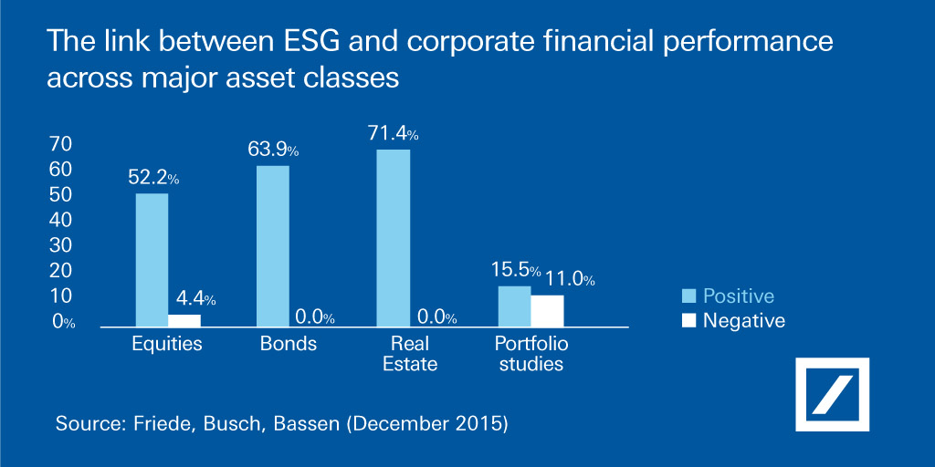

RELATION OF ESG WITH FINANCIAL PERFORMANCE AND CORPOATE LEADERSIP
ESG plays an important role in the suitability of the Companies. It is often suggested that there is a relation or link between ESG initiates and financial performance. Financial performance can be classified as “financial visibility” where the company achieves its economic goals (Orlitzky et al., 2003). Financial performance can be measured by accounting-based variables (e.g. return on assets (ROA) and market-based items (e.g. Tobin’s Q). Literature stresses that the link between ESG or CSR and financial performance may be linked with a time lag of at least one year (Scholtens, 2008). ESG performance is an aggregate measure that arises from CSR activities.

The senior management and in particular the CEO will have significant influence on the implementation of the ESG policies and thus will also enhance corporate leadership of the company. In fact, this is a causal relationship. Good leader leads to good ESG implementation resulting in good financial performance contributing to good corporate leadership which strengthens the ESG initiatives. CEO or senior management can insert influence on strategic decisions within the company. They may influence the financial and nonfinancial reporting and thus the financial and non-financial performance. Sawir (2015) said that financial performance reflects its achievement similar to that of a health rate.

The researcher tries to establish some theoretical study if any link between ESG and financial performance. Stakeholder theory (Freeman, 1984) may be employed in our study. With this conceptual analysis, long-term success of products and services of a firm was the result of satisfaction of the needs of different stakeholders (Freeman, 1984). If stakeholders are satisfied with stakeholder relations concepts of the company, this will achieve increased sustainability performance (Clarkson et al., 2008). The consequence will be good reputation of the company attracting new sustainable shareholder leading to increased financial performance. With empirical research on CSR –financial performance, it comes out with mixed results. The researcher is with the view that ESG performance is positively related to financial performance (ROA)

There are other conceptual theories indicating the importance of ESG initiatives and its influence on financial performance. The legitimacy theory, developed by Guthrie, J and Parker, L. D., argues that companies must disclose certain information (community services, human resources management, and product and service contributions) to convince society that the organizational activities are possible and contribute to social value. Legitimacy theory argues that , firms provide ESG disclosure on a voluntary basis to demonstrate that they are complying with societal expectations and norms. ESG disclosure is aimed at gaining social legitimacy for environmental or social impacts caused by the firm’s operation. Political economic theory also recognizes social and environment disclosure in annual report as strategic tool to reach companies goals and can affect the attitude of stakeholders.
The main objective of the majority businesses is to maximize profits and increase the market value on a long term basis. Economic sustainability performance contains financial costs and benefits and reflects the company’s long term profitability and financial sustainability. Financial indicators include return on equity (ROE), return on assets (ROA) and economic value added (EVA). These indicators allow the investors to better assess the risks and returns of their investments. A study analyzed the impact of sustainability indicators (ESG) on economic (Market and financial) performance among companies listed in European countries indicating a significant positive relationship. The underlying principle behind ESG disclosure-economic sustainability performance is that they always come from those socially responsible firms that seriously perform ESG initiatives..

The researcher has gone through some qualitative research in the form of surveys or online surveys and interviews with General Staff in focus group (an extract of which is appended below) in collecting the ESG feedback from the stakeholders for preparation of the ESG Report. The first approach is to gather the impression of the staff on the prevailing ESG initiatives undertaken by the Company and the second step is to collect information whether they have noticed any improvement in financial performance (higher profit return, lower operating cost with the increasing efficiency and effectiveness in the various operating units).

Extract of the Sample Online Survey:
Hong Kong Ferry (Holdings) Company Limited: 2020 Online Survey for Stakeholders
Section 1: Feedback on ESG Report 2019
Section 2: Importance of ESG Topics
Section 3: Stakeholders’ Comments and Recommendations
Section 4 ESG’s impact on financial performance and corporate leadership
Q5: Which environmental targets listed below would be the most relevant to HK Ferry Group’s operations? (You may choose more than one option)
Q6: To identify main topics for the upcoming ESG Report 2020, how would you rate the importance of the following ESG aspects from the perspective of a HK Ferry Group stakeholder?
Q8: What ESG topics should HK Ferry Group focus on for future ESG initiatives?)
Q11: Which focus areas should HK Ferry Group’s management provide for Board’s discussion?
Q14: Please share your thoughts on how HK Ferry Group could enhance its customer service and customer engagement performance.
Q15: Are you aware of any emerging trend of interest from companies in managing and monitoring various environmental and social issues? If so, what are the environmental and social factors that HK Ferry Group should consider with respect to its customers?
Q16: Please share your thoughts on HK Ferry Group's overall performance on sustainability (e.g. environmental protection, staff communication and engagement, community investment and procurement practice, etc.).
Q18: Which areas should HK Ferry Group focus on to further improve its crisis management responses?
Q19: Do you think that with ESG initiatives, the Company can enhance its financial performance and corporate leadership? Can you give your reasons?”
Extract of Sample Interview questions:
- Perceptions on ESG Report 2019
  - As an employee, do you feel the ESG Report 2019 effectively covered all of what you think Hong Kong Ferry should be reporting on? If not, what issues do you think should be included? Which parts of ESG Report 2019 should be included again this year (e.g. data, case studies, objectives and targets)?

- Perception on ESG Performance
  - In your opinion, how important is Environmental, Social and Governance to Hong Kong Ferry?
  - What is your view on Hong Kong Ferry's current ESG initiatives and direction? Are there any examples of positive initiatives that have impressed you?

  - How can Hong Kong Ferry improve its ESG performance (e.g. governance, community, environment, staff welfare, safety, amongst others)? Are there any impacts from your operations that require further attention by Hong Kong Ferry? What are these issues and how should Company handle and address these issues?
  - How could you help Hong Kong Ferry to better achieve its ESG performance?
  - Do you think that enhanced ESG performance would lead to good financial performance? Do you recall that the operating profit improved and cost reduced in the past years?
  - Do you think that enhanced ESG performance would lead to good corporate leadership? Do you recall that the company atmosphere has been improved and employees’ motivation and morale enhanced?

- Environmental and Safety Performance
  - What key ESG initiatives, achievements did your department / functioning unit have in 2019? Any comments or suggestions for improvement? You may consider the following aspects: Various ESG initiatives listed for the respondents to select.”

This is the first qualitative study carried out by the researcher. The results of the online survey have been obtained whereas the focus group interview has yet to be completed in late November/early December 2020.
After conducting the search on the credit of those companies with good ESG rating, the following companies have been chosen for review:
CLP Holdings Limited (stock code 2)
Kerry Properties Limited (stock code 683)
Henderson Land Development Company Limited (stock code 12)
New World Development Company Limited (stock code 17)
Sun Hung Kai Properties Limited (stock code 16)
Upon consolidation of the data from the online survey and interviews, the researcher would link up the connection with those companies chosen above (which has the reputation of good corporate governance and ESG initiatives) and send out the forms to them and arrange time for interviews to further conduct a survey on the relationship between ESG and financial performance and corporate leadership.

FINDING FROM THE RESEARCH
The Most Controversial Companies (MCC) 2018 Report shows how major corporations from different business sectors, are put under threat of reputational and financial loss due to the inadequate management of ESG risks. Many companies have faced the dynamic of ESG issues. ESG criteria are increasing popular for investors to evaluate companies they would like to invest. These include many mutual funds and brokerage firms offering products that employ ESG criteria. ESG criteria also help investors not to invest those companies which pose greater financial risk due to their environmental or other practices. According to the most recent report from US SIF Foundation, investors held US$11.6 trillion in assets chosen according to ESG criteria at the beginning of 2018, an increase from US$8.1 trillion as compared to that 2016. Boston-based Trillium Asset Management, with US$2.8 billion under management as of March 2020, uses ESG as selection factors for strong long-term performance. Many big companies like Morgan, Chase and Goldman Sachs have published annual reports that extensively review their ESG initiates.

As published by the Harvard Business Review in 2019, they have interviewed 70 senior executives at 43 global institutional investing forms, including large institutional asset manager like BlackRock and giant asset owners and retirement and pension fund administrators like the California State Teachers’ Retirement System (CalSTRS), and the government pension funds of Japan, Sweden and the Netherland and found that ESG was almost the major concern of senior managers of the large enterprises.

During the months of Covid-19 crisis, reputable news outlets have claimed that ESG investments have better performance than the standard stock market benchmarks. A report noticed that Nuveen Winslow Large Cap Growth ESG Fund (NVLIZ) fell only 7.4% as compared to 13.7% fall in the S7 P 500 index from December 31, 2019 to April 2020.
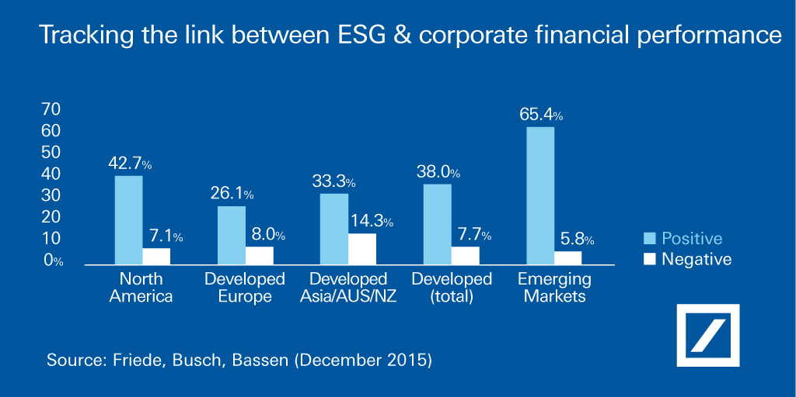
CONCLUSION
The world is faced with covid-19 pandemic since the early part of this year. The pandemic is creating unprecedented disruption throughout our lives and global economy Customers demand, supply, financial markets, the labour force and every aspect of the day-to-day business are affected. Business community faced the unpredictable crisis and should implement crisis management plans in place and to strive for sustainability plans including ESG initiates to manage the companies in the period of uncertainty. The business world is facing with great temptation to reduce their spending on ESG so as to save cost and enhance profits. The portion of ESG spending is growing to be quite substantial with the reduced revenue and climbing operating cost. ESG scores are not only measure of performance but rather a measure of overall transparency. There is a clear relationship between the ESG score and firm performance from the finding as there is a social contract between the firm and the stakeholders. The cooperation among all stakeholders including the shareholders, regulators, management, suppliers, and customers is very important and it is an art on how to motivate various stakeholders to actively involved in ESG formulation, implementation and monitoring process

After reviewing the requirement of the regulatory bodies in Hong Kong and other western countries, it is noted that t a strategic and moderate disclosure can enhance corporate efficiency rather than a pro-forma disclosure with limited transparency or over disclosure with much unfavorable information. Also, the effective execution of ESG activities is essential to both CSR performance and corporate financial performance. The importance of the business leaders to promote effective ESG strategies is also important.

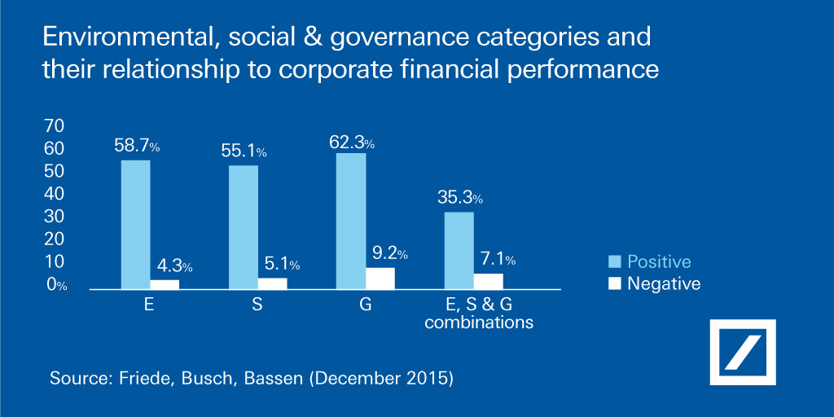

RECOMMENDATION
After reviewing the impact of ESG on financial performance and corporate leadership, the researcher has noticed that some new driving initiatives should be added to ESG initiatives to make them more meaningful and sustainable. The role of the stakeholders is very important for the successful implementation of ESG and the long term sustainability of the corporations, in particular listed companies in Hong Kong. The stakeholders should collaborate among themselves for the good of the companies. ESGC should be the new initiatives for future company. With environmental, social and governance as various dimensions for improvement, we shall seek the assistance of all stakeholders to contribute to ESG implementation. Companies with good performance will get attention of stakeholders who can improve financial performance. Unless and until the stakeholders share the success and failure of ESG implementation that they will be more active in the ESH exercises. ESGC should be the new tern in next generation where every stakeholder is educated to participate in the ESG exercise. The researcher believes that the future ESGC index will be more representative and highly recognized in the global market.
References
- Alsayegh, M.F., Rashidah, A.R. and Saeid, H. (2020) “Corporate Economic, Environmental, and Social Sustainability Performance through ESG Disclosure” Proquest.com Retrieved from
https://search.proquest.com/docview/2403314275/964E82B8058C4C32PQ
- Chen, J. (2020) “Environmental, Social, and Governance (ESG) Criteria”
Investopedia.com Retrieved from
https://www.investopedia.com/terms/e/environmental-social-and-governance-esg-criteria.asp
- Coulson-Thomas, C. (2018) “Corporate Leadership and Governance for Increasing Stakeholder Involvement” Effective Executive; Hyderabad Vol.21, Iss. 1 Retrieved from
https://search.proquest.com/docview/2027472527/AC7C6893BDBF4EABPQ/1?accountid=130472
- Deutsche Bank (2016) “ESG and financial performance: aggregated evidence from more than 2000 empirical studies” Retrieved from
https://www.db.com/newsroom_news/2016/ghp/esg-and-financial-performance-aggregated-evidence-from-more-than-200-empirical-studies-en-11363.htm
- Eccles R.G. and Klimenko S. (2019) “The Investor Revolution”
Harvard Business Review May-June Issue
- Haninun H.,Lindrianasari, L., and Denziana A. (2018) “The effect of environmental performance and disclosure on financial performance”
Int. J. Trade and Global Markets, Vol. 11 Nos 1/2,

- Hong Kong Ferry (Holdings ) Company Limited –Annual Report (2019)
Retrieved from
http://www.hkf.com/images/rpt/1587540290PFNl6.pdf
- KPMG (2018) “Integrating ESG into your Business A step-by-step ESG guide for Hong Kong-listed issuers” Retrieved from
https://assets.kpmg/content/dam/kpmg/cn/pdf/en/2020/01/integrating-esg-into-your-business.pdf
- Li, Weian (2018) “Corporate governance evaluation of Chinese listed companies”
Nankai Business Review International; Bingly Vol 9, Iss. 4 Retrieved from
https://search.proquest.com/docview/2137388229/A2095BA1E1D6433DPQ/224?accountid=130472
- Minutolo, M.C., Kristjanpoller W. D. and Stakeley J. (2019) “Exploring environmental, social, and governance disclosure effects on the S&P 500 financial performance” WILEY Business Strategy and the Environment
- Nankai University (2020) “China Corporate Governance Net”
Retrieved from
www.cg.org.cn
- Rajgopal, S. (2020) “How is ESG Performing In The Covid-19 Crisis”
Forbes.com Retrieved from
https://www.forbes.com/sites/shivaramrajgopal/2020/05/21/how-is-esg-performing-in-the-covid-19-crisis/
- Rodriguez-Fernandez, M., et al. (2019)

“Influence of ESGC Indicators on Financial Performance of Listed Travel and Leisure Companies” Sustainability; Basel Vol. 11, Iss. 19, Retrieved from
https://search.proquest.com/docview/2398142991/BDB0D256F

- Dr. Savelyeva, T. (2020) “Qualitative Research Methods HKBM 7003”
University of Wales Trinity Saint David
- The Stock Exchange of Hong Kong Limited “Main Board Listing Rules” Retrieved from
https://en-rules.hkex.com.hk/rulebook/main-board-listing-rules
- Tradingeconomics.com (2019) “China - Listed Domestic Companies, Total”
Retrieved from
https://tradingeconomics.com/china/listed-domestic-companies-total-wb-data.html
- Velte, P. (2019) “Does CEO power moderate the link between ESG performance and financial performance” Proquest.com Retrieved from
https://search.proquest.com/docview/2392381875/BDB0D256F9B14D4APQ/2?accountid=130472
- Xie, J. et al. (2018) “Do environmental, social, and governance activities improve corporate financial performance?”
WILEY Business Strategy and the Environment

