Revision 1 (PLA, PAL, FPGA)
Q1
- For the functions the $F_{1}\text{ (A, B, C)=}∑_{m}\text{ (4,5,6,7)}$ and $F_{2}\text{ (A, B, C)=}∑_{m}\text{ (1, 2, 3)}$.
Answer the following.
  - Show the truth tables for the functions $F_{1}$ and $F_{2}$
  - Logic Expressions
  - Show how $F_{1}$ and $F_{2}$ can be implemented using one Decoder.
  - Design them using Programmable Logic Array (PLA).
Solution
Truth Table for $F_{1} and F_{2}$
A | B | C | $$F_{1}$$ | $$F_{2}$$
0 | 0 | 0 | 0 | 0
0 | 0 | 1 | 0 | 1
0 | 1 | 0 | 0 | 1
0 | 1 | 1 | 0 | 1
1 | 0 | 0 | 1 | 0
1 | 0 | 1 | 1 | 0
1 | 1 | 0 | 1 | 0
1 | 1 | 1 | 1 | 0

Logic Expression
$F_{1}\text{ =}\text{AB}\overline{C}+ABC+A\overline{B}\overline{C}+A\overline{B}C$
$F_{2}\text{ =}\overline{A}\overline{B}C+\overline{A}B\overline{C}+\overline{A}BC$

Decoder Diagram
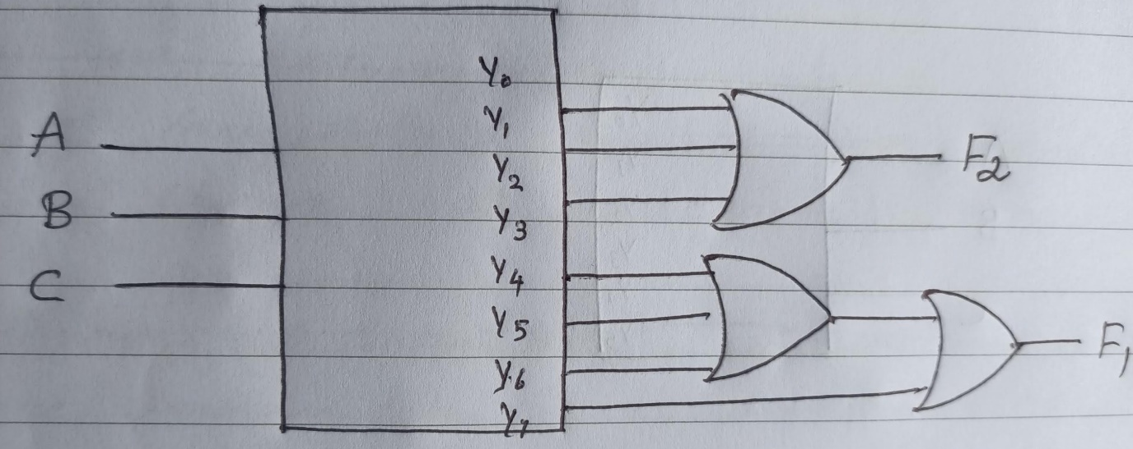

PLA Diagram

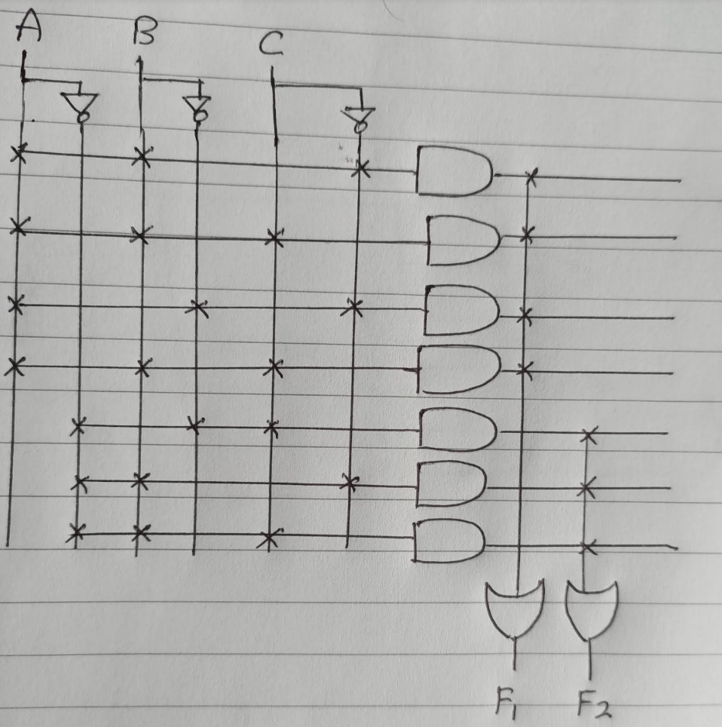

Q2
- For a 3- input LUT of an FPGA Logic block and determine the bits to be stored in its storage cell by using the function $f= \overline{A}\overline{B}\overline{C}+\overline{A}B\overline{C}+A\overline{B}\overline{C}+ABC$ to realize by answering the following
  - Truth Table
  - Design a 3- input LUT of an FPGA by assuming the value of inputs to be 001 respectively.

Solution
Truth Table
A | B | C | f
0 | 0 | 0 | 1
0 | 0 | 1 | 0
0 | 1 | 0 | 1
0 | 1 | 1 | 0
1 | 0 | 0 | 1
1 | 0 | 1 | 0
1 | 1 | 0 | 0
1 | 1 | 1 | 1

Design
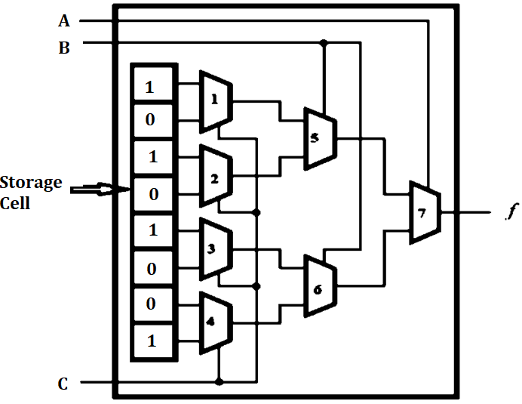

Q3
- Design the following function using PAL.
- $f_{1}= x_{1}x_{2}{\overline{x}}_{3}+{\overline{x}}_{1}x_{2}x_{3}$and
- $f_{2}= {\overline{x}}_{1}{\overline{x}}_{2}$+ $x_{1}x_{2}x_{3}$
Solution
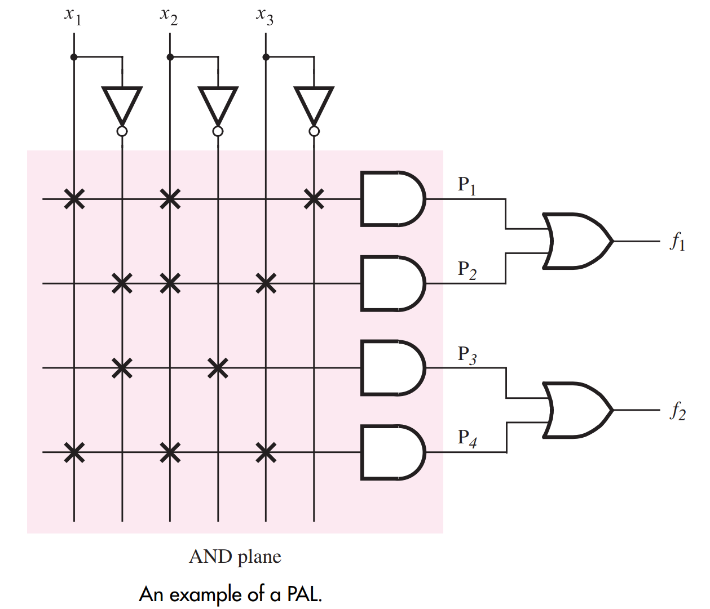

Q4
- Write short notes on FPGA
Solution :Refer Lecture 15
- Explain the operation of 3 input LUTs
Solution : Refer Lecture 15

